CA6C1 – DevOps - National Insitute of Technology, Trichy

Assignment 2 – Setting Up DOCKER – Workshop

Name:Anwar Hussain

Roll No:205224001

Q1: Using Docker Desktop or Docker Playground, perform the following:

1. Create a Container with PostgresDB or mySQL database installed (5 Marks)
2. Pull mysql

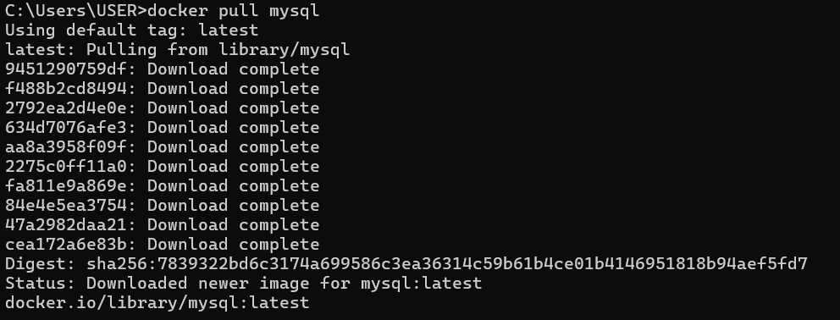

2)Run the image



3)Execute mysql

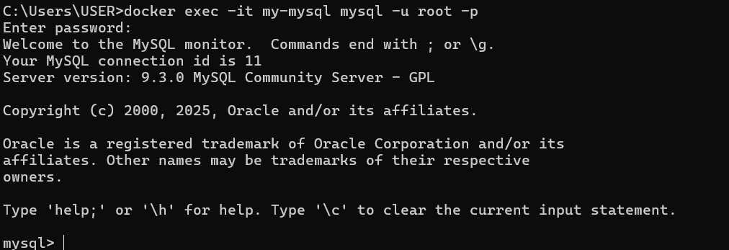

4)Run mysql commands

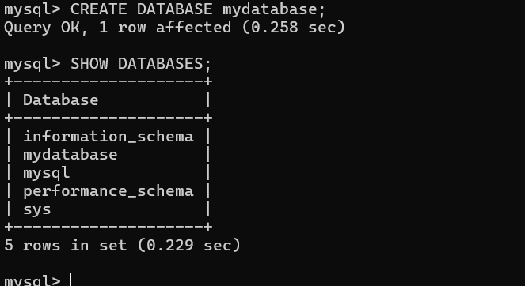

5)Show Docker Image

