DEVOPS ASSIGNMENT 2

**Name:** Mistuk Roy

**ROLL NO:** 205224012

**BRANCH:** M.TECH DATA ANALYTICS

**Q1. A) Create a Container with PostgresDB or mySQL database installed**

**Step 1:** We need to pull the docker image using the below command.

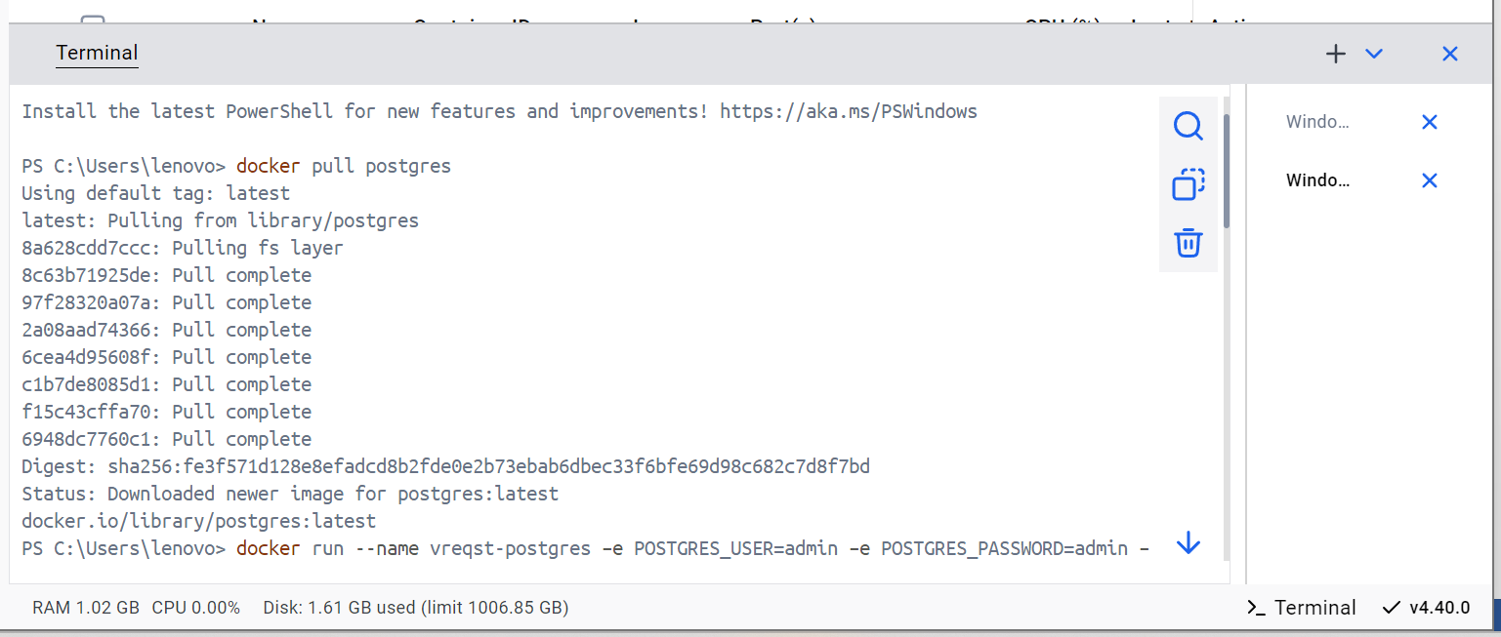

**Step 2:** Run the docker image using the Postgres credentials

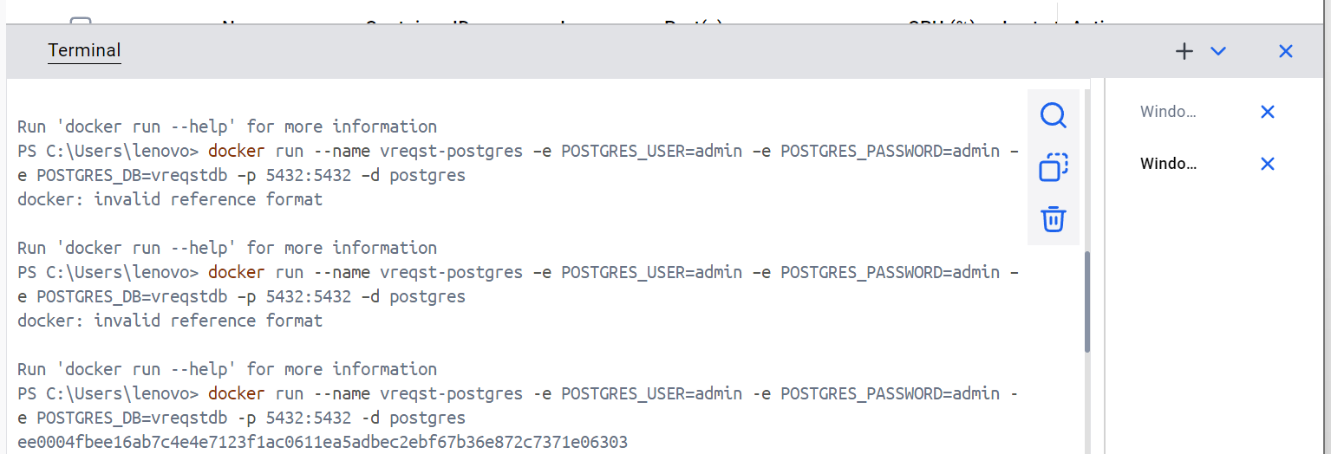

**Step 3:** Check whether the docker image is running or not



**Step 4:** Connect to the database and test by creating a TABLE

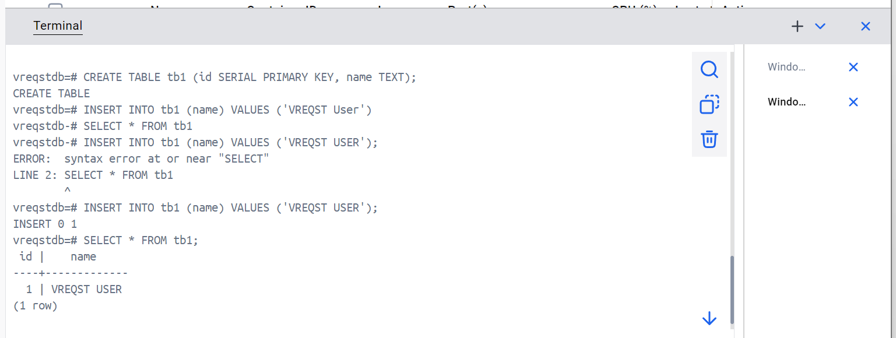

**Q1 B) Deploy VReqST – A requirement specification tool in a container.**

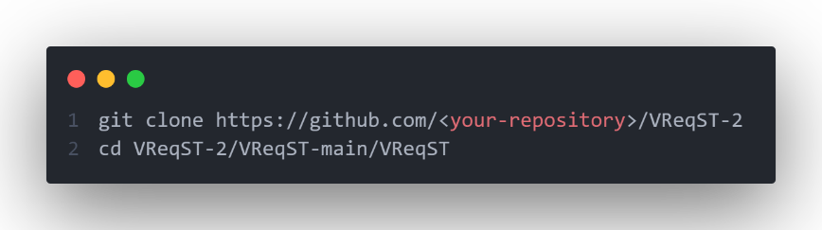**Step 1 :** Clone the Repository using the commands

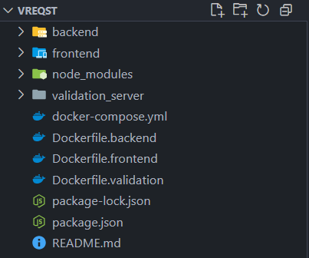**Step 2:** Verify the folder structure

**Step 4:** Create Collections in MongoDB Atlas and use MONGO_URI to link to the application (the link is given in docker-composer file)

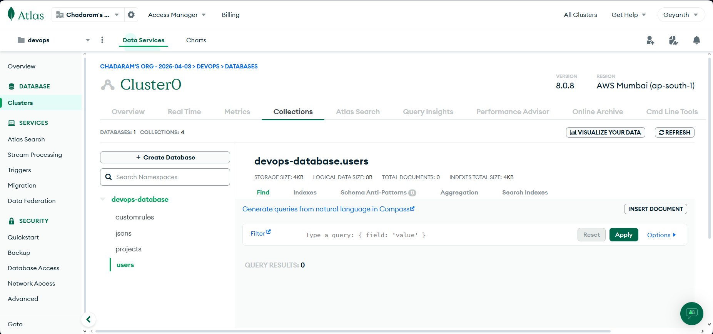

**Step 3:** Setup Docker

1. **Install Docker & Docker Compose -** Ensure both Docker and Docker Compose are installed and working.
2. **Create docker file `docker-compose.yml` -** Used to run the docker containers
3. 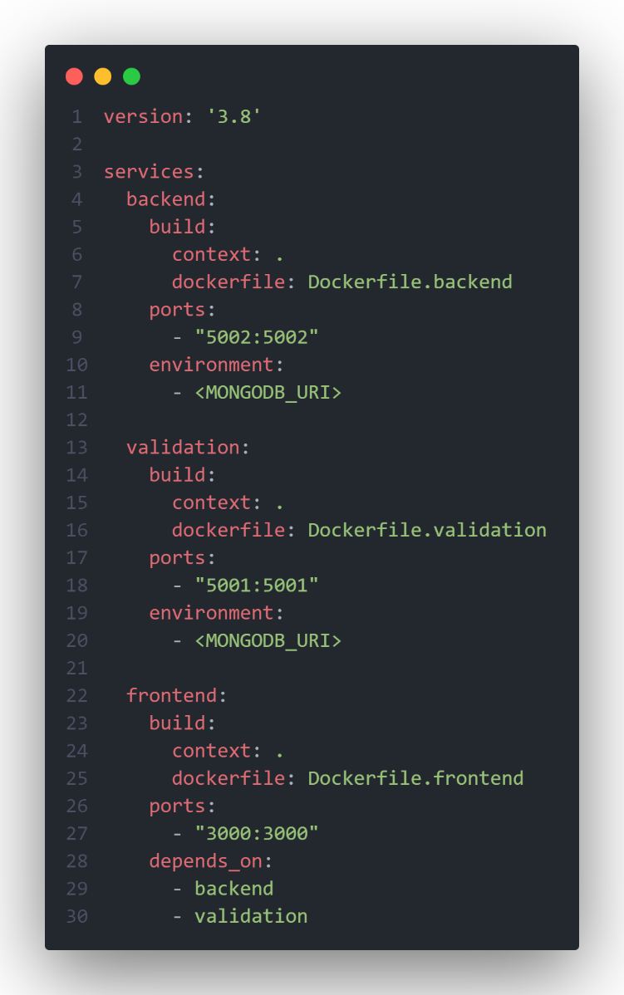**Create subfolders for different services** - Configure `Dockerfile.frontend`, `Dockerfile.backend`, `Dockerfile.validation`
4. 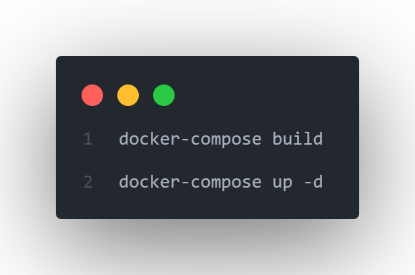**Build and Start Container**

Outputs: 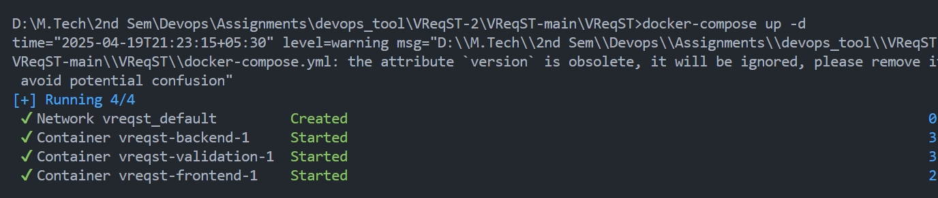

* Running the Application

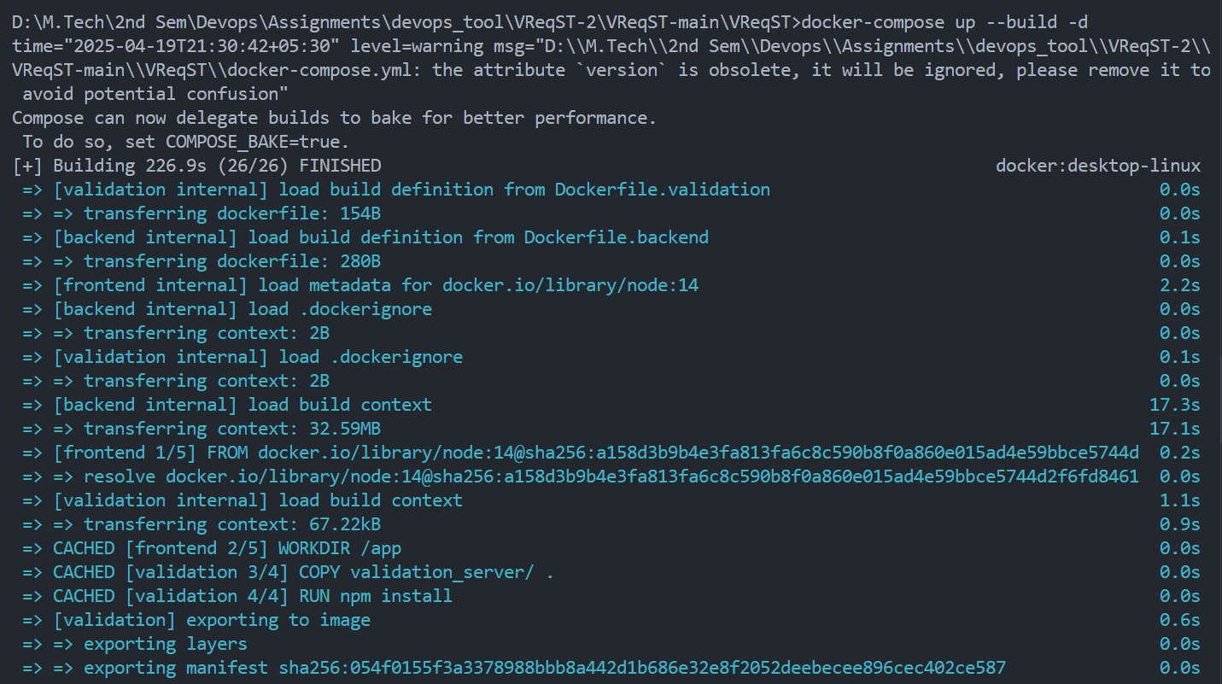

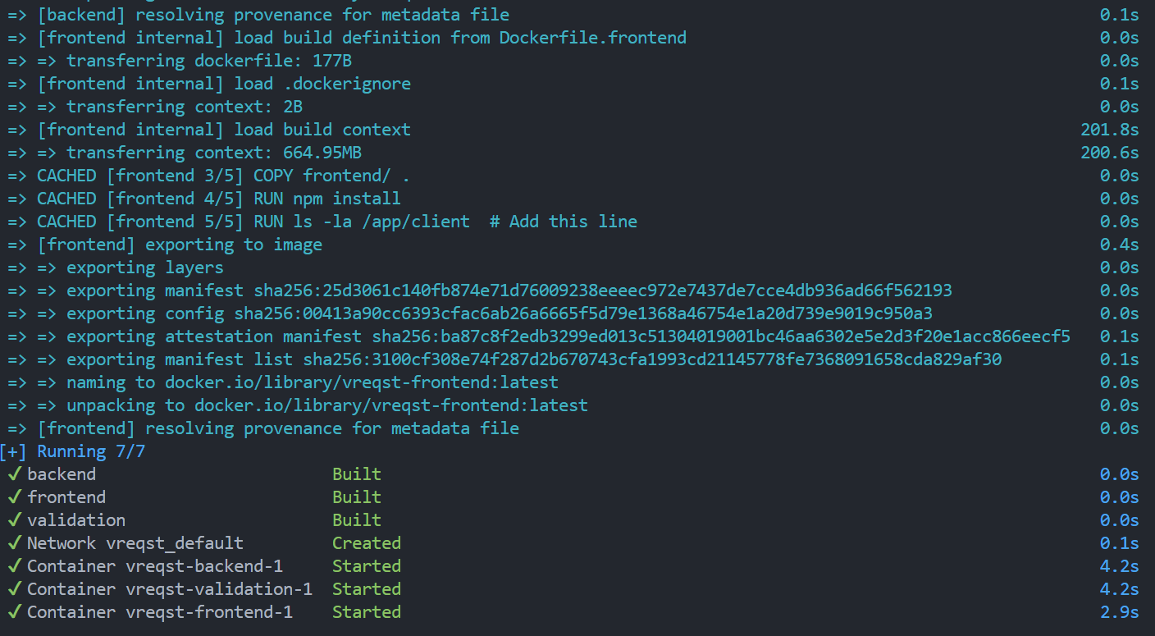

**Step 4:** Access the Application

Open your browser and go to: **http://localhost:3000**