**Assignment - 2**

**Q1 : Using Docker Desktop or Docker Playground, perform the following:**

**a. Create a Container with PostgresDB or mySQL database installed (5 Marks)**

**Ans:** Docker Desktop is used as the platform here.

1. **Pull The PostgreSQL image:**

Command : docker pull

Output : : 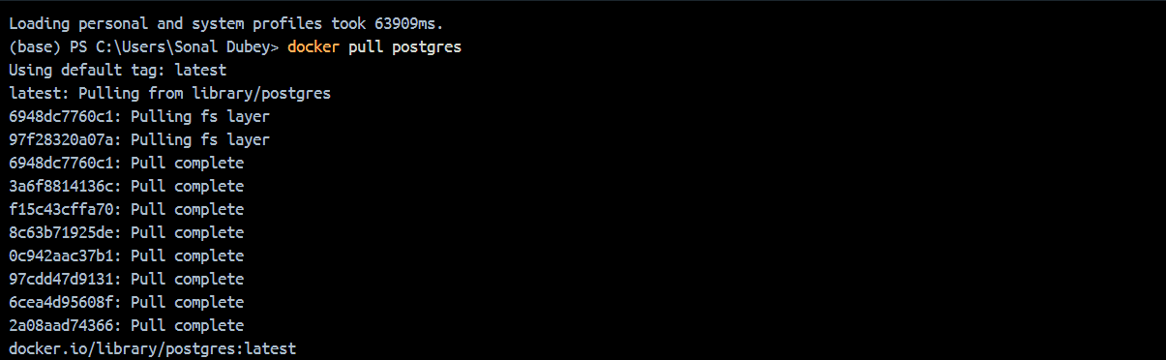

1. **Run a PostgreSQL container:**

Command : docker run --name my-postgres-container -e POSTGRES_PASSWORD=mysecretpassword -p 5432:5432 -d postgres

Output :



1. **Check running containers:**

Command : docker ps

Output :



**b: Deploy VReqST – A requirement specification tool in a container. All the artifacts required for the tool as listed here - https://docs.google.com/viewer?url=https://raw.githubusercontent.com/sai11101 989/sai11101989.github.io/main/Course/DevOps_NIT_Spring2025/VReqST_ICSE20 25_Artifacts.pdf (20 Marks)**

1. **Clone the repository:**

Command : git clone https://github.com/sai11101989/VReqST.git

cd VReqST/VReqST

Output :

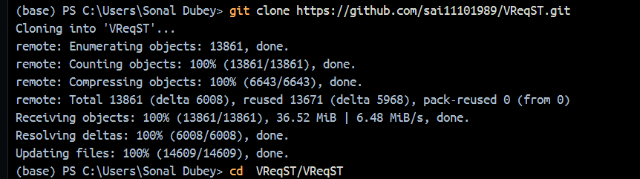

1. **Create a Dockerfile:**

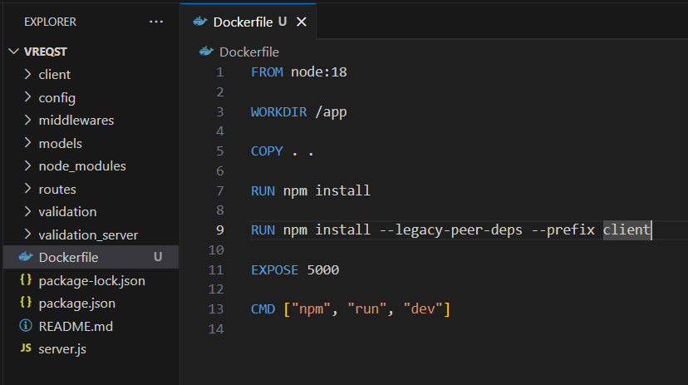

1. **Build the Docker image:**

Command : docker build -t vreqst-app .

Output :

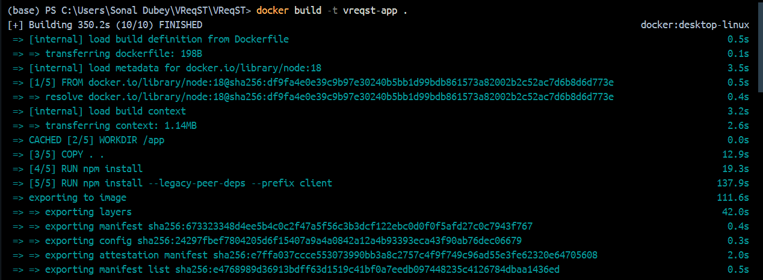

1. **Run the container:**

Command : docker run --name vreqst-container -p 5000:5000 vreqst-app

Output :

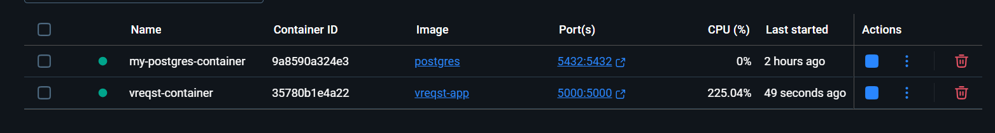

1. **Dockerfile for validation-server:**

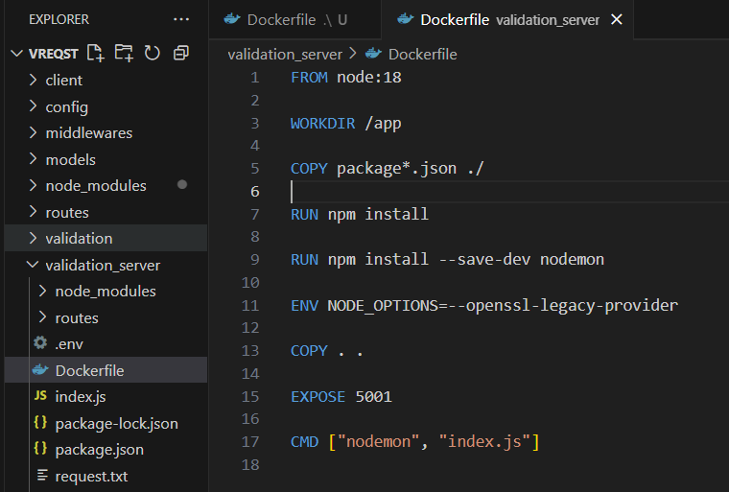

1. **Build the image for validation-server and run the container:**

Command : docker build -t validation-server .

docker run --name validation-server-container -p 5001:5001 validation-server

