**Deliver pipeline workflow**

**Objective:**

**To streamline the jobs in effective manner.**

**Problem statement**:

* + To create a pipeline workflow in Jenkins
  + Jobs will be created to sync with the workflow structure
  + To install a Delivery pipeline plugin in Jenkins
  + To configure the Delivery pipeline plugin and assign the jobs to be triggered
  + Pipeline view to be created after the configuration made in the Delivery pipeline
  + Trigger the Delivery pipeline and see all the dependency jobs are triggered

Steps to create a jobs and pipeline as shown below:

Click the New Item in the menu and create the new job. Follow the below screen to create a new job.

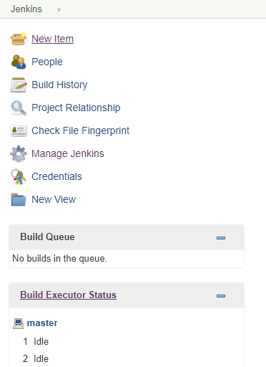

Create a new job called BuildJob_Test as per the below screen.

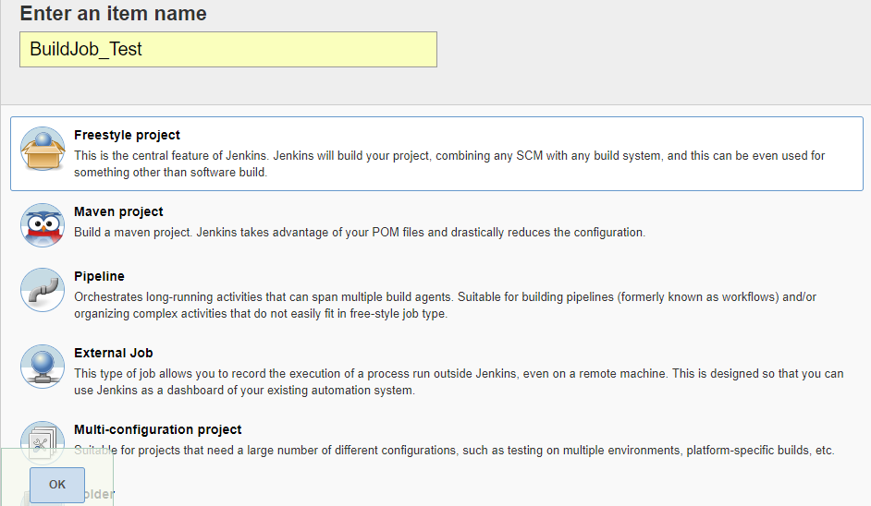

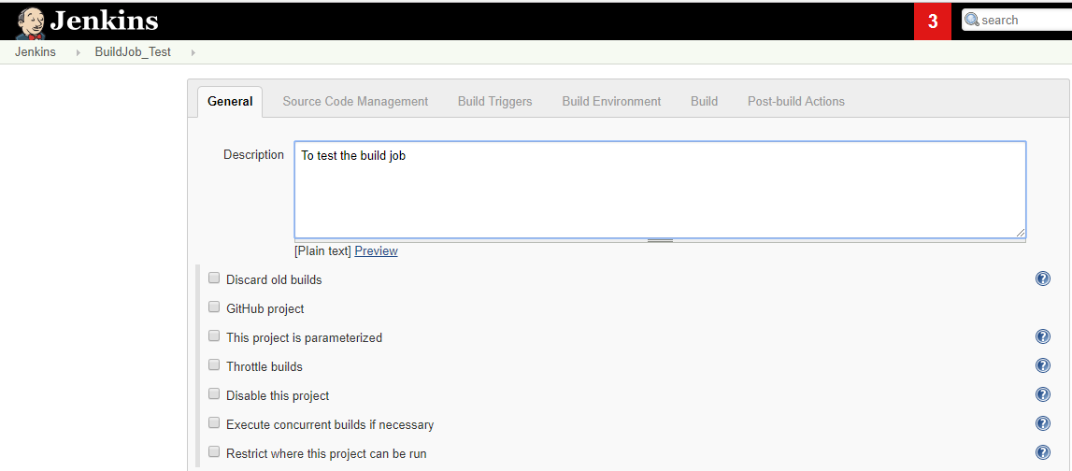

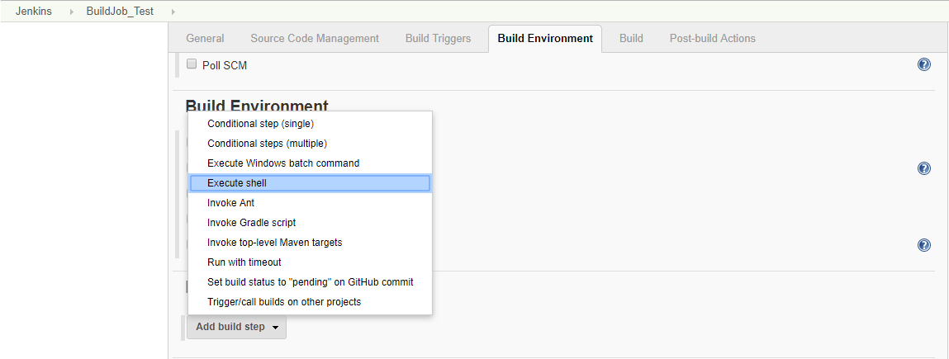

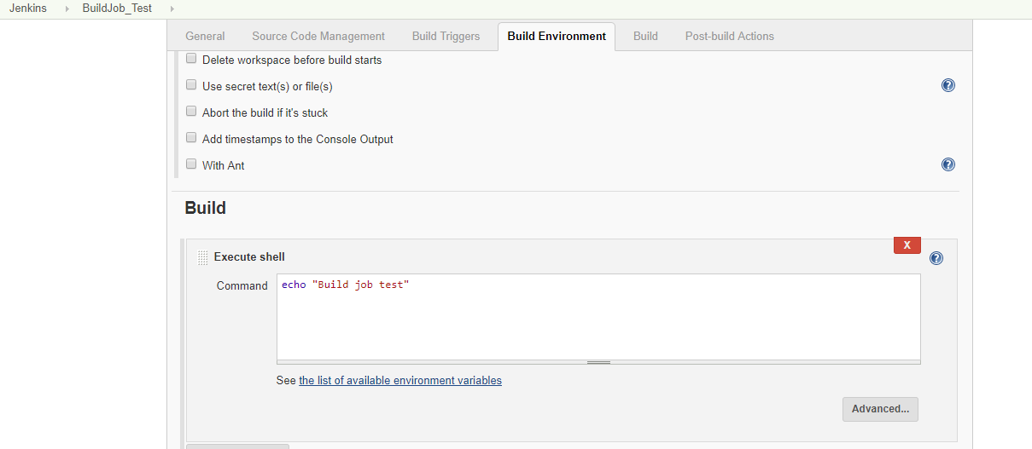

Second job: DeployJob_Test

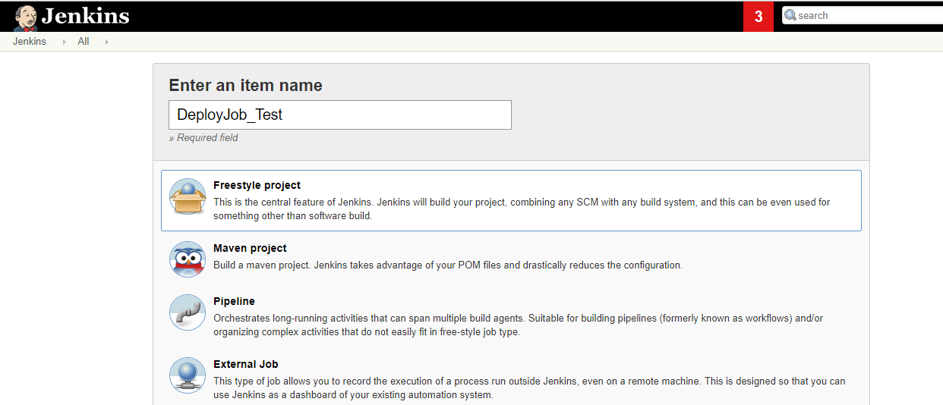

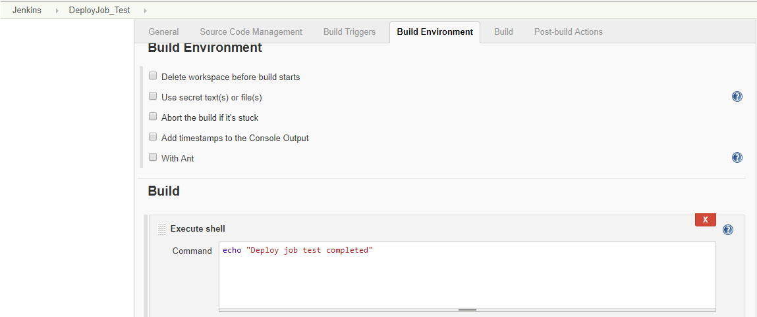

Run the first job BuildJob_test and see the output:

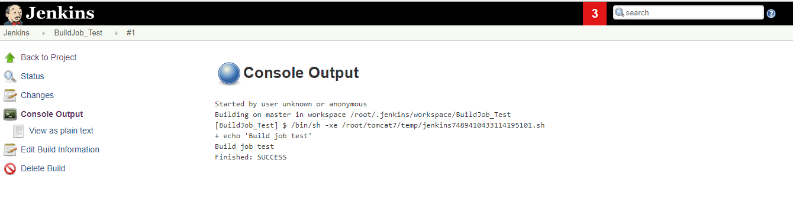

Go to dashboard and select the DeployJob_Test and choose configure option. Select the checkbox and type BuildJob_Test. Once the Build job is completed this job will be triggered.

Select Build after other projects are built checkbox as below:

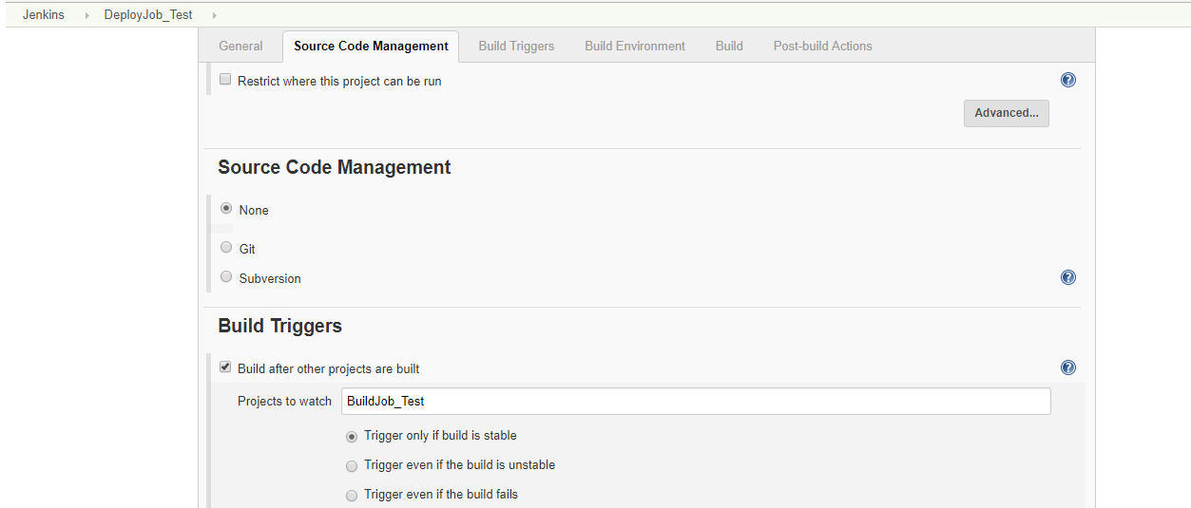

Go to dashboard and select the TestJob and choose configure option. Select the checkbox and type DeployJob_Test. Once the deployment job is completed this job will be triggered.

Click and apply and save it.

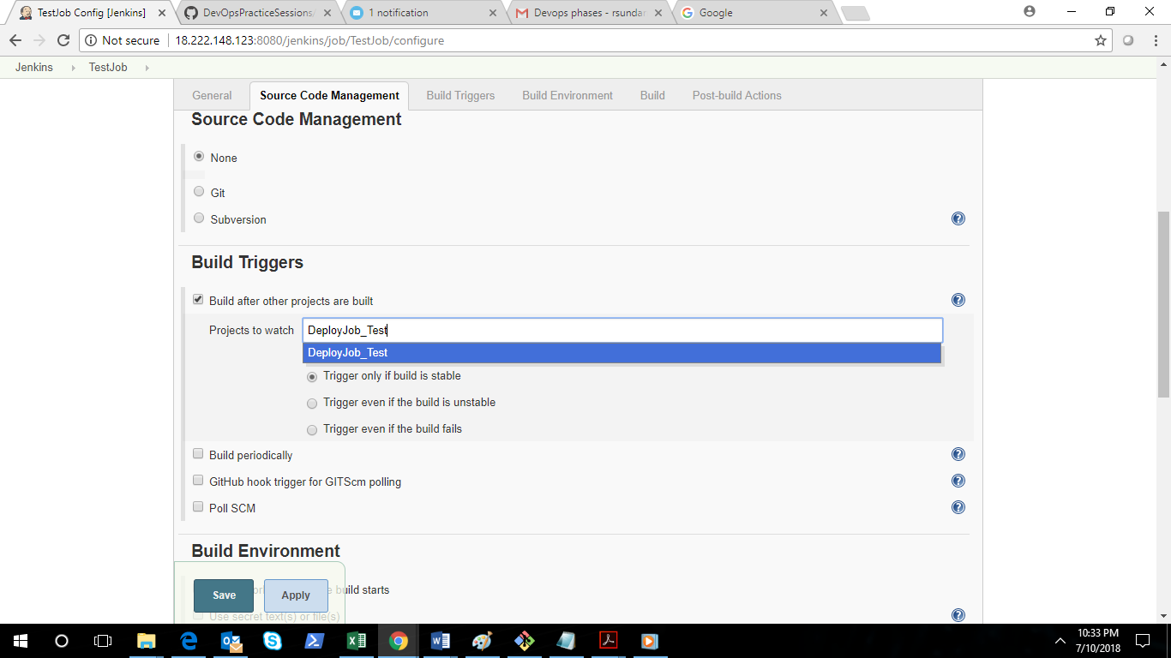

Select the BuildJob_Test and click BuildNow.

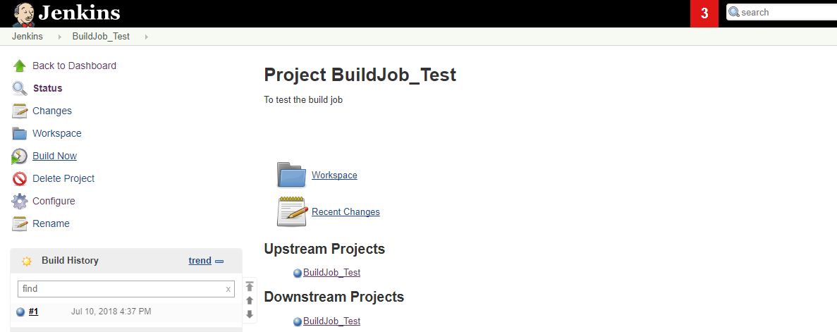

One the build is started you will able to see the dependency is started in pending status.

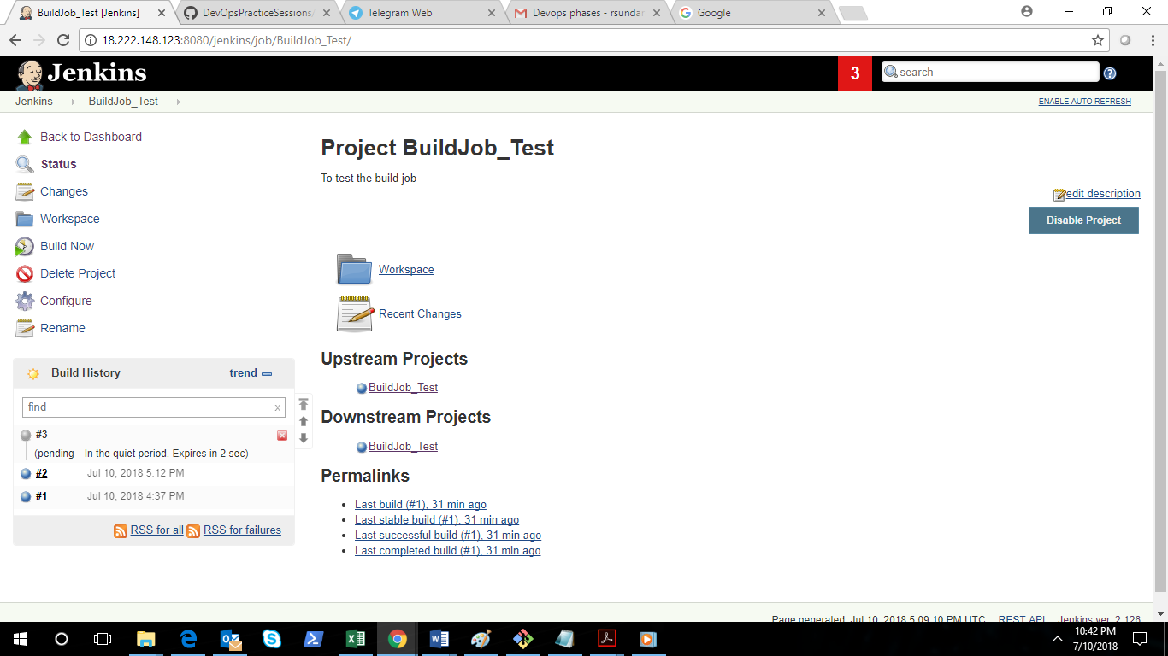

Setup all the jobs as per the above guidelines.

We need to install the **Delivery pipeline plugin** to configure these jobs.

Click manage Jenkins and select Manage Plugins.

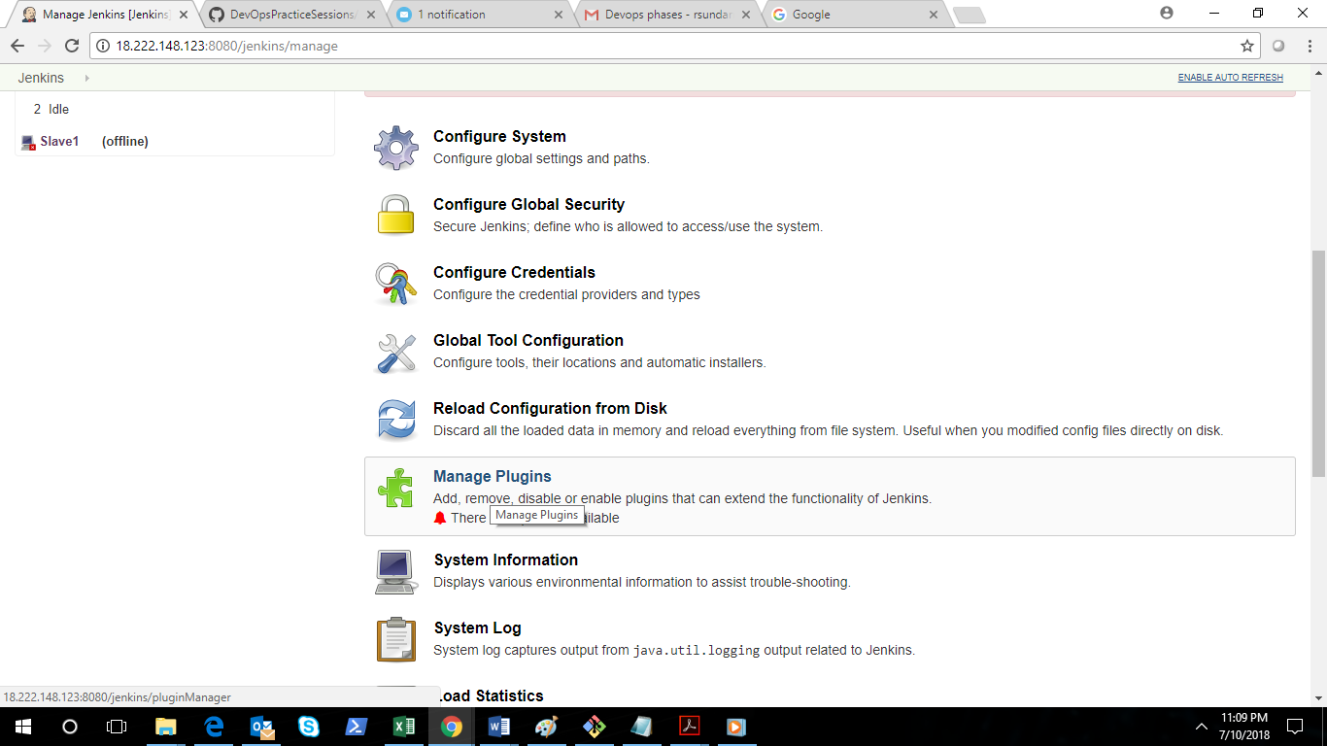

Select the available tab and search delivery and then select the Delivery pipeline as below.

Click the install without restart button.

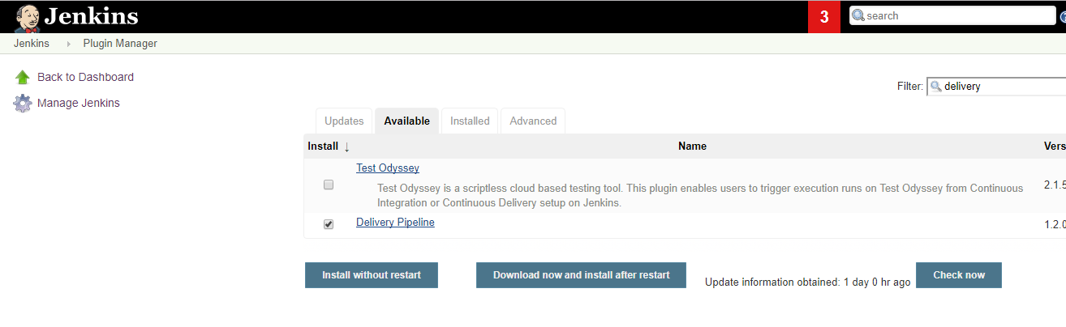

Select the + symbol as per the below screen.

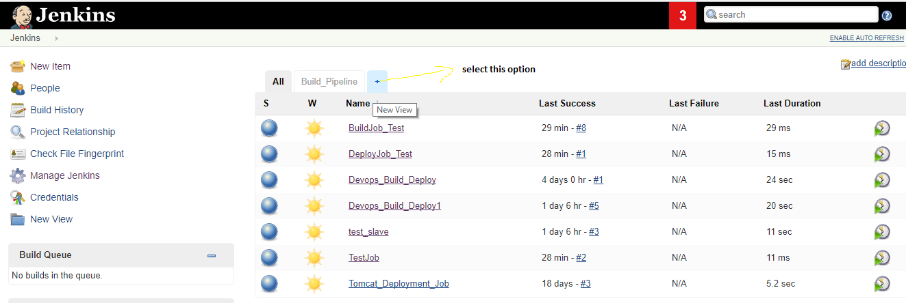

Give the view name and select the Delivery pipeline view option and click Ok.

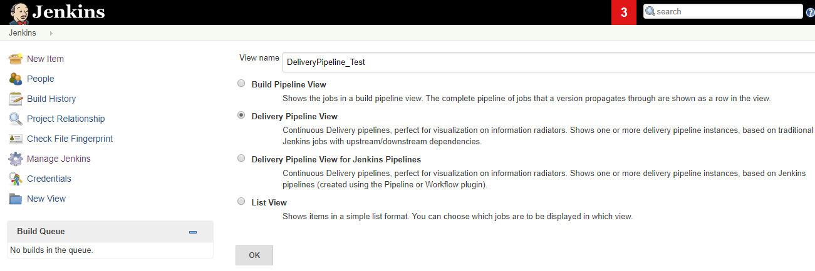

Once you see the next screen go to pipeline section and click add. The below screen will be displayed.

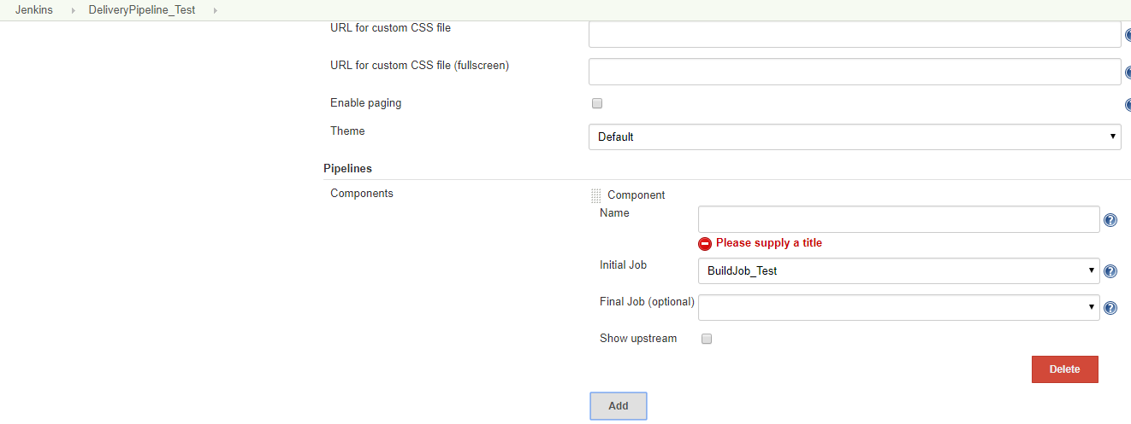

Select the initial job as per the below screen and click ok.

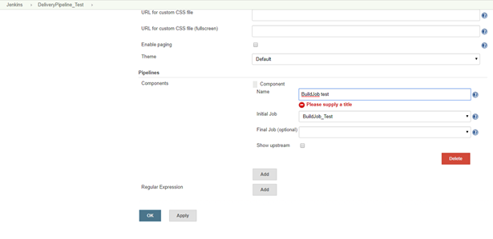

Click the checkbox “Enable start of new pipeline build”. This will give a provision in the pipeline to build the trigger the job manually.

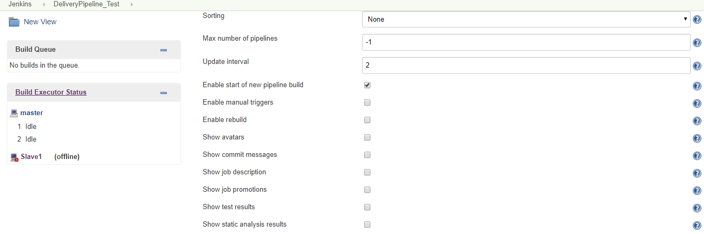

Click the DeliveryPipeline_Test tab and see the workflow.

ow 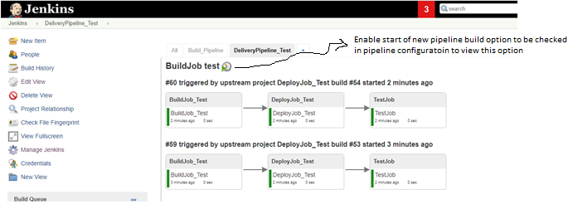

Once we click the build now option in the above screen the below blue colour showning in the second job which is currently in-progress.

