**Objective**: To create a job and configure the GitHub project.

To create a new job called Git_config. Select the freestyle project and click OK.

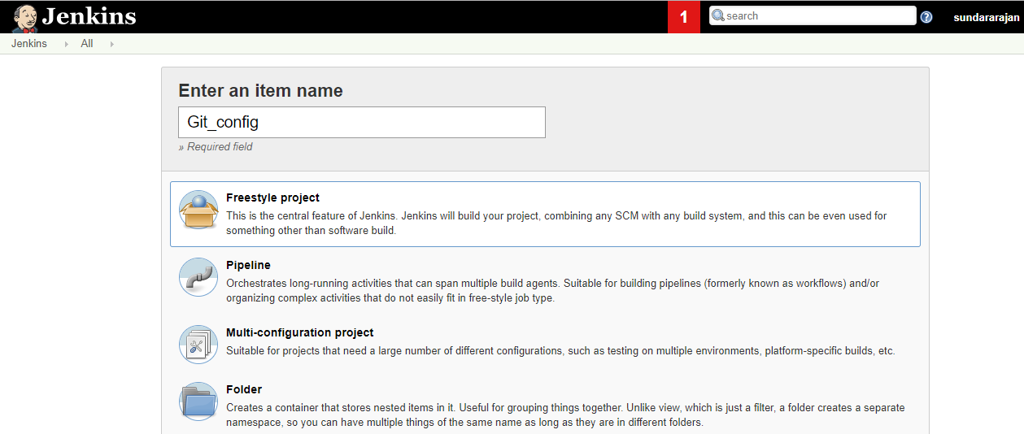

Configure the git repository in the job. Select Source Code management and under that select the Git option and provide your Git URL.

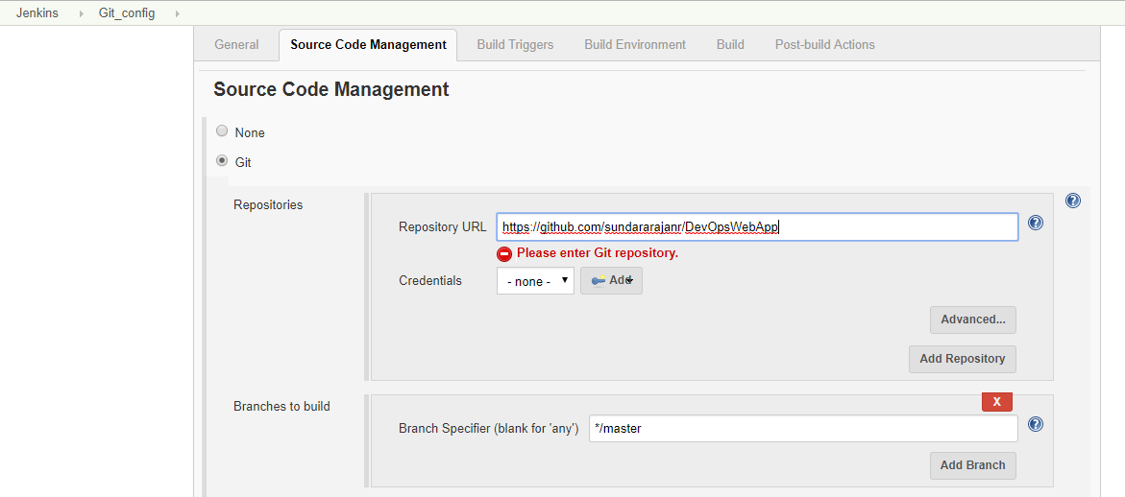

Click Add button and select Jenkins as per the below screen.

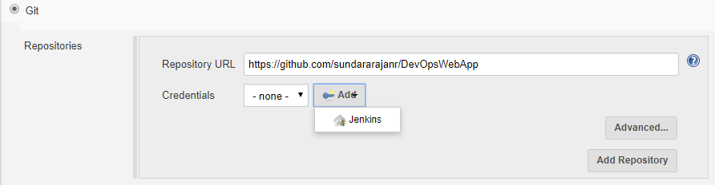

Provide your GitHub credentials as per the below screen and click add.

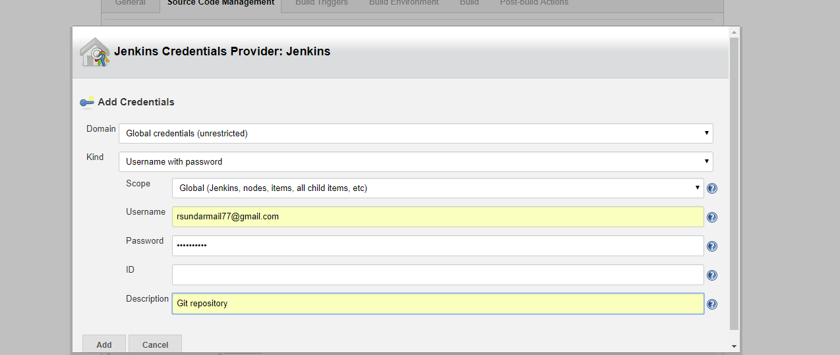

Select the credentials drop down and select the recently added one. Click Save.

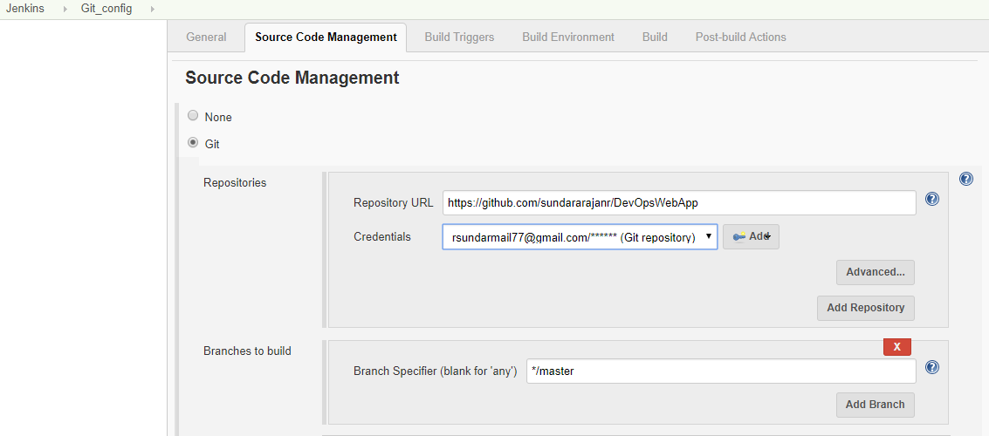

Click the workspace menu and nothing appears in the right hand side because we don’t have any source code available at the moment. Click the build menu

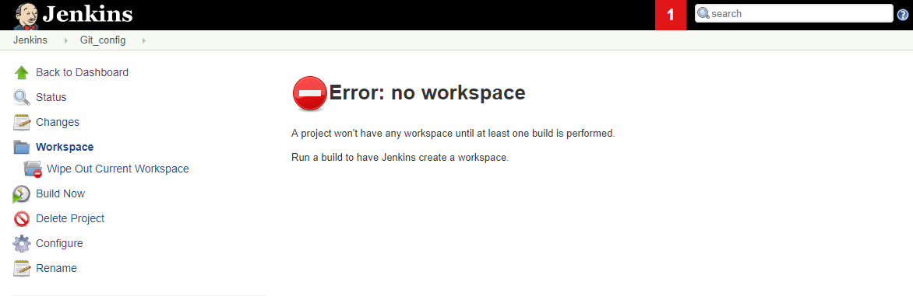

Click the Build Now button and it appears in the left hand side.

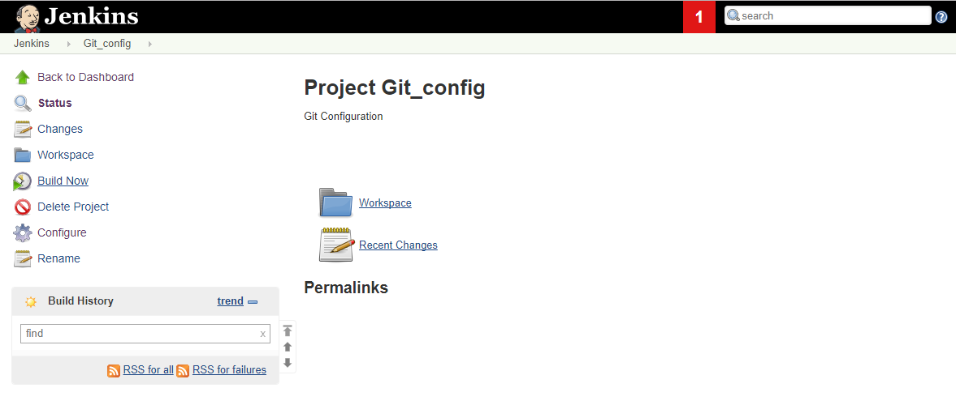

Build is succeeded and you will able to see the blue color against the build number (#1).

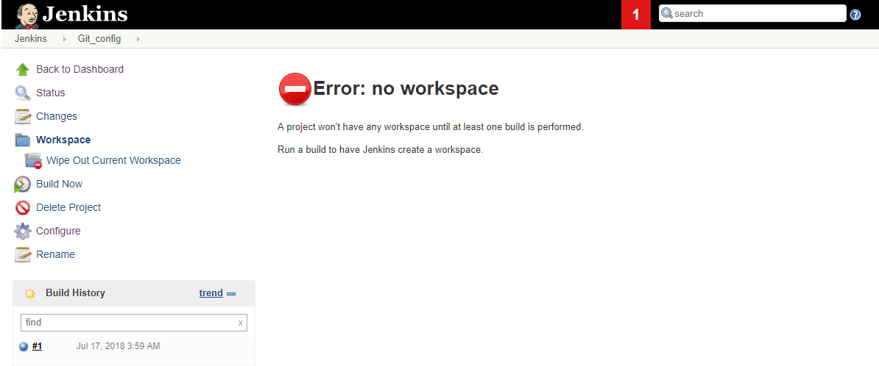

Click the console output menu and see the logs.

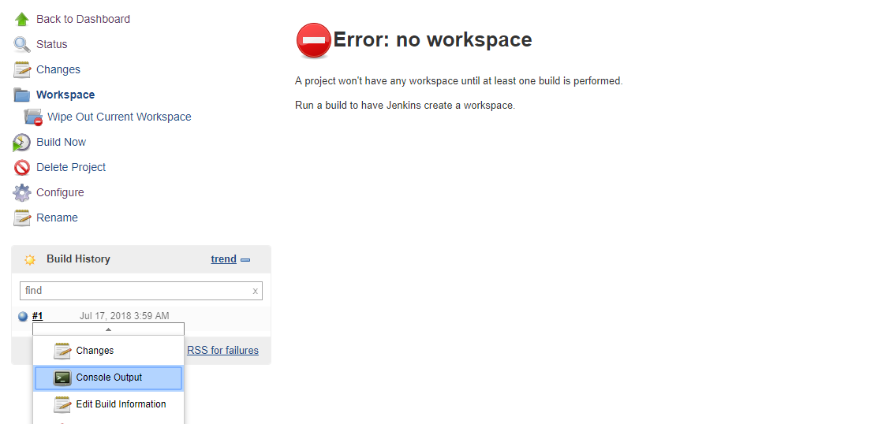

Once you clicked the console output and you will able to see the output as shown in the below.

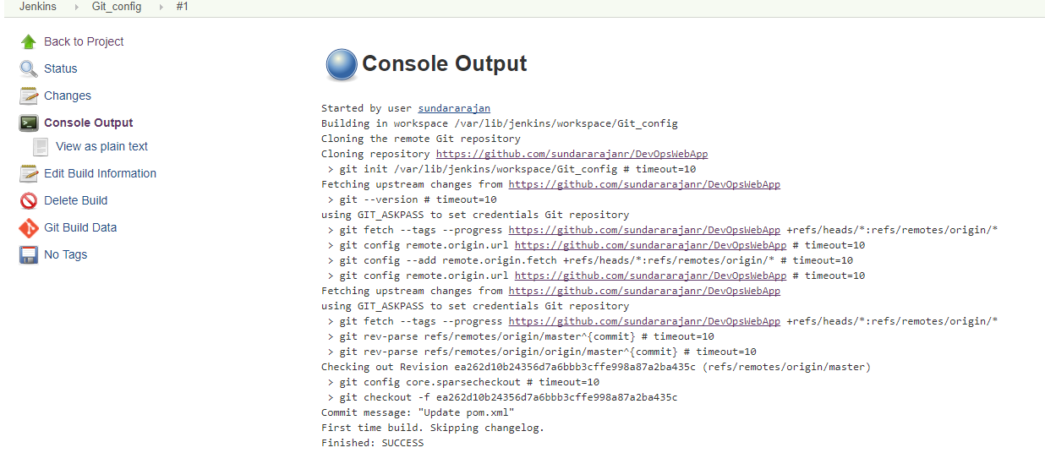

Now you click the workspace and see the folders and files.

