**Scenario**:

* Role based authentication strategy plugin will be installed from admin user credentials.
* New role and project will be created using role based plugin
* Create the new project and assign to newly created user
* Role profiles credentials mapped to project

**Resolution**:

Login into the newly created user and check whether all the roles are replicated and check the menus appropriately.

**Click the Manage Jenkins in the below screen.**

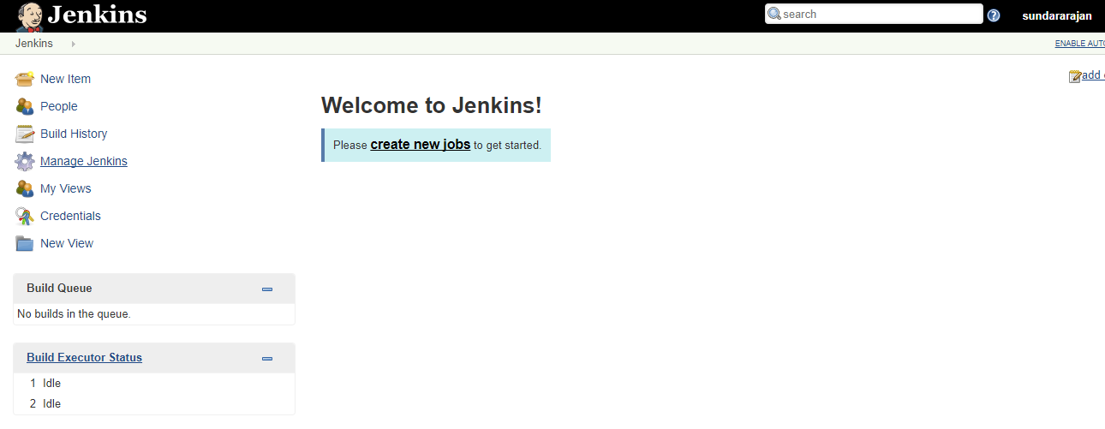

**Click the Manage plugins**:

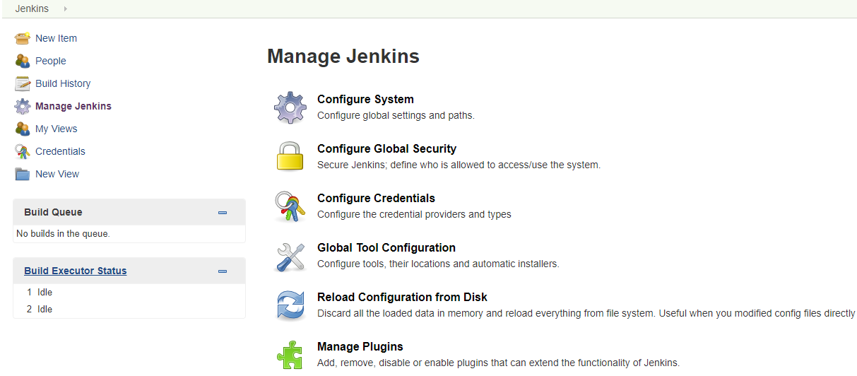

Click the available tab and got to Filter column and search Role-based Authorization strategy:

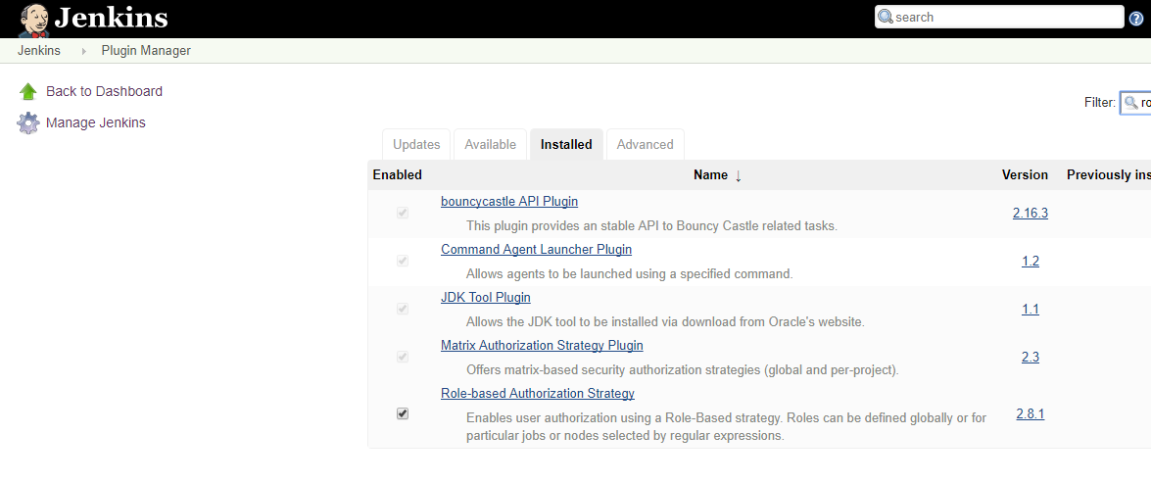

Click ok once you selected the above role plugin and install the same.

Go to manage Jenkins and select the configure Global security.

Select the role based strategy from Authorization category.

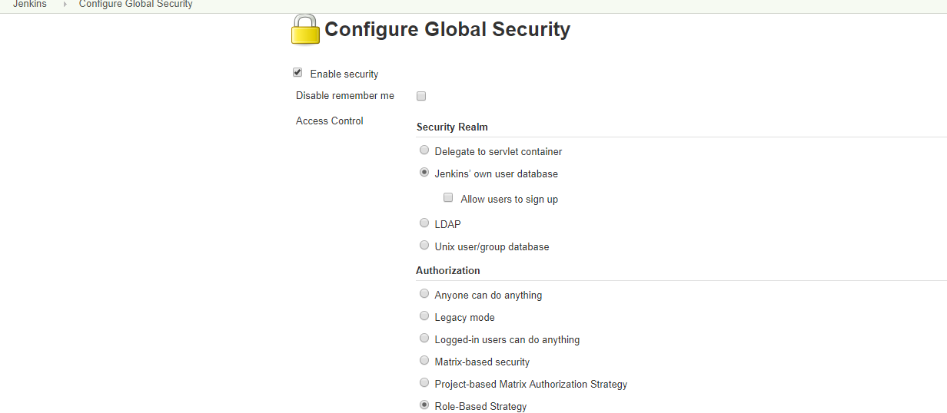

Go to manage Jenkins and select the Manage users and create a new user.

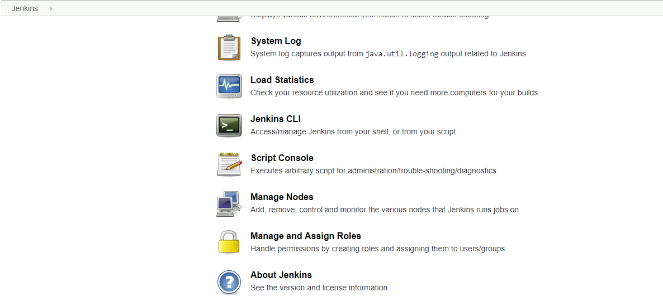

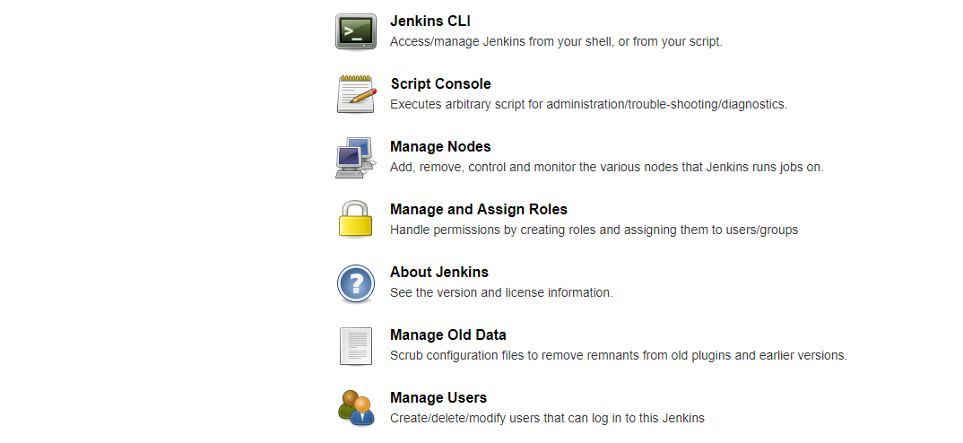

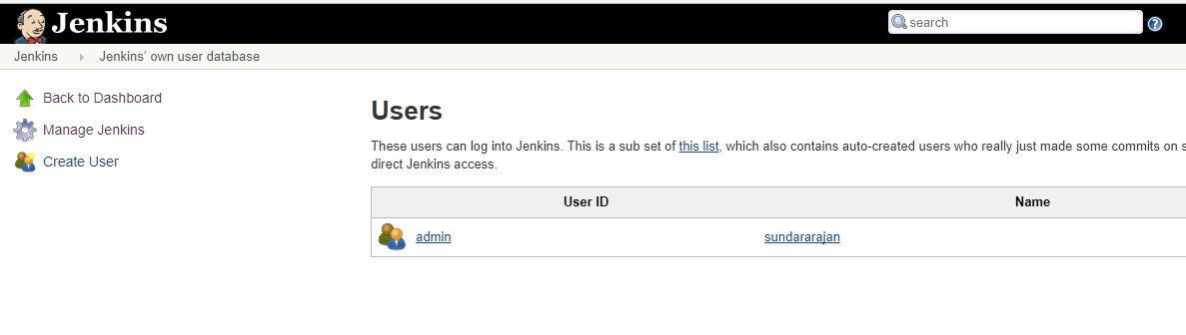

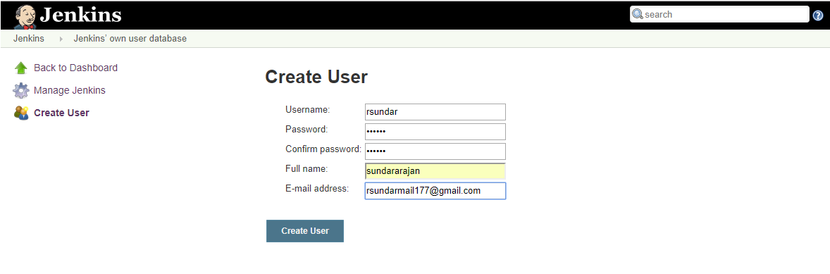

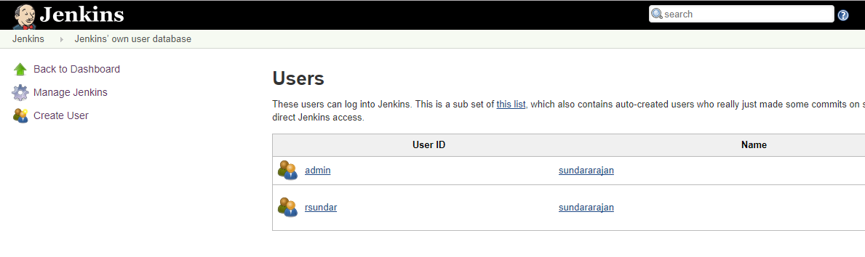

Once the user is created go to manage Jenkins and select the Manage and assign roles. Click the Manage roles link to create one more role called Dev.

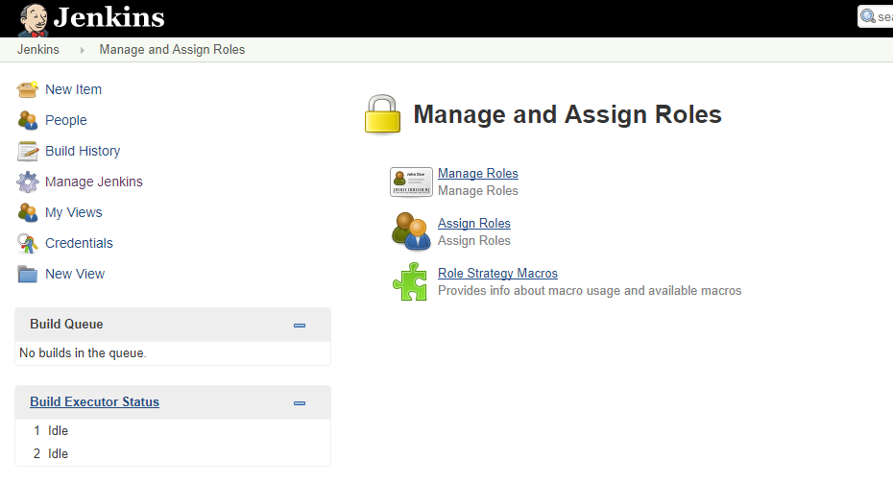

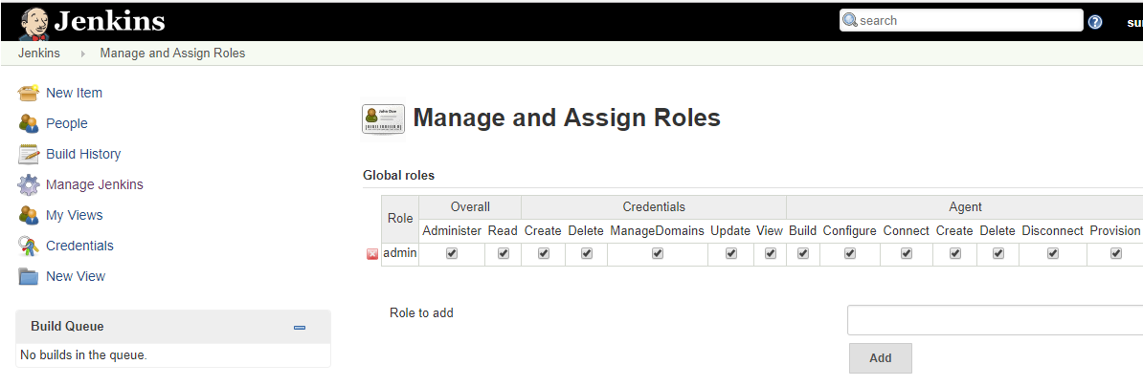

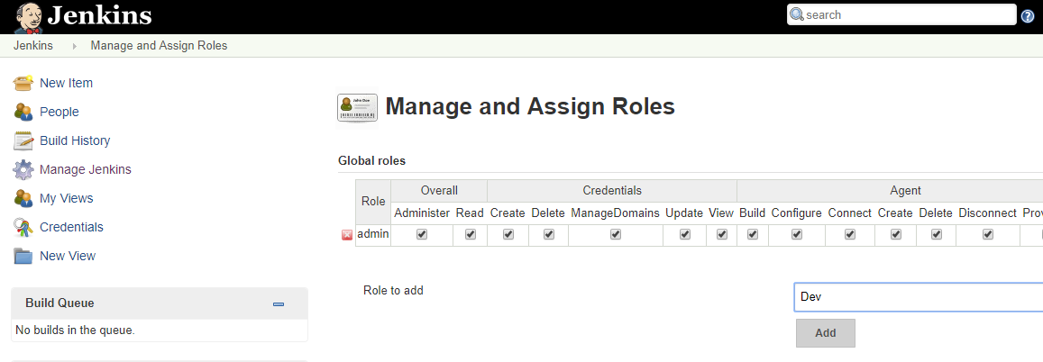

Click Add button once you given the name in role to add textbox.

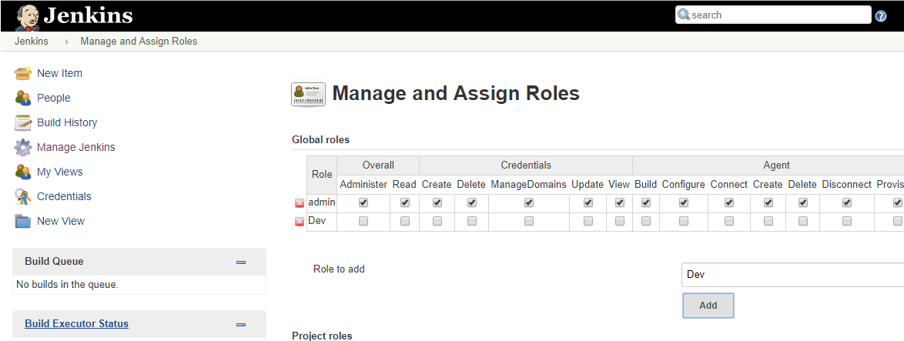

Provide Read permission as shown in the below for Dev Role.

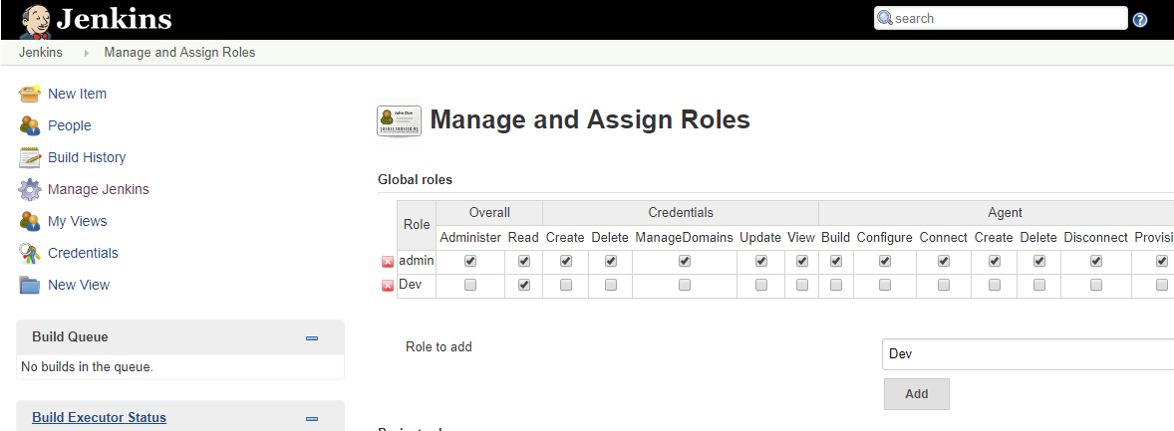

Next go to project role and enter the project name and assign the roles appropritately.

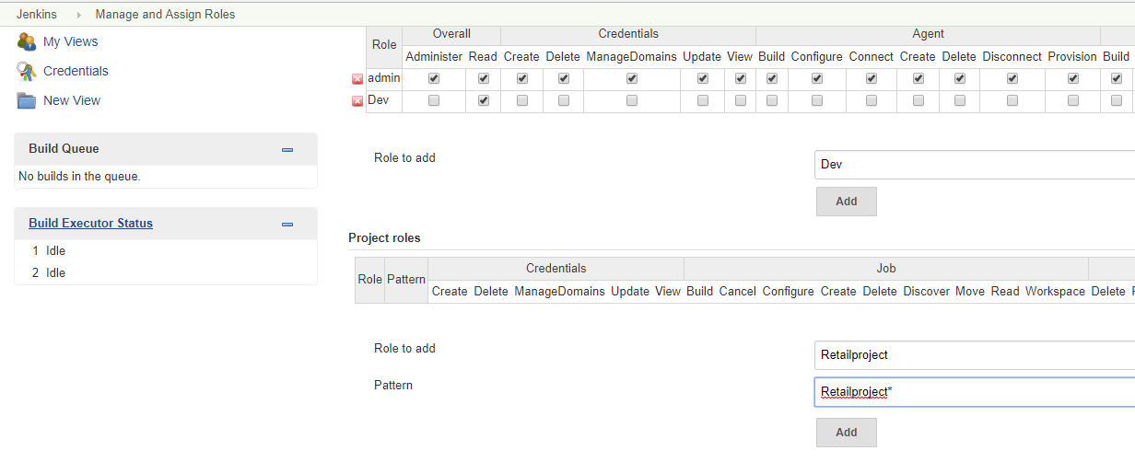

Once you select the pattern as per the below screen and save it.

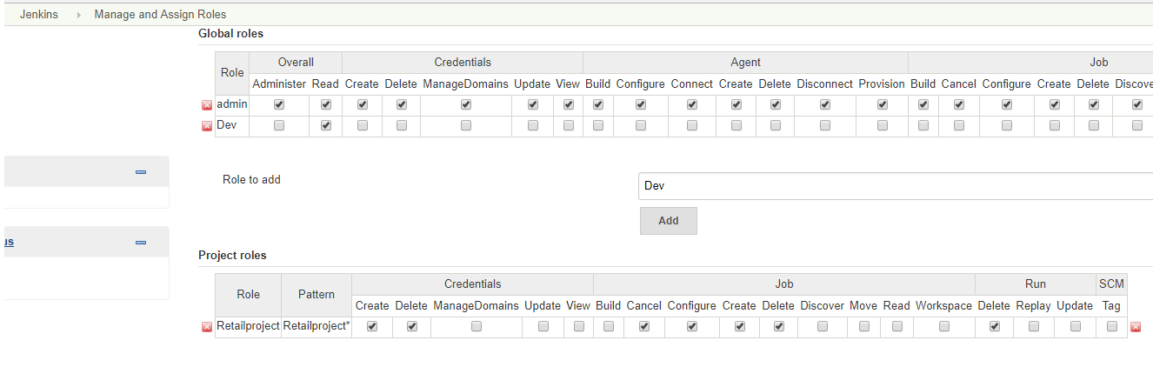

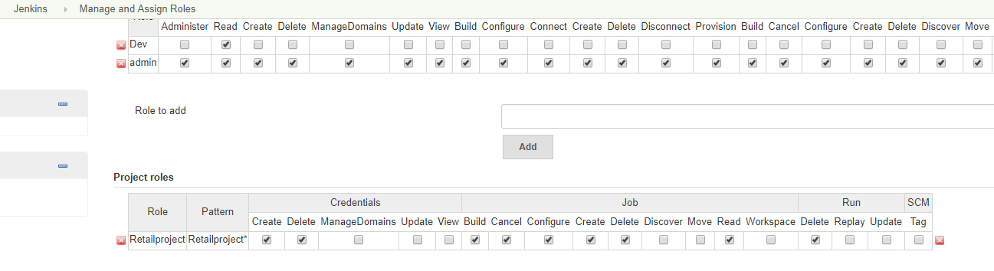

Choose Assign roles link as shown in the below screen.

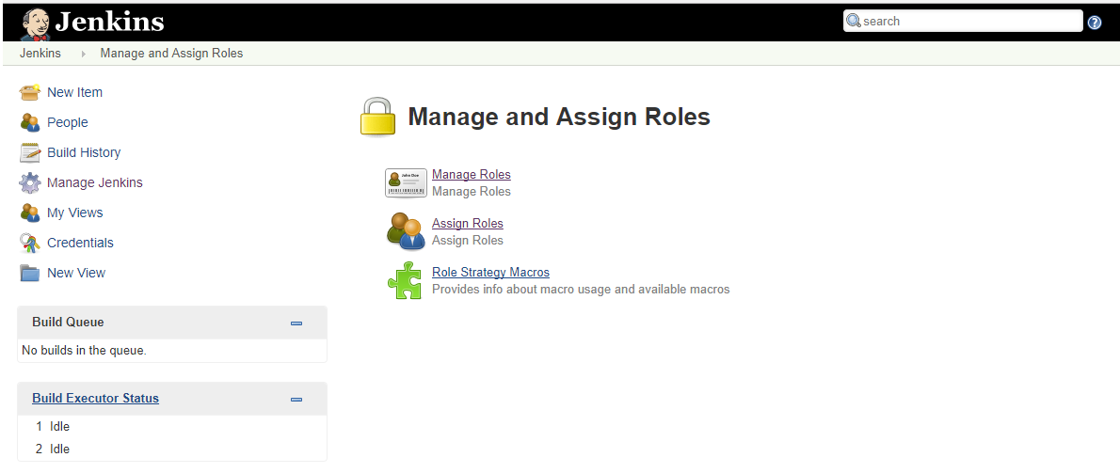

There are two roles one is Global and next one is project perspective.

Create a user and assign it to specific role as shown in the below screens.

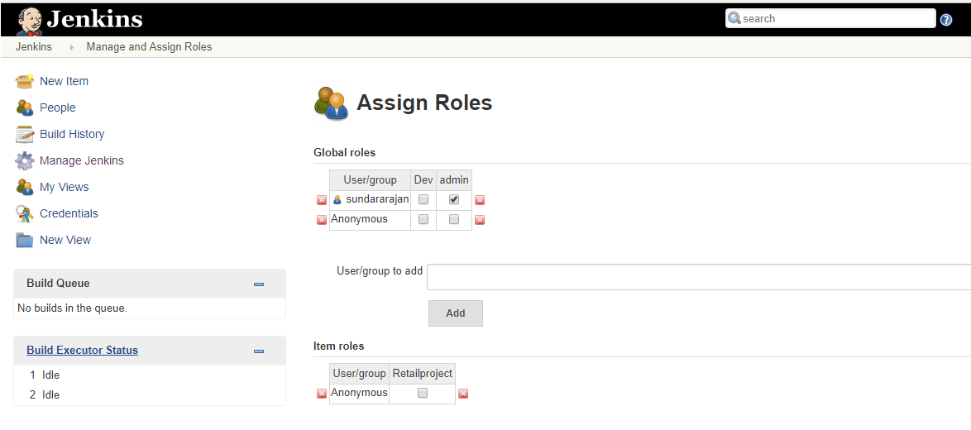

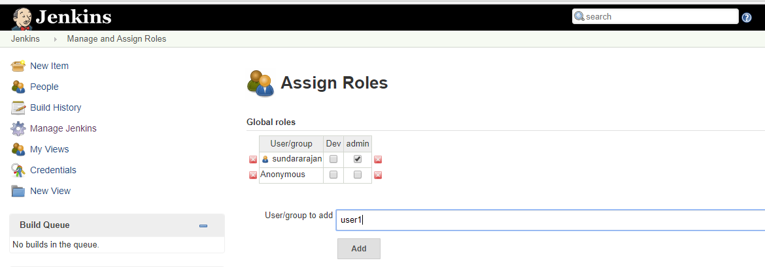

Assign the user1 into the Dev role category.

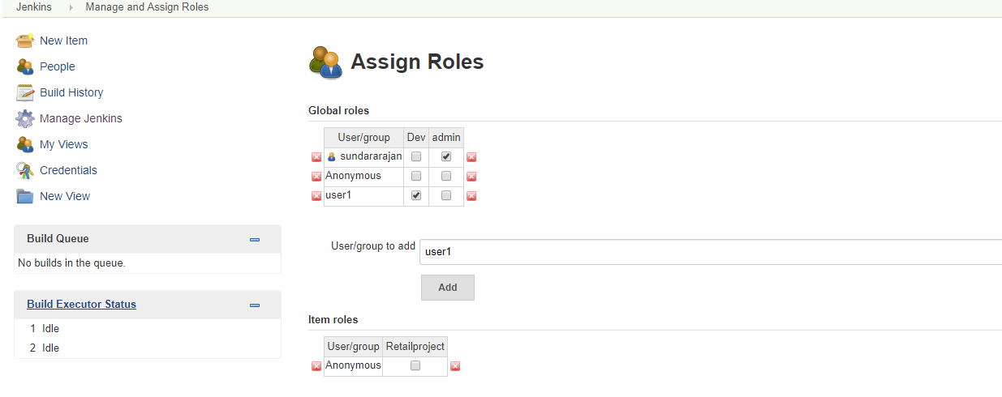

Go to Item roles and add the user and assign to the project.

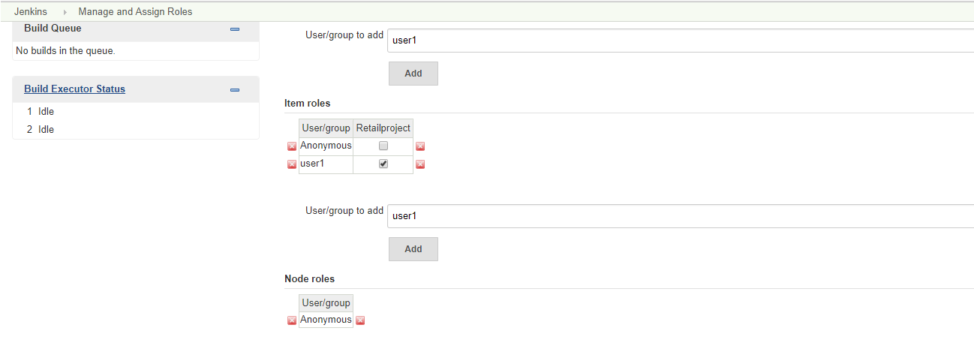

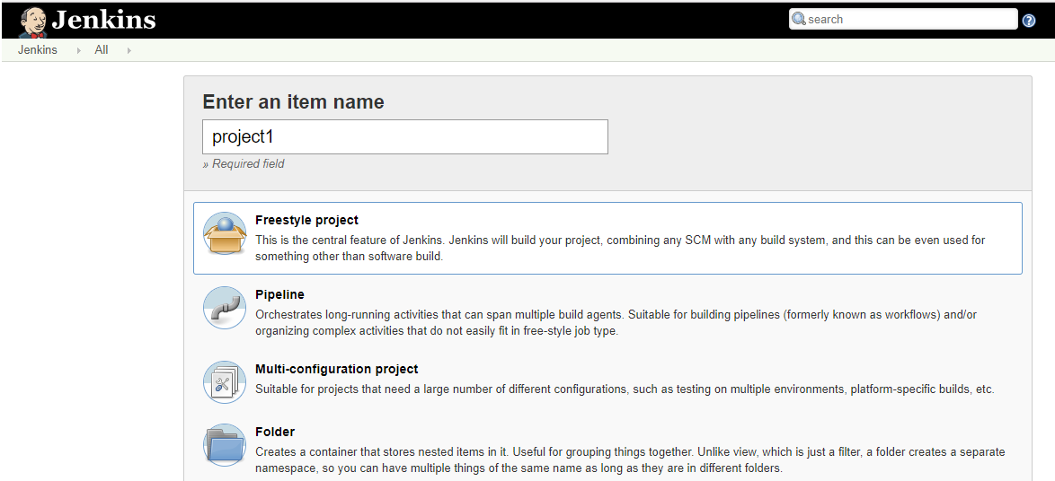

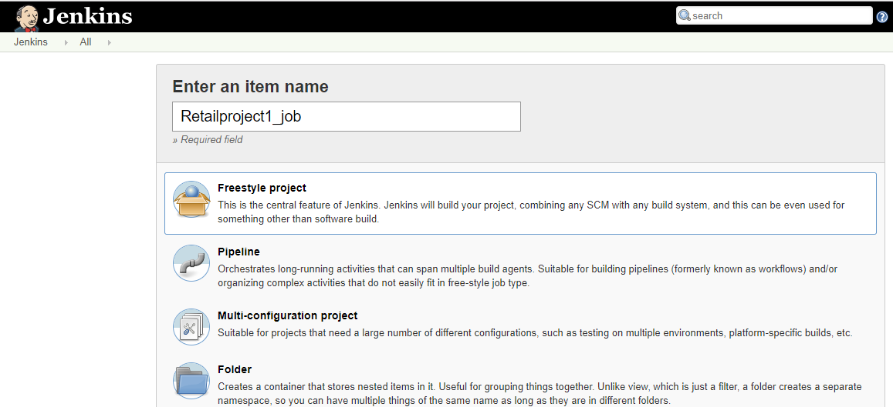

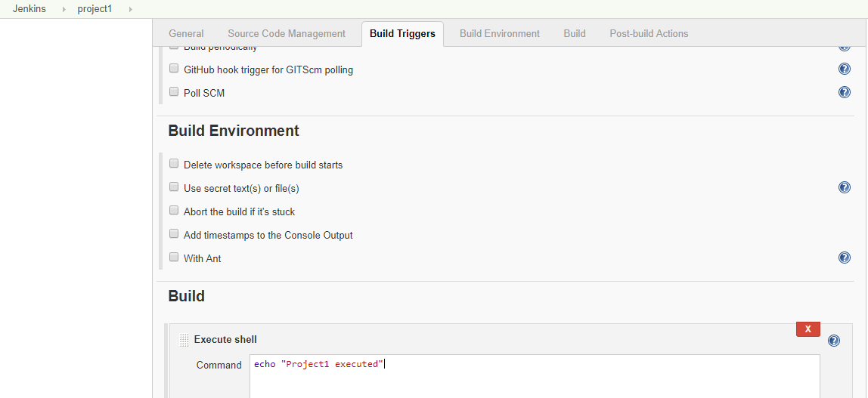

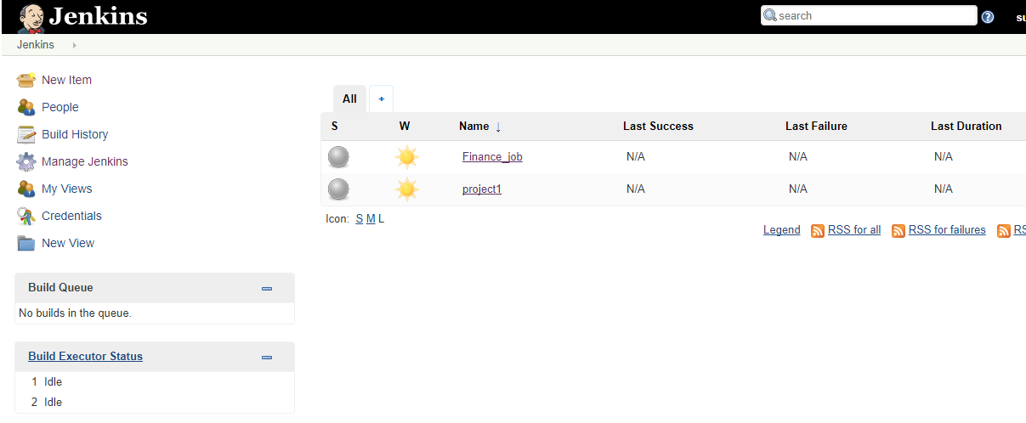

Login with the user1.

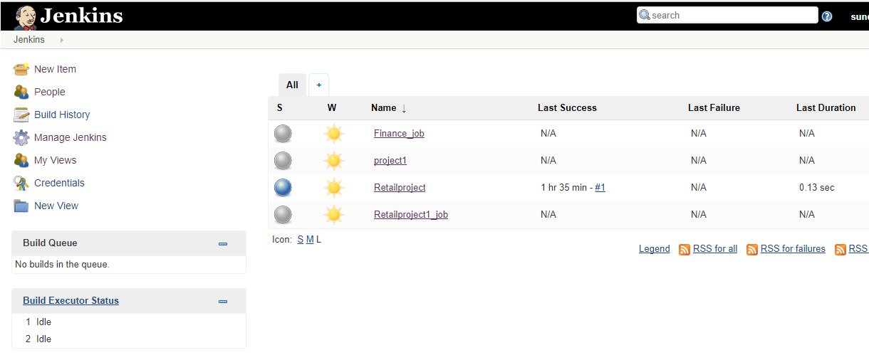

Logout with the existing user and Login with the user1 credentials.

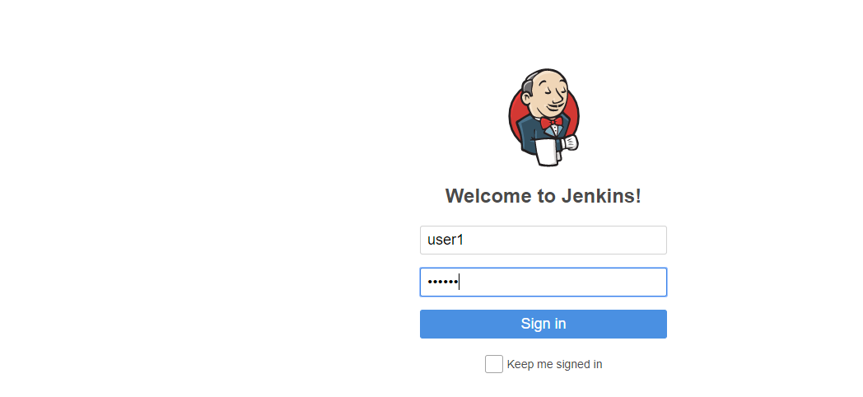

Only Retailproject is visible for user1. Check the below screen shot.

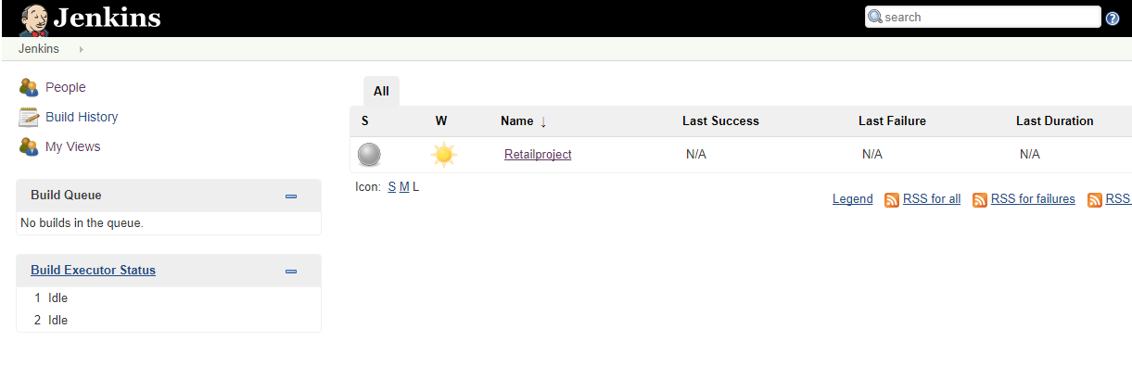

Click Build Now and check whether the build is succeeded or not.

