GERRIT:
Create a project in gerrit
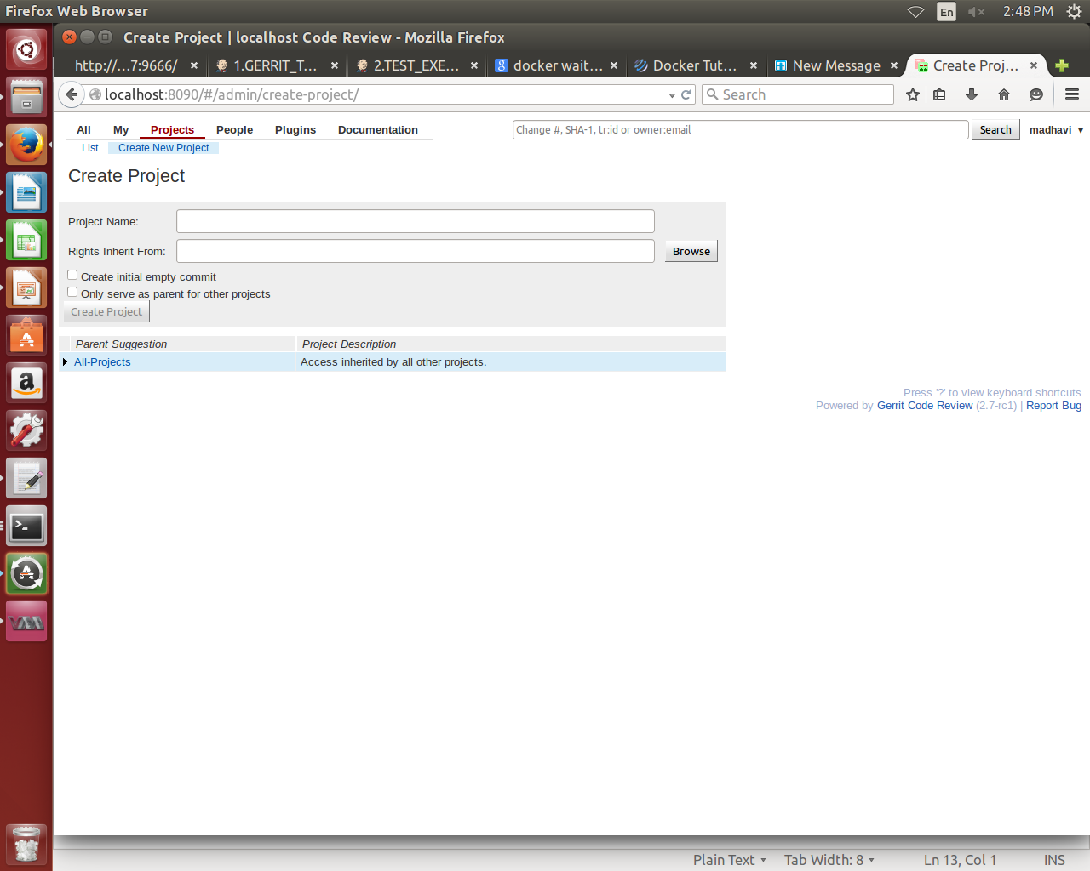

Adding ssh keys:

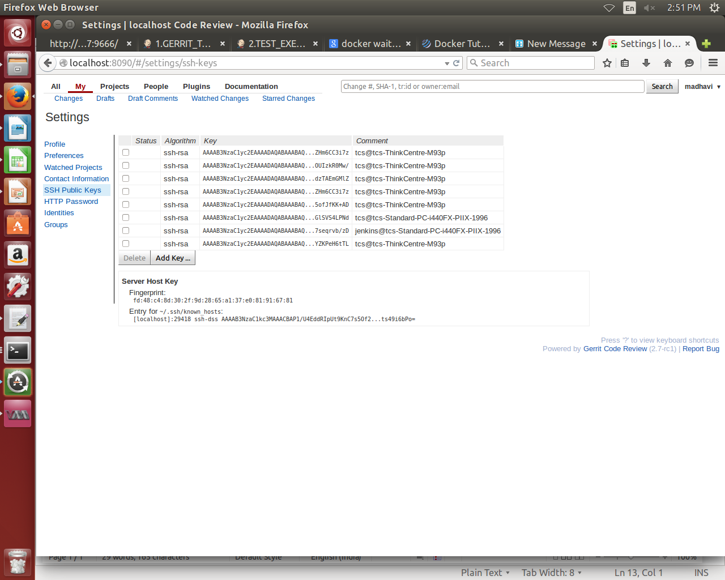

cd ServiceOrchestration
git add .
Git commit -m “inital commit”
git push <GERRIT PROJECT URL> master

Gerrit,jenkins integration:

http://toastedbits.com/post/26

Refer:Instructions file in jenkins

