Plugins to be installed:
1.Amazon EC2 Plugin
2.Ansicolor
3.Artifact Deployer plugin
4.Authentication Tokens API plugin
5.Build Flow Plugin
6.Build Monitor Plugin
7.Build Pipeline Plugin
8.CloudBees Docker Custom Build Environment Plugin
9.CloudBees Folders Plugin
10.conditional-buildstep
11.Copy Artifact Plugin
12.Copy To Slave Plugin
13.Dashboard View
14.Delivery Pipeline plugin
15.Docker build step plugin
16.Docker Commons plugin
17.Docker plugin
18.Durable task plugin
19.EnvInject plugin
20.Gearman plugin
21.Gerrit Trigger
22.Git Client plugin
23.Git Parameter Plug-in
24.GIT plugin
25.Git server plugin
26.Git Hook plugin
27.Hudson Personal view
28.JClouds plugin
29.JobConfigHistory plugin
30.Join plugin
31.jQuery plugin
32.Libvirt Slave plugin
33.MapDB API plugin
34.Matrix Reloaded plugin
35.Maven Repository Server plugin
36.Multijob plugin
37.Next Build Number plugin
38.Node Iterator API plugin
39.Parameterised Remote Trigger Plugin
40.Parameterised Trigger plugin
41.promoted builds plugin
42.Python plugin
43.Redmine plugin
44.Robot Framework plugin
45.ruby-runtime
46.Run Condition plugin
47.SCM API plugin
48.SCM Sync Configuration plugin
49.scripttrigger
50.ShiningPanda plugin
51.Simple Parameterized Builds Report plugin
52.SLOCCount plug-in
53.Static Code Analysis plug-ins
54.Swarm plugin
55.Token Macro plugin
56.Violations plugin
57.Warnings plugin
58.Workspace Cleanup plugin
59.xUnit plugin
60.Xvnc plugin

Docker plugin configuration:

1. Go to Manage Jenkins -> Configure System

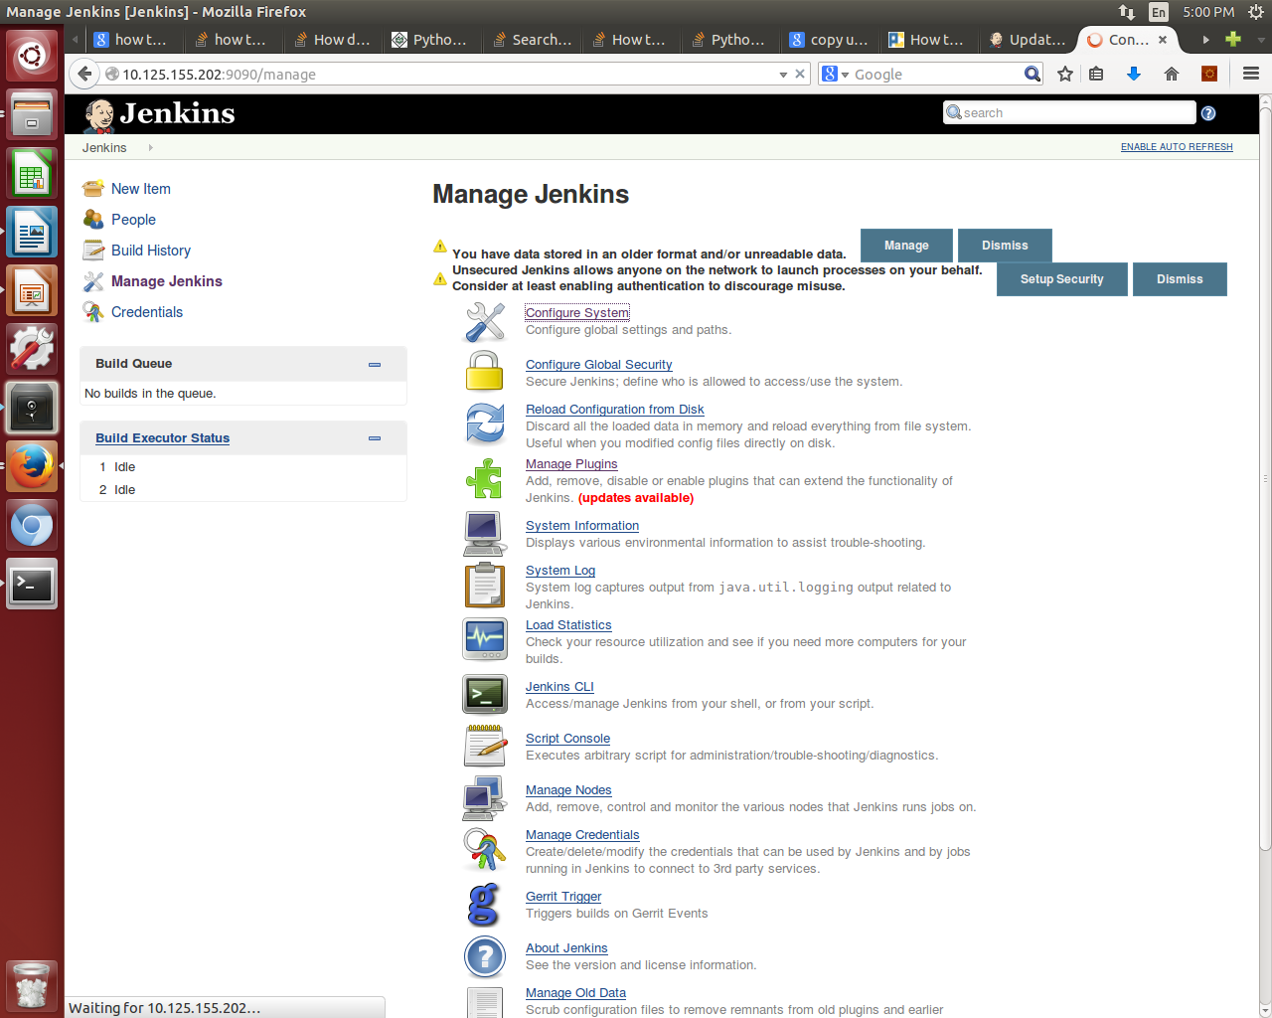

2. Under Cloud, select Docker from the drop down to get a configuration form and fill the name (as per your choice) and docker URL with the ip addr of the machine in which the Docker is installed.

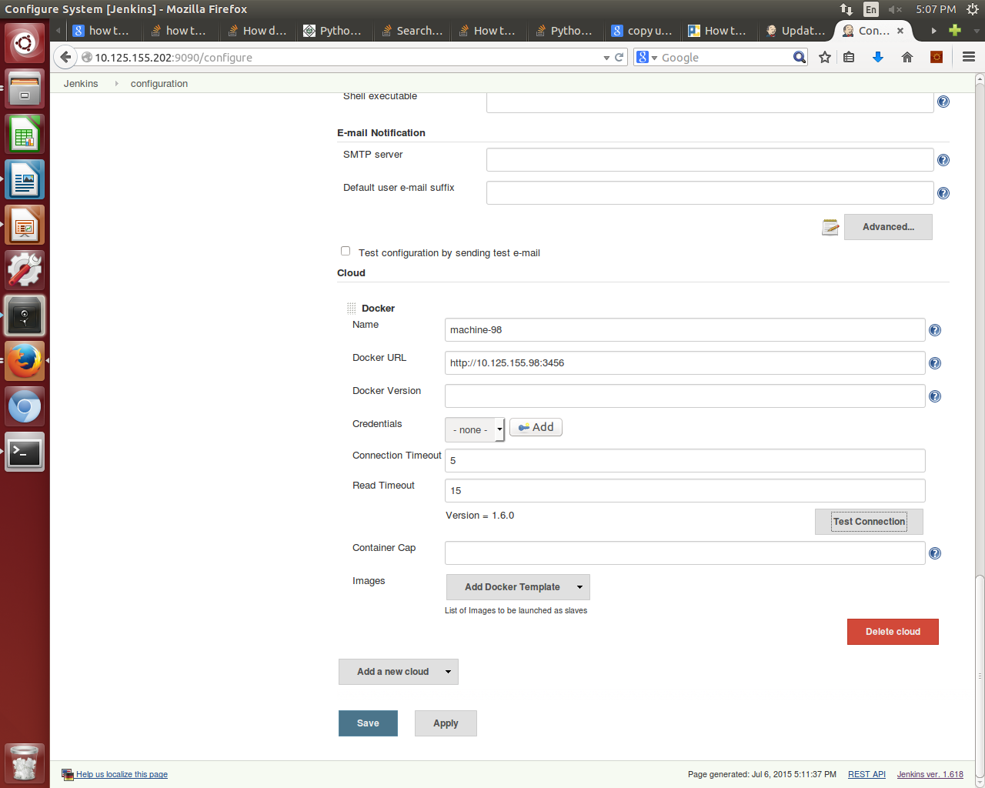

3. Save the configuration by clicking on Save button.

Gerrit Configuration:

1. Go to Manage Jenkins -> Gerrit Trigger

2. Click on Add New Server

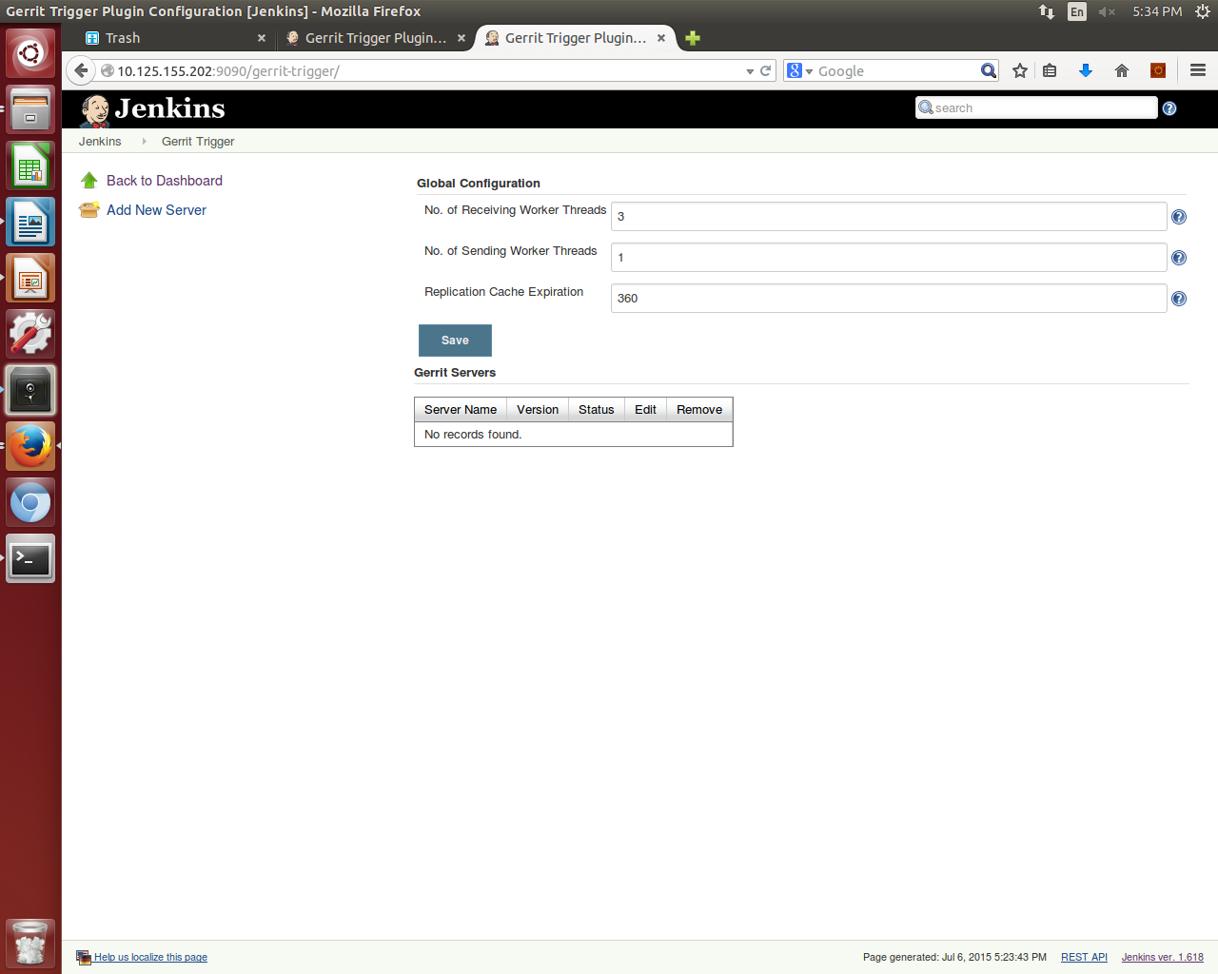

3.Add the server and select the 'Gerrit Server with Default Configurations', and click on OK.
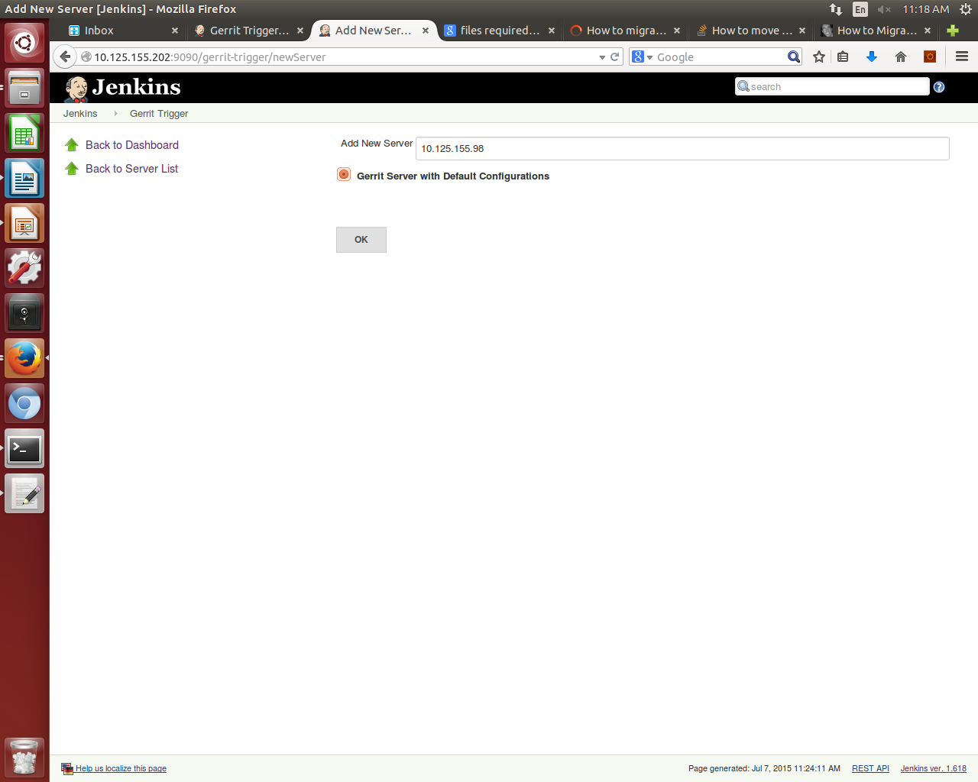

4. Configure the Gerrit Server

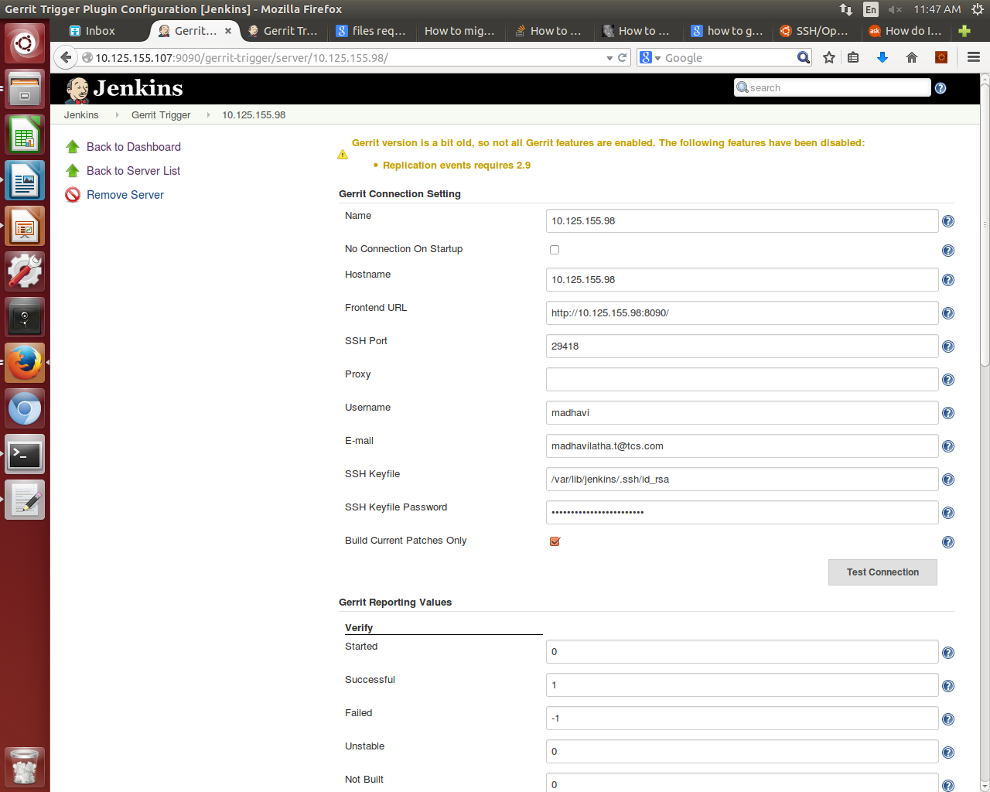
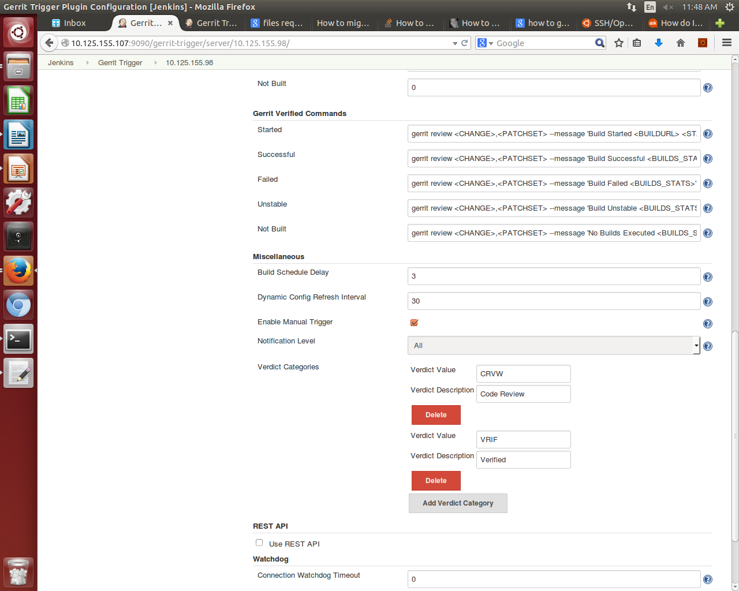

5. Save the Configuration.

