Terraform apply Screenshot

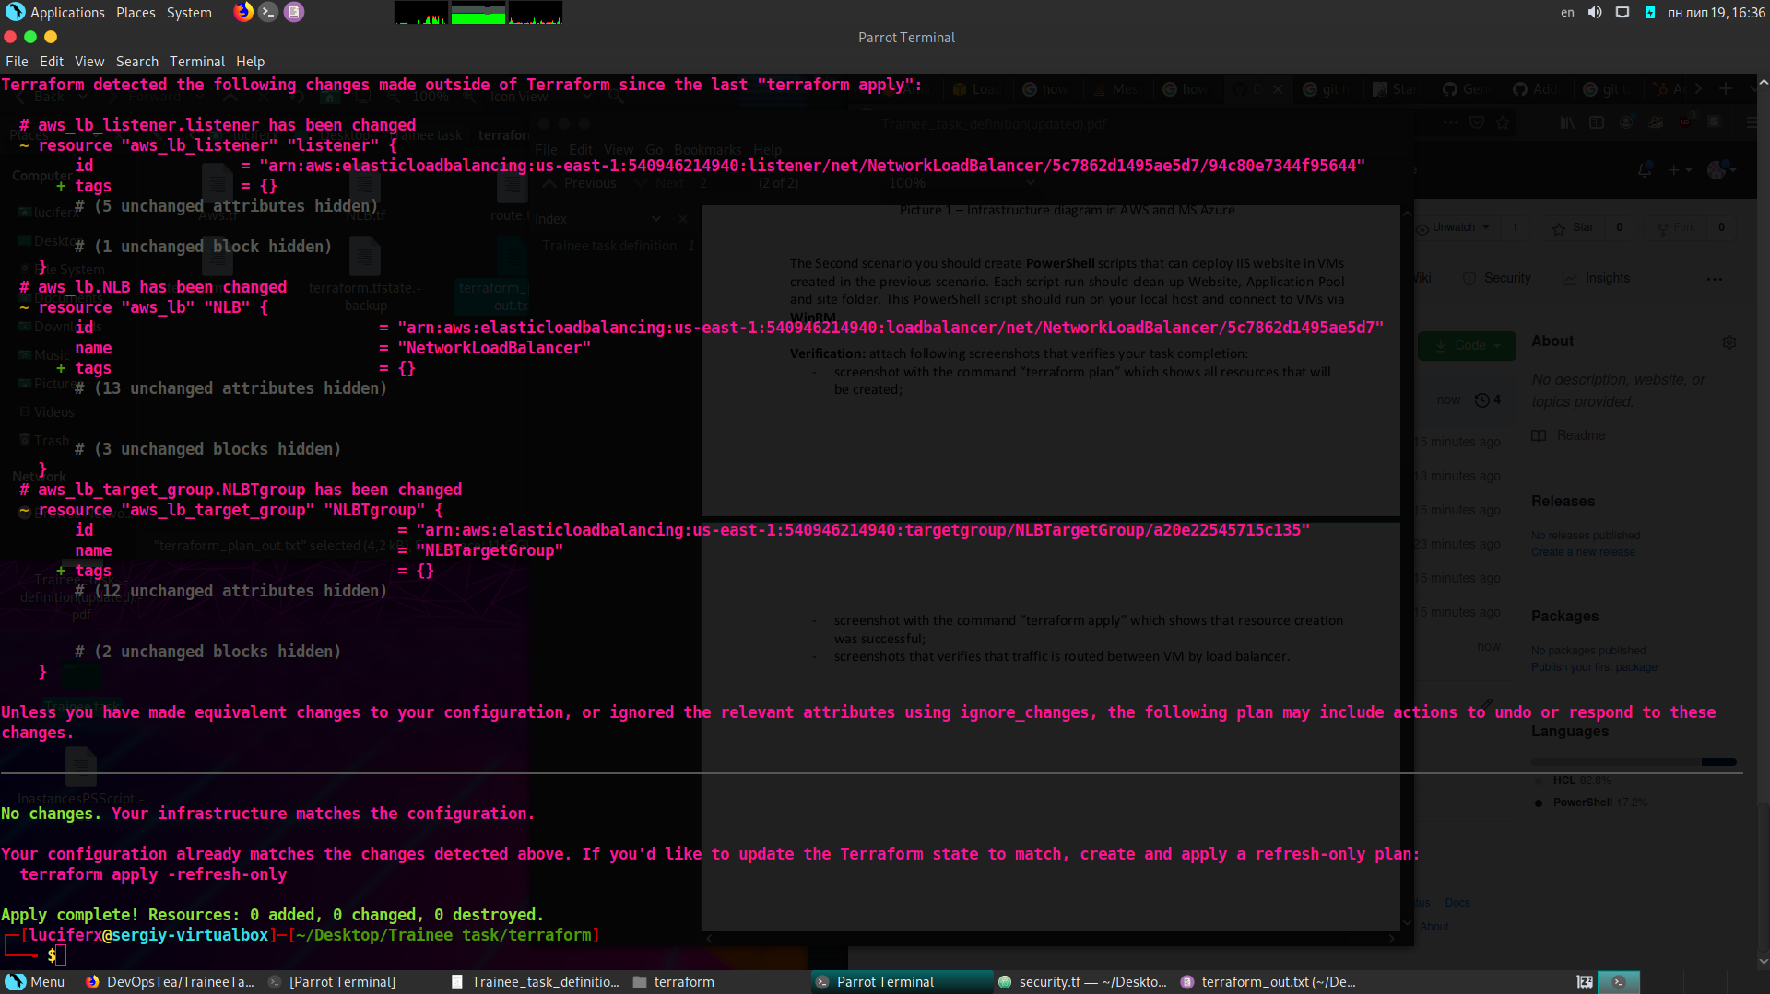

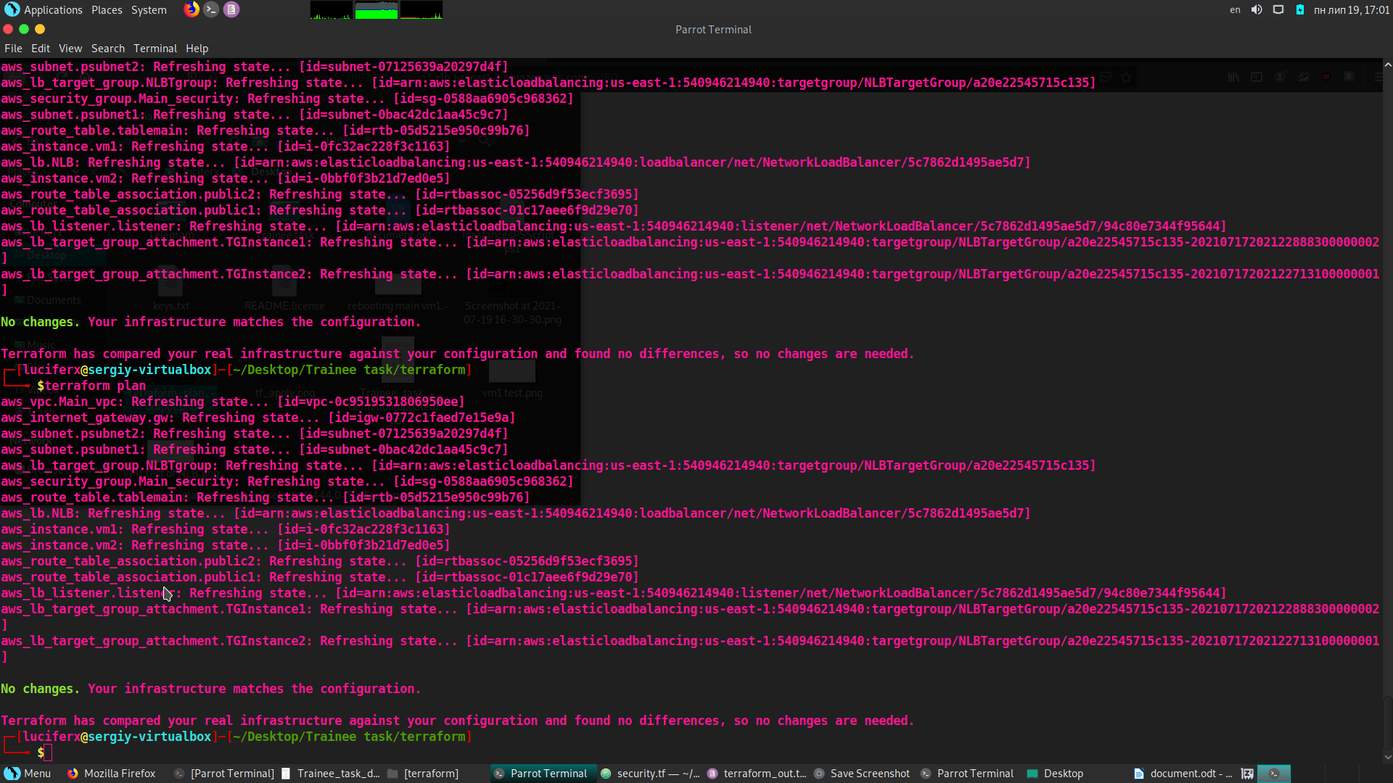Terraform plan Screenshot

Normal routing between Instances

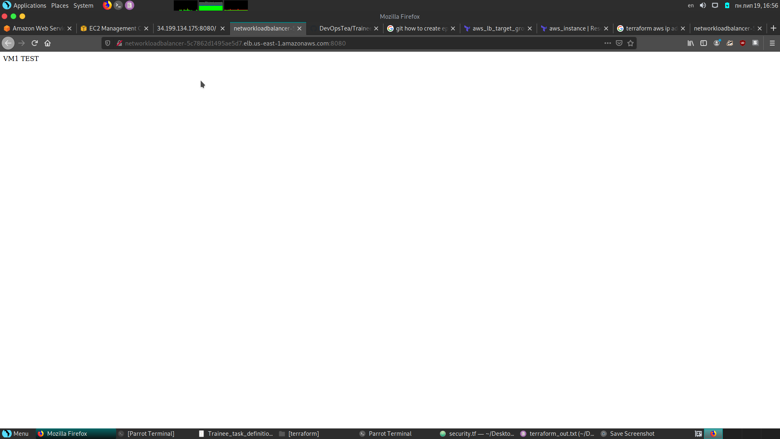

Rebooting VM1

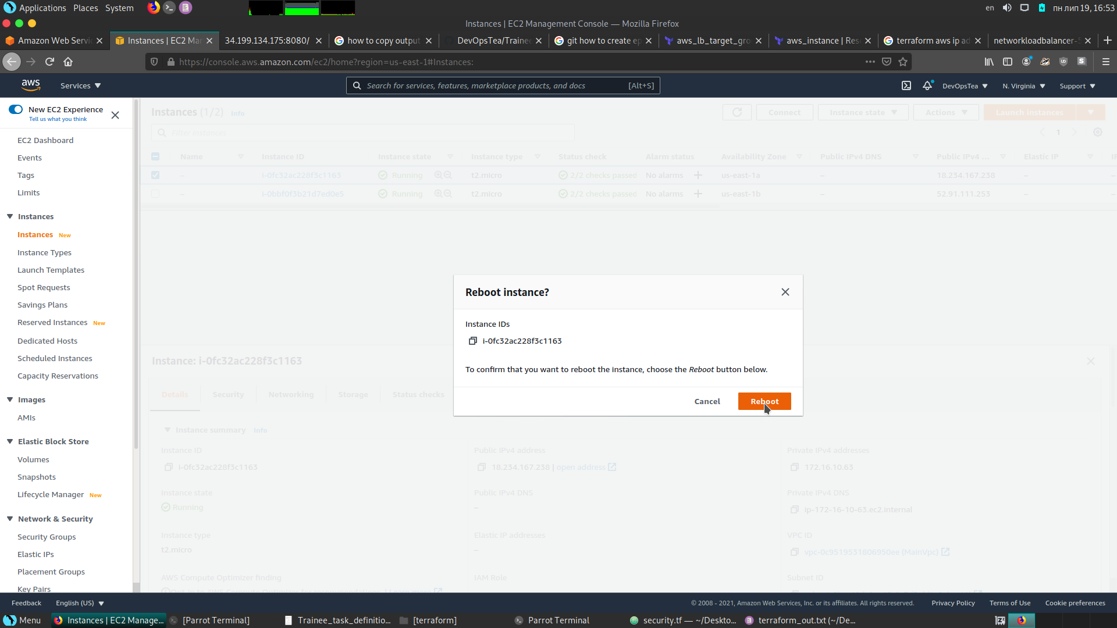

HealthCheck pending

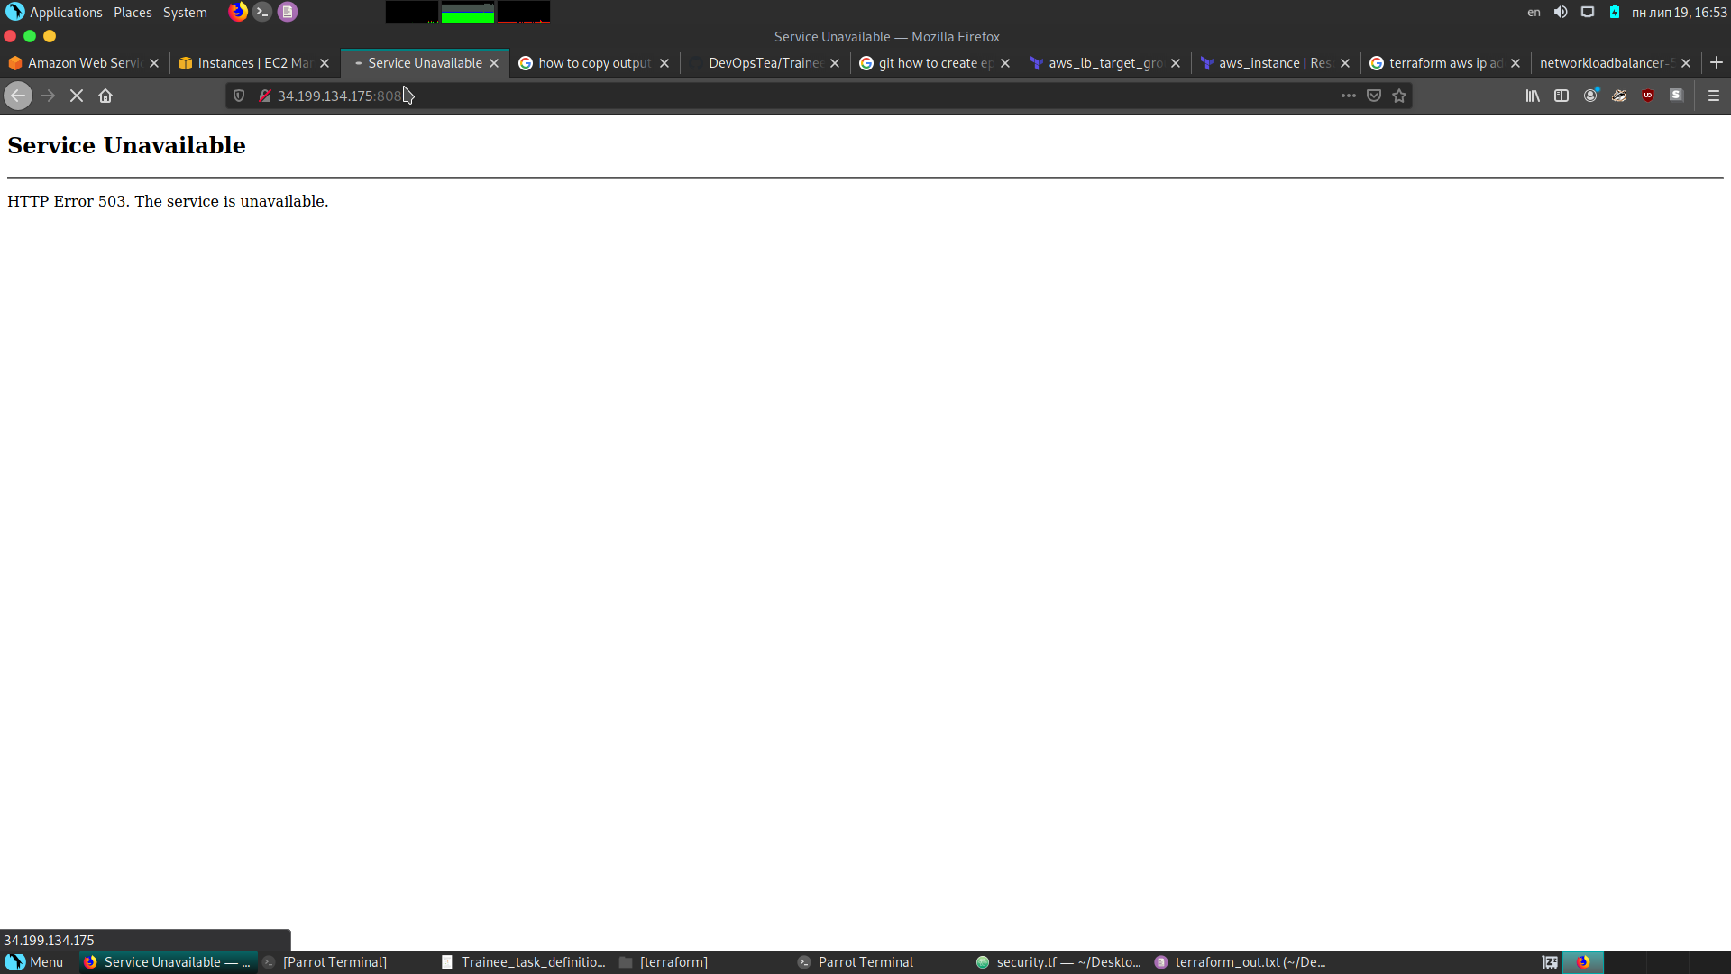

Load balancer routes client to 2nd instance.

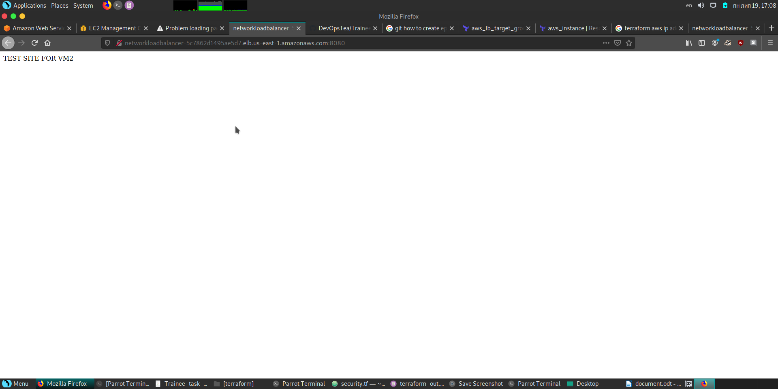

Powrshell scripts are attached to repository.

Scripts that deploy and clean IIS(Redeploy.ps), are located on Instances with name Script that runs Redeploy.ps is located on my local machine, and makes PSSession that starts Redeploy.ps on remote instances.