Automated Talent Acquisition System
Software Requirement Specification
ARICENT:
Revision Number: v1.1

Copyright © 2006-2014The Aricent Group. All Rights Reserved. No part of this document may be reproduced, stored in a retrieval system, distributed or transmitted, in any form, or by any means, electronic or otherwise, including photocopying, reprinting, or recording, for any purpose, without the express prior written permission of The Aricent Group.
Printed in ________
TRADEMARKS: Aricent and the Aricent Logo are trademarks and registered trademarks of The Aricent Group or its subsidiaries or affiliates in the U.S. and certain other countries. The use of these trademarks without Aricent’s prior written consent is strictly prohibited. Other third party trademarks referenced are the property of their respective owners. Please note that the above list is not all-inclusive, and the absence of any mark from this list does not mean that it is not an Aricent trademark.
DISCLAIMER The information in this book is provided “AS - IS”, without warranty of any kind, express or implied, including but not limited to a warranty of merchantability, fitness for any particular purpose, title or non-infringement of third party rights, and Aricent specifically disclaims all other warranties, conditions or representations. This document is provided for informational purposes only, and should not be construed as a representation or a commitment on the part of Aricent. Information in this document is subject to change without notice.
REQUESTS For information requests or for obtaining permission for the use of this work, please submit a written request to: Corporate Marketing and Legal, The Aricent Group, 303 Twin Dolphin Drive, Suite 600 Redwood City, CA 94065

DOCUMENT No.: ARICENT:

Document Revision History
REVISION HISTORY
Revision No. | Date | Description of Change | Author | Reviewed & Approved By
1.0 | 22/01/2016 | Initial Document | Aricent | Vikram, Siddhant
1.1 | 29/01/2016 | Incorporated review comments | Aricent

Contents

1. Introduction 3
1.1 Purpose 6
1.2 Scope 6
1.3 Overview 6
1.4 Definition, Acronyms, and Abbreviations 6
2. General Description 3
3. Functional Requirements 10
4. Interface Requirements 10
4.1 User Interfaces 11
4.2 Hardware Interfaces 11
4.3 Communications Interfaces 11
5. Other non-functional attributes 12
5.1 Security 13
5.2 Reliability 13
5.3 Extensibility 13
5.4 Reusability 13
5.5 Serviceability 13
6. Use Case Models and Sequence Diagrams 14
6.1 Use Case Model 15
6.2 Class & Sequence Diagrams 16
6.2 ER Diagram 17
7. Specific Requirments 18
7.1 Use case Reports 19
8. Open Issues 20

1. Introduction
  - Purpose
The purpose of this document is to define and describe the requirements of the Auto Talent Acquisition System (ATAS) and to spell out the system’s functionality and its constraints.
  - Scope
The scope of the Automated Talent Acquisition includes :The Automated Talent Acquisition System that is to be developed provides the job code creation, online CV uploading and many other facilities. The basic scope of the project is given as under.
- Manager’s Area
- TA’s Area
- Tech Lead's Area
- Technical panel
  - Overview
What is Talent acquisition? Talent acquisition is a strategic approach to find the attractive and best top talent who efficiently meeting the project requirement.

The need of this application comes to hassle free the job of Talent acquisition team. With ATAS, talent acquisition team can easily manage the recruitment process. This application would help the organization to find the best talent as per their project requirement. ATAS is divided into below modules:
Profile Uploading >> Screening >> Interviewing >> Offer releasing
In Talent acquisition process of ATAS, manager publishes the job code and description to TA then TA will look for the candidates having skills as per the job description by screening the candidate’s profile. If candidate profile is suitable against a particular job code, an interview panel would be arranged for the candidate. Candidate may have to go through two rounds depending on the panel feedback. Once the candidate is selected, he/she would get the offer letter from the organization.

Process steps/flow:
1. Gathering CV:
Manager creates Position and job Descriptions.
Manager decides the interview panel for jobs.
TA Collects the all CVs from job portals, internal employee referral and, third party vendors.
TA then Screen CV and invite candidate.

2. Screening:
Screening is done by Tech Lead. Here he/she checks that candidate's profile is efficiently meeting the Job Description or not.

3. Interviewing:
Interviewer conduct interview for candidate. And update the result to Manager or TA.

4: Employment Offers:
If Candidate is selected by the interviewer then TA will share the employment offer with Aricent.
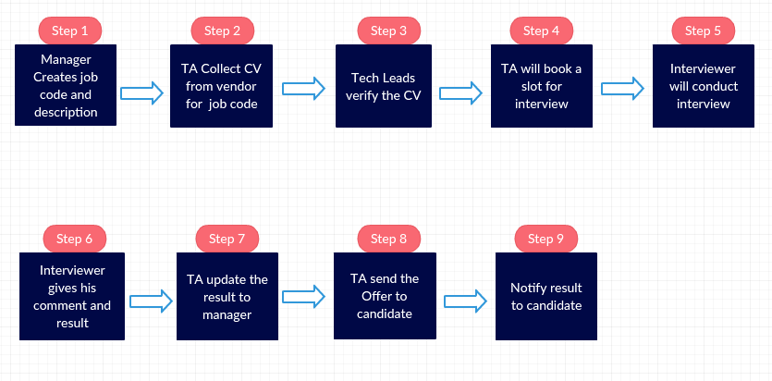

The main challenges we face in Manual Talent acquisition process are:
- Inform each other manually after completing the process.
- Inability to reach candidates that fit job profiles for critical roles at the moment of need.
- Frustration of desirable candidates due to complex processes.
- Misalignment of localized Talent acquisition processes with the needs of a global organization.
- Inflated cost-per-hire or inability to assess talent acquisition costs.

  - Definition, Acronyms, and Abbreviations
- HTML (Hyper Text Markup Language): It is used to create static web pages.
- JSP (Java Server Pages): It is used to create dynamic web content.
- J2EE (Java 2 Enterprise Edition): It is a programming platform, belonging to the Java platform, which is used for developing and running distributed java applications.

- WSAD (WebSphere Studio Application Developer ): It is a designer toolkit which is designed to develop more complex projects by providing a complete dynamic web service.
- DB2 (IBM Database 2): It is a database management system that provides a flexible and efficient database platform to raise a strong "on demand" business applications.
- HTTP (Hyper Text Transfer Protocol): It is a transaction oriented client/ server protocol between a web browser and a web server.
- XML (Extensible Markup Language): It is a markup language that was designed to transport and store data.
- Ajax (Asynchronous Java Script and XML): It is a technique used in java script to create dynamic web pages.
- Web 2.0: It is commonly associated with web applications which facilitate interactive information sharing, interoperability, user-centered design and collaboration on the World Wide Web.

Technologies to be used:
J2EE: (Servlet, JSP, JAXP, Java Beans) Application architecture.
MAVEN: For building and deployment
HTML & CSS: Static pages
JQuery: Front End Validation.
Apache-tomcat: Deployment Server
JAVA: Application architecture.
Hibernate : ORM tool
MySQL: Oracle MySql DB.
Ajax: Asynchronous Java Script and XML.
Web 2.0: RSS Feed 2.0.
Eclipse: Development tool.
Spring MVC Module: Framework for web development.
Angular JS: For Web page development.

2. General Description
2.1 Product Functions
The product should make the Talent acquisition process easier and streamlined for the users (employees) and enhance the time efficiency and tracking of the candidate’s profile.

2.2 User Characteristics
The users include the employees of the Aricent as they input data for selection process of candidates. For this system, the user is required to know the basic usability of computer as well as a very base level understanding of net surfing.

2.3 User Problem Statement
Currently everything is manual and in mails. That is very tedious and hectic job. This solution is to automate to ease the Talent acquisition process in Aricent

3. Functional Requirements
ATAS facilitates communication between Managers, TA, Tech Lead, Interviewer , using an application that provides real-time tracking through all stages of the Talent acquisition process - from job creation to the new employee joining Aricent.

ATAS encourages interaction between the Manager-TA and TA-Tech Lead. This partnership ensures that the position description matches the needs of the Manager, and that candidates are screened and presented to the Tech Lead.

Once the Tech Lead accepts the candidate slate, the interviewing process begins. Each candidate's status is updated automatically and available to both the Manager and the TA. When a hiring decision is made, ATAS close the record.
Position Descriptions:
Information includes items like the job code and description, and basic qualifications for each job code. For the Manager, this automated feature ensures that up-to-date titles and qualifications are used.
Managers are encouraged to include detailed job duties as well as job related preferences to the position description. This information will be reviewed in the strategy session with your TA. The posting may be customized by your TA in order to attract the highest quality applicants for your position.
Create Interview Panel:
Manager will be responsible for selecting the interviewer with desired skills.
Create TA Panel:
Manager will be responsible for selecting the TA for any skills set.
Upload CV:
TA will collect the related CVs from job portals, internal employee referral and, third party vendors. He/she will screen and upload the CV in the ATAS.TAs are responsible to assign the candidate's CV to Tech Lead for screening.

Screening Candidate profile:
Tech Leads are responsible to screening of the candidate's CV for given job code and description. If screening is done then TAs are responsible to process the candidate to next level.
Check interviewer’s available slots:
TA will be responsible for assigning the CV to interviewer on their slots availability. TA can see only those interviewer having skills as per the job description.
Interviewing Candidates:
Interviewer will conduct interviews with candidates assigned by the TA. In an effort to ensure consistency and to select the best candidates for open positions, behavioral interviewing techniques are recommended.
Interviewers are responsible for being consistent and equitable in interviewing candidates. They should schedule and plan to spend the same amount of interview time with all candidates.
Offer Process:
If Candidate is selected the TA is responsible to send the Offer to candidate. He/She will be responsible to close the record.

4. Interface Requirements
4.1 User Interfaces
- 4.1.1 GUI
The user interface for this program is web pages designed in Jsps and angular JS. Web pages includes forms for the users to query and organize data to suit their needs
- 4.1.2 CLI
There is no command line interface.

5. Other non-functional attributes

5.1 Security
The system shall be designed with a level of security appropriate for the sensitivity of information enclosed in the database. More interaction is needed with client about the volatility of the information. Since there is no obvious information that is of a high security level such as credit card information, the only requirements that could be implemented are encrypting the database and/or making the database password-protected, by user’s request.

5.2 Binary Compatibility
This system will be compatible with any computer that has internet access, and will be designed with more than one computer in mind.

5.3 Reliability
Reliability is one of the key attributes of the system. Back-ups will be made regularly so that restoration with minimal data loss is possible in the event of unforeseen events. The system will also be thoroughly tested by all team members to ensure reliability.

5.4 Extensibility

The system shall be designed and documented in such a way that anybody with an understanding of J2EE/MySQL and hibernate shall be able to extend the system to fit their needs.

5.5 Reusability
The system should be designed in a way that allows the database to be re-used regularly for the various silent auctions that the organization shall hold.

5.6 Serviceability
The maintenance of the system should be able to be sufficiently performed by any person with a basic understanding of J2EE/MySQL and hibernate.

6. Use Case Models and Sequence Diagrams
This section presents a list of the fundamental sequence diagrams and use cases that satisfy the system’s requirements. The purpose is to provide an alternative, "structural" view of the requirements stated above and how they might be satisfied in the system.
6.1 Use Case Model
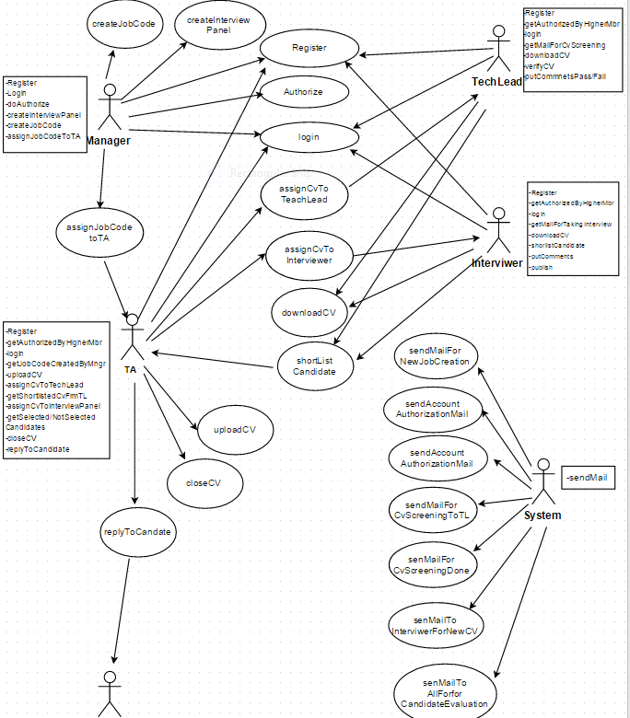

6.2 Class Diagram & Sequence Diagrams

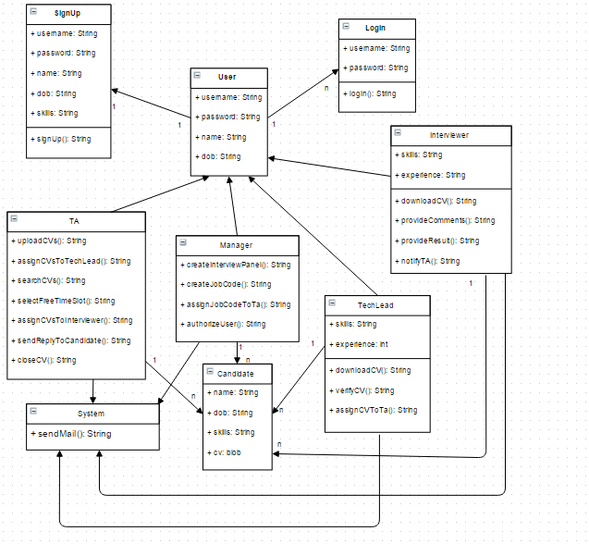

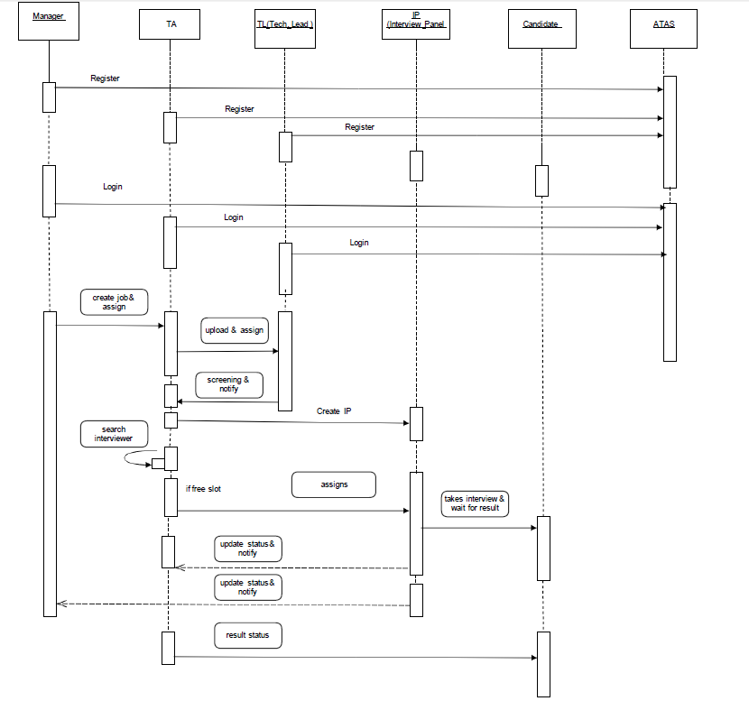

6.3 ER Diagram

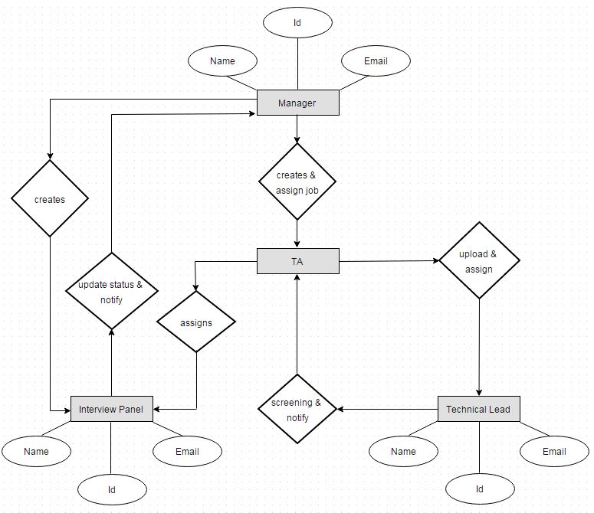

7. Specific Requirements
7.1 Use case Reports:
USECASE | DESCRIPTION
Register | Manager can register any user.
Notify User | Send a mail to user for account authorisation.
Login | TA, Tech Lead, Interviewer and Manager can login from ATAS
Create Interview Panel | Manger will create the profile for interviewer .This profile will have info about his technical expertise and level and calendar plugin.
Create TA Panel | Manger will create the profile for TAs .
Create job code | Only Manager will have privilege to create job code.
Assign job code to TA | Manager will assign the job code to TA.
Notify TA for new Job code | System will Send a mail to TA for new Job Code
Upload CV | Assigned TA will upload matching CV in ATAS
Assign CV for Screening | Assigned TA will now assign the CV to Tech Lead for screening.  (multiple assignment)
Notify Tech Lead for new CV | System will send a mail to Tech Lead for new CV Screening. Send only one mail in case of multiple assignment.
Download CV | Tech lead will Download the CV for screening. Download all the CV will be possible for TA.
Verify CV | Tech Lead will verify the CV and he will put the status and comment for CV.
Assign CV to TA | After comments of Tech Lead CV will automatically assign to TA.
Notify TA for screening | System will send a mail to TA for Screening done.
Search CV | From the mail TA will get candidate id and he/she will search the particular ID.
Assign CV to Interviewer(L1,L2,L3) | TA will search the interviewer for given job code and assign the CV to him.
Select free slot for interview | Interviewer will have his calendar information screen from where TA can see the free slot and assign the task.
Notify Interviewer(L1,L2,L3) for new CV assignment | System will send a mail to interviewer for new CV.
Download CV | Interviewer will download the CV.
Comment and status | Interviewer (L1, L2, and L3) will provide his comment and result of candidate.
Notify TA | System will Send a mail to Manager, Tech Lead, and TA.
Close the CV | TA will close the CV permanently if selected and close for 6 month if not selected.

8. Open Issues
Q. Multiple CV Upload?
Q. What if resume already present on system?

Template Revision History:
Rev | Date of Issue | Author | Approver | Scope

