SNHU CS 499 Computer Science Capstone
Enhancement Narrative- Software Design/Engineering
Jessica Johnson
06/20/2026

Narrative
This milestone focuses on enhancing my Raspberry Pi Smart Thermostat project that was originally developed in CS 350 Emerging Systems Architectures and Technologies. The original project was designed to simulate the behavior of a programmable thermostat using Python, GPIO components, PWM LEDs, an AHT20 temperature sensor, an LCD display, and multiple thermostat operating states including off, heat, and cool. I selected this artifact for my ePortfolio because it demonstrates both software and hardware integration while also showing problem-solving, modular programming, and embedded systems development skills. I felt this project represented some of my strongest software engineering work because it combines physical hardware interaction with software logic and real-time system behavior. It also gave me an opportunity to further improve the project in a way that reflects professional software engineering practices and better system organization.
For the CS 499 enhancement, I expanded the thermostat system by adding dashboard-ready status tracking and a Flask-based web dashboard prototype. The original project only displayed information directly on the LCD screen and through serial output, so I wanted to improve the usability and organization of the system by preparing it for remote monitoring capabilities. To support this enhancement, I added a centralized thermostat status dictionary that stores system information such as the thermostat mode, current temperature, set point, LED activity, and last update time. I also created a reusable dashboard status method to improve modularity, code organization, and future scalability. I selected Flask because it allowed me to create a lightweight web interface without changing the existing thermostat control logic. Separating the dashboard from the thermostat functionality improved maintainability and followed software engineering principles that encourage keeping user interface components separate from system processing. Centralizing thermostat data into a single status structure also reduced duplication and made it easier for multiple components to access the same information. In addition, I developed a simple Flask dashboard that displays thermostat information through a browser interface in a cleaner and more user-friendly way. These enhancements improved the overall maintainability and organization of the project while also demonstrating stronger software engineering practices related to modular design, accessibility, and system scalability. I also spent time improving comments and documentation throughout the code to better explain the purpose behind different sections of the system and make the project easier to follow and maintain.
This enhancement helped me better understand the importance of designing software in a way that is scalable, organized, and easier to maintain over time. One thing I learned during this process was how helpful centralized status tracking can be when different parts of a system need access to the same information. I also gained experience working with Flask and creating a simple browser-based dashboard for an embedded systems project. This was my first time integrating a lightweight web interface into an embedded systems project, which helped me better understand how software and hardware components can work together to improve usability. One challenge I faced was making sure the enhancement stayed realistic and aligned with the original thermostat architecture instead of overcomplicating the project with unnecessary features. Another challenge was determining how to organize the thermostat data so it could be shared between the thermostat logic and the dashboard. I addressed this by creating a centralized status dictionary that stores key system information in one location. This approach simplified future enhancements and reduced the need for multiple components to independently track the same data. This process also reinforced how important clear documentation, thoughtful organization, and maintainable code structure are in software engineering projects. Throughout development, I regularly tested dashboard updates, verified thermostat status values, and reviewed display output to ensure the dashboard information remained synchronized with the thermostat system. This process reinforced the importance of incremental testing and debugging when enhancing an existing application. Overall, this enhancement strengthened my understanding of modular programming, software organization, and how embedded systems can be expanded into more user-friendly applications through web-based interfaces.
Running Flask Dashboard
The screenshot below shows the completed Flask dashboard enhancement running locally through a browser interface.
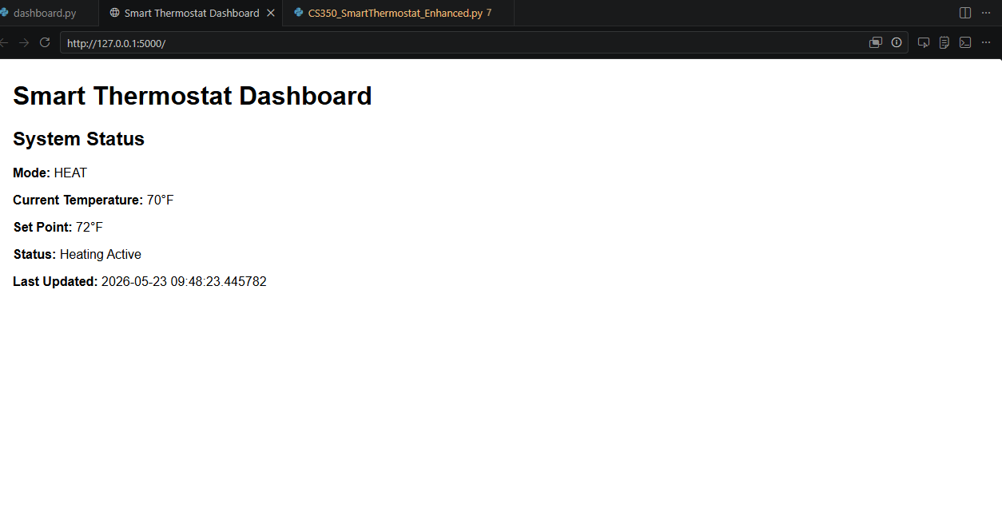
Course Outcome Alignment
This enhancement aligns with Course Outcome 3 by improving the overall functionality, organization, and usability of the original thermostat system through modular programming and centralized status tracking. The addition of the web dashboard also helped prepare the project for future scalability and remote monitoring capabilities.
This enhancement aligns with Course Outcome 4 because I used Flask and Python to expand the original embedded systems project into a browser-based monitoring interface. The project demonstrates software engineering skills involving system integration, modular design, debugging, and improving the overall user experience.
This enhancement also aligns with Course Outcome 5 by reinforcing a security mindset and maintainability focus throughout the system. While the dashboard currently operates in a local environment, future remote monitoring implementations would require authentication, access controls, and additional security measures to protect system information. The use of centralized data management, improved documentation, and better separation of responsibilities also supports the development of systems that are easier to maintain, secure, and expand over time.

