**ARA (AI POWERED RESEARCH ASSISTANT)**

**A SYNOPSIS**

**ON**

**MINI PROJECT**

**SUBMITTED IN PARTIAL FULFILLMENT OF THE REQUIREMENTS FOR THE AWARD OF THE DEGREE**

**OF**

**BACHELOR OF TECHNOLOGY**

**IN**

**COMPUTER SCIENCE AND ENGINEERING**

**Submitted by**

|  |  |  |  |
| --- | --- | --- | --- |
| Kaustubh Warade  CSE/RN/74 255823 | Aditya Deshmukh CSE/RN/34 255783 | Devansh Parapalli CSE/RN/35 255784 | Yashasvi Thool CSE/RN/77 255826 |

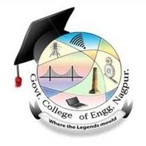

**DEPARTMENT OF COMPUTER SCIENCE AND ENGINEERING GOVERNMENT COLLEGE OF ENGINEERING, NAGPUR**

**January 2024**