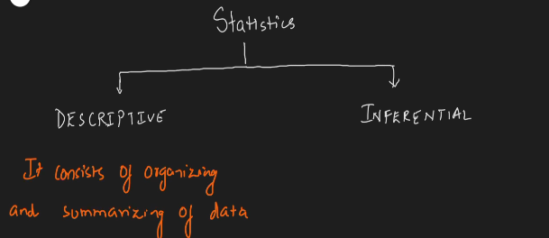

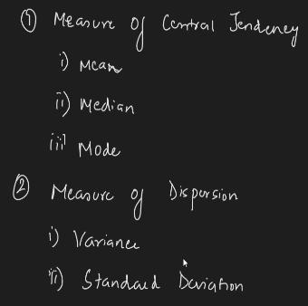

**Inferential Statistic** : first collect some data(sample data) using some experiments derive conclusion and this is made for some other data which is called Population data.

Population (N) And Sample (n)

Measure of Central Tendency :

1. Mean
2. Median
3. Mode

Measure of Dispersion :

1. Variance
2. Standard Deviation

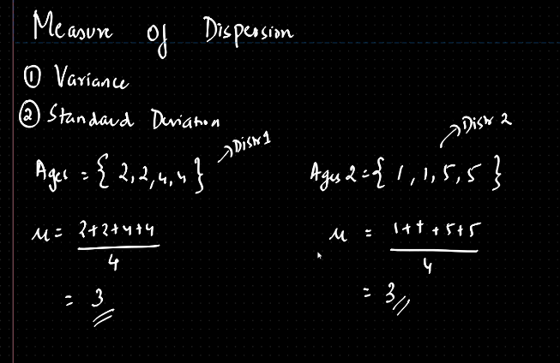

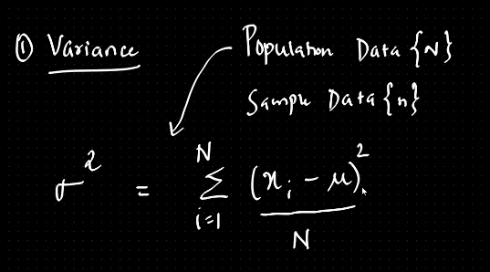 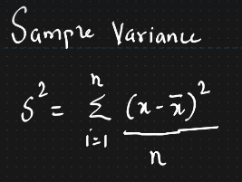

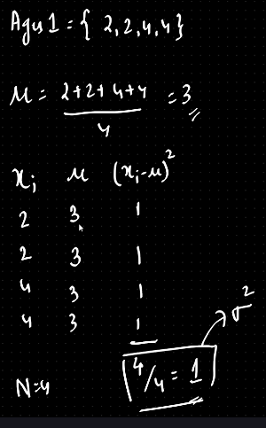 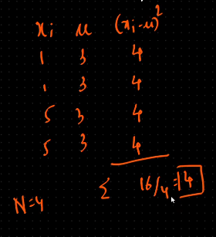

* Why we divide sample variance by (n-1) while it is N in the case of Population variance ?
* To overcome unbiased estimation

**Standard Deviation**

* Square root of variance
* How far a data point is away from the mean

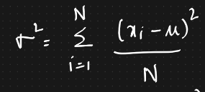 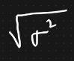

Variable : it is a property that can take up any value

Types of variables

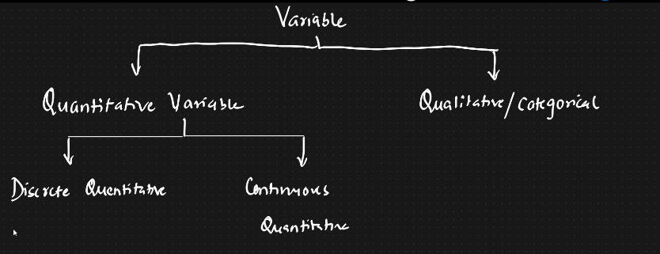

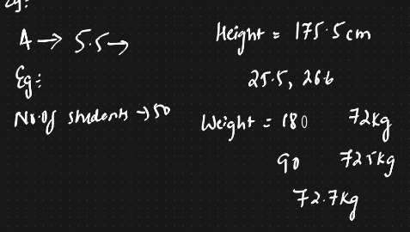 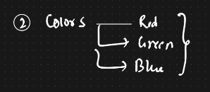

Random Variable :

It is a function which define some values through some experiments/process

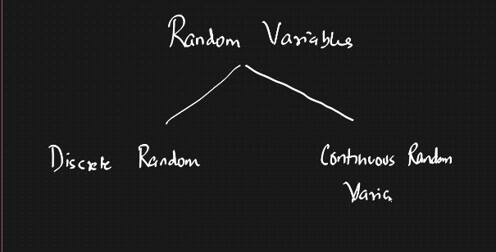

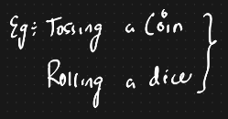 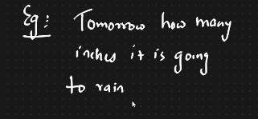

Histograms :

Finding the frequency based on bins

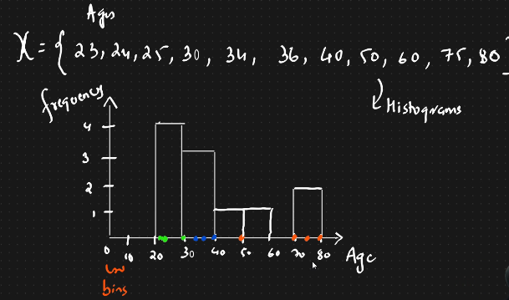 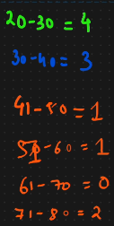

Percentile and Quartiles

Percentile : A percentile is a value below which certain percentage of observation lie

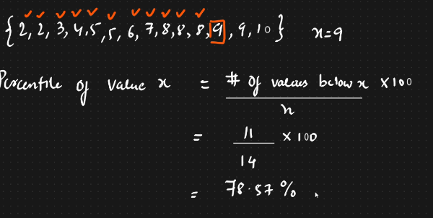 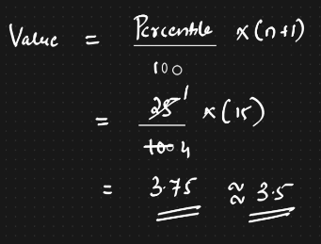

Quartiles :

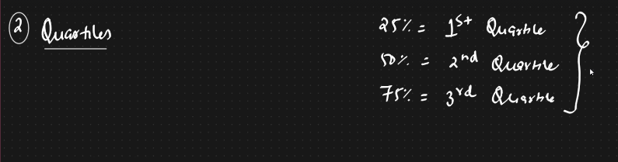

**5 Number Summary**

