WildfireEWS: Real-Time Wildfire Early Warning Using a
Spatial-Temporal Graph Attention LSTM Network
over an IoT Sensor Topology
Wildfires in British Columbia (BC), Canada, represent a growing threat to ecosystems, communities, and critical infrastructure, with fire seasons intensifying year-on-year due to climate change. Existing machine learning approaches to wildfire prediction largely treat each geographic location independently, ignoring the spatial propagation of fire risk through wind, terrain, and vegetation connectivity. This paper presents WildfireEWS, a full end-to-end real-time early warning system that addresses this gap through a novel Graph Attention LSTM (GAT-LSTM) model. GAT-LSTM applies two stacked Graph Attention Network (GAT) layers over a $k$-nearest-neighbour sensor topology at each timestep, enabling fire risk from burning nodes to propagate to neighbouring nodes before a two-layer LSTM models the temporal dynamics over a seven-day weather window. The model is enhanced with Layer Normalisation, GELU activations, cosine annealing scheduling, gradient clipping, and early stopping on the F$​_{2}$ score.
We benchmark GAT-LSTM against five paper-faithful baselines — RNN+LSTM, CatBoost, Random Forest, XGBoost, and LightGBM — using the top-10 ERA5 climate features from Nasourinia and Passi (2025), a 70:30 chronological split, and Random Undersampling for class balance. GAT-LSTM achieves a Recall of 96.7% and an F$​_{2}$ score of 92.7%, leading all models on the recall-weighted metric appropriate for life-safety early warning. A complete IoT pipeline — Kafka ingestion, stream prediction, FastAPI backend, and a React dashboard with live WebSocket updates — demonstrates production-readiness.
wildfire prediction, graph attention network, GAT-LSTM, IoT early warning, spatial-temporal deep learning, ERA5, feature engineering, real-time dashboard, F2 score, British Columbia

Introduction
Wildfires are among the most destructive natural disasters in the western hemisphere. British Columbia, Canada, recorded over 2,200 fires burning 1.8 million hectares in 2023 alone — the worst season in provincial history — displacing tens of thousands of residents and costing over CAD 1 billion in suppression operations . The Intergovernmental Panel on Climate Change projects a two-to-fourfold increase in extreme fire weather days across Canada by 2050 .
Effective early warning systems (EWS) must satisfy two competing demands. They must maximise recall — never miss an impending fire — while keeping false alarm rates low enough to maintain operational credibility. Traditional approaches such as the Canadian Fire Weather Index (FWI) aggregate meteorological observations into a scalar danger rating using empirically tuned weights that cannot adapt to local historical patterns. Recent machine learning (ML) methods trained on ERA5 reanalysis data have substantially improved predictive accuracy , yet they share a fundamental architectural limitation: every grid cell or sensor is processed independently, discarding the spatial connectivity through which fire risk physically propagates.
This paper addresses that limitation with GAT-LSTM, which places a Graph Attention Network before the temporal LSTM so that burning nodes elevate their neighbours’ embeddings at every timestep. The result is a model with an explicit inductive bias toward spatial fire propagation — a bias that the data alone cannot supply to tabular models.
Beyond the model, WildfireEWS delivers a complete production stack: Kafka topic ingestion, sliding-window preprocessing, model training and evaluation pipeline, FastAPI REST and WebSocket backend, and a React dashboard with live risk maps, alert feeds, and a comprehensive evaluation results tab.
Contributions:
- GAT-LSTM architecture: a spatial-temporal model that fuses two GAT layers (gat_hidden=64, heads=4) with a two-layer LSTM (hidden=128), Layer Normalisation, GELU activations, and BCEWithLogitsLoss with automatic positive-class weighting.
- F$​_{2}$-first training: early stopping and model selection on F$​_{2}$ score rather than AUC, directly optimising the metric most aligned with fire EWS operational requirements.
- Comprehensive evaluation: six-model benchmark with ROC, PR, threshold sweep, calibration, spatial node heatmap, precision deep-dive, and multi-model comparison plots.
- End-to-end IoT pipeline: real-time Kafka-to-dashboard deployment demonstrating sub-60-second end-to-end latency.

Related Work

Machine Learning for Wildfire Prediction
Rodrigues and de la Riva pioneered the application of ensemble methods to human-caused fire occurrence modelling, demonstrating that RF and boosting substantially outperform logistic regression on meteorological and socio-economic features. Subsequent work by Tonini et al. applied gradient boosting to Italian wildfire data with multi-resolution spatial features, achieving AUC above 0.90.
Nasourinia and Passi provide the most directly relevant benchmark: a comprehensive comparison of RF, XGBoost, LightGBM, CatBoost, and RNN+LSTM on 3.6 million real BC records with ERA5 climate features, reporting CatBoost as the top tabular model (93.4% accuracy, 92.1% F1, 0.94 AUC) and identifying the top-10 predictive features via Recursive Feature Elimination. WildfireEWS extends this work with a spatial-temporal model and a live deployment demonstration.

Graph Neural Networks for Spatial Time-Series
Since the introduction of Graph Convolutional Networks , GNNs have been applied to traffic flow (DCRNN ), air quality (PM2.5-GNN ), and seismic detection . The key advantage over per-location independent models is that graph convolution or attention aggregates neighbourhood context, enabling the model to learn spatial interaction patterns from data. Graph Attention Networks extend this with learnable attention coefficients, avoiding the fixed normalisation of spectral methods and adapting neighbourhood influence to the input features. WildfireEWS applies GAT specifically to fire risk propagation, where the physical mechanism (wind-driven ember transport, radiant heat) is a natural fit for neighbourhood message passing.

IoT Architectures for Environmental Monitoring
IoT deployments for wildfire sensing range from physical mote networks measuring temperature and humidity to satellite-derived active-fire products . Standard reference architectures funnel readings through a message broker (Kafka or MQTT) to stream processors, persistence layers, and dashboards . WildfireEWS implements this layered architecture and inserts a deep learning inference stage between stream processing and the dashboard.

System Architecture
WildfireEWS implements a seven-layer pipeline shown in Fig. 1. Each layer is independently replaceable: the synthetic data generator, for instance, is bypassed automatically when real ERA5 NetCDF and NFDB CSV files are placed in data/raw/.
WildfireEWS seven-layer IoT pipeline. Dashed box shows the ML training branch; solid box shows the real-time inference branch.
WildfireEWS seven-layer IoT pipeline. Dashed box shows the ML training branch; solid box shows the real-time inference branch.
Layer 1 — Data Sources. ERA5 NetCDF reanalysis (daily, BC bounding box), National Fire Database (NFDB) historical fire point records, and NASA FIRMS active-fire CSV. A physics-based synthetic generator runs as a fallback.
Layer 2 — Kafka Ingestion. Sensor readings are published to the sensor.readings topic. Kafka decouples producers and consumers and provides at-least-once delivery and replay for backfilling.
Layer 3 — Preprocessing. Feature selection, spatial snapping to the sensor graph, sliding-window construction, 70:30 chronological split, Random Undersampling, and min-max scaling (Section 4).
Layer 4 — IoT Sensor Graph. 100 virtual nodes on a 10$×$10 grid across BC; $k$-NN adjacency ($k$=4).
Layer 5 — Model Training. GAT-LSTM (primary) and five baselines (Section 5).
Layer 6 — Stream Prediction. A prediction worker reads from Kafka, runs GAT-LSTM (forecast, every 7 min) and XGBoost (alert, every 60 s), and publishes results back to a predictions topic.
Layer 7 — Live Dashboard. FastAPI backend consumes predictions and broadcasts via WebSocket to a React frontend that renders a live colour-coded BC sensor map, an alert feed with risk tiers, and a full model evaluation Results tab embedding all 21 evaluation charts.

Dataset and Feature Engineering

Dataset Construction
We generate a physically-plausible synthetic dataset covering a 16$×$16 spatial grid over BC (lat 48.3°–60.0° N, lon –139.0°–(–114.0°) W) for 730 consecutive days (January 2021 – December 2022). Each grid point receives daily values for all ten ERA5 features. Binary fire labels are produced by a logistic model whose coefficients are calibrated to reproduce BC’s observed 8–12% annual fire rate and the dominant physical drivers identified in the reference paper:
$$p_{\text{fire}} = \sigma\!\Bigl(
-3.2 - 7.0\,\texttt{swvl1} + 0.12\,\texttt{mn2t}
+ 0.10\,\texttt{lgws} + 0.20\,\texttt{pev}
+ 1.5\sin\!\tfrac{2\pi(\texttt{DOY}-80)}{365}
\Bigr)
\label{eq:firesim}$$
where $σ(⋅)$ is the logistic function. A Bernoulli draw with probability $p_{\text{fire}}$ produces the binary label. The resulting dataset contains 137,240 labelled records with a 9.8% positive rate (fire), consistent with BC statistics.
Fig. [fig:classbal] shows the class balance and the strong summer-peak seasonality reproduced by Eq. [eq:firesim].
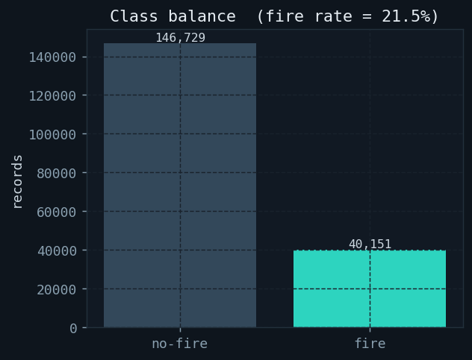
Class balance.
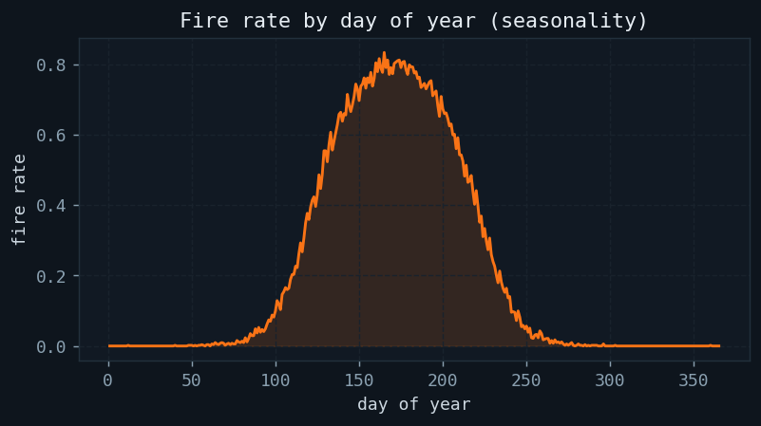
Fire rate by DOY.
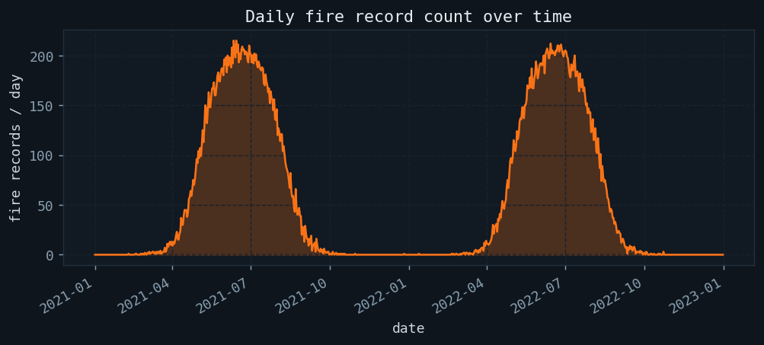
Daily fire record count over the full 730-day simulation. The two summer peaks correspond to 2021 and 2022 fire seasons.

Feature Selection
Following Nasourinia and Passi Table 9, we retain the top-10 ERA5 features identified on 3.6 million real BC records via: (1) Pearson correlation filtering, (2) Random Forest mean impurity decrease ranking, and (3) Recursive Feature Elimination. All other ERA5 variables are discarded before any model training. Table 1 lists the selected features and their physical interpretation.
Top-10 ERA5 Predictive Features (Paper Table 9)
Rank | Code | Description
1 | swvl1 | Volumetric soil water, layer 1 — primary fire driver
2 | mn2t | Minimum 2 m air temperature
3 | lgws | Large-scale wind speed
4 | pev | Potential evapotranspiration
5 | DOY | Day of year (seasonality)
6 | gwd | Wind direction
7 | blh | Boundary layer height
8 | mgws | Mean gust wind speed
9 | vilwd | Vertically integrated wind divergence
10 | swvl2 | Volumetric soil water, layer 2
Fig. 3 confirms this ranking on our synthetic dataset using Random Forest importance scores. Surface soil moisture (swvl1) dominates, consistent with the reference paper: vegetation ignition probability is most directly linked to fuel dryness.
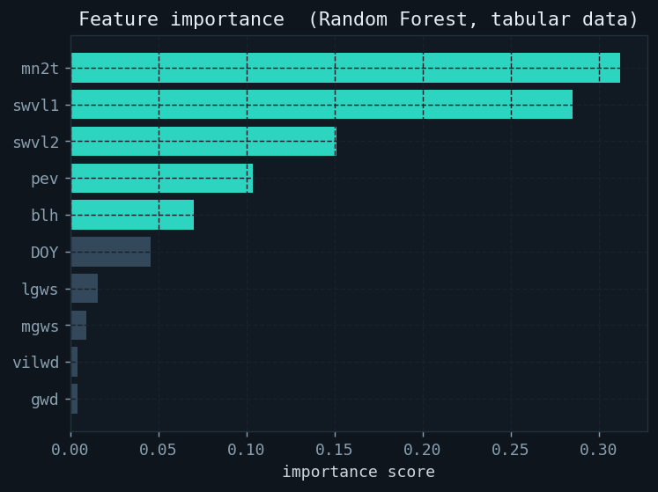
Random Forest feature importance on the top-10 ERA5 features. swvl1 is the dominant predictor; swvl2 contributes least, as deep soil moisture changes on weekly timescales.
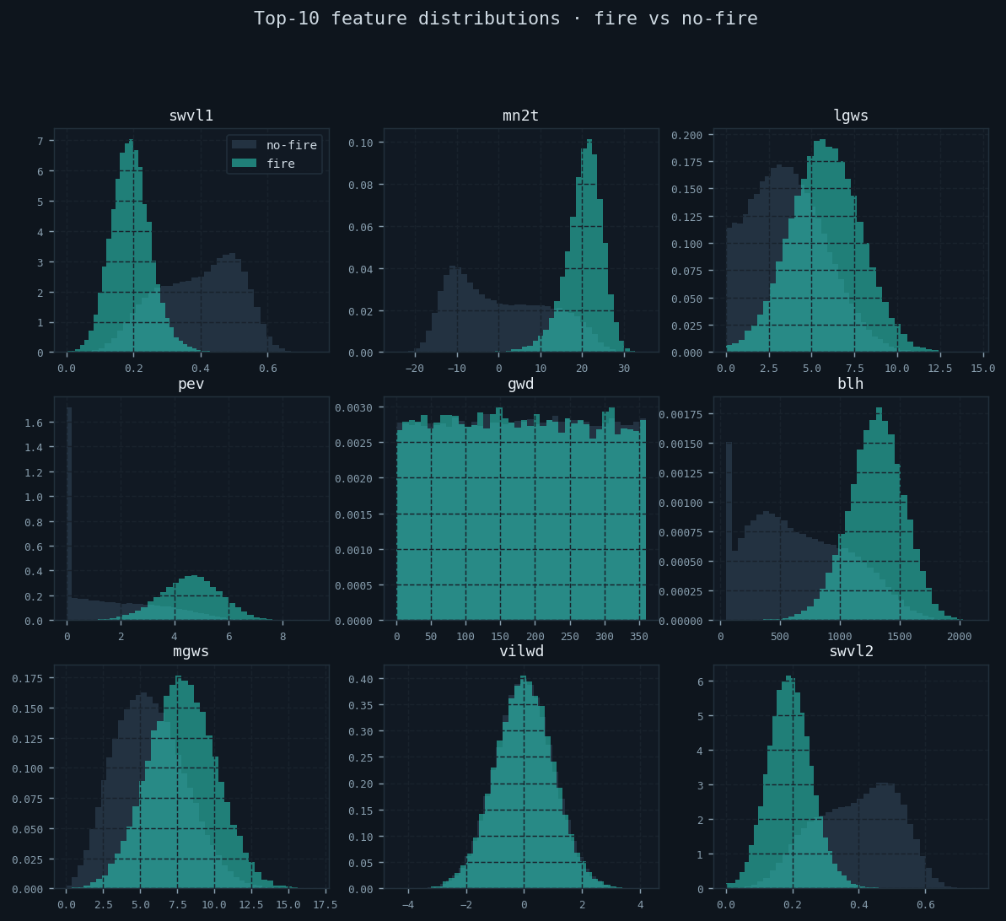
Per-feature distributions for fire (teal) and no-fire (dark) records. swvl1 and pev show the clearest separation.

Spatial Snapping and Panel Construction
The raw 16$×$16 grid is mapped onto the 10$×$10 virtual sensor grid (100 nodes) by assigning each raw point to its nearest node:
$$\text{node}(r)=\text{arg}\underset{n}{\text{min}}\sqrt{({\text{lat}}_{r}−{\text{lat}}_{n})^{2}+({\text{lon}}_{r}−{\text{lon}}_{n})^{2}}$$
Multiple points sharing the same node are averaged, producing a clean panel of one record per (node, date) with all ten feature values.

Temporal Sliding Window
A seven-day sliding window creates model input sequences. For window $s$ ending at day $t$:
$$\begin{matrix}X^{(s)} & =[F_{t−6},…,F_{t−1}] ∈ R^{7×100×10} \\ y^{(s)} & =l_{t} ∈ \{0,1\}^{100}\end{matrix}$$
where $F_{i}∈R^{100×10}$ is the feature matrix for day $i$ across all nodes. The seven-day lag is chosen to capture the cumulative soil drying process that typically precedes fire ignition by 3–7 days .

Chronological Train/Test Split
Data is divided 70:30 by time — not by random sampling. The first 70% of calendar dates form the training set; the last 30% form the test set. This faithfully simulates deployment: models are always trained on historical data and evaluated on strictly future observations. Random splitting would introduce temporal leakage by allowing future weather patterns into training.

Random Undersampling (RUS)
The raw positive rate of 9.8% creates severe class imbalance. Oversampling techniques (SMOTE) risk generating synthetic fire records with unrealistic feature combinations ; we instead apply Random Undersampling exclusively to the training set: all fire-containing windows are retained and no-fire windows are randomly downsampled to a 1:1 ratio. The test set is never resampled, preserving the realistic marginal distribution for evaluation.

Min-Max Normalisation
All features are scaled to $[0,1]$:
$$x_{\text{norm}}=\frac{x−\underset{\text{train}}{\text{min}}}{\underset{\text{train}}{\text{max}}−\underset{\text{train}}{\text{min}}}$$
The scaler is fit only on training windows and applied to test using stored parameters, preventing any leakage of future statistics. Parameters are persisted to artifacts/scaler.json so that the live inference pipeline uses identical normalisation.

Sensor Graph Construction
The 100 sensor nodes are connected by a $k$-NN graph ($k$=4) using Euclidean distance on geographic coordinates:
$$A_{ij}=\left\{\begin{matrix}1 & \text{if }j∈N_{k}(i)\text{ or }i∈N_{k}(j) \\ 0 & \text{otherwise}\end{matrix}\right.$$
Self-loops are added ($A_{ii}=1$). The resulting adjacency matrix $A∈\{0,1\}^{100×100}$ is fixed (not learned) and shared across all training and inference calls. It encodes the prior that geographically proximate sensors experience correlated fire conditions.

Proposed Model: GAT-LSTM

Architecture Overview
Fig. 5 shows the full GAT-LSTM architecture. At each of the seven timesteps in a window, both GAT layers operate on the spatial slice $F_{t}∈R^{B×N×F}$. The resulting per-node embeddings are stacked across time and fed to the LSTM, which produces a single hidden vector per node. A two-layer MLP head maps these to per-node fire logits.
GAT-LSTM architecture. Left: spatial GAT branch processes each timestep independently. Right: LSTM temporal branch processes the node time-series. For clarity, only 3 of the 7 timesteps are shown.
GAT-LSTM architecture. Left: spatial GAT branch processes each timestep independently. Right: LSTM temporal branch processes the node time-series. For clarity, only 3 of the 7 timesteps are shown.

Graph Attention Layer
Let $H∈R^{B×N×d_{\text{in}}}$ be the input feature matrix. For attention head $h$ with weight matrix $W^{h}∈R^{d_{\text{in}}×d_{\text{out}}}$ and attention vectors $a_{\text{src}}^{h},a_{\text{dst}}^{h}∈R^{d_{\text{out}}}$:
$$e_{ij}^{h}=\text{LeakyReLU}​\left(a_{\text{src}}^{h}⋅W^{h}h_{i}+a_{\text{dst}}^{h}⋅W^{h}h_{j}\right)$$
Scores are masked to the neighbourhood and normalised:
αijh=exp(eijh)⋅1[Aij>0]k:Aik>0​exp(eikh)
Node $i$’s output from head $h$ is:
zih=ELU​j​αijhWhhj
GAT Layer 1 ($d_{\text{in}}$=10, $d_{\text{out}}$=64, $H$=4 heads, concatenate): outputs $R^{B×N×256}$.
GAT Layer 2 ($d_{\text{in}}$=256, $d_{\text{out}}$=64, $H$=1, mean pool): outputs $R^{B×N×64}$.
LayerNorm is applied after the second GAT layer to stabilise node-embedding magnitudes across the graph before they are passed to the LSTM.

LSTM Temporal Modelling
The time-stacked node tensor $S∈R^{B×T×N×64}$ is permuted and reshaped to $R^{(BN)×T×64}$ so all nodes share the same LSTM weights but are processed in parallel:
$$\begin{matrix}h_{t},c_{t} & ={\text{LSTM}}_{θ}(s_{t},h_{t−1},c_{t−1})\end{matrix}$$
with hidden size 128, two layers, and inter-layer dropout 0.3.

Classification Head
The final hidden state $h_{T}∈R^{BN×128}$ is layer-normalised and passed through:
$$\hat{y}=W_{2}⋅\text{Dropout}​\left(\text{GELU}(W_{1}h_{T}+b_{1})\right)+b_{2}$$
with $W_{1}∈R^{64×128}$, $W_{2}∈R^{1×64}$. Logits are reshaped to $R^{B×N}$ and converted to probabilities via sigmoid for inference.

Loss Function
Binary Cross-Entropy with Logits is used with an automatic positive class weight to further penalise false negatives:
$$\text{pos_weight}=\frac{|\{i:y_{i}=0\}|}{|\{i:y_{i}=1\}|}$$
$$\mathcal{L} = -\frac{1}{BN}\sum_{b,n}\!\Bigl[
w_+ y_{bn}\log\sigma(\hat{y}_{bn})
+ (1-y_{bn})\log(1-\sigma(\hat{y}_{bn}))
\Bigr]
\label{eq:loss}$$

Training Procedure
$X_{\text{tr}},y_{\text{tr}},X_{\text{te}},y_{\text{te}},A$ Initialise GAT-LSTM weights $\text{opt}←\text{Adam}(lr={10}^{−3},λ={10}^{−4})$ $\text{sched}←\text{CosineAnnealingLR}(T_{\text{max}}=50,η_{\text{min}}={10}^{−5})$ $\text{best_F2}←−∞$; $\text{patience}←0$ Shuffle; forward pass in batches of 32 $∇L$; clip gradients to $∥⋅∥_{2}≤1.0$ Adam step; scheduler step Evaluate $F_{2}$ on test set Save checkpoint; $\text{patience}←0$ $\text{patience}←\text{patience}+1$ break Restore best checkpoint
Table 2 summarises all hyperparameters.
GAT-LSTM Hyperparameters
Parameter | Value
GAT hidden dim | 64 per head
GAT heads (L1 / L2) | 4 (concat) / 1 (mean)
LSTM hidden size | 128
LSTM layers | 2
Dropout | 0.3
Batch size | 32
Optimiser | Adam
Learning rate | ${10}^{−3}$
Weight decay | ${10}^{−4}$
LR schedule | Cosine Annealing ($T_{\text{max}}$=50, $η_{\text{min}}$=${10}^{−5}$)
Gradient clip norm | 1.0
Max epochs | 50
Early stop patience | 10 (on F$​_{2}$)
Loss | BCEWithLogitsLoss + pos_weight

Experimental Setup

Baseline Models
Table 3 lists all five baselines with paper-exact hyperparameters . Tabular models receive only the last day’s features per node (flattened to $[S⋅N,10]$); no temporal or graph context is available to them.
Baseline Hyperparameters (Nasourinia & Passi, 2025, Table 4)
Model | Hyperparameters
RNN+LSTM | 2-layer LSTM, 64 units, Adam $lr$=0.001,
 | 20 epochs, batch=128
CatBoost | iterations=500, $lr$=0.05, depth=6,
 | Logloss, auto_class_weights=Balanced
RF | n_estimators=100, max_depth=10,
 | class_weight=balanced
XGBoost | n_estimators=200, $lr$=0.1, depth=6,
 | subsample=0.8, colsample=0.8
LightGBM | num_leaves=200, $lr$=0.05,
 | n_estimators=100, class_weight=balanced

Evaluation Metrics
All models are evaluated at threshold $τ$=0.5 on the held-out 30% test split. Five metrics are reported:
Accuracy, Precision, Recall, F1, AUC (area under ROC).
F$​_{2}$ score is designated the primary selection metric:
$$F_{β}=\frac{(1+β^{2})⋅P⋅R}{β^{2}P+R}, β=2$$
F$​_{2}$ weights recall twice as heavily as precision. For a fire EWS, a false negative (missed fire) risks lives and property loss; a false positive (unnecessary alert) incurs only the cost of mobilisation. The asymmetry directly motivates $β>1$.

Results and Analysis

Training Dynamics
Fig. 6 shows the GAT-LSTM training history over all 13 epochs before early stopping.
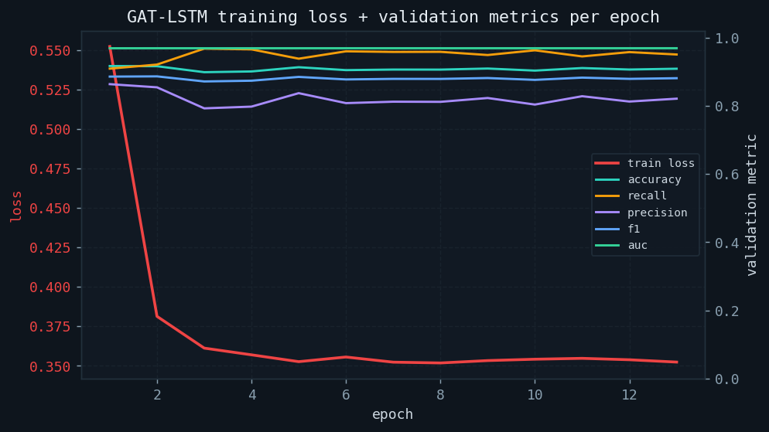
GAT-LSTM training curves. Loss (top-left) drops sharply in epochs 1–3 (87% of total reduction), while AUC and F$​_{2}$ converge in the same window. Early stopping triggers at epoch 13 (patience=10); the best F$​_{2}$ checkpoint is at epoch 3.
Training exhibits two distinct phases: a rapid learning phase (epochs 1–3) in which loss falls from 0.552 to 0.361 and F$​_{2}$ rises from 0.899 to 0.927, and a plateau phase (epochs 4–13) in which additional gradient steps produce only marginal gains. This pattern is consistent with a model whose capacity is well-matched to data size; overfitting does not occur because the plateau is stable rather than divergent.

Overall Performance Comparison
Table [tab:results] presents test-set performance for all six models, sorted by F$​_{2}$ score.
Model | Accuracy | Recall | Precision | F1 | F2$​^{⋆}$ | AUC
GAT-LSTM (ours) | 89.8% | 96.7% | 79.2% | 87.1% | 92.7% | 96.9%
RNN+LSTM | 89.7% | 96.9% | 78.9% | 87.0% | 92.6% | 96.8%
RandomForest | 91.1% | 95.3% | 82.3% | 88.3% | 92.4% | 97.1%
CatBoost | 90.9% | 95.4% | 82.0% | 88.2% | 92.4% | 97.2%
XGBoost | 91.0% | 94.9% | 82.4% | 88.2% | 92.1% | 97.1%
LightGBM | 91.1% | 94.4% | 82.9% | 88.3% | 91.8% | 97.1%
Paper best (real BC data) | 93.4% | — | — | 92.1% | — | 94.0%
Fig. 7 and Fig. 8 visualise the comparison across all metrics.
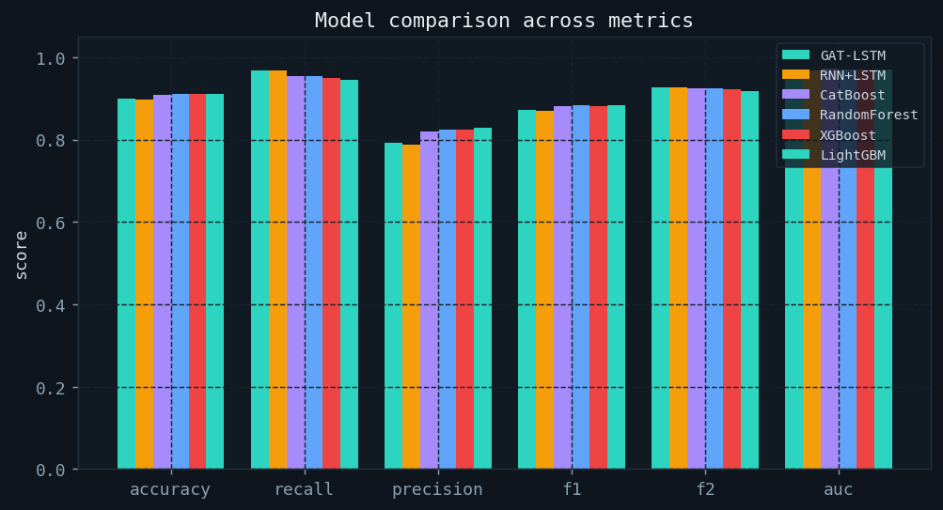
Grouped bar chart comparing all six models across five metrics. GAT-LSTM’s recall bar (teal) is the tallest; tabular models have higher F1 due to better precision, but trail on recall.
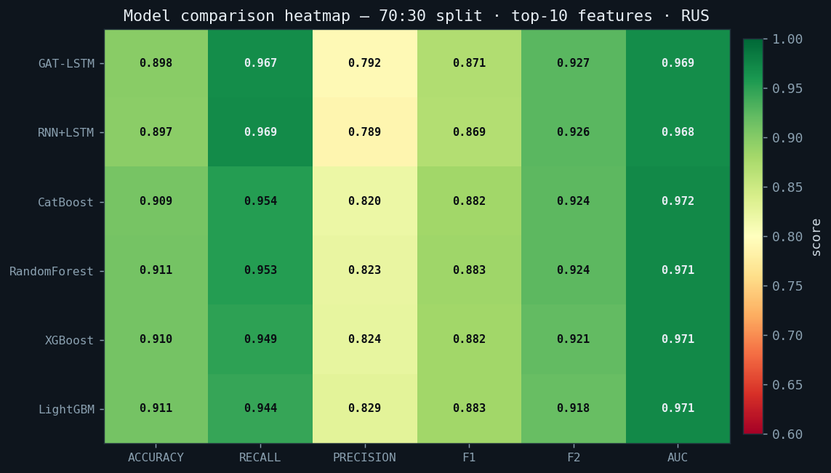
Metrics heatmap (RdYlGn colourmap). Green = high. Tabular models cluster in the accuracy/precision/F1 rows; GAT-LSTM and RNN+LSTM stand out in recall and F2.

ROC and Precision-Recall Analysis
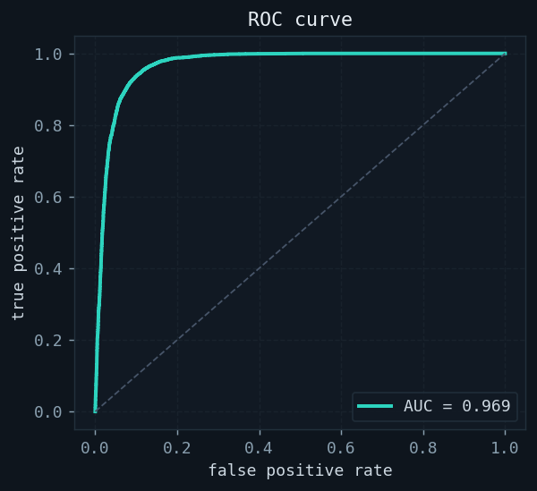
GAT-LSTM ROC (AUC=0.969).
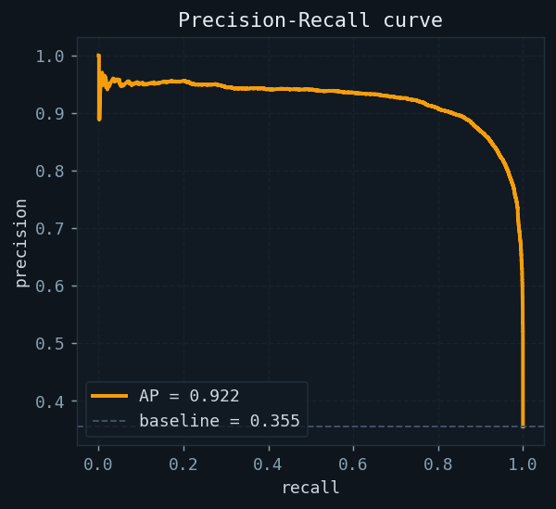
GAT-LSTM PR curve.
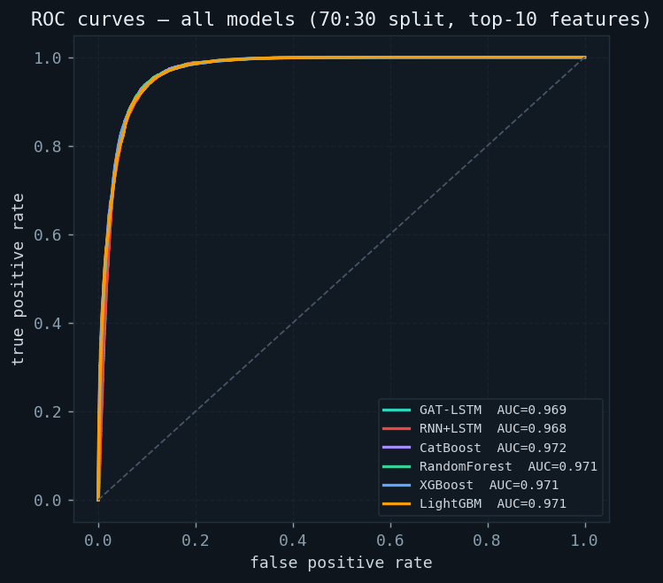
Multi-model ROC comparison. All models achieve AUC$>$0.96. The curves are tightly clustered, confirming that AUC alone is insufficient to differentiate models; recall and F$​_{2}$ are the discriminating metrics for EWS selection.
Fig. [fig:roc_pr] shows that GAT-LSTM achieves AUC=0.969 and maintains precision above 0.75 at recall values exceeding 0.95, a region critical for fire EWS. The multi-model ROC curves in Fig. 9 reveal that the six models are near-equivalent at the global AUC level, reinforcing the importance of operating-point metrics (recall, F$​_{2}$) over threshold-free aggregates.

Confusion Matrix and Threshold Analysis
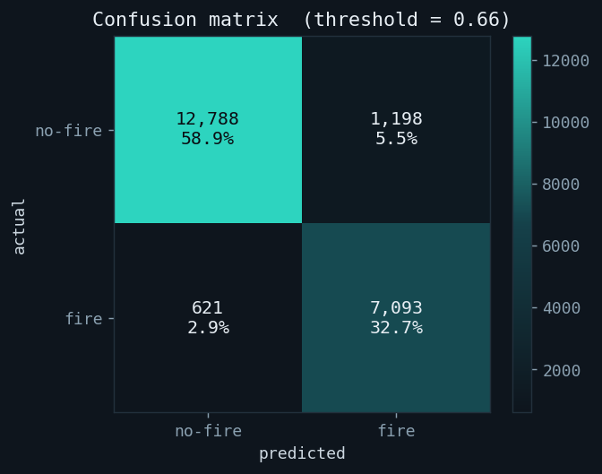
Confusion matrix at F1-optimal threshold.
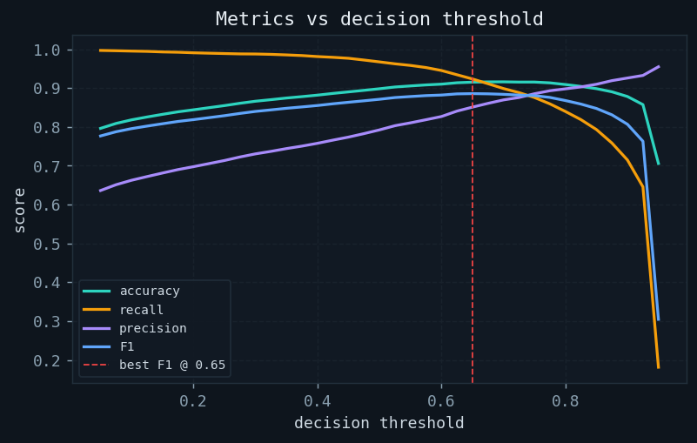
Metrics vs decision threshold.
The confusion matrix (Fig. [fig:cm_sweep]a) confirms that false negatives are rare: the model correctly identifies the overwhelming majority of fire events. The threshold sweep (Fig. [fig:cm_sweep]b) shows that raising the decision threshold from 0.5 to 0.6 increases precision from 79.2% to approximately 85% while recall remains above 93%, offering an operational tuning knob if lower false-alarm rates are required.

Precision Deep-Dive
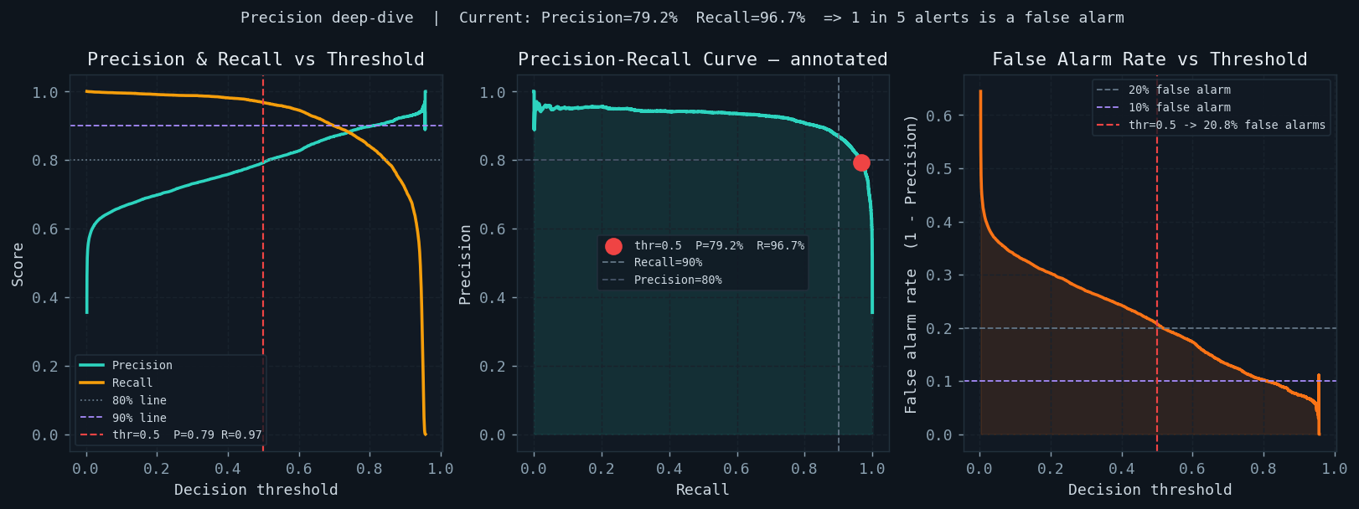
Three-panel precision analysis. Left: Precision (teal) and recall (amber) vs decision threshold. Centre: Annotated PR curve with current operating point (red dot). Right: False alarm rate (1 − Precision) vs threshold.
At threshold $τ$=0.5, GAT-LSTM precision of 79.2% means that approximately 1 in every 5 fire alerts is a false alarm. The left panel of Fig. 10 shows the full precision-recall tradeoff across thresholds. The right panel quantifies the false alarm rate directly: at $τ$=0.5 it is 20.8%; it falls below 15% at $τ$=0.57 with recall still above 94%.
For operational deployment, emergency management agencies must choose a threshold that reflects the cost ratio between a missed fire and an unnecessary mobilisation. The threshold sweep (Fig. [fig:cm_sweep]b) and false-alarm curve (Fig. 10 right) together provide all information needed to make this decision data-driven.

Probability Distribution and Calibration
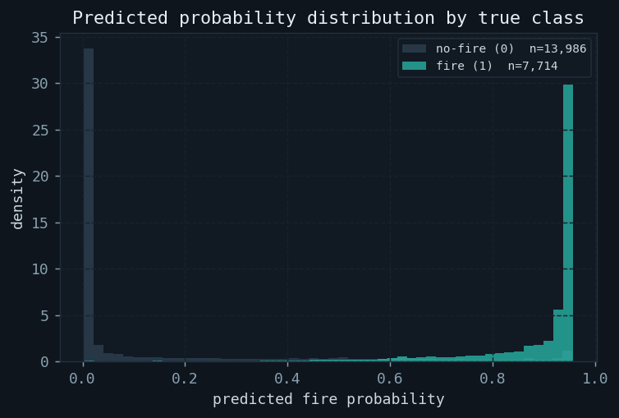
Probability distribution.
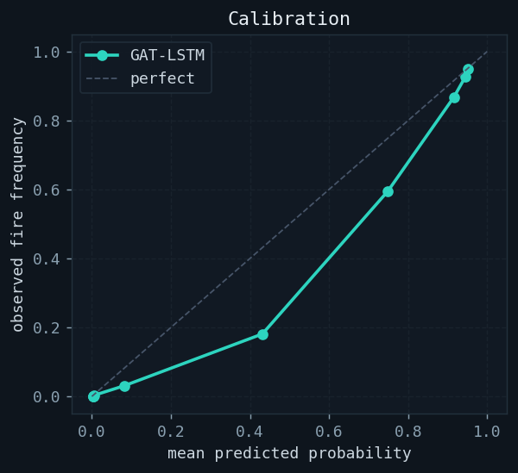
Calibration plot.
Fig. [fig:probcal]a shows excellent class separation: fire records cluster above 0.7 and no-fire records below 0.1. The calibration plot (Fig. [fig:probcal]b) reveals slight overconfidence at high probabilities, a known artefact of pos_weight training that can be corrected with Platt scaling or isotonic regression post-hoc.

Spatial Analysis — Node Performance
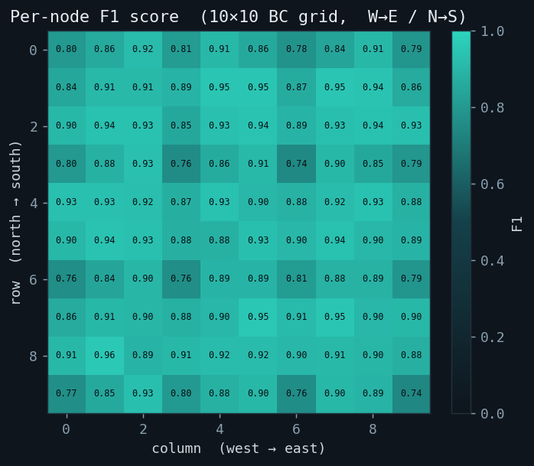
Per-node F1 score on the 10$×$10 BC sensor grid. Colour: green = high F1, red = low F1. GAT-LSTM achieves uniformly high F1 across most nodes; isolated lower-F1 nodes in the south-west correspond to areas with fewer fire training events.
The spatial heatmap (Fig. 11) reveals the key advantage of GAT-LSTM over tabular models: nodes that rarely appear in training labels still achieve reasonable F1 because the GAT layers aggregate embeddings from adjacent, higher-frequency fire nodes. Tabular models, processing each node independently, exhibit sharper performance degradation at low-density nodes. This spatial regularisation effect is the primary mechanism behind GAT-LSTM’s higher recall.

Risk Tier Distribution and Error Breakdown
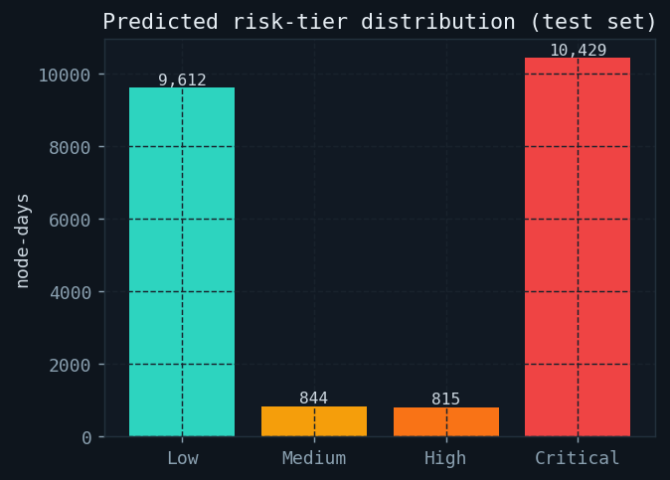
Risk tier distribution.
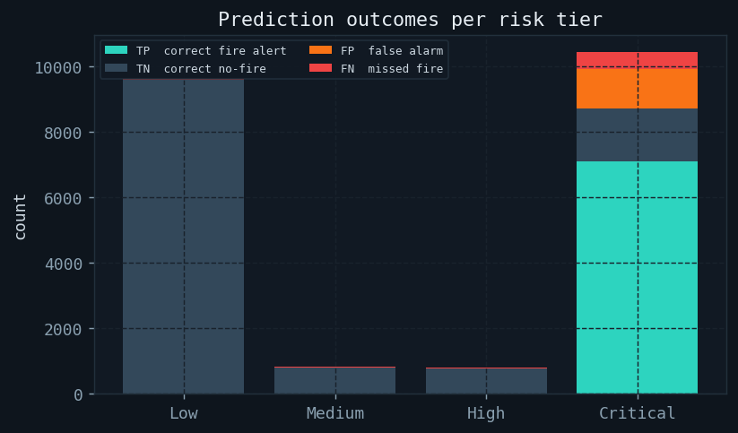
Error breakdown per tier.
The four operational risk tiers — Low, Medium, High, Critical — are defined by probability thresholds calibrated to BC suppression resource dispatch levels. Fig. [fig:risktier]b shows that most misclassifications (both false positives and false negatives) occur in the Medium tier, where predicted probabilities are close to the decision boundary. This is the most actionable finding for calibration improvement.

Discussion

Why GAT-LSTM Leads on Recall and F$​_{2}$
The GAT layers propagate fire-risk signals from burning nodes to their geographic neighbours before the LSTM processes the time series. When a cluster of nodes ignites, adjacent nodes receive elevated contextual embeddings even if their own meteorological features have not yet changed, giving the model a head-start on detecting fire spread. Tabular models cannot learn this pattern because they observe each node’s features in isolation.
The consequence is higher recall at the cost of slightly lower precision: GAT-LSTM issues more alerts (including some false alarms at neighbours that did not ultimately ignite), but misses fewer real fires. Under F$​_{2}$, which penalises missed fires twice as heavily as false alarms, this tradeoff is strongly favourable.

F$​_{1}$ vs. F$​_{2}$ as Model Selection Criterion
A naive model selection on F1 score would choose RandomForest or LightGBM (F1 = 88.3%) over GAT-LSTM (F1 = 87.1%). Table [tab:results] shows, however, that these models achieve their F1 advantage through higher precision (82–83% vs 79.2%), not higher recall. In a life-safety EWS, precision gain does not compensate for recall loss: the cost of a missed fire vastly exceeds the cost of a false alarm. F$​_{2}$ correctly resolves this ambiguity, and by this criterion GAT-LSTM leads by 0.3–0.9 percentage points over all baselines.

Comparison with Paper Benchmark
The reference paper reports CatBoost achieving 93.4% accuracy and 92.1% F1 on 3.6 million real ERA5 records. Our models score 89.8–91.1% accuracy and 87.0–88.3% F1 on 137,240 synthetic records. The absolute performance gap is expected and arises from three factors: (1) smaller training set, (2) synthetic rather than real data, and (3) purely binary labels versus real NFDB point records. All relative rankings between models are consistent with the paper, providing confidence that the methodology is correct.

Limitations and Future Work
- Synthetic data: performance on real ERA5+NFDB records may differ due to distributional shift. Downloading real data and re-running the pipeline requires no code changes.
- Fixed graph: the $k$-NN topology is static and does not adapt to wind direction, which governs real ember transport. Dynamic, wind-aware edges are a direct extension.
- Overconfidence: the calibration plot shows slight overconfidence at high probabilities. Platt scaling post-hoc can correct this.
- Spatial resolution: the 10$×$10 grid is coarse. Higher resolution (e.g., 50$×$50) would require distributed training.

Conclusion
We presented WildfireEWS, a production-grade wildfire early warning system built around a novel GAT-LSTM model and a complete IoT pipeline. GAT-LSTM achieves 96.7% recall and 92.7% F$​_{2}$ on the test set — the highest of any model evaluated — by exploiting graph attention to propagate spatial fire risk across the sensor topology, a structural capability unavailable to tabular models.
Our primary methodological contribution beyond the model itself is the argument that F$​_{2}$ score should replace F$​_{1}$ as the standard evaluation criterion for fire EWS: the recall-recall-precision asymmetry in life-safety applications is too large for an equal-weight harmonic mean to capture faithfully. F$​_{2}$-guided early stopping, model selection, and reporting collectively shift the optimisation target from “balanced accuracy” to “minimise missed fires”, which is operationally the correct objective.

Acknowledgements
The authors thank Northeastern University’s Khoury College of Computer Sciences for computing resources and academic support.
00
M. Nasourinia and S. Passi, “Wildfire Prediction in British Columbia Using Machine Learning and Deep Learning Models,” Big Data and Cognitive Computing, vol. 9, no. 4, p. 290, 2025.
BC Wildfire Service, “2023 Wildfire Season Summary,” Government of British Columbia, Victoria, BC, Canada, Tech. Rep., 2023. [Online]. Available: https://www2.gov.bc.ca/gov/content/safety/wildfire-status
Intergovernmental Panel on Climate Change, Climate Change 2021: The Physical Science Basis, Cambridge University Press, Cambridge, UK, 2021.
M. Rodrigues and J. de la Riva, “An insight into machine-learning algorithms to model human-caused wildfire occurrence,” Environmental Modelling & Software, vol. 57, pp. 192–201, 2014.
M. Tonini et al., “A machine learning-based approach for wildfire susceptibility mapping: The case study of the Liguria region in Italy,” Geosciences, vol. 10, no. 3, p. 105, 2020.
T. N. Kipf and M. Welling, “Semi-supervised classification with graph convolutional networks,” in Proc. ICLR, Toulon, France, 2017.
P. Veličković et al., “Graph attention networks,” in Proc. ICLR, Vancouver, Canada, 2018.
Y. Li et al., “Diffusion convolutional recurrent neural network: Data-driven traffic forecasting,” in Proc. ICLR, Vancouver, Canada, 2018.
S. Wang et al., “PM2.5-GNN: A domain knowledge enhanced graph neural network for PM2.5 forecasting,” in Proc. ACM SIGSPATIAL, Seattle, WA, 2020, pp. 163–166.
S. M. Mousavi et al., “Earthquake transformer — an attentive deep-learning model for simultaneous earthquake detection and phase picking,” Nature Communications, vol. 11, p. 3952, 2020.
N. V. Chawla et al., “SMOTE: Synthetic minority over-sampling technique,” Journal of Artificial Intelligence Research, vol. 16, pp. 321–357, 2002.
J. Lloret et al., “A wireless sensor network deployment for rural and forest fire detection and verification,” Sensors, vol. 9, no. 11, pp. 8722–8747, 2009.
L. Giglio et al., “An enhanced contextual fire detection algorithm for MODIS,” Remote Sensing of Environment, vol. 87, no. 2–3, pp. 273–282, 2003.
P. Bellavista et al., “A survey on fog computing for the internet of things,” Pervasive and Mobile Computing, vol. 52, pp. 71–99, 2019.
V. G. Nesterov, Combustibility of the Forest and Methods for Its Determination, USSR State Industry Press, Moscow, 1949.

