Assignment 3:

Design application for sale during Diwali Festival

Sample output :

# Root page: index.html

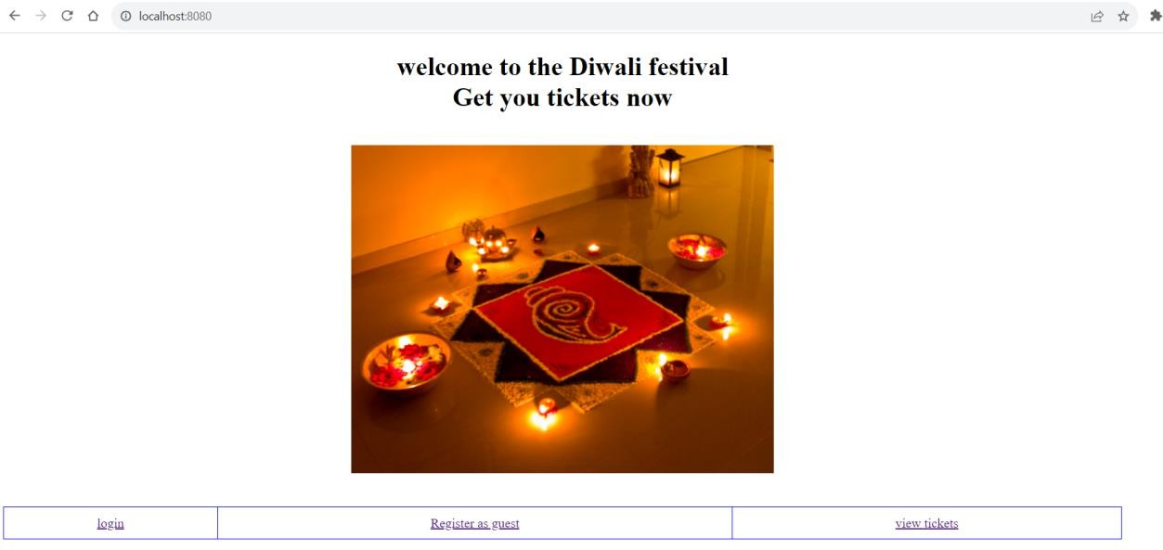

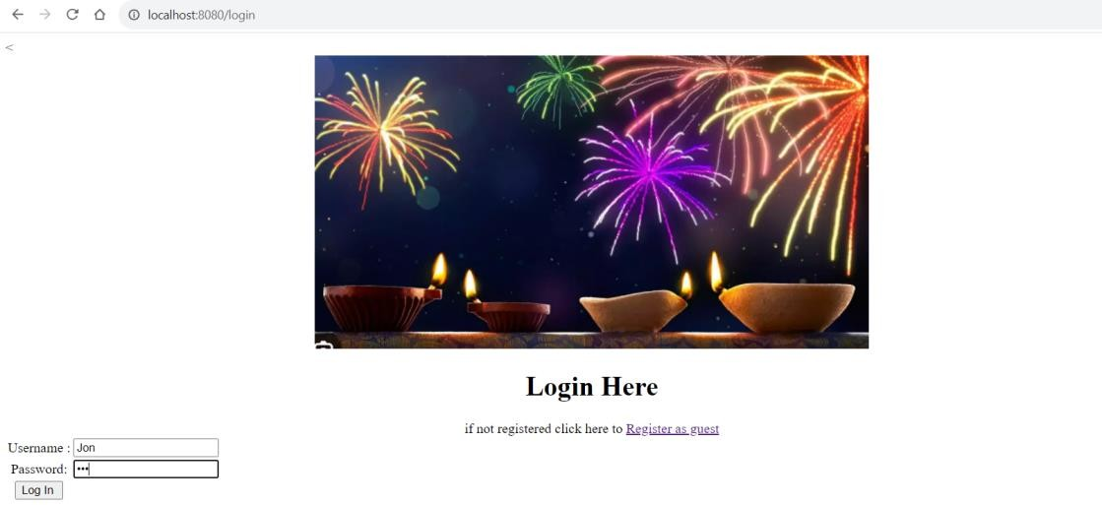I am logging as Jon**(login Page)**

**Add page** : it has dropdown for select with guest name in ascending order.

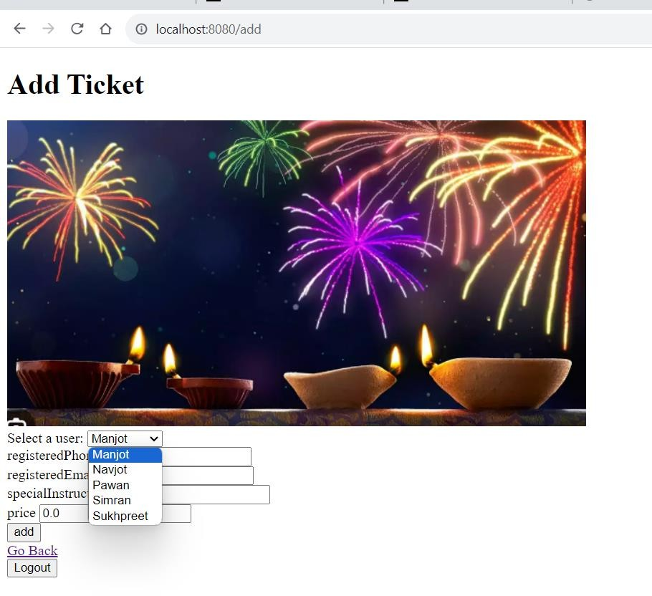

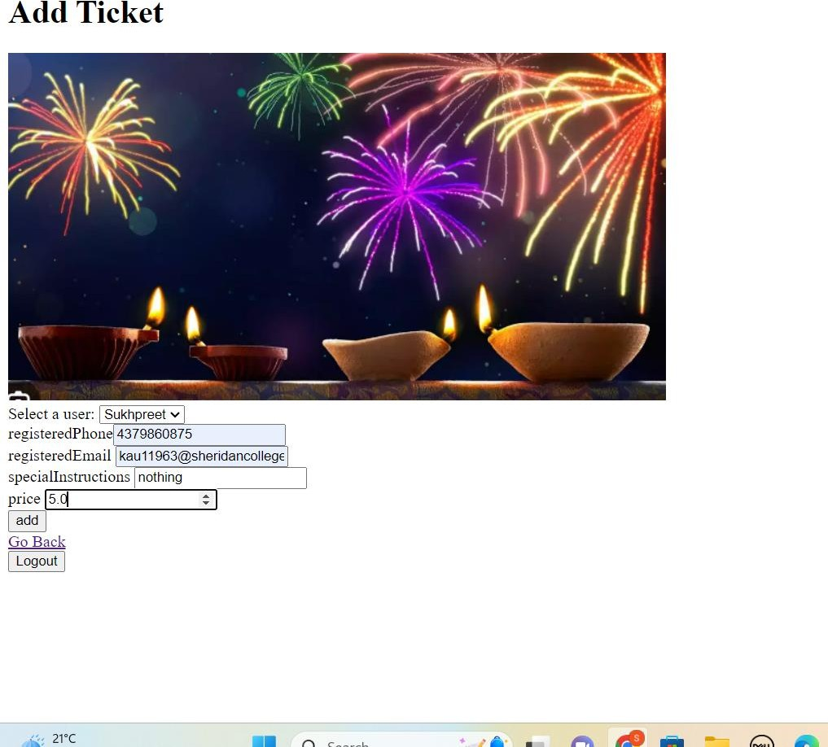

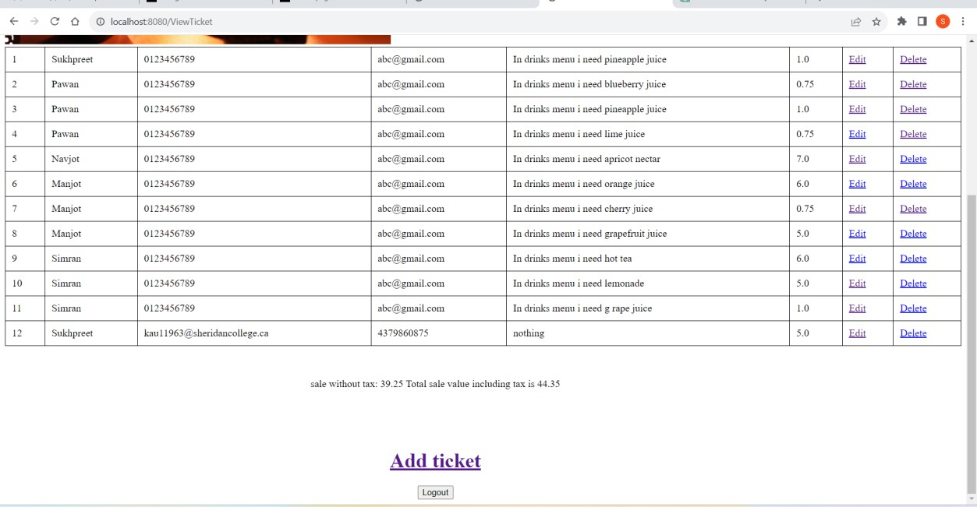Record got added at last place

# A screenshot of a video Description automatically generatedViewing tickets as vendor As Jon was vender

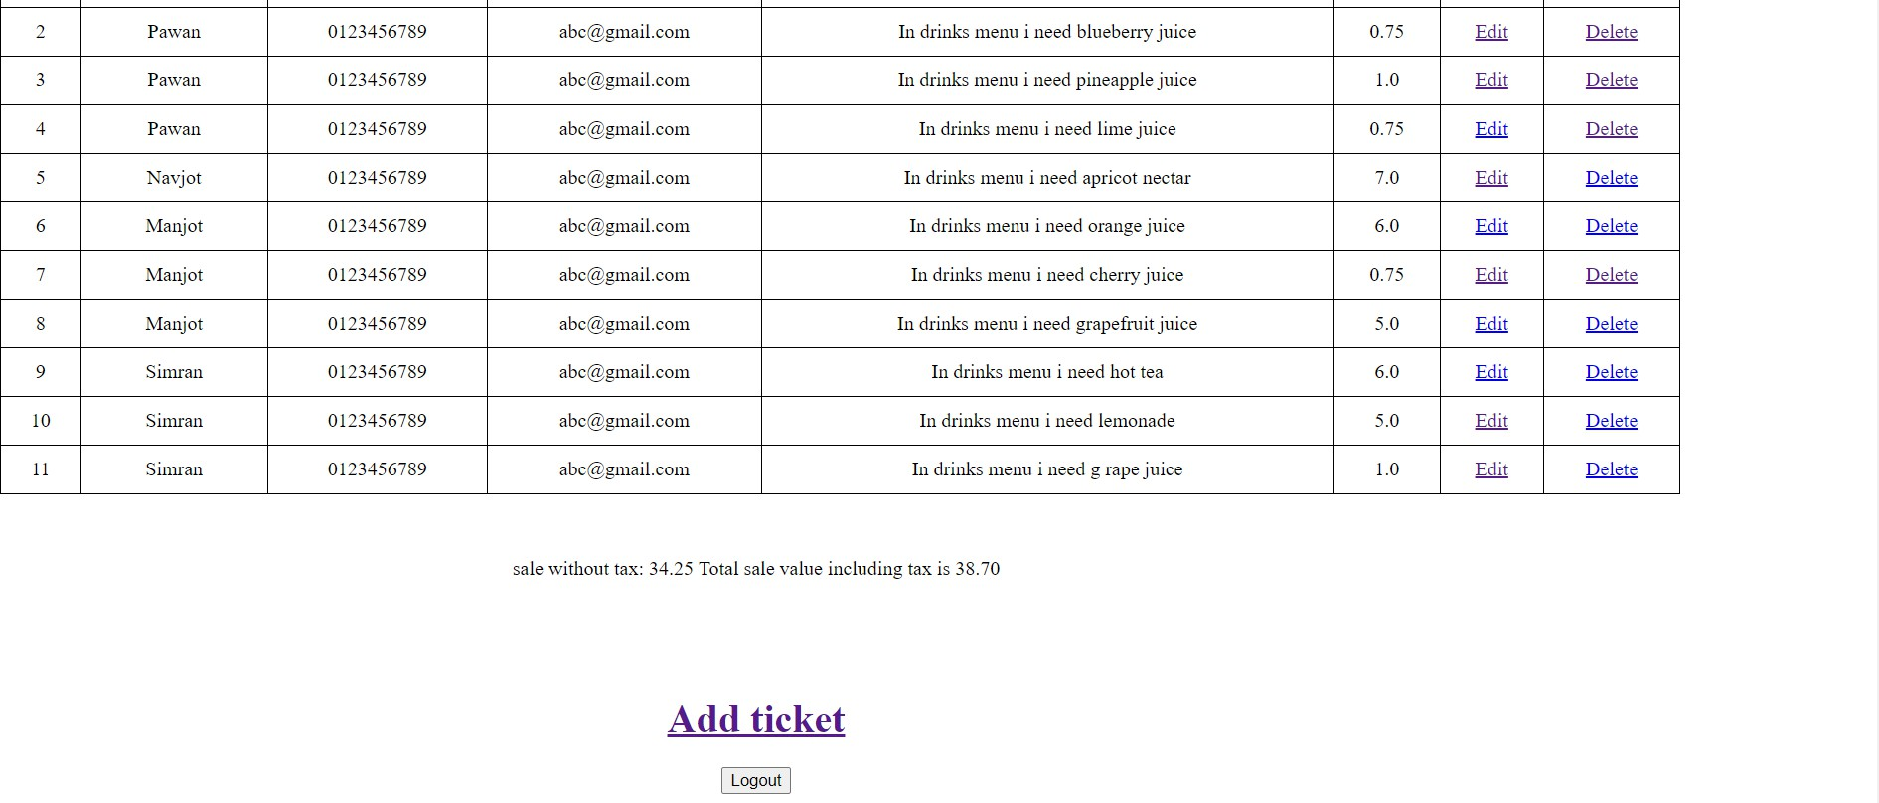

Total sale value is shown in two decimal places and after including tax as well

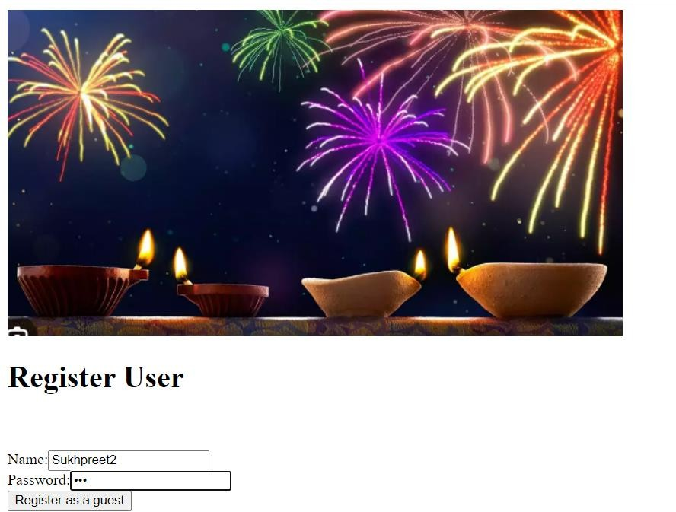Now registering as guest with username Sukhpreet2

Once I successfully registered I am returned back to the homepage.

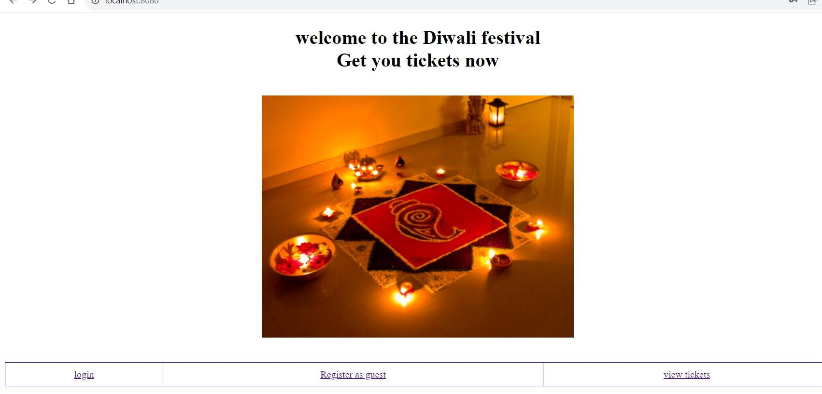

Then I have to login in order to view tickets.

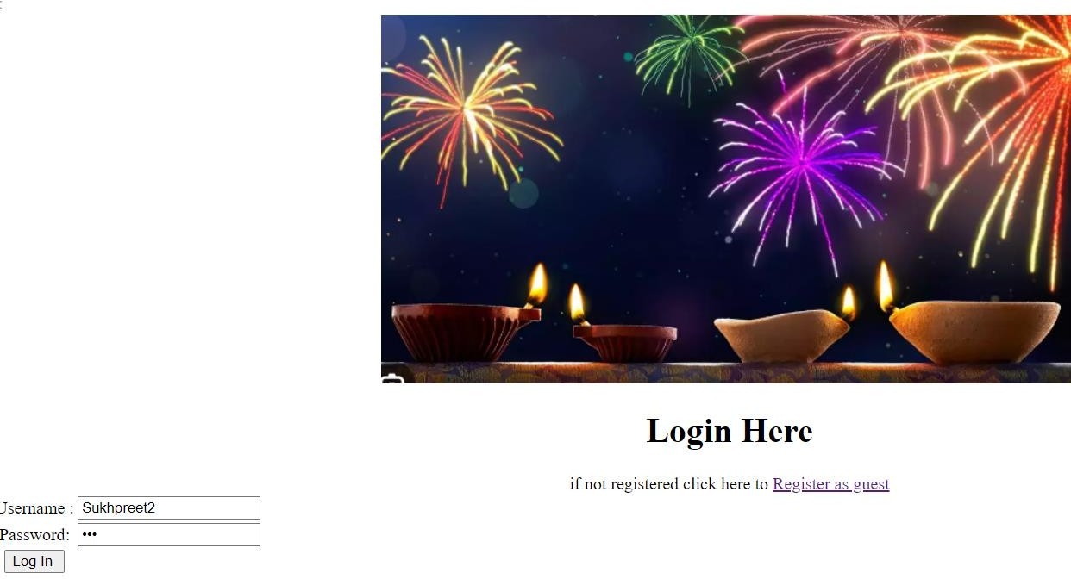

As Sukhpreet2 is just newly registered user then

Sukhpreet2 do not have any tickets so this page will be returned.

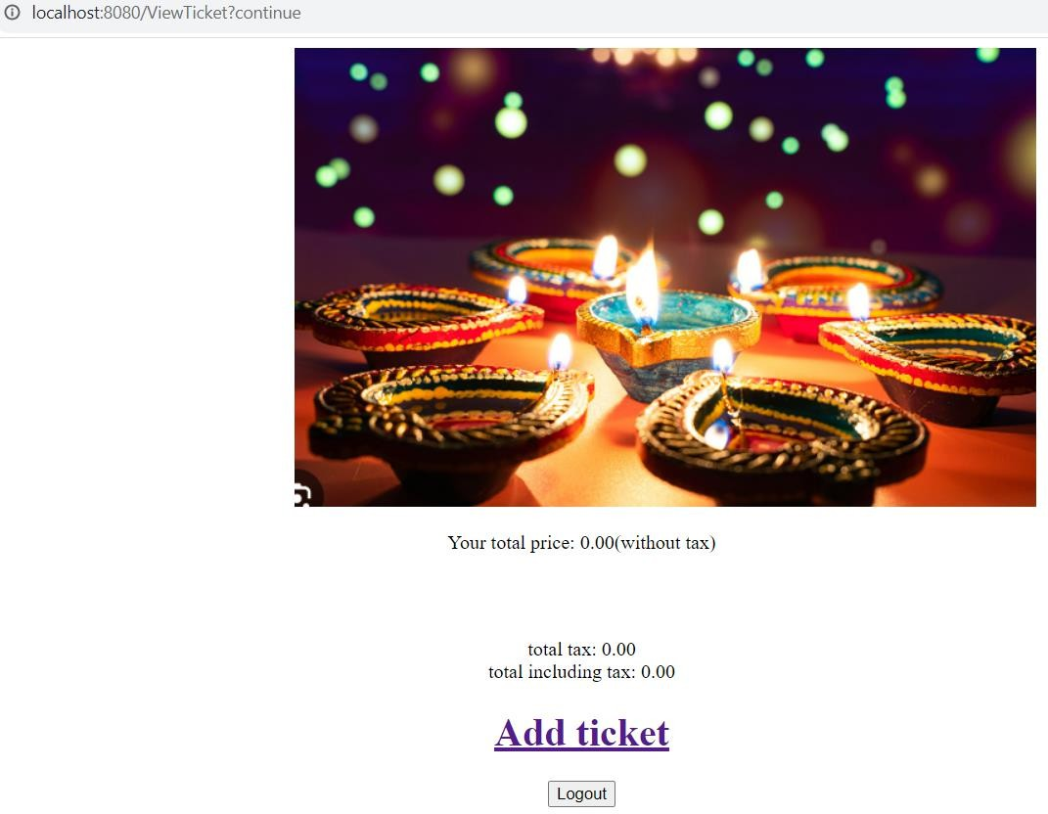

# A screenshot of a computer Description automatically generatedViewing tickets as Guest i.e. Sukhpreet

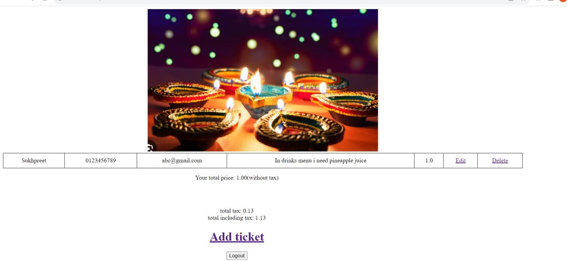

Sale value and the tax is shown upto 2 decimal places.

But if after login as Sukhpreet”(guest user) I will try to add ticket:

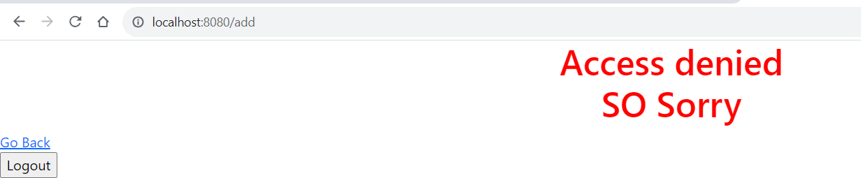

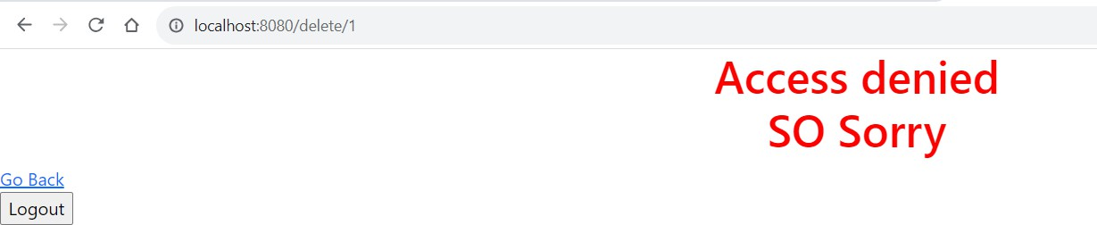Delete ticket:

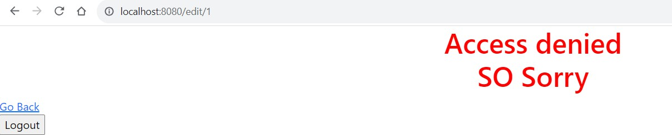Edit ticket:

# Editing a ticket as a Vender:

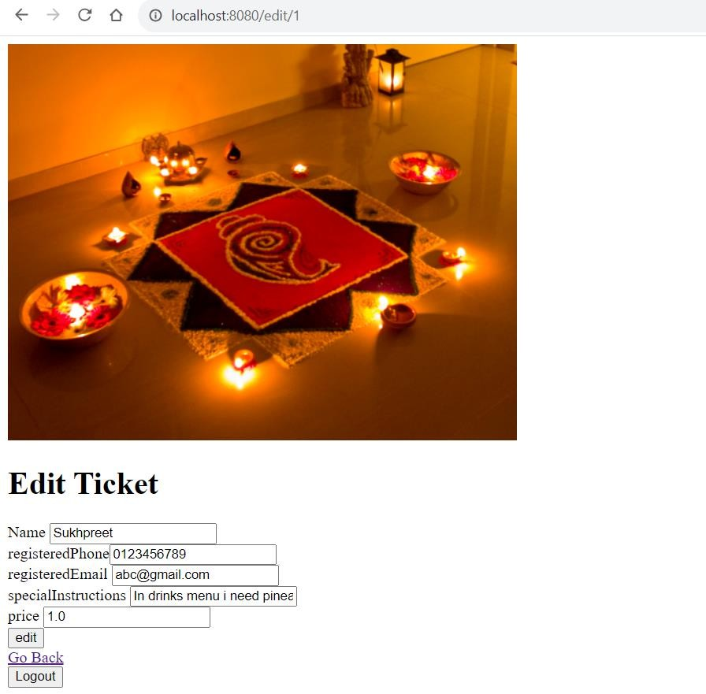

“Jon” is going to edit phone number of above ticket to 1234567890

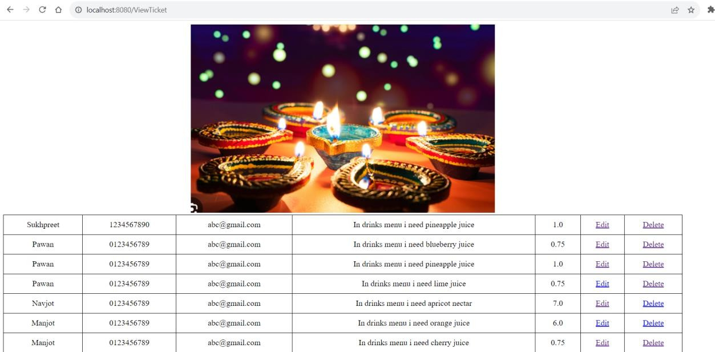

As we can see here the data of 1st ticket is changed

# Delete a ticket as Vender:

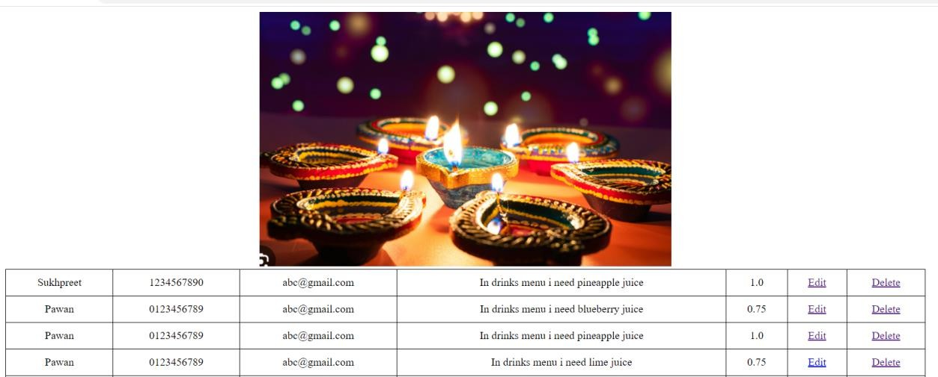“Jon” is going to delete 1st ticket:

After deleting 1st ticket:

