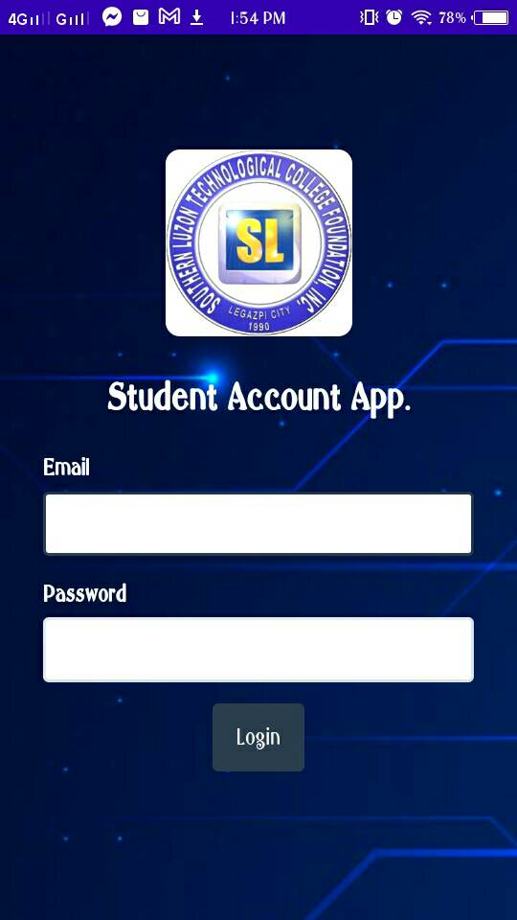

W/o white background po. Send po kami png ng SL logo thru email nalang po siguro para di low quality ng image (?)



|  |  |  |  |  |  |  |
| --- | --- | --- | --- | --- | --- | --- |
| **School Year** | | | | | | |
| **2022-2023** | | | | | | |
| **Semester** | **Total Fee** | **Amount Paid** | **Date of Payment** | **OR** | **Balance** | **STATUS** |
|
| 1st | 12,000 | 5,000 | 12-10-2022 | 12345 | 7,000 | **PAID** |
| 2nd | 12,000 |  |  |  |  | UNPAID |

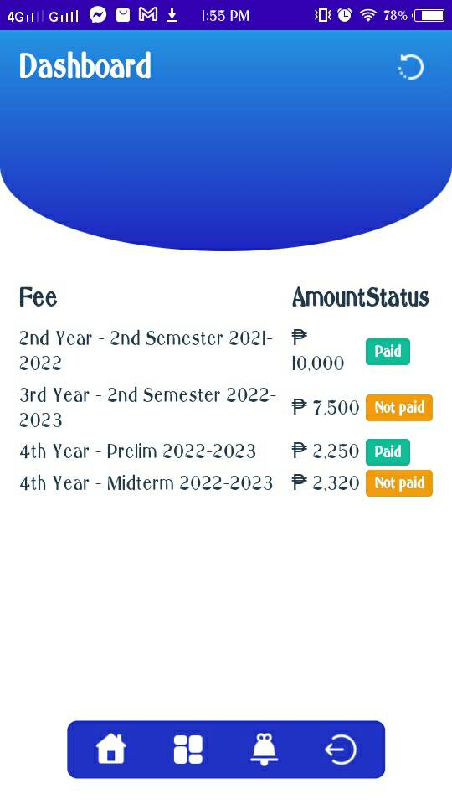



Eto po yung SOA format

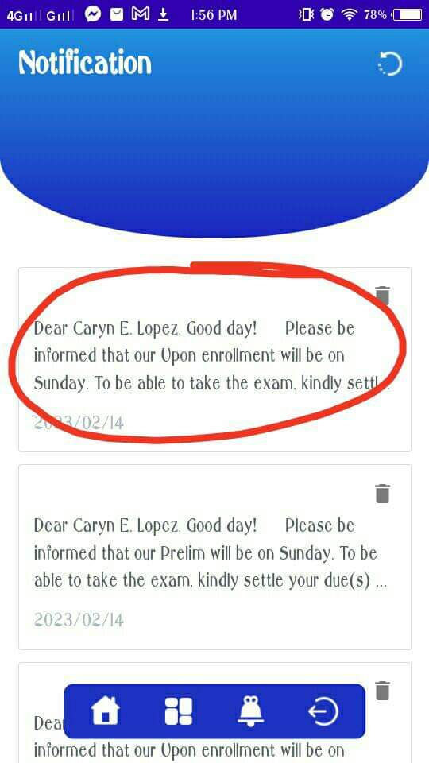

Pwede po ba ito sir ma-open pag ni-click? And may suggestion/reco. Lang po kasi acc. na kung pwede din daw po ba na may function na pwedeng mag-comment or message yung student thru that app regarding sa payments then magnonotify din po sa Websystem and mababasa din ng Acc./admin (?)

