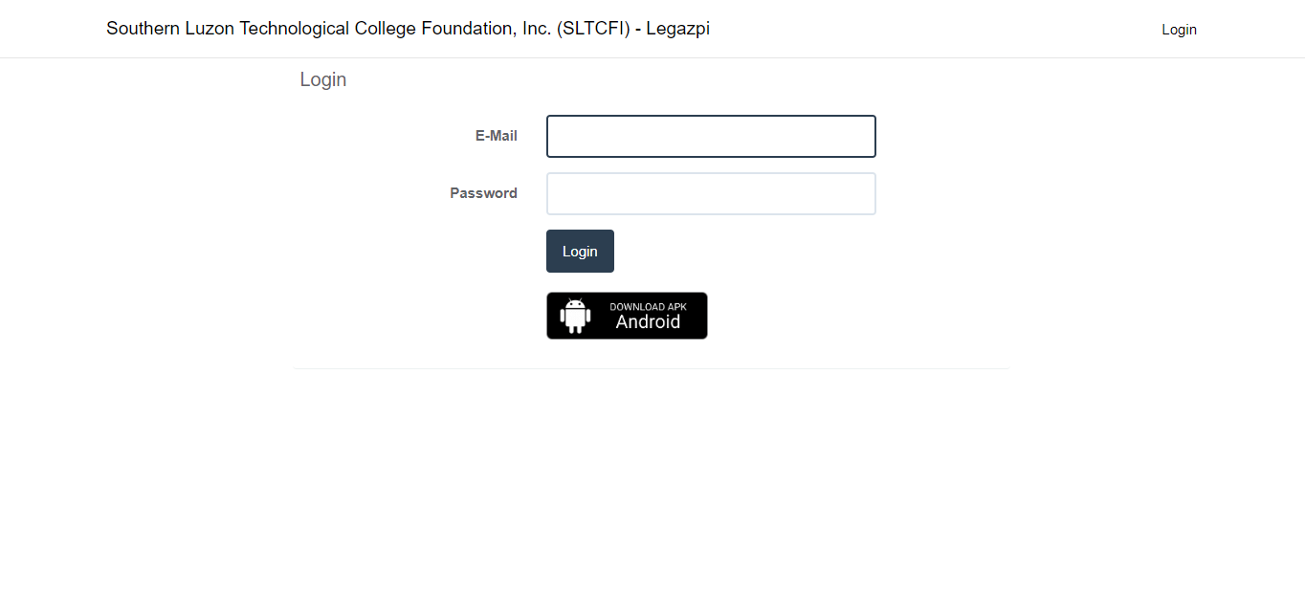

Click here to download

**SL Accounting App**



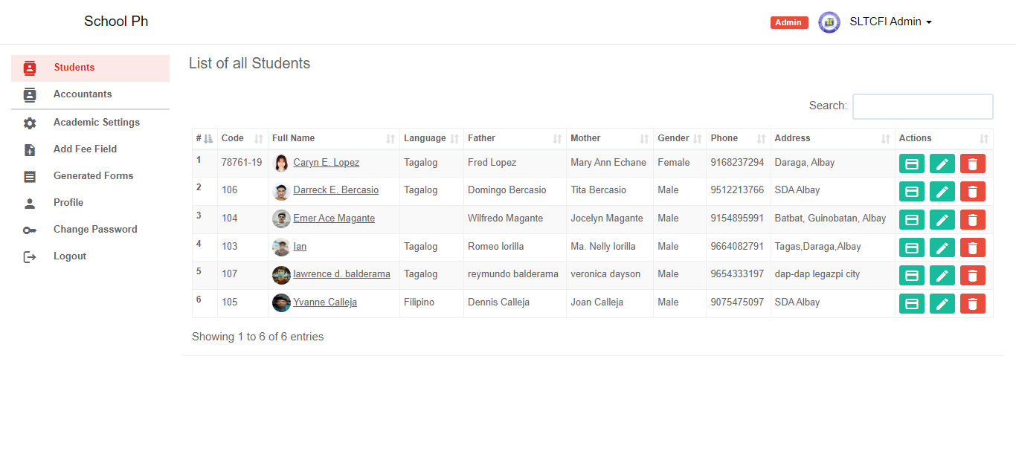



**ID No.**



No underline / kahit no pic na po



**COURSE & YEAR**

DROPDOWN LIST (PER COURSE/YEAR)



**SLTCFI - LEGAZPI**



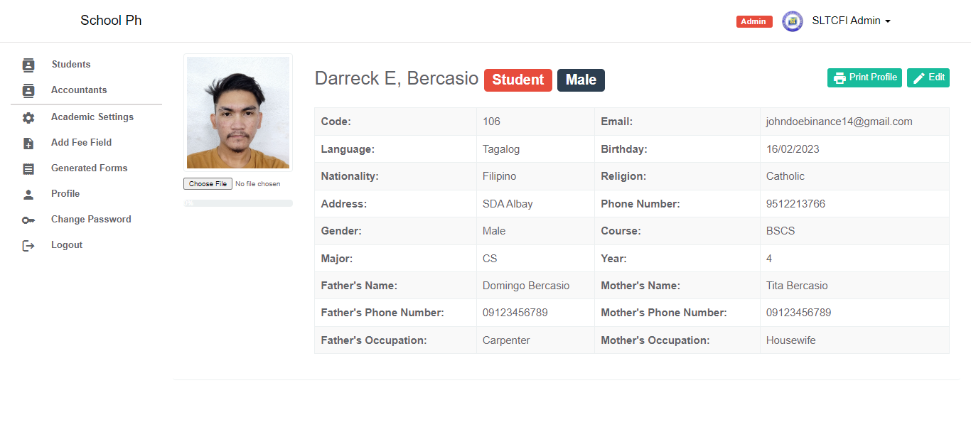

COURSE / YEAR



FORMAT

**ID No.:**

**Major:**

**Email Add.:**

**Mobile No.:**

**Address:**

**ID No.:**



**STATEMENT OF ACCOUNT (format by Acc.)**

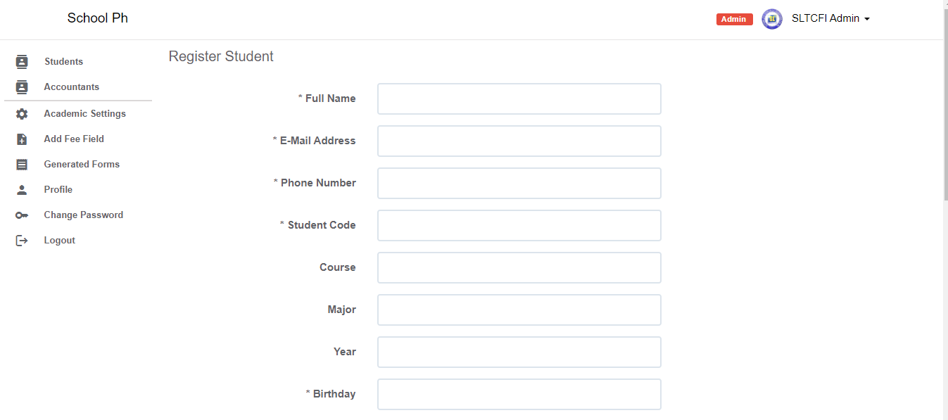



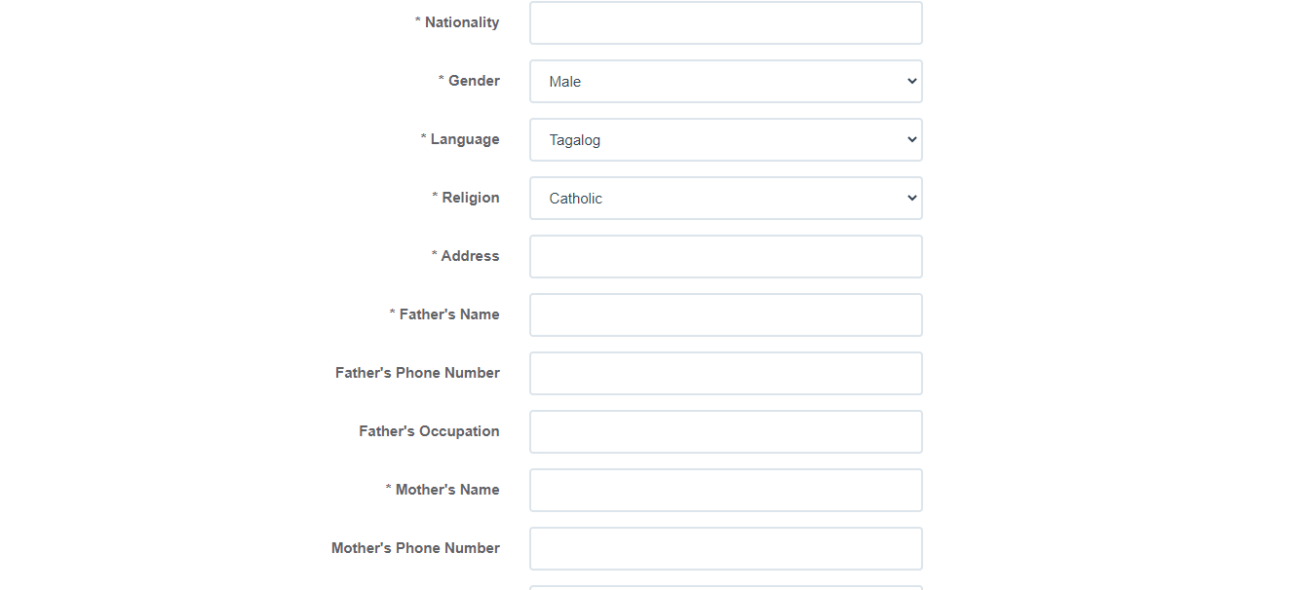







Then ito po na Balance list, pwede po ba sa baba or ka-dugtong ng student info. (?) Diyan po sa may nakalagay na Statement of Account.

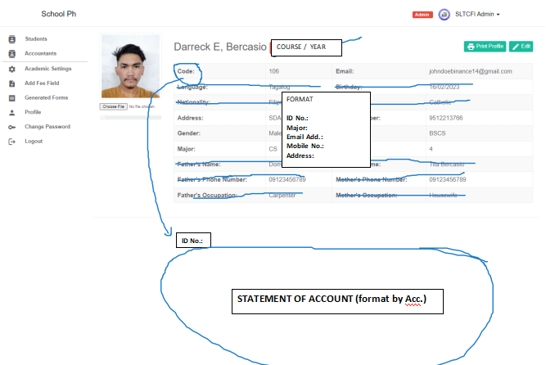

**SOA - FORMAT**

Dropdown list of A.Y



|  |  |  |  |  |  |  |
| --- | --- | --- | --- | --- | --- | --- |
| **School Year** | **Semester** | **Amount** | **Balance** | **Date of Payment** | **OR** | **STATUS** |
|
| 2020-2021 | 1st | 12,000 | 7,000 | 10-10-2020 | 12345 | **PAID** |
| 2nd | 12,000 | 5,000 |  |  | UNPAID |



IF yung nandito po sa STATUS ay naka “PAID” na lahat

**UNPAID**

**UNPAID**

**PAID**

**PAID**

**PAID**

**UNPAID**



Jan po magrereflect kung paid na or unpaid

