HIGHER DIPLOMA IN INFORMATION TECHNOLOGY (HDIT)
HDIT 21132 — Emerging Technologies
Integrated Simulation Project (Individual)
SMART HOSPITAL
An Integrated Emerging Technologies Solution Using IoT, Virtual Reality (VR) and Augmented Reality (AR)
Submitted by
Miss. Junaideen Risny Suha
Student ID: 03241035
Module Code: HDIT 21132
Submission Date: 30 July 2026

Table of Contents
Chapter 1 – Introduction3
1.1 Problem Background3
1.2 Problem Statement3
1.3 Objectives3
1.4 Scope3
Chapter 2 – Proposed Solution5
2.1 System Overview5
2.2 Technologies Used5
Chapter 3 – IoT Simulation6
3.1 Design6
3.2 Devices Used6
3.3 Configurations6
3.4 Screenshots7
Chapter 4 – VR Simulation8
4.1 Environment Design8
4.2 Interactive Elements8
4.3 Screenshots8
Chapter 5 – AR Simulation11
5.1 AR Design11
5.2 User Interactions11
5.3 Publishing and Testing11
5.4 Screenshots12
Chapter 6 – Integration15
6.1 How IoT, VR and AR Work Together15
6.2 Benefits of the Proposed Solution15
Chapter 7 – Conclusion16
7.1 Challenges16
7.2 Conclusion16

Chapter 1 – Introduction

1.1 Problem Background
Hospital patient wards depend on continuous, accurate monitoring of both patient wellbeing and the physical environment around them. Ward temperature and humidity affect patient comfort and recovery, while hazards such as smoke or fire require an immediate response. In many wards this monitoring is still done manually — nurses and doctors physically check rooms, read thermometers, and respond to alarms only after noticing them. This creates a gap between the moment a condition becomes unsafe and the moment staff actually respond to it.
At the same time, hospitals regularly bring in new staff, students, and visitors who are unfamiliar with the layout of a ward and the purpose of the equipment inside it. Without a quick way to learn what a piece of equipment does or where a facility is located, staff lose time asking colleagues or searching paper documentation, which is inefficient in a fast-paced clinical environment.
Emerging technologies — the Internet of Things (IoT), Virtual Reality (VR) and Augmented Reality (AR) — offer a way to close both gaps: IoT can sense and react to ward conditions automatically, VR can let staff safely explore and learn a ward before ever entering it, and AR can put the same contextual information directly in front of a user, on their own device, at the point of need.

1.2 Problem Statement
Patient wards that rely on manual observation for environmental monitoring and emergency response are slower to react to unsafe conditions than an automated system would be, and staff, students and visitors have no fast, in-context way to identify ward equipment and facilities without prior training or assistance. This project addresses both problems by simulating a connected, explorable, and information-rich “Smart Hospital” ward.

1.3 Objectives
- To design and simulate an IoT-based patient room monitoring and automation network in Cisco Packet Tracer, using temperature/humidity and smoke sensors to automatically control a fan, light and emergency siren.
- To build an interactive Virtual Reality walkthrough of a smart hospital ward in Delightex EDU, so that staff or students can explore the ward and learn the purpose of each asset before working on site.
- To develop a WebAR experience in MyWebAR that lets a user view the same ward in augmented reality and tap on furniture and equipment to instantly see contextual information.
- To demonstrate how IoT, VR and AR can be integrated around a single Smart Hospital scenario to improve patient safety, staff efficiency and staff training.

1.4 Scope
The project is a proof-of-concept limited to a single patient ward area consisting of two patient bed sections, a reception and waiting area, and an attached washroom. The IoT component is simulated entirely within Cisco Packet Tracer and is not deployed on physical hardware. The VR component is built as a browser-based walkthrough in Delightex EDU. The AR component is delivered as a WebAR experience through MyWebAR, accessible via a shareable link and QR code without requiring a dedicated mobile application. The simulation does not connect to a real hospital information system or electronic health record.

Chapter 2 – Proposed Solution

2.1 System Overview
The proposed solution, Smart Hospital, integrates three emerging technologies around one shared patient-ward scenario:
- IoT layer: senses room conditions (temperature, humidity, smoke) and automatically controls safety and comfort devices (siren, fan, light) through a central gateway, without waiting for a staff member to notice a problem.
- VR layer: gives staff and students an interactive 3D walkthrough of the ward, with clickable hotspots on every major asset that describe what it is and how it is used — used for orientation and training.
- AR layer: lets a user view the same ward through a phone camera or browser and tap on any piece of furniture or equipment to instantly see the same contextual information, at the point of need, without needing to consult a manual or a colleague.
Because all three layers are built around the same ward and the same set of assets (beds, patient monitors, fire extinguishers, the emergency siren, the air-conditioning/fan, and the reception area), a user experiences one consistent Smart Hospital story whether they are looking at the sensor network, walking through the VR ward, or scanning objects in AR.

2.2 Technologies Used
Technology | Tool | Role in the solution
IoT | Cisco Packet Tracer | Simulates the sensor/actuator network, the central gateway, and the monitoring terminal.
VR | Delightex EDU | No-code, browser-based 3D scene builder used to construct the explorable hospital ward.
AR | MyWebAR (DEVAR CoBlocks) | WebAR builder with block-based event scripting used to make ward objects tap-to-inform in AR.

Chapter 3 – IoT Simulation

3.1 Design
The IoT network was built in Cisco Packet Tracer as a star topology. A DLC-100 Home Gateway sits at the centre of the network and connects wirelessly to every sensor and actuator placed in the simulated patient room, as well as to a laptop used as the monitoring and administration terminal. This mirrors how a real ward gateway would aggregate readings from several bedside and room sensors and expose them to a single monitoring point.

3.2 Devices Used
The network satisfies the assignment's minimum requirements of at least five IoT devices, at least two sensors, dashboard/monitoring functionality, and network connectivity between devices:
Device | Type | Function
DLC100 Home Gateway | Hub / Controller | Central point that connects and coordinates every device on the ward network.
Patient Room Temperature & Humidity Sensor | Sensor | Reports ambient temperature and humidity readings from the patient room.
Patient Room Smoke Detector | Sensor | Detects smoke as an early warning for fire hazards.
Hospital Emergency Siren | Actuator | Sounds an audible alarm to alert staff during an emergency.
Patient Room Smart Light | Actuator | Provides remotely/automatically controlled room lighting.
Patient Room Smart Fan | Actuator | Provides remotely/automatically controlled air circulation.
Laptop-PT | Monitoring terminal | Runs the IoT Monitor application used to view and manage the network.

3.3 Configurations
The monitoring laptop was configured with the IoT Monitor desktop application, authenticating to the Home Gateway using the IoT server address 192.168.25.1 with an administrator login. This lets ward staff view live sensor readings and the status of every connected actuator from a single terminal, rather than checking each device physically.
An automation rule links the safety sensors to the actuators so the ward can react without a staff member being present: the Patient Room Smoke Detector is tied to the Hospital Emergency Siren, so smoke automatically triggers the alarm, and the temperature/humidity sensor readings inform when the Smart Fan and Smart Light should switch on, keeping the room within a comfortable range for the patient.

3.4 Screenshots
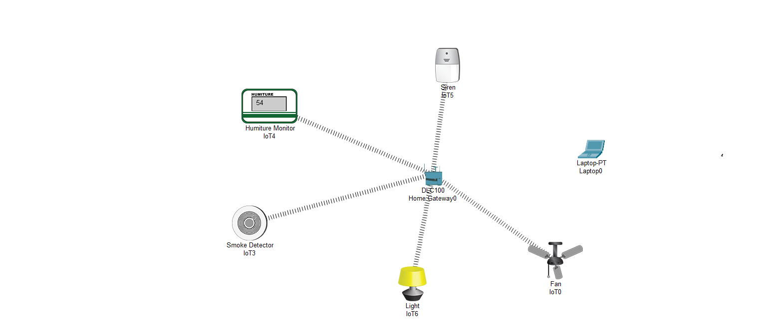
Figure 3.1 — Initial IoT network topology in Cisco Packet Tracer, connecting sensors and actuators to the Home Gateway.
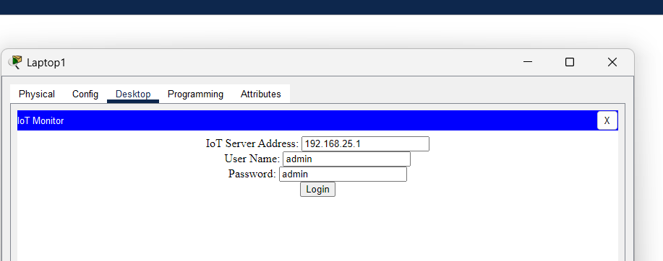
Figure 3.2 — IoT Monitor application on the monitoring laptop, authenticating to the gateway at 192.168.25.1.
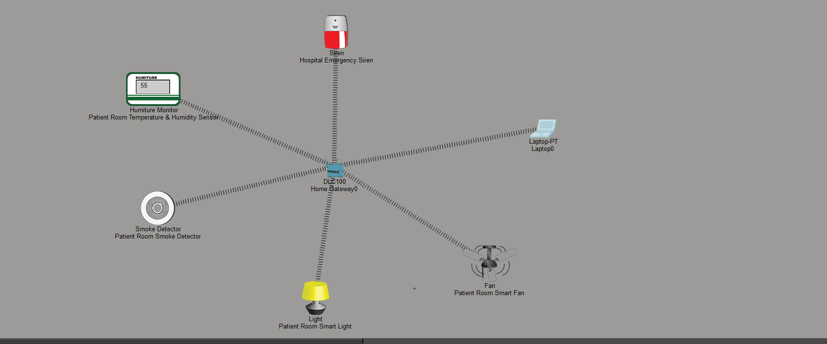
Figure 3.3 — Final labelled IoT topology showing each sensor and actuator's role in the patient room.

Chapter 4 – VR Simulation

4.1 Environment Design
The VR ward was built in Delightex EDU as a top-down, walkable 3D environment set within a small city block. The ward contains two patient bed sections (each with a bed, a patient figure, a doctor or nurse, and a Patient Record Monitor), a reception and waiting area (a receptionist, a visitor figure, and three separate waiting areas with seating), and an attached washroom (toilet, sink and bathtub). Objects were placed and labelled using Delightex EDU's built-in library (Props, Decorations, Food, Accessories and Symbols), which satisfies the requirement for a complete virtual environment with navigation capability.

4.2 Interactive Elements
Every major asset in the ward was given a clickable hotspot that opens an information card describing it — well beyond the minimum of five interactive objects required. Examples include:
- Patient 2 & Doctor Section — describes the doctor performing a routine checkup while reviewing the Patient Record Monitor.
- Attending Physician — describes the doctor reviewing medical charts beside the bed.
- Patient Record Monitor & Lamp — explains the health-indicator display and the nearby bedside lamp.
- Ward Fire Extinguisher — explains its role in the room's fire emergency protocol.
- Smart Dual-Climate AC Unit — explains that it eliminates the need for a separate ceiling fan by switching between cooling and warming modes.
- Hospital Emergency Siren — explains that it is mounted to alert doctors, nurses and staff during a medical or fire emergency.
- Reception Laptop — explains its use by the receptionist for patient records and visitor entries.
- Patient Waiting Areas 1–3 and the Main Waiting Area Flower Vase — describe the seating and decor provided for visitors.

4.3 Screenshots
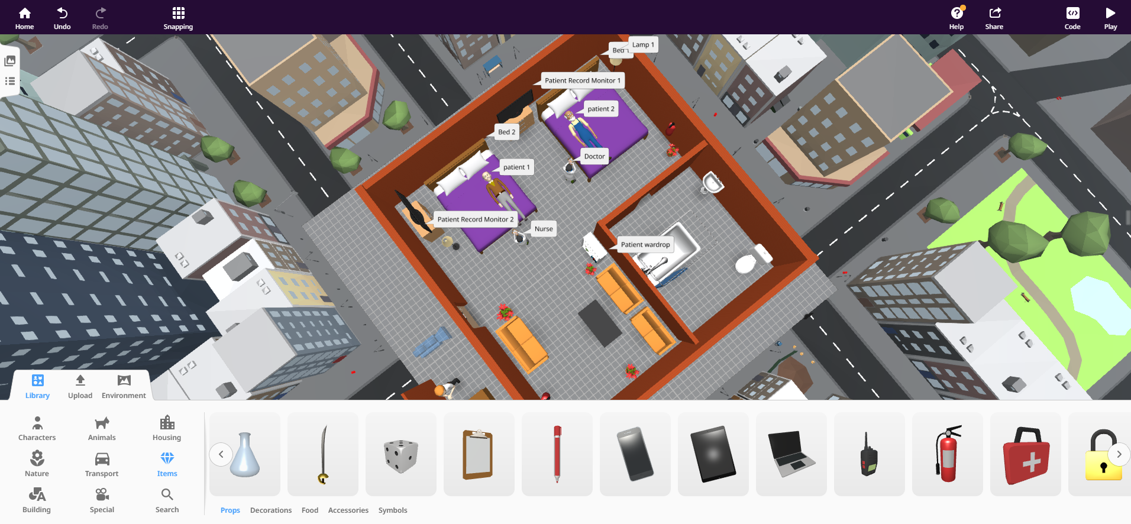
Figure 4.1 — Building the ward layout in the Delightex EDU editor, placing beds, monitors and furniture.
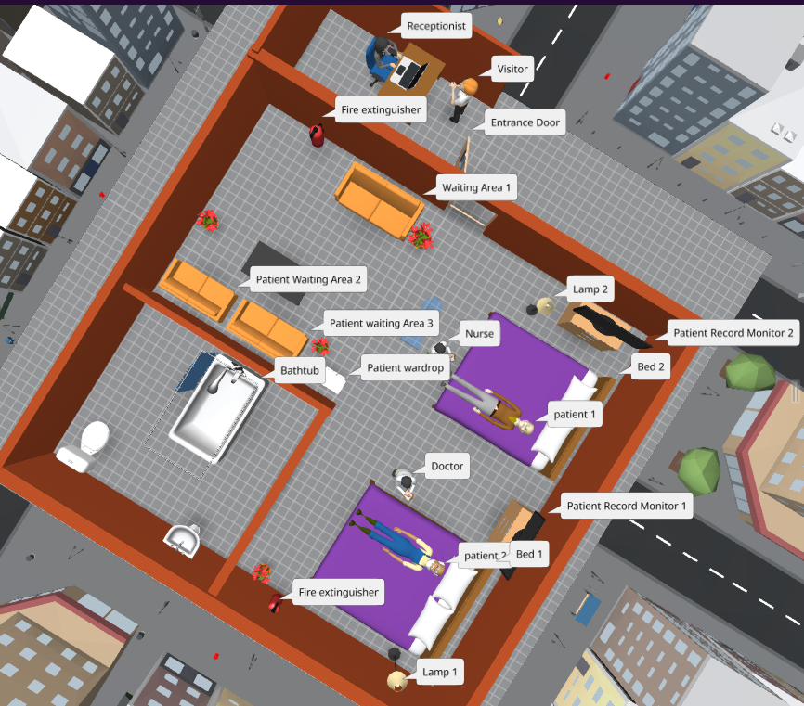
Figure 4.2 — Ward expanded to include the reception desk, waiting areas and washroom.
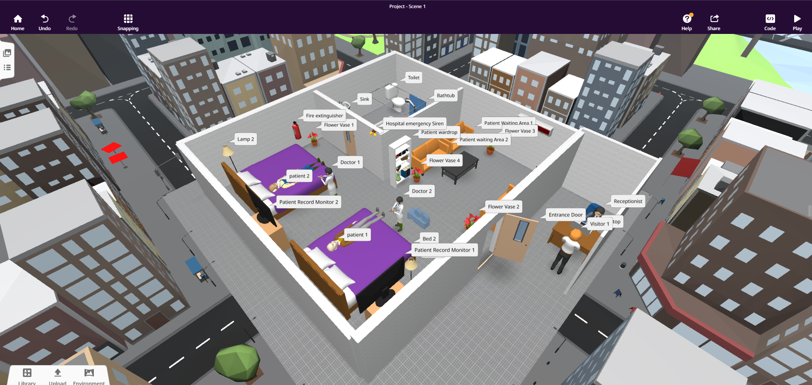
Figure 4.3 — Completed ward scene with every asset labelled, viewed from the Delightex EDU editor.
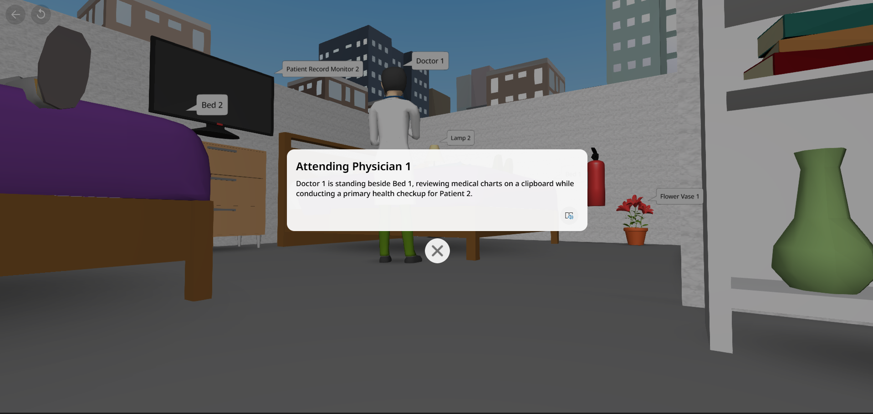
Figure 4.4 — Interactive info panel triggered by clicking the attending physician hotspot.
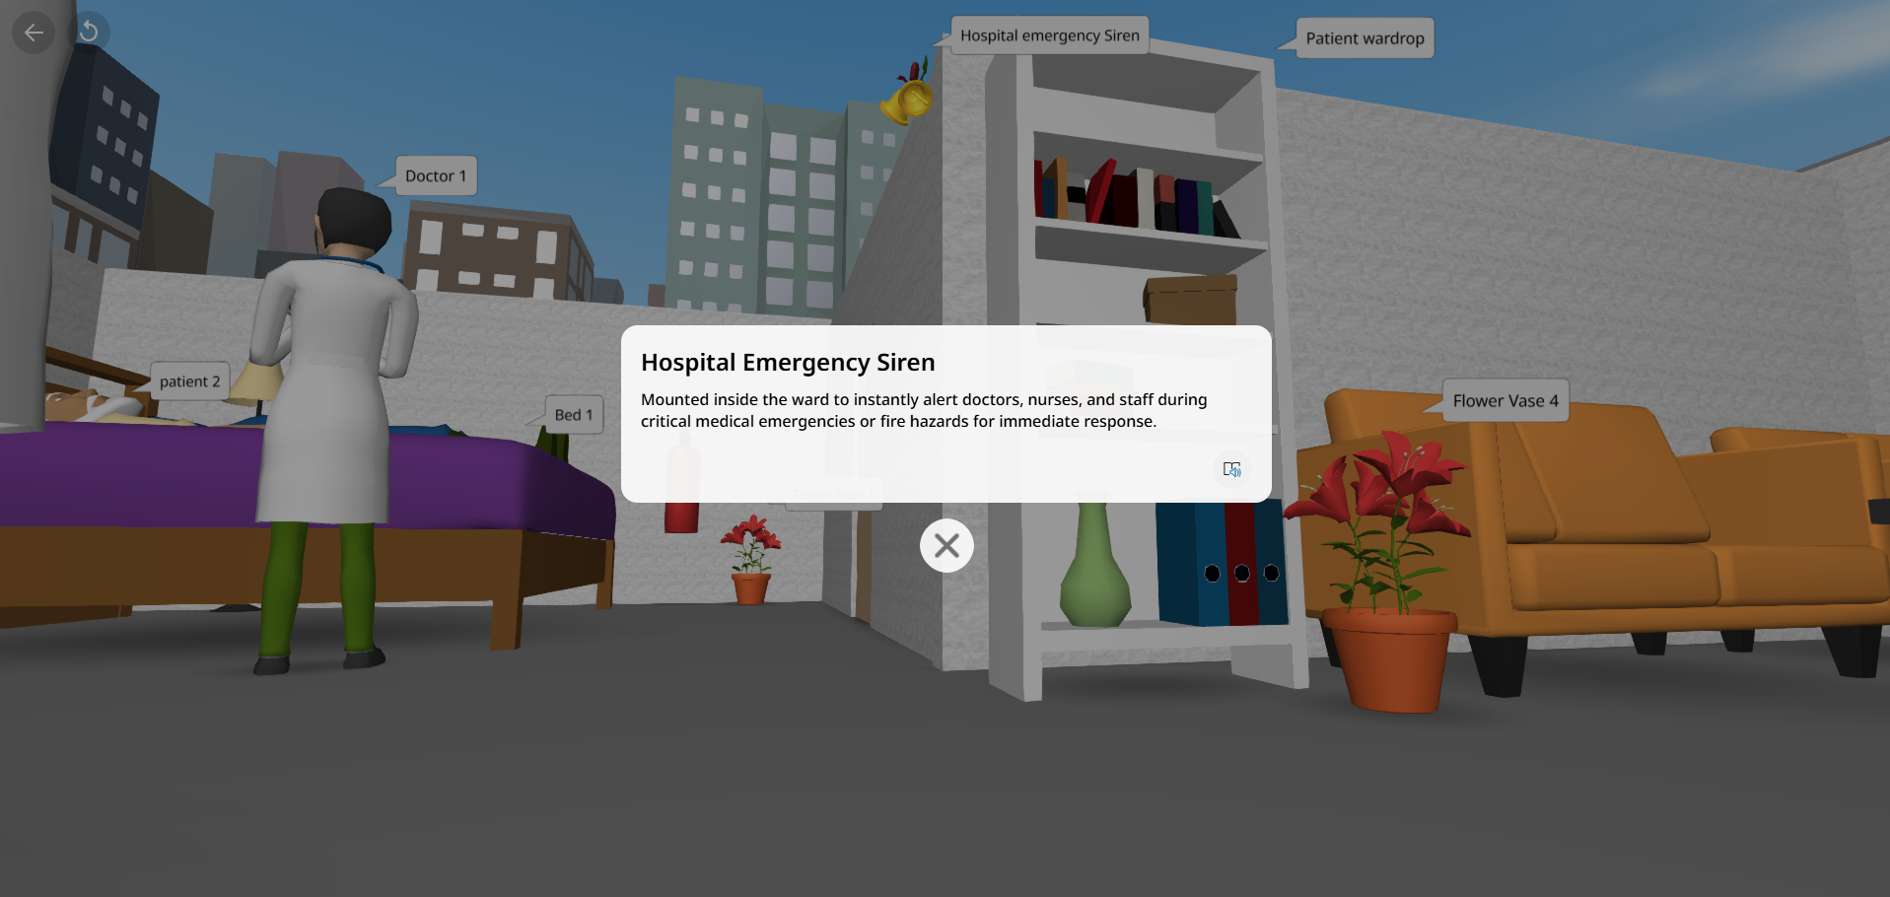
Figure 4.5 — Interactive info panel for the Hospital Emergency Siren.
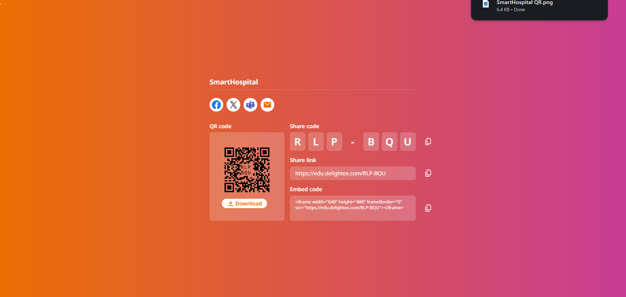
Figure 4.6 — Published VR project “SmartHospital”, shareable via link (edu.delightex.com/RLP-BQU) or QR code.

Chapter 5 – AR Simulation

5.1 AR Design
The same Smart Hospital ward concept was rebuilt as a 3D AR scene in MyWebAR, using its built-in asset library (beds, sofas, doctor and patient figures, a reception desk, an air-conditioning unit, a TV/patient monitor, a bookshelf, flower pots, fire extinguishers, lamps, an electric fan and door props). Once published, the scene can be launched from a phone through a WebAR link or QR code, letting a user view the ward through their camera without installing a dedicated app — satisfying the requirement for at least one complete AR scene.

5.2 User Interactions
Interactivity was programmed using MyWebAR's CoBlocks visual scripting tool, with a “when [object] is clicked → show info panel with title … text …” rule created for every interactive object in the scene. In total, 44 click-to-inform rules were scripted, well beyond the minimum of three AR objects required. Examples include:
- Double bed / Double bed1 → patient information for Bed 1 and the Patient 2 & Doctor section.
- Fire extinguisher / Fire extinguisher1 → the Ward Fire Extinguisher safety information.
- Air Conditioner → the Smart Dual-Climate AC Unit description.
- Electric Fan → the Oscillating Table Fan description.
- Bells → the Hospital Emergency Siren description.
- Laptop → the Reception Laptop description.
- Adjustable sofa / sofa1 / sofa2 and Flower pot / pot1 / pot2 / pot3 → descriptions of each patient waiting area.
- TV / TV1 → the Patient Record Monitor descriptions.
- Classroom door1 → the Hospital Main Entrance Door description.
This gives the AR experience the same information-overlay and user-interaction capability as the VR walkthrough, but delivered through a live camera view rather than a pre-built 3D environment.

5.3 Publishing and Testing
The AR scene was tested using the DEVAR MyWebAR mobile launcher before being published live. The published experience is accessible via a direct link (mywebar.com/p/Project_0_zo25pog188) and a QR code, which can also be embedded on a webpage.

5.4 Screenshots
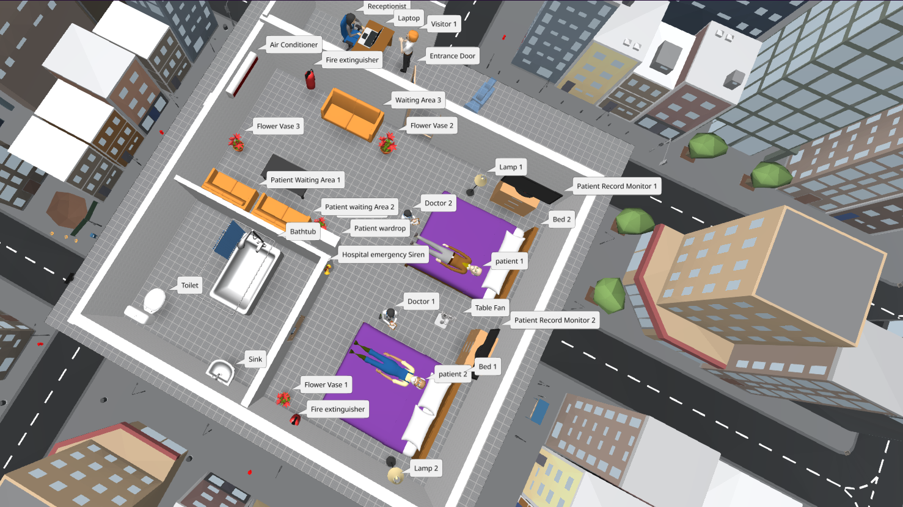
Figure 5.1 — Completed ward scene in the MyWebAR editor, with every object labelled for AR interaction.
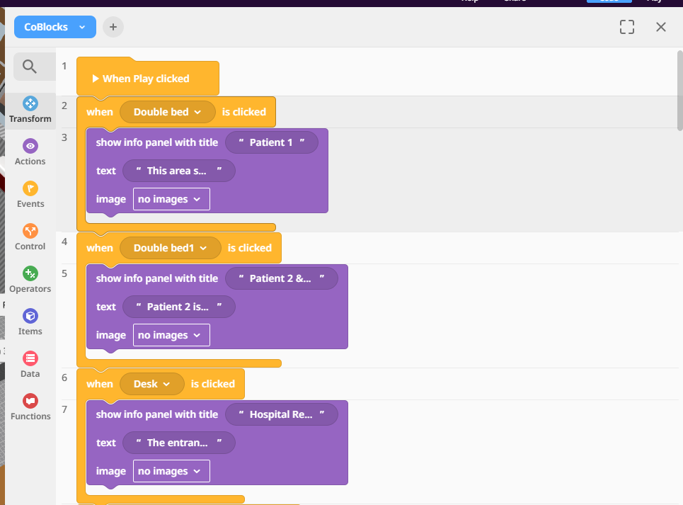
Figure 5.2 — CoBlocks event scripts defining click-to-inform behaviour for the beds and reception desk.
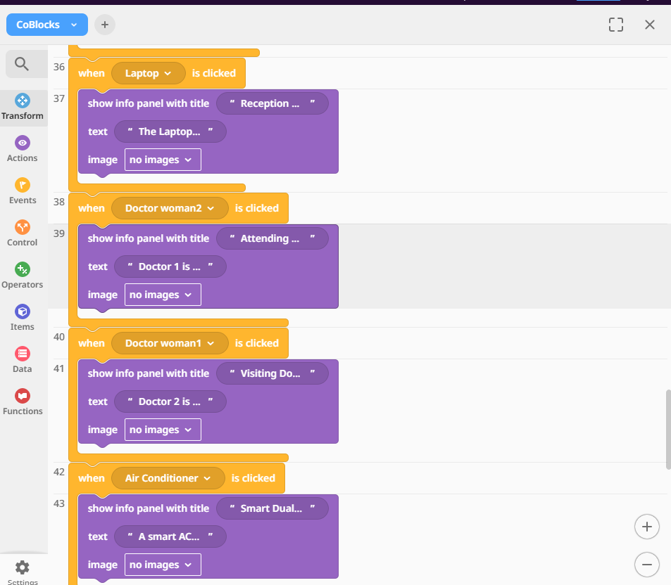
Figure 5.3 — Additional CoBlocks scripts for the laptop, air conditioner and doctor figures.
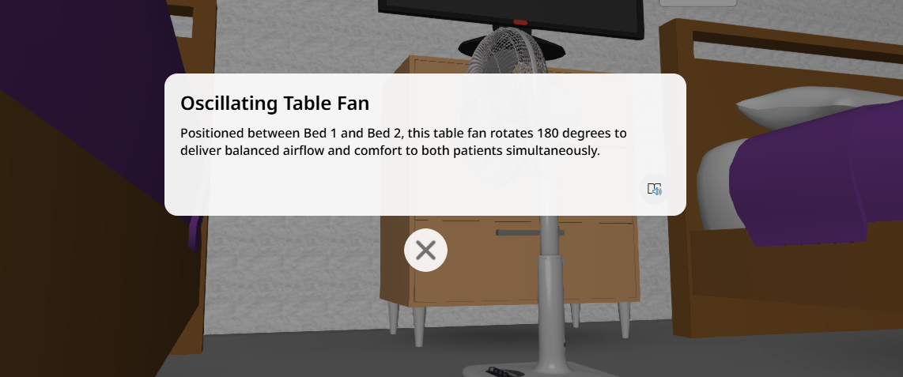
Figure 5.4 — Example info panel shown in preview when the Oscillating Table Fan is tapped.
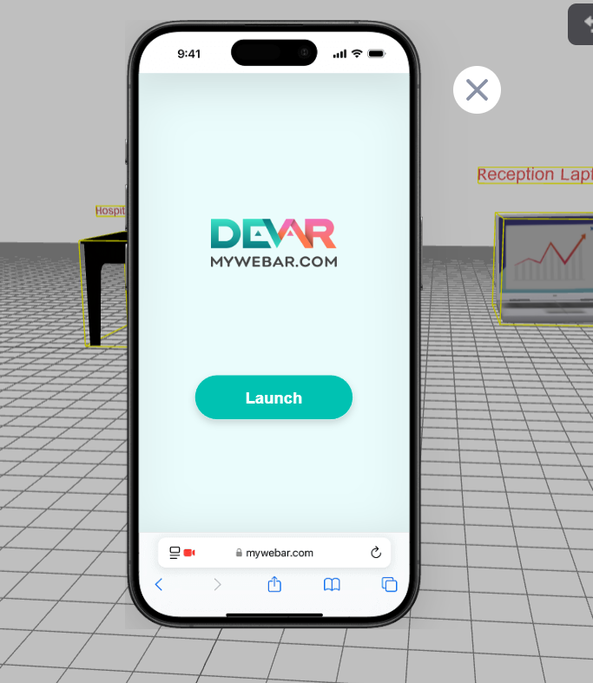
Figure 5.5 — Testing the AR experience on a mobile device through the DEVAR MyWebAR launcher.
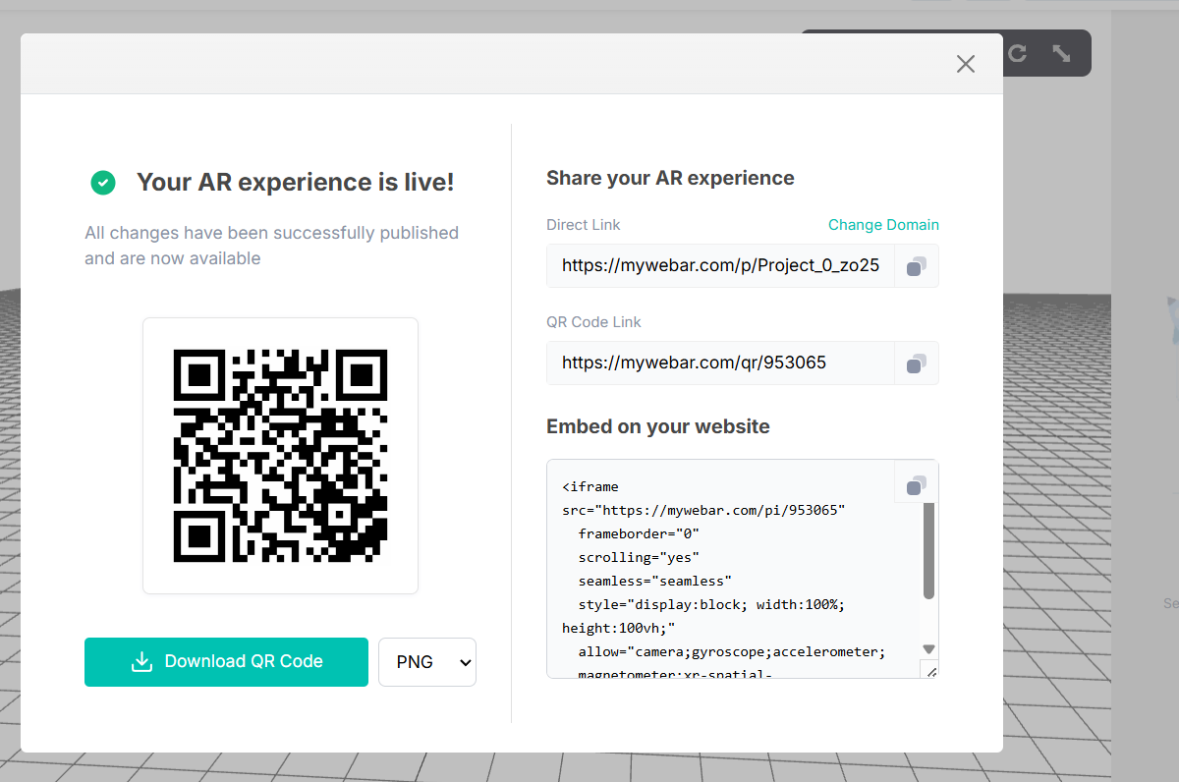
Figure 5.6 — Published AR experience with its live share link and QR code.

Chapter 6 – Integration

6.1 How IoT, VR and AR Work Together
The three components are built around the same ward and the same set of assets, so they function as three layers of one system rather than three separate exercises:
- The IoT layer is the ward's physical safety net — it senses temperature, humidity and smoke and automatically drives the siren, fan and light, protecting the patient even when no staff member is present to notice a problem.
- The VR layer is the orientation and training layer — new staff or students can walk through the same ward virtually, clicking on every asset (the same siren, monitors and fire extinguisher simulated in Packet Tracer) to learn what it is and where it is before ever entering the physical space.
- The AR layer bridges sensing and training with real-time, in-context reference — because it runs from a phone via a simple link or QR code, on-duty staff or visitors can tap the same equipment and instantly see the information a VR trainee already learned, without opening a manual or asking a colleague.
Because the same naming and asset set (beds, patient monitors, the emergency siren, the air-conditioning/fan, the reception desk) is reused across all three tools, a user experiences one consistent Smart Hospital story across sensing, training and point-of-need reference, rather than three disconnected demos.

6.2 Benefits of the Proposed Solution
- Faster emergency response, since the siren and comfort devices react automatically to sensor readings instead of waiting for a manual check.
- Reduced staff training time and fewer orientation errors, because new staff can rehearse locating and understanding ward equipment in VR before working on a real ward.
- Quicker access to equipment and facility information for staff and visitors, through AR tap-to-inform interactions instead of paperwork or asking around.
- Low-cost, low-risk prototyping, since the entire ward — sensors, walkthrough and AR experience — was simulated in free tools before any real hardware or physical build-out was required.

Chapter 7 – Conclusion

7.1 Challenges
The main challenge encountered during this project was getting started with the AR component in MyWebAR. The CoBlocks event-scripting model — linking a click on a specific 3D object to a corresponding info panel — was unfamiliar at first, and it took some time to understand how objects, events and panels connected to one another. Once the pattern was understood, it became straightforward to repeat, and it was ultimately used to script 44 interactive events covering every asset in the ward.

7.2 Conclusion
This project set out to design and simulate a Smart Hospital solution that integrates IoT, VR and AR around a single patient-ward scenario. The IoT network in Cisco Packet Tracer meets the assignment's requirements for sensors, actuators, automation and monitoring; the Delightex EDU environment provides a fully explorable, labelled VR ward well beyond the minimum interactive-object requirement; and the MyWebAR experience delivers the same information through a tap-to-inform AR interface accessible from any phone. Together, the three components show how connected sensing, immersive training and point-of-need AR reference could realistically improve patient safety, staff efficiency and staff training in a real hospital ward.

