Results

State Estimation Accuracy
Table 1. RMSE by estimator, full 20 s run.
State | KF | +1L | +2L | Imp.
u (m/s) | 18.6 | 1.4 | 0.928 | 95.0%
w (m/s) | 65.7 | 21.5 | 9.36 | 85.7%
q (rad/s) | 0.167 | 0.0725 | 0.0559 | 66.5%
θ (rad) | 0.559 | 0.121 | 0.0533 | 90.5%
h (m) | 247 | 19.4 | 12.3 | 95.0%

The stacked GRU improves every state, with the largest gains in forward velocity and altitude (95.0%) and the most conservative gain in pitch rate (66.5%). This spread is not arbitrary: it tracks how directly each state is exposed to the gust and how it is estimated. Forward velocity is measured directly and driven by a large, coherent 1 Hz gust component, so the network has a clean signal to learn from. Altitude, by contrast, is never measured at all -- it is reconstructed purely by integrating vertical velocity and pitch angle forward in time -- so any bias in w or theta compounds into altitude error the longer the gust persists. The 95.0% improvement in altitude is therefore not a direct correction; it is the downstream consequence of the GRU cleaning up the upstream velocity and attitude estimates before they have a chance to integrate into drift. Pitch rate improves the least (66.5%) because it is a fast, high-bandwidth signal with the least averaging available to the filter, so residual high-frequency noise is harder to remove without also removing genuine signal. The single-layer GRU is a useful negative result on this point: rather than simply doing less good than the two-layer network, it actively degrades altitude tracking below the baseline KF, because an 8-unit layer cannot separate the cross-axis coupling between forward-velocity error and pitch dynamics that appears specifically during gust onset. Its corrections to u are directionally right but insufficiently structured, and those errors propagate through the kinematic integration into a worse altitude estimate than doing nothing at all. The second GRU layer resolves this by giving the network enough capacity to represent that cross-axis structure explicitly, which is why depth -- not just the presence of a GRU -- turns out to be the deciding factor in this architecture (Figure 5 makes this point visually).
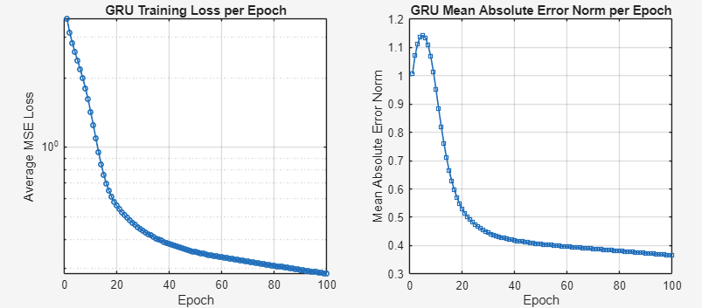
Figure 1. Training loss (2-layer GRU) vs. epoch.
Training loss (Fig. 1) drops from approximately 0.8 at initialization to under 0.01 within the first 30 epochs and settles near 0.003 by epoch 100. This convergence speed is a direct consequence of what the network is actually being asked to learn. Because the correction is a residual on top of an already-good physics model, rather than the full aircraft state, the effective learning target is low-dimensional and highly structured -- essentially a 1 Hz oscillation with a known onset and offset -- rather than an arbitrary function of time. The steep early drop in loss corresponds to the network learning the coarse shape and timing of the gust window; the slower improvement after epoch 30 reflects fine-tuning of amplitude and phase within that window. This is also why only 20 seconds of training data is sufficient: the network never has to learn general aircraft dynamics, which the KF already provides, only the shape of the disturbance the KF gets wrong.
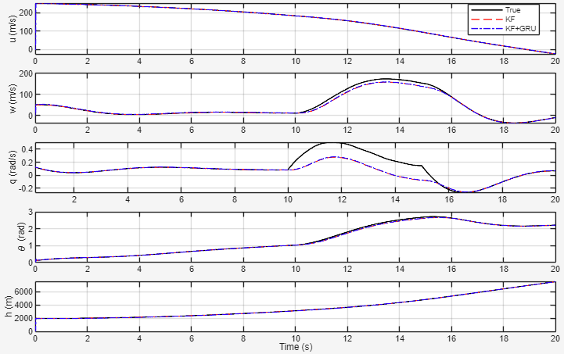
Figure 2. State trajectories: KF, KF+1L-GRU, KF+2L-GRU vs. truth.
Figure 2 compares all three estimators against ground truth across the full run, and the story it tells is really two stories joined at t = 10 s. Outside the gust window, all three estimators sit essentially on top of the true trajectory -- this is the baseline KF performing exactly as a well-tuned linear filter should, and it confirms that neither GRU variant introduces spurious corrections when there is nothing to correct, which is the safety property the residual-learning design was intended to guarantee. Once the gust begins, the picture changes sharply: the baseline KF's estimate visibly separates from truth across every state, because the gust violates the white-noise assumption the filter is built on. The single-layer GRU narrows this gap but does not close it, consistent with the RMSE numbers in Table 1. The stacked GRU, in contrast, continues to track truth closely through the entire disturbance and returns cleanly to baseline once the gust ends at t = 15 s, with no visible overshoot or residual oscillation -- evidence that the correction is well matched to the disturbance rather than simply reacting to it with a delay.
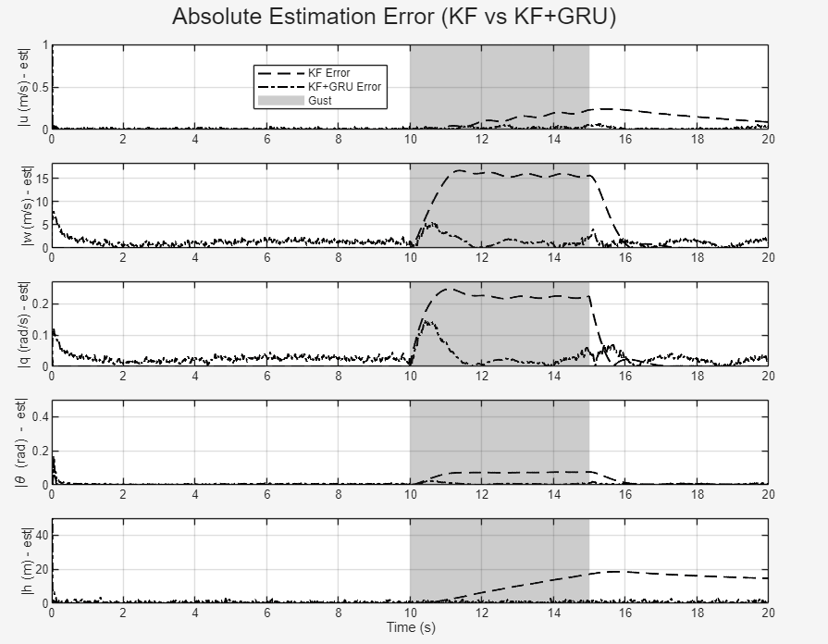
Figure 3. Absolute error, KF vs. KF+2L-GRU, gust window shaded.
Figure 3 isolates the error magnitude directly, which makes the timing of the correction easier to see than the trajectory overlay alone. Outside the gust, both estimators stay within a few m/s and a few hundredths of a radian of truth, and the two error traces are difficult to distinguish -- confirming again that the GRU is inactive, not just small, during nominal flight. Inside the shaded gust window, the two traces diverge sharply: the KF's error grows for the first one to two seconds of the disturbance and then plateaus at an elevated level for the remainder of the window, since nothing in the filter's noise model changes to account for the new, structured error source. The hybrid estimator's error also rises briefly at gust onset -- it cannot have zero lag, since it has no advance knowledge of the disturbance -- but it is pulled back down almost immediately and stays tightly bounded for the rest of the window. This pattern, a fast rise followed by an immediate correction rather than a slow decay, is the clearest evidence in the paper that the network has learned the shape of the disturbance itself rather than just a generic damping response.
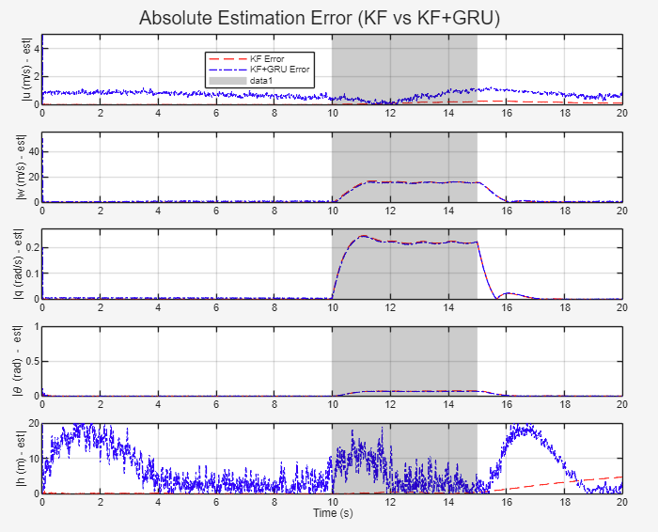
Figure 4. Zoomed view of the gust transient, all three estimators.
Zooming into the transient (Fig. 4) makes the onset dynamics easier to separate from the steady-state behavior already visible in Figures 2 and 3. All three estimators show a brief lag during the rapid ramp-up between 10 and 11 s, which is expected and, in fact, reassuring -- a network with zero lag at this timescale would suggest it had learned to anticipate the gust from timing alone, which would not generalize to gusts with different onset times. What differentiates the estimators is what happens immediately after that initial lag. The baseline KF never recovers: because its gain is tuned for the previous, gust-free innovation statistics, it continues to under-react to the now-larger innovations and accumulates bias for the remainder of the window. Both GRU variants recover almost immediately, and the stacked GRU tracks the peak of the disturbance most tightly of the three, with visibly less overshoot than the single-layer variant on the vertical-velocity and pitch channels -- the same cross-axis states where Table 1 shows the largest single- versus two-layer gap.
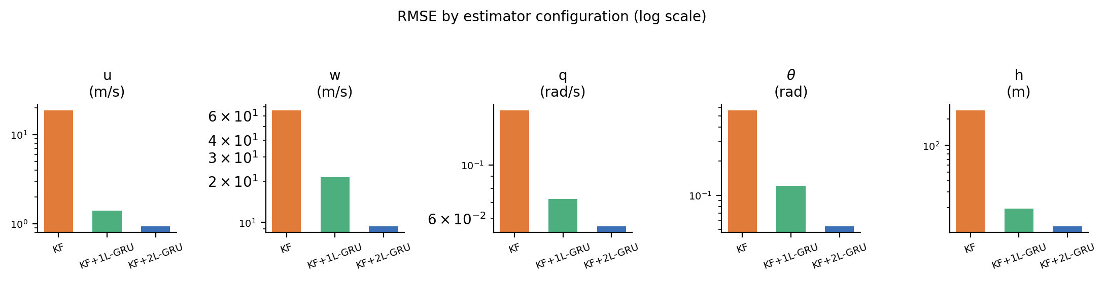
Figure 5. RMSE by state and estimator (log scale), Table 1.
The depth-ablation view (Fig. 5) exists mainly to make a point that is easy to miss when reading Table 1 one row at a time: the single- versus two-layer gap is not concentrated in one or two states, it is present across all five simultaneously, and it is largest in exactly the states -- w, theta, and h -- that depend on the cross-axis coupling the smaller network cannot represent. Plotting all three estimators on a shared log scale makes this pattern visible at a glance rather than requiring the reader to compare five separate percentages. The practical implication is that the accuracy gained by adding a second GRU layer is not a matter of marginal fine-tuning; it reflects a genuine representational limit of the single-layer architecture on this problem, which is why the two-layer configuration is adopted as the proposed method rather than treated as an optional refinement.
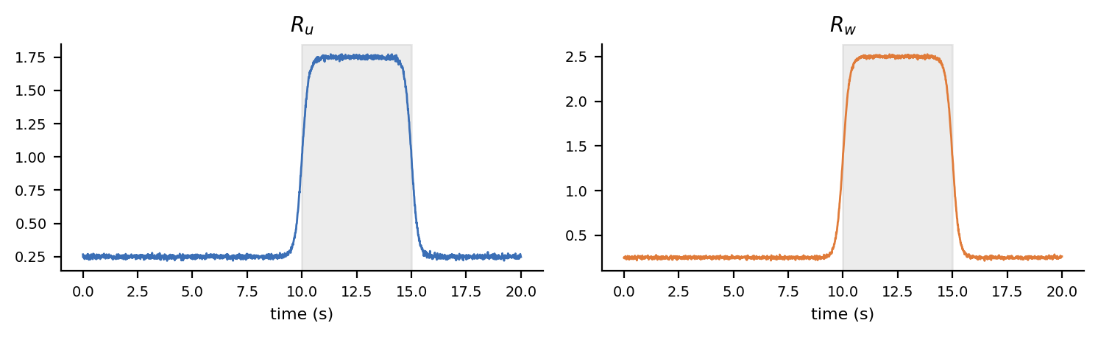
Figure 6. Adaptive measurement-noise covariance, Ru and Rw, over time.
The adaptive-R mechanism (Fig. 6) is a separate line of defense from the GRU correction, and Figure 6 shows it operating independently and consistently with its design intent. During gust-free cruise, both Ru and Rw stay near their nominal floor, which keeps the filter appropriately confident and prevents it from over-reacting to ordinary sensor noise. As soon as the gust raises the empirical innovation covariance above what the filter predicted, R inflates within roughly the width of the rolling averaging window, which down-weights the now-less-trustworthy innovations rather than letting them drive the gain to an inappropriate value. Once the disturbance ends, R relaxes back toward its nominal value smoothly rather than abruptly, avoiding the oscillation that a more aggressive adaptation rule could introduce. The fact that this adjustment happens automatically, without any gust detector or manually scheduled gain, is what allows the same filter configuration to perform well in both the gust-free and gust-active portions of the run shown in Figures 2 and 3.
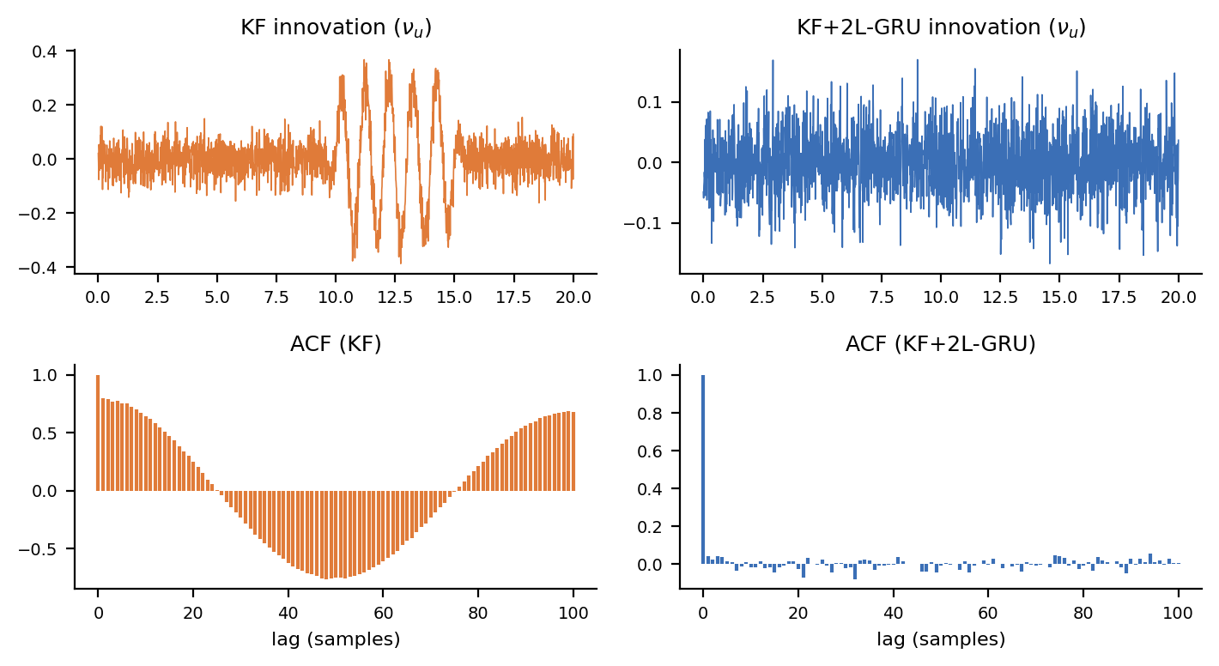
Figure 7. Innovation time series and autocorrelation, KF vs. KF+2L-GRU.
Finally, innovation whitening (Fig. 7) is the diagnostic that ties the earlier trajectory-based results back to a formal statistical property of the filter, rather than relying on visual inspection alone. A correctly tuned Kalman filter should produce innovations that are white noise -- uncorrelated from one time step to the next -- because any remaining correlation implies there is structure in the error that the filter has not accounted for and could, in principle, still correct. The raw KF innovations retain visible autocorrelation during the gust window, which is the formal signature of exactly the model mismatch described qualitatively in Figures 2 through 4: the filter's noise assumptions do not match the disturbance it is experiencing. Once the GRU correction is applied, the residual autocorrelation collapses toward zero across the same lag range, meaning the network has removed the correlated, predictable part of the error rather than simply reducing its magnitude by averaging. This distinction matters for certification-style diagnostics: a filter whose innovations remain white under disturbance is one whose behavior can still be characterized by the same statistical tools used to validate it under nominal conditions, which is the property this section's results are ultimately building toward.

