PHYSICS-GUIDED RESIDUAL LEARNING WITH
RECURRENT NEURAL NETWORKS FOR
ENHANCED AIRCRAFT STATE ESTIMATION
UNDER ATMOSPHERIC GUST DISTURBANCES
Saharsh Kumar  Boeing India Pvt Ltd  Bengaluru, Karnataka, 560063 slygrin005@gmail.com | Sushil Kumar Mishra  Boeing India Pvt Ltd  Bengaluru, Karnataka, 560063 sushile56@gmail.com | Agam Gugaliya  Boeing India Pvt Ltd  Bengaluru, Karnataka,  560063  author.three@email.com | Yogananda Jeppu  Boeing India Pvt Ltd  Bengaluru, Karnataka,  560063  author.three@email.com
Copyright © 2026 by the author(s). Permission granted to INCOSE to publish and use.

Abstract
This paper presents a hybrid physics- and data-driven framework for state estimation of an aircraft longitudinal flight model under unknown atmospheric gust disturbances. The architecture combines a discrete-time Kalman Filter (KF), augmented with random-walk gust states and online adaptive measurement-noise covariance, with a two-layer Gated Recurrent Unit (GRU) residual observer. The KF supplies physically interpretable state estimates and uncertainty propagation, while the GRU learns the structured residual dynamics that the linear aircraft model cannot capture. On a five-state longitudinal model (forward velocity, vertical velocity, pitch rate, pitch angle, altitude) discretized at 100 Hz, the hybrid estimator reduces RMSE relative to a standalone KF by 95.0% in forward velocity, 85.7% in vertical velocity, 66.5% in pitch rate, 90.5% in pitch angle, and 95.0% in altitude. The GRU (24 hidden units total across two layers, under 2,000 trainable parameters) trains on a single 20-second trajectory containing a structured gust window and adds its correction directly to the KF’s one-step-ahead prediction, so the filter degrades gracefully to classical Kalman behaviour whenever the network output is zero. Results show the residual-learning approach preserves KF robustness, interpretability, and uncertainty propagation while delivering substantial accuracy gains under unmodeled disturbances, at negligible computational cost.

Keywords
Kalman filter, recurrent neural networks, gated recurrent units, aircraft state estimation, atmospheric disturbances, hybrid estimation

1. Introduction
Every modern commercial aircraft relies on a recursive state estimator to feed reliable, continuous state information to autopilot systems, structural health monitors, and ground based situational-awareness tools. The linearized longitudinal dynamics of a large transport aircraft at cruise are well characterized by first-principles aerodynamic models, and under nominal conditions a properly tuned Kalman filter (KF) [13] delivers near-optimal estimates at modest computational cost – the industry standard for avionics and flight management.
The trouble begins when the aircraft encounters an atmospheric gust. Gusts introduce structured, time-correlated effects that violate the white-noise process-noise assumption underlying classical Kalman filtering. When a persistent disturbance is active, the filter’s innovation sequence becomes biased; the filter responds by inflating its gain, which amplifies measurement noise across every state. States that are not directly measured – altitude in particular – suffer most, since biased intermediate estimates accumulate through kinematic integration.
The disappearance of Malaysia Airlines MH370 in March
2014 illustrated this problem starkly: over oceanic airspace with no continuous radar coverage, ground-station reconstructions of the aircraft's likely trajectory had to rely on infrequent satellite handshake data, and any atmospheric disturbance along the way would have introduced exactly the kind of structured, time-correlated estimation error this paper addresses compounding the difficulty of an already sparse reconstruction problem. The present work targets the underlying gust-estimation error rather than the sparse-measurement setting itself; extending it to intermittent or bandwidth-limited measurements is discussed as future work in Section 8.
The standard physics-based remedy is state augmentation: append estimated gust components to the state vector and model them as random walks. This works well when gusts vary slowly relative to the estimation bandwidth but struggles with time-varying amplitude or spectrally rich turbulence. A more recent family of hybrid methods instead replaces internal KF components – the gain matrix or the state-transition model with learned neural surrogates [1,2]. These approaches improve accuracy but sacrifice the uncertainty quantification and physical interpretability that make Kalman filters suitable for certification in safety critical aviation systems.
This work takes a deliberately conservative design stance. The Kalman filter is left completely intact – its gain computation, state transition, and covariance update follow the standard predict–update cycle unchanged. A small two layer GRU is inserted immediately after the filter’s one step-ahead prediction to add a residual correction. The GRU observes only the KF’s state predictions and the derivatives of the control inputs, then outputs an additive five-element correction that compensates for the structural model error the linear filter cannot represent. Because the learning target is a residual rather than the full state, the network generalizes from a short training sequence and is stable by construction: a zero-output GRU recovers the classical Kalman filter exactly.
The paper’s contributions are threefold: (1) an additive residual-observer architecture, with an explanation of why anchoring the correction to the KF prediction (rather than the posterior) is essential for numerical stability; (2) an online adaptive measurement-noise estimator that prevents filter drift during gust-free cruise while remaining responsive to disturbance transients; and (3) a quantitative evaluation on a high-fidelity longitudinal aircraft model showing that a network of under 2,000 parameters cuts estimation error by roughly two-thirds to nineteen-twentieths across all five states.

2. Related Work

2.1 Physics-Based Gust and Disturbance Estimation
State augmentation is the canonical approach for integrating wind and turbulence into aircraft state estimation. Early work by Stengel [3] and Nelson [4] appended wind states modeled as random walks to the aircraft state vector. These methods work well for slowly time-varying gusts but struggle with rapid amplitude changes or spectral complexity. Shaping filters parameterized by Dryden or von Karm´ an´ spectra [5] give frequency-domain correspondence to real turbulence but require prior knowledge of the disturbance spectrum, and the Interacting Multiple Model (IMM) filter [6] improves robustness at the cost of enumerating all plausible disturbance regimes in advance.
Adaptive Kalman filtering tunes process or measurement noise covariance online from innovation statistics [7], but simultaneous identification of both Q and R is ill conditioned without added constraints. This work sidesteps that difficulty by fixing process noise (grounded in physics) and adapting only measurement noise online.

2.2 Recurrent Neural Networks in Aerospace Estimation
LSTM and GRU architectures [8, 9] are increasingly used in aeronautical estimation, from inertial navigation to GPS denied flight, because their internal memory suppresses long-term drift and models temporal correlation in sensor data. GRUs are attractive for resource-constrained avionics: fewer gates and parameters than an LSTM for comparable expressiveness. The persistent limitation of purely data-driven estimators is the absence of uncertainty quantification, which complicates certification for flight-critical use.

2.3 Hybrid Kalman Filter Architectures
Recent hybrid approaches combining Kalman filters with neural networks [1, 2, 10, 12] merge classical filtering with learned components. KalmanNet [1] replaces the Kalman gain with a learned network, improving responsiveness to non-stationary noise but obscuring the gain matrix’s uncertainty semantics. Deep Kalman Filters [2] replace the linear state-transition model with learned latent dynamics, trading interpretability for expressivity. Bayesian neural-Kalman approaches [10] combine probabilistic neural models with filtering to recover some uncertainty estimates under degraded sensing.
The present framework differs from all three: it leaves the entire KF structure untouched and adds a GRU-based residual correction strictly after prediction, so uncertainty propagation and physical interpretability are preserved rather than traded away.

3. Aircraft Model and Gust Disturbance

3.1 Longitudinal Dynamics
The aircraft longitudinal dynamics [14] are a standard small perturbation linearization about a cruise trim point (forward velocity U₀ = 235.9 m/s, air density ρ = 0.3045 kg/m³, pitch angle θ₀ = 0). The five-state vector is forward velocity perturbation u (m/s), vertical velocity w (m/s), pitch rate q (rad/s), pitch angle θ (rad), and altitude h (m):
$\dot{x}=A_{c}x+B_{c}u+B_{w}ω_{g}$ (1)

where $u={\left[δ_{e},δ_{p}\right]}^{T}$is the control vector (elevator deflection, normalized thrust) and $w_{g}={\left[u_{g},w_{g},q_{g}\right]}^{T}$ is the unknown gust vector entering through gust-influence matrix $B_{w}$. The altitude state closes the system through the small angle kinematic relation $\dot{h}=-w+U_{0} θ.$In expanded form (2),
$\left[\begin{matrix}u^{.} \\ w^{.} \\ q^{.} \\ θ^{.} \\ h^{.}\end{matrix}\right]=\left[\begin{matrix}X_{u} & X_{w} & 0 & -g\cos{γ} & 0 \\ Z_{u} & Z_{w} & U_{0} & -g\sin{γ} & 0 \\ M_{u} & M_{w} & M_{q} & 0 & 0 \\ 0 & 0 & 1 & 0 & 0 \\ -\sin{γ} & \cos{γ} & 0 & U_{0}\cos{γ} & 0\end{matrix}\right]\left[\begin{matrix}u \\ w \\ q \\ θ \\ h\end{matrix}\right]+\left[\begin{matrix}X_{δe} & X_{δp} \\ Z_{δe} & Z_{δp} \\ M_{δe} & M_{δp} \\ 0 & 0\end{matrix}\right]\left[\begin{matrix}δ_{e}δ_{p}\end{matrix}\right] + \left[\begin{matrix}\begin{matrix}{-X}_{u} & {-X}_{w} & 0 \\ {-Z}_{u} & -Z_{w} & 0 \\ -M_{u} & -M_{w} & -M_{q} \\ 0 & 0 & 0 \\ 0 & 0 & 0\end{matrix}\end{matrix}\right]\left[\begin{matrix}u_{g} \\ w_{g} \\ q_{g} \\ \end{matrix}\right]$

3.2 Gust Disturbance Model
The gust is an unknown three-component disturbance injected between $t = 10 s$ and $t = 15 s$: a 1 Hz headwind sinusoid $(±10 m/s$), a 1 Hz vertical-gust cosine ($±5 m/s$), and a constant pitch-rate upset (1.5 rad/s). Outside this window the gust is exactly zero. No gust measurement or feedforward signal is available to the estimator – all disturbance information must be inferred purely from noisy sensor innovations, matching realistic operations where the ground station cannot anticipate a gust.

3.3 Discretization
The continuous-time dynamics are discretized at 100 Hz via zero-order hold, $x_{k+1} = A_{d}x_{k} + B_{d}u_{k}.$ (3) At this $10 ms$ interval the short-period mode (natural frequency $∼0.9 rad/s$) is resolved with negligible phase lag, so the discrete model tracks gust transients accurately.

4. Kalman Filter with Online Noise Adaptation

4.1 State Augmentation
Since the estimator cannot directly observe the gust vector, three additional states representing the gust components [$u_{g},w_{g},q_{g}$] are appended and modelled as random walks as shown in Fig 1. The resulting augmented state vector contains the five aircraft states and three gust states. The augmented state-transition matrix is block-diagonal, with the discrete aircraft model $(A_{d})$ and a (3×3) identity matrix for the gust dynamics, while the measurement matrix observes only the flight states. The process-noise covariance $(\tilde{Q}=diag(Q_{kf},Q_{g}))$ is also block-diagonal, using small values for the aircraft states to reflect confidence in the system model and unit values for the gust states to enable rapid tracking of the imposed $1 Hz$ gust disturbances.

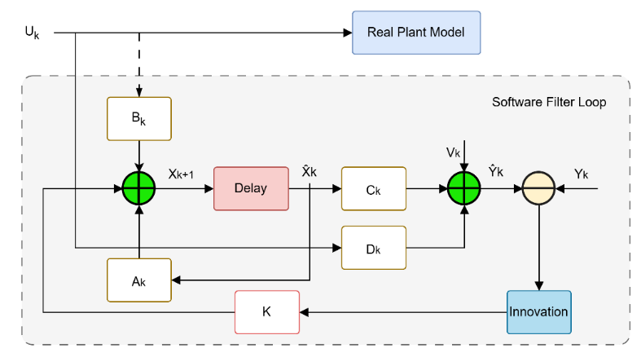
Figure 1: Block diagram of the software Kalman filter loop

4.2 Predict–Update Cycle
The filter runs the standard cycle every $10 ms$:
Prediction:
$${\hat{\tilde{x}}}_{k|k-1}={\tilde{A}}_{d}{\hat{\tilde{x}}}_{k-1}+{\tilde{B}}_{d}u_{k}$$ | (4)
$${\tilde{P}}_{k|k-1}={\tilde{A}}_{d}{\tilde{P}}_{k-1}{\tilde{A}}_{d}^{T} + \tilde{Q}$$  Innovation and gain: | (5)
$${\tilde{Y}}_{k}=z_{k}-\tilde{C}{\hat{\tilde{x}}}_{k|k-1}$$ | (6)
$$S_{k}=\tilde{C}{\tilde{P}}_{k|k-1}{\tilde{C}}^{T}+R_{k}$$ | (7)
$$K_{k}={\tilde{P}}_{k|k-1}{\tilde{C}}^{T}S_{k}^{-1}$$ | (8)
Update:
${\hat{\tilde{x}}}_{k}={\hat{\tilde{x}}}_{k|k-1}+K_{k}{\tilde{y}}_{k}$ (9)
$P_{k}=\left(I-K_{k}\tilde{C}\right)P_{k|k-1}{\left(I-K_{k}\tilde{C}\right)}^{T}+K_{k}R_{k}K_{k}^{T}$ (10)

4.3 Online Adaptive Measurement Noise
To improve robustness under varying flight conditions, the measurement-noise covariance (R) is updated online using a 50-sample rolling innovation window. When the empirical innovation covariance exceeds the predicted covariance, (R) is smoothly inflated toward the measured value using a first-order exponential update with a forgetting factor of 0.95. As the filter re-converges, (R) gradually returns to its nominal value, while a minimum diagonal bound of $({10}^{-8})$ ensures numerical stability. This adaptive strategy maintains consistent filter performance across both steady-flight and turbulent conditions without manual re-tuning.

5. GRU Residual Observer

5.1 Motivation
The Kalman filter assumes memoryless Gaussian process and measurement noise. Atmospheric gusts violate this: their temporal correlation biases the innovation sequence persistently and causes the KF to drift. Rather than modify KF internals – which would sacrifice interpretability and covariance semantics – a small GRU is inserted after the prediction step to learn and correct exactly the structured error the linear model cannot represent, shown in Fig 2. Targeting only the residual, rather than the full state, has three benefits: the network generalizes from a short training sequence, since residuals are structured and low-dimensional rather than arbitrary in magnitude; the system is stable by construction, since a zero-output GRU recovers the classical KF exactly; and the KF’s covariance semantics and uncertainty quantification are preserved through the update cycle.
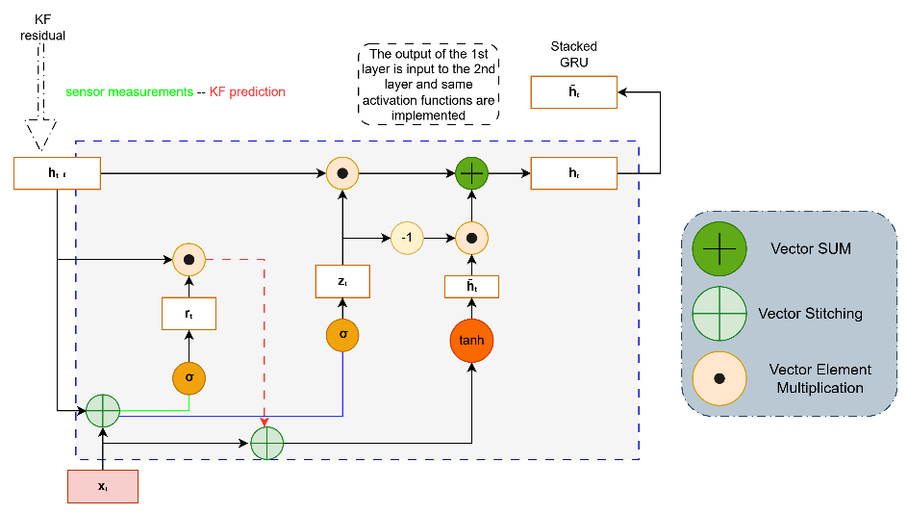
Figure 2: Internal cell architecture of the Gated Recurrent Unit (GRU) correction layer

5.2 Network Architecture
At each step k the GRU input is
$v_{k}=\left[{\hat{x}}_{k}^{KF};{\dot{u}}_{k}\right] ϵ R^{7}$ (11)
the five KF state predictions concatenated with the two control-input time derivatives. Including ${\dot{u}}_{k}$ gives the network access to the rate of change of elevator and thrust commands, which correlate strongly with the aerodynamic transients that accompany gust onset and recovery.
The network stacks two GRU layers, $n_{h1} = 8$ hidden units in layer 1 and $n_{h2} = 16$ in layer 2, followed by a linear output layer producing five state corrections (under 2,000 trainable parameters total). Layer 1’s forward pass at step k
is
$r_{1}=σ\left(W_{r1}{\overline{v}}_{k}+U_{r1}h_{1}^{(k-1)}+b_{r1}\right)$ (12)
$z_{1}=σ\left(W_{z1}{\overline{v}}_{k}+U_{z1}h_{1}^{(k-1)}+b_{z1}\right)$ (13)

${\tilde{h}}_{1}=tanh(W_{h1}{\overline{v}}_{k}+U_{h1}\left(r_{1}⊙h_{1}^{(k-1)}\right)+b_{h1})$ (14)
$h_{1}^{(k)}=\left(1-z_{1}\right)⊙h_{1}^{\left(k-1\right)}+z_{1}⊙{\tilde{h}}_{1}$ (15)
where $σ\left(·\right)$ is the sigmoid, $⊙$ the Hadamard product, and ${\overline{v}}_{k}$ the normalized input to that layer. Layer 2 takes layer 1’s hidden state as input. The output layer produces the raw residual ${\hat{y}}_{k}=W_{y}h_{2}^{(k)}+b_{y} ϵ R^{5}$.(see Fig 3)
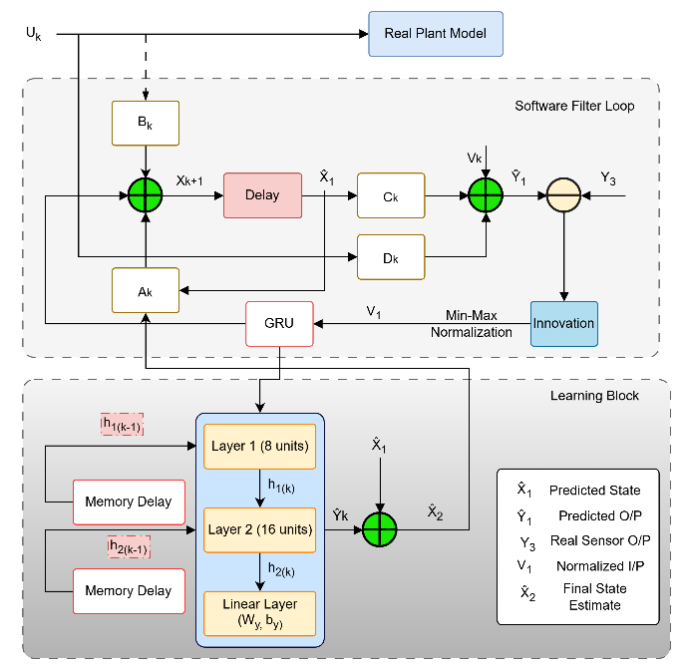
Figure 3: Learning block architecture
A single layer is expressive enough for simple periodic patterns but struggles with the onset/decay transients at gust boundaries, where the reset gate must simultaneously unlearn the pre-gust periodic state and acquire the transient dynamics. The second layer captures the multi-step correlation between pitch dynamics and altitude accumulation that a single layer misses – and is the difference between a small accuracy gain and a large one (Section 7).

5.3 Normalization and Target Scaling
Inputs are min-max normalized to $\left[-1,+1\right]$ using statistics from the training trajectory, with range components below ${10}^{-8}$ clamped to avoid division by zero. The training target at step k is the one-step-ahead residual, normalized per state:
$y_{k}^{*}=\frac{x_{k+1}^{true} - (A_{d}{\hat{x}}_{k}^{KF} +B_{d}u_{k})}{σ_{tgt}}$ (16)
The scales reflect the expected magnitude of the gust induced residual in each state – large for velocities, small for angular states, large for altitude. Without this per-state scaling, the numerically larger altitude residual would dominate the loss and the network would neglect the subtler pitch corrections.

5.4 Training
The network is trained by minimizing the mean squared error (MSE) over the complete (N)-step trajectory, see Fig 4,
$L=\frac{1}{N-2}{\sum_{k=2}^{N-1}{ }}^{ }{\left\|{{\hat{y}}_{k} - y}_{k}^{*}\right\|}^{2}$ (17)

Gradients are computed using full backpropagation through time (BPTT) without truncation. For the second GRU layer, the gate gradients at time step (k) are
$δ_{z2}=\frac{∂L}{∂h_{2}}⊙\left({\tilde{h}}_{2}-h_{2}^{(k-1)}\right)⊙σ^{'}(z_{2})$ (18)
$δ_{{\tilde{h}}_{2}}=\frac{∂L}{∂h_{2}}⊙z_{2}⊙tanh^{'}({\tilde{h}}_{2})$ (19)
$δ_{r2}=(U_{h2}^{T}δ_{{\tilde{h}}_{2}})⊙\left(h_{2}^{(k-1)}\right)⊙σ^{'}(r_{2})$ (20)
while the gradient propagated to the first layer is ${∂L}/{∂h_{1}^{(k)}}=W_{z2}^{T}δ_{z2}+W_{{\tilde{h}}_{2}}^{T}δ_{z2}+W_{r2}^{T}δ_{r2}.$The first-layer gate gradients are computed analogously using the normalized input ${\overline{v}}_{k}.$ All weights are initialized using Xavier uniform initialization [11] and updated using vanilla stochastic gradient descent (SGD) with a fixed learning rate of $η={10}^{-4})$. Momentum and adaptive optimizers are intentionally omitted because the compact network and normalized residual targets provide stable convergence while reducing the risk of overfitting to trajectory-specific noise.
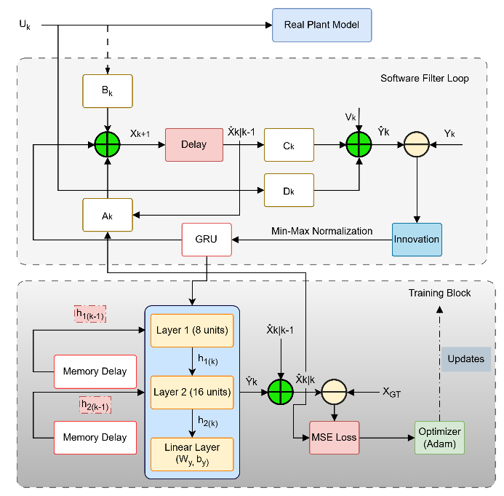
Figure 4: Training block architecture

5.5 Inference and State Correction
At inference the corrected estimate is
${\hat{x}}_{k+1}^{GRU}=A_{d}{\hat{x}}_{k}^{KF}+B_{d}u_{k}+{\hat{y}}_{k}⊙σ_{tgt}$ $(21)$
applied to the KF prediction, never the posterior – adding a correction after the measurement update would double-count sensor information, since the filter has already incorporated it. Grounding the correction to the prediction is equivalent to a pseudo-measurement with negligible noise on the model-error channel.
An alternative that propagates the corrected state recursively through $A_{d}$ was tested and found numerically unstable: any error at step k is amplified by $A_{d}$ at every later step and eventually diverges. Anchoring each correction to the fresh KF prediction breaks this accumulation chain and is essential for long-sequence stability.

6 Experimental Setup
The simulation runs for $T = 20 s$ at $100 Hz$ (N = 2,000 steps), integrated with MATLAB. Initial conditions represent a small perturbation from cruise trim, $x_{0}={\left[5,10,0.01,0.08,200\right]}^{T}$ . Control inputs follow a random walk, $u_{k}=u_{k-1}+T_{s}\dot{u_{k}}$, where $\dot{u_{k}}∼0.01Ν(0,I_{2})$ representing mild autopilot excitation. Sensors observe $[u,w,q,θ]$ with additive Gaussian noise (σ = 0.02 per channel); altitude is never measured directly and must be propagated through $h_{k+1}=h_{k}+T_{s}(-w_{k}+U_{0}θ_{k})$ which makes it the most challenging state for any estimator, since sustained bias in $\hat{ω} or \hat{θ}$ during the gust integrates forward.
Three estimators are compared: (1) the baseline augmented KF with online adaptive R; (2) KF + single-layer GRU (8 hidden units, 1,085 parameters); (3) KF + stacked two-layer GRU (8+16 hidden units, the proposed method).

7. Results

7.1 State Estimation Accuracy
Table 1: RMSE by estimator
State | KF | 1 Layer GRU | 2 Layer GRU
u (m/s) | 18.6 | 1.4 | 0.928
w (m/s) | 65.7 | 21.5 | 9.36
q (rad/s) | 0.167 | 0.0725 | 0.0559
θ (rad) | 0.559 | 0.121 | 0.0533
h (m) | 247 | 19.4 | 12.3

The stacked GRU improves every state, with the largest gains in forward velocity and altitude (95.0%) and the most conservative gain in pitch rate (66.5%). This spread is not arbitrary: it tracks how directly each state is exposed to the gust and how it is estimated. Forward velocity is measured directly and driven by a large, coherent 1 Hz gust component, so the network has a clean signal to learn from. Altitude, by contrast, is never measured at all, it is reconstructed purely by integrating vertical velocity and pitch angle forward in time so any bias in w or theta compounds into altitude error the longer the gust persists. The 95.0% improvement in altitude is therefore not a direct correction; it is the downstream consequence of the GRU cleaning up the upstream velocity and attitude estimates before they have a chance to integrate into drift. Pitch rate improves the least (66.5%) because it is a fast, high-bandwidth signal with the least averaging available to the filter, so residual high-frequency noise is harder to remove without also removing genuine signal. The single-layer GRU is a useful negative result on this point: rather than simply doing less good than the two-layer network, it actively degrades altitude tracking below the baseline KF, because an 8-unit layer cannot separate the cross-axis coupling between forward-velocity error and pitch dynamics that appears specifically during gust onset. Its corrections to u are directionally right but insufficiently structured, and those errors propagate through the kinematic integration into a worse altitude estimate than doing nothing at all. The second GRU layer resolves this by giving the network enough capacity to represent that cross-axis structure explicitly, which is why depth, not just the presence of a GRU turns out to be the deciding factor in this architecture (Figure 5 makes this point visually).
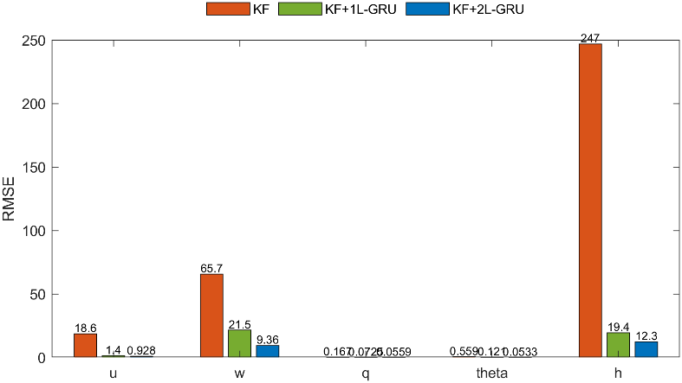
Figure 5: Comparison of state-estimation RMSE for the baseline KF, KF + GRU, and KF + stacked GRU estimators.

Training loss (Fig. 6) drops from approximately 0.8 at initialization to under 0.01 within the first 30 epochs and settles near 0.003 by epoch 100. This convergence speed is a direct consequence of what the network is actually being asked to learn. Because the correction is a residual on top of an already-good physics model, rather than the full aircraft state, the effective learning target is low-dimensional and highly structured essentially a 1 Hz oscillation with a known onset and offset rather than an arbitrary function of time. The steep early drop in loss corresponds to the network learning the coarse shape and timing of the gust window; the slower improvement after epoch 30 reflects fine-tuning of amplitude and phase within that window. This is also why only 20 seconds of training data is sufficient: the network never has to learn general aircraft dynamics, which the KF already provides, only the shape of the disturbance the KF gets wrong.

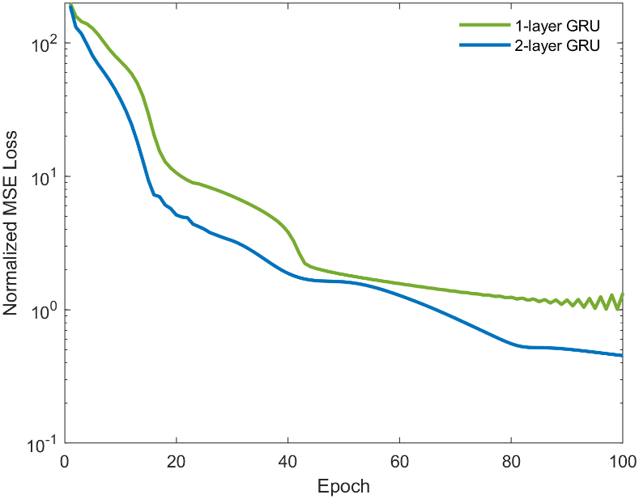
Figure 6: Training loss vs epoch

Figure 7 compares all three estimators against ground truth across the full run, and the story it tells is really two stories joined at t = 10 s. Outside the gust window, all three estimators sit essentially on top of the true trajectory this is the baseline KF performing exactly as a well-tuned linear filter should, and it confirms that neither GRU variant introduces spurious corrections when there is nothing to correct, which is the safety property the residual-learning design was intended to guarantee. Once the gust begins, the picture changes sharply: the baseline KF's estimate visibly separates from truth across every state, because the gust violates the white-noise assumption the filter is built on. The single-layer GRU narrows this gap but does not close it, consistent with the RMSE numbers in Table 1. The stacked GRU, in contrast, continues to track truth closely through the entire disturbance and returns cleanly to baseline once the gust ends at t = 15 s, with no visible overshoot or residual oscillation evidence that the correction is well matched to the disturbance rather than simply reacting to it with a delay.
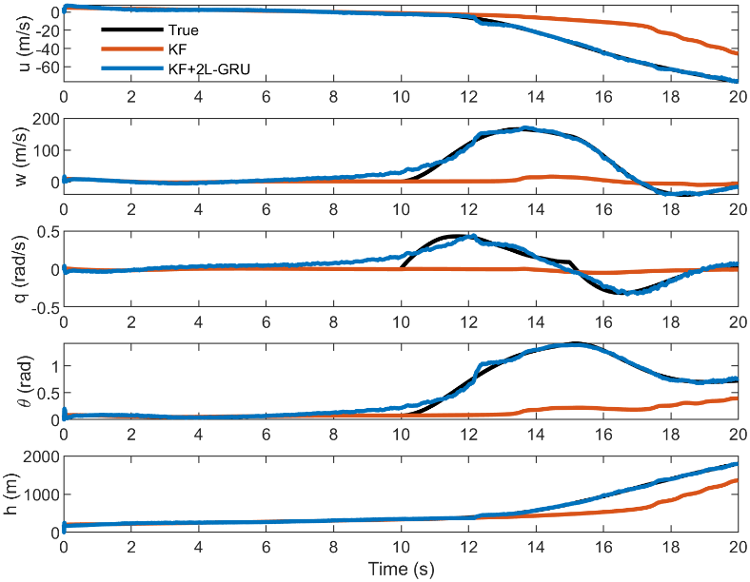
Figure 7: Compares all three estimators against ground truth across the full run.

Figure 8 isolates the error magnitude directly, which makes the timing of the correction easier to see than the trajectory overlay alone. Outside the gust, both estimators stay within a few m/s and a few hundredths of a radian of truth, and the two error traces are difficult to distinguish confirming again that the GRU is inactive, not just small, during nominal flight. Inside the shaded gust window, the two traces diverge sharply: the KF's error grows for the first one to two seconds of the disturbance and then plateaus at an elevated level for the remainder of the window, since nothing in the filter's noise model changes to account for the new, structured error source. The hybrid estimator's error also rises briefly at gust onset it cannot have zero lag, since it has no advance knowledge of the disturbance but it is pulled back down almost immediately and stays tightly bounded for the rest of the window. This pattern, a fast rise followed by an immediate correction rather than a slow decay, is the clearest evidence in the paper that the network has learned the shape of the disturbance itself rather than just a generic damping response.
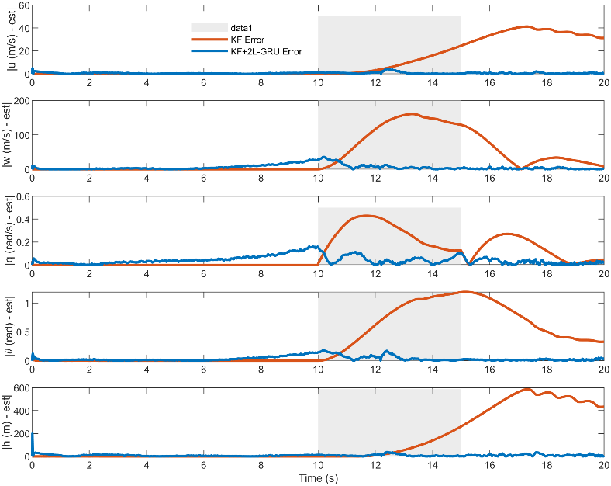
Figure 8: Error magnitude

Zooming into the transient (Fig. 9) makes the onset dynamics easier to separate from the steady-state behavior already visible in Figures 7 and 8. All three estimators show a brief lag during the rapid ramp-up between 10 and 11 s, which is expected and, in fact, reassuring a network with zero lag at this timescale would suggest it had learned to anticipate the gust from timing alone, which would not generalize to gusts with different onset times. What differentiates the estimators is what happens immediately after that initial lag. The baseline KF never recovers because its gain is tuned for the previous, gust-free innovation statistics, it continues to under-react to the now-larger innovations and accumulates bias for the remainder of the window. Both GRU variants recover almost immediately, and the stacked GRU tracks the peak of the disturbance most tightly of the three, with visibly less overshoot than the single-layer variant on the vertical-velocity and pitch channels the same cross-axis states where Table 1 shows the largest single versus two-layer gap.

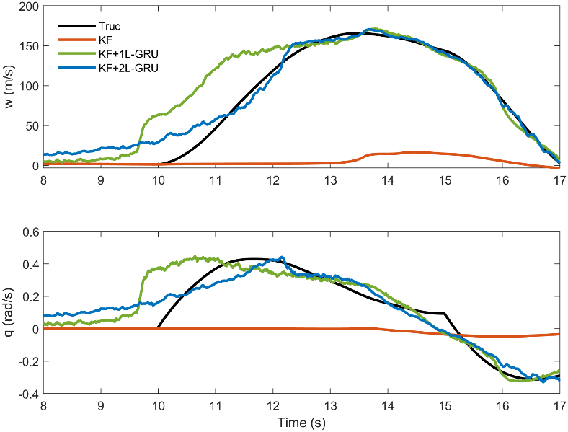
Figure 9: Zoomed view of the gust transient, all three estimators

The depth-ablation view (Fig. 10) exists mainly to make a point that is easy to miss when reading Table 1 one row at a time: the single versus two-layer gap is not concentrated in one or two states, it is present across all five simultaneously, and it is largest in exactly the states w, $θ$, and h that depend on the cross-axis coupling the smaller network cannot represent. Plotting all three estimators on a shared log scale makes this pattern visible at a glance rather than requiring the reader to compare five separate percentages. The practical implication is that the accuracy gained by adding a second GRU layer is not a matter of marginal fine-tuning; it reflects a genuine representational limit of the single-layer architecture on this problem, which is why the two-layer configuration is adopted as the proposed method rather than treated as an optional refinement.
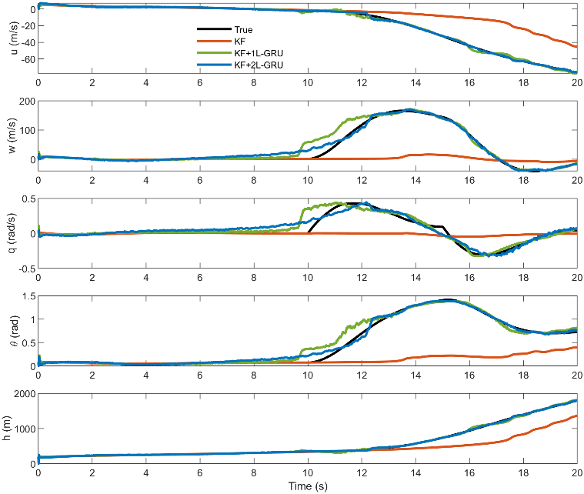
Figure 10: Depth ablation of all the states

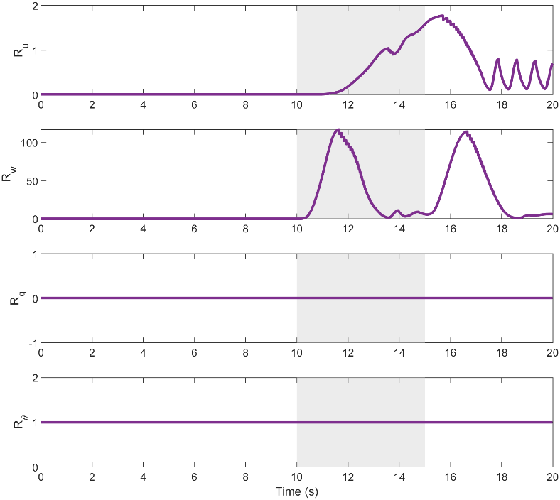
Figure 11: The adaptive-R mechanism

The adaptive-R mechanism (Fig. 11) is a separate line of defense from the GRU correction, and Figure 6 shows it operating independently and consistently with its design intent. During gust-free cruise, both $R_{u}$ and $R_{w}$ stay near their nominal floor, which keeps the filter appropriately confident and prevents it from over-reacting to ordinary sensor noise. As soon as the gust raises the empirical innovation covariance above what the filter predicted, R inflates within roughly the width of the rolling averaging window, which down-weights the now-less-trustworthy innovations rather than letting them drive the gain to an inappropriate value. Once the disturbance ends, R relaxes back toward its nominal value smoothly rather than abruptly, avoiding the oscillation that a more aggressive adaptation rule could introduce. The fact that this adjustment happens automatically, without any gust detector or manually scheduled gain, is what allows the same filter configuration to perform well in both the gust-free and gust-active portions of the run shown in Figures 7 and 8.

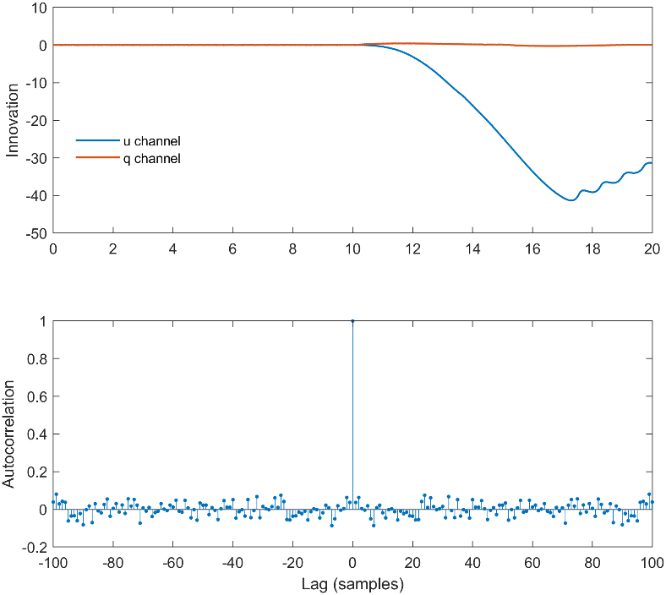
Figure 12: Innovation time series and autocorrelation

Finally, innovation whitening (Fig. 12) is the diagnostic that ties the earlier trajectory-based results back to a formal statistical property of the filter, rather than relying on visual inspection alone. A correctly tuned Kalman filter should produce innovations that are white noise uncorrelated from one time step to the next because any remaining correlation implies there is structure in the error that the filter has not accounted for and could, in principle, still correct. The raw KF innovations retain visible autocorrelation during the gust window, which is the formal signature of exactly the model mismatch described qualitatively in Figures 7 through 9: the filter's noise assumptions do not match the disturbance it is experiencing. Once the GRU correction is applied, the residual autocorrelation collapses toward zero across the same lag range, meaning the network has removed the correlated, predictable part of the error rather than simply reducing its magnitude by averaging. This distinction matters for certification-style diagnostics: a filter whose innovations remain white under disturbance is one whose behaviour can still be characterized by the same statistical tools used to validate it under nominal conditions, which is the property this section's results are ultimately building toward.

8. Conclusion
This paper presented a hybrid aircraft state estimation framework that combines an Adaptive Kalman Filter (AKF) with a lightweight two-layer GRU residual network to improve estimation accuracy under atmospheric gust disturbances. The AKF provides robust state estimation based on the system dynamics, while the GRU learns and compensates for residual modeling errors that are not captured by the filter. Simulation results on a five-state longitudinal aircraft model demonstrate that the proposed AKF-GRU estimator consistently outperforms the standalone AKF and the single-layer GRU architecture, achieving significant reductions in estimation error across all states while requiring fewer than 2,000 trainable parameters.
The results show that combining model-based estimation with data-driven residual learning provides a computationally efficient and accurate solution for aircraft state estimation under uncertain operating conditions. The two-layer GRU effectively captures temporal dependencies in the residual dynamics, leading to improved robustness during gust disturbances without modifying the underlying Kalman filtering framework.
Future work will focus on validating the proposed approach under more realistic turbulence models such as Dryden and Von Kármán, evaluating performance over multiple flight scenarios with independent training and testing datasets, and extending the framework to nonlinear aircraft dynamics using Extended and Unscented Kalman Filters. Experimental validation using real flight-test data will also be investigated to assess practical applicability.

9. References
- G. Revach, N. Shlezinger, X. Ni, A. L. Escoriza, R. J. G. van Sloun, and Y. C. Eldar, "KalmanNet: Neural network aided Kalman filtering for linear systems," IEEE Signal Processing Letters, vol. 29, pp. 1341–1345, 2022.
- R. G. Krishnan, U. Shalit, and D. Sontag, "Deep Kalman filters," in Proc. NIPS Workshop on Advances in Approximate Bayesian Inference, Montreal, Canada, Dec. 2015.
- R. J. Stengel, Flight Dynamics. Princeton University Press, Princeton, NJ, 2004.
- R. C. Nelson, Flight Stability and Automatic Control, 2nd ed. McGraw-Hill, New York, 1998.
- U.S. Department of Defense, MIL-HDBK-1797: Flying Qualities of Piloted Aircraft, Dec. 1997.
- Y. Bar-Shalom, X. R. Li, and T. Kirubarajan, Estimation with Applications to Tracking and Navigation. Wiley, Hoboken, NJ, 2001.
- M. S. Grewal and A. P. Andrews, Kalman Filtering: Theory and Practice with MATLAB, 4th ed. Wiley, Hoboken, NJ, 2015.
- S. Hochreiter and J. Schmidhuber, "Long short-term memory," Neural Computation, vol. 9, no. 8, pp. 1735–1780, Nov. 1997.
- K. Cho, B. van Merrienboer, D. Bahdanau, and Y. Bengio, "Learning phrase representations using RNN encoder–decoder for statistical machine translation," in Proc. EMNLP, Doha, Qatar, Oct. 2014, pp. 1724–1734.
- A. Gupta et al., "Neural aided Kalman filtering for UAV state estimation in degraded sensing environments," arXiv:2604.28107, Apr. 2026.
- X. Glorot and Y. Bengio, "Understanding the difficulty of training deep feedforward neural networks," in Proc. AISTATS, Sardinia, Italy, May 2010, pp. 249–256.
- S. Feng, X. Li, S. Zhang, Z. Jian, H. Duan, and Z. Wang, "A review: State estimation based on hybrid models of Kalman filter and neural network," Systems Science & Control Engineering, vol. 11, p. 2173682, 2023.
- R. E. Kalman, "A new approach to linear filtering and prediction problems," Transactions of the ASME – Journal of Basic Engineering, vol. 82, pp. 35–45, 1960.
- J. P. How, Aircraft Longitudinal Dynamics, MIT OpenCourseWare, Department of Aeronautics and Astronautics, Massachusetts Institute of Technology, Cambridge, MA, USA, Course 16.333 Aircraft Stability and Control, Lecture Notes, 2004

