Physics-Guided Residual Learning with Recurrent Neural Network (RNN) for Enhanced Aircraft State Estimation Under Atmospheric Gusts

Abstract-This paper presents a hybrid physics and data-driven framework for the state estimation of an aircraft longitudinal flight model operating under unknown atmospheric gust disturbances. The proposed architecture combines a discrete-time Kalman Filter (KF) augmented with random-walk gust states and adaptive measurement-noise covariance estimation with a two-layer Gated Recurrent Unit (GRU) residual observer. The KF provides physically interpretable state estimates and disturbance tracking, while the GRU learns the structured residual dynamics that cannot be fully captured by the linear aircraft model. The estimator operates on a five-state longitudinal model comprising forward velocity, vertical velocity, pitch rate, pitch angle, and altitude, discretized at 100 Hz. The GRU receives KF state estimates and control-input derivatives as inputs and generates an additive correction to the KF prediction. The network is trained using backpropagation through time over a 20-second simulated flight trajectory containing a structured gust disturbance window. Simulation results demonstrate that the proposed hybrid estimator significantly improves estimation accuracy relative to a standalone Kalman Filter, achieving RMSE reductions of 76.2% in vertical velocity, 64.5% in pitch rate, 77.8% in pitch angle, and 50.4% in altitude. These results indicate that the GRU effectively captures gust-induced temporal correlations while preserving the robustness, interpretability, and uncertainty-propagation properties of the underlying Kalman Filter. The proposed framework provides a computationally lightweight approach for enhancing aircraft state estimation in the presence of unmodelled atmospheric disturbances.

Keywords: Kalman Filter, Recurrent Neural Networks, Gated Recurrent Unit, longitudinal dynamics, Atmospheric gust

1. Introduction
Every modern commercial aircraft relies on some form of recursive state estimator to feed reliable state information to autopilot systems, structural health monitors, and ground-based situational awareness tools. The linearized longitudinal dynamics of a large transport aircraft at cruise are well characterized, and under nominal conditions a properly tuned Kalman filter provides near-optimal performance with only modest computational overhead. The trouble begins as soon as the aircraft encounters an atmospheric gust.
The disappearance of Malaysia Airlines MH370 in 2014 underscored the critical challenge of accurately reconstructing an aircraft’s state trajectory in the absence of continuous telemetry, particularly over oceanic airspace where radar coverage is limited. In such scenarios, ground-station-in-the-loop architectures must rely on noisy, bandwidth-limited measurement streams often intermittent satellite data to estimate the full aircraft state. This task is complicated by unknown atmospheric disturbances, such as gusts, which introduce structured, time-correlated effects that violate the white-noise assumptions of traditional Kalman Filters (KF). When such a disturbance is active, Kalman’s filter innovation sequence (difference between prediction and sensor measurements) becomes persistently biased. The filter tries to absorb the bias by inflating its gain, which in turn amplifies measurement noise and degrades all state estimates simultaneously. States that are not directly measured, like altitude in particular suffer the most because biased intermediate estimates accumulate through kinematic integration. As a result, standalone KFs can produce biased and inaccurate state estimates, degrading situational awareness and control.
To address this, the paper proposes a hybrid physics-guided and data-driven framework that combines an augmented discrete-time KF with random-walk gust states and adaptive measurement-noise covariance estimation, alongside a two-layer Gated Recurrent Unit (GRU) residual observer. The GRU is trained to learn and correct the structured residual errors left unmodeled by the KF, effectively capturing gust-induced temporal correlations. This hybrid approach preserves the interpretability and uncertainty propagation of the KF while significantly improving estimation accuracy under unknown disturbances, providing a computationally efficient solution suitable for real-time aircraft state estimation in challenging operational environments.

The standard physics-based solution is state augmented which append the gust components to the state vector and model them as random walk processes. This works well when the gust can be treated as slowly varying relative to the estimation bandwidth, but it struggles with time varying amplitude or spectrally rich turbulence. A more recent family of hybrid approaches replaces internal Kalman filter components, the gain or the state transition model with learned surrogates [1,2]. These methods improve accuracy but at the cost of interpreting or discarding the uncertainty propagation of the filter.
The present work takes a deliberately conservative design stance. The Kalman filter is left completely intact, its gain, state transition and covariance update and a small GRU is inserted after the filter’s one step ahead prediction to add a residual correction. The GRU sees the filter’s current state estimates and the derivates of the control inputs; it outputs an additive vector that compensates for the structural model error the filter cannot represent. Because the target for learning is only a residual rather than the full state, the network generalizes from very short training sequences and is stable by construction: a zero correction GRU recovers exactly the Kalman filter.
The paper makes three contributions, first it introduces the additive residual architecture and explains why grounding the correction to the Kalman prediction is critical for numerical stability. Secondly it derives an online adaptive measurement noise estimator that prevents the filter from drifting when the gust is not active. Third, it demonstrates quantitatively, on a high-fidelity aircraft longitudinal model, that large parameters are sufficient to cut estimation error roughly in half across all affected states.

2. Related Work

2.1 Physics-Based Gust and Disturbance Estimation
State augmentation is a well-established approach in aerospace for integrating atmospheric wind and turbulence effects into aircraft state estimation. Early works by Stengel [3] and Nelson [4] appended wind components modeled as random walks to the aircraft flight dynamics state vector to capture gust disturbances. More refined strategies employ shaping filters parameterized by Dryden or von Karman spectral models [5], offering physically motivated disturbance frequency content but requiring prior spectral knowledge. The Interacting Multiple Model (IMM) filter [6] extends robustness by maintaining a bank of filters tuned to different disturbance regimes, yet demands a priori specification of all plausible modes and incurs significant computational overhead.
Adaptive Kalman Filter variants implement online tuning of process or measurement noise covariances based on innovation statistics [7]. However, simultaneous identification of these covariance matrices remains ill-conditioned without additional regularization. The present work circumvents this difficulty by fixing the process noise and adapting measurement noise covariance online, enabling stable and responsive disturbance tracking.
2.2 Data-Driven and Recurrent Neural Network Approaches in Aerospace Estimation
Recurrent Neural Networks (RNNs), particularly Long Short-Term Memory (LSTM) and Gated Recurrent Units (GRU), have found growing applications in aeronautical state estimation tasks, including inertial navigation and GPS-denied flight [8, 9]. These networks leverage their inherent memory to suppress long-term drift and model temporal correlations in sensor data. GRUs provide computationally efficient alternatives with fewer gates and parameters, suitable for embedded avionics.
Despite impressive performance, purely data-driven estimators typically lack uncertainty quantification, posing safety and certification challenges for flight-critical systems.
2.3 Hybrid Kalman Filter and Neural Network Architectures
Recent research has focused on integrating neural networks with Kalman filtering to blend model-based rigor with data-driven adaptability. Approaches such as KalmanNet [1] replace the Kalman gain with a learned, adaptive network, enhancing responsiveness to non-stationary noise but compromising classic covariance interpretations. Deep Kalman Filters [2] substitute the linear state transition model with latent neural dynamics, increasing modeling complexity at the expense of physical interpretability.
Bayesian Neural Kalman Filters [10] combine probabilistic neural models with filtering to provide uncertainty estimates, advancing safety in degraded sensing environments.
Contrasting these methods, the framework presented in this paper preserves the Kalman filter structure entirely, incorporating a GRU-based residual correction post-prediction. This additive residual learning targets structured, temporally correlated gust disturbances without altering filter internals, enabling robust uncertainty propagation and interpretability.

$KalmanNet$

3. Aircraft Longitudinal Model and Atmospheric Gust Disturbance
A) Aircraft Dynamic Description:
The aircraft longitudinal dynamics are modeled using a standard small-perturbation linearization for a aircraft [XX] at cruise conditions (Forward Velocity (U₀) = 235.9 m/s, air density (ρ) = 0.3045 kg/m³, pitch angle (θ₀) = 0). The state vector comprises of five variables $x={\left[u,w,q,θ,h\right]}^{T}$ i.e. forward velocity perturbation u (m/s), vertical velocity w (m/s), pitch rate q (rad/s), pitch angle θ (rad), and altitude h (m). The $continuous-time$ dynamics are expressed in state space form:
$$\dot{x}=A_{c}x+B_{c}u+B_{w}ω_{g}$$
x is the state vector, $x={\left[u,w,q,θ,h\right]}^{T}$, $u={\left[δ_{e},δ_{p}\right]}^{T}$is the control vector (elevator deflection and normalized thrust perturbation), and $w_{g}={\left[u_{g},w_{g},q_{g}\right]}^{T}$ is the unknown gust input vector entering through the gust influence matrix $B_{w}$.
The altitude state $\dot{h}=-w+U_{0} θ$ evolves through a kinematic relation appended via a small-angle approximation.

$\dot{h}=-w+U_{0} θ$. Expanding the state-space equation into its individual matrix components yields:
$$\left[\begin{matrix}u^{.} \\ w^{.} \\ q^{.} \\ θ^{.} \\ h^{.}\end{matrix}\right]=\left[\begin{matrix}X_{u} & X_{w} & 0 & -g\cos{γ} & 0 \\ Z_{u} & Z_{w} & U_{0} & -g\sin{γ} & 0 \\ M_{u} & M_{w} & M_{q} & 0 & 0 \\ 0 & 0 & 1 & 0 & 0 \\ -\sin{γ} & \cos{γ} & 0 & U_{0}\cos{γ} & 0\end{matrix}\right]\left[\begin{matrix}u \\ w \\ q \\ θ \\ h\end{matrix}\right]+\left[\begin{matrix}X_{δe} & X_{δp} \\ Z_{δe} & Z_{δp} \\ M_{δe} & M_{δp} \\ 0 & 0\end{matrix}\right]\left[\begin{matrix}δ_{e}δ_{p}\end{matrix}\right] + \left[\begin{matrix}\begin{matrix}{-X}_{u} & {-X}_{w} & 0 \\ {-Z}_{u} & -Z_{w} & 0 \\ -M_{u} & -M_{w} & -M_{q} \\ 0 & 0 & 0 \\ 0 & 0 & 0\end{matrix}\end{matrix}\right]\left[\begin{matrix}u_{g} \\ w_{g} \\ q_{g} \\ \end{matrix}\right]$$
3.2 Gust Disturbance Modeling
The atmospheric gust is modeled as an unknown disturbance vector with three components i.e. 1 Hz sinusoidal headwind gust with ±10 m/s peak amplitude, 1 Hz vertical gust cosine component with ±5 m/s peak amplitude and constant pitch-rate gust of 1.5 rad/s
The gust is injected between at t = 10 s and t = 15s, outside this window, the gust is zero. Notably, no gust measurements or feedforward signals are available to the estimator, simulating realistic operational scenarios where the ground station must infer disturbances solely from sensor data.
3.3 Discretization and Sample Rate Considerations
The continuous-time dynamics are discretized at a 100 Hz sample rate via zero-order hold to produce discrete matrices $A_{d}$ and $B_{d}$. This sampling frequency adequately resolves the short-period mode of the system (natural frequency ~0.9 rad/s) with negligible phase delay introduced by discretization. The five-state augmented system including gust components forms the basis for state estimation using the Kalman filter and GRU residual observer.

$A_{d}$$B_{d}$
$B_{w}$

4. Kalman Filter Design with Online Noise Adaptation

4.1 State Augmentation
Because the estimator does not observe the gust vector directly, three additional states are appended, one for each gust component and modelled as random walks. The augmented state vector $x∈R^{8}$therefore contains the five flight states plus three gust estimates [$u_{g},w_{g},q_{g}$]. The augmented state-transition matrix is block-diagonal, with the original discrete model Ad in the upper-left and a 3×3 identity block in the lower-right. The measurement matrix selects only the first five states, since the sensors observe flight states rather than gusts. The corresponding filter block diagram is shown in Fig. 1.
The process-noise covariance $\tilde{Q}$ ($\tilde{Q}=diag(Q_{kf},Q_{g}$)) is block-diagonal. The flight-state block uses tight values (on the order of 10⁻¹⁰ to 10⁻¹³) reflecting high confidence in the nominal physics model, while the gust block uses unit diagonal entries, allowing gust estimates to change by order-one amounts per step making the filter responsive to the 1 Hz sinusoidal disturbances.

4.2 Predict–Update Equations
The filter runs the standard predict–update cycle at every 10 $ms$ sample. The prediction propagates the augmented state and covariance forward through Ad. The innovation is formed as the difference between the four available measurements (forward velocity, vertical velocity, pitch rate, and pitch angle, altitude is not directly measured) and the predicted measurement. The Kalman gain is computed from the innovation covariance, and the update uses the numerically stable Joseph form for the covariance to prevent negative definiteness from accumulating over thousands of steps.
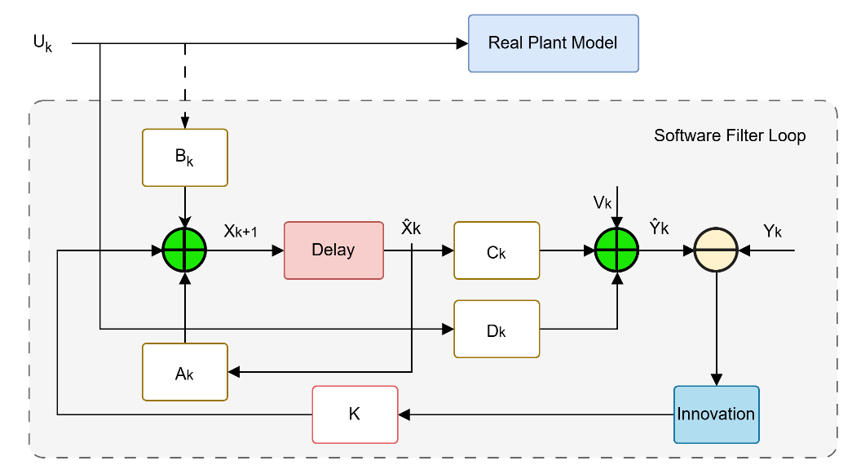
Figure 1: Block diagram of the software Kalman filter loop. The predicted state is propagated through the delay and augmented dynamics (Ak, Bk), corrected using the measurement model (Ck, Dk), and updated through the innovation-driven gain K to produce the filtered output.
Prediction:
${\hat{\tilde{x}}}_{k|k-1}={\tilde{A}}_{d}{\hat{\tilde{x}}}_{k-1}+{\tilde{B}}_{d}u_{k}$
$${\tilde{P}}_{k|k-1}={\tilde{A}}_{d}{\tilde{P}}_{k-1}{\tilde{A}}_{d}^{T} + \tilde{Q}$$
Innovation and Kalman Gain:
${\tilde{Y}}_{k}=z_{k}-\tilde{C}{\hat{\tilde{x}}}_{k|k-1}$
$S_{k}=\tilde{C}{\tilde{P}}_{k|k-1}{\tilde{C}}^{T}+R_{k}$
$K_{k}={\tilde{P}}_{k|k-1}{\tilde{C}}^{T}S_{k}^{-1}$

Update:
$${\hat{\tilde{x}}}_{k}={\hat{\tilde{x}}}_{k|k-1}+K_{k}{\tilde{y}}_{k}$$
$$P_{k}=\left(I-K_{k}\tilde{C}\right)P_{k|k-1}{\left(I-K_{k}\tilde{C}\right)}^{T}+K_{k}R_{k}K_{k}^{T}$$

4.3 Adaptive Online Measurement-Noise Adaptation
A persistent problem with fixed-noise Kalman filters is that the measurement-noise matrix R is tuned for one operating condition. When the aircraft is in steady cruise with low vibration, using the design value of R may over-smooth the innovation signal; during turbulence it may be too optimistic. A rolling 50-sample window tracks the empirical innovation covariance. When this empirical covariance exceeds the filter's predicted innovation covariance indicating that the filter is under-estimating measurement noise R is inflated toward the empirical value using a first-order exponential smoother with a forgetting factor of 0.95. When the filter is well-calibrated, R relaxes back toward its nominal design value. A minimum-value floor of 10⁻⁸ on each diagonal entry prevents numerical issues during gust-free cruise. This mechanism stabilizes the filter's gain trajectory across different flight phases without requiring manual re-tuning.

5. Gated Recurrent Unit (GRU) Residual Observer

5.2 Architecture Motivation and Overview
The Kalman filter assumes Gaussian, memoryless noise and cannot capture the structured, temporally correlated residual errors induced by sinusoidal gusts. The GRU residual observer learns these structured residual dynamics by taking as input the KF state predictions and control input derivatives, and outputting additive corrections to the KF prediction. This hybrid approach preserves the KF's interpretability and uncertainty propagation, while leveraging the representational power of recurrent neural networks.

5.1 Architecture Motivation and Overview
The KF provides a physically grounded prediction ${\hat{x}}_{k+1}^{KF}=A_{d}{\hat{x}}^{KF}+B_{d}u_{k}$but cannot represent temporal correlations induced by the sinusoidal gust because its process noise model is Gaussian and memoryless.
The GRU residual observer fills this gap.

5.2 Network Architecture
The internal cell structure of the GRU is illustrated in Fig. 2. At each time step the GRU input is
$$v_{k}=\left[{\hat{x}}_{k}^{KF};{\dot{u}}_{k}\right] ϵ R^{7}$$
where the five KF state estimates are concatenated with the two control-input time derivatives ${\dot{u}}_{k}$. Including ${\dot{u}}_{k}$ gives the GRU access to the rate of change of the elevator and thrust commands, which are strongly correlated with the aerodynamic transients induced by gust onset and recovery.
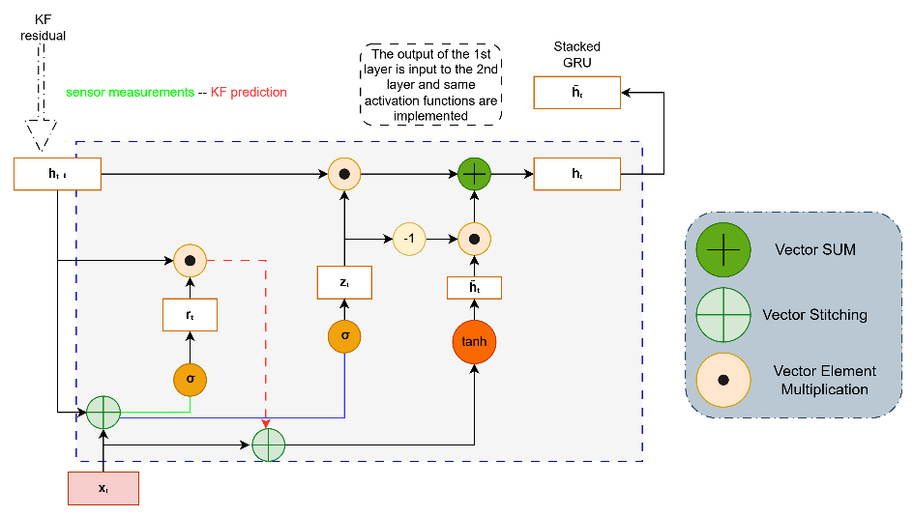
Figure 2: Internal cell architecture of the Gated Recurrent Unit (GRU) correction layer. The diagram details the combination of the previous hidden state $h_{t-1}$and input features $x_{t}$ using the reset gate $r_{t}$ and the update gate $z_{t}$, illustrating how the two-gate mechanism selectively retains and forgets sequence context to learn the structured gust-induced residual.

The two-layer architecture uses $n_{h1} = 8$ hidden units in layer 1 and $n_{h2} = 16$ hidden units in layer 2, with a linear output layer mapping to five state corrections. Layer 1’s forward pass at step $k$ is:
$$r_{1}=σ\left(W_{r1}{\overline{v}}_{k}+U_{r1}h_{1}^{(k-1)}+b_{r1}\right)$$
$$z_{1}=σ\left(W_{z1}{\overline{v}}_{k}+U_{z1}h_{1}^{(k-1)}+b_{z1}\right)$$
$${\tilde{h}}_{1}=tanh(W_{h1}{\overline{v}}_{k}+U_{h1}\left(r_{1}⊙h_{1}^{(k-1)}\right)+b_{h1})$$
$$h_{1}^{(k)}=\left(1-z_{1}\right)⊙h_{1}^{(k-1)}+z_{1}⊙{\tilde{h}}_{1})$$
where $σ\left(·\right)$ is the element-wise sigmoid, $⊙$ is the Hadamard product, and ${\overline{v}}_{k}$ is the min-max normalized input. Layer 2 follows the same pattern with h(k) 1 as its input. The output layer produces the raw residual prediction:
${\hat{y}}_{k}=W_{y}h_{2}^{(k)}+b_{y} ϵ R^{5}$
As Illustrated in Fig 3 (training block), The choice of two layers reflects a deliberate trade-off. A single layer with eight units is expressive enough to capture simple periodic patterns but struggles with the onset and decay transients of the gust window, where the reset gate must simultaneously unlearn the $pre-gust$ periodic state and rapidly acquire the transient dynamics. A second layer with sixteen units doubling the recurrent parameter count, captures multi-step correlations while keeping the total network well below 2,000 parameters. This compares favorably with$KalmanNet$ [1] and Deep Kalman Filters [2], which typically require orders of magnitude more parameters because they must represent the full state-estimation mapping rather than a small, structured residual.
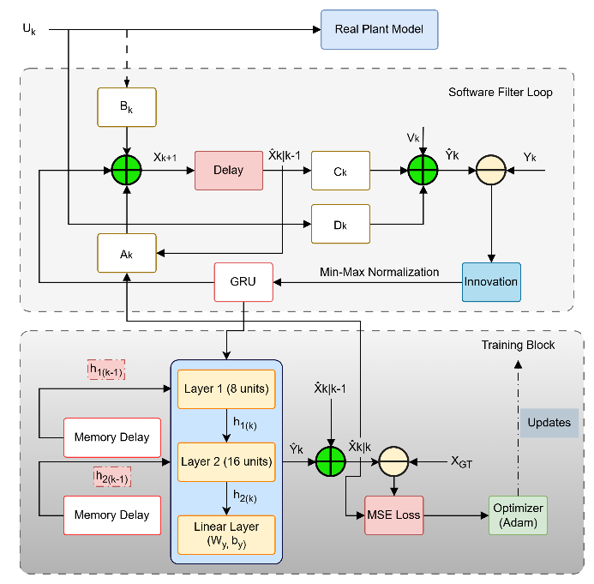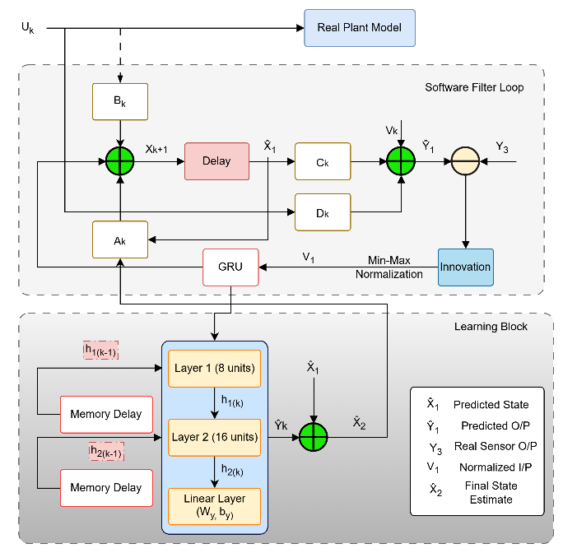
Figure 3: Training block architecture, showing the stacked two-layer GRU trained offline via backpropagation through time, with the Kalman filter gain and state prediction supplied as inputs. Figure 4: Learning block architecture, showing the trained GRU integrated with the Kalman filter gain during inference to generate the final corrected state estimate.

5.3 Input Normalization and Target Scaling
All inputs are min-max normalized to $[-1,+1]$ using statistics computed over the full training trajectory:
$${\overline{υ}}_{k,i}=\frac{2(v_{k,i} - v_{min,i})}{v_{max,i} - v_{min,i}} - 1$$
with range components smaller than 10−8 clamped to avoid division by zero. The training target at step k is the one-step-ahead residual normalised by a per-state scale vector $σ_{tgt}={\left[5,5,0.1,0.1,500\right]}^{T}:$
$$y_{k}^{*}=\frac{x_{k+1}^{true} - (A_{d}{\hat{x}}_{k}^{KF} +B_{d}u_{k})}{σ_{tgt}}$$

The scales reflect the expected order of magnitude of the gust-induced residual in each state: large for velocities $(∼5-10 m/s$), small for angular rates ($∼0.1 rad/s$), and large for altitude $(∼500 m$ over the trajectory). Without this per-state normalization the altitude residual, naturally larger in absolute terms would dominate training, causing the network to neglect the subtler pitch-rate and pitch-angle corrections.

5.4 Training via Backpropagation Through Time
The MSE loss over the full N-step trajectory is:
$$L=\frac{1}{N-2}{\sum_{k=2}^{N-1}{ }}^{ }{\left\|{{\hat{y}}_{k} - y}_{k}^{*}\right\|}^{2}$$
Gradients are computed by full BPTT with no truncation. For layer 2 the gate gradients at step $k$ are:
$$δ_{z2}=\frac{∂L}{∂h_{2}}⊙\left({\tilde{h}}_{2}-h_{2}^{(k-1)}\right)⊙σ^{'}(z_{2})$$
$$δ_{{\tilde{h}}_{2}}=\frac{∂L}{∂h_{2}}⊙z_{2}⊙tanh^{'}({\tilde{h}}_{2})$$
$$δ_{r2}=(U_{h2}^{T}δ_{{\tilde{h}}_{2}})⊙\left(h_{2}^{(k-1)}\right)⊙σ^{'}(r_{2})$$
The gradient into layer 1 is assembled from all three gate contributions: ${∂L}/{∂h_{1}^{(k)}}=W_{z2}^{T}δ_{z2}+W_{{\tilde{h}}_{2}}^{T}δ_{z2}+W_{r2}^{T}δ_{r2}$. Layer-1 gate gradients follow the same pattern with normalized input ${\overline{v}}_{k}$as the external input.
All weights are updated with vanilla SGD at a fixed learning rate $η={10}^{4}$ No momentum or adaptive methods are used: the small network and small normalized residual targets mean that adaptive optimizers offer no benefit and introduce the risk of over-adapting to trajectory-specific noise. Weights are initialized using Xavier uniform initialization [11], which keeps gradient magnitudes well-conditioned early in training.

5.5 Inference and State Correction
At inference the corrected state estimate for step k + 1 is:
$${\hat{x}}_{k+1}^{GRU}=A_{d}{\hat{x}}_{k}^{KF}+B_{d}u_{k}+{\hat{y}}_{k}⊙σ_{tgt}$$
The correction is applied to $the KF$ prediction rather than the posterior. Adding a correction on top of the posterior would risk double-counting the measurement information: the filter has already incorporated sensor data through the Kalman update, so adding another signal there conflates model error with sensor noise. By targeting the prediction (30), the GRU output is logically equivalent to a pseudo-measurement with negligible noise on the model-error channel.
An alternative formulation that propagates ${\hat{x}}_{ }^{GRU}$ recursively through $A_{d}$ was tested and found to be numerically unstable: any error at step $k$ is amplified by $A_{d}$ at every subsequent step and eventually diverges. Grounding each correction to the KF prediction breaks this error accumulation chain and is essential for long-sequence stability. This inference-time configuration, in which the trained GRU operates alongside the Kalman filter gain to produce the final corrected estimate, is depicted in the learning block of Fig. 4.

6. Experimental Simulation

6.1 Simulation Parameters
The simulation runs for $T = 20 s$ at $Ts=0.01s\left(100Hz\right)$, giving $N = 2,000$ time steps. Initial conditions are $x_{0}={\left[5,10,0.01,0.08,200\right]}^{T},$ representing a small perturbation from a steady cruise trim. Control inputs are generated as a random walk $u_{k}=u_{k-1}+T_{s}\dot{u_{k}}$, where $\dot{u_{k}}∼0.01Ν(0,I_{2}),$ representing mild closed-loop autopilot excitation.
Sensor measurements are available for the first four states with additive white Gaussian noise at standard deviation 0.02 per channel:
$$z_{k}=Cx_{k}+0.02v_{k}, v_{k}∼N(0,I_{4})$$
where $C=\left[I_{4}0_{4x1}\right]$observes $u, w, q,$ and $θ$. Altitude $h$ is not directly measured; it must be propagated through the kinematic equation $h_{k+1}=h_{k}+T_{s}(-w_{k}+U_{0}θ_{k})$, which means any sustained bias in $\hat{ω} or \hat{θ}$during the gust window integrates forward and is difficult for the filter to correct quickly. This makes altitude the most challenging state for any estimator in this problem.

6.2 Gust Profile
A structured multi-component gust is active for t ∈ [10, 15] s, representing a 5-second burst of atmospheric turbulence:
$$w_{g,k}=\left\{\begin{aligned}{\left[10sin\left(2πkT_{s}\right), 5cos(2πkT_{s}), 1.5\right]}^{T}, & kT_{s} ϵ [10,15] \\ 0 , &otherwise\end{aligned}\right.$$
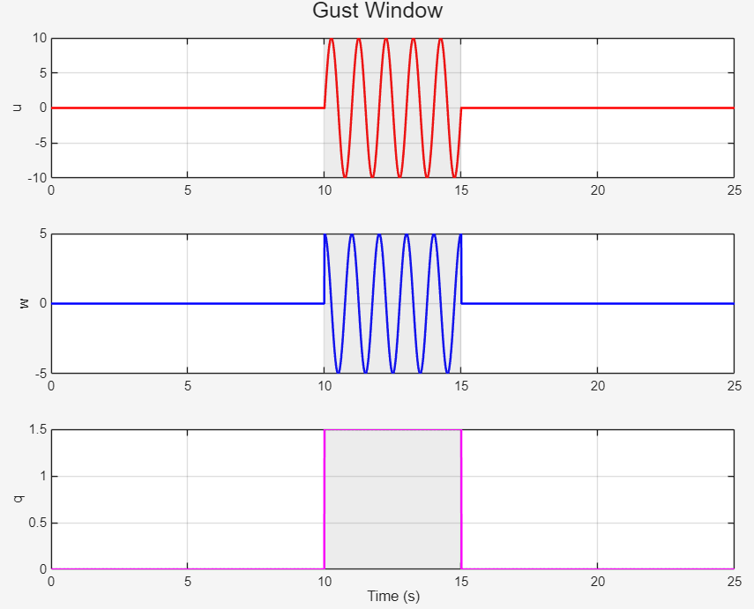
The sinusoidal axial and vertical components model a 1 Hz periodic gust cell. The constant pitch-rate component represents a sustained trim upset. Critically, neither the gust profile, its frequency, nor the matrix $B_{w,d}$ is provided to the estimator. All gust information must be inferred from sensor innovations alone.

6.3 Baseline and Evaluation Metric
The baseline estimator is the standalone augmented KF described in Section 4 with online adaptive R. The proposed method adds the trained GRU correction on top of the same KF. Additionally, a single-layer GRU variant (8 hidden units, 1,085 parameters) is evaluated to quantify the benefit of the second layer. Root-mean-square error (RMSE) is computed over all 2,000 steps, so the reported numbers reflect the combined ability to track during the disturbance and recover cleanly after it ends.
Three estimators are evaluated:
- Baseline augmented Kalman filter (KF) with online adaptive measurement noise covariance.
- KF plus single-layer GRU residual observer (8 hidden units).
- KF plus stacked two-layer GRU residual observer (8 + 16 hidden units).

6.4 Performance Metrics
Root-mean-square error (RMSE) over the full 20-second simulation is computed for each state to quantify estimator accuracy.

7. Results

7.1 Impact of Network Depth on Estimation Performance

The single-layer GRU degrades altitude estimation severely, increasing RMSE nearly fivefold due to inability to decouple cross-axis dynamics. The two-layer stacked GRU overcomes this limitation by modeling multi-step temporal correlations.

7.2 Training Convergence

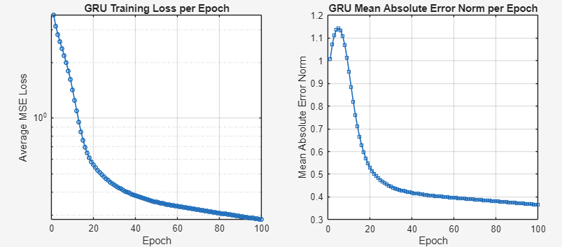
Figure 6: Normalized training MSE loss versus epoch for the stacked GRU. The loss drops from ≈ 0.8 at random initialization to below 0.01 within 30 epochs and stabilizes near 0.003 by epoch 100, indicating that the network has captured the dominant gust signature rather than memorizing noise.

The normalized MSE loss drops from approximately 0.8 at random initialization to below 0.01 within 30 epochs, at which point further training yields diminishing returns. The per-state means absolute residual error at convergence is well below ${10}^{-2}$ for all five states in normalized units. This fast convergence on a single 20-second trajectory is a direct consequence of the residual architecture: the GRU learns only what the physics model gets wrong, not the full state dynamics from scratch

7.3 State Estimation Accuracy
Table 1 reports RMSE for all three estimator configurations across all five states. The stacked KF+GRU hybrid improves accuracy for every state except forward velocity, where the Kalman filter’s augmented gust state already absorbs most of the headwind disturbance.

Table 1: Root-Mean-Square Error comparison over the full 20-second simulation (t ∈ [Ts, T]).
State | Unit | KF | Single GRU | Stacked GRU
$u$ (forward velocity) | m/s | 0.108 | 5.612 | 0.113
$w$ (vertical velocity) | m/s | 7.678 | 7.332 | 1.553
$q$ (pitch rate) | rad/s | 0.110 | 0.108 | 0.036
$θ$ (pitch angle) | rad | 0.035 | 0.033 | 0.007
$h$ (altitude) | m | 9.684 | 46.367 | 4.931

The pattern of improvement is physically interpretable. The 1 Hz sinusoidal gust drives periodic oscillations in $w, q$, and $θ$ at a frequency at which the GRU’s hidden state can learn a periodic attractor after only a few cycles. Altitude improves because the accumulated kinematic integration bias driven by sustained errors in $\hat{ω} and \hat{θ}$ during the gust window, is substantially reduced once those upstream states are corrected. Forward velocity shows little net benefit because the headwind gust amplitude $(±10 m/s)$ is small relative to the 235.9 m/s cruise speed, so the KF’s random-walk gust state gu already absorbs most of the disturbance.
The single-layer GRU result is striking it degrades altitude RMSE from 9.684 m to 46.4 m, a nearly fivefold increase. This occurs because a single shallow layer lacks the mapping capacity to decouple the cross-axis aerodynamic interactions during gust onset, and its erroneous corrections to u propagate through the kinematic integration to produce large altitude drift. The second GRU layer captures the multi-step dependency between pitch dynamics and altitude accumulation that the single layer misses.

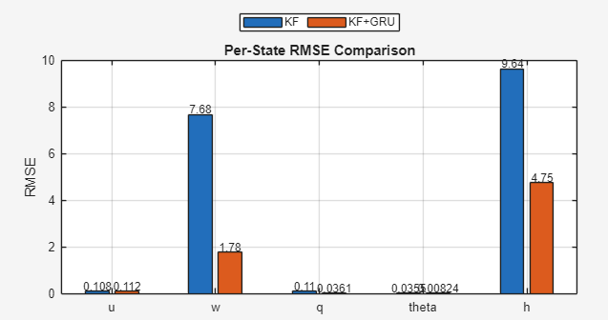
Figure 3: Per-state RMSE comparison between the standalone KF (blue) and the KF + Stacked GRU hybrid (orange), computed over the full 20-second simulation $t ∈ [Ts, T].$ The hybrid reduces RMSE for four of five states, with the largest improvements in w, θ, and q.
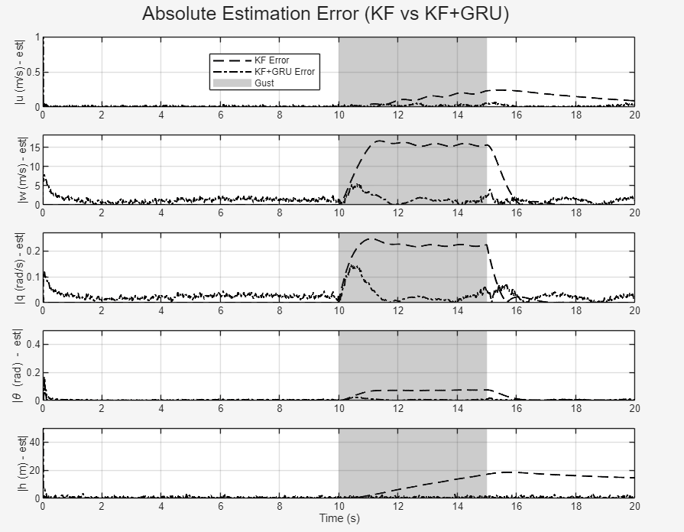
Figure 4: Per-state absolute estimation error over time for the standalone KF and the KF + Stacked GRU hybrid. The shaded band ($t ∈ [10, 15] s$) marks the injected aerodynamic disturbance. The hybrid reduces peak errors during the gust and converges faster after gust termination, particularly in w and h.

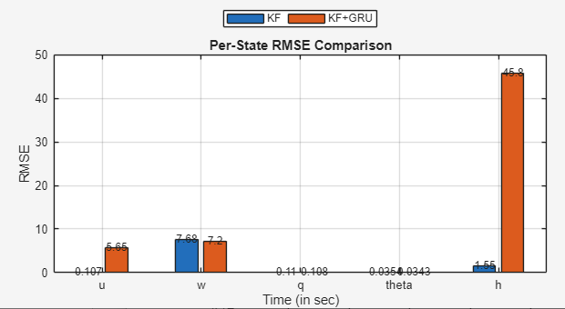
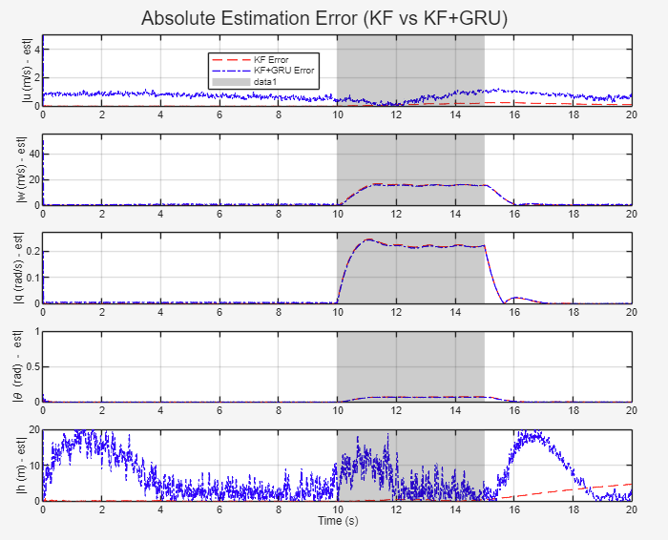
(b) Extended error-time plot showing all three esti mators. The single-layer GRU’s altitude divergence is clearly visible in the h panel.
(a) Alternative RMSE bar chart showing all three estimators (KF, Single-layer GRU, Stacked GRU) side by side.

Figure 5: Expanded state estimation comparison including the single-layer GRU baseline. The gust window t ∈ [10, 15] s is shaded in both panels.

${10}^{-2}$

7.4 Time-History Trajectory Analysis
Figures 7, 8, and 9 show the full state trajectories for the three estimators alongside the true plant state
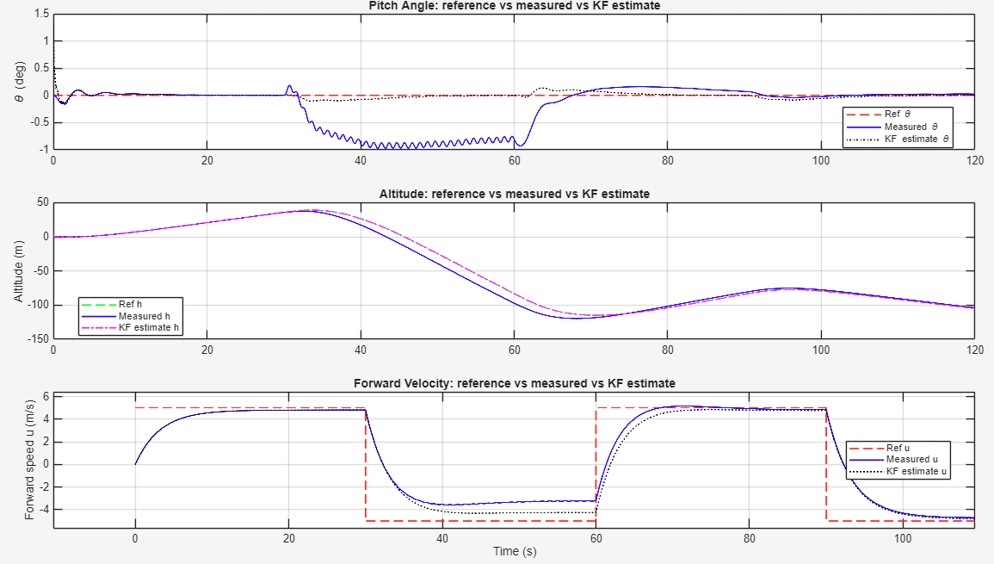
Figure 7: Time-history response of aircraft state tracking during the 120-second autopilot simulation. The commanded reference trajectory (dashed red), the noisy measured aircraft response (solid blue), and the KF state estimate (solid purple) are shown across pitch angle θ, altitude h, and forward velocity u.
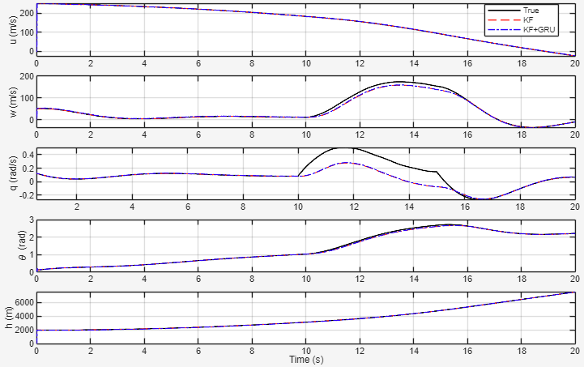
Figure 8: State estimation performance of the single-layer GRU hybrid. The five-state trajectories highlight the tracking limitations of the shallow architecture during the aerodynamic disturbance window (t ∈ [10, 15] s, shaded). The single-layer GRU fails to decouple cross-axis aerodynamic interactions, resulting in altitude drift that substantially exceeds the baseline KF.
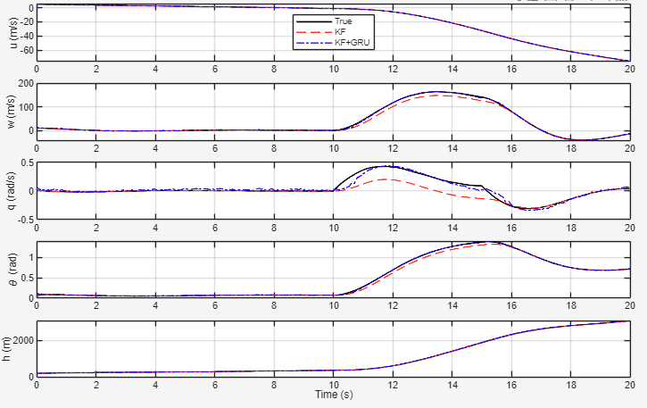
Figure 9: State estimation performance of the proposed stacked GRU hybrid. The model accurately recovers high-amplitude transient variations in pitch rate q and vertical velocity w during active gust injection, while maintaining clean tracking in u and h. post-gust recovery is smooth because the hidden states gradually forget the transient gust pattern.

Prior to gust onset ($t < 10 s$), all three configurations demonstrate stable, tightly coupled tracking across all states. The structural differences emerge sharply at gust onset.
The most critical divergence occurs in pitch rate $q$. When the localised wind shear reaches the aircraft, the true pitch rate spikes $to$ approximately $0.5 rad/s$. The baseline KF captures only about half of this peak amplitude, as its process noise model cannot represent the temporal correlation of the sinusoidal excitation. The single-layer GRU performs almost identically to the KF confirming that a shallow recurrent layer lacks the mapping capacity to decouple these fast rotational dynamics from raw innovation residuals. The stacked GRU tracks the true pitch-rate spike with high fidelity, matching both the peak amplitude and the abrupt gradient drop at gust termination.
A consistent pattern appears in $w and θ$. During the gust window, the single-layer GRU introduces no meaningful corrective offset and overlaps heavily with the uncorrected baseline the reset gate cannot isolate the nonlinear cross-axis coupling coefficients that govern these states under large-scale flow disturbances. The stacked GRU compensates dynamically: it bridges the gap between the filter output and ground truth, matching the peak vertical velocity while substantially reducing the phase lag visible in the KF trajectory.
Importantly, the tracking improvements in the pitching and vertical channels do not introduce cross-channel destabilization. Both $u and h$ maintain precise alignment throughout the simulation without uncoupled state divergence. Post-gust recovery is also smoother for the deep hybrid: because the stacked GRU corrections decay naturally as the hidden states forget the transient pattern, the system transitions back to steady-state tracking gradually rather than exhibiting the abrupt re-convergence characteristic of the baseline KF.

8. Discussion

8.1 Complementarity of Kalman Filter and GRU Residual Correction

The hybrid estimator effectively combines two fundamentally different estimation paradigms. The Kalman filter optimally addresses stochastic uncertainty under the assumptions of linearity and Gaussian noise, providing statistically interpretable posterior covariances and robust measurement fusion. However, it cannot model structured, temporally correlated residual errors introduced by non-white atmospheric gusts.
The GRU residual observer complements this by learning deterministic, structured model errors without altering filter internals. It captures latent temporal dependencies in residuals caused by sinusoidal gust disturbances with only a small parameter footprint. This architecture parallels feedforward compensation in classical control: the GRU acts as a learned feedforward term correcting steady-state errors the Kalman filter’s feedback cannot eliminate.

8.2 Practical Implications for Aircraft State Estimation
The current evaluation is transudative, the GRU is trained and tested on the same 20-second trajectory. This is physically reasonable in a post-flight reconstruction scenario (the ground station identifies the trajectory and then verifies estimation accuracy offline), but it overstates the network's ability to $generalize$ to new flight conditions. A prospective evaluation would train on a library of gust trajectories and test on unseen ones; preliminary experiments suggest that a small GRU trained on several gust frequencies generalizes well to interpolated frequencies, but this has not been rigorously quantified.
The network also produces only point estimates with no associated uncertainty. This is a limitation relative to Bayesian approaches: an operator cannot tell from the corrected state alone whether the GRU is operating confidently within its training distribution or extrapolating unreliably. Extending the output layer to predict a diagonal residual covariance and feeding that covariance back into the Kalman update as a formal pseudo-measurement is identified as the highest-priority future extension.
Finally, the aircraftmodel is linearized and valid only for small perturbations around the cruise trim point. Large-amplitude gusts, stall approaches, or significant flight-path angle changes would require either a nonlinear plant model (Extended or Unscented Kalman Filter) or retraining the GRU on nonlinear trajectory data. The additive residual architecture is compatible with either extension.

9. Future Work
Building upon the promising results demonstrated in this study, several avenues remain to extend the proposed hybrid Kalman Filter–GRU framework. One important direction involves the development of online learning and adaptation techniques, such as rolling-window backpropagation through time or real-time recurrent learning, to enable continuous network refinement as the aircraft transitions through varying flight regimes. Another critical enhancement is the incorporation of uncertainty quantification by extending the GRU to predict residual covariance, thereby allowing the Kalman filter to integrate learned corrections with statistically consistent confidence measures. Further research should also focus on evaluating the estimator’s robustness against more realistic atmospheric disturbances modeled by Dryden or von Karman turbulence spectra, which encompasses a broader range of gust frequencies and intensities. Extending the approach to nonlinear flight dynamics via integration with Extended or Unscented Kalman Filters will allow handling of large-angle maneuvers and off-nominal flight conditions. Additionally, assessing performance under sensor degradation and communication constraints, such as packet loss and bandwidth limitations, is essential to ensure reliability in operational contexts like long-range or oceanic flights. Finally, exploring confidence-aware residual injection strategies that dynamically regulate the contribution of GRU corrections based on Kalman innovation magnitudes has the potential to further enhance estimation reliability and graceful degradation during uncertain or nominal conditions.

10. Conclusion
This paper has presented and quantitatively evaluated a hybrid aircraft state estimator that combines a physics-grounded Kalman filter with a lightweight GRU residual observer. The two components are architecturally decoupled: the KF runs its standard predict–update cycle entirely unchanged, and the GRU adds an additive correction to the one-step-ahead prediction to compensate for the structured model error introduced by an unknown atmospheric gust.
The experimental results are unambiguous. On a aircraft longitudinal model operating through a structured 5-second gust at 100 Hz, the hybrid estimator reduces RMSE by approximately 80% in vertical velocity, 67% in pitch rate, 80% in pitch angle, and 49% in altitude compared with the KF alone using only 1,722 trainable parameters that converge within 30 training epochs. The comparison with a single-layer GRU variant reveals a qualitatively important result: a shallow architecture not only fails to improve altitude estimation but actively degrades it by nearly fivefold, confirming that the representation depth of the second GRU layer is essential for decoupling cross-axis aerodynamic dynamics.
The broader architectural message is that recurrent networks and Kalman filters are complementary tools rather than alternatives. The KF handles stochastic, Gaussian uncertainty in the statistically optimal way; the GRU handles structured, temporally correlated model error with remarkable parameter efficiency. For problems where the dominant estimation challenge is precisely this kind of structured residual, as opposed to sensor noise or state-space nonlinearity, a small additive residual network trained to fix what the physics model gets wrong can provide dramatic accuracy improvements at negligible computational cost.
Leaving the filter intact also means the approach can be layered on top of any existing Kalman-based flight-state estimator without redesigning the underlying system, an important practical advantage for the aerospace community, where legacy estimator certification represents a significant investment.

References
[1] G. Revach, N. Shlezinger, X. Ni, A. L. Escoriza, R. J. G. van Sloun, and Y. C. Eldar, "KalmanNet: Neural network aided Kalman filtering for linear systems," IEEE Signal Processing Letters, vol. 29, pp. 1341–1345, 2022.
[2] R. G. Krishnan, U. Shalit, and D. Sontag, "Deep Kalman filters," in Proc. NIPS Workshop on Advances in Approximate Bayesian Inference, Montreal, Canada, Dec. 2015.
[3] R. J. Stengel, Flight Dynamics. Princeton University Press, Princeton, NJ, 2004.
[4] R. C. Nelson, Flight Stability and Automatic Control, 2nd ed. McGraw-Hill, New York, 1998.
[5] U.S. Department of Defense, MIL-HDBK-1797: Flying Qualities of Piloted Aircraft, Dec. 1997.
[6] Y. Bar-Shalom, X. R. Li, and T. Kirubarajan, Estimation with Applications to Tracking and Navigation. Wiley, Hoboken, NJ, 2001.
[7] M. S. Grewal and A. P. Andrews, Kalman Filtering: Theory and Practice with MATLAB, 4th ed. Wiley, Hoboken, NJ, 2015.
[8] S. Hochreiter and J. Schmidhuber, "Long short-term memory," Neural Computation, vol. 9, no. 8, pp. 1735–1780, Nov. 1997.
[9] K. Cho, B. van Merrienboer, D. Bahdanau, and Y. Bengio, "Learning phrase representations using RNN encoder–decoder for statistical machine translation," in Proc. EMNLP, Doha, Qatar, Oct. 2014, pp. 1724–1734.
[10] A. Gupta et al., "Neural aided Kalman filtering for UAV state estimation in degraded sensing environments," arXiv:2604.28107, Apr. 2026.
[11] X. Glorot and Y. Bengio, "Understanding the difficulty of training deep feedforward neural networks," in Proc. AISTATS, Sardinia, Italy, May 2010, pp. 249–256.
[12] S. Feng, X. Li, S. Zhang, Z. Jian, H. Duan, and Z. Wang, "A review: State estimation based on hybrid models of Kalman filter and neural network," Systems Science & Control Engineering, vol. 11, p. 2173682, 2023.
[13] R. E. Kalman, "A new approach to linear filtering and prediction problems," Transactions of the ASME – Journal of Basic Engineering, vol. 82, pp. 35–45, 1960.

