HOUSE PRICE PREDICTION
Machine Learning Project using Python & Streamlit
COLLEGE PROJECT SUBMISSION
Machine Learning Model: Linear Regression
Dataset Records: 545
Input Features: Area, Bedrooms, Bathrooms, Parking
Target Variable: House Price
Academic Project Report

1. Introduction
House price prediction is a supervised machine-learning problem in which historical housing data is used to estimate the price of a house from its characteristics. This project implements a Linear Regression model and presents the results through an interactive Streamlit dashboard.

2. Objectives
- Load and analyze the house-price dataset.
- Select relevant numerical features for prediction.
- Train a Linear Regression model using scikit-learn.
- Evaluate the model using R² Score and Mean Absolute Error.
- Visualize important patterns in the dataset.
- Develop an interactive Streamlit application for price estimation.

3. Dataset and Features
The dataset contains house characteristics and corresponding prices. The model uses four numerical input features.
Feature | Description | Role
area | House area in square feet | Input
bedrooms | Number of bedrooms | Input
bathrooms | Number of bathrooms | Input
parking | Number of parking spaces | Input
price | House price | Target

4. Methodology
The data is divided into training and testing sets using an 80:20 split with random_state=42. A Linear Regression model is trained on the training set. The trained model is then used to predict prices for the unseen test set.

5. Model Performance
Metric | Value
R² Score | 0.4840
Mean Absolute Error | ₹1,245,976.25
Dataset Records | 545
Training Records | 436
Testing Records | 109
R² Score measures the proportion of variation in the target variable explained by the model. Mean Absolute Error (MAE) represents the average absolute difference between actual and predicted house prices.

6. Data Visualization
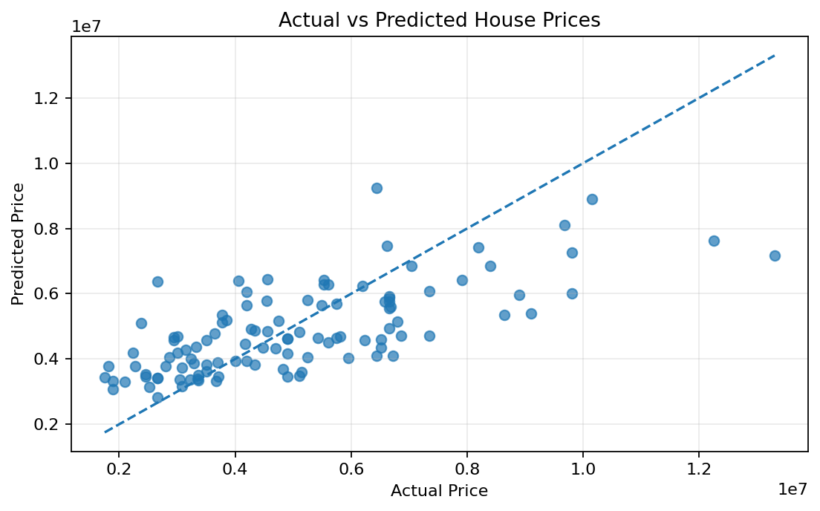
Figure 1. Actual vs Predicted House Prices
The scatter plot compares actual test-set prices with prices predicted by the Linear Regression model. Points closer to the diagonal reference line represent smaller prediction errors.
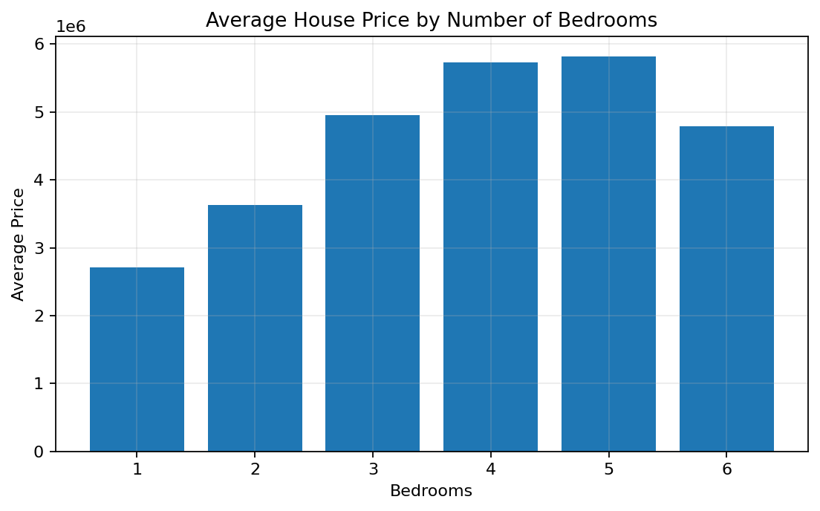
Figure 2. Average House Price by Number of Bedrooms
This chart displays the average house price for each bedroom category present in the dataset.
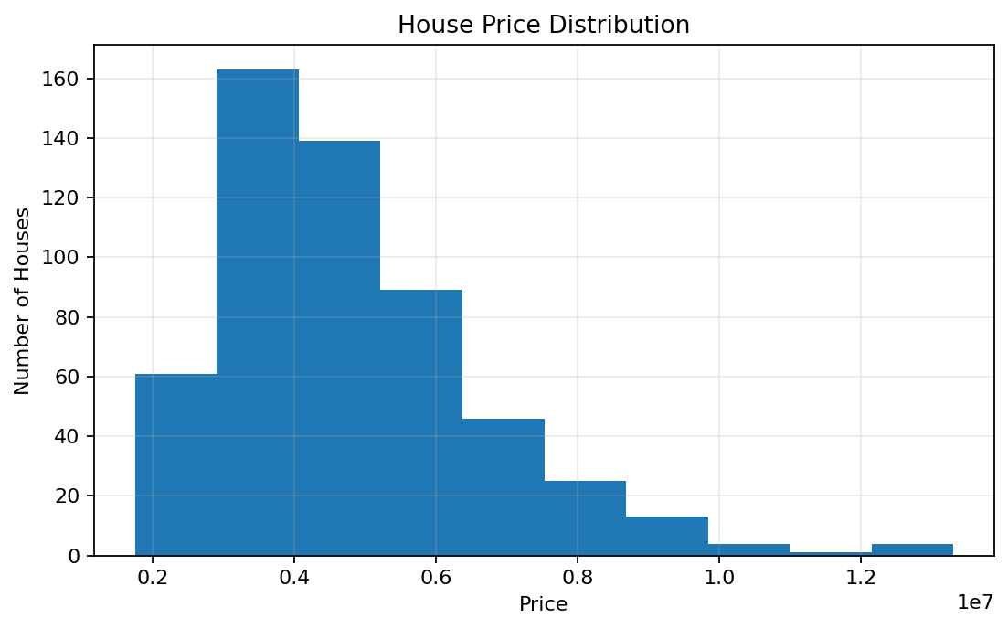
Figure 3. House Price Distribution
The histogram shows the distribution and spread of house prices across the dataset.
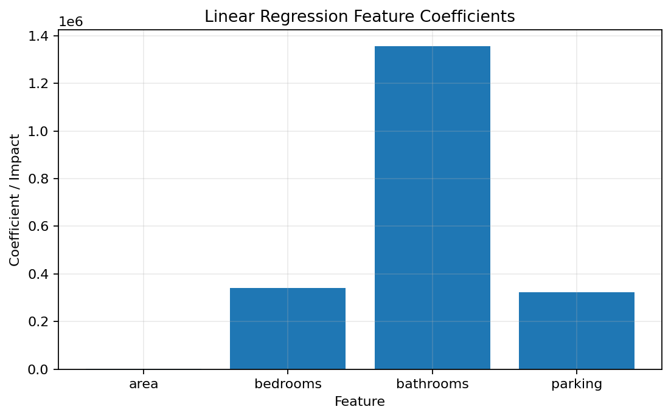
Figure 4. Linear Regression Feature Coefficients
The feature coefficients show the estimated linear relationship between each input feature and price while holding the other features constant. The coefficients should be interpreted in the units of the original dataset.
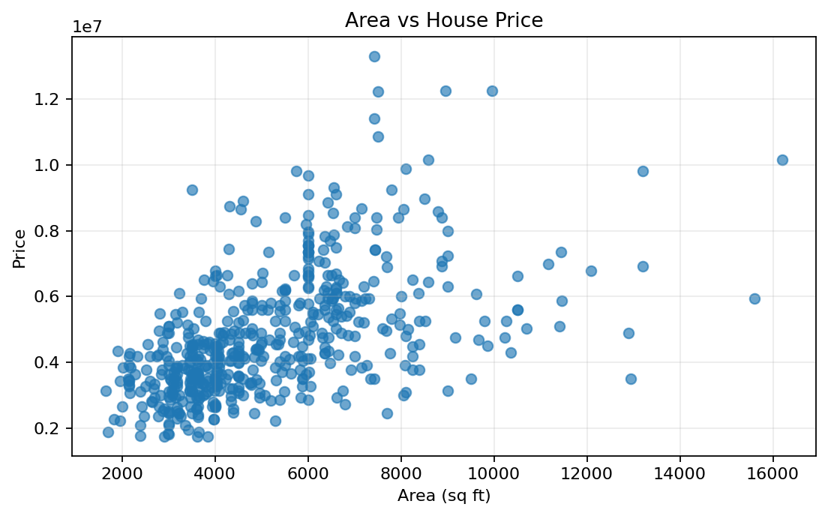
Figure 5. Area vs House Price

7. Streamlit Application
The Streamlit dashboard allows a user to enter area, bedrooms, bathrooms, and parking spaces through sidebar controls. After selecting the prediction button, the trained Linear Regression model generates an estimated house price. The application also displays model-performance metrics, charts, and a dataset preview.

8. Prediction Workflow
- User enters house details in the sidebar.
- The input values are converted into a Pandas DataFrame.
- The trained Linear Regression model receives the four input features.
- The model generates the estimated house price.
- The application displays the prediction and compares it with the dataset average.

9. Technologies Used
- Python
- Pandas
- Scikit-learn
- Matplotlib
- Streamlit
- Microsoft Word / DOCX

10. Key Code Components
- pd.read_csv() – loads the dataset.
- train_test_split() – divides data into training and testing sets.
- LinearRegression() – creates the regression model.
- model.fit() – trains the model.
- model.predict() – generates house-price predictions.
- mean_absolute_error() and r2_score() – evaluate model performance.
- st.number_input() – accepts house details from the user.
- st.metric(), st.bar_chart(), and st.scatter_chart() – display results.

11. Conclusion
This project demonstrates a complete machine-learning workflow for house-price prediction. The workflow includes dataset loading, feature selection, model training, model evaluation, data visualization, and deployment through a Streamlit interface. Linear Regression provides an interpretable baseline for estimating house prices from the selected numerical features. The resulting performance depends on the quality and representativeness of the dataset and the suitability of the selected features.

