**Front End Conception**

1. **Landing page**



Find a lawyer in your area (hyperlink)

Lawyers Legal Doc Tribunal Law.. Arbitration

Customer Login Provider Login

Search box for services Drop Box for Citires

**Drop down for above menus**

|  |  |  |  |
| --- | --- | --- | --- |
| Lawyer | Legal Documentation | Arbitration | Tribunal Court Lawyer |
| Criminal | Notaries | Business | Consumer |
| Civil | legal agreements | Family | Cooperative |
| Business | Deeds |  | labour |
| Company Act | Legal Notices |  | industrial |
| Trade |  |  | family |
| Family |  |  | Human rights |
| Muslim Law |  |  | School |
|  |  |  | MAT |
|  |  |  |  |

**Scrolling down will provide links and tabs to some latest legal topics. See below example**

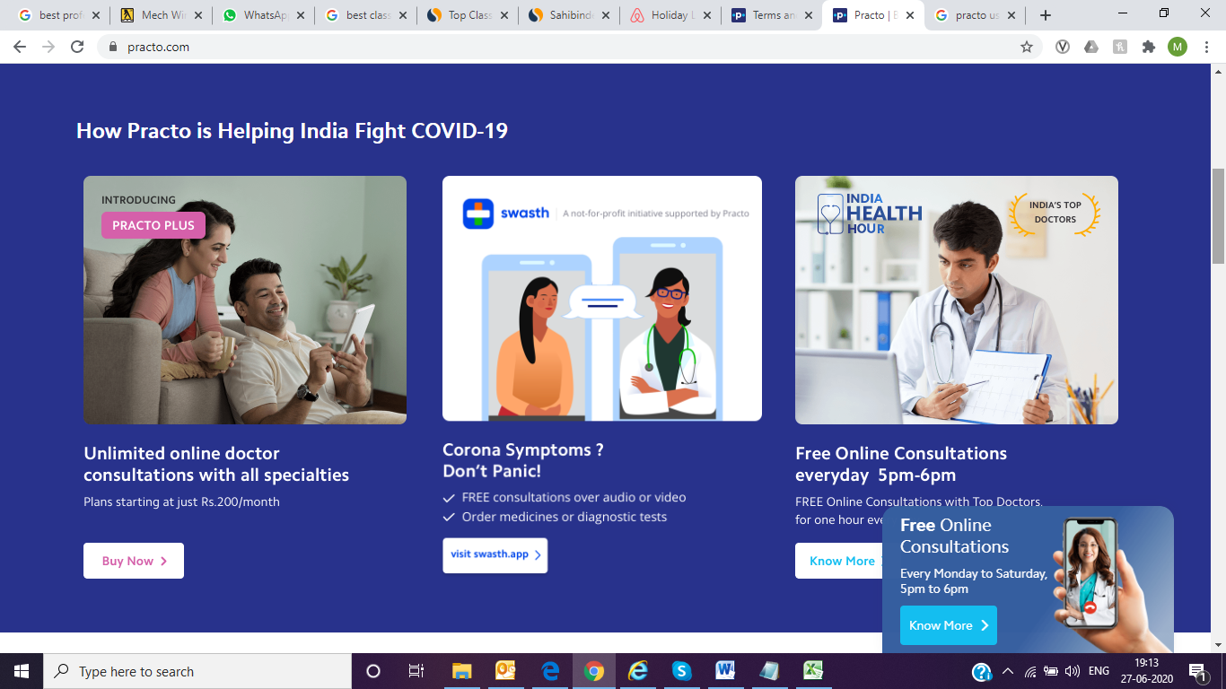

1. **Every option will lead to the specified services listings**

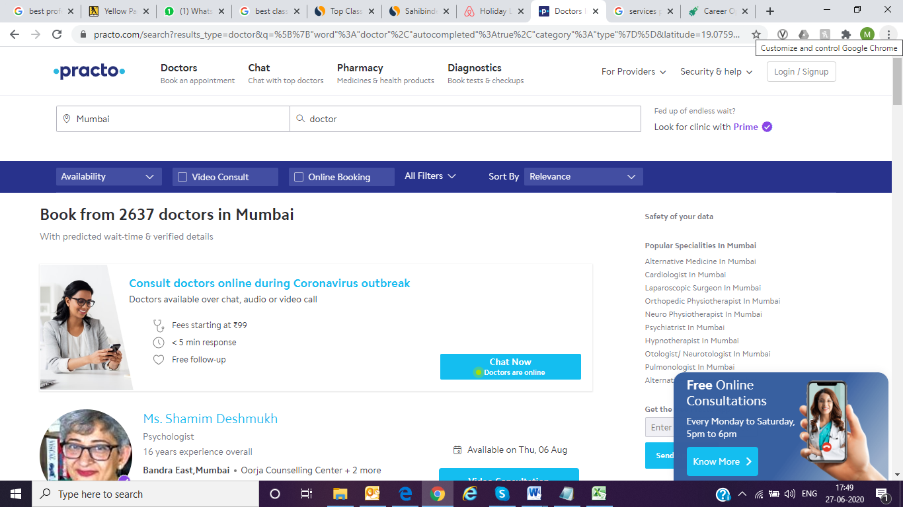

1. **Every featured listing should be as below.**

**Goolgle location of lawyer or service provider in reference to the user.**

**There should be a filter and sort buttons to filter the lawyers or services in terms of specialisation, fees, distance, location, availability.**

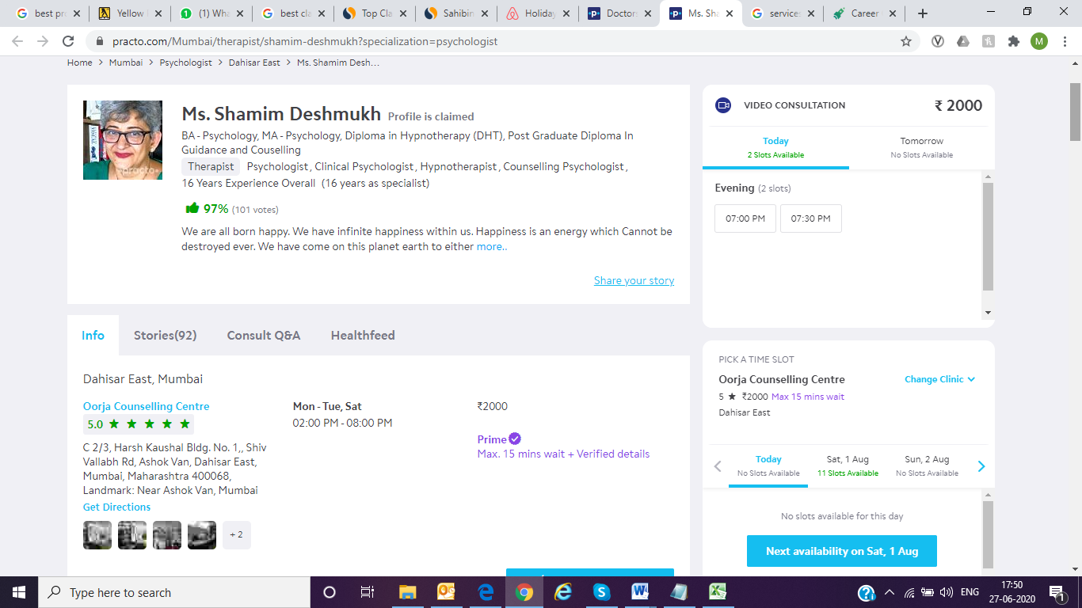

1. Name, Qualifications, Specialisty , introduction story, ratings (submitted by the registered user only).



1. **Info (Address, timings, fees), client feedback, Q&A,**

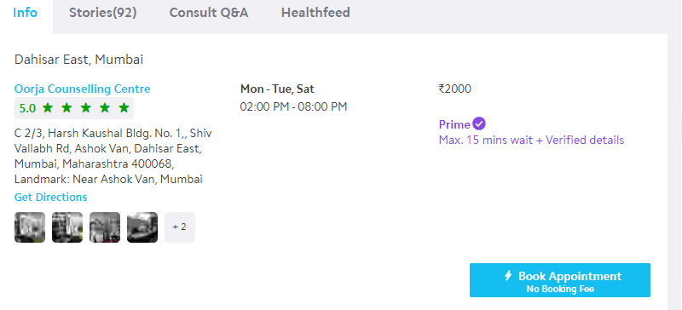

1. Same kind of entries will reflect for every options of the menus.
2. User registration and professional registration first step will remain as below.

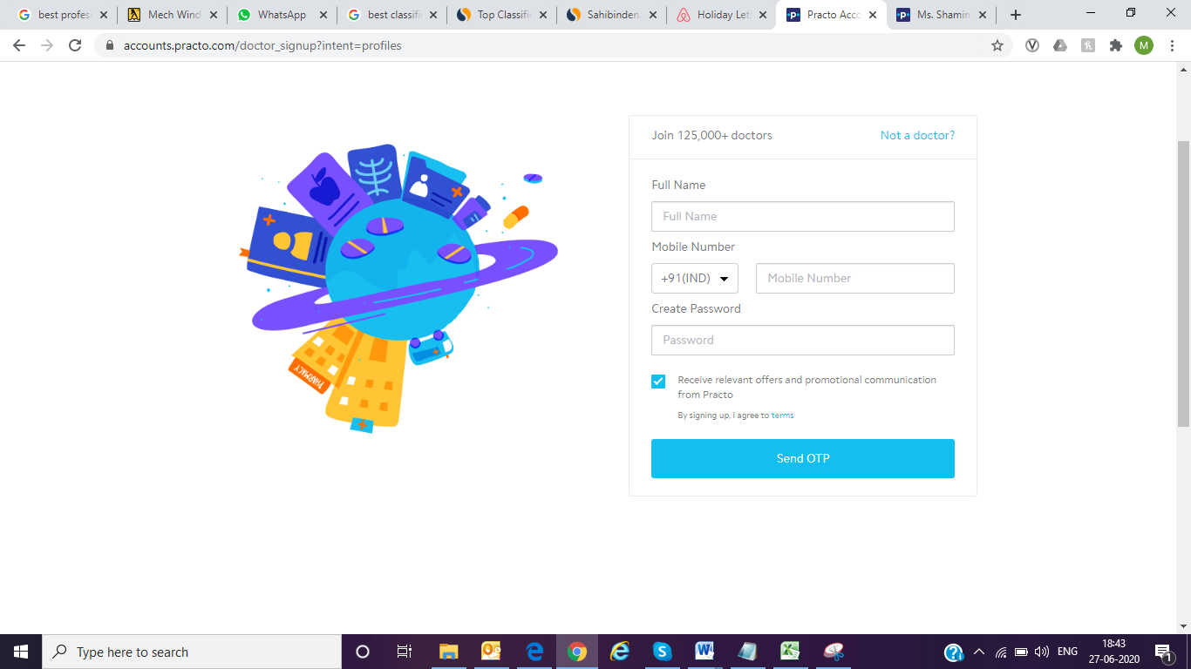

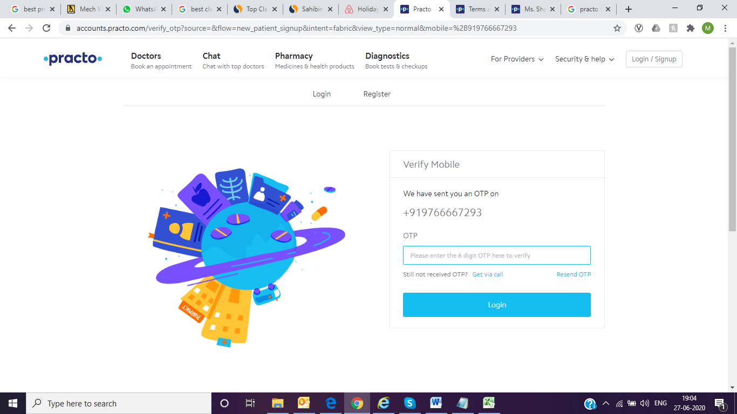

1. **Please follow the link below to understand the professional registration process.**

<https://help.practo.com/practo-ray/getting-started/steps-to-get-listed-on-practo/>

1. User registration will be simple, post verification of mobile number it will lead to address

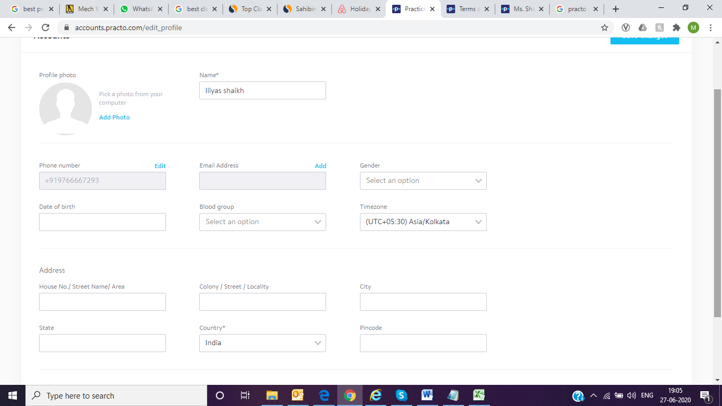

**Time zone auto populated based on IP and GPS details.**