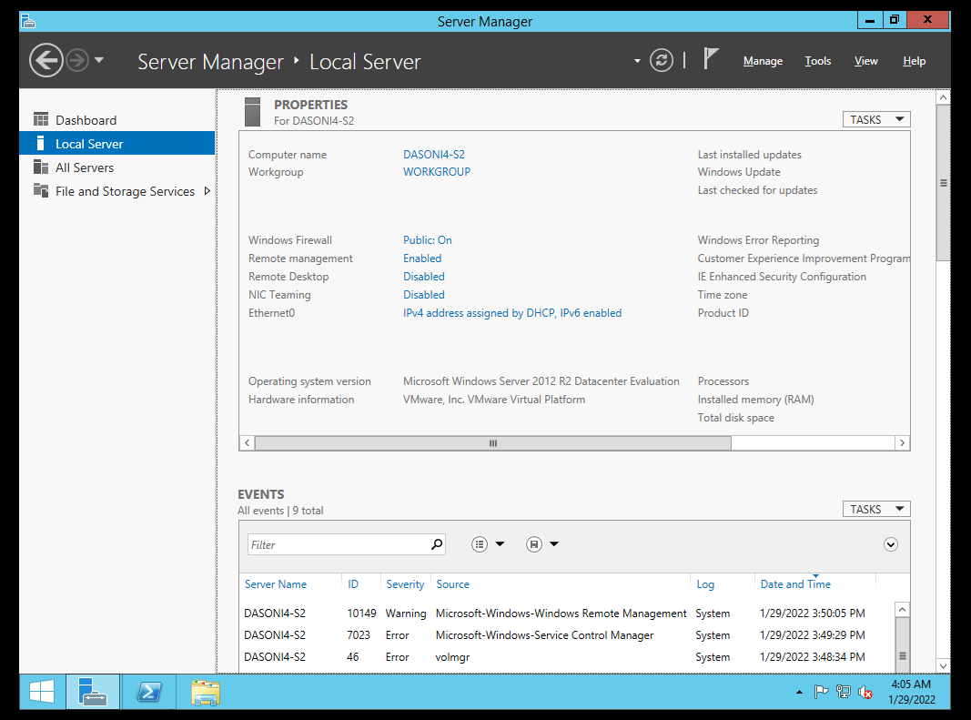

**[1.] Server1 VM with the installation of Windows Server 2012 on it.**

SERVER-1

[2.] **Server Manager-Local Server and the changed Computer Name .**

[3.] Server2 VM with the installation of Windows Server 2012 on it.

SERVER-2

[4.] **Server Manager-Local Server and the changed Computer Name**

[5.] **Client1 VM with the installation of Windows 8.1 on it.**