**GROUP-7 (PROJECT-1)**

**MEMBERS WITH STUDENT NUMBERS :-**

1. SONI DEV ALPESHBHAI – 130759210
2. SINGH MANNAV – 135675213
3. TONGA YONKEU SERGE – 056728132

**DEFINING THE PROBLEM**

You are part of a group for a group project in a class. The group project due date is coming up shortly but one of the group members often misses class and has not been helping with their part of the group project. You and your other group members are concerned that this will affect your mark on the group project as well as the class. The group member who has been missing class has mentioned in passing that it is difficult for them to get to campus due to a long commute and that their part time job is requiring a lot of their time. You and your other group members want to get a good mark on this project and want to ensure that it is submitted on time.

**Who is affected by the problem ?**

We (Group 7) are affected by the problem.

**What is the problem ?**

One of our group member is missing the classes and he is not able to contribute his fair amount of work in the group project.

**Where is the problem ?**

The problem is in his long distance commute and his time demanding part-time job.

**When is the problem ?**

The problem is on the due date assigned to us by our instructor before which we are supposed to submit out project.

**FISHBONE DIAGRAM (ISHIKAWA DIAGRAM)**

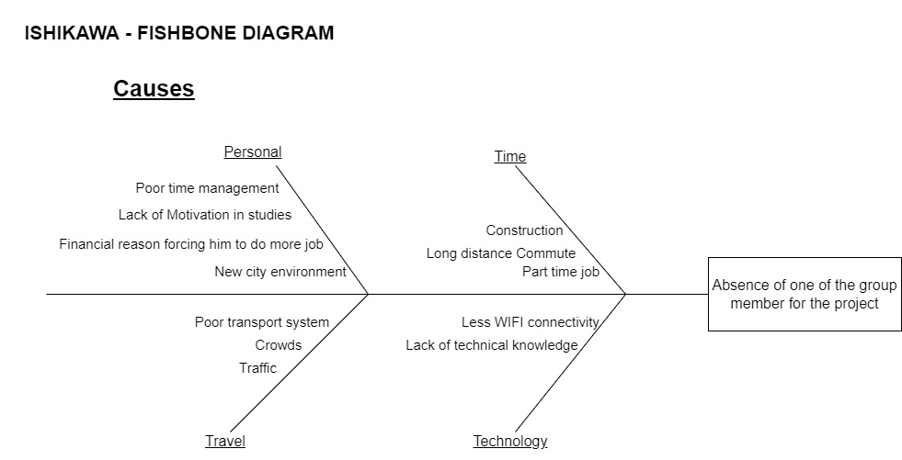

**EXPLANATION OF POSSIBLE CAUSES IN THE FISHBONE DIAGRAM**

**PROBLEM**

Absence of one of the group member for the project.

**TIME**

1. **Long distance commute** – It is likely that the distance between the group member’s accommodation to the college is huge so due to such reason, he/she has a difficult time for travelling to the college. Hence, he/she might not be able to attend the course.
2. **Part time job** – His/ her part time job consumes a lot of time and might be one of the reason for not attending the course regularly.
3. **Construction** - Maybe be his/her transportation route might underwent some kind of construction work which makes his/her travel to college difficult.

**PERSONAL**

1. **Poor time management**

– He/ She might be having a hard time while dealing with job and studies at the same time.

1. **Lack of motivation to study**

– Maybe he/she has lost his/her interest in the studies due to his environment.

1. **Financial reason**

– It might be one of the reason where the group member has to dedicate more time in the job apart from the studies.

1. **New city/country environment** – It is likely that the person is having a hard time to cope up with the new and changing environment and it might be one of the reason as well.

**TRAVEL**

1. **Traffic**

– Due to the huge lanes of traffic in the cities, he would barely be able to make to the college on time.

1. **Crowd**

– Getting through the crowds on subways or at other transportation stations might be one of the obstacle for him/her to get to the college on time.

1. **Poor transportation system**

– Maybe at the place where the group member is living has an abrupt supply of transportation vehicles.

**TECHNOLOGY**

1. **Lack of network connectivity on his/her device**

– Maybe at times when the group member is travelling, the connection gets cut off which make him/her unable to use the device location to get through the college. Moreover, without an internet connection he will not be able to attend the course or group discussion virtually.

1. **Lack of technical knowledge**

– Maybe he/she is unaware with the technical advantages of using a device as a time scheduler. Thus, contributing one of the causes for this problem.

**MIND MAP**

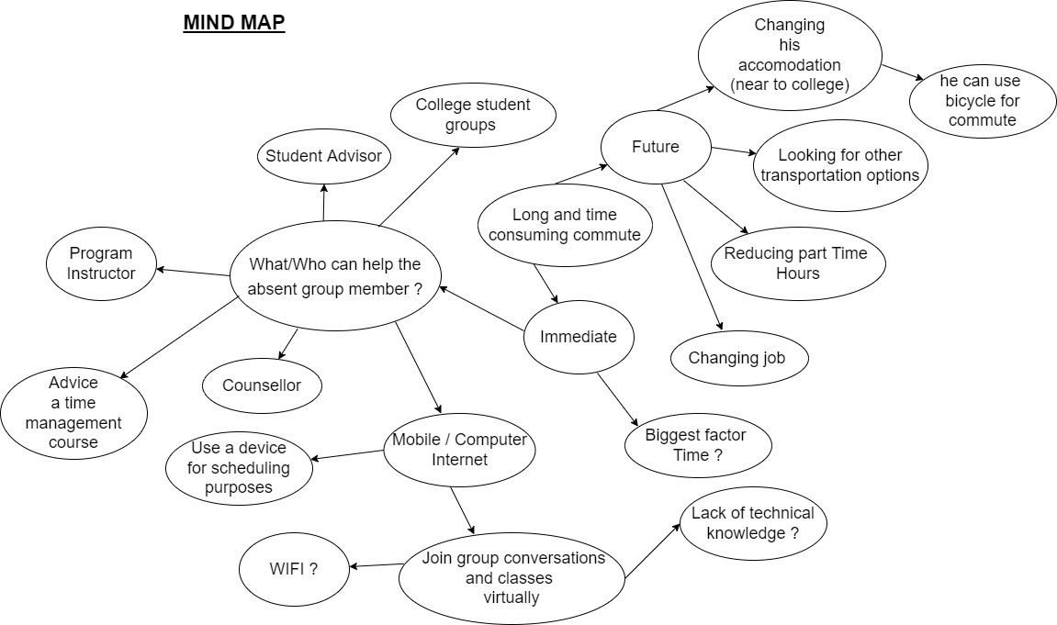

**SOLUTIONS**

1. **TO MEET A STUDENT ADVISOR / COUNSELLOR**

* Advising the group member to schedule an appointment with a student advisor or a counsellor of the college regarding his problem in time scheduling might solve the problem since they are professionals in advising other students regarding such problems.

1. **TO FIND AN ANOTHER JOB WHERE LESS LABOUR IS REQUIRED**

* Maybe he/she gets tired after going for the part time job which ultimately affects their studies. Hence, we can advise him to find a job where less physical work is required. For an instance, security jobs are one of the prime examples of it. Through this, the group member will be able to spend more time on the project.

1. **CHANGING THE ACCOMODATION**

* One of the causes was regarding the long distance commute problems for attending the college. Therefore, by advising him to change his/her accommodation to a nearby place from the college may resolve the issue.

1. **REDUCING THE HOURS AT JOB**

* In order to balance work and study, everything should be prioritize equally. So, he/she should be adivised to try to reduce his/her job hours in order to cope up with the group project and studies.

1. **TO JOIN TIME MANAGEMENT SESSIONS**

* Poor time management is the main cause of the problem over here. It is a common issue among the students at any college or universities. Fortunately, at times college organize many seminars regarding this and he/she should be encouraged to join those sessions.

**TRADE OFF ANALYSIS FOR IMMEDIATE OPTIONS**

1. **TO MEET A STUDENT ADVISOR / COUNSELLOR**

– very fast and the most reliable solution for the problem.

1. **TO FIND AN ANOTHER JOB WHERE LESS LABOUR IS REQUIRED**

– very very slow since it is not that easy and simple to find an another job.

1. **CHANGING THE ACCOMODATION**

– very slow that is because it is not easy to find accommodation especially near the college but he/she can shift to college residents (hostels).

1. **REDUCING THE HOURS AT JOB**

– very fast. He/ She can request to the manager of their part time job to help them in order to reduce the job hours.

1. **TO JOIN TIME MANAGEMENT SESSIONS**

– fast, but is college organizing the event or the session now ?

**IMPLEMENTATION – (FLOWCHART)**

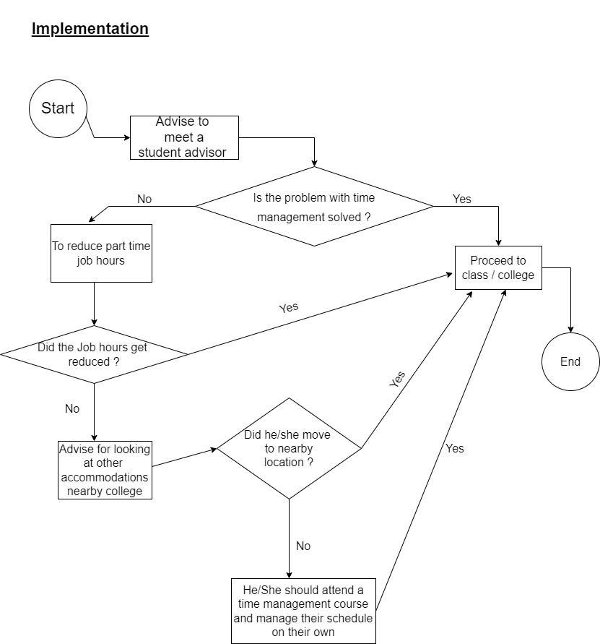

**FLOWCHART EXPLANATION**

The instructions which are mentioned below are based on three main causes for the problem which are :-

1. Time Management
2. Travel
3. Commute

* There are a few ways by following which the group member can possibly be able to avoid this problem.
* At first, he/ she should be advised to schedule a meeting with the student advisor or student council to discuss this problem.
* If the problem is resolved after discussing that with a student advisor or student council then he/ she may be able to attend the college or class on time.
* If the problem is not resolved then he/she can try to negotiate with their part-time job manager in order to reduce their job hours.
* If the job hours are reduced then it will be possible for him/ her to attend the college on time and to focus on the studies more as compared to the part time job.
* Unfortunately, if the problem is not resolved then he/she might go for an another option.
* The next thing which he/she can look upon is to change the accommodation to a nearby place to that of the college in order to save the time which he/she had to spend in the long distance commute.
* If he/she had moved to a nearby accommodation to that to the college then the group member can be able to attend the classes on time.
* However, if he/she fails to get the accommodation then the last option which is left for him/her is to learn the time management skill all by himself/herself, in order to balance the job and study at the same time and he/she can also participate in the time management courses which are held by the college on a regular basis.
* After following this series of implementation of tasks then he/she can be able to avoid this problem.

**GROUPS’ SCRIPTS FOR THE PRESENTATION**

1. SONI DEV’S SCRIPT :

1. SINGH MANNAV’S SCRIPT :

1. SERGE’S SCRIPT :

