**GROUP-7 (PROJECT-2)**

**MEMBERS WITH STUDENT NUMBERS :-**

1. SONI DEV ALPESHBHAI – 130759210
2. SINGH MANNAV – 135675213
3. TONGA YONKEU SERGE – 056728132

**OVERVIEW OF TECHNOLOGY :-**

- Artificial Intelligence is one of the most emerging technologies around this technical era.

* It is an approach to make a computer, a robot or a product to think how smart a human think. Majority of the tasks in the present era are being tackled with the help of AI (Artificial Intelligence).
* There have been several applications of AI (Artificial Intelligence) in several sectors like banking, schooling, tourism and guidance, and medical sectors, etc.
* AI (Artrificial Intelligence) is a tool, with the help of which anyone can automate any tasks or programs they want to with the help of scripting or coding (lines of execution). For an instance, solving a complex mathematical problem without human involvement, human speech recognition and many more.
* More or less, anything is possible, with the help of AI (Artificial Intelligence) , if the machine or the robot is programmed in a correct manner.
* There have been many products in the market nowadays, which uses the functionality of AI (Artificial Intelligence) for their application.

For example, Alexa assistance or Google assitance are the prime examples of it.

* Several industries are now adapting AI (Artificial Intelligence) in order to boost their efficiency in running buisinesses.
* All the popular tech companies at silicon valley, like Google, Facebook, Amazon and Snapchat are not adapting AI (Artificial Intelligence) for their recruiting and employee hiring processes.
* It often allows machines to work independently and allow them to execute suitable actions on solving complex problems, without any human involvement, which are difficult for a mere human.
* In the recent years, along with Machine Learning, AI (Artificial Intelligence) has proved to be the most popular and preferred technology in the present area. This sector is so vast which offers several applications and can be used in each and every field we can think of.
* In the present moment, even task like weather forecasting is being carried out by AI (Artificial Intelligence).
* Any kind of mathematical, logical or real life problems can be solved through the application of AI (Artificial Intelligence).

**HOW THIS TECHNOLOGY HELPS SOCIETY/ HUMANITY**

-To begin with, there are countless advantages of AI (Arificial Intelligence) :-

[1.] To solve any complex task, where a human involvement is not feasible or possible. To be more precise, human can work upto a certain extent since we need energy to carry out a specific amount of work. On the other hand, machines can work for a longer period of time as compared to a human and much adaptable to the changes in the workfield which makes them more preferred than a human in any sector.

[2.] It is more convenient to use and are comprehendable. It is obvious that the sole purpose of programming or designing a robot or a machine is to simply a given task. Therefore, they are designed in such a way that they are more convenient to use i.e, they are user-friendly.

[3.] It is cost effective for larger buisinesses. Human labourers or employees working for industry are needed to be paid for a regular basis, however it is a complete opposite scenario for the machines. Since, machines are not required to be paid for what they are working. Therefore, they are considered better options in work industries. Only a specific amount of money is being spent for carrrying out the maintenace of the machines.

[4.] WIth the implememtation of AI (Artificial Intelligence) in the machines, they became more accurate and proficient in carrying out work.

[5.] It saves alot of time for us, by carrying out extra or unwated tasks in the industries, allowing us to focus more on important and productive tasks.

**OVERVIEW OF PROBLEMS**

-> Even though AI (Artificial Intelligence) was meant for the betterment of human life, there exists several negative impacts which should not be overlooked and are discussed In the following lines :—

[1.] If machines or AI (Artificial Intelligence) take over most of the work at the industries then there will be no work available for humans. Hence, this will encourage unemployment in the markets.

[2.] Moreover, if AI (Artificial Intelligence) take over the entire job sectors then there will be sudden decrease in the human empowerment. Therefore, AI (Artificial Intelligence) will slowly replace the human in each and every field.

[3.] It has been observed, from the recent years that after the introduction of AI (Artificial Intelligence), humans are becoming much more dependent with the AI (Artificial Intelligence) for everything.

[4.] Even though AI (Artificial Intelligence) is designed for carrying out things in an accurate manner, there might be some case where it sustains some technical problems or errors in the middle of the process which will result into some serious consequences in the end.

[5.] After the advent of AI (Artificial Intelligence), human are becoming much more lazy and hence results in the waste of potential and talent of humans.

-> There are multiple problems associated with the AI (Artificial Intelligence) which can be mentioned. However, unemployment is the main concern, nowadays, for everyone which is affecting the economy of the nation on a large scale.

**ISHIKAWA’S DIAGRAM (FISHBONE DIAGRAM)**

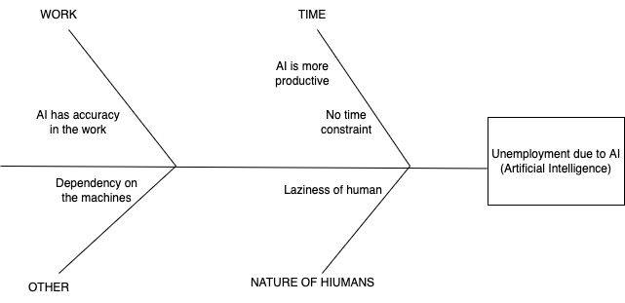

**POSSIBLE CAUSES :—**

**[1.] WORK**

* AI (Aritificial Intelligence) has an accuracy in their work : It is obvious, that machines perform what they are programmed for and are often regarded as perfect in executing the tasks they are assigned to, since they execute the program designed in them line by line. Hence, they have more accuracy in carrying out a work as compared to a human.

**[2.] TIME**

**-** AI (Artificial Intelligence) is more productive : Hence, machines are programmed to solve a complex task, there is a certain amount of time machines take to complete a certain task (solely based on how the code is being written in them) i.e, data structures and algorithms - it provides us the factor of how the execution of the code is efficient for the machine and how fast it can execute the written code. Therefore, AI (Artificial Intelligence) is more productive than humans.

**-** No time constraint : There is no time constraint for any machine when they are assigned any work. To be more specific, they can work for as many hours one want. In the case of humans, there is a limit where we can carry out a work. However, machines can even perform a repetitive work for all day without taking any breaks simultaneously.

**[3.] NATURE OF HUMANS**

* Laziness of humans : This is also one of the factors which affects the problem. Since, at times, humans become much more retarded and lazy to carry out work and hence they seek support from the machines in order to execute and solve the problem.

**[4.] OTHERS**

**-** Dependency on the machines : In the recent years, humans are becoming more dependent on the machines, even for small things due to which human empowerment has being lost. Hence, due to such reasons, unemployment has been increased at a large scale.

**POTENTIAL SOLUTIONS :—**

**-** In order to avoid certain problems in the future, we have outlined some of the potential solutions which might help us in order to eliminate this problem.

[1.] AI (Artificial Intelligence) should be restricted to only those area at the industries where human involvement is not possible i.e, for the tasks which only machines can perform. By implementing this solution, we can atmost reduce the use of AI in every task and thus there will be employment available for the humans in industries.

[2.] AI (Artificial Intelligence), should only focus on solving or executing less significant tasks in the industries, which will be productive because humans can be able to allocate their majority of time on other important tasks which are more important. Hence, might get rid of the issue.

[3.] The use of AI (Artificial Intelligence) should be restricted upto certain hours a day, by imposing such strict regulations in the industries, the use of AI (Artificial Intelligence) can be regulated on this basis.

[4.] AI (Artificial Intelligence) should be restricted in the non-technical fields like tourism, and medical sectors where human involvement is much more necessary, in order to reduce its usage.

[5.] We should make the young generations aware by educating them the harmful effects of using AI (Artificial Intelligence) in an excessive manner. There should be a co-curricular course in the school syllabus in order to make them learn about this issue.

-> By following the mentioned solutions, one might avoid the problem of unemployment in the jobs, due to the introduction of AI (Artificial Intelligence) in the work areas.

**TRADE OFF ANALYSIS :—**

[1.] The restriction of the AI (Artificial Intelligence) to only those work where human involvement is not possible : It is a slow process since the job industry is too huge to bring even a small change in the system.

[2.] AI (Artificial Intelligence) should only focus on executing less significant tasks allowing human employees to work on more important tasks : It is a fast process, since the decision is all depended upon the specific industry itself whether to allow AI (Artificial Intelligence) to handle less significant tasks or more significant tasks. Such decisions can be taken instantaneously.

[3.] The use of AI (Artificial Intelligence) should be restricted upto certain hours a day, by imposing such strict regulations in the industries : It is a slow process, since in order to bring a common law to change the whole job industries, it takes alot of time in executing the law.

[4.] AI (Artificial Intelligence) should be used less in the non-technical fields - This is a slow process too, since to bring a huge change in the system, it takes alot of time.

[5.] We should make the young generations aware by educating them the harmful effects of using AI (Artificial Intelligence) in an excessive manner - It is a fast process, to include a new curriculum in the syllabus of school education.

**IMPLEMENTATION (FLOWCHART) :—**

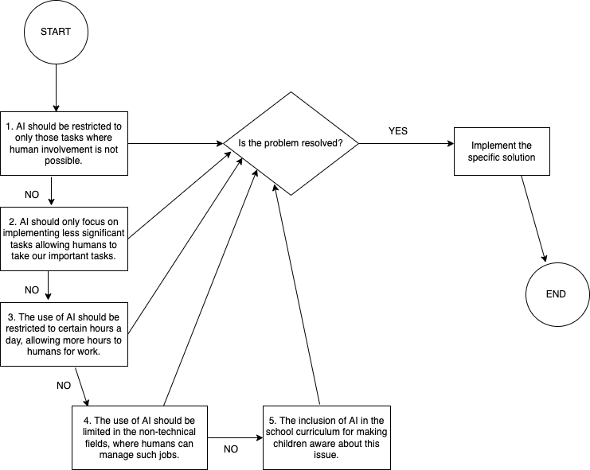

**EXPLANATION OF FLOWCHART : —**

* First of all, AI (Artificial Intelligence) should be restricted to only those tasks where human involvement is not possible or where the tasks demand much more physical labour and hence, is difficult for a human to carry out the task on his own. Although, this is a realiable solution and thus should work, if it does work then one should start initiating the process or solution. If the solution does not work then one can move to the next solution.
* Following this, the another solution is that the AI (Artificial Intelligence) should only focus on executing less significant tasks other than significant tasks, where human involvement is needed. Even though, the solution is reliable and it would fairly work for the given issue or problem. However, if the soution does not work for the assigned problem, then we should go for the next available option.
* The next solution is that the use of AI (Artificial Intelligence) should be restrictred to certain hours a day, allowing more hours for a human to work. Hence, by following this, one can be able to get rid of the problem.
* If not, then the use of the AI (Artificial Intellgence) should be limited in non-technical fields, such as medical sectors and tourisms.
* If the above solution does not work for the given issue, then the only option left for us, is to include a topic stating the awareness regarding the threats that the AI (Artificial Intelligence) possesses in the school curriculum of children. To make the younger generations aware about the issue from a very small scale.
* I ensure that after implementing, all the solutions step by step and one after the another in an orderly manner one would be able to eliminate the potential problems.

**FUTURE OF THE TECHNOLOGY :—**

As discussed above there are several applications of AI (Artificial Intelligence) out there,

and it has a bright future out there. Some of the prime applications of AI (Artificial Intelligence) are mentioned in the ensuing lines.

- [1.] AI (Artificial Intelligence) applications are being widely used in the digital speakers and digital assistances.

- [2.] It will be used as a medium for the future applications, in order to incorporate decision making and hence speeding up certain tasks.

- [3.] Artificial intelligence (AI) is regarded to as machine intelligence and is manifested by humanoid or non-humanoid robots that behave like humans, which can be applied in businesses to improve and enhance operational efficiency.

- [4.] Artificial Intelligence (AI) has also been used widely in the medical sectors as well. AI (Artificial Intelligence) is being widely used in precision cardiovascular medicine.

- [5.] AI (Artificial Intelligence) has also its foundations in hydrology. For an instance, in hybrid wavelet.

—> AI (Artificial Intelligence) has many advantages in almost every field out there in the market and hence, it is one of the most successful career for anyone to pursue in the future.

**REFERENCES :—**

[1.] Rahman, Was. AI and Machine Learning. SAGE Publications Pvt. Ltd, 2020.

[2.] Rodgers, Waymond. ARTIFICIAL INTELLIGENCE IN A THROUGHPUT MODEL Some Major Algorithms. CRC PRESS, 2020.

[3.] Prentice, Catherine, et al. “Emotional Intelligence or Artificial Intelligence- an Employee Perspective.” Journal of Hospitality Marketing & Management, vol. 29, no. 4, Routledge, 2020, pp. 377–403, https://doi.org/10.1080/19368623.2019.1647124.

[4.] Krittanawong, Chayakrit, et al. “Artificial Intelligence in Precision Cardiovascular Medicine.” Journal of the American College of Cardiology, vol. 69, no. 21, Elsevier Inc, 2017, pp. 2657–64, https://doi.org/10.1016/j.jacc.2017.03.571.

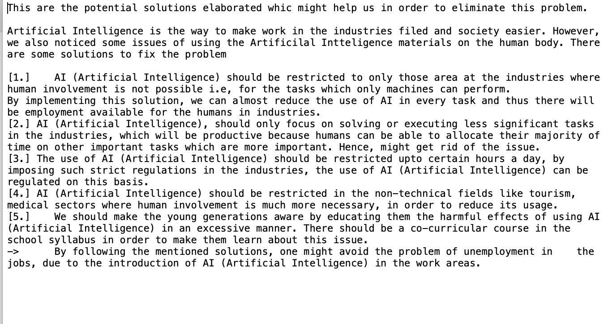[5.] Nourani, Vahid, et al. “Applications of Hybrid wavelet–Artificial Intelligence Models in Hydrology: A Review.” Journal of Hydrology (Amsterdam), vol. 514, Elsevier B.V, 2014, pp. 358–77, https://doi.org/10.1016/j.jhydrol.2014.03.057.

SCRIPTS :-

[1.] MANNAV SCRIPT’S :-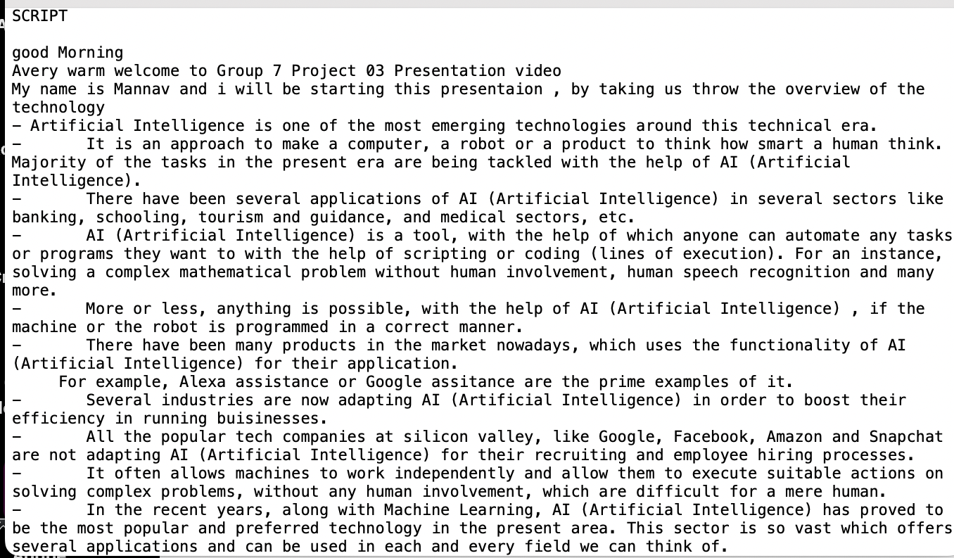

[2.] SERGE TONGA YONKEU’S SCRIPT :-

[3.] DEV SONI’S SCRIPT :-