**React**

Author:- Jordan Walke  
First Release:- May 29, 2013  
Current Release :- 16.13.1  
----------------------  
Javascript Library  
React has component based architecture for application development.  
---------  
Required - Node and NPM  
nove –v  
npm –v  
**************************************************

React Component :-   
1.) Class Component  
2.) Function Component

*****************

1. Class Component (Stateful):-

start with class, constructor, state, life cycle methods. for a simple data show.

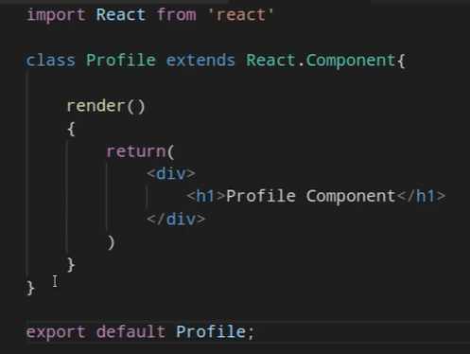

Constructor :-

The constructor is a method that’s automatically called during the creation of an object from a class. It can handle your initial setup stuff like defaulting some properties of the object, or sanity checking the arguments that were passed in. Simply put, the constructor aids in constructing things.

In React, the constructor is no different. It can be used to bind event handlers to the component and/or initializing the local state of the component. The constructor() method is fired before the component is mounted and like most things in React, has a few rules that you should follow when using them.

we take a **props** value from the **constructor()** and pass it to the **super()** method:

constructor(props) {  
 super(props);   
 console.log(this.props);  
 }

The constructor comes in very handy, but sometimes it’s just too much. If you aren’t planning on maintaining state in your component and aren’t binding any event handlers, you don’t need to define a constructor at all.

1. Functional Components:-

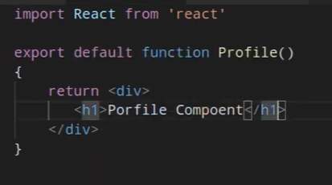

JSX :- Javascript XML. It’s allow to write html within javascript.

**Props:-** it’s like parameter. Data transfer from parent to child or sibling to sibling component. It can not be changed.

**Props with Functional Components:-**

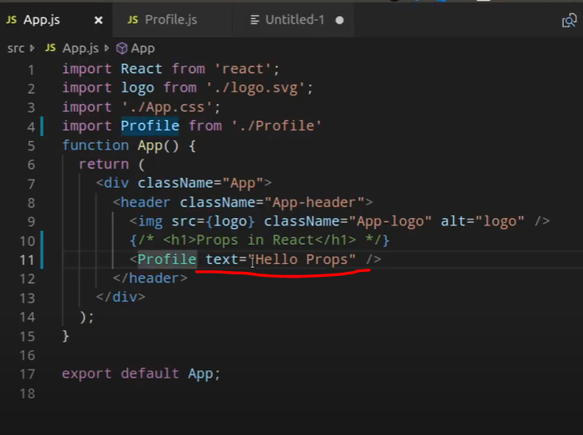 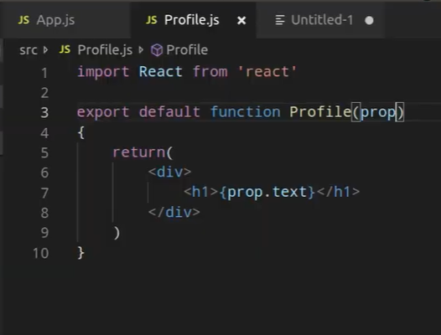

Prop if we use object:-

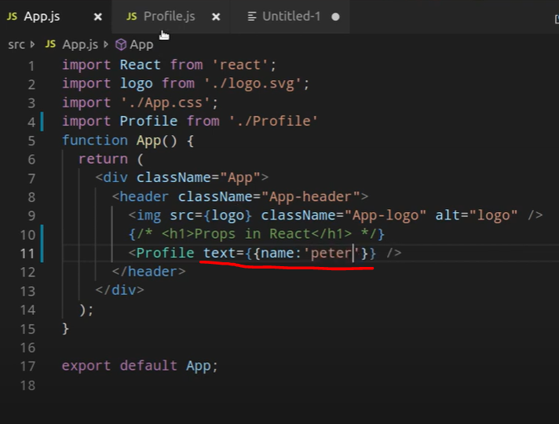 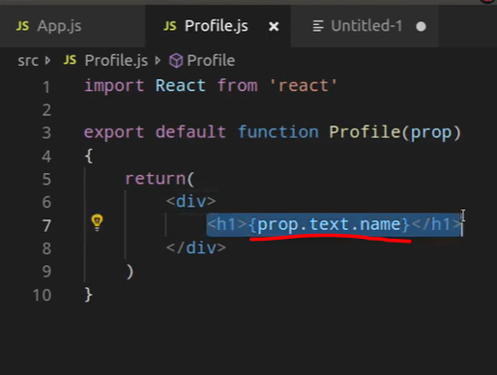

**Props with Class Components:-**

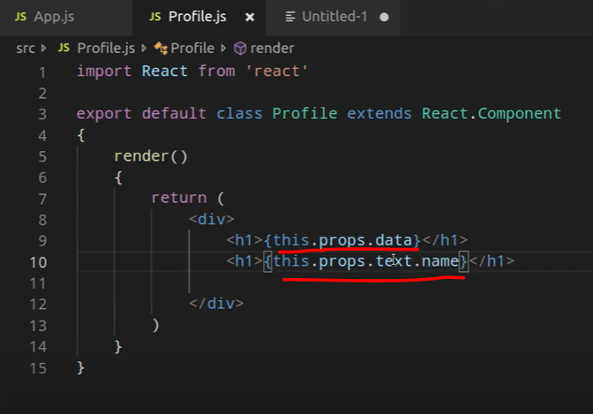

**State:-** it’s a internal object of a class . it’s private. We can not access it outside of a class. State key values can be changed.

