Assignment – 6

Aim : What is Logical Extraction Technique & Data Extraction by using MobilEdit.

Logical Extraction

Logical acquisition methods interact with mobile devices using protocols such as AT
commands and OBEX (OBject Exchange),and only extracts data that is accessible through the operating system.

Logical mobile phone acquisition systems interact with the phone operating system to extract data, much in the same way the vendor synchronization systems do. As such, there are limitations to the information retrievable,and only information relevant to the Operating System is available. As such, information potentially relevant in a forensic investigation might not be acquired; information such as deleted items won’t be extracted. Mobile phones generally have a baseline of extractable data from such tools; phone address book, call register, SMS and photographs, but additional information is not guaranteed.

The limitation to these forms of applications is that it relies on the assumption that the desktop application and the investigator are assuming that the phone’s logic is not making any changes to other areas of the phone’s memory. However, this assumption cannot be verifi ed without the source code and circuit schematics of the phone’s software and hardware, which are rarely, if ever,publicly available.

There are several commercial & Open source forensic tools specifi cally designed to acquire data from mobile phones. This section introduces some of the more popular commercial tools. Some of the tools for Locical Extraction are listed below
- Mobiledit ( For All Mobile Phones )
- MPE+ (For All Mobile Phones )
- Data Recovery From Iphone ( Iphone Recovery Too l)
- LANTERN ( iPhone Forensics )
- AF LOGICAL ( Android Data Recovery )

Mobiledit
MOBILedit Forensic is digital forensics product by Compelson Labs that searches, examines and report datas from GSM/CDMA/PCS cell phone devices. MOBILedit! connects to cell phone devices via an Infrared (IR) port, a Bluetooth link, Wi-Fi, or a cable interface. After connectivity has been established, the phone model is identified by its manufacturer, model number, and serial number (IMEI) and with a corresponding picture of the phone.

Data acquired from cell phone devices are stored in the .med file format. After a successful logical acquisition, the following fields are populated with data: subscriber information, device specifics, Phonebook, SIM Phonebook, Missed Calls, Last Numbers Dialed, Received Calls, Inbox, Sent Items, Drafts, Files folder. Items present in the Files folder, ranging from Graphics files to Camera Photos and Tones, depend on the phone’s capabilities. Additional features include the myPhoneSafe.com service, which provides access to the IMEI database to register and check for stolen phones.

MOBILedit is a platform that works with a variety of phones and smartphones (a complete list of supported handsets is available on the manufacturer’s website) and explores contents of the phone through a MS Outlook-like folder structure. This allows backup of the information stored on the phone, storing it on a PC or copy data to another phone via Phone Copier feature.

Advantage Of Mobiledit
- Support for Almost All Phones
- Extract Important Application Data
- Bypass the Passcode on iOS Using the Lockdown Files Method
- Bypass the PIN Code with an Integrated SIM Cloning Tool
- Examine the Phone Data Without Having the Phone
- Extract Data from iOS Even When the Phone has Setup Encryption for the Backup
- Get a List of Skype, Gmail or Facebook Contacts Without Even Knowing the Accounts' Password
- Having Trouble Connecting Androids by Cable? Investigate Them Via Wi-Fi
- Powerful SIM Analyzer Retrieves All Possible Information From SIM Card
- We Will Navigate You Through the Phone Connection Process Without a Hassle
- Excellent Support for European Phones
- Retrieve All Important Data with a Physical Acquisition
- Integrated Search Plugin
- Well Organized View of Media Files
- Additional Assistance with Connection due to Unique Driver Detection and Repair System
- Export Phone Data to I2 Software and Other Tools
- The New Connection Kit with a Complete SIM Cloning Package
- Analyze the MOBILedit Forensic reports in a new powerful Search Too
- Collection of All Phone Drivers Needed to Connect a Phone

Step 1 : When we connect our mobile phone to the software it shows the screen which shows as below it retrieve all the logical data from the supported mobile phones

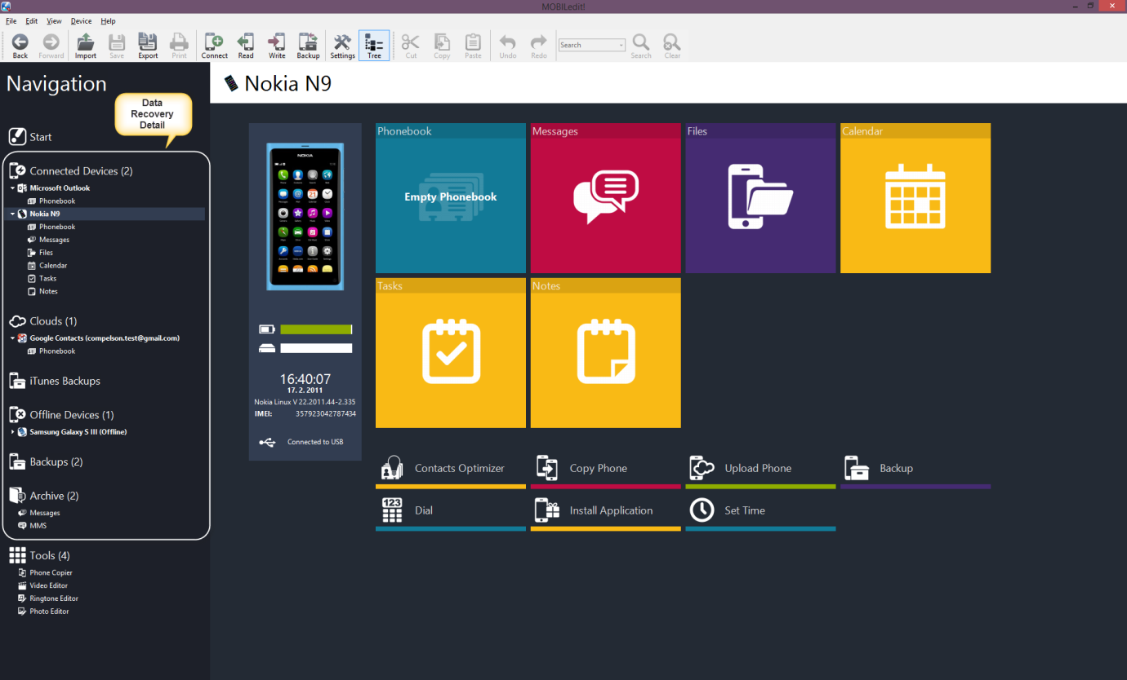

Step 2 : Working with files within phone memory or a data card.

MOBILedit! can both read files stored in mobile phone's internal memory and in an inserted storage card. This feature offers to copy files from phone to computer. You can easily get photographs, recordings, MP3s and other files from the devices.
Some phones may have data transfer limitations set by the phone manufacturer (for example, blocked access to Java applications, etc).Files can be copied through Copy To function (from the phone to another place)
- Files is the whole file system of the device. User normally does not have access to the whole system.
- Media means your media files - Music, Videos, Pictures stored and indexed in the phone.
- User files are files and folder accessable for user.
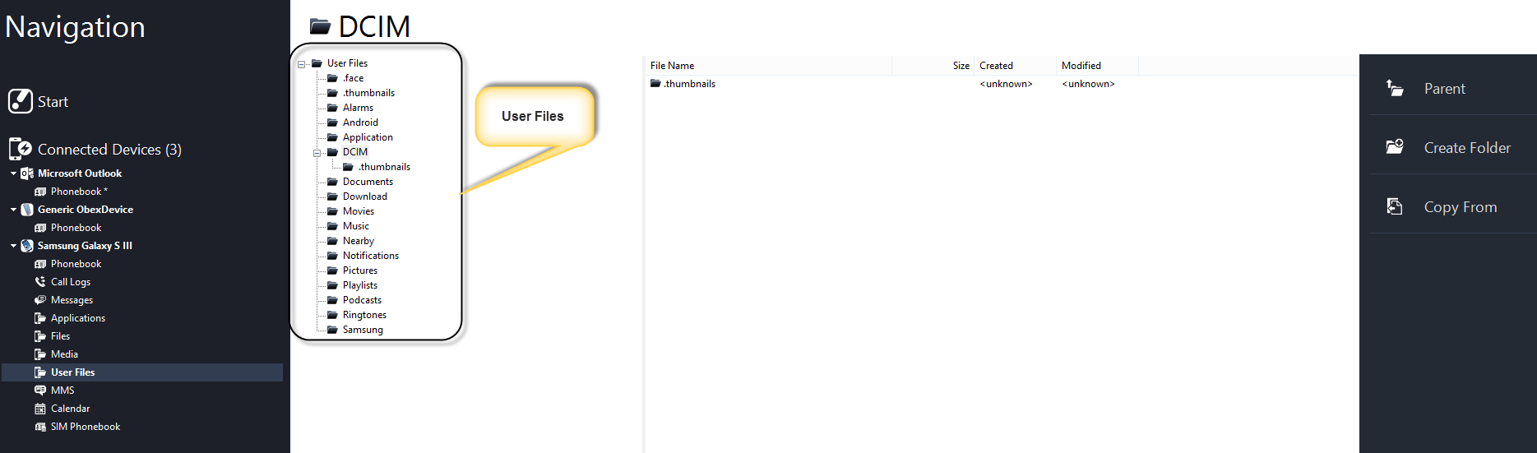

MOBILedit can also read Applications and Application data.

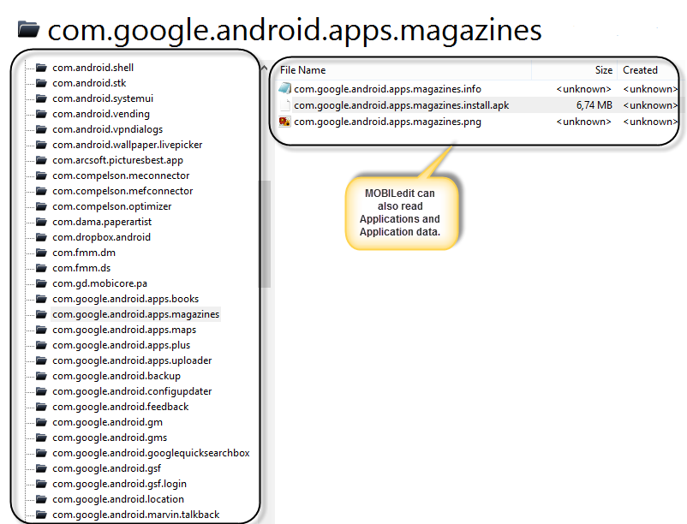

Step 4 : Tool Bars & Operation
MOBILedit Toolbars

Main Toolbar

Edit Toolbar
MOBILedit! contains two standard toolbars:
- Main Toolbar
- Edit Toolbar
Main Toolbar
- Toolbar common for all the plugins, containing the basic features.
Edit toolbar
- Each plugin has its own adjusted toolbar, which is on the right side by default. The toolbar offers features specific to every plugin.
Additionally, at the bottom you will note the status bar with information about current state of the program.
It is possible to move all toolbars to your desired location, resize them, add or remove commands and change their configuration.
Commands can be called up from the toolbars, from the context menu (accessible by a right mouse click) or from the shortcut bars.

