Assignment – 1

Aim : Fundamentals Of Wireshark

Wireshark is a network packet analyzer. A network packet analyzer will try to capture network packets and tries to display that packet data as detailed as possible.

Some intended purposes Wireshark for:
- Network administrators use it to troubleshoot network problems

- Network security engineers use it to examine security problems

- QA engineers use it to verify network applications

- Developers use it to debug protocol implementations

- People use it to learn network protocol internals Beside these examples Wireshark can be helpful in many other situations too.

Features of Wireshark provides:
- Available for UNIX and Windows.
- Capture live packet data from a network interface.
- Open files containing packet data captured with tcpdump/WinDump, Wireshark, and a number of other packet capture programs.
- Import packets from text files containing hex dumps of packet data.
- Display packets with very detailed protocol information.
- Save packet data captured.
- Export some or all packets in a number of capture file formats.
- Filter packets on many criteria.
- Search for packets on many criteria.
- Colorize packet display based on filters.
- Create various statistics.

Starting page view of Wireshark:
Wireshark allows to capture the different network interfaces in our system/device and also capture the different VM’s running on Device.
For Example:

- Wi-Fi

- VMware Network Adapter VMnet8

- Ethernet

- VMware Network Adapter VMnet1
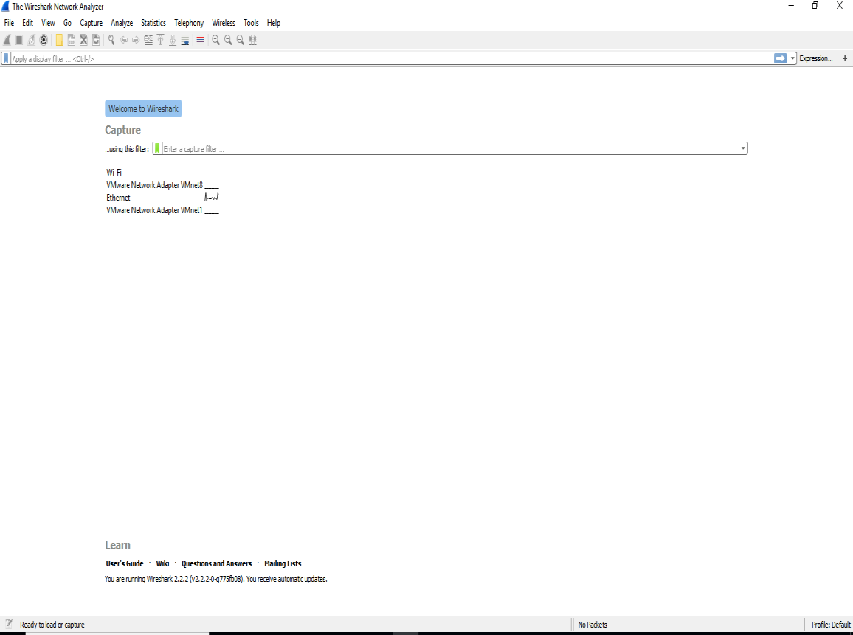

Configuring the Main window:
After selecting the Capture network interface in wireshark, it shows the all the related information about the packets running in our device.
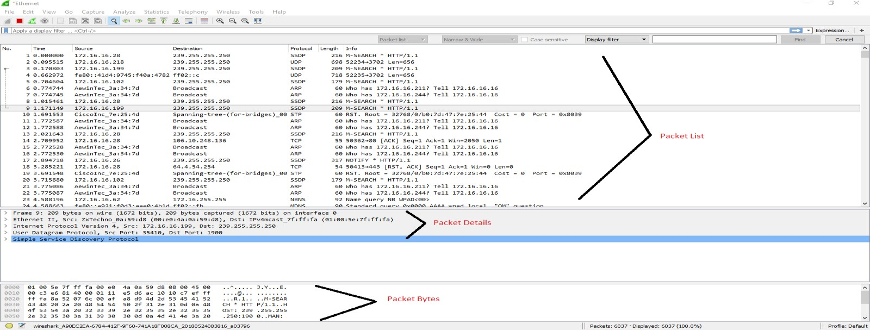

Step 1: Filter for a specific Day to Day frame in Wireshark

To filter for a specific Day to Day with respect to time frame in Wireshark, there is the frame.time filter. Used as in the example below, this will show all packets that have arrived in the time frame of May 24, 2018 9:14:17 to May 24, 2018 09:14:32.

Filter 1: (frame.time >= "May 24, 2018 09:14:17") && (frame.time <= "May
24, 2017 09:14:32")
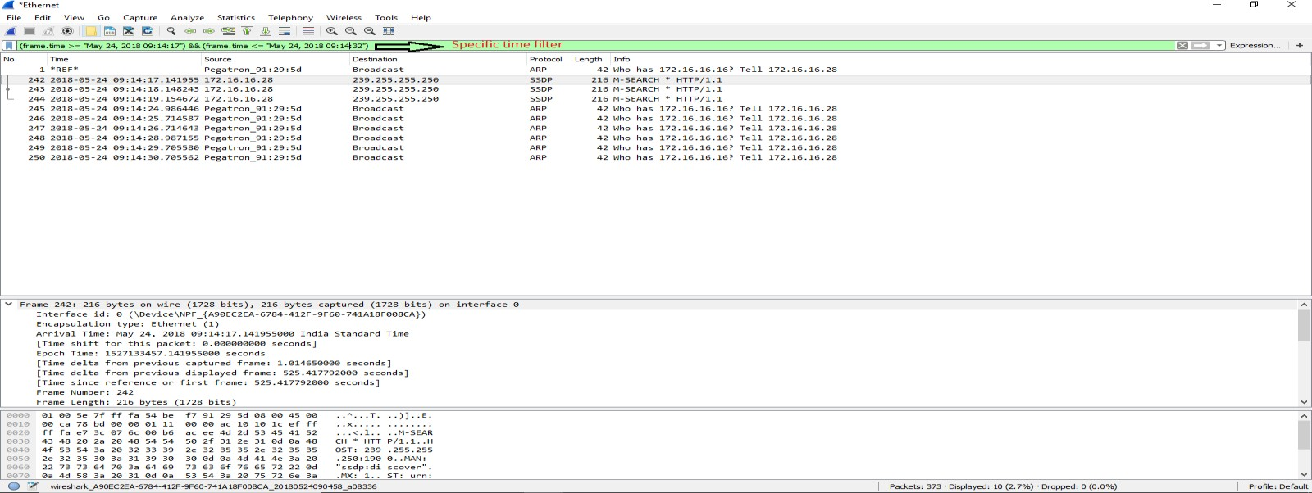

Filter for a specific time frame in Wireshark:

To filter for a specific time frame in Wireshark, there is the frame.time filter. Used as in the example below, this will show all packets that have arrived in the time frame of May 24, 2018 9:14:30

Filter 2: Frame.time == “May 24,2018 09:14:30.705562”
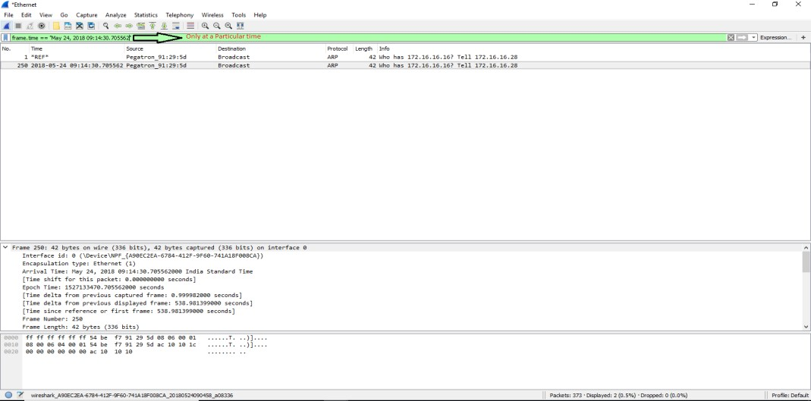

Step 2: Configuring coloring rules
Coloring rules define how Wireshark will color protocols and events in the capture data. Working with the coloring rules will help you lot with network troubleshooting, we are able to see different protocols in different colors.
To start coloring rules, proceed as follows:
  - Go to View menu
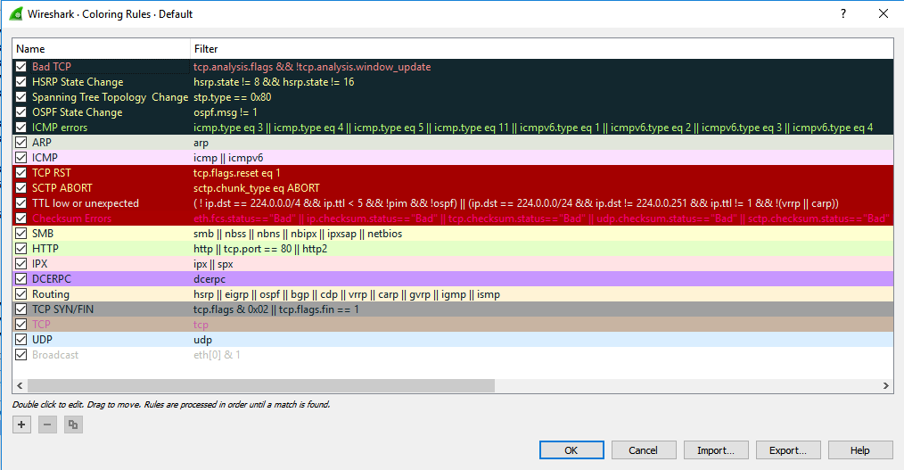
  - On the lower part of the menu, choose the coloring rules
Step 3: Filter for Particular IP Source:

This filter gives the only list of one particular source IP address that Displays the packet list form the Source related IP address.
Filter 3: ip.src == 172.16.16.28
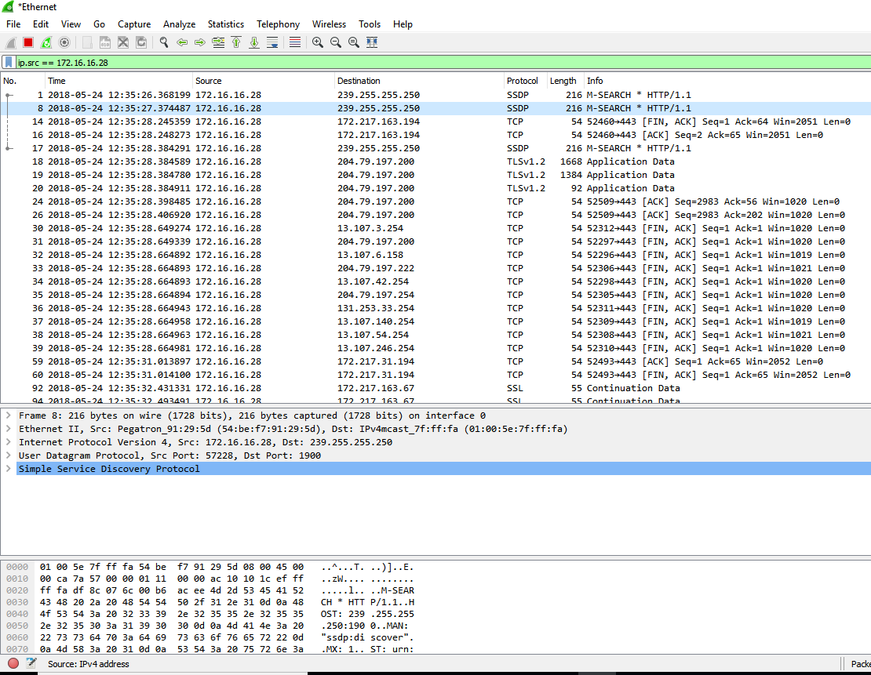

Step 4: Filters to display Frame length greater than 64 Bytes
This filter gives the only list of Frames list having length of greater than 64 bytes.

Filter 4: frame.len > 64
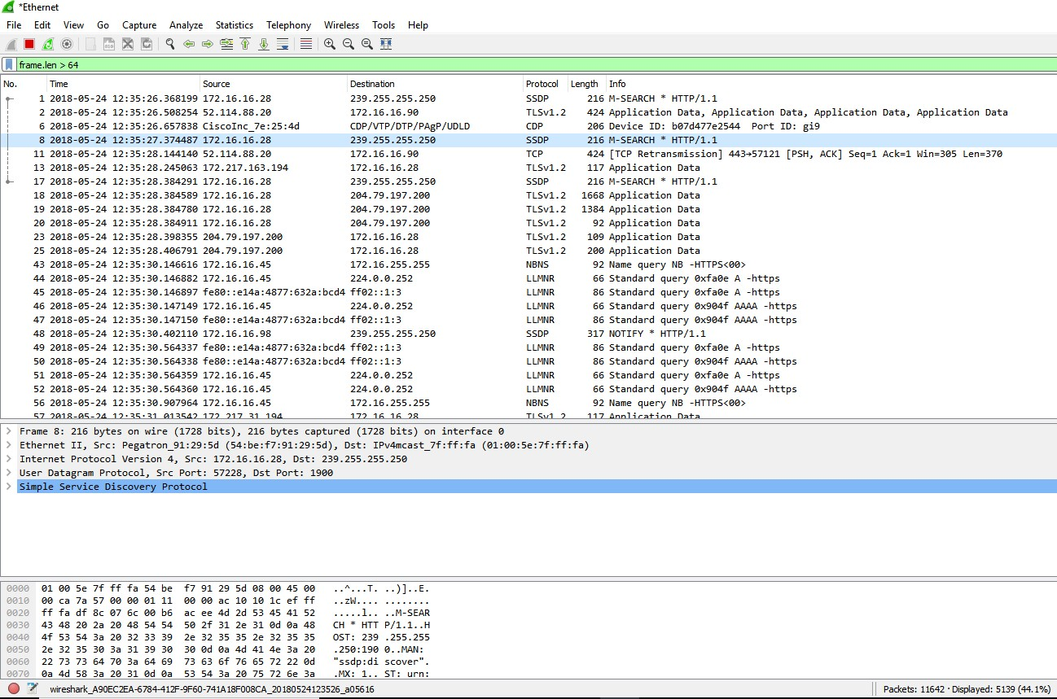

Step 5: Filter for Frame length less than 1500

This filter gives the only list of Frames list having length of less than 1500 bytes.

Filter 6: frame.len < 1500
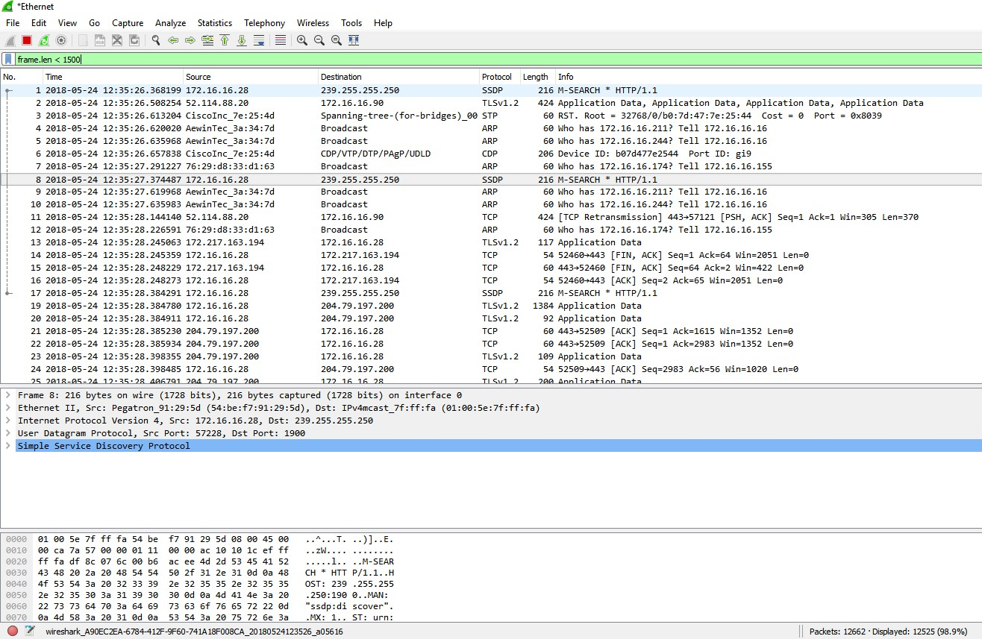

Step 6: Filter for to display greater than or equal to 64

This filter gives the only list of Frames list having length of greater than and equals 64 bytes.

Filter 6: frame.len >=64
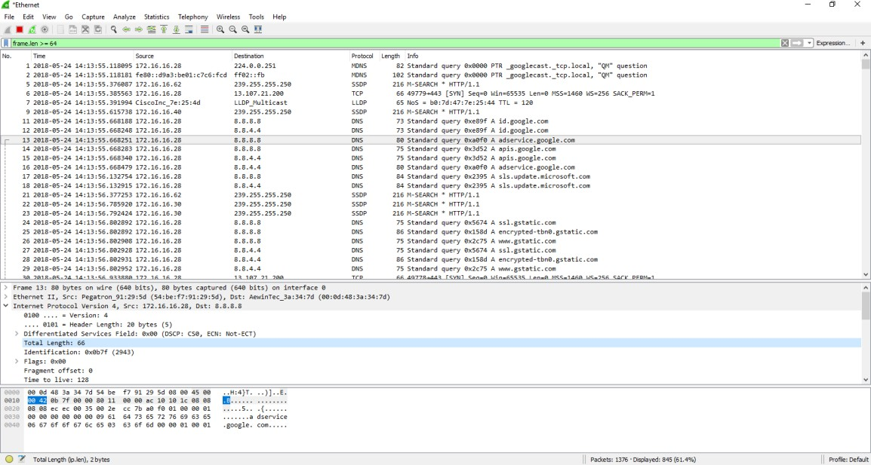
Step 7: Filter for Display Frame length less than or equal to 1500:

This filter gives the only list of Frames list having length of less than and equals 1500 bytes.

Filter 7 : frame.len <=1500
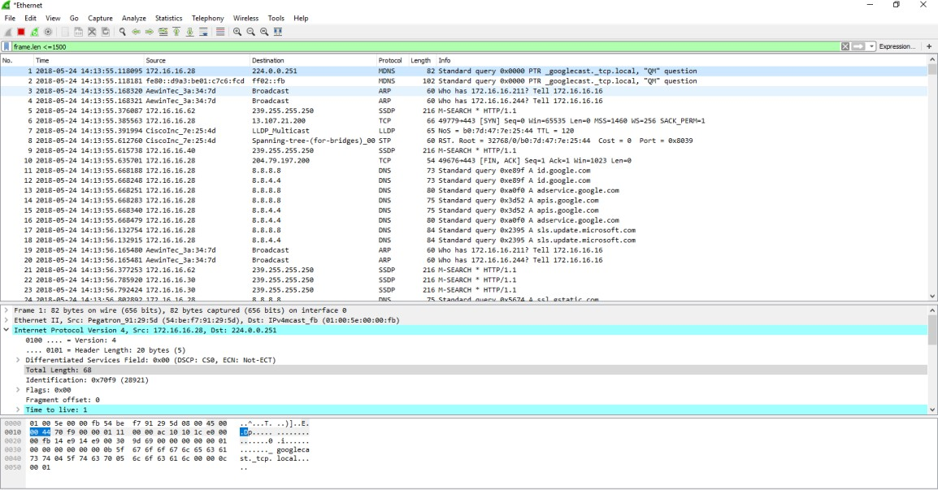

Step 8: Filter to Display HTTP Response
This filter display the all the HTTP related packets.

Filter 8: http.response
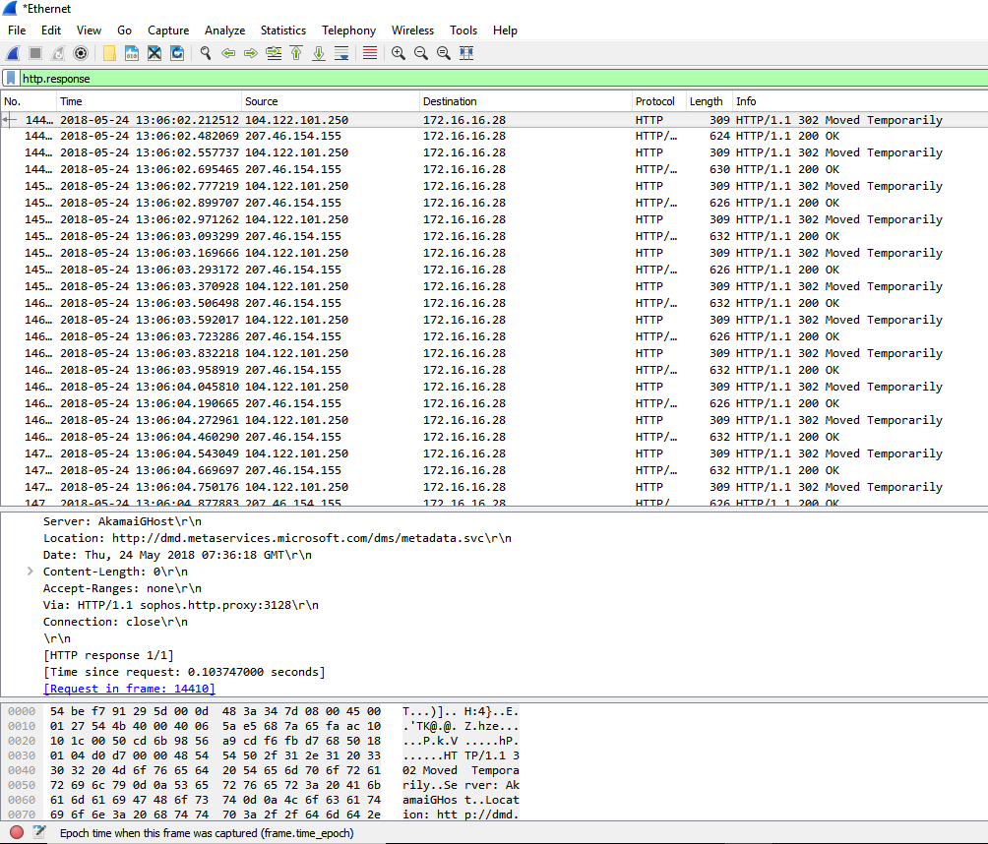
Step 9: Filter to Display All SYN flags sent from same IP address
This filter Displays all SYN flags sent from IP address practically and all connected opened from IP address.

Filter 9: ip.src==172.16.16.28 and tcp.flags.syn==1
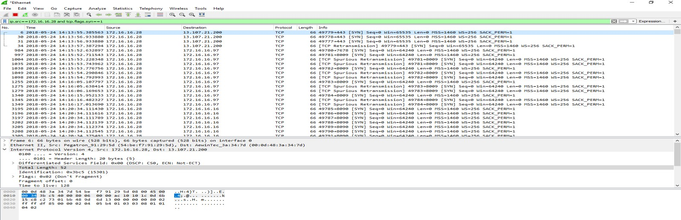
Step 10: Filter to Display the packets going to two different IP addresses
This filter Displays the all packets going in or out the two different IP addresses.

Filter 10: ip.addr == 172.16.16.28 or ip.addr ==239.255.255.250
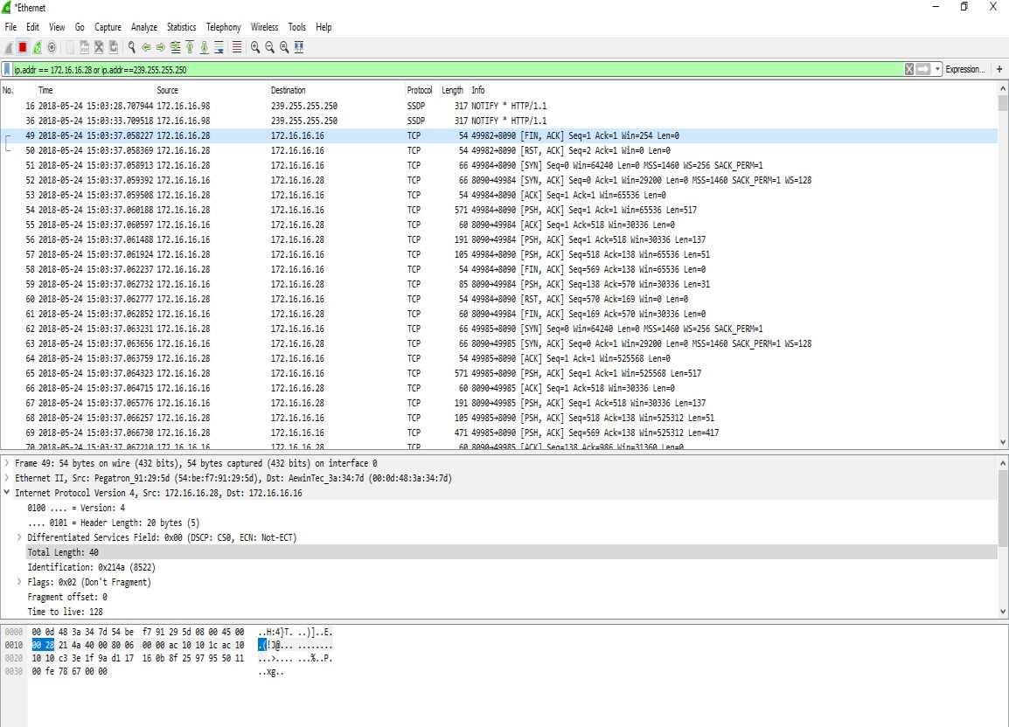
Step 11: Filter for Display packets not related to the particular protocols
This filter not display the any of the mention related protocols in the given filter.

Filter 11: not arp and not icmp
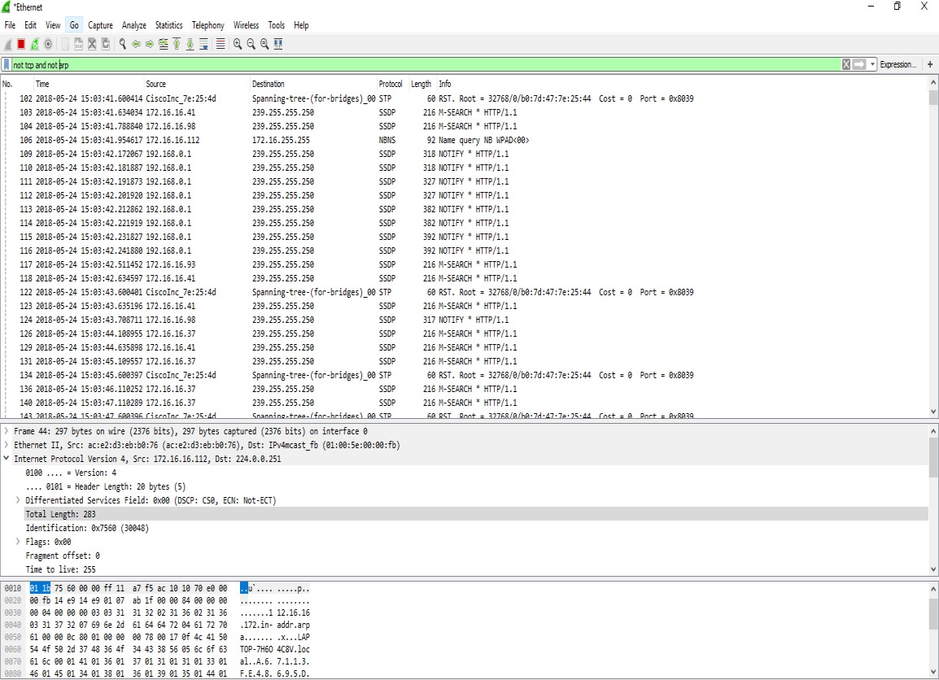

Step 12: Filter to Display a specific MAC address:

This filter display the packets both source and destination that related to specific MAC address.

Filter 12: eth,addr == 54-BE-F7-91-29-5E
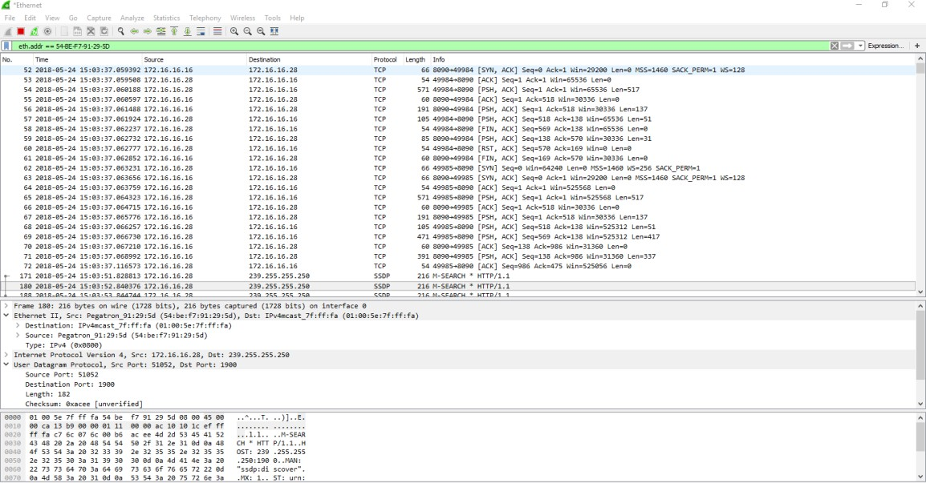
Step 13:Filter to Display the source MAC address:
This filter display the all MAC address that are related to the given source MAC address in filter.
Filter 13 : eth.src == 54-BE-F7-91-29-5E
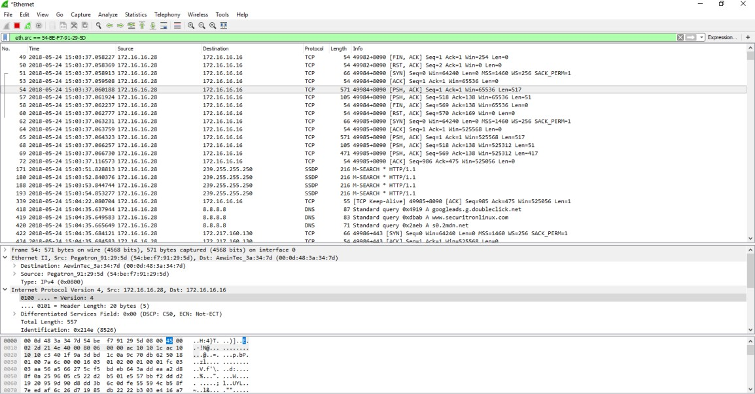

Step 14: Filter to Display the destination MAC address

This filter display the all MAC address that are related to the given destination MAC address in filter.

Filter 14: eth.dst == 54-BE-F7-91-29-5E
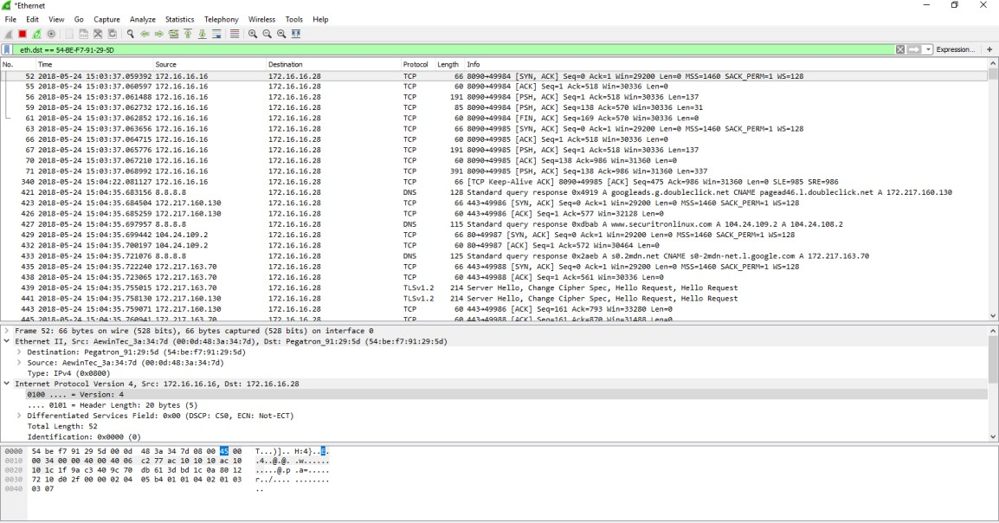

Step 15: Filter to display packets from the specific TCP and UDP
This filter display the packets that are related to TCP and UDP.

Filter 15: tcp.dstport == 80 , udp.dstport==80
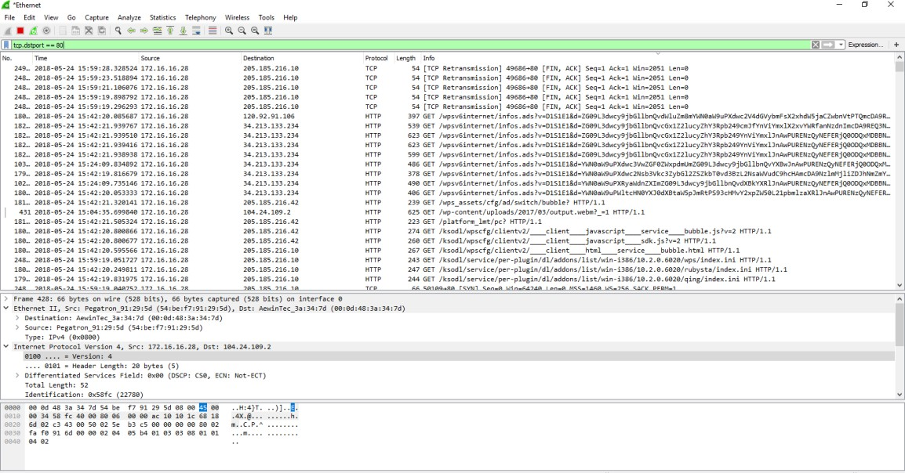

Step 16: Filter to display the packets from the IP address to the HTTP server

This filter displays the all the packets from the specific IP address to the HTTP server.

Filter 16: ip.addr == 172.16.16.28 and tcp.dstport == 80
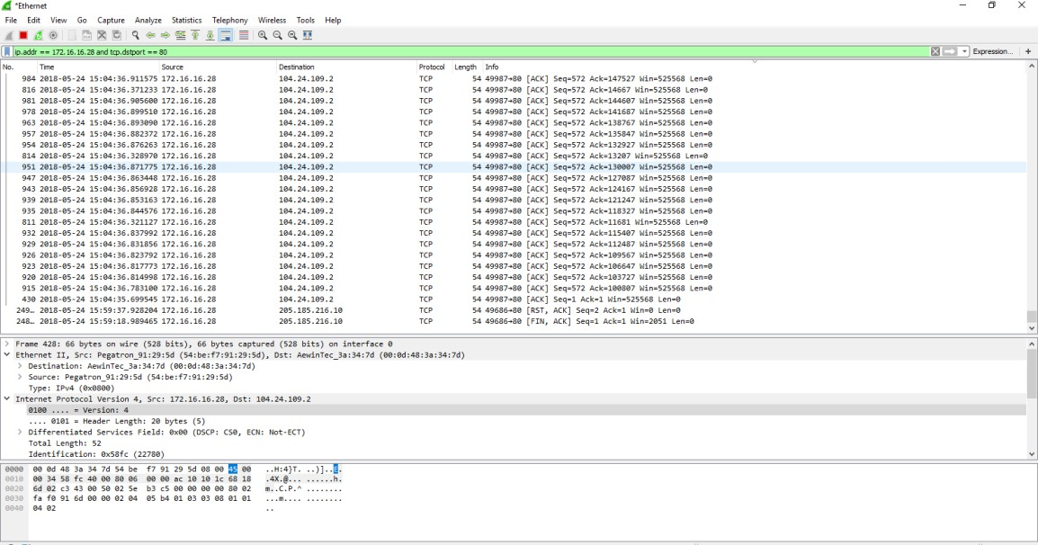
Step 17: Filter to Display the retransmission in a specific TCP connection
This filter display the packets are retransmission to a specific TCP connection.

Filter 17: tcp.stream eq 16 && tcp.analysis.retransmission
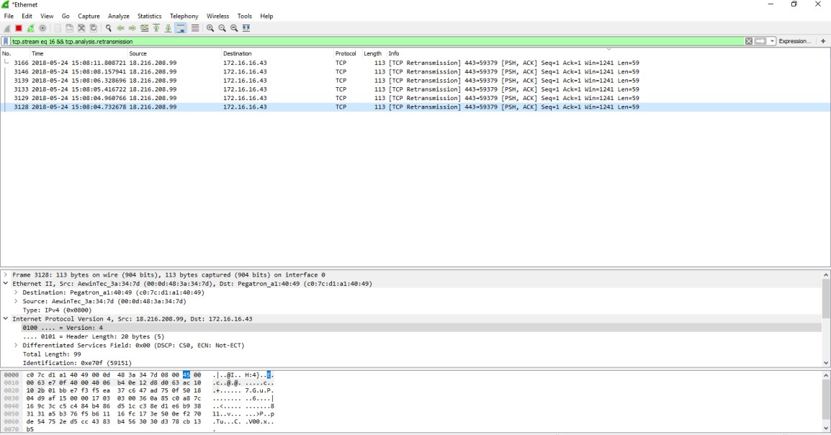

Step 18: Filter to Display the HTTP requests packets from specific website
This filter display the HTTP packets that are related to the given website name in the filter.

Filter 18: http.request.uri.contains”way2sms.com”
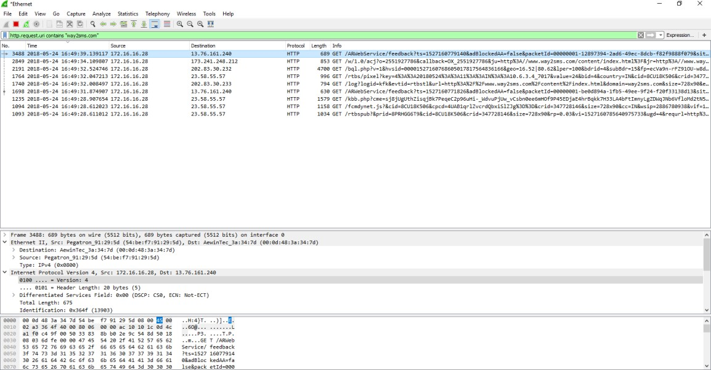
Summary tool from the statistics menu:
This statistics displays the general information about the data that runs the network. How to do it:
1. From the statistics menu, choose capture file properties
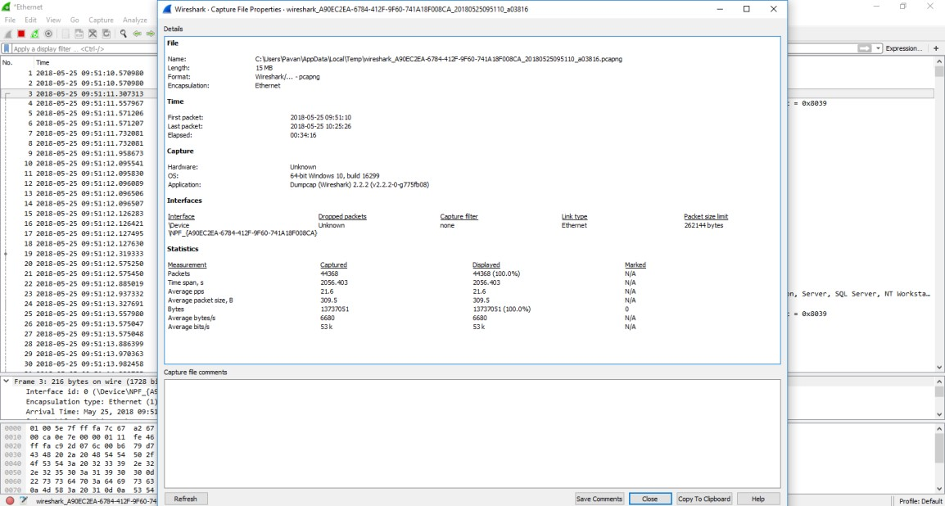

The protocol hierarchy tool from the statistics menu:
We learn how to get protocol hierarchy information of the data that runs over the network.
How to do it:
1. From the statistics menu, choose protocol hierarchy
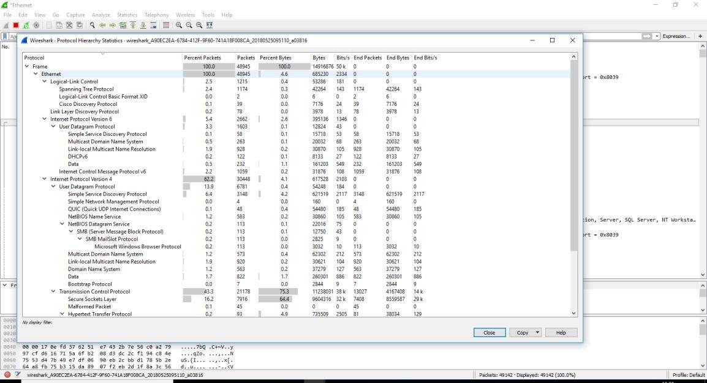

The conversation tool from the statistics menu:
We will learn how to get information about conversation that runs over the network. How to do it:
1.From the statistics menu, choose conversations
