Assignment - 1

Aim: To analyse the suspected email header to know the origin of sender.

Requirements: → Email header.
→ email tracer.

Theory:
An email consists of three vital components: the envelope, the header(s), and the
body of the message. The envelope is something that an email user will never see since it is part of the internal process by which an email is routed. The body is the part that we always see as it is the actual content of the message contained in the email. The header(s), the third component of an email, is perhaps a little more difficult to explain, though it is arguably the most interesting part of an email.

Procedure:

Step 1: Open an email you want to check.
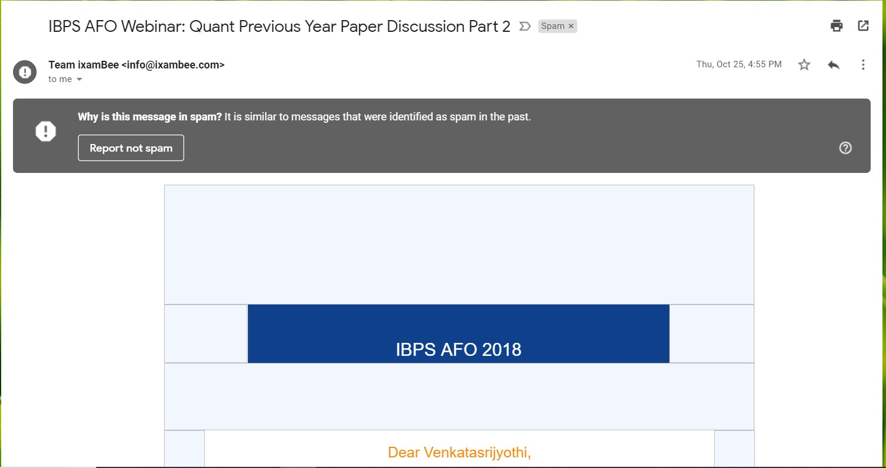

Step 2: Select options and show original.
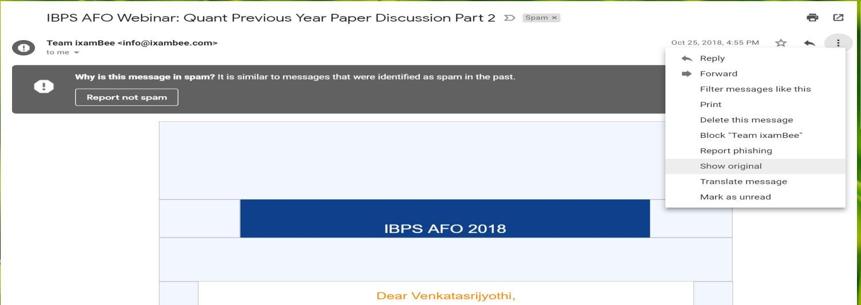

Step 3: click on copy to clipboard.

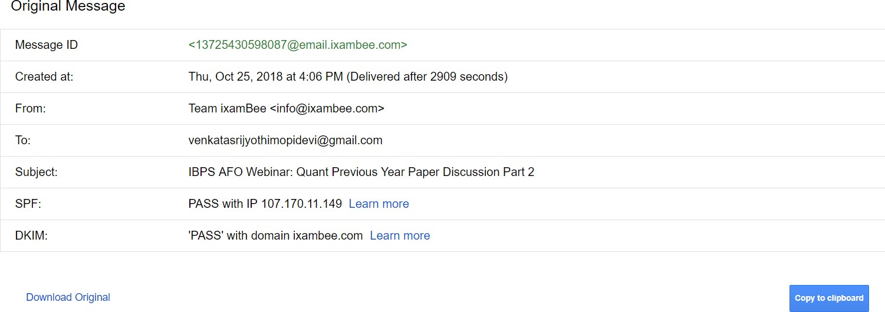

Step 4: go to the Email Header Analyzer website and paste the copied code.

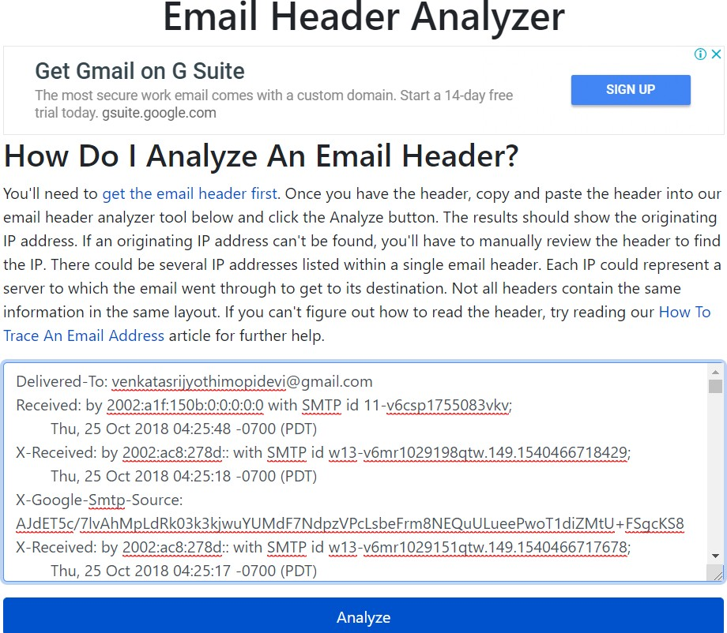

Step 5: The email analysis as shown.
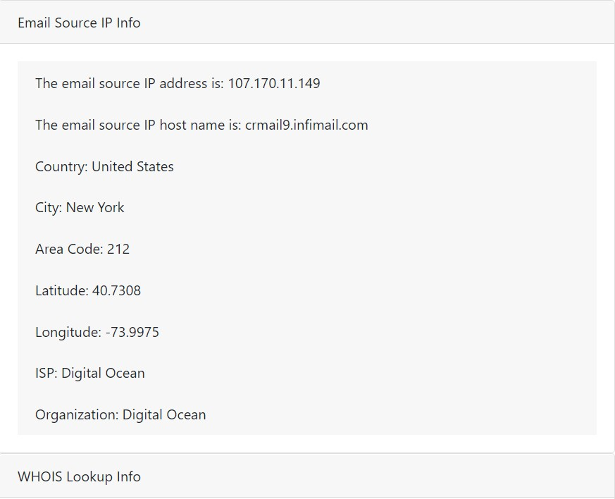

Step 6: If you have suspected a fake mail id in our account, we can check the origin of the mail.
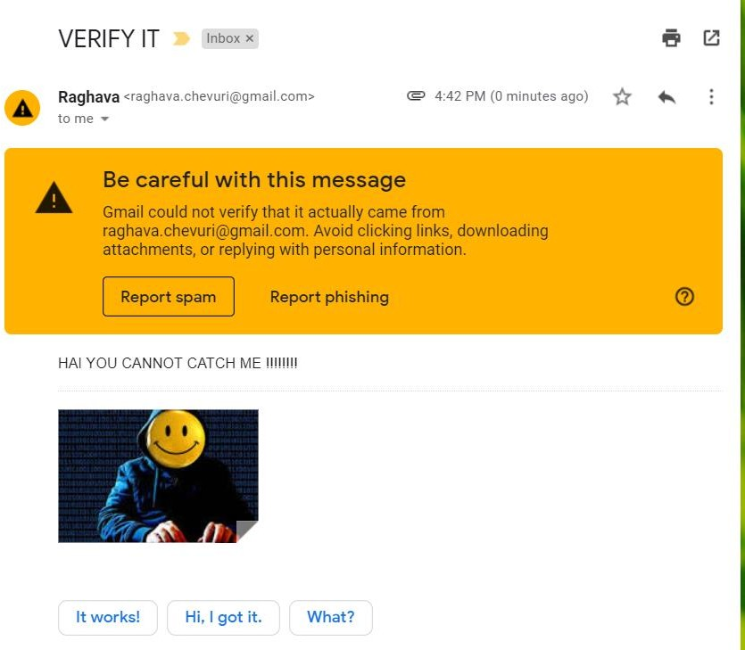

Step 7: Open the original message.

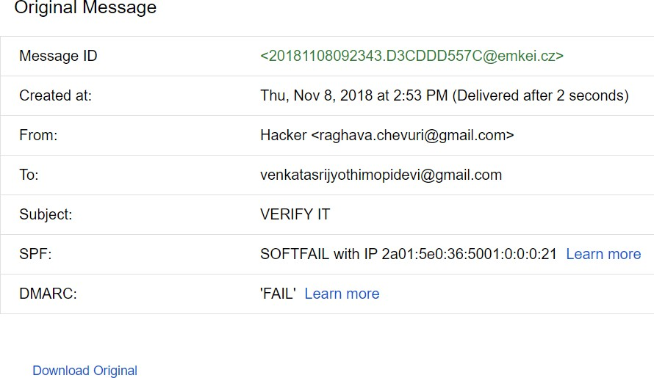

Step 8: First open the mail and then go to options and open original mail after opening the original mail we have an option like copy to clipboard.
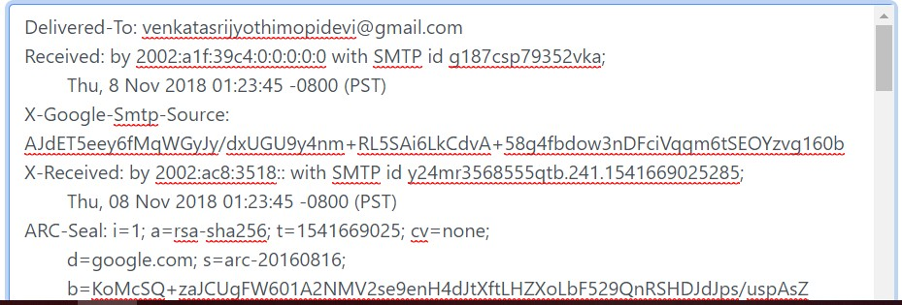

Step 9: Open the link http://whatismyipaddress.com/trace-email and scroll down and paste the header in the box and click get source.
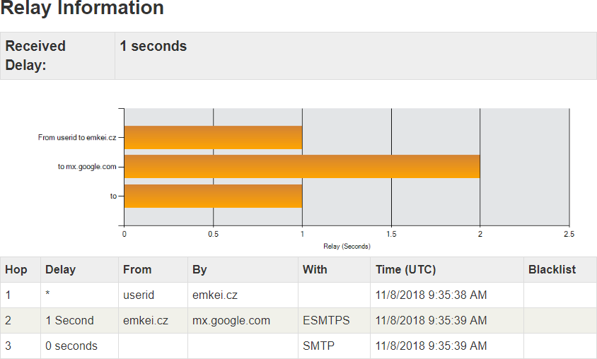

Step 10: After that it will analyse the header and show the source of the mail as shown below it shows that the mail is came from a site called emkei.cz now open that website and check.
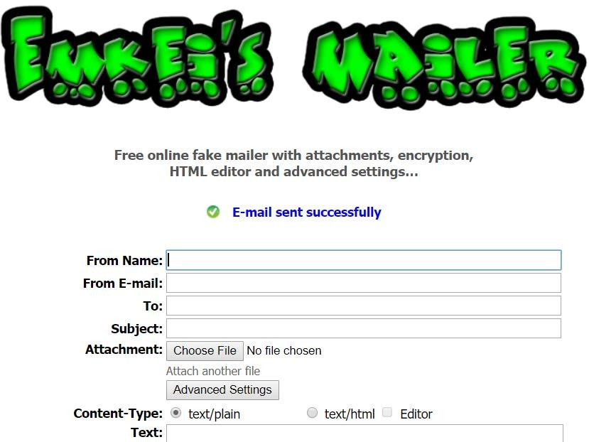
Result: This is a spam mail came from a website emkei.cz it is a fake mail sender site.

