Assignment 1

Aim : Integrity Checksum by using Hash Calculator.
It is important to understand when data has been corrupted or it has been tampered with. A hashing program can be used to verify if data has changed, or if it has remained the same. A hashing program performs a hash function on data or a file, which returns a (usually much shorter) value. There are many different hash functions, some very simple and some very complex. When the same hash is performed on the same data, the value that is returned is always the same. If any change is performed on the data, the hash value returned will be different.
HashCalc: A fast and easy-to-use calculator that allows to compute message digests, checksums and HMACs for files, as well as for text and hex strings. It offers a choice of 13 of the most popular hash and checksum algorithms for calculations.
MD5: The MD5 algorithm is a widely used hash function producing a 128-bit hash value.
SHA-1: SHA-1 (Secure Hash Algorithm 1) is a cryptographic hash function which takes an input and produces a 160-bit (20-byte) hash value known as a message digest typically rendered as a hexadecimal number, 40 digits long.
SHA-256: A Cryptographic hash (sometimes called 'digest') is a kind of 'signature' for a text or a data file. SHA-256 generates an almost-unique 256-bit (32-byte) signature for a text.
RIPEMD - 160 : RIPEMD (RACE Integrity Primitives Evaluation Message Digest) is a family of cryptographic hash functions. RIPEMD was based upon the design principles used in MD4, and is similar in performance to the more popular SHA-1. RIPEMD-160 is an improved, 160-bit version of the original RIPEMD, and the most commonly used version in the family.
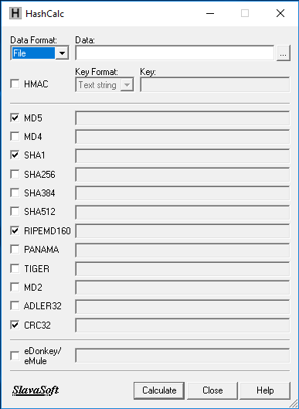
Above screenshot depicts the HashCalc home screen which consists of various crypto-algorithms to calculate hash for any file.
Steps:
- Download and install HashCalc from the following link.
http://www.slavasoft.com/download.htm.
- Follow the installation wizard to install HashCalc. After successful installation, open HashCalc executable file. Upon executing, a screen with different radio buttons will be displayed as in above screenshot.
- HashCalc can calculate Hashes for either “files” or any “String”. Select any Data Format to calculate hash as shown in Figure . User can select required Hash algorithm by selecting them.

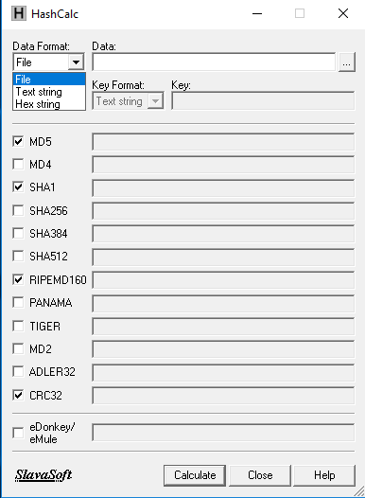

- Let us assume that we need to calculate hash of a text file with name sample.txt which contains the following data as shown in below figure.

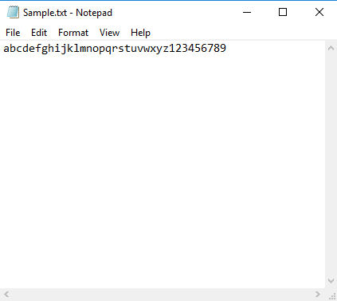

- Browse the required file from browse button (3 dotted button which lies right side of data text field) and select the file.
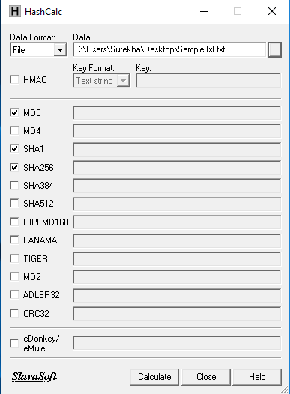

- After browsing a file, click on calculate button which calculates the required hashes of the selected file, the Hash Values are shown in below figure.
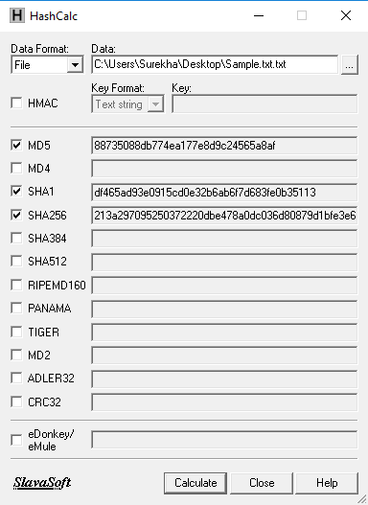

- All the selected hash algorithms generates the Hashes for the given file. Since Hash function will be unique, if the file is modified i.e., changing any single character or modifying any values from the file results in different set of hash values as shown in below screenshots.

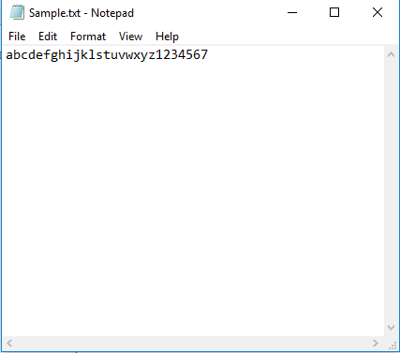
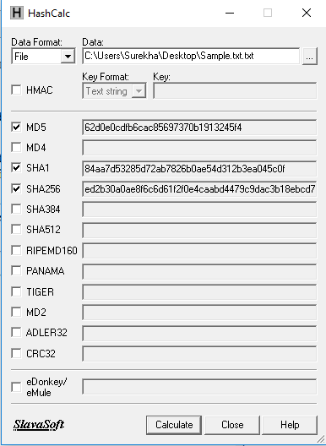
- By Observing above screenshots, we came to know that the hash will be changed completely for any minimal modification of the file.

