Assignment – 3

Aim : Fundamentals & Interpretation Of $MFT File in windows file system .
MFT:
The master file table (MFT) is a database in which information about every file and directory on an NT File System (NTFS) volume is stored. There is at least one record for every file and directory on the NTFS logical volume. Each record contains attributes that tell the operating system (OS) how to deal with the file or directory associated with the record.
As files are added to an NTFS file system volume, more entries are added to the MFT and the MFT increases in size. When files are deleted from an NTFS file system volume, their MFT entries are marked as free and may be reused. However, disk space that has been allocated for these entries is not reallocated, and the size of the MFT does not decrease.
The NTFS file system reserves space for the MFT to keep the MFT as contiguous as possible as it grows. The space reserved by the NTFS file system for the MFT in each volume is called the MFT zone. Space for file and directories are also allocated from this space, but only after all the volume space outside of the MFT zone has been allocated.
By using the FTK Imager we are creating MFT file.
Open the FTK Imager.
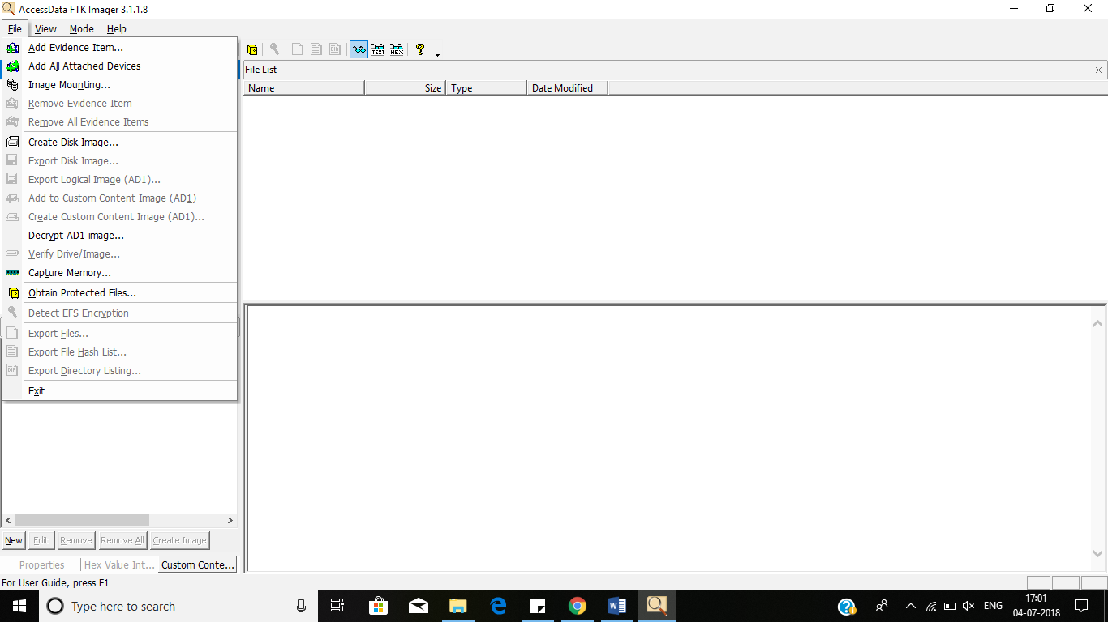

Selecting the source evidence file as Physical drive.
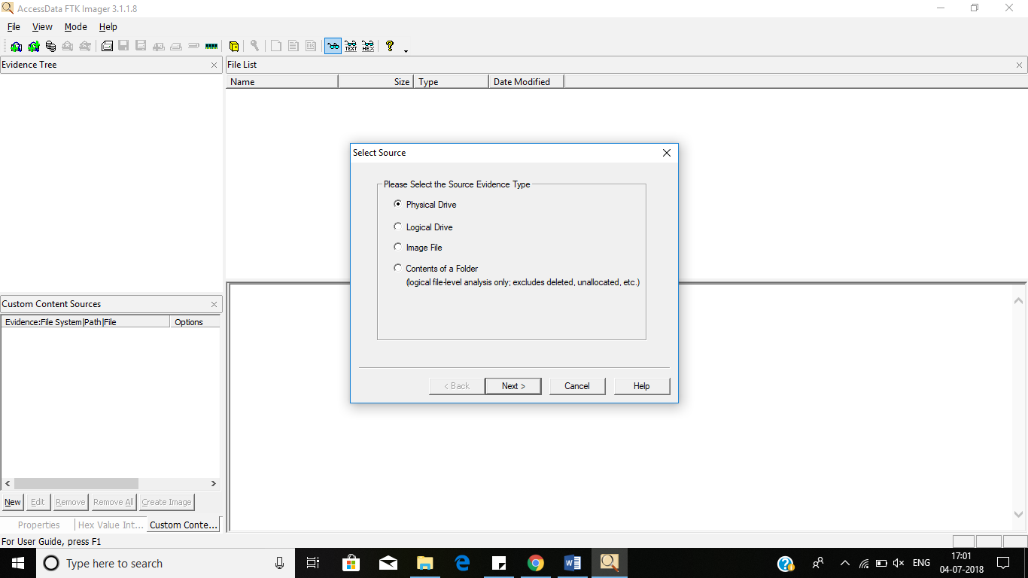

Selecting source drive from the available drives.
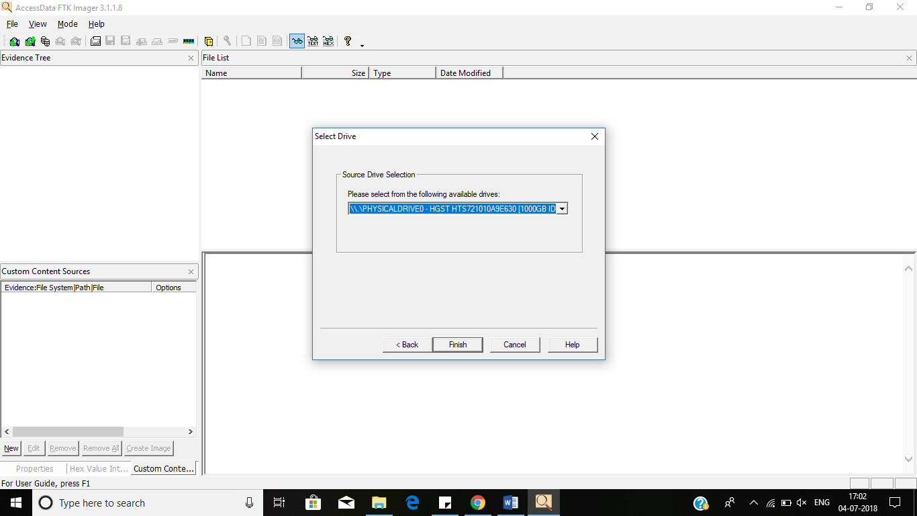

After click on the finish it will display the evidence tree like below the image.

In the root folder the $MFT file is present right click on the file export it and save the file in the selected file location.
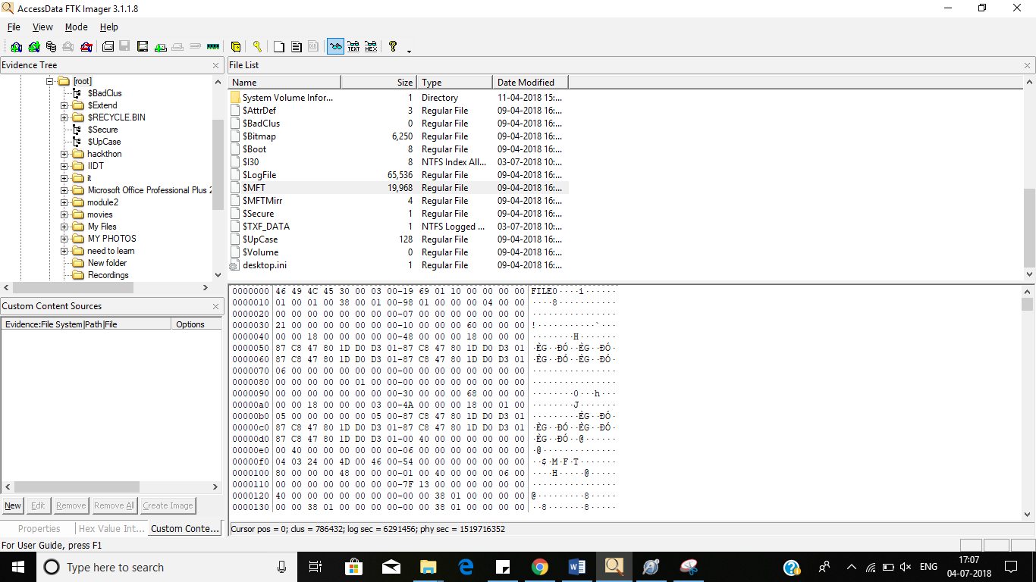

$MFT file is stored on the desktop location.

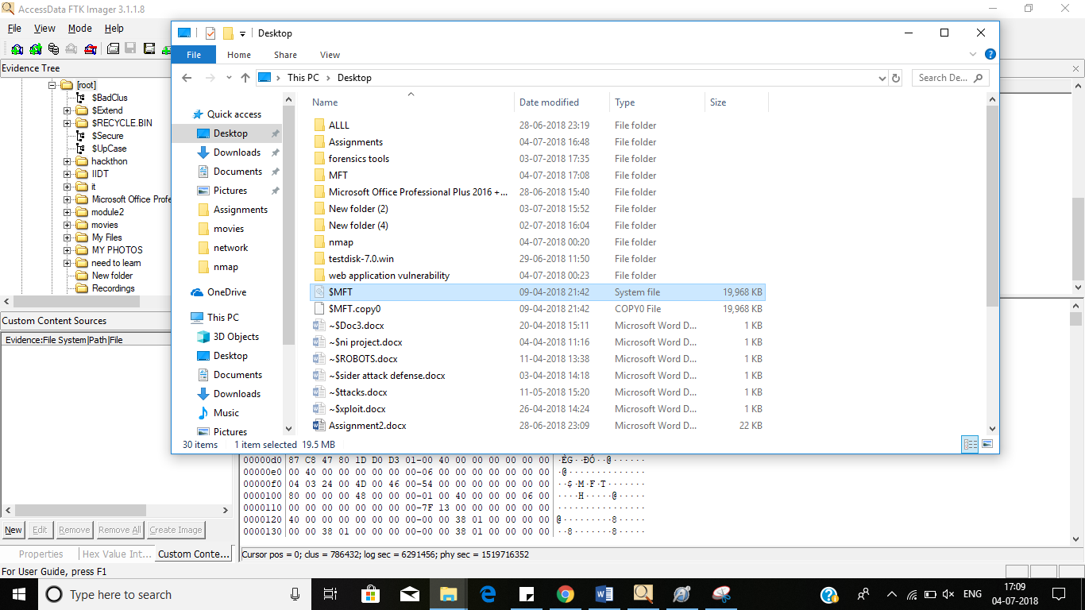

To analyses this $MFT file using Mft2Csv. It will convert the $MFT file in to Excel Format file.
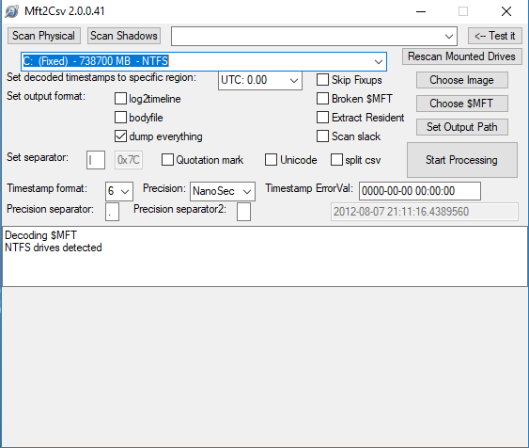

Select the $MFT file.
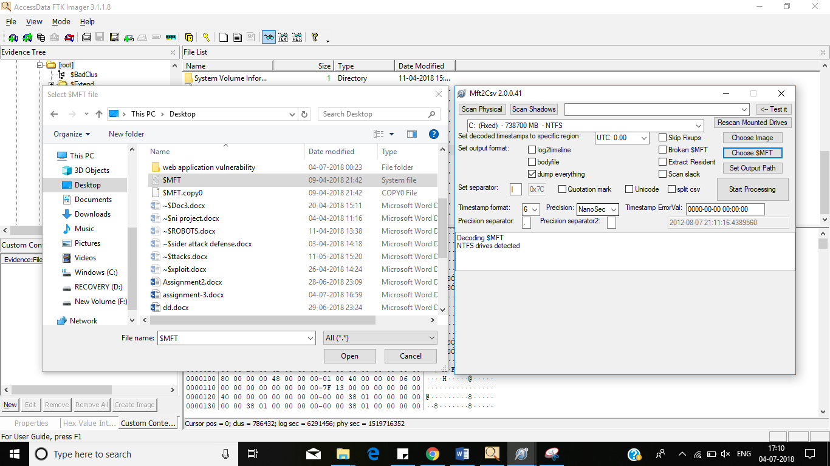

Set the record Size as 1024 bytes
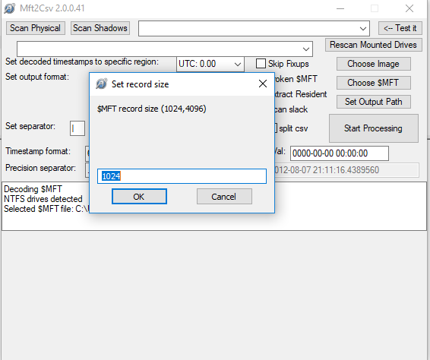

Click on the start processing it will start the process of converting the $MFT file in to Csv format.
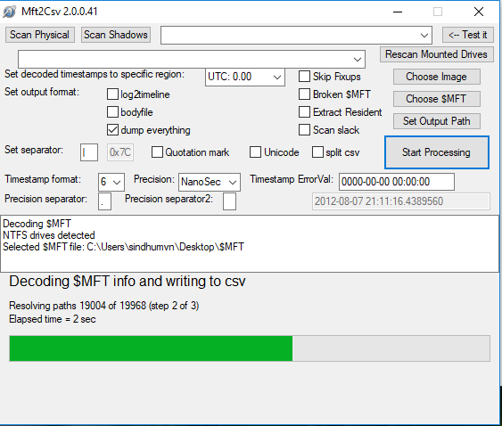
After completed the file the file stored on the particular location as shown in the below image

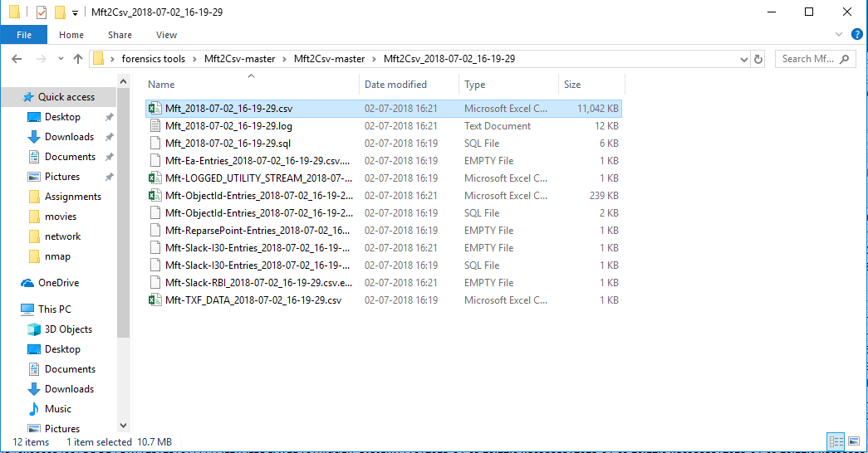

The converted Excel file is look like as shown by using this we can analyses the data related to the computer.
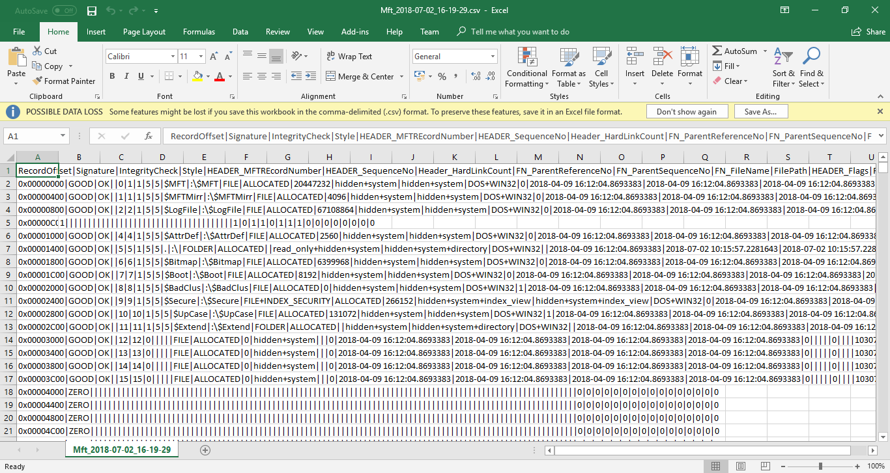

NTFS walker:
NTFSWalker is a free tool for the Windows operating system that can be used to explore and recover data on NTFS partitions. The program can display data of connected partitions or do the same for drive images if available.
It displays a list of available partitions and drives on startup, and offers to load disk images in the Advanced Tab. Once a drive has been selected it displays the available partitions, and then detailed information about the partition and data contained.

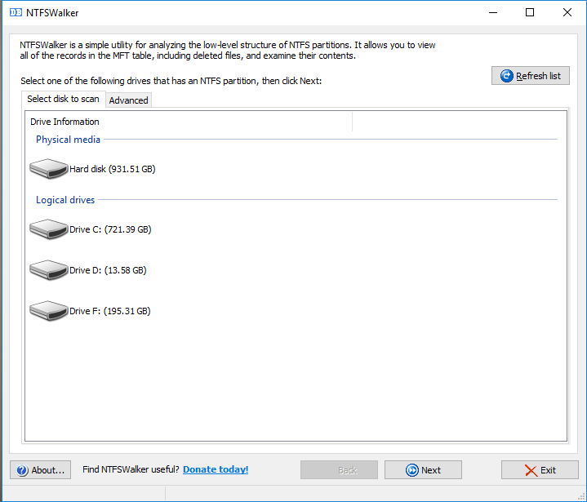

Select the Particular partition to recover the data and click on next.
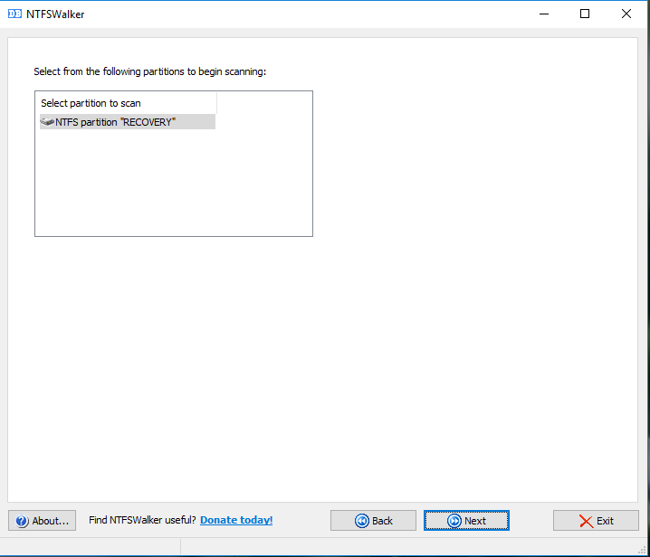

Existing files are displayed with a file icon in front of their row, while files that have been deleted with a red X. Those files may still be recoverable, especially if the size information is greater than 0 and a name is still displayed for the file.
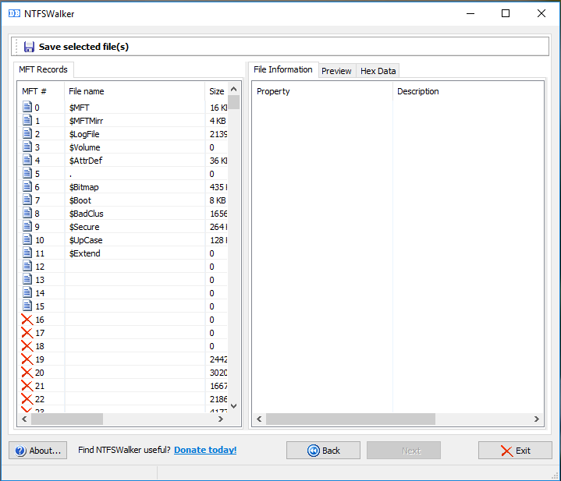

It will display file information related to the particular file
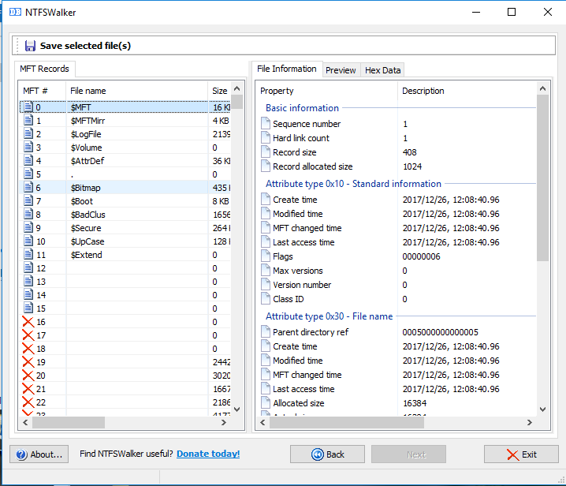

Hex data finally displays the file in hex code.

