Assignment – 4

Aim : Data Interpretation Techniques & File Signature Analysis in windows file system.
File Signature:
In computing, a file signature is data used to identify or verify the contents of a file. In particular, it may refer to:
- File magic number: bytes within a file used to identify the format of the file; generally a short sequence of bytes (most are 2-4 bytes long) placed at the beginning of the file see list of file signatures
- File checksum or more generally the result of a hash function over the file contents data used to verify the integrity of the file contents, generally against transmission errors or malicious attacks. The signature can be included at the end of the file or in a separate file.

WINHEX:
WinHex is a disk editor and a hex editor useful in data recovery and digital forensics.
WinHex, made by X-Ways Software Technology AG of Germany, is a powerful application that you can use as an advanced hex editor, a tool for data analysis, editing, and recovery, a data wiping tool, and a forensics tool used for evidence gathering. Customers using WinHex include the Oak Ridge National Laboratory, Hewlett Packard, National Semiconductor, several law enforcement agencies, and many other companies with data recovery and protection needs. Here we use winhex for Data gathering ,the first 8 bits in winhex are file signature for particular file.

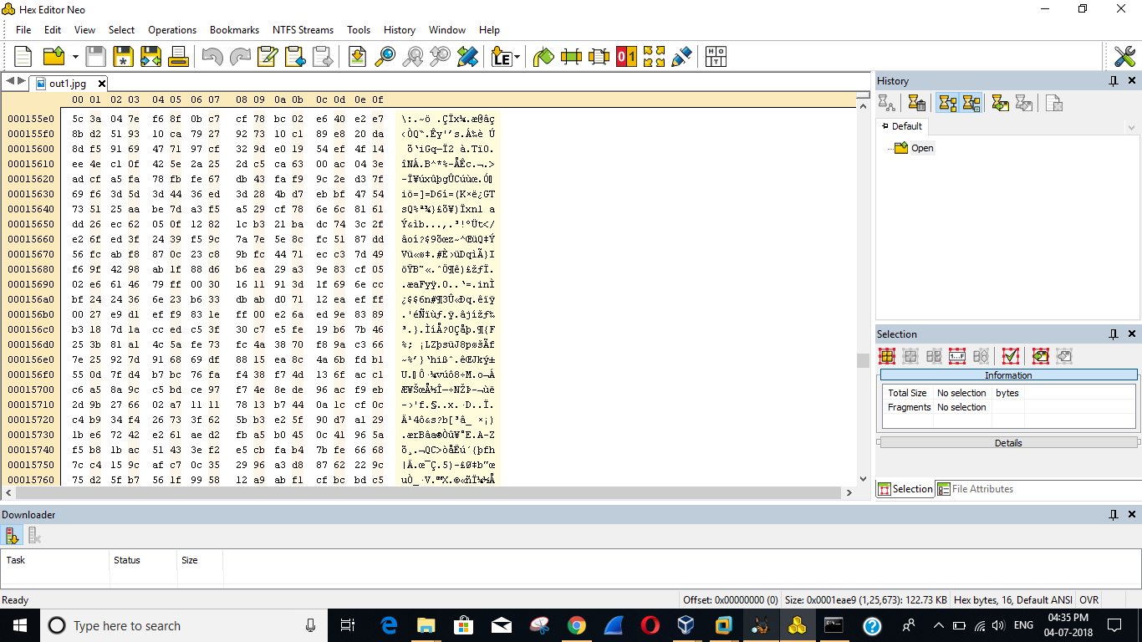

BAD EXTENTION:
In Bad extension we use a file in one format and save it in other format then the file wont run in pc. For example if we take jpg file and changed it in to .exe then the pc wont open respective file . as the file extension is different from its respective digital signature.

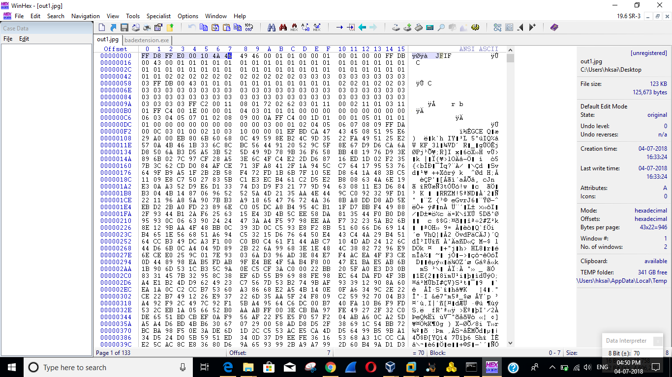
Saved the file as .exe
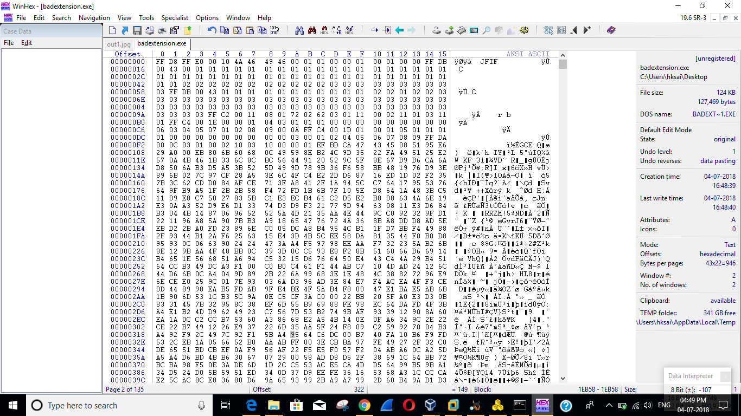

Pc is not supporting the changed file format
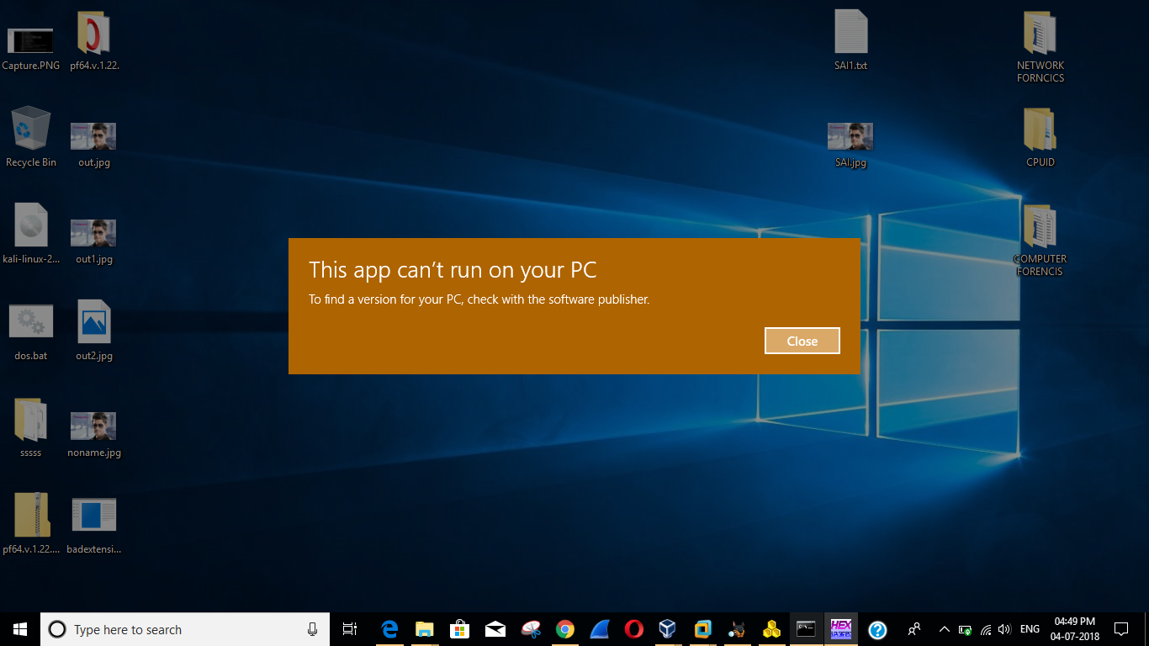

COMBINATION OF FILE:
In combination of file we combine two files in winhex by using stenographic technequie Steganography is the practice of concealing a file, message, image, or video within another file, message, image, or video. The word steganography combines the Greek words steganos, meaning "covered, concealed, or protected", and graphein meaning "writing". Generally, the hidden messages appear to be (or to be part of) something else: images, articles, shopping lists, or some other cover text. For example, the hidden message may be in invisible ink between the visible lines of a private letter.

- Text file is created.

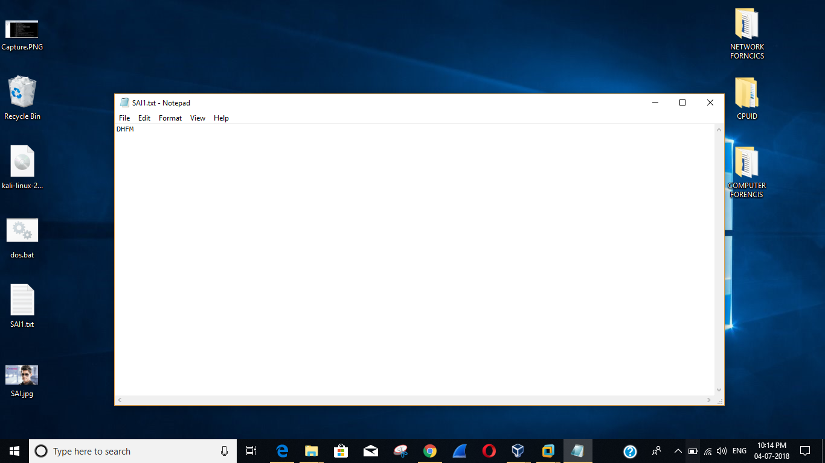

- Text file and image file is combined ,we can see the text in txt file using winhex
