Assignment - 5
Aim: To analyse the underlying data source using Autopsy

About Tool:
Autopsy is computer software that makes it simpler to deploy many of the open source programs and plugins used in The Sleuth Kit. The graphical user interface displays the results from the forensic search of the underlying volume making it easier for investigators to flag pertinent sections of data.

Procedure:
Step 1:
Open the Autopsy application to create new case
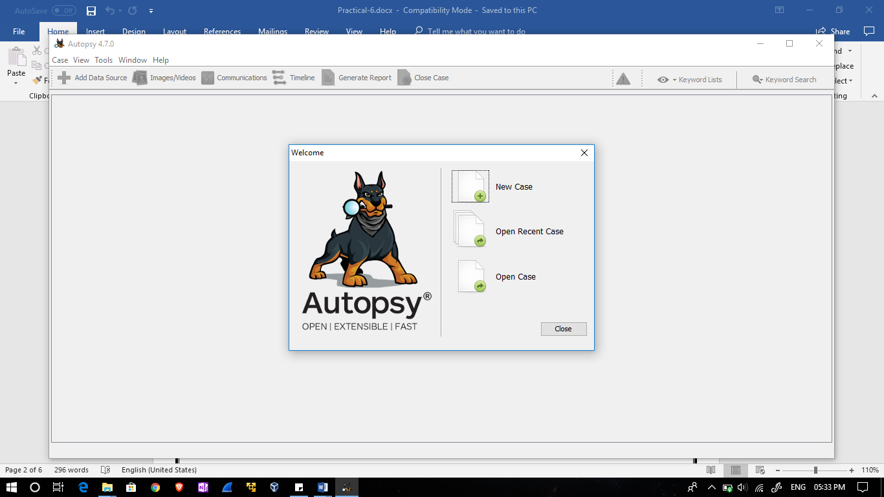

Step 2:
Give the case name and base dictionary and case type is single user.
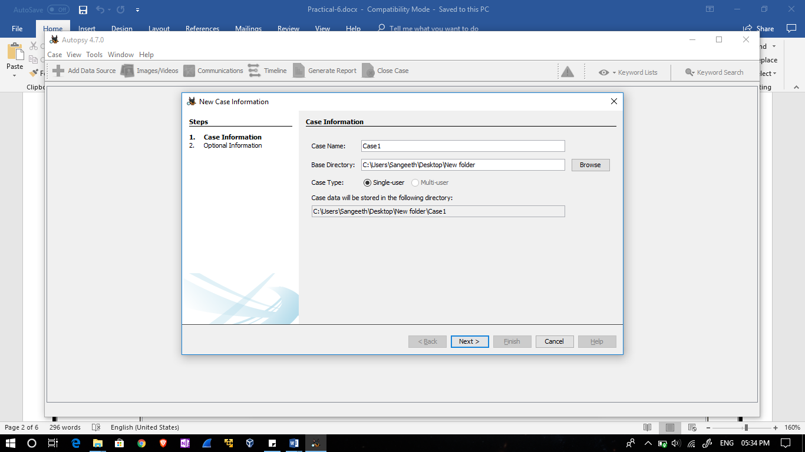
Step 3:
Give optional information and click on finish.
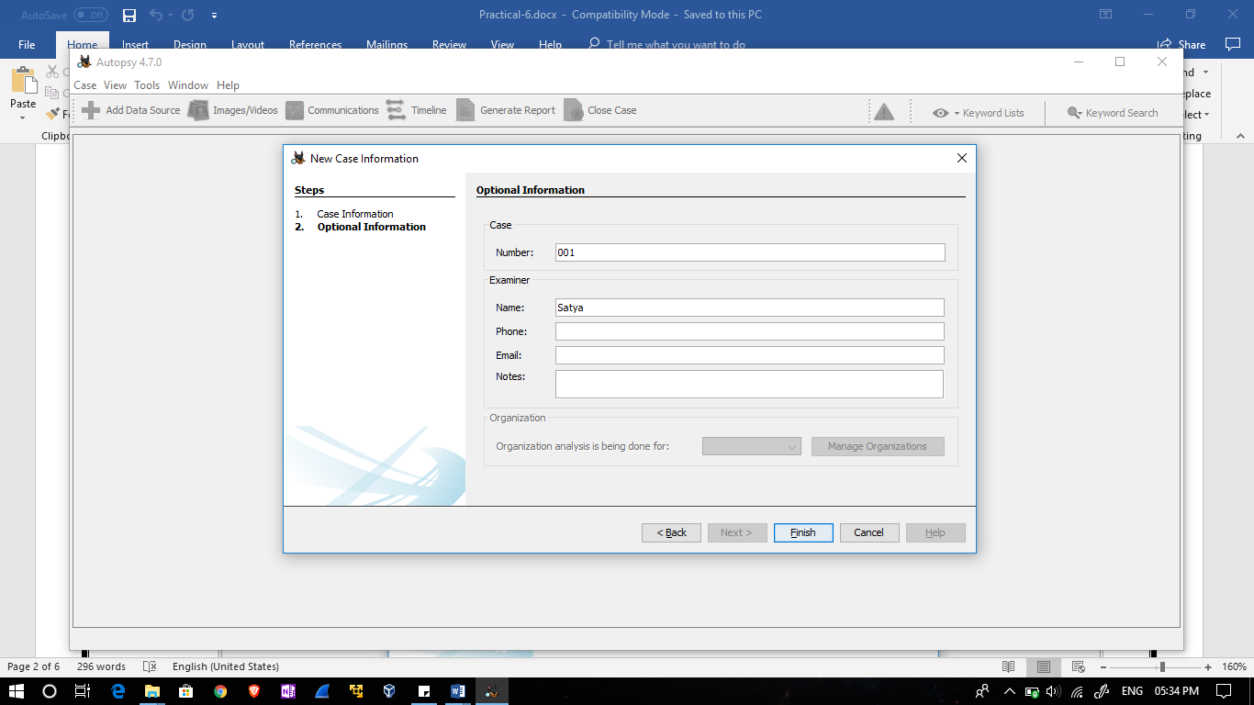

Step 4:
It will create a new case database.
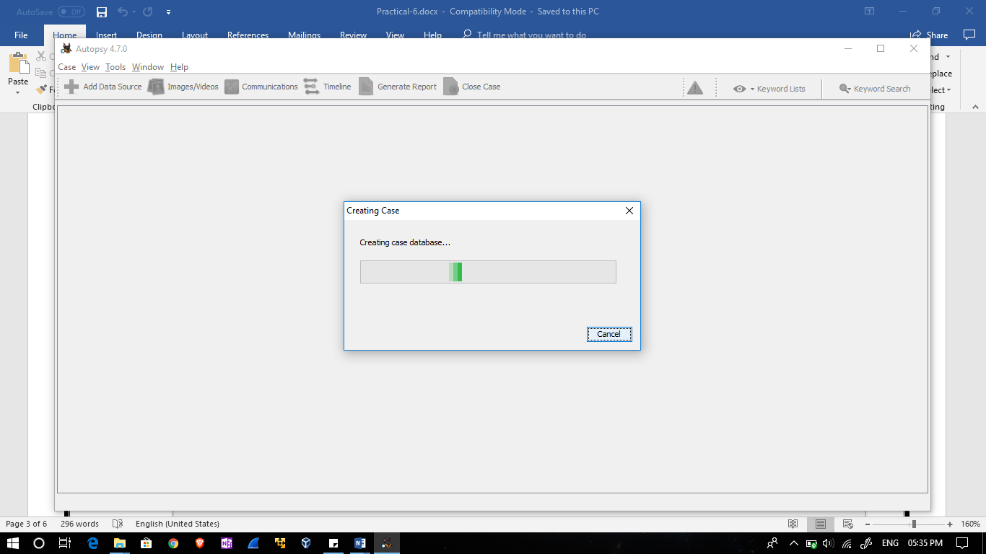
Step 5:
After you create a case, it automatically prompts you to add a data source. Select data source as Disk Image or VM file.
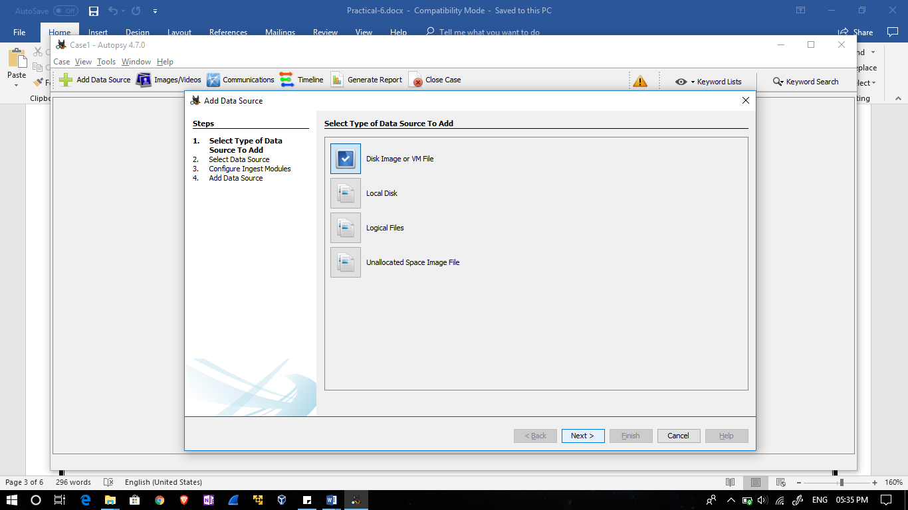

Step 6:
Browse the vmdk file of VM machine. And select the timezone.
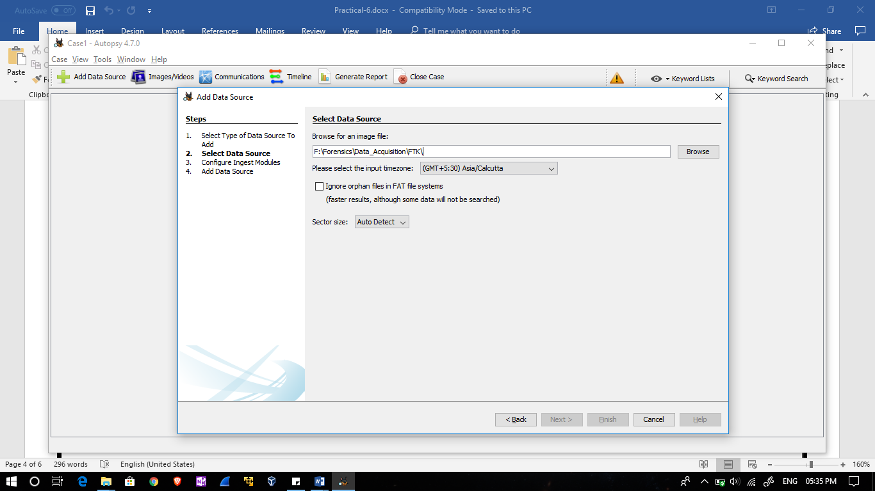
Step 7:
While it is examining the data source, you will be prompted with a list of ingest modules to enable.
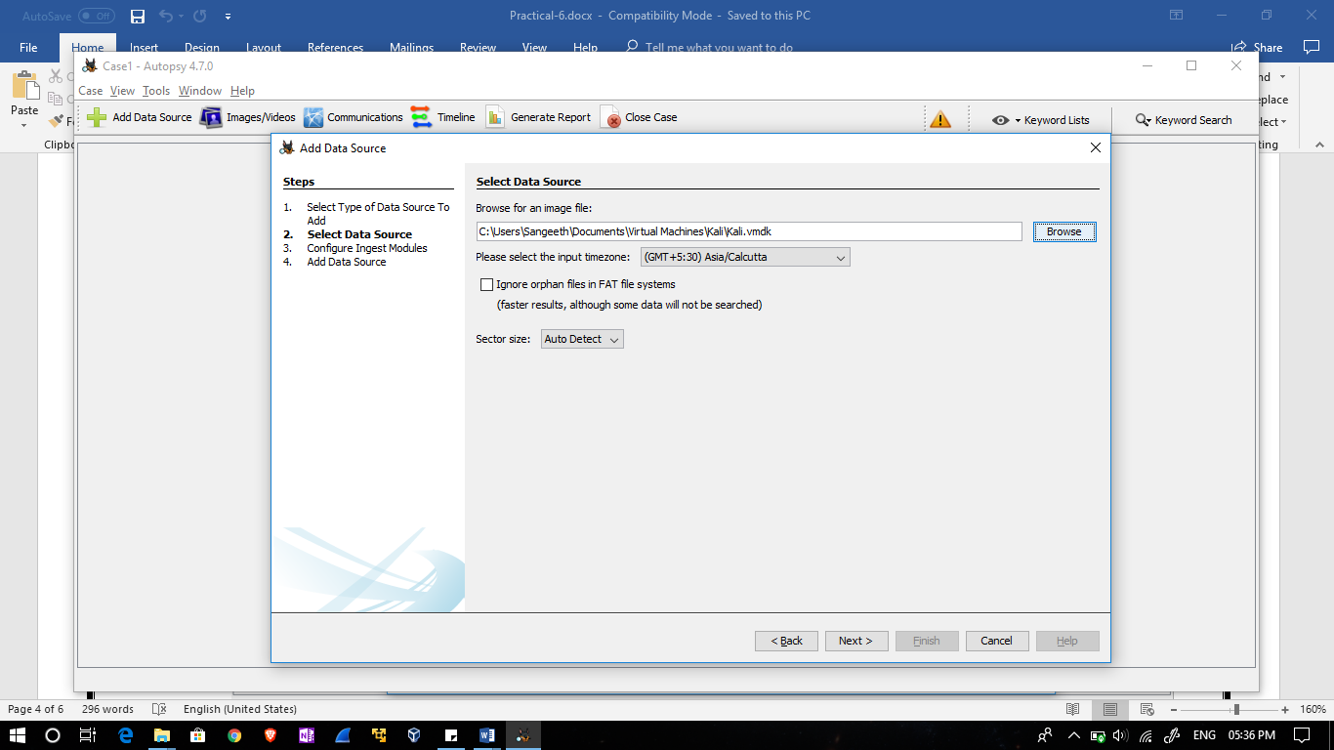

Step 8:
After you configure the ingest modules, you may need to wait for Autopsy to finish its basic examination of the data source.
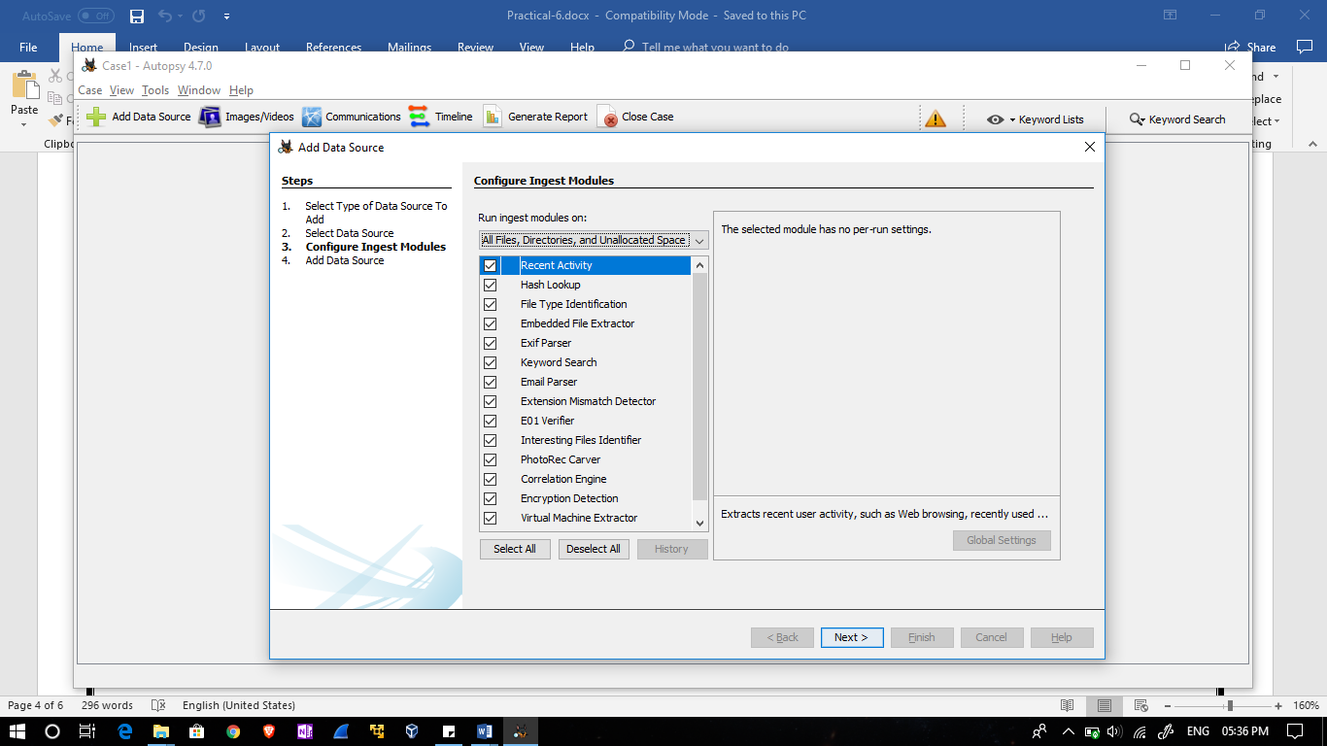
Step 9:
The data source is added to view the log click on finish
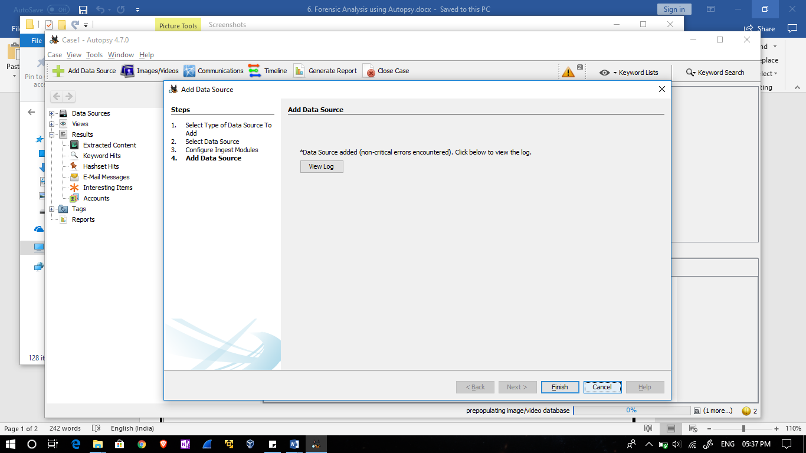

Step 10:
After the ingest modules have been configured and the basic examination of the data source is complete, the ingest modules will begin to analyze the file contents.
