# Sliding Window Techniques

The sliding window technique is a common algorithmic approach used for solving various problems that involve processing or analyzing a sequential data structure, such as arrays, strings, or streams.

It involves creating a fixed-size window that moves through the data structure one step at a time, typically from left to right, to perform specific operations or computations on the elements within the window.

**What is the Sliding Window Algorithm?**

The Sliding Window algorithm is a method for finding a subset of elements that satisfy a certain condition in issues.



The Sliding Window Algorithm is a specific technique used in computer science and programming to efficiently solve problems that involve arrays, strings, or other data structures by maintaining a**“window”**of elements within a certain range and moving that window through the data to perform operations or calculations.

***Using the Sliding Window Technique:***

The Sliding Window Technique is a powerful approach to efficiently solve problems involving arrays, strings, or sequences by maintaining a moving **“window”** of elements and performing operations as the window slides through the data. This technique helps reduce time complexity compared to brute-force methods.

* **Determine Window Size:** Decide on a fixed window size that defines the number of elements to consider at each step.
* **Initialize and Process**: Start with the initial elements within the window. Perform any initial calculations or operations.
* **Slide the Window:** Iterate through the data, updating the window by adding the next element and removing the leftmost one.
* **Update and Evaluate**: Adjust calculations or data structures based on the new element. Evaluate if the current window meets the problem’s conditions.
* **Continue Sliding:** Repeat the sliding, updating, and evaluation steps until the end of the data is reached.
* **Return Result**: Return the final result or outcome based on the processed windows.

***Problem****:*Given an array of integers, find the maximum sum of a subarray with a fixed window size.

Let’s consider the array: **[2, 1, 5, 1, 3, 2]**and a **window size of 3.**

1. Initialization: Start with the first 3 elements: [2, 1, 5]. Calculate their sum: 2 + 1 + 5 = 8.
2. Slide the Window: Move the window one step to the right: [1, 5, 1]. Calculate the sum: 1 + 5 + 1 = 7.
3. Update and Evaluate: Compare the current sum (7) with the previous maximum sum (8). Since 8 is greater, keep the maximum sum as 8.
4. Slide the Window: Move the window again: [5, 1, 3]. Calculate the sum: 5 + 1 + 3 = 9.
5. Update and Evaluate: Compare the current sum (9) with the previous maximum sum (8). Update the maximum sum to 9.
6. Slide the Window: Continue sliding the window: [1, 3, 2]. Calculate the sum: 1 + 3 + 2 = 6.
7. Update and Evaluate: Compare the current sum (6) with the previous maximum sum (9). Since 9 is greater, the maximum sum remains 9.
8. Final Result: After sliding through all windows, the maximum sum found is 9.

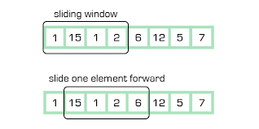

**Implementations of the sliding window technique:**

* **In CPP:**

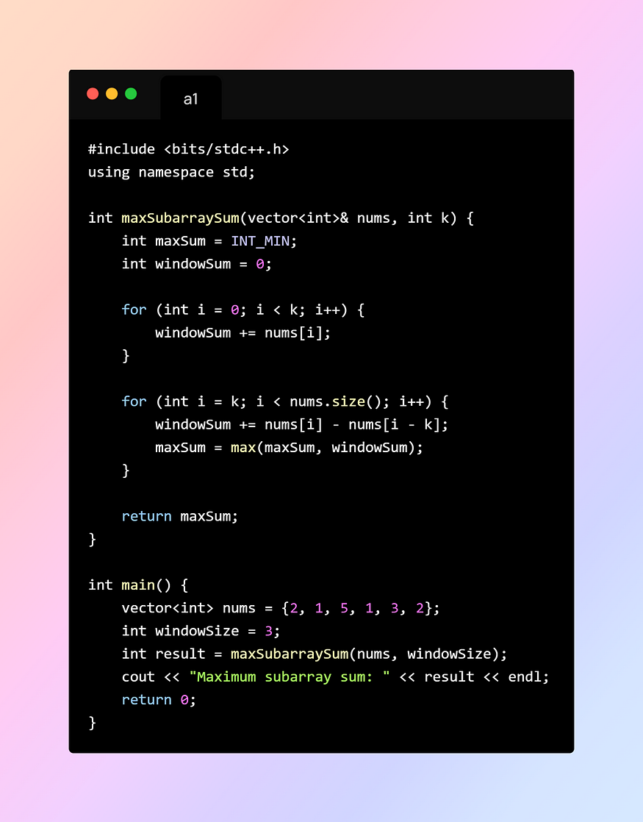

* **In Java:**

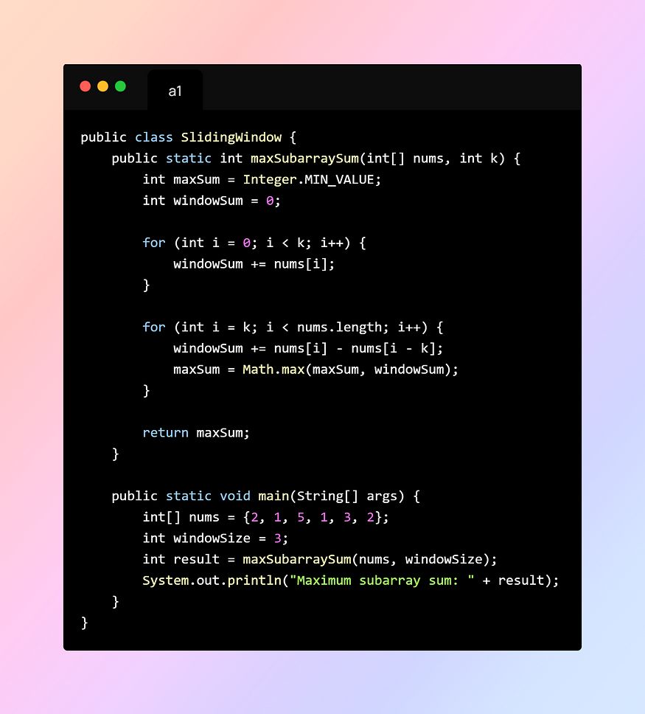

***Time and Space complexity of the sliding window technique:***

* **Time Complexity**:
* The time complexity of the sliding window technique is usually linear or close to linear, O(n), where n is the size of the input data structure (e.g., array or string). This is because you process each element once as the window slides through the data.
* **Space Complexity:**
* The space complexity of the sliding window technique is generally constant, O(1), because you’re maintaining a fixed-size window and a few additional variables to perform calculations or store intermediate results. The amount of extra memory used doesn’t grow with the input size; it remains constant regardless of the input size.

**Common Problems based on the “sliding window technique”:**

1. **Maximum/Minimum Subarray Sum:**
2. **Longest Substring with K Distinct Characters:**
3. **Longest Subarray with Ones after Replacement:**
4. **Find All Anagrams in a String:**
5. **Smallest Subarray with Sum at Least K:**
6. **Maximum Consecutive Ones after Flipping Zeros:**
7. **Minimum Window Substring:**
8. **Longest Repeating Character Replacement:**
9. **Fruit Into Baskets:**
10. **Subarrays with Product Less than K:**

**Introducing the concept of a variable-size window:**

While the basic sliding window technique involves a fixed-size window that moves through the data structure, the variable-size sliding window introduces flexibility by allowing the window size to change dynamically based on certain conditions.

This is particularly useful when the problem involves finding a subarray or substring that satisfies certain criteria.

***Variable Size Sliding Window Approach:***

In this approach, instead of maintaining a fixed-size window throughout the entire process, you adjust the window size as needed. The window can grow or shrink depending on the problem’s requirements.

**Example Problem: Longest Subarray with Sum Less Than K**

* **Problem**: Given an array of positive integers and an integer K, find the length of the longest subarray whose sum is less than K.

1. Initialize variables: left to track the start of the subarray and right to iterate through the array.
2. Initialize windowSum as the first element of the array.
3. Initialize maxLength to keep track of the maximum subarray length.

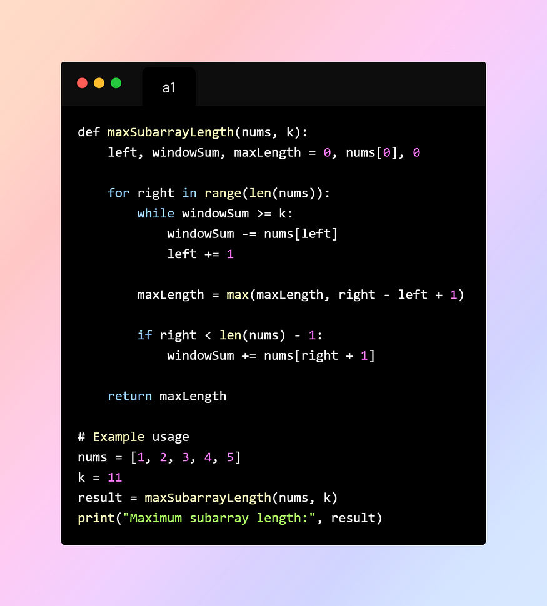

**Conclusion:**

In conclusion, the sliding window technique is a powerful and versatile algorithmic approach that provides an efficient solution for various problems involving sequential data structures like arrays and strings.

It offers a structured way to process contiguous segments of data within these structures while optimizing time complexity and sometimes space complexity.

Advantages of usingthe sliding window technique:

1. Optimization: By maintaining a window of elements, the technique avoids redundant calculations and comparisons, leading to optimized computations.
2. Constant Space Complexity: The sliding window technique often requires only a constant amount of additional memory, making it memory-efficient.
3. Efficiency: The sliding window technique often reduces time complexity from a naive brute-force approach to linear or nearly linear, making it well-suited for processing large datasets.