**[19. Remove Nth Node From End of List](https://leetcode.com/problems/remove-nth-node-from-end-of-list/)**

Ref: https://www.youtube.com/watch?v=3kMKYQ2wNIU

Given the head of a linked list, remove the nth node from the end of the list and return its head.

**Example 1:**

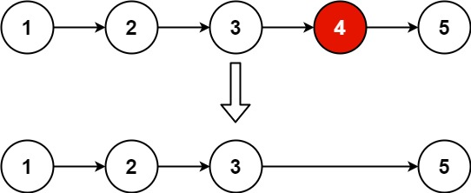

**Input:** head = [1,2,3,4,5], n = 2

**Output:** [1,2,3,5]

**Example 2:**

**Input:** head = [1], n = 1

**Output:** []

**Example 3:**

**Input:** head = [1,2], n = 1

**Output:** [1]

**Constraints:**

* The number of nodes in the list is sz.
* 1 <= sz <= 30
* 0 <= Node.val <= 100
* 1 <= n <= sz