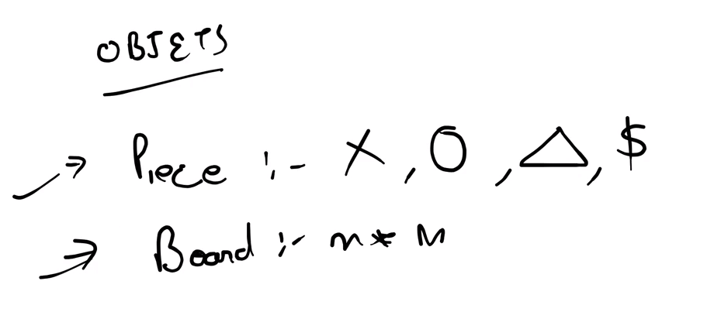

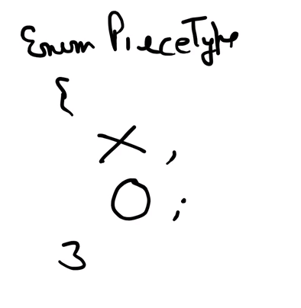

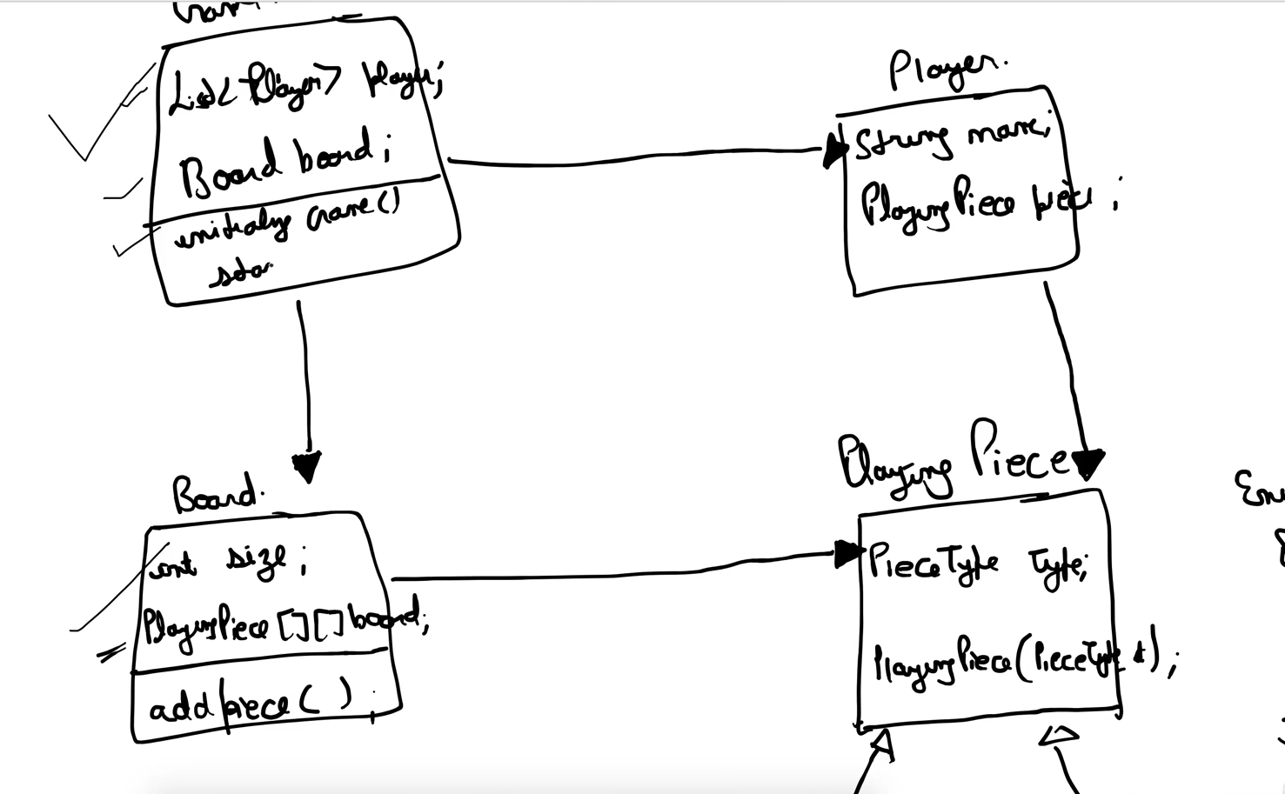

PieceType:

* public enum PieceType {

X,

O;

}

PlayingPiece:

* public PieceType pieceType
* PlayingPiece(PieceType pieceType)

PlayingPieceO:

* PlayingPieceO extends PlayingPiece
* public PlayingPieceO() {

super(PieceType.O);

}

PlayingPieceX:

* PlayingPieceO extends PlayingPiece
* public PlayingPieceO() {

super(PieceType.O);

}

Player:

* String name
* PlayingPiece playingPiece
* public Player(String name, PlayingPiece playingPiece)
* public String getName()
* public PlayingPiece getPlayingPiece()

Board:

* int size
* PlayingPeice [][] board
* Board(int size)
* **boolean** addPiece(**int** row, **int** column, PlayingPiece playingPiece)
* public List<Pair<Integer, Integer>> getFreeCells()
* public void printBoard()

TicTacToeGame:

* Deque<Player> players;