**MA-374 Lab-11**

Name- Dev Sandip Shah

Roll No.- 200123074

**Question 1:**

* In the Vasicek Model the risk neutral dynamics of r can be expressed as -
$$dr=(b-ar)dt+σdW$$

* On comparing with the model we get $a=β and b=βu.$
* Price of the bond is calculated using following formulae -
$$B(t,T)=\frac{1-e^{-a(T-t)}}{a}$$

$$A(t,T)=\frac{(B(t,T)-T+t)(ab-\frac{σ^{2}}{2})}{a^{2}}-\frac{σ^{2}B^{2}(t,T)}{4a}$$

$$ρ(t,T)=e^{A(t,T)-B(t,T)r(t)}$$

* Yield can be calculated from the price using following formula–
$$Yield=\frac{-log(p(t,T))}{T-t}$$

* t = 0 in our case.

**Term structure for the given parameters is plotted using 10 time units.**

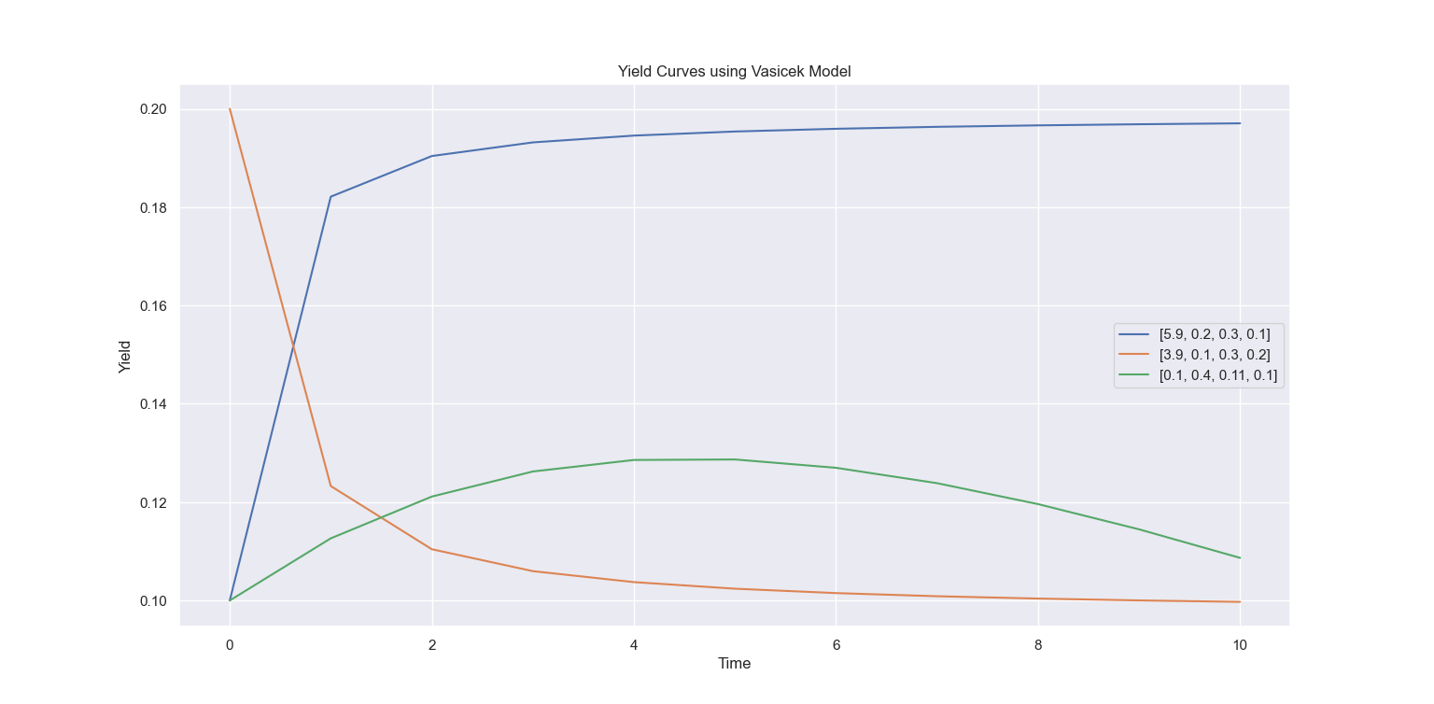

**Now, yield curves versus maturity up to 500 time units for 10 different values of r(0) are plotted for all the three sets of parameters.**

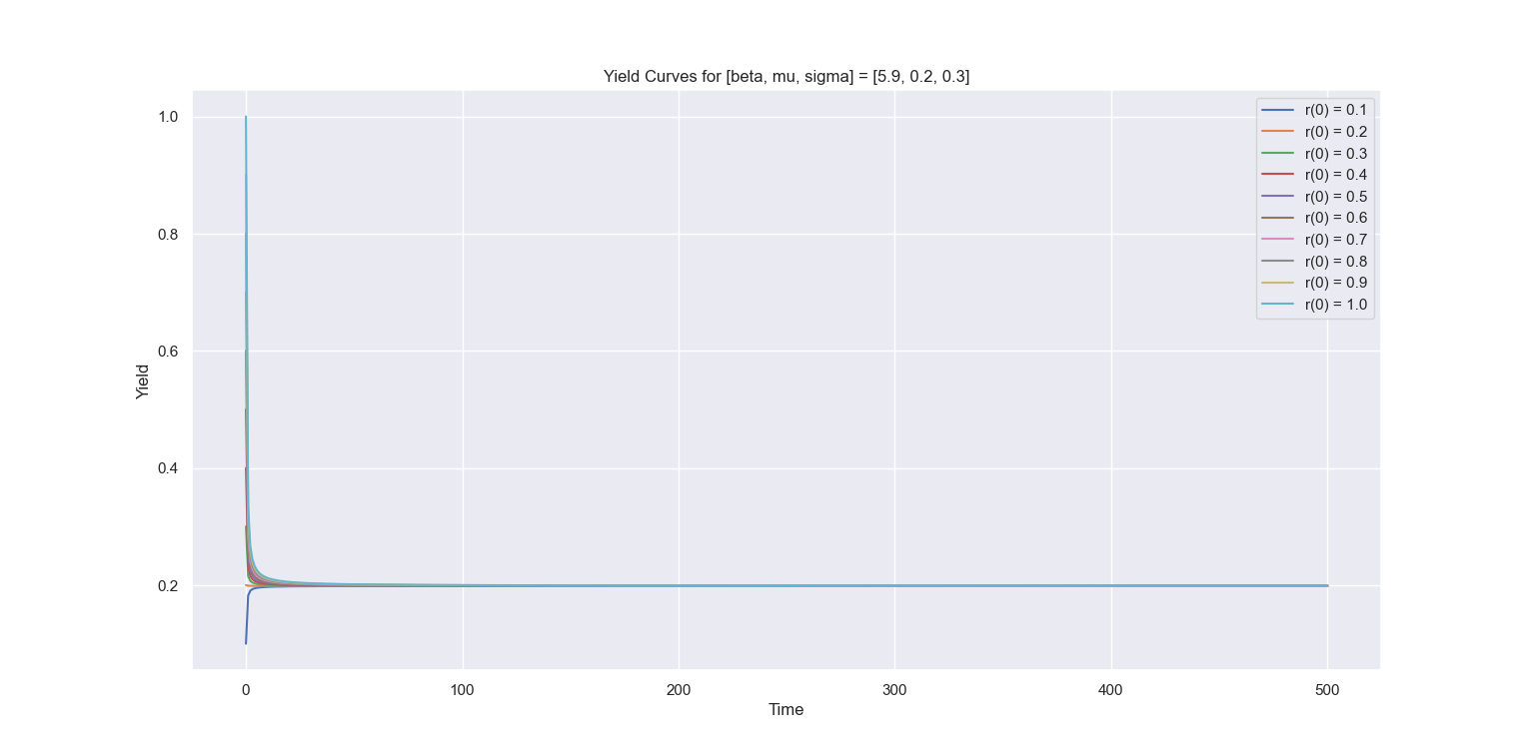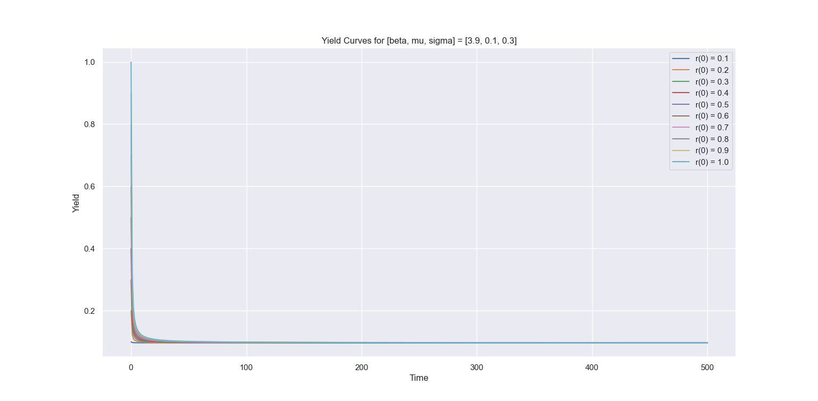

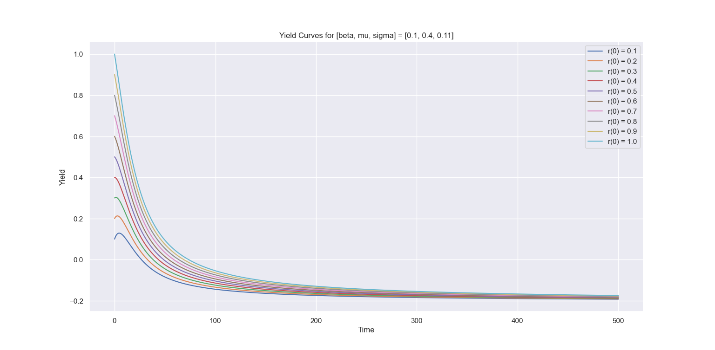

**Observations :**

* For higher r(0), yield is higher
* Yield converges to a limit for all the parameters.
* Yield can increase or decrease with time to maturity. It depends on the prediction made using the current parameters about the future interest rates.

**Question 2:**

* In the CIR(Cox-Ingersoll-Ross) model the risk neutral dynamics of r can be expressed as –
$$dr=a(b-r)dt+σ\sqrt{r}dW$$

* On comparing with the model we get a = β and b = μ.
* Price of the bond is calculated using following formulas –
* Yield can be calculated from the price using following formula –
$$Yield=\frac{-log(p(t,T))}{T-t}$$

* t = 0 in our case.

**Term structure for the given parameters is plotted using 10 time units.**

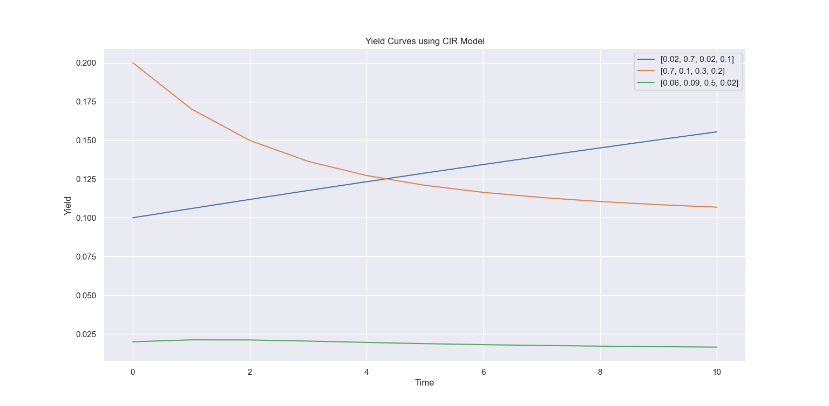

**Now, yield curves versus maturity up to 600 time units for r(0) = 0.1:0.1:1 is plotted for [beta, mu, sigma] = [0.02, 0.7, 0.02].**

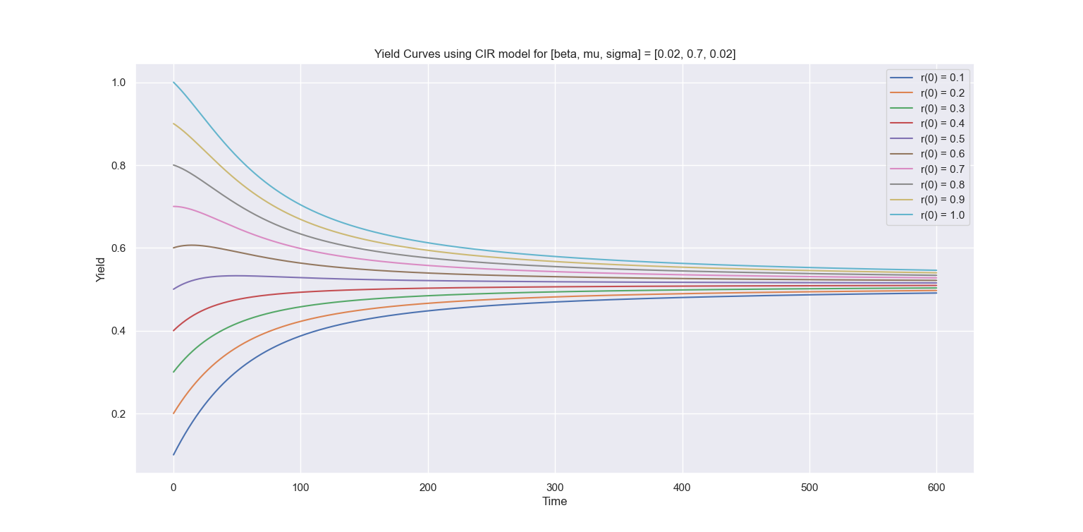

**Observations :**

* For higher r(0), yield is higher.
* Yield converges to a limit.
* Yield can increase or decrease with time to maturity. It depends on the prediction made using the current parameters about the future interest rates.