**MA374: Financial Engineering Lab**

**Lab03**

**Dev Sandip Shah**

**200123074**

**Question 1**

Given expression for u and d are:

Initial price of the American Call option price = 12.123047074012304 and Put option price = 5.27983714598915.

(Graphs in next page)

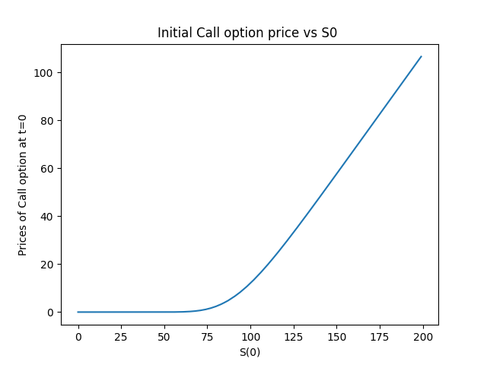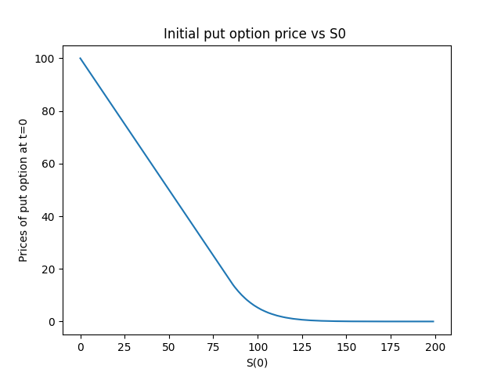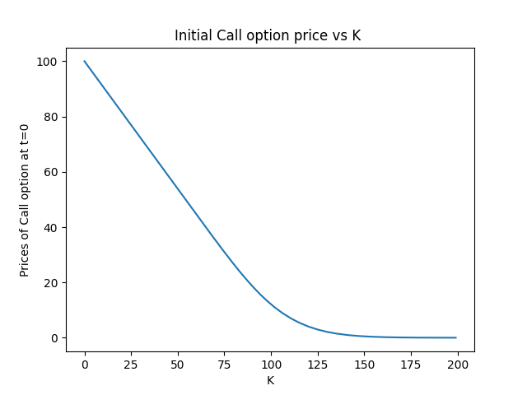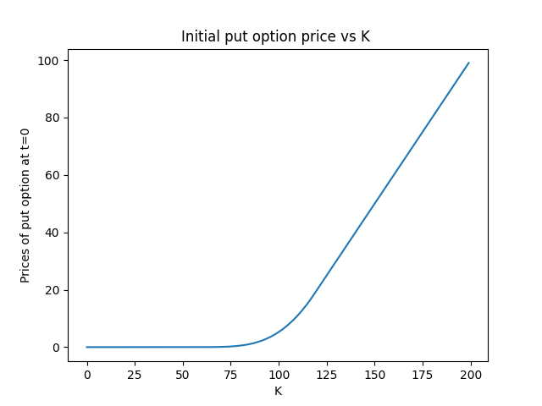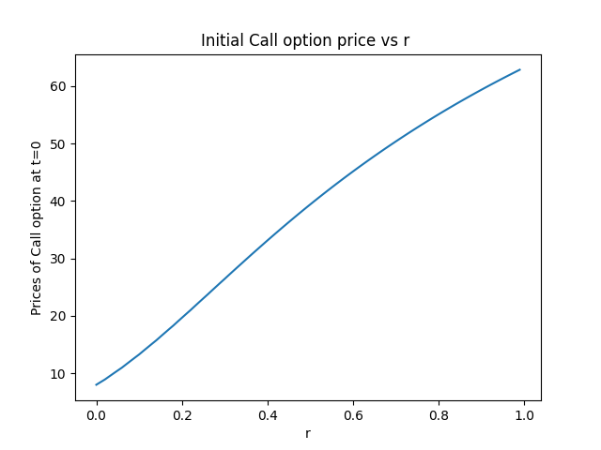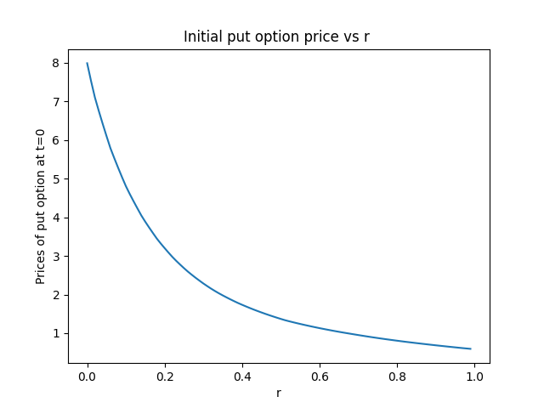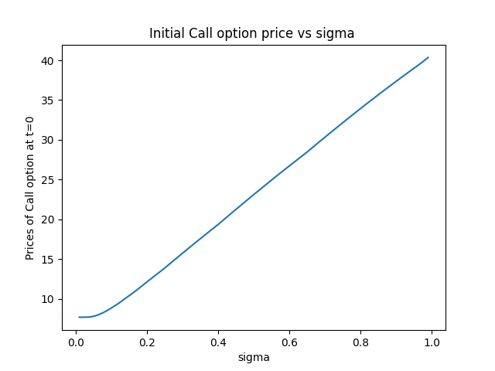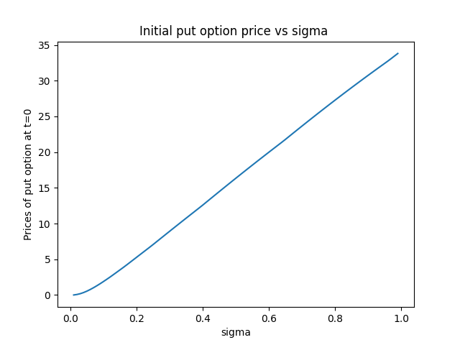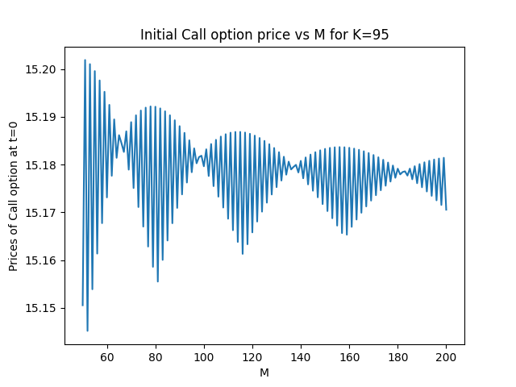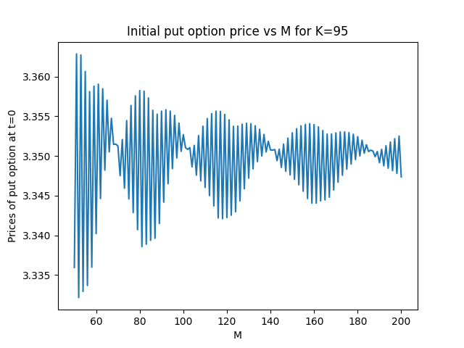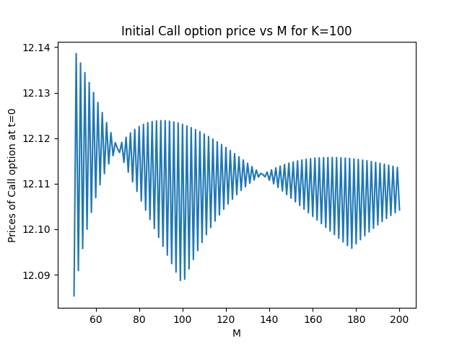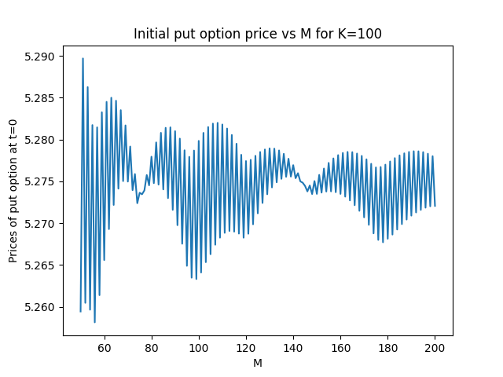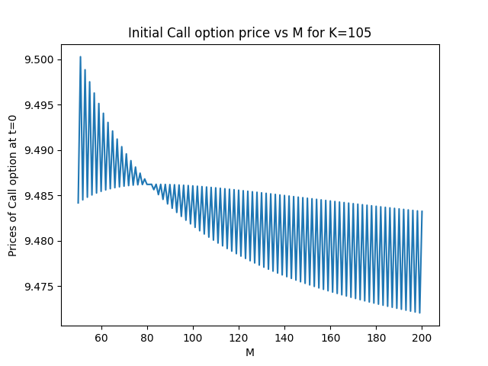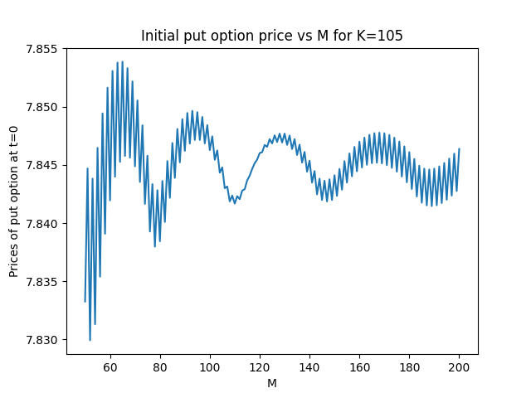

**Question 2**

For the European Option, we use the following data,

The payoff of the lookback option is given as,

and

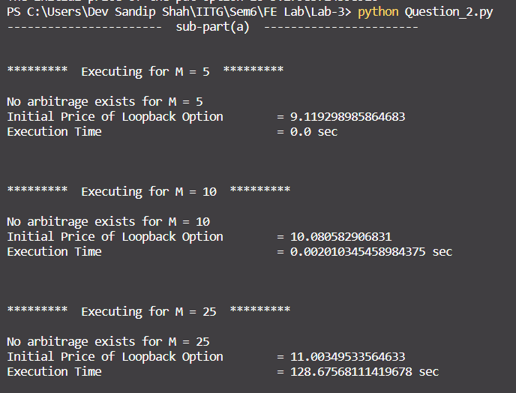

1. Screenshots-

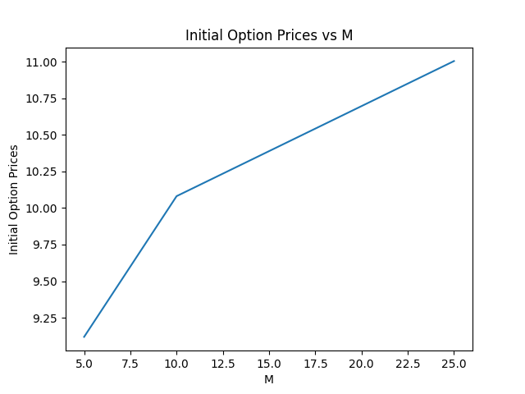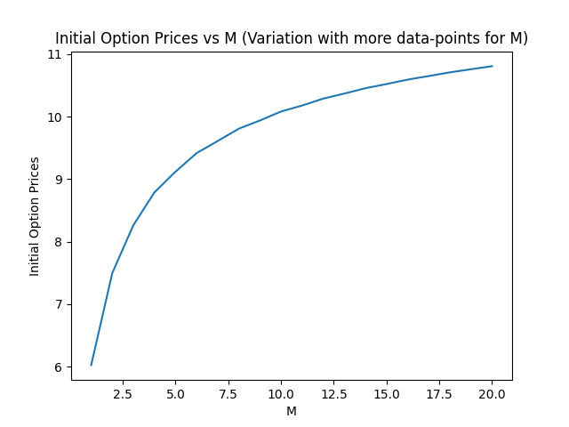

1. Below image shows the table for all intermediate values for M = 5. Here each row denotes the option price at each intermediate level. Last level has 32 values, coming in 2 lines in image.

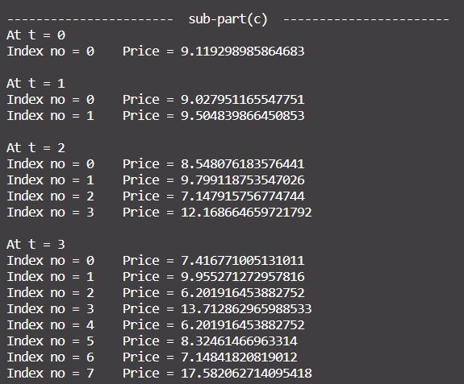

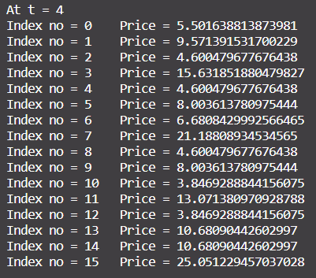

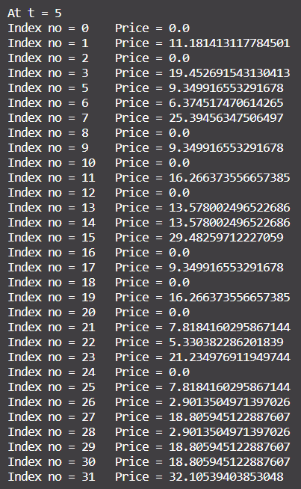

**Question 3**

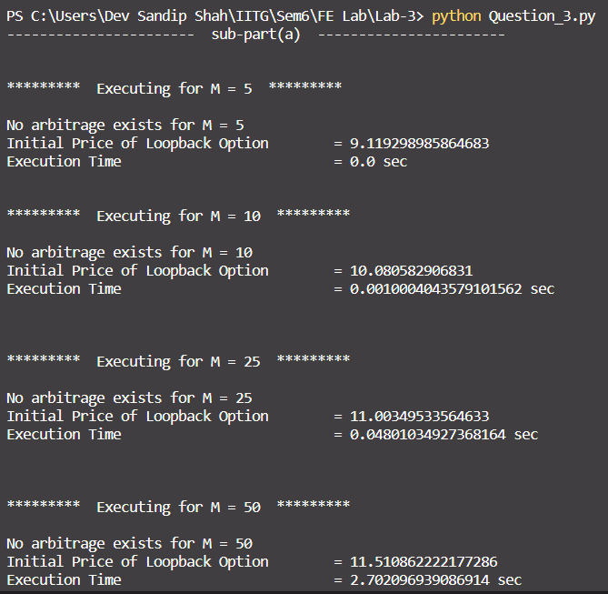

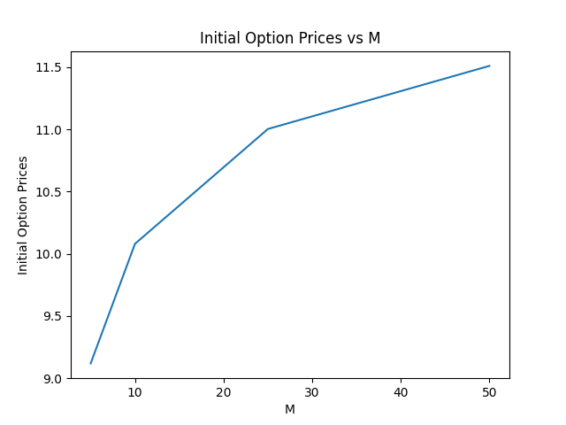

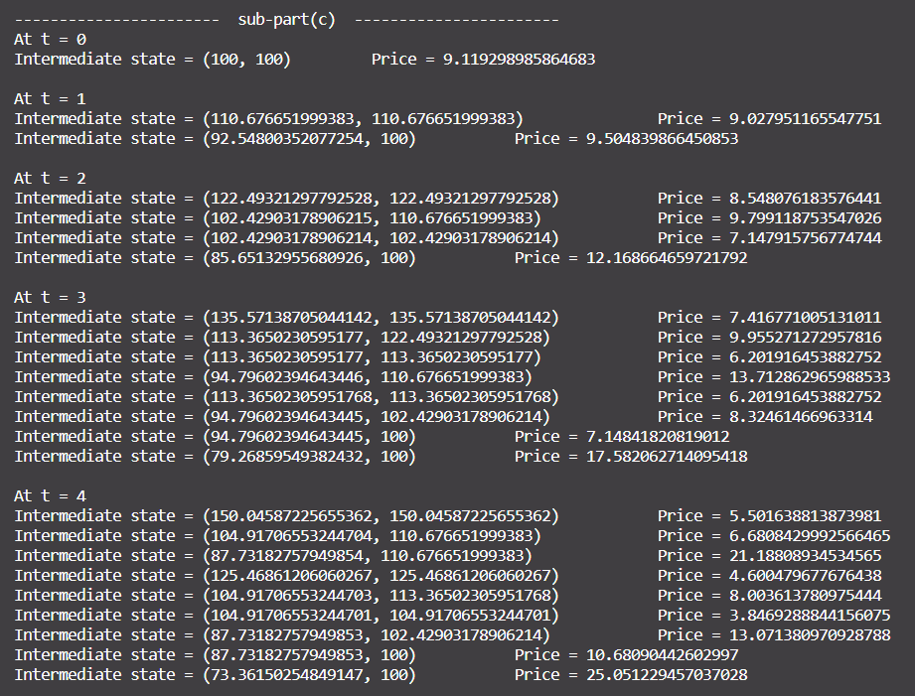

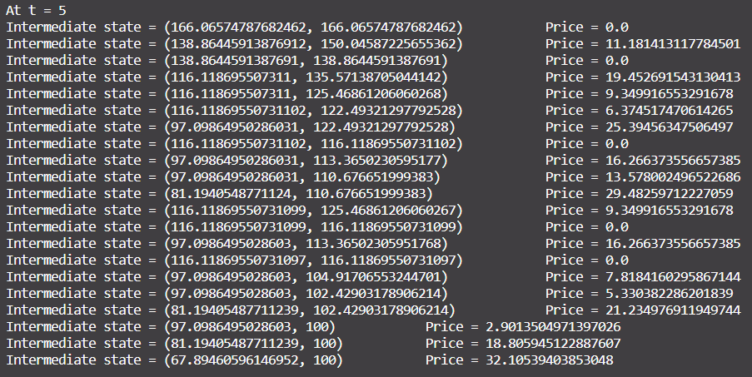

Maximum value of M for the algorithm to run in reasonable in time:

* For binomial: 15
* For Markov: 50

**Time Complexity**

* Time complexity for binomial algorithm is O(2^M) because we are exploring every path of the binomial tree.
* Markov algorithm depends on 2 states, the current stock price and maximum stock price encountered along the path till now. Time complexity of this algorithm is O(M^4), because number of unique paths is bounded by O(M^2) and hence, maximum stock prices is also bounded by O(M^2).

**Question 4**

Output on running the code, following is the output:

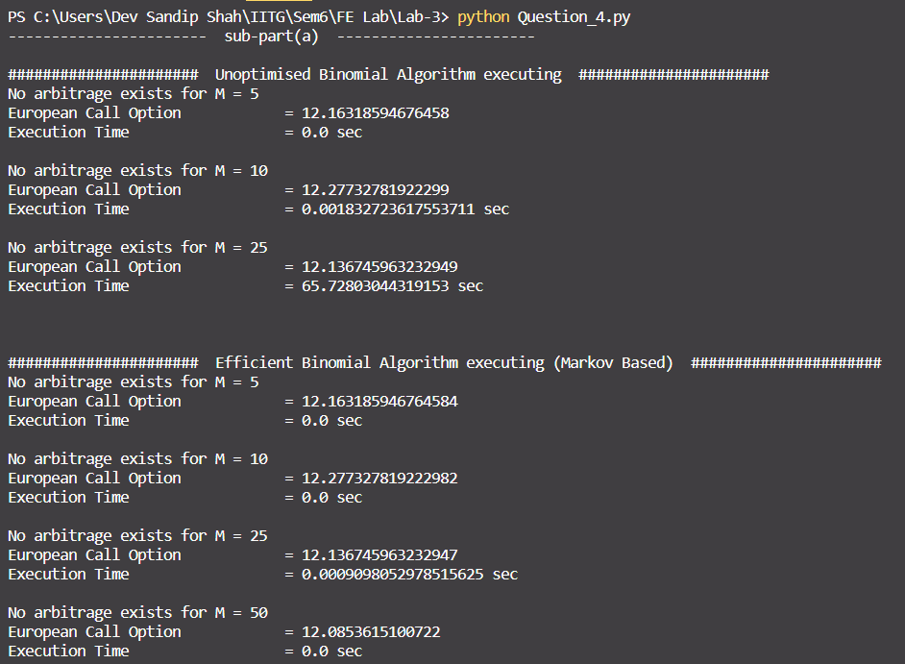

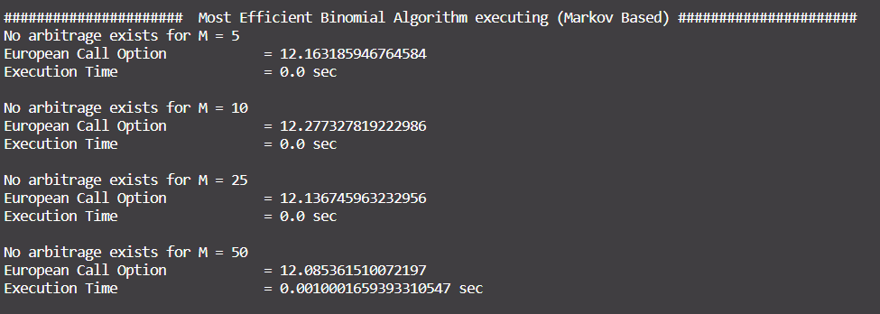

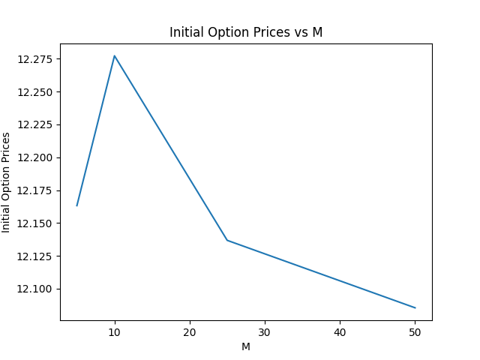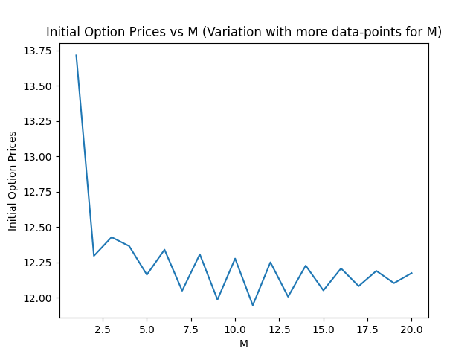

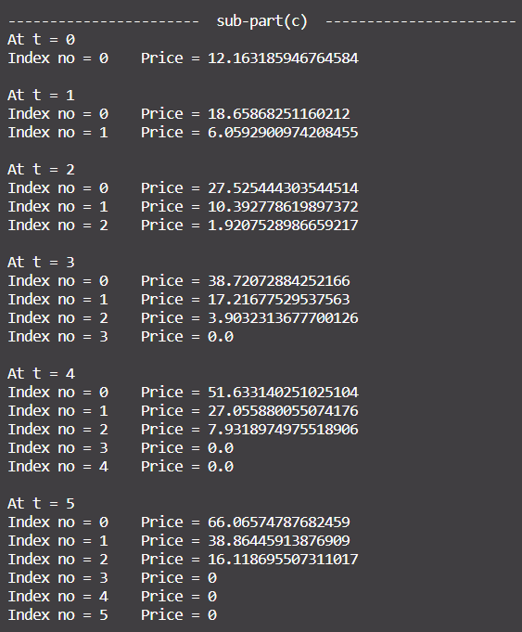

In a reasonable amount of time, we found that

* for Binomial
* for Markov

Below is the table showing the comparison time and initial Option Value.

**Time Complexity**

* Time complexity for binomial algorithm is O(2^M) because we are exploring every path of the binomial tree.
* Markov algorithm depends on 2 states, the step number and count of up steps encountered along the path till now. Time complexity of this algorithm is O(M^3), because number of unique states is bounded by O(M^2) and hence, number of up states is also bounded by O(M).