Group M10 Report

CS344 - Operating Systems Laboratory- Assignment 02

Members-
Dhruvesh Bhure 200123018
Soham Roy 200123055
Dev Sandip Shah 200123074

Part A

- GetNumProc() and GetMaxPid()-
To create the system calls getNumProc() and getMaxPID(), a procedure similar to the one used to create a system call in the previous assignment is used. We also create user programs named testNumProc and testMaxPid to use the above system calls. Two functions namely, getNumProc and getMaxPID are implemented in proc.c which help us in achieving the desired functionalities. They are attached below.
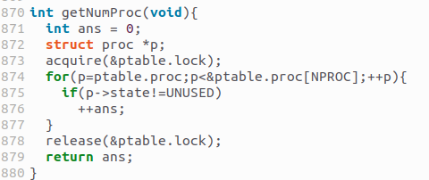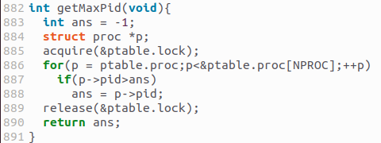
As can be seen, the functions access ptable by acquiring its lock and then loop through it to carry out their respective tasks.

The output obtained on calling the user programs is attached below:

First, a ls command is run which shows the list of user programs available. This process is run with process ID 3. Because process ID 1 and 2 are allotted to system processes because of which the next available process ID is 3 which is allotted to ls. After completion of ls process, testMaxPid is run. The next available process ID is 4 which is allotted to testMaxPid. At this time, 3 processes (ls has already terminated) are currently running on the xv6 OS, the two system processes with PID 1 and PID 2 and testMaxPid with PID 4. Hence, the output is 4. Similarly, when testNumProc is run, 3 processes are running (2 system processes and 1 testNumProc). Hence the output is 3.
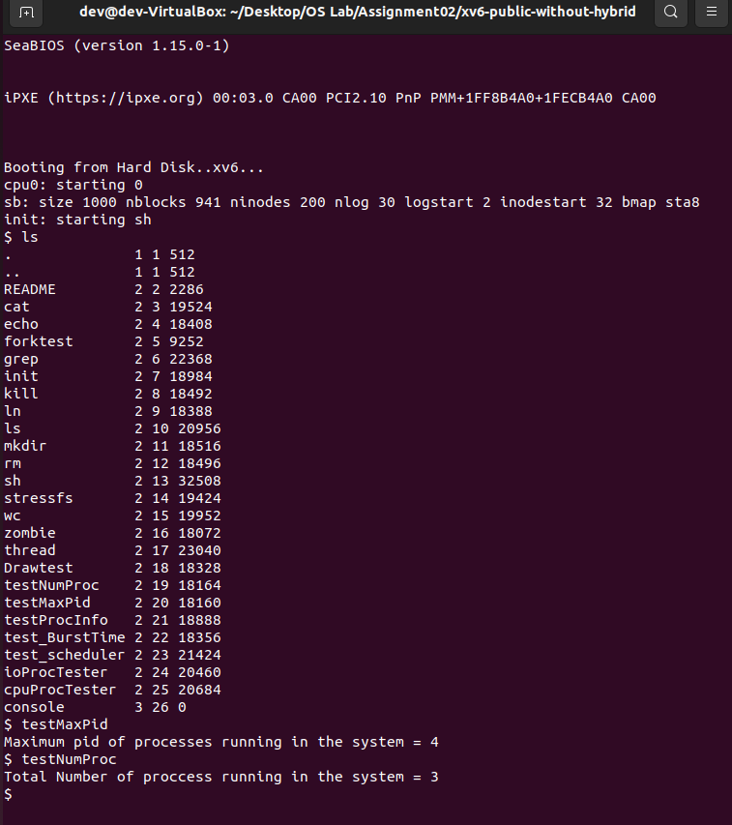

- GetProcInfo()-
The first few steps to implement the system call getProcInfo is identical to those of previously made system calls. But here we also have to pass some arguments to the system call unlike the ones we previously made above. Also, we need to devise a way to store the number of context switches for every process.

We solve the problem of passing parameters to syscall using argptr which is a predefined system call which serves our purpose.

As for the context switch part, we will solve the problem by modifying struct proc to include one additional member named numSwitches which will store the number of context switches. Now we need to initialise numSwitches for every process. We do this by setting
p->numSwitches to 0 in allocproc() since before any process is run, it is allocated (assigned a place in ptable) using allocproc. The next thing we do is add the statement
(p->numSwitches)++ to scheduler(). This ensures that every time a process is scheduled, the number of context switches are updated accordingly.

We create a dummy process defaultParent and set it as parent of every process using p->parent=&defaultParent in allocproc(). fork() replaces it with original parent after process is allocated. We set the PID of defaultParent to -2 in scheduler(). Using defaultParent, we instantly know if the process has a parent or not and if it has, we get its PID using p->parent->pid. The implementations are given below:
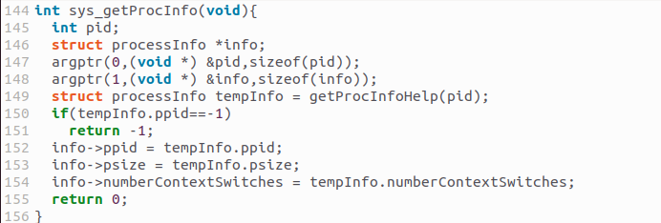
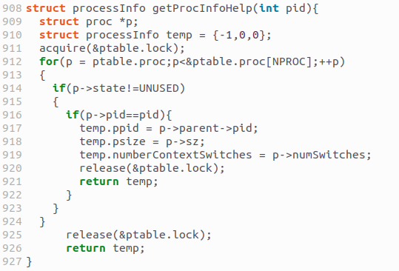

As can be seen above, we use temp (a dummy variable of type processInfo) to indicate that there exists no process with the given PID. The output obtained on running testProcInfo is given below:
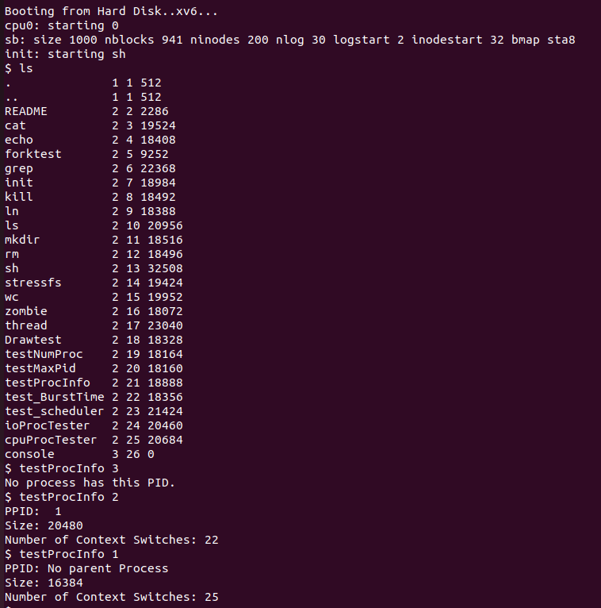

testProcInfo takes process ID as a command line parameter which it then passes to getProcInfo which then passes it to getProcInfoHelp. getProcInfoHelp iterates over ptable to find out the desired information and then returns the obtained values in the form of a processInfo variable. From this, we extract the desired information.

- set_burst_time() and get_burst_time()-
For this part, an additional attribute namely burst_time has to be added to proc structure. We also have to implement 2 system calls namely, set_burst_time and get_burst_time which will set and get the burst time of current process to a given value respectively. We have already defined an attribute named burst_time but we need to set it to a default value before any changes are made. We do this by setting p->burst_time to 0 (we took the default value of burst time to be 0) in allocproc().

Now, the next problem we face is how to access the current process without any given info such as process ID etc. The solution is to use a predefined function in xv6 namely myproc() which returns the pointer to proc structure of current process. Using this, we can easily access and change the burst times of current process. The implementation for both the functions are given below.
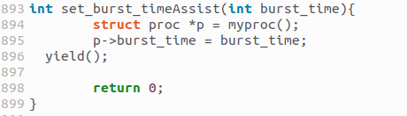
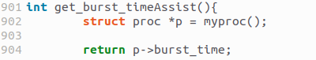

To test the above processes, we create a user program named test_BurstTime. It is shown below.
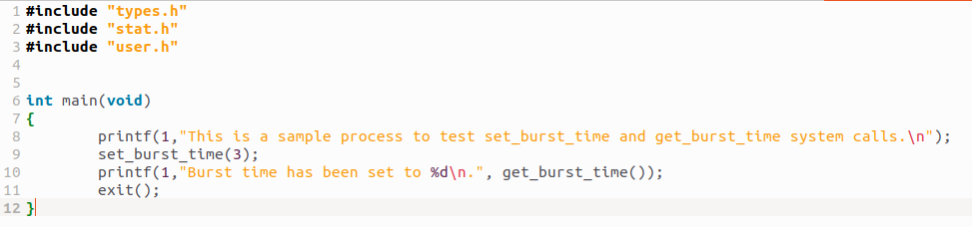
The output when the above user program is run is shown below.
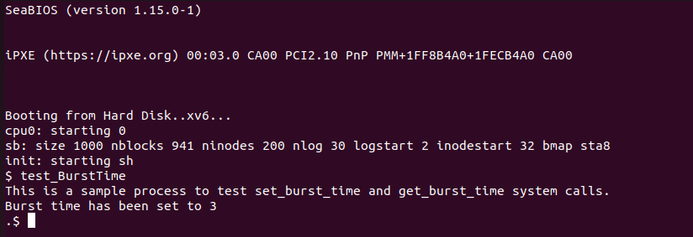

As we can see, the burst time is set to 3. It changes from the default burst time (0) to 3 indicating that the above functions are working correctly.

Part B
- Scheduler Implementation-
Keeping the burst times in mind, we have implemented a ‘Shortest Job First’ (SJF) scheduler to replace the previously used ‘Round Robin’ scheduler. In order to do this, we had to do two things:

- Remove the pre-emption of the current process (yield) on every OS clock tick so the current process completely finishes first. In the given round robin scheduler, the forced pre-emption of the current process with every clocktick is being handled in the trap.c file. We simply remove the following lines from trap.c to fix this issue.
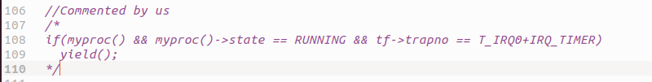
- Change the scheduler so that processes are executed in the increasing order of their burst times. In order to do this, we implemented a priority queue (​min heap)​ using a simple array which sorts processes by​ burst time.​Of course, this heap is locked. The queue at any particular time would contain all the ‘RUNNABLE’ processes on the system. When the scheduler needs to pick the next process, it simply chooses the process at the front of the priority queue by calling extractMin(). We had to make the changes to proc.c.
- Declare priority queue:

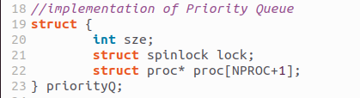

- Implement the following functions in priority queue. All done in proc.c:

- InsertIntoPQ (Inserts a given process into the priority queue)-

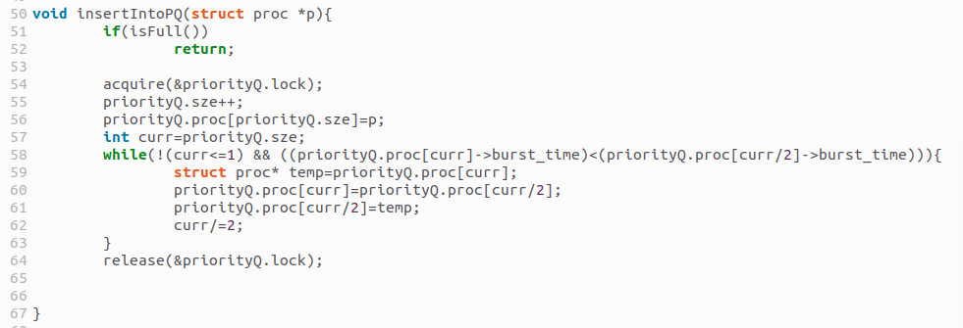

- isEmpty (Checks if priority queue is empty or not)-

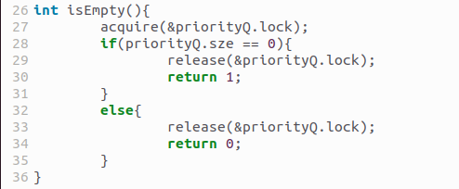

- isFull (Checks if priority queue is full or not)-

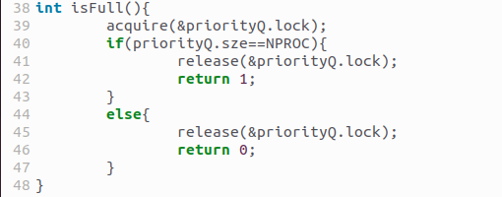

- extractMin (removes process at the front of the queue and returns it)-

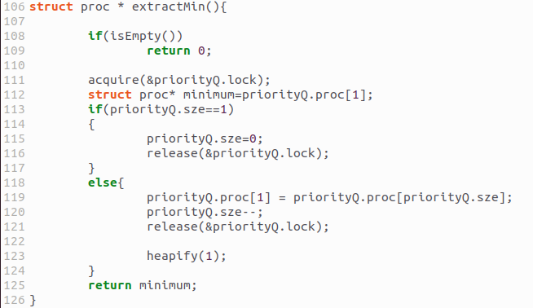

- changeKey (Changes the burst time of a process with a given PID in the priority queue and updates the queue accordingly)-
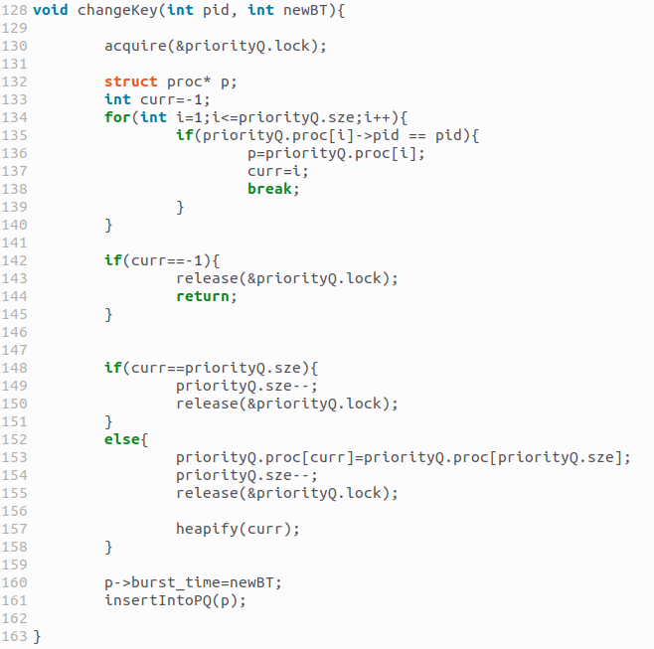

- heapify (basically converts the array into min heap assuming that left subtree and the right subtree of the root are already min heaps)-
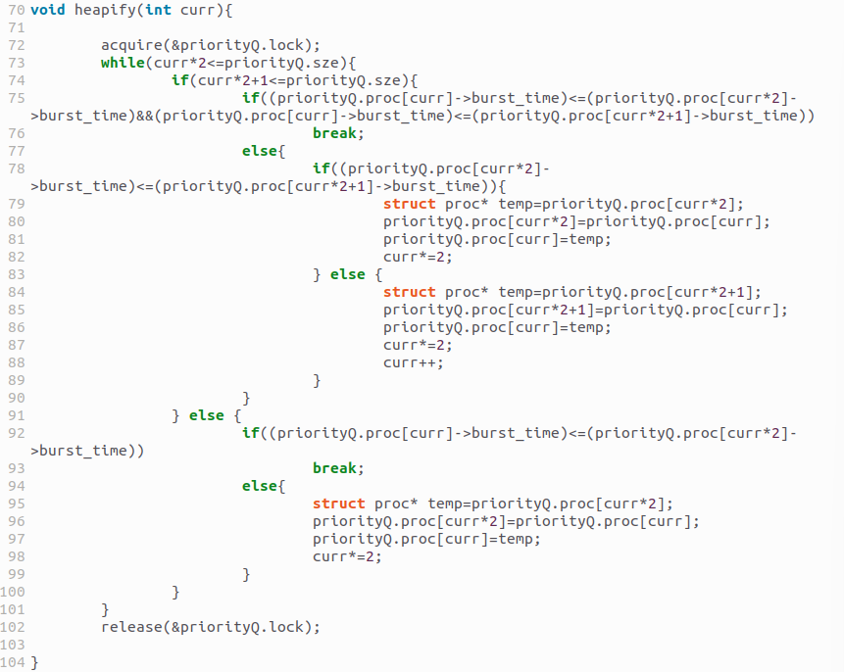
- Change the scheduler so that it uses the priority queue to schedule the next process (priority queue locks are acquired and released in the priority queue functions):
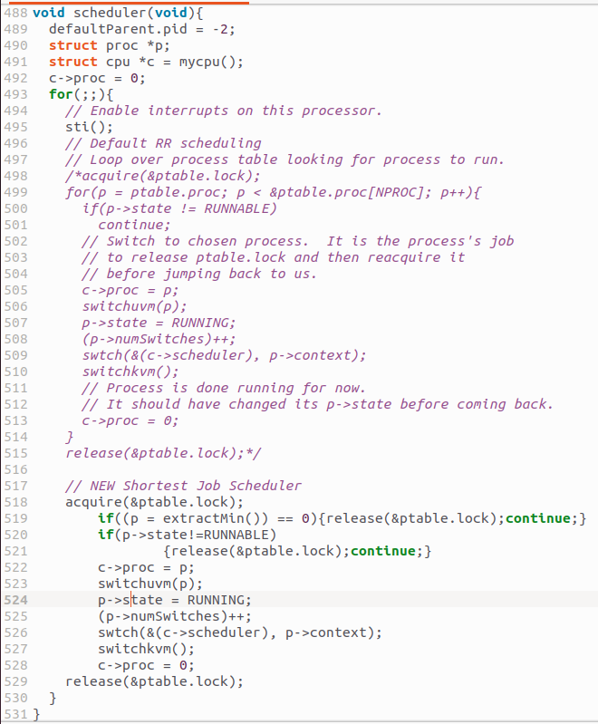

- Insert processes into the priority queue as and when their state becomes RUNNABLE This happens in five functions – yield, kill, fork, userinit, wakeup1. The code from the fork function is given below. The rest of the instances are identical. The variable check is created to check if the process was already in the RUNNABLE state in which case it is already in the priority queue and shouldn’t be inserted again:
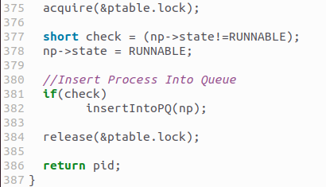

- Insert a yield call into set_burst_time. This is because when burst time of a process is set, its scheduling needs to be done on the basis of the new burst time. yield switches the state of the current process to RUNNABLE, inserts it into the priority queue and switches the context to the scheduler.
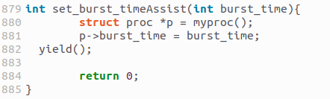

Runtime Complexity-
The runtime complexity of the scheduler is O(logn) because extractMin has a O(logn) time complexity and that is the dominating part of the scheduling process. The rest of the statements run in O(1) time. (Refer to the scheduler function shown in an above picture).

Corner Case Handling and Safety:

- If the queue is empty, extractMin returns 0 after which the scheduler doesn’t schedule any process. (See scheduler function)

- If the priority queue is full, insertIntoPQ rejects the new process and simply returns so no new process is inserted into the queue by removing an older process.

- When inserting a process into the priority queue, it is always checked whether the element was already in the priority queue or not. This is done by checking the state of the process prior to it becoming RUNNABLE. If it was already runnable, it was already in the queue.

- The priority queue functions are robust and don’t lead to situations where a segmentation fault would occur.

- Although the priority queue is expected to have only RUNNABLE processes, our scheduler checks if the process at the front is RUNNABLE or not. If not, the scheduler doesn’t schedule this process. If the process somehow changed state, this measure protects the operating system.

- When ZOMBIE child processes are freed, the priority queue is also checked for the processes and these processes are removed from there too using changeKey and extractMin.

- In order to maintain data consistency, a lock is always used when
accessing priorityQ.​This lock is created especially for priorityQ and​ is
initialised in pinit:
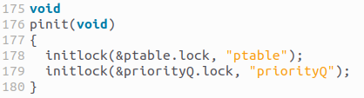

- Test_scheduler Program-
Testing was done to make sure our new scheduler is robust and works correctly in every case. In order to do this, we forked multiple​ processes and gave them different burst times. Roughly half of the processes are CPU​ bound processed and​ the other half are I/O​ bound processes.

- CPU bound processes consist of loops that run for many iterations (10^8). An interesting fact we learned was that the loops are ignored by the compiler if the information computed in the loop isn’t used later. Hence, we had to use the information computed in the loop later.
- I/O bound processes were simulated by calling ​ sleep(1) 100​ times. ​ sleep changes​ the state of the current process to sleeping for a given number of clock ticks, which is something that happens when processes wait for user input. When one I/O bound process is put to sleep, the context is switched to another process that is decided by the scheduler.

We first made a program called ​test_scheduler to​ check if the SJF​ scheduler​ is working according to burst times. It takes an argument equal to the number of forked processes and returns stats of each executed process:
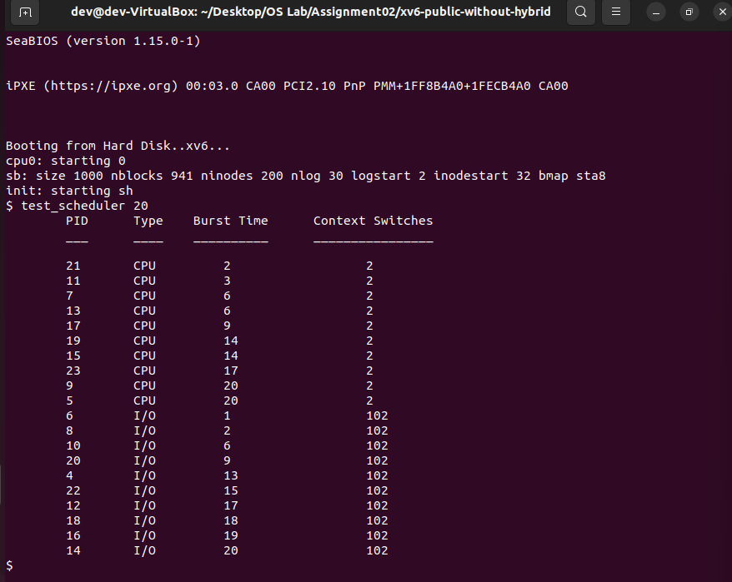

As you can see, all CPU bound processes and I/O bound processes are sorted by their burst times and CPU bound processes finish first. The CPU bound processes finish first because I/O bound processes are blocked by the ‘​sleep’​ system call. Since the processes are sorted by burst time, we can say that the SJF scheduler is working perfectly.

The context switches are also as expected. In the case of ​CPU bound processes, ​first the process is switched in after which ​set_burst_time is​ called because of which the process is yielded and the next process is brought in. Finally, when the earlier process is chosen again by the scheduler, it finishes. In the case of I/O​ bound processes, they​ are also put to sleep 100 times. Hence, the processes have 100 additional context switches (they are brought back in 100 more times).

This is in contrast to the default​ Round Robin Scheduler.​We created two special programs called cpuProcTester and​ ioProcTester to​ compare the Round Robin Scheduler with the SJF​ Scheduler.​ cpuProcTester runs CPU processes to simplify the comparison. ioProcTester ​only​ runs I/O bound processes.

This is the output with the Round Robin (RR) Scheduler:
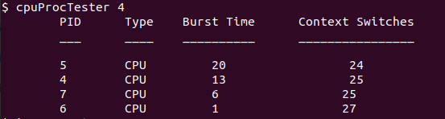

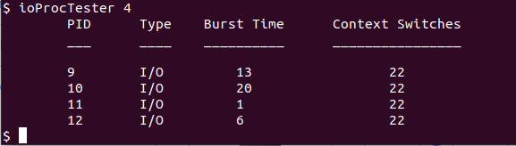

This is the output with the Shortest Job First (SJF) Scheduler:

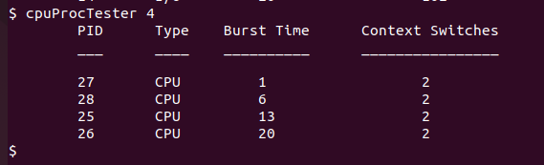

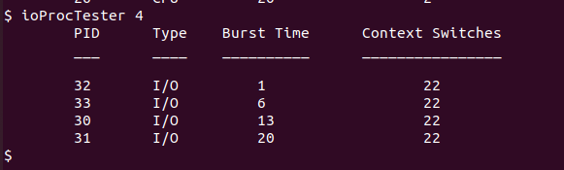

As you can see, since the Round Robin (RR) scheduler uses an FCFS queue, the order of execution is highly related to the PID of the process whereas in the SJF scheduler, the scheduling is happening by the burst times. Also, the number of context switches in the RR scheduler is very high. This is because of forced pre-emption on every clock tick.

Some Notes regarding testing-

-> Burst times are generated by the random number generator created in the file ​random.c. We​ made this file a user library.
-> set_burst_time yields​ the current process as mentioned in an above point. This is so that the new burst times are used in scheduling.

- Hybrid Scheduling-

We implemented a scheduler that behaves as a hybrid between Round Robin and SJF schedulers. We did this by modifying the ​trap.c, proc.c ​and ​defs.h ​files​.

We first create the logic for setting up a time quantum. In order to do this, we declare an extern int variable in defs.h so it can be initialised in proc.c. This variable is called ​quant. ​It is initialised to 1000 by default as the burst times are between 1 and 1000. The assignment asks us to make the time quantum equal to the burst time of the process with the shortest burst time in the priority queue. However, the default burst time is zero. If the burst time of a process is zero, we do not know how long the process will run and hence we assign a default burst time of zero. Therefore, the ​quant variable is modified in the set_burst_time function. ​If the burst time to be set is less than the ​quant ​value, ​quant’s value is set to burst time.

Next, we create another priority queue called ​priorityQ2 ​and the corresponding functions for this priority queue. Functions like insertIntoPQ, heapify, extractMin etc were created corresponding to ​priorityQ. ​The corresponding functions for ​priorityQ2 ​are ​insertIntoPQ2, extractMin2, heapify2 etc. ​The functions are the same as the original ones except they modify priorityQ2 instead of priority.

We then modified the clock tick interrupt handler in the trap.c file. At every clock tick, we increment the running time (​added parameter in struct proc – run_time ​which is initialised to zero when proc is created in allocproc) field of the current process (myproc()). By default, processes have burst time zero. If the burst time of a process isn’t manually set, we don’t want to kill the process as soon as its first clock tick is observed since that may seriously affect the functioning of the OS. So, before we check if the current running time is equal to the burst time of the process, we check if the burst time is zero. We only make the equivalence check between ​run_time ​and ​burst_time ​if the burst_time value is non zero. If the equivalence is true, we ​exit() ​the current process. Otherwise, we make the next check - we check if the running time of the current process is divisible by the time quantum, ​quant. ​If true, we pre-empt the current process and insert into the other priority queue ​priorityQ2.

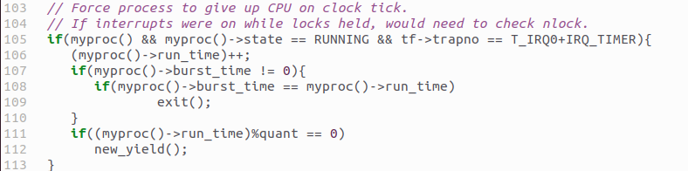

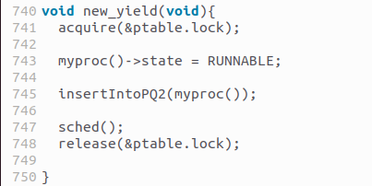

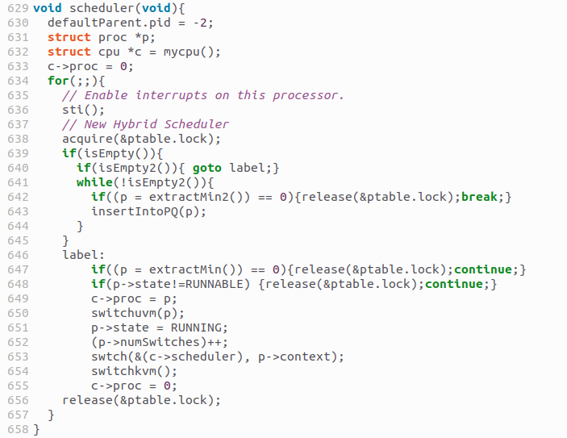

The final part is the testing which is done using three user programs - ​test_scheduler, cpuProcTester and ioProcTester. ​In the code files corresponding to these programs, we did the following:

- In ​test_scheduler.c, ​half of the forked processes are I/O bound processes and the other half are CPU bound processes. All forked processes are assigned a random burst time between 1 and 1000. CPU bound processes consist of loops that run for 10^9 iterations and I/O bound processes consist of calling sleep(1) 10 times.
- In ​cpuProcTester.c, ​we just made all the forked processes CPU bound. Burst times are assigned randomly between 1 and 1000. A loop of 10^9 iterations is run (takes some time - approximately 200 ticks).

- In ​ioProcTester.c, ​every forked process is I/O bound. In order to simulate I/O, we are simply calling ​sleep(1) ​10

times. Burst times are assigned at random with values between 1 and 1000.

The output obtained from the above tests are shown below.
Results-

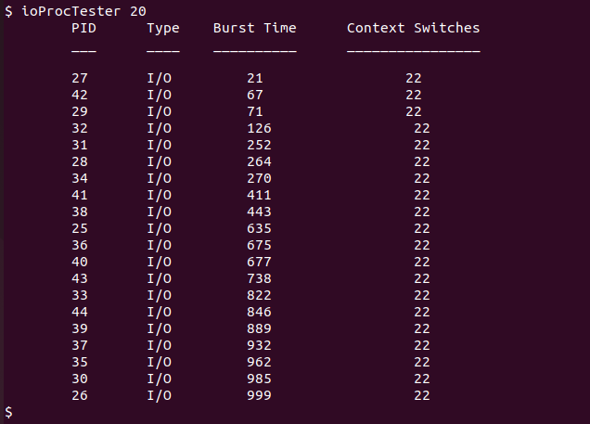
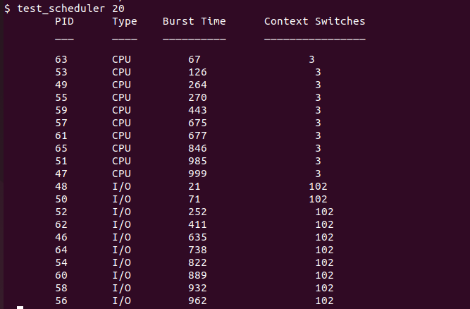

Here’s the exciting part. Results were as we expected. There were three key observations: ● Not all CPU bound processes were actually completed. This is because some of them had a burst time lower than their actual execution time and were killed before they printed anything. This proves that when the run_time value of the process becomes equal to the burst_time value of that process, the process is actually being exited.
● There was a considerably higher number of context switches with this new hybrid scheduling in the CPU bound processes. This is because the CPU processes are being pre-empted every quant clock ticks.
● The I/O bound processes weren’t affected by the pre-emption and they behaved just like they did in SJF scheduling. This is because they are sleeping most of the time. Their actual execution time is very low. The likelihood of them experiencing quant clock ticks is very low since quant is expected to be a 2-3 digit number (burst times are chosen randomly between 1 and 1000 which affects quant). Hence, they didn’t get forcefully pre-empted at regular intervals. They just went to sleep repeatedly. Hence, their number of context switches remained the same as they would be in SJF scheduling.
● Note: When we are using a combination of CPU and I/O bound processes, some CPU bound processes are getting pre-empted more than others since I/O bound processes are returning from the SLEEPING state and forcing the currently running CPU bound processes to get pre-empted. This leads to out of order execution of some CPU bound processes.
● Also, if you want to compare it with the round robin scheduler, refer to the pictures in the previous section and compare them with the ones in this section

