Game Design Document

Fill up the following document

1. Write the title of your project.

The title of my project is “Catch the Runner”

1. What is the goal of the game?

The goal of the game is to catch the runner. You are controlling the diner or the catcher who has to catch the runner which is controlled by the computer.

1. Write a brief story of your game.

The story is the 2 people are friends and they are playing a catch catch game and the catcher is the person that is controlled by the person whereas the runner is computerised.

1. Which are the playing characters of this game?

* Playing characters are the ones who respond to the user based on the input from the user.
* Cars, monkeys, dinos, wizards, etc., are the playing characters in the game.

|  |  |  |
| --- | --- | --- |
| Number | Character Name | What can this character do? |
| 1 | The catcher | The catcher catches the runner |
| 2 |  |  |
| 3 |  |  |
| 4 |  |  |
| 5 |  |  |
| 6 |  |  |
| 7 |  |  |
| 8 |  |  |

1. Which are the Non-Playing Characters of this game?

* Non-Playing characters are the ones that don't have an action or behavior when the user interacts with the game.
* Hurdles, stones, bananas, coins, etc., are non-playing characters in the game.

|  |  |  |
| --- | --- | --- |
| Number | Character Name | What can this character do? |
| 1 | The runner | The runner is running away the catcher |
| 2 | The walls | They are the obstacles stoping the catcher |
| 3 | The moving buildings | They are the background. |
| 4 |  |  |
| 5 |  |  |
| 6 |  |  |
| 7 |  |  |
| 8 |  |  |

Draw your imagination of this game. What does this game look like?

* Draw the game either on your computer or on paper.
* Add images of the game scenes to show each of the playing and non-playing characters at least once
* 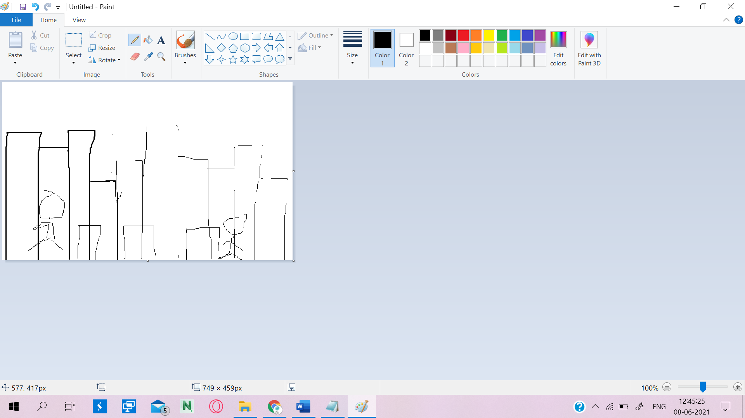.

How do you plan to make your game engaging?

To make my game engaging I will give players to make the catcher sit in one place and also when it wants to run it can run. This will make the game more engagind to play.