DBMS Project Report
Indian Agriculture & Crop Production Database
Student: Dev Manjibhai Sheta
Roll No.: 23BCP110
Program: B.Tech Computer Science & Engineering
Pandit Deendayal Energy University (PDEU), Gandhinagar
Team Size (N): 1 | Database Engine: MySQL 8.0

A. Introduction
This project implements a relational database for storing and analyzing India's district-level agricultural crop production data. The system captures area cultivated, production quantity, and yield for crops grown across every state and district of India, segmented by season and year, over a 27-year period (1997-2023).

Project Scope
The scope covers conceptual design (ER modeling), logical design (relational schema with normalization), physical implementation in MySQL, an automated data-loading pipeline, and a graded set of analytical SQL queries. Physical-level tuning (indexing, query optimization) and database security/backup automation were intentionally scoped out to keep the project focused on core relational design and querying, which are this lab's primary learning objectives.

Objectives
- Design a normalized (3NF) relational schema for real-world agricultural data
- Correctly model the fact table conceptually as a ternary relationship between District, Crop, and Season
- Build an automated ETL pipeline to clean and load a large public dataset into MySQL
- Develop a graded range of SQL queries — from basic retrieval to subquery-based analysis
- Demonstrate sound database design principles: normalization, referential integrity, and data quality validation

Tools and Technologies Used
Component | Choice
RDBMS | MySQL 8.0 (via MySQL Workbench)
ETL / Automation | Python 3 (pandas, mysql-connector-python)
Data Source | data.gov.in / data.desagri.gov.in (Govt. of India open data)
Development OS | macOS
Documentation | Markdown, Word (this report)

Unlike a synthetic or toy dataset, this project uses real government data, which surfaced a genuine data-quality problem (detailed in Section g) that had to be identified and resolved — giving the project practical, not just theoretical, database engineering value.

B. Requirements Analysis

Data Requirements — what the database stores
- States and their districts (740 districts across 34 states/UTs)
- Crops grown, with their type classification (Cereal, Pulses, Oilseeds, etc.)
- Cropping seasons (Kharif, Rabi, Whole Year, Summer, Autumn, Winter)
- Yearly production records: area cultivated, total production, and yield, per district/crop/season/year combination

Functional Requirements — what users query the database for
- Aggregate production statistics by state, district, crop, or season
- Trends over time (year-over-year production/yield changes)
- Comparative analysis (which states/districts are most productive, most diverse)
- Outlier and threshold-based lookups (highest production records, above-average yields)
- Insertion of new yearly records without duplicating existing ones

Non-Functional Requirements
- Referential integrity must be enforced between every production record and its state/district/crop/season
- The schema must scale to the full 27-year, 740-district dataset (~455,000+ records) without redesign
- Data loading must handle missing/malformed values gracefully rather than failing on the first bad row

Use Case Summary
Actor | Use Case
Agricultural analyst | Query production trends by state/crop/year
Policy researcher | Compare crop diversity and yield across regions
Database administrator | Load new yearly data; maintain referential integrity

C. Conceptual Design — ER Diagram
The diagram below uses standard Chen ER notation: rectangles for entities, ellipses for attributes (primary keys underlined), and a diamond for the relationship, with cardinalities and participation constraints marked on each connecting line.
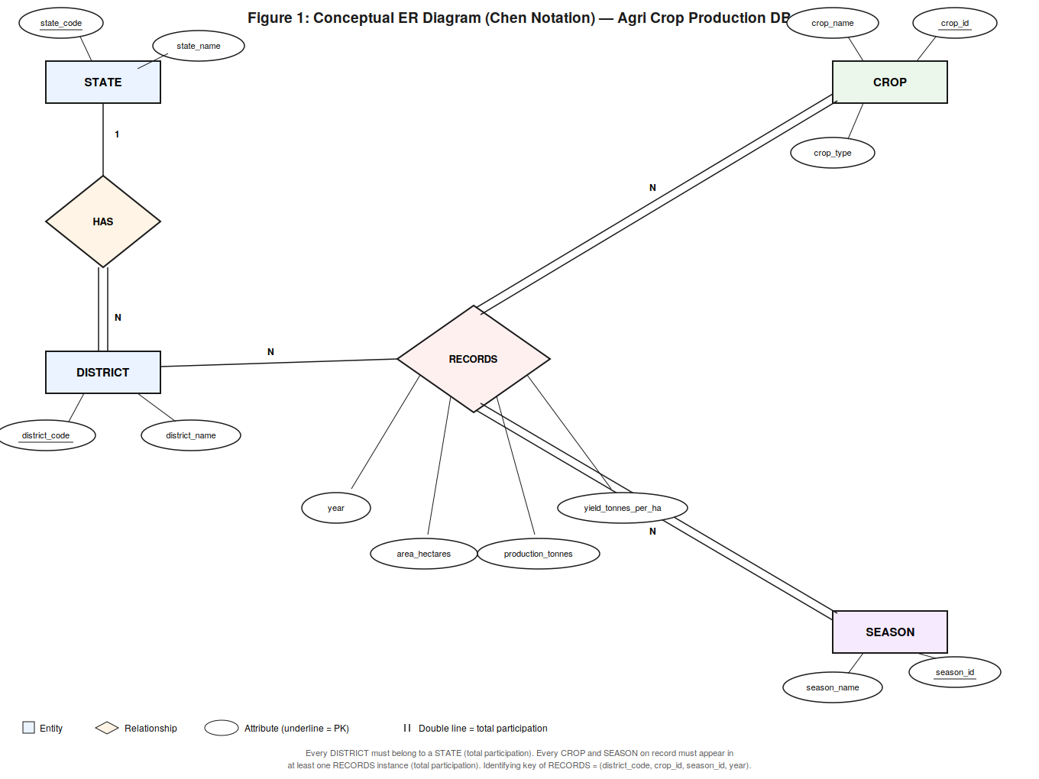
Figure 1: Conceptual ER Diagram (Chen Notation)
STATE (1) has (N) DISTRICT, and every DISTRICT must belong to exactly one STATE (total participation, shown with a double line). DISTRICT, CROP, and SEASON jointly participate in the ternary relationship RECORDS, whose own attributes (year, area_hectares, production_tonnes, yield_tonnes_per_ha) describe each individual production record. CROP and SEASON both have total participation in RECORDS — every crop and season in the database exists because it appears in at least one production record.
Modeling crop_production as a ternary relationship (rather than as just another entity) is the conceptually correct choice here: it genuinely depends on three independent dimensions (district, crop, season) simultaneously, plus the discriminator year. Its identifying key is therefore the composite (district_code, crop_id, season_id, year) — enforced in the physical schema as a UNIQUE constraint even though a surrogate key (id) is used as the primary key for implementation convenience.

D. Logical Design — Relational Schema
The conceptual ER model is mapped to five relational tables: four dimension tables plus one fact table. The diagram below shows this logical design using crow's-foot notation.
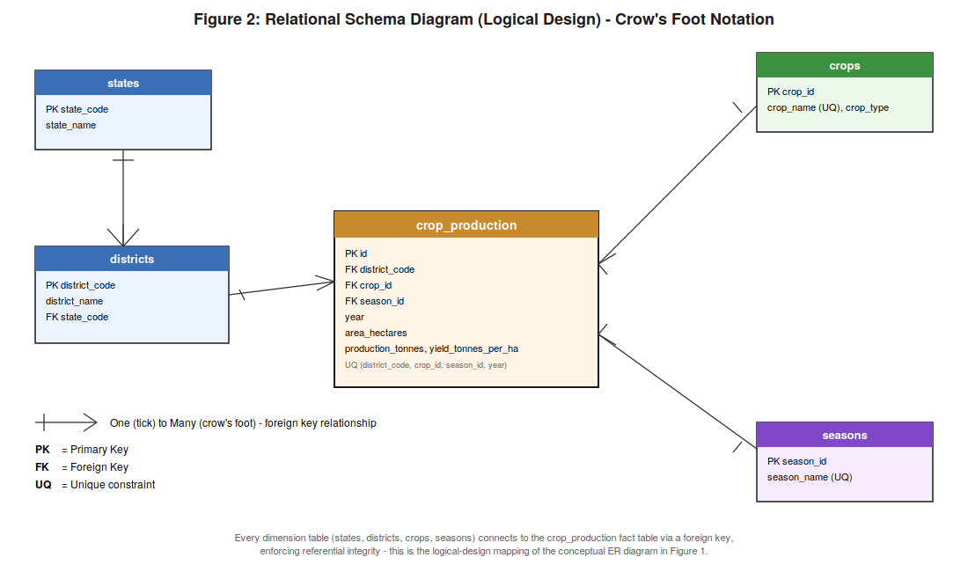
Figure 2: Relational Schema Diagram (Crow's Foot Notation)

Data Dictionary

states
Column | Data Type | Constraint | Description
state_code | VARCHAR(10) | PRIMARY KEY | Unique code identifying a state/UT
state_name | VARCHAR(100) | NOT NULL, UNIQUE | Full name of the state/UT

districts
Column | Data Type | Constraint | Description
district_code | VARCHAR(10) | PRIMARY KEY | Unique code identifying a district
district_name | VARCHAR(100) | NOT NULL | Name of the district
state_code | VARCHAR(10) | FOREIGN KEY -> states | Links district to its parent state

crops
Column | Data Type | Constraint | Description
crop_id | INT | PRIMARY KEY, AUTO_INCREMENT | Surrogate key (see Section g for why crop_code was not used)
crop_name | VARCHAR(100) | NOT NULL, UNIQUE | Name of the crop — the true natural identifier
crop_type | VARCHAR(50) | NULLable | Category, e.g. Cereal, Pulses, Oilseeds

seasons
Column | Data Type | Constraint | Description
season_id | INT | PRIMARY KEY, AUTO_INCREMENT | Surrogate key
season_name | VARCHAR(50) | NOT NULL, UNIQUE | e.g. Kharif, Rabi, Whole Year

crop_production (fact table)
Column | Data Type | Constraint | Description
id | INT | PRIMARY KEY, AUTO_INCREMENT | Surrogate key for the record
district_code | VARCHAR(10) | FOREIGN KEY -> districts | District where the crop was grown
crop_id | INT | FOREIGN KEY -> crops | Crop grown
season_id | INT | FOREIGN KEY -> seasons | Cropping season
year | VARCHAR(9) | NOT NULL | Agricultural year, e.g. 2015-16
area_hectares | DECIMAL(12,2) | NULLable | Area under cultivation
production_tonnes | DECIMAL(12,2) | NULLable | Total production
yield_tonnes_per_ha | DECIMAL(10,4) | NULLable | Production per unit area

Additional constraint: UNIQUE KEY (district_code, crop_id, season_id, year) — enforces the composite identifying key derived from the conceptual model and prevents duplicate production records for the same combination.

Normalization Justification (1NF -> 3NF)
Stage | Issue in raw data | Fix applied
1NF | Raw CSV has atomic fields but massive repetition (state name repeated per row) | Baseline - already atomic, no repeating groups
2NF | state_name depends only on district, not the full key - a partial dependency | Extracted states and districts into separate tables
3NF | crop_type depends on crop_name, not on the production record - a transitive dependency | Extracted crops and seasons into separate lookup tables

The final crop_production table retains only data that depends on the full key: area, production, and yield.

DDL (Create Table Statements)
CREATE TABLE states (
state_code VARCHAR(10) PRIMARY KEY,
state_name VARCHAR(100) NOT NULL UNIQUE
);
CREATE TABLE districts (
district_code VARCHAR(10) PRIMARY KEY,
district_name VARCHAR(100) NOT NULL,
state_code VARCHAR(10) NOT NULL,
FOREIGN KEY (state_code) REFERENCES states(state_code),
UNIQUE KEY uq_district_state (district_name, state_code)
);
CREATE TABLE crops (
crop_id INT AUTO_INCREMENT PRIMARY KEY,
crop_name VARCHAR(100) NOT NULL UNIQUE,
crop_type VARCHAR(50)
);
CREATE TABLE seasons (
season_id INT AUTO_INCREMENT PRIMARY KEY,
season_name VARCHAR(50) NOT NULL UNIQUE
);
CREATE TABLE crop_production (
id INT AUTO_INCREMENT PRIMARY KEY,
district_code VARCHAR(10) NOT NULL,
crop_id INT NOT NULL,
season_id INT NOT NULL,
year VARCHAR(9) NOT NULL,
area_hectares DECIMAL(12,2),
production_tonnes DECIMAL(12,2),
yield_tonnes_per_ha DECIMAL(10,4),
FOREIGN KEY (district_code) REFERENCES districts(district_code),
FOREIGN KEY (crop_id) REFERENCES crops(crop_id),
FOREIGN KEY (season_id) REFERENCES seasons(season_id),
UNIQUE KEY uq_production_record (district_code, crop_id, season_id, year)
);

E. Implementation — Data Loading

Table Entries Summary (relations >= 5xN, records > 3000xN, N = 1)
Table | Row Count | Description
states | 34 | All Indian states/UTs
districts | 740 | All districts, linked to their state
crops | ~115 | Unique crops (after data-quality fix, see Section g)
seasons | 7 | Kharif, Rabi, Whole Year, etc.
crop_production | ~455,338 | Fact table - one row per district/crop/season/year combination
Total | ~456,234 | Well above the required minimum of 3,000

Data source: Area, Production, Yield (APY) dataset, Ministry of Agriculture & Farmers Welfare, Government of India (via data.gov.in / data.desagri.gov.in), covering 1997-2023.

ETL Pipeline Summary
- Read the ~455K-row CSV using pandas
- Standardize column names; replace placeholder values (-, NA, blank) with proper NULLs
- Coerce numeric columns (area, production, yield) with error handling for malformed values
- Deduplicate and load dimension tables first (states, districts, crops, seasons)
- Map crop_name and season_name to their surrogate keys, then batch-insert the fact table in chunks of 5,000 rows using INSERT IGNORE to skip exact duplicates safely

F. Query Development and Examples
Queries are organized from basic to advanced, covering single-table retrieval, multi-table joins with aggregation, and standard subqueries/EXISTS - the range of SQL concepts expected at undergraduate DBMS level.

Section 1: Basic Queries

1.1 List all states
SELECT * FROM states ORDER BY state_name;

1.2 List all crops of a specific type
SELECT crop_name, crop_type FROM crops WHERE crop_type = 'Cereals';

1.3 Count total crop production records
SELECT COUNT(*) AS total_records FROM crop_production;

1.4 All distinct crop types
SELECT DISTINCT crop_type FROM crops WHERE crop_type IS NOT NULL;

1.5 All production records from a specific year
SELECT * FROM crop_production WHERE year = '1997-1998' LIMIT 20;

1.6 Number of records per year
SELECT year, COUNT(*) AS record_count
FROM crop_production
GROUP BY year
ORDER BY year;

1.7 Simple threshold filter
SELECT * FROM crop_production
WHERE production_tonnes > 100000
ORDER BY production_tonnes DESC
LIMIT 20;

Section 2: Intermediate Queries (Joins, Grouping, HAVING)

2.1 All districts in a given state
SELECT d.district_name
FROM districts d
JOIN states s ON d.state_code = s.state_code
WHERE s.state_name = 'Gujarat'
ORDER BY d.district_name;

2.2 Total production of a specific crop, all-time
SELECT SUM(cp.production_tonnes) AS total_production
FROM crop_production cp
JOIN crops c ON cp.crop_id = c.crop_id
WHERE c.crop_name = 'Rice';

2.3 Average area cultivated per crop
SELECT c.crop_name, ROUND(AVG(cp.area_hectares), 2) AS avg_area
FROM crop_production cp
JOIN crops c ON cp.crop_id = c.crop_id
GROUP BY c.crop_name
ORDER BY avg_area DESC
LIMIT 10;

2.4 Top 10 crop-producing states (all-time)
SELECT s.state_name, SUM(cp.production_tonnes) AS total_production
FROM crop_production cp
JOIN districts d ON cp.district_code = d.district_code
JOIN states s ON d.state_code = s.state_code
GROUP BY s.state_name
ORDER BY total_production DESC
LIMIT 10;

2.5 Season-wise total production comparison
SELECT se.season_name, SUM(cp.production_tonnes) AS total_production
FROM crop_production cp
JOIN seasons se ON cp.season_id = se.season_id
GROUP BY se.season_name
ORDER BY total_production DESC;

2.6 Crop diversity per state
SELECT s.state_name, COUNT(DISTINCT cp.crop_id) AS distinct_crops_grown
FROM crop_production cp
JOIN districts d ON cp.district_code = d.district_code
JOIN states s ON d.state_code = s.state_code
GROUP BY s.state_name
ORDER BY distinct_crops_grown DESC
LIMIT 10;

2.7 Filtering grouped results with HAVING
SELECT d.district_name, s.state_name, COUNT(DISTINCT cp.crop_id) AS crop_variety
FROM crop_production cp
JOIN districts d ON cp.district_code = d.district_code
JOIN states s ON d.state_code = s.state_code
GROUP BY d.district_name, s.state_name
HAVING crop_variety > 20
ORDER BY crop_variety DESC
LIMIT 10;

2.8 Top 5 districts by average yield for a given crop
SELECT d.district_name, s.state_name,
ROUND(AVG(cp.yield_tonnes_per_ha), 2) AS avg_yield
FROM crop_production cp
JOIN districts d ON cp.district_code = d.district_code
JOIN states s ON d.state_code = s.state_code
JOIN crops c ON cp.crop_id = c.crop_id
WHERE c.crop_name = 'Wheat'
GROUP BY d.district_name, s.state_name
HAVING COUNT(*) > 5
ORDER BY avg_yield DESC
LIMIT 5;

2.9 CASE WHEN - bucket production into size categories
SELECT cp.id, cp.production_tonnes,
CASE
WHEN cp.production_tonnes >= 100000 THEN 'Very High'
WHEN cp.production_tonnes >= 10000 THEN 'High'
WHEN cp.production_tonnes >= 1000 THEN 'Medium'
ELSE 'Low'
END AS production_category
FROM crop_production cp
LIMIT 20;

2.10 Year-over-year production trend for a specific crop
SELECT cp.year, SUM(cp.production_tonnes) AS total_production
FROM crop_production cp
JOIN crops c ON cp.crop_id = c.crop_id
WHERE c.crop_name = 'Rice'
GROUP BY cp.year
ORDER BY cp.year;

Section 3: Advanced Queries (Subqueries, EXISTS)

3.1 Crops whose average yield beats the overall average yield
SELECT c.crop_name,
ROUND(AVG(cp.yield_tonnes_per_ha), 2) AS crop_avg_yield
FROM crop_production cp
JOIN crops c ON cp.crop_id = c.crop_id
GROUP BY c.crop_name
HAVING crop_avg_yield > (SELECT AVG(yield_tonnes_per_ha) FROM crop_production)
ORDER BY crop_avg_yield DESC
LIMIT 15;

3.2 States that have ever produced more than 1,000,000 tonnes of any single crop (EXISTS)
SELECT s.state_name
FROM states s
WHERE EXISTS (
SELECT 1
FROM crop_production cp
JOIN districts d ON cp.district_code = d.district_code
WHERE d.state_code = s.state_code
AND cp.production_tonnes > 1000000
)
ORDER BY s.state_name;

3.3 Crops grown in every single season
SELECT c.crop_name
FROM crop_production cp
JOIN crops c ON cp.crop_id = c.crop_id
GROUP BY c.crop_name
HAVING COUNT(DISTINCT cp.season_id) = (SELECT COUNT(*) FROM seasons);

3.4 District(s) with the single highest production value recorded
SELECT d.district_name, s.state_name, c.crop_name, cp.year, cp.production_tonnes
FROM crop_production cp
JOIN districts d ON cp.district_code = d.district_code
JOIN states s ON d.state_code = s.state_code
JOIN crops c ON cp.crop_id = c.crop_id
WHERE cp.production_tonnes = (SELECT MAX(production_tonnes) FROM crop_production);

Results:

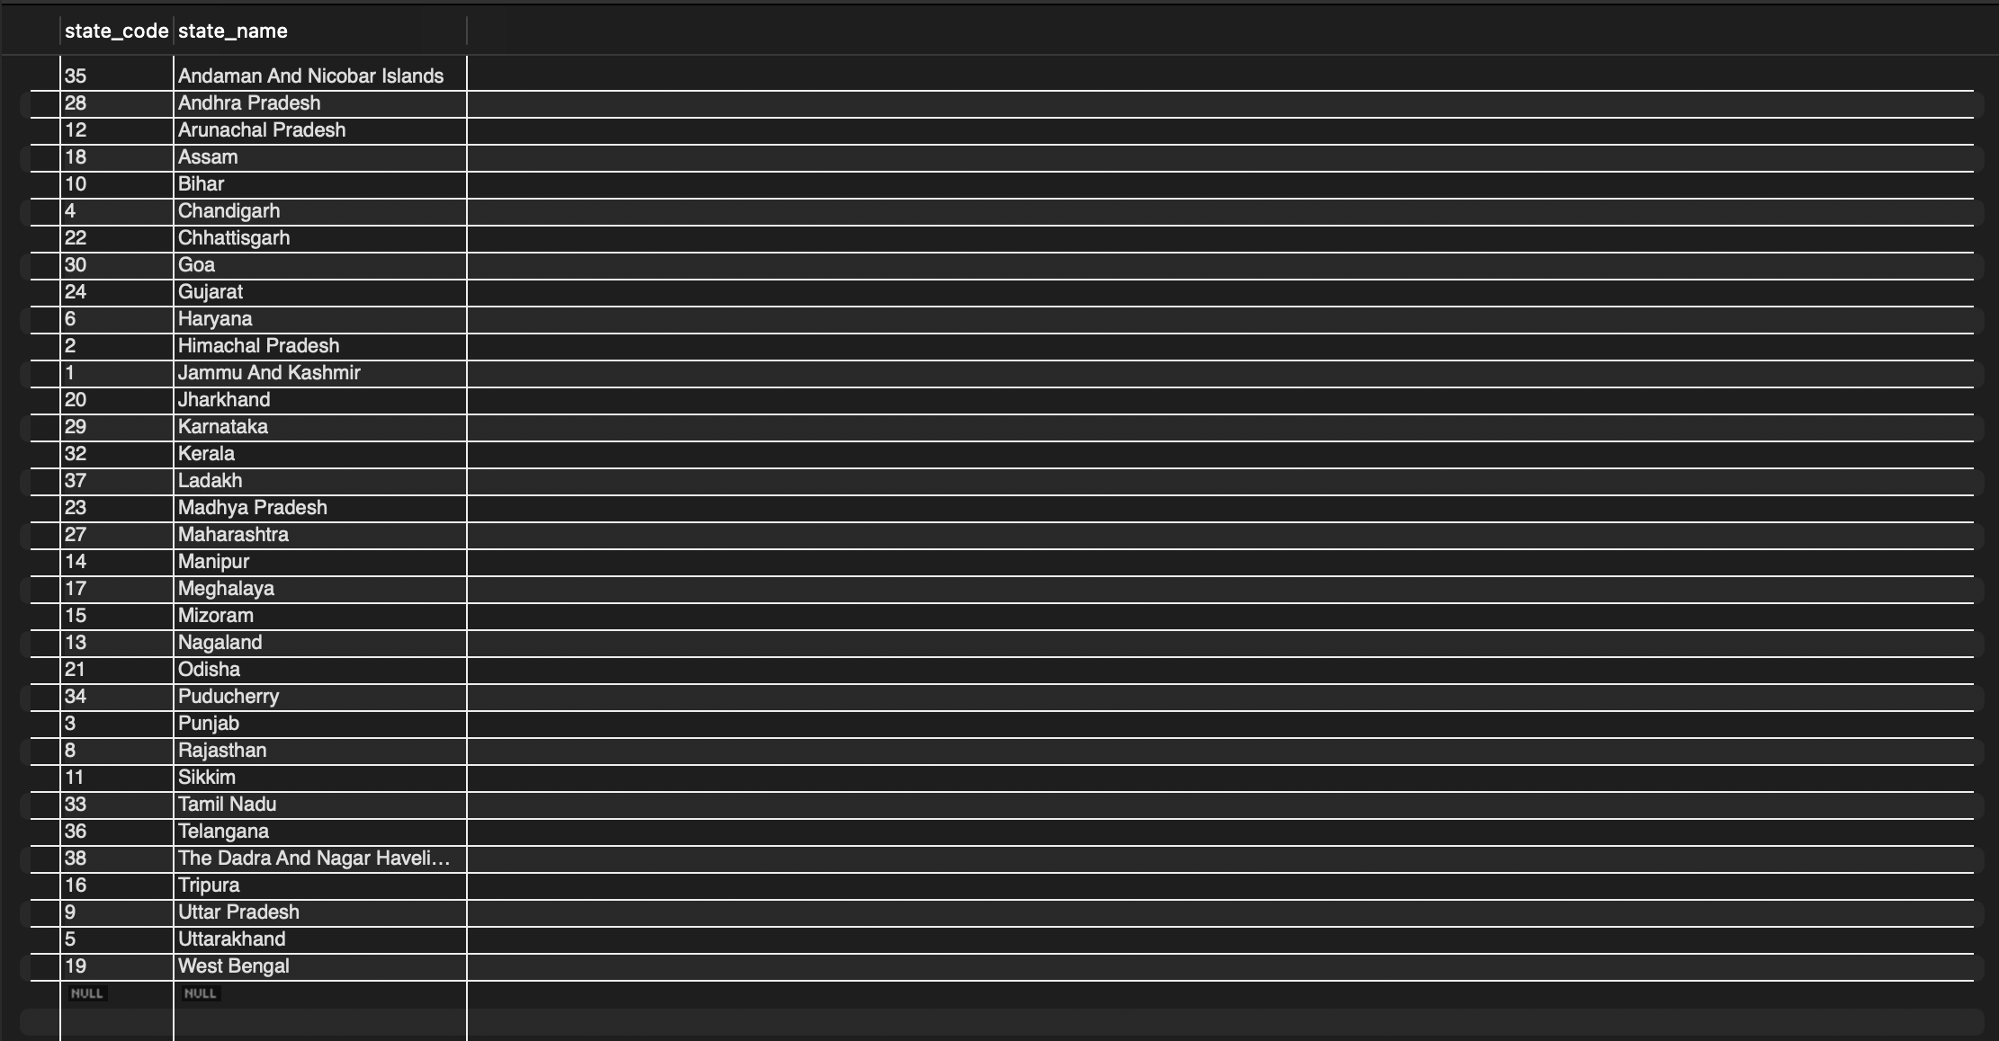

1.1 List all States

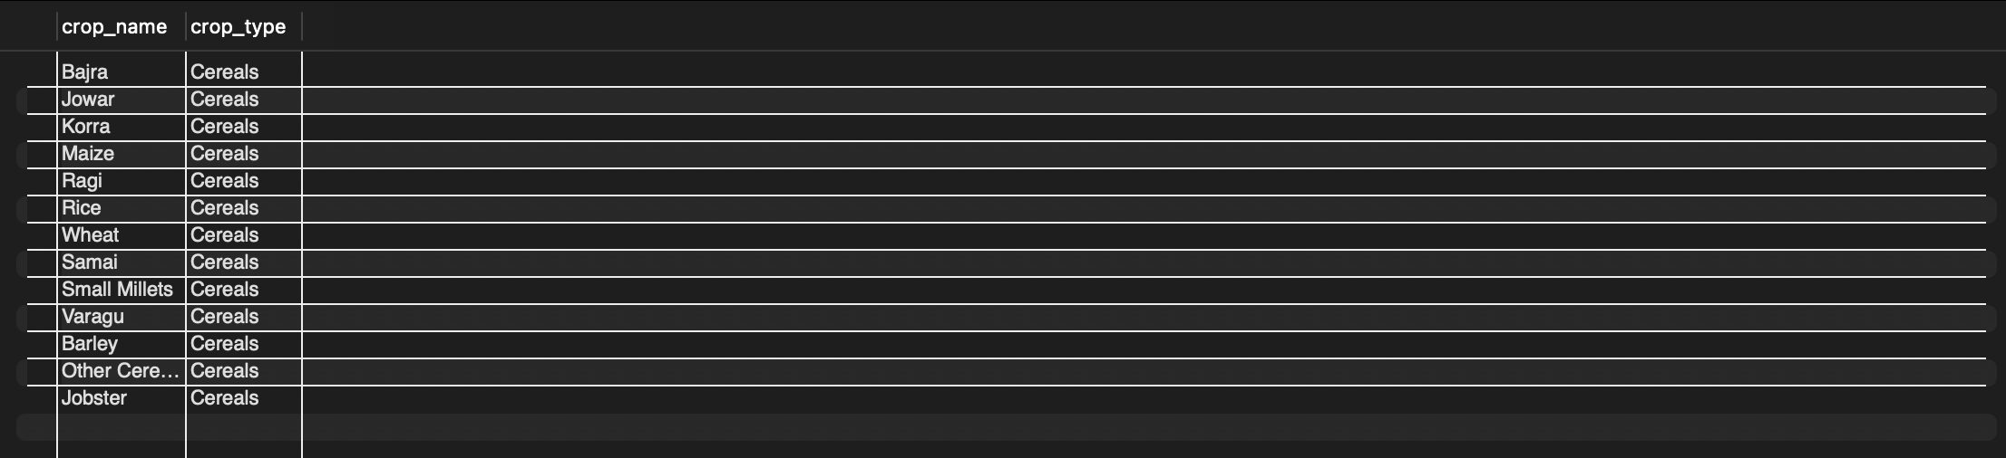
1.2 List all crops of a specific type

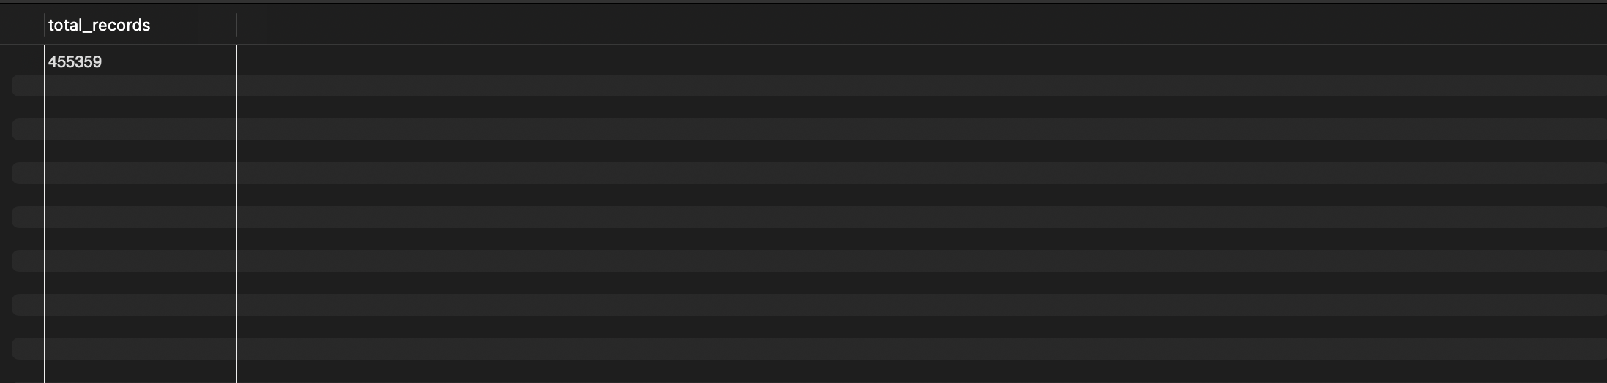
1.3 Count total crop production records

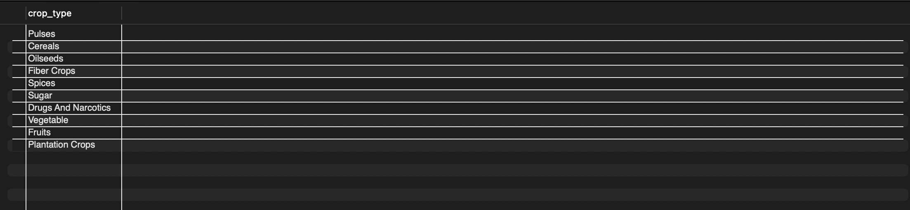
1.4 All distinct crop types

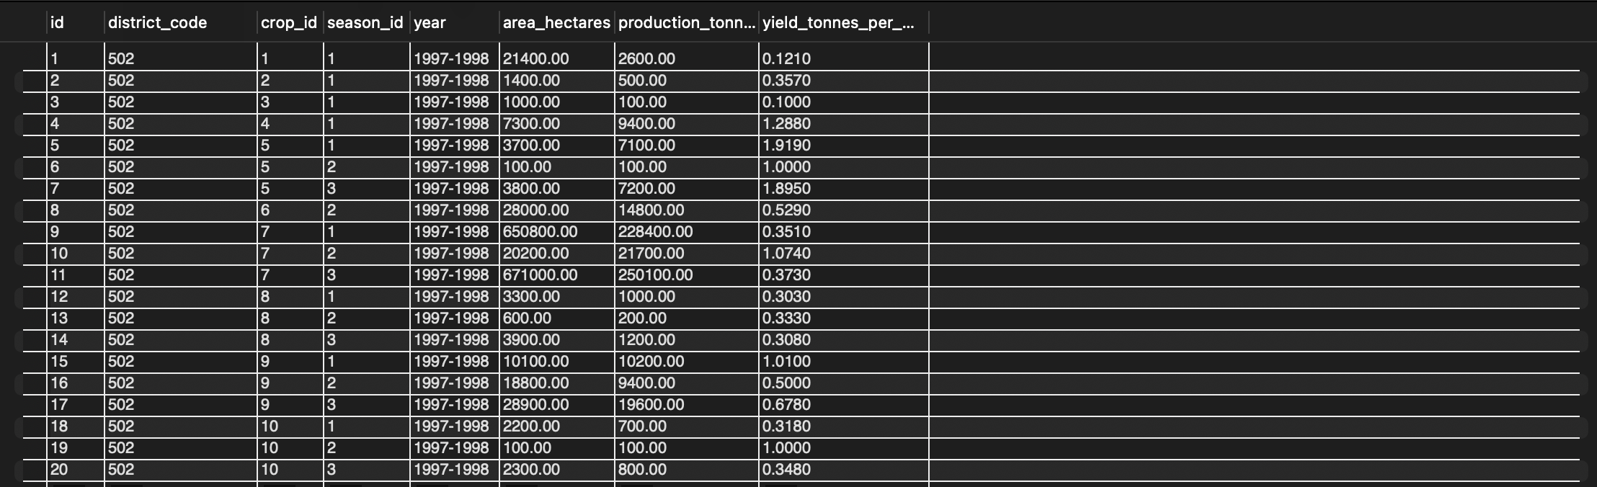
1.5 All production records from a specific year

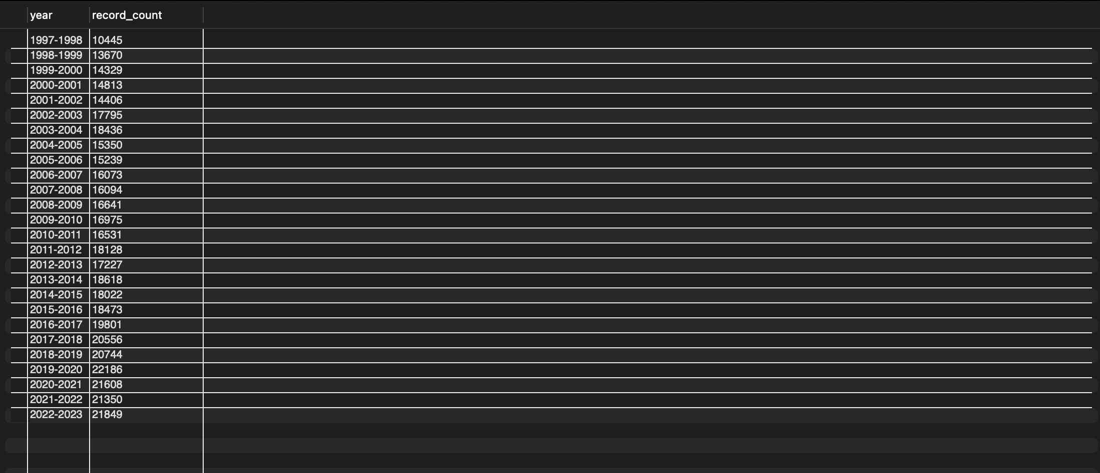
1.6 Number of records per year

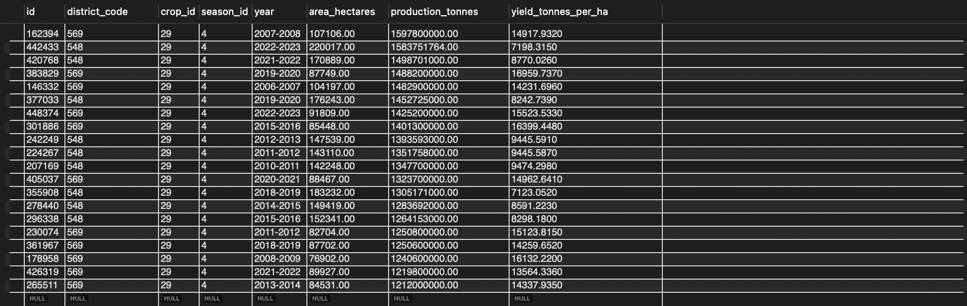
1.7 Simple filter with a threshold

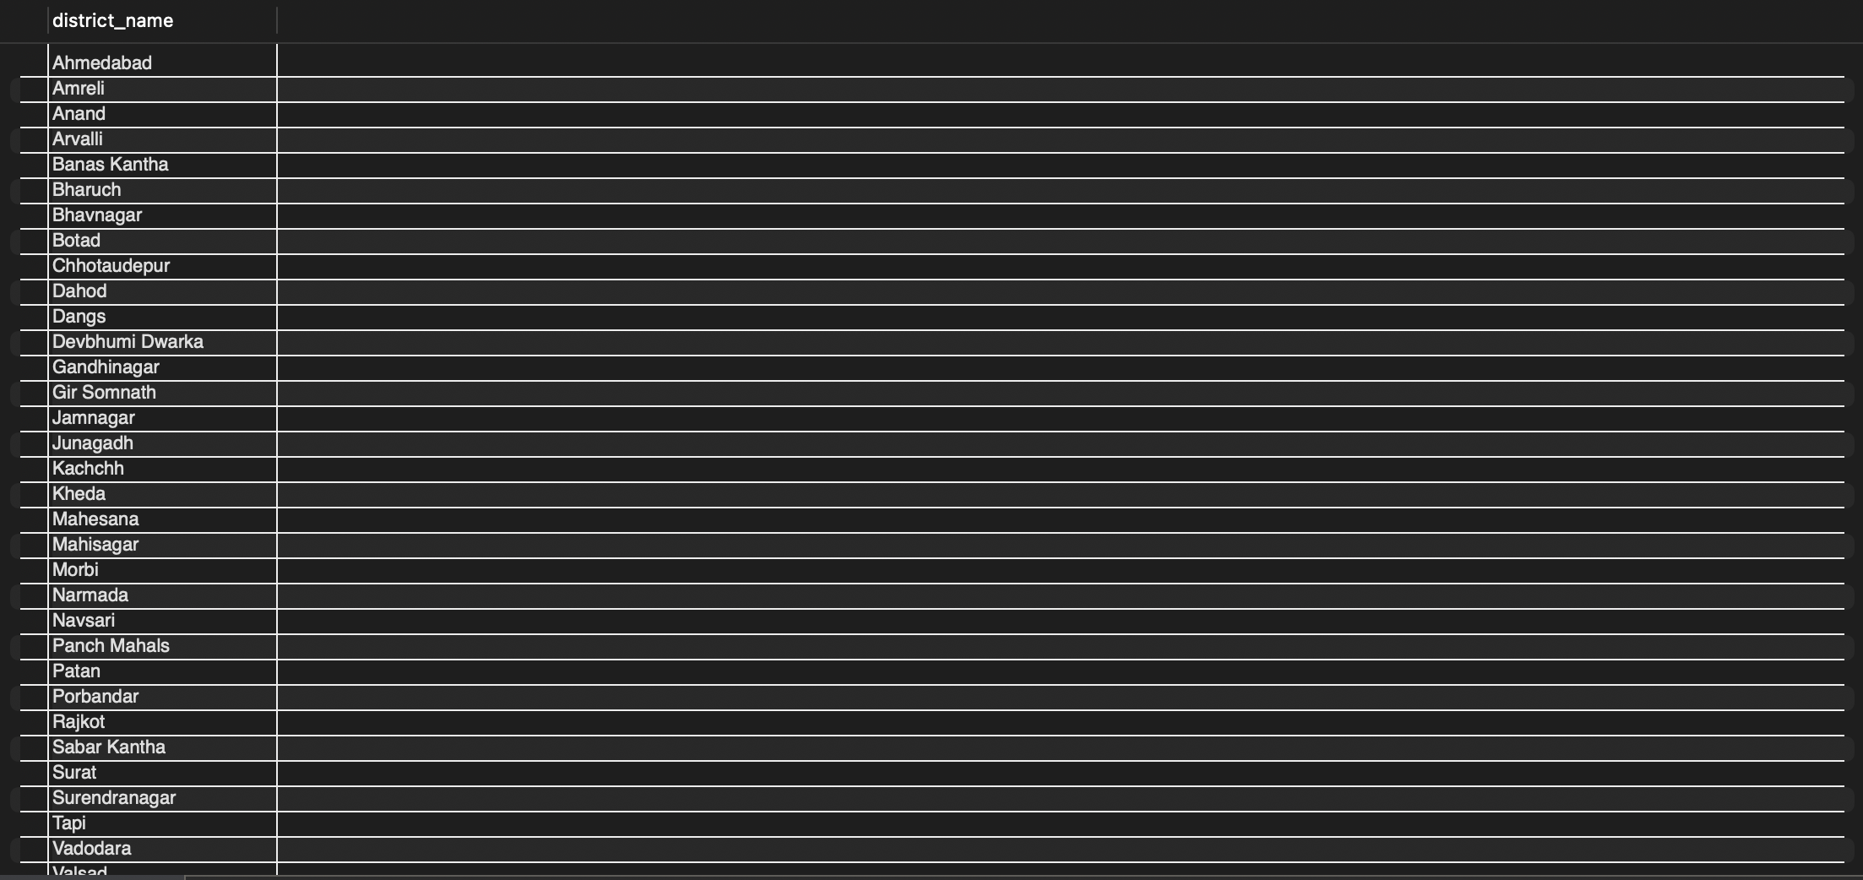
2.1 All districts in a given state

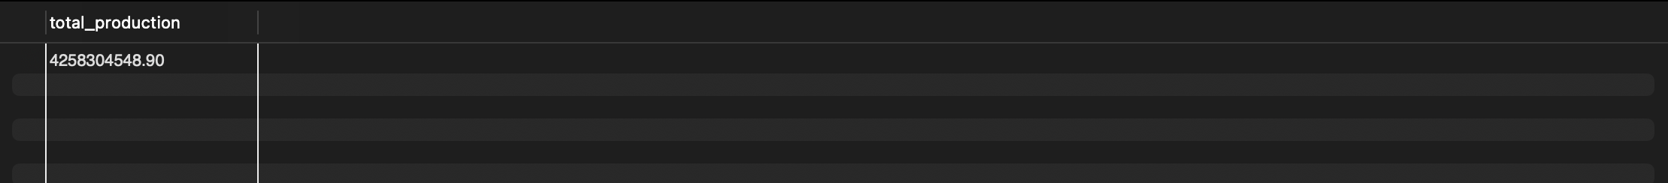
2.2 Total production of a specific crop, all-time

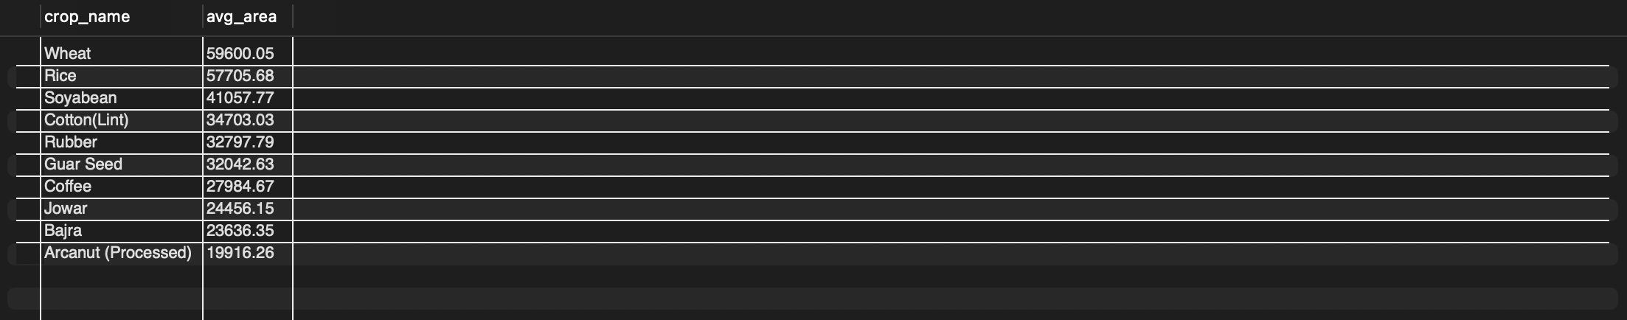
2.3 Average area cultivated per crop

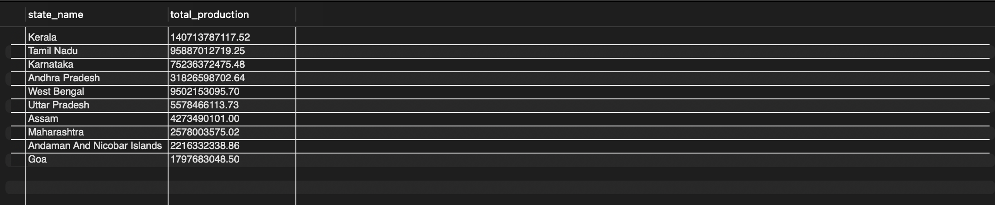
2.4 Top 10 crop-producing states (all-time)

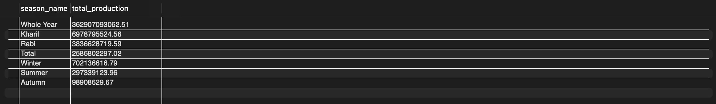
2.5 Season-wise total production comparison

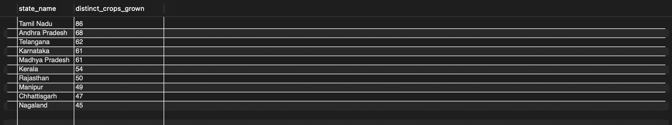
2.6 Crop diversity per state

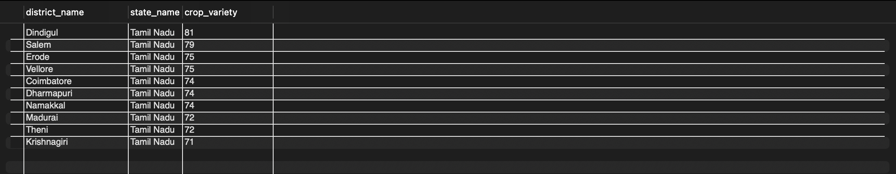
2.7 Filtering grouped results with HAVING

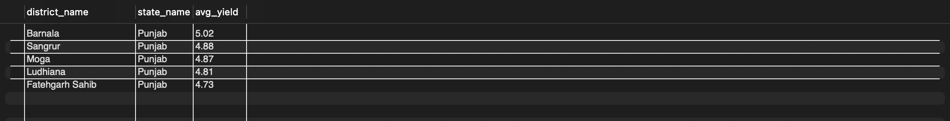
2.8 Top 5 districts by average yield for a given crop

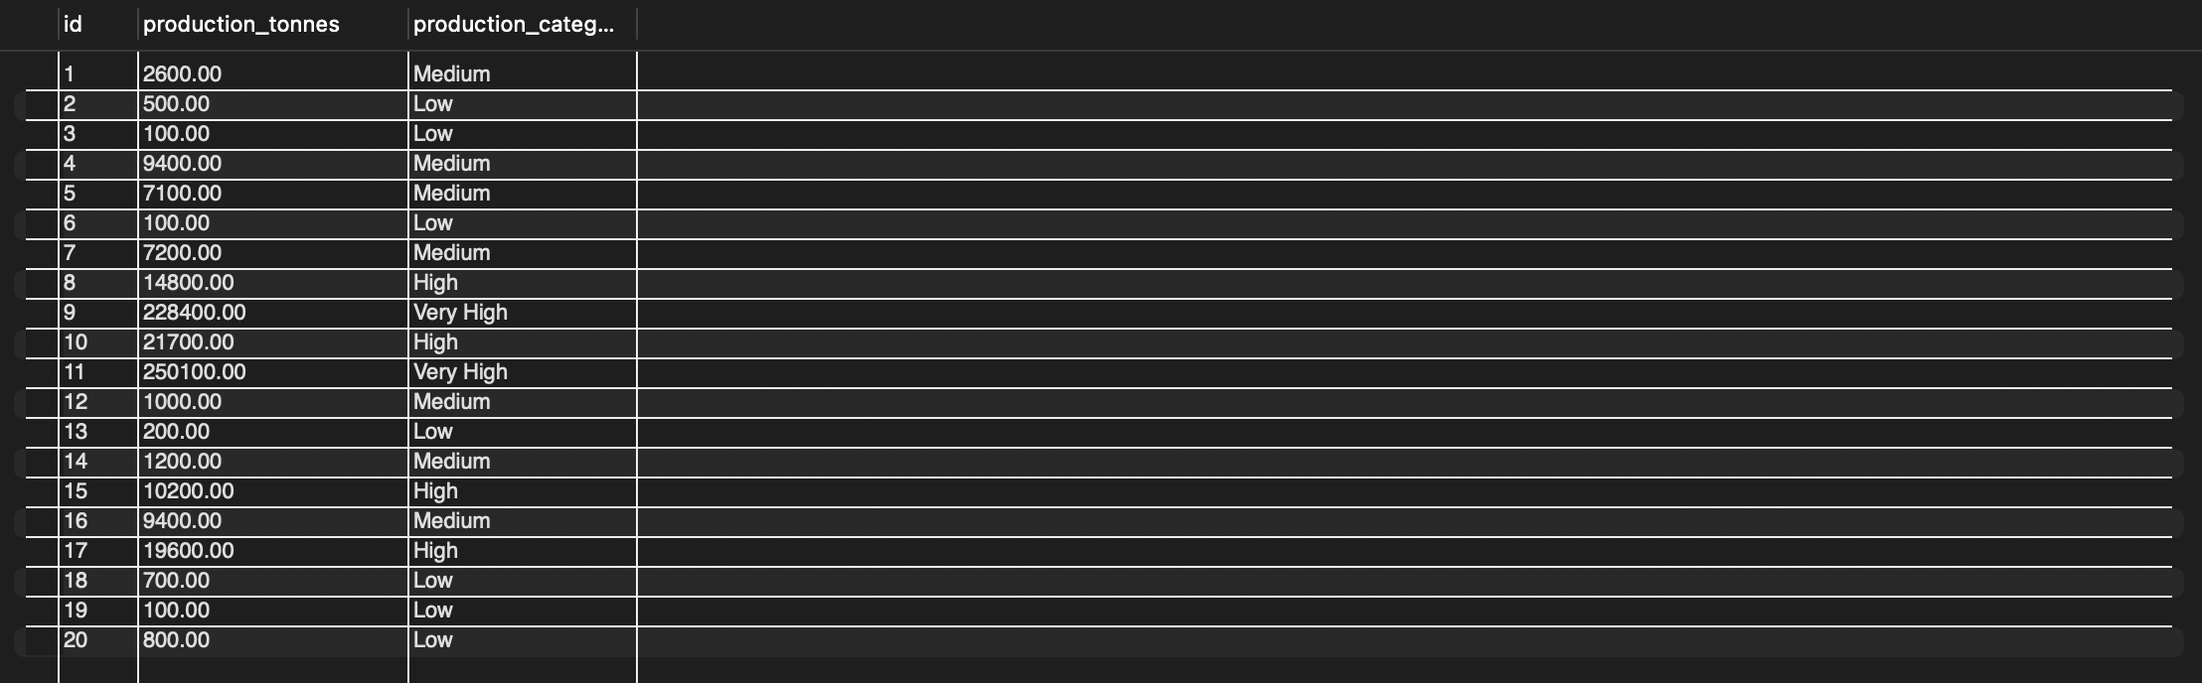
2.9 CASE WHEN — bucket production into size categories

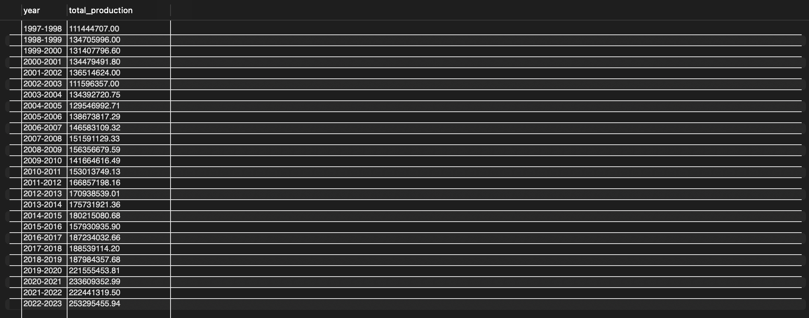
2.10 Year-over-year production trend for a specific crop
3.1 Crops whose average yield beats the overall average yield

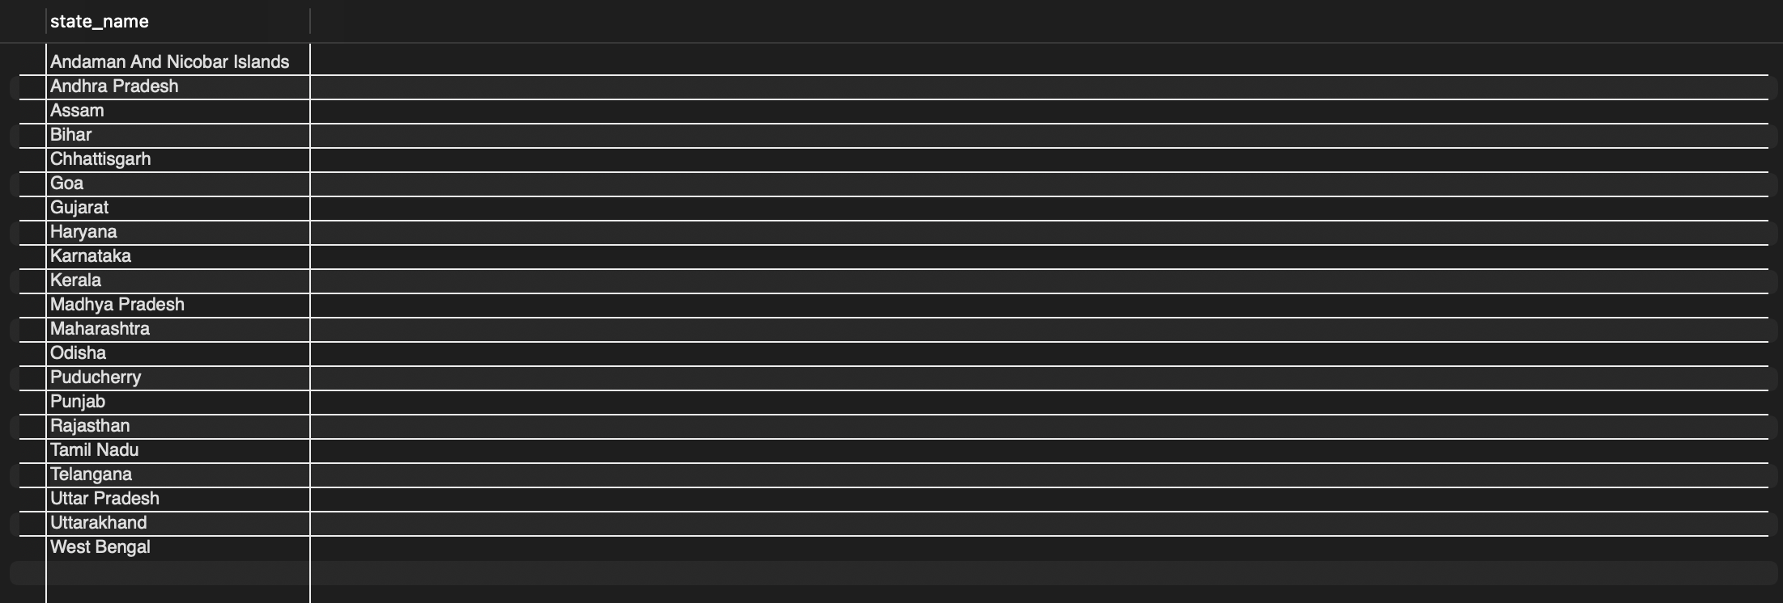
3.2 States that have ever produced more than 1,000,000 tonnes of any single crop (EXISTS)

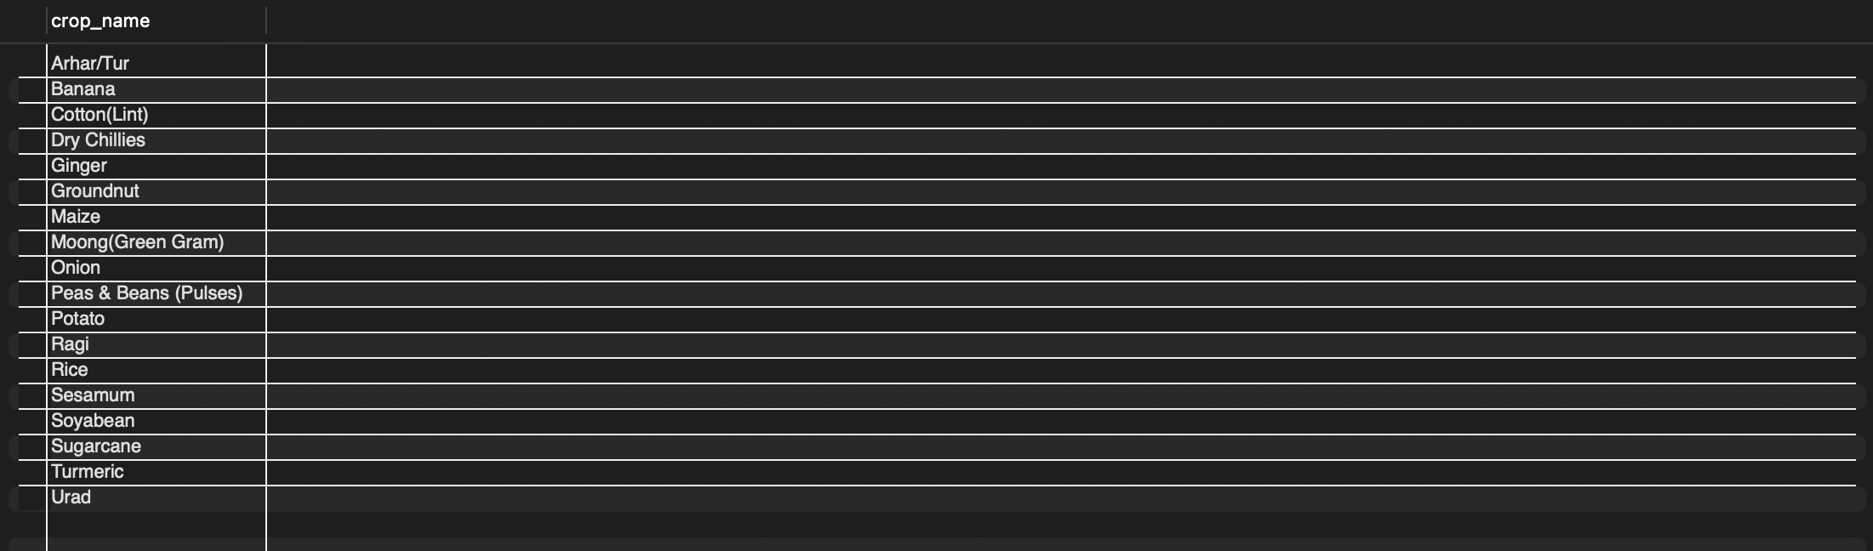
3.3 Crops grown in every single season (subquery with COUNT comparison)

3.4 District(s) with the single highest production value recorded

G. Testing and Evaluation

1. Data Integrity Testing — the crop_code discovery
During loading, crops.crop_code (the field originally assumed to be the natural key) was found to be non-unique in the raw government dataset — a single code mapped to as many as 7 different crop names. This was discovered by comparing df['crop_code'].nunique() (94) against df['crop_name'].nunique() (115) in the raw data. The schema was corrected to use a surrogate key (crop_id) with crop_name as the true unique field, and the ETL pipeline was rewritten to re-map records accordingly.

2. Referential Integrity Testing
Verified that foreign key constraints reject invalid references:
-- Attempting to insert a production record with a non-existent crop_id
-- should FAIL with a foreign key constraint error:
INSERT INTO crop_production (district_code, crop_id, season_id, year, production_tonnes)
VALUES ('001', 999999, 1, '2023-24', 5000);
-- Expected: Error 1452 (23000): Cannot add or update a child row:
-- a foreign key constraint fails

3. Constraint Testing (Uniqueness)
Verified that the UNIQUE KEY on crop_production prevents duplicate records for the same district/crop/season/year:
-- Re-running the loader a second time uses INSERT IGNORE, so duplicate
-- rows matching the existing UNIQUE KEY are silently skipped rather
-- than causing duplicate data. Verified: re-running load_data.py twice
-- produced the same final row count both times.

4. Load Verification
SELECT COUNT(*) FROM states; -- 34
SELECT COUNT(*) FROM districts; -- 740
SELECT COUNT(*) FROM crops; -- ~115
SELECT COUNT(*) FROM seasons; -- 7
SELECT COUNT(*) FROM crop_production; -- ~455,338

5. Functional Testing
All 21 queries (Section f) were executed against the loaded dataset and verified to return semantically correct, non-empty results with properly joined state/district/crop/season names.

Challenges Faced and Resolutions
Challenge | Resolution
mysql-connector-python wrote the literal word 'nan' into INSERT statements for missing numeric values | Explicitly converted NaN -> None before insertion so MySQL correctly interprets them as NULL
crop_code was assumed to be a natural key but was found to be non-unique | Redesigned crops table around a surrogate key (crop_id) with crop_name as the true unique identifier
Loading ~455K rows in a single transaction risked memory issues and made progress hard to track | Batched inserts (5,000 rows per batch) with progress logging

H. Conclusion
This project successfully models and populates a normalized relational database for Indian agricultural crop production data, sourced from an authoritative government dataset spanning 27 years and 740 districts. The design demonstrates justified normalization (1NF -> 3NF) grounded in the actual structure of the data, a conceptually correct ternary-relationship model for the fact table, referential integrity via foreign keys and uniqueness constraints, a working automated ETL pipeline handling real-world data quality issues, and a graded progression of SQL queries from basic retrieval to subquery-based analysis.

Unique Features (compared to typical fresher DBMS projects)
- Uses a real, large-scale, authoritative government dataset (not synthetic/Kaggle-toy data), spanning nearly three decades
- Surfaced and resolved a genuine data integrity defect in the source data (non-unique crop_code), rather than assuming the raw data was clean
- Implements an automated Python ETL pipeline with proper NULL-handling and batch processing for ~455K records, rather than manual data entry

Future Work
- Extend the schema with rainfall/weather data to analyze climate impact on yield
- Expose the database via a simple web dashboard for interactive querying
- Add indexing and query optimization as a follow-up performance-tuning phase

