## Name: Dev Sheta

## Roll No.: 23BCP110

## Branch: B.Tech Computer Engineering

## Sem./Year: 5 (3rd year)

## Division: 2

## Group: G4

## Pandit Deendayal Energy University

# Experiment: 4

* Portfolio Website Including forms like Login Page, Review Form and Registration Form in HTML and Using External CSS file with classes and IDs.

**CODE:**

**Not Included HTML Code of:**

* **index.html**
* **edu.html**
* **skill.html**
* **contact.html**

**Filename: forms.html**

**<!DOCTYPE html>**

**<html lang="en">**

**<head>**

**<meta charset="UTF-8">**

**<meta name="viewport" content="width=device-width, initial-scale=1.0">**

**<title>Forms</title>**

**<link rel="stylesheet" href="style.css">**

**</head>**

**<header>**

**<h1>Hello I'm Dev Sheta, These are Forms</h1>**

**<nav>**

**<table id="nav">**

**<tr>**

**<td><a href="index.html">Home</a></td>**

**<td><a href="edu.html">Education</a></td>**

**<td><a href="skill.html">Skills</a></td>**

**<td><a href="contact.html">Contact me</a></td>**

**<td><a href="forms.html">Forms</a></td>**

**</tr>**

**</table>**

**</nav>**

**<hr>**

**</header>**

**<body>**

***<!-- Login Page -->***

**<form action="#">**

**<table class="frm">**

**<th colspan="2">**

**<h3>Login Page</h3>**

**</th>**

**<tr>**

**<td>**

**<div class="left">**

**<label for="user">Username: </label>**

**</div>**

**</td>**

**<td>**

**<div class="right">**

**<input type="text" name="user_name" id="user" size="30" placeholder="Enter your username">**

**</div>**

**</td>**

**</tr>**

**<tr>**

**<td>**

**<div class="left">**

**<label for="pass">Password: </label>**

**</div>**

**</td>**

**<td>**

**<div class="right">**

**<input type="password" name="password" id="pass" size="30" placeholder="Enter your password">**

**</div>**

**</td>**

**</tr>**

**<tr>**

**<td></td>**

**<td>**

**<div class="right">**

**<input type="checkbox" id="conf" name="agreement">**

**<label for="conf" id="remme">Remember me</label>**

**</div>**

**</td>**

**</tr>**

**<tr>**

**<td></td>**

**<td>**

**<div class="right">**

**<a href="#">Forgot Password</a><br>**

**</div>**

**</td>**

**</tr>**

**<tr>**

**<td colspan="2">**

**<div>**

**<input type="submit" value="Login" class="btn">**

**</div>**

**</td>**

**</tr>**

**</table>**

**</form>**

**<hr>**

***<!-- Review Form -->***

**<form action="#">**

**<table class="frm">**

**<th colspan="2">**

**<h3>Review Form</h3>**

**</th>**

**<tr>**

**<td>**

**<div class="left">**

**<label for="revn">Your Name: </label>**

**</div>**

**</td>**

**<td>**

**<div class="right">**

**<input type="text" name="rev_name" id="revn" size="30" placeholder="Enter your name">**

**</div>**

**</td>**

**</tr>**

**<tr>**

**<td>**

**<div class="left">**

**<label for="mail">Email Address: </label>**

**</div>**

**</td>**

**<td>**

**<div class="right">**

**<input type="email" name="e_mail" id="mail" size="30" placeholder="Enter your email">**

**</div>**

**</td>**

**</tr>**

**<tr>**

**<td>**

**<div class="left">**

**<label for="phone">Phone Number: </label>**

**</div>**

**</td>**

**<td>**

**<div class="right">**

**<input type="tel" name="p_num" id="phone" size="30" placeholder="Enter phone number">**

**</div>**

**</td>**

**</tr>**

**<tr>**

**<td>**

**<div class="left">**

**<label for="rating">Rate my website (out of 5): </label>**

**</div>**

**</td>**

**<td>**

**<div class="right">**

**<input type="range" name="rate" id="rating" list="markers" value="50">**

**<datalist id="markers">**

**<option value="0"></option>**

**<option value="25"></option>**

**<option value="50"></option>**

**<option value="75"></option>**

**<option value="100"></option>**

**</datalist>**

**</div>**

**</td>**

**</tr>**

**<tr>**

**<td>**

**<div class="left">**

**<label for="feed">Feedback: </label>**

**</div>**

**</td>**

**<td>**

**<div class="right">**

**<textarea id="feed" rows="5" cols="50"**

**placeholder="Please share your experience with us"></textarea>**

**</div>**

**</td>**

**</tr>**

**<tr>**

**<td>**

**<div class="left">**

**<label for="feed">Would you recommend us to a friend?</label>**

**</div>**

**</td>**

**<td>**

**<div class="right">**

**<input type="radio" name="ans" value="Yes" id="y">**

**<label for="y">Yes</label>**

**<input type="radio" name="ans" value="No" id="n">**

**<label for="n">No</label>**

**</div>**

**</td>**

**</tr>**

**<tr>**

**<td></td>**

**<td>**

**<div class="right">**

**<input type="checkbox" id="rev">**

**<label for="rev">I agree to terms and conditions.</label>**

**</div>**

**</td>**

**</tr>**

**<tr>**

**<td colspan="2">**

**<input type="submit" value="Submit Review" class="btn">**

**</td>**

**</tr>**

**</table>**

**</form>**

**<hr>**

***<!-- Registration Form -->***

**<form action="#">**

**<table class="frm">**

**<th colspan="2">**

**<h3>Registration Form</h3>**

**</th>**

**<tr>**

**<td>**

**<div class="left">**

**<label for="fname">First Name: </label>**

**</div>**

**</td>**

**<td>**

**<div class="right">**

**<input type="text" name="first" id="fname" size="30" placeholder="Enter your firstname">**

**</div>**

**</td>**

**</tr>**

**<tr>**

**<td>**

**<div class="left">**

**<label for="lname">Last Name: </label>**

**</div>**

**</td>**

**<td>**

**<div class="right">**

**<input type="text" name="last" id="lname" size="30" placeholder="Enter your lastname">**

**</div>**

**</td>**

**</tr>**

**<tr>**

**<td>**

**<div class="left">**

**<label for="mail_r">Email: </label>**

**</div>**

**</td>**

**<td>**

**<div class="right">**

**<input type="email" name="e_mail" id="mail_r" size="30" placeholder="Enter your email">**

**</div>**

**</td>**

**</tr>**

**<tr>**

**<td>**

**<div class="left">**

**<label for="pass_r">Password: </label>**

**</div>**

**</td>**

**<td>**

**<div class="right">**

**<input type="password" name="password1" id="pass_r" size="30" placeholder="Enter your password">**

**</div>**

**</td>**

**</tr>**

**<tr>**

**<td>**

**<div class="left">**

**<label for="rpass">Re-type Password: </label>**

**</div>**

**</td>**

**<td>**

**<div class="right">**

**<input type="password" name="password2" id="rpass" size="30"**

**placeholder="Re-type your password">**

**</div>**

**</td>**

**</tr>**

**<tr>**

**<td>**

**<div class="left">**

**<label for="phone_r">Contact: </label>**

**</div>**

**</td>**

**<td>**

**<div class="right">**

**<input type="tel" name="p_num" id="phone_r" size="30" placeholder="Enter your contact number">**

**</div>**

**</td>**

**</tr>**

**<tr>**

**<td>**

**<div class="left">**

**<label for="gen">Gender:</label>**

**</div>**

**</td>**

**<td>**

**<div class="right">**

**<select name="gender" id="gen">**

**<option value="" selected disabled hidden>Choose Gender Here</option>**

**<option value="male">Male</option>**

**<option value="female">Female</option>**

**</select>**

**</div>**

**</td>**

**</tr>**

**<tr>**

**<td colspan="2">**

**<input type="submit" value="Submit" class="btn">**

**</td>**

**</tr>**

**</table>**

**</form>**

**<hr>**

**</body>**

**<footer>**

**<p>Made By <b><i>Dev Sheta</i></b> (23BCP110)</p>**

**</footer>**

**</html>**

**External CSS File:**

**Filename: style.css**

**@import url('https://fonts.googleapis.com/css2?family=Poppins:ital,wght@0,100;0,200;0,300;0,400;0,500;0,600;0,700;0,800;0,900;1,100;1,200;1,300;1,400;1,500;1,600;1,700;1,800;1,900&display=swap');**

**footer {**

**text-align: center;**

**}**

**body {**

**/* background-color: wheat; */**

**color: gray;**

**font-family: 'Poppins';**

**}**

**table#nav {**

**width: 100%;**

**text-align: center;**

**background-color: grey;**

**border-radius: 10px;**

**}**

**table#nav a {**

**text-decoration: none;**

**color: gray;**

**}**

**table#nav td {**

**background-color: wheat;**

**border-radius: 10px;**

**width: 20%;**

**}**

**h1 {**

**background-color: wheat;**

**color: gray;**

**border: 3px solid gray;**

**border-radius: 10px;**

**text-align: center;**

**}**

**h2 {**

**text-align: center;**

**}**

**h3 {**

**text-align: center;**

**}**

**ul li a {**

**color: gray;**

**}**

**/* Forms style */**

**input {**

**border: 1px solid gray;**

**background-color: wheat;**

**border-radius: 4px;**

**padding: 3px;**

**}**

**.btn {**

**color: gray;**

**background-color: wheat;**

**border-radius: 5px;**

**padding: 5px 30px;**

**font-size: medium;**

**}**

**textarea {**

**background-color: wheat;**

**border-radius: 5px;**

**font-family: 'Poppins';**

**}**

**select {**

**background-color: wheat;**

**border: 1px solid gray;**

**border-radius: 8px;**

**padding: 0 10px;**

**font-family: 'Poppins';**

**color: gray;**

**}**

**#rating {**

**accent-color: gray;**

**}**

**.frm {**

**text-align: center;**

**width: 100%;**

**/* background-color: wheat; */**

**}**

**.frm td {**

**width: 30%;**

**padding-bottom: 8px;**

**}**

**.left {**

**text-align: right;**

**margin-right: 30px;**

**}**

**.right {**

**text-align: left;**

**}**

**.right a,**

**#remme {**

**font-size: small;**

**}**

**OUTPUTS:**

**Using External Style Sheet**

Output of index.html:

Output of edu.html:

Output of skill.html:

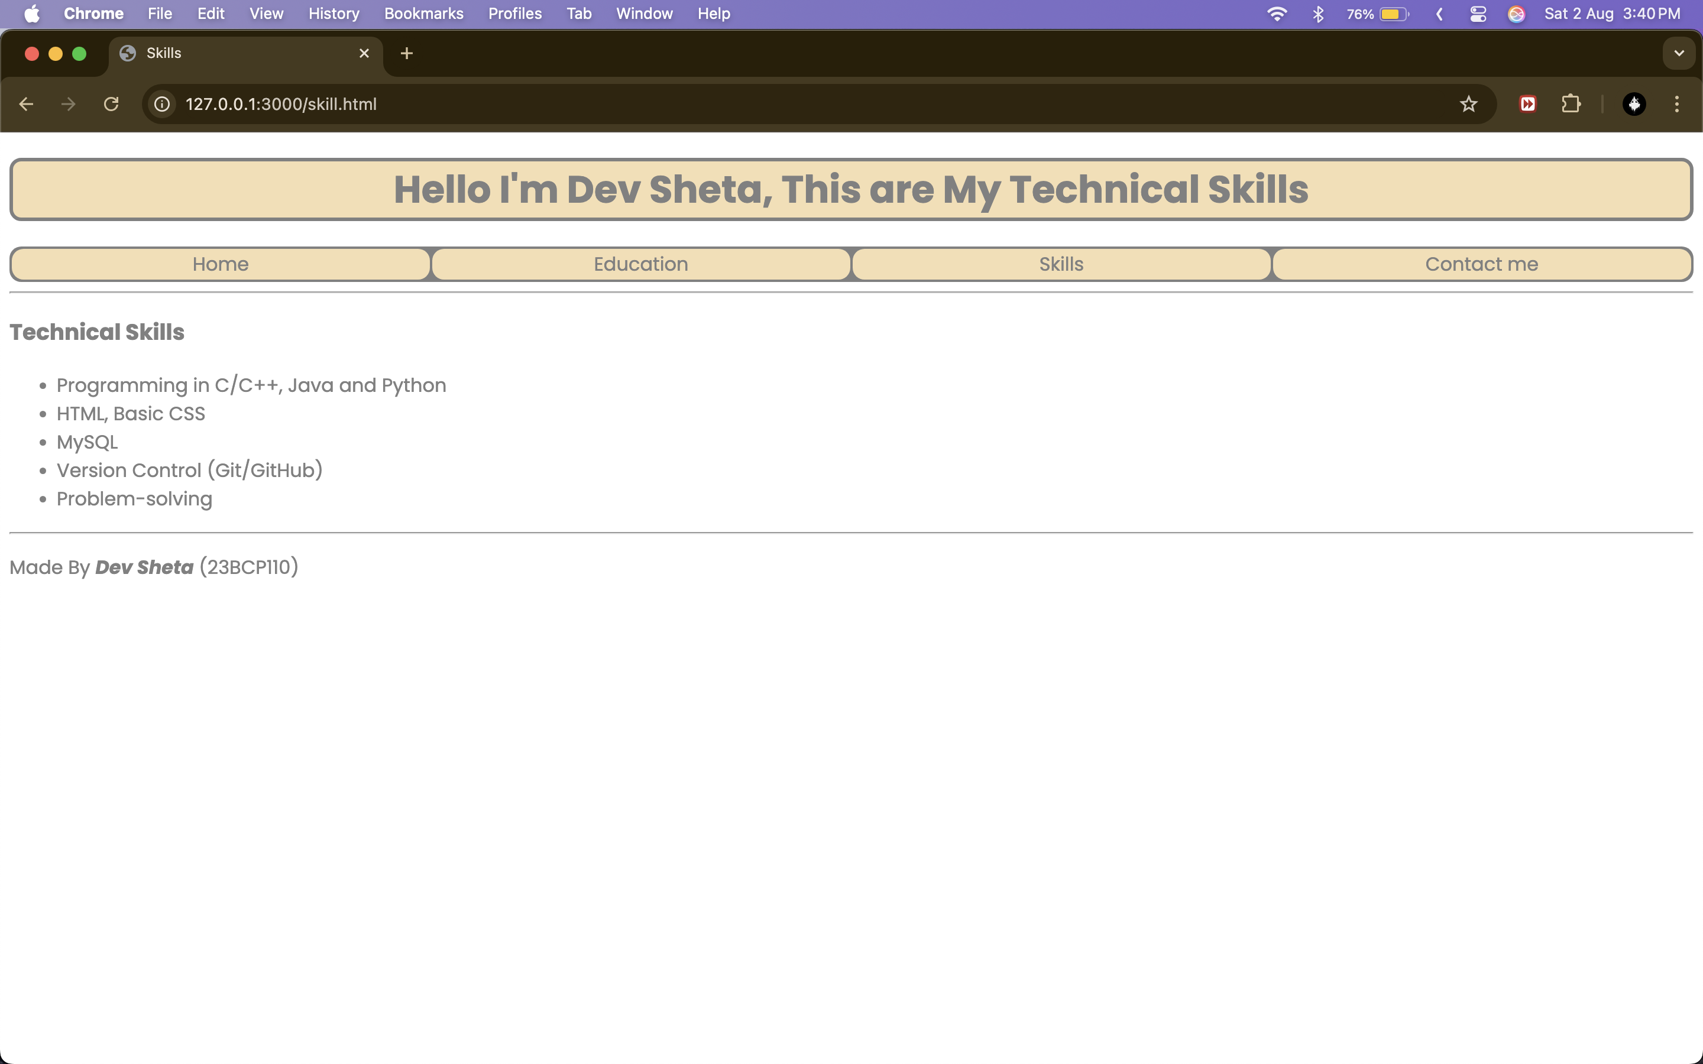

Output of contact.html:

Output of forms.html:



