**Blog App Document**

# Create server

* First we have to create server by using command **npx init** , it will create **package.json** file into your directory which consist of details information about your project.
* Install some packages into ypor projects
* Make changes into your script to start server through nodemon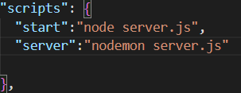
* Create server.js file into your project directory
* Import all packages into server.js file

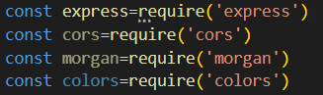

* Create rest object of app to add all functionality of express



* Create middleware for project

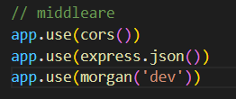

* Create routes into server.js file and also create listener by giving particular port

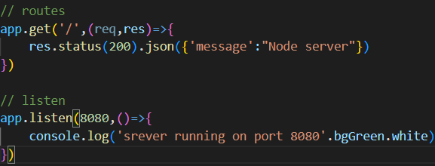

* Create dotenv file into root folder to hide your secrete credentials from to get public, so add tour port number init then import and configure dotenv into server.js file. Create seprate port onject and import port number from .env file

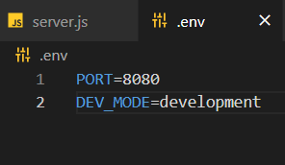

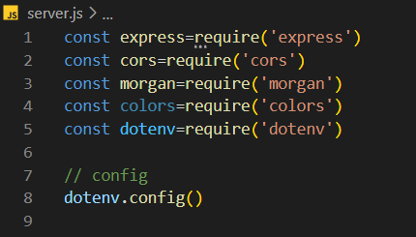

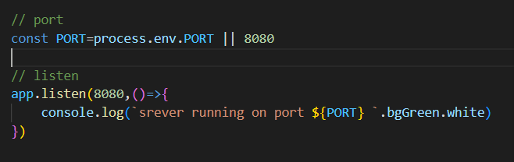

# Connect with mongodb cloud database

* Go to mongodb atlas website login there and create project after that create free cluster.
* Then in security quickstart add username and password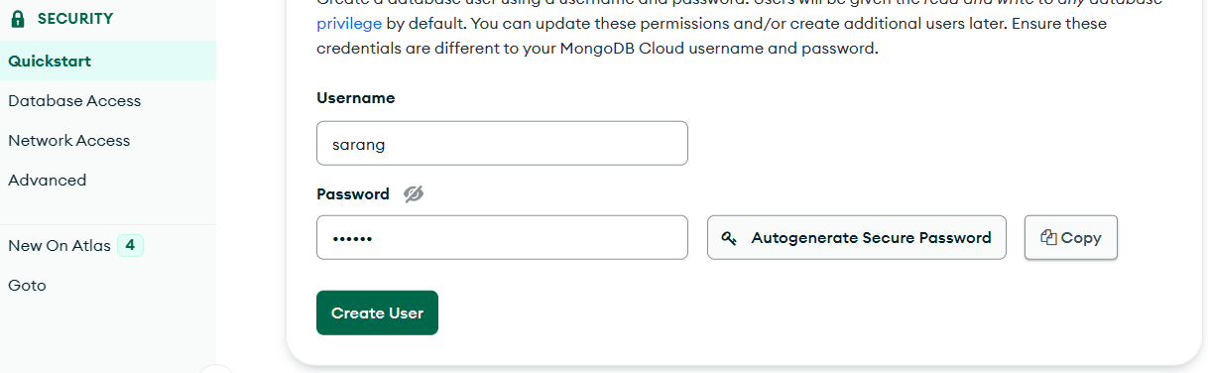
* Go to network add ip access ,click allow from anywhere and conform.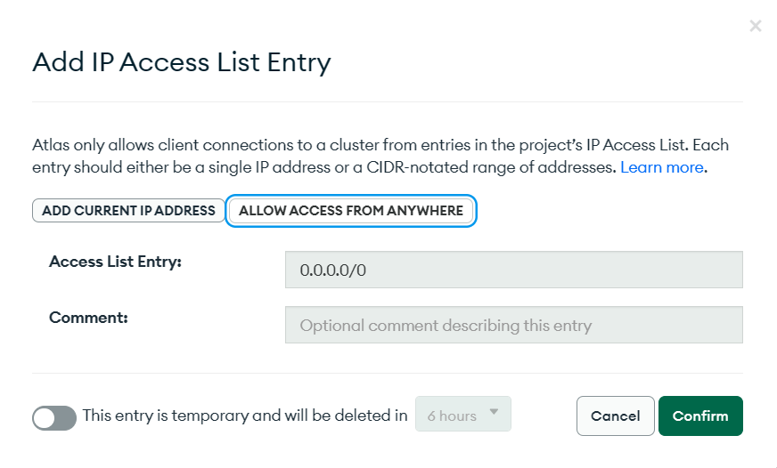
* Got to database click on connect option go to connect application copy mongo url and paste url into . env file 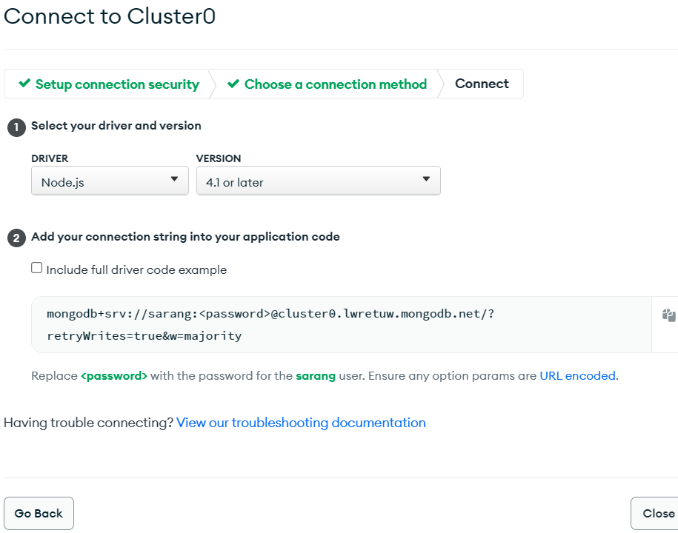
* Add your actual password to ther url into .env file
* Create config folder into root and create db.js file
* Inside it we create connectDB function in which we import mongoose
* Using mongoose.connect() and passing url into it we connect wit DB
* At the end export function 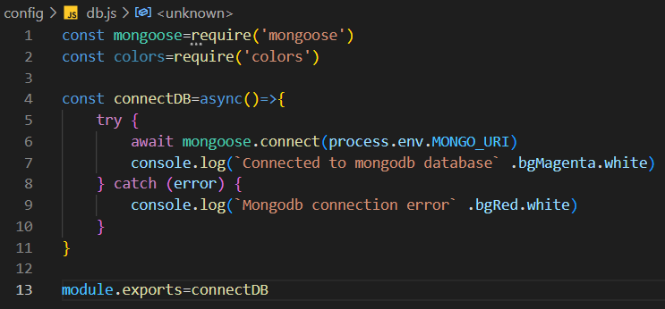
* Then import that function into server.js file 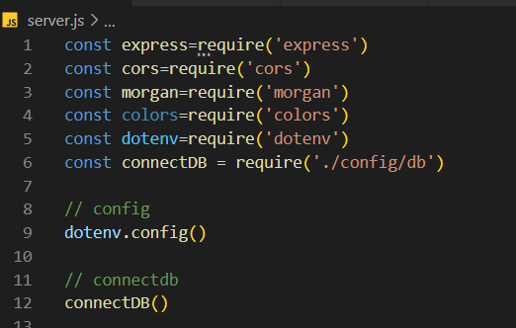

# User model,routes and controller created

* Create model folder in root and create userModel.js file init
* Import mongoose and create userSchema by using mongoose.Schema({})
* Add all your field value insite schema and their type
* At the end use mongoose.model() method and pass field name and user schema init assign it to variable called uselModel
* Export userModel
* 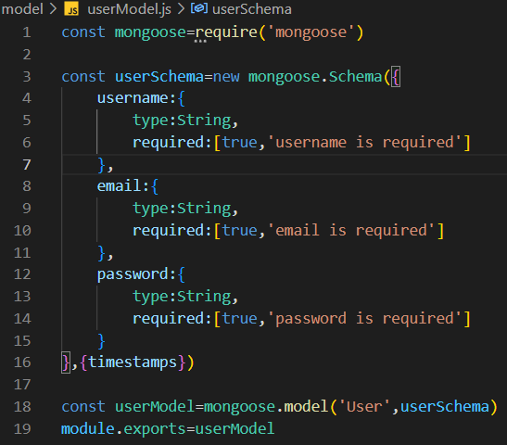
* Now create controller,routes folder into your root and also create userController.js file in controller and userRotes.js in routes
* Create multiple user routes by importing express then use express.routes() method and store into vasiavle route and export that variable
* Create multiple route using routes.get(),post(),put() and pass your endpoint and controller functions 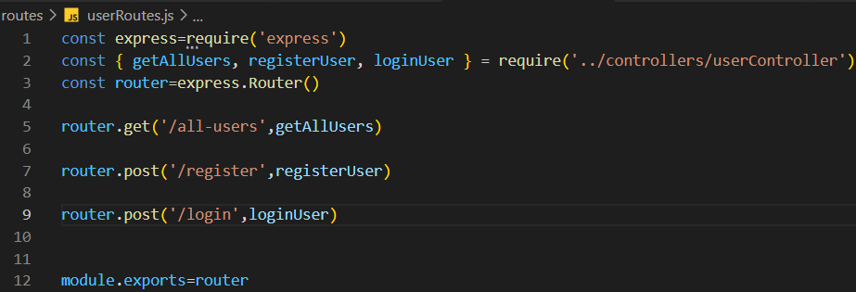
* Similirly create controllers funcitns in userController.js file and export it 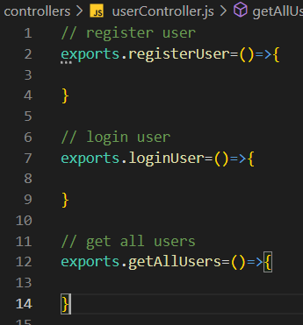

# Register controller API

* First we make our callback fuction async and pass req,res to parameter
* We use try/catch block to handle errors
* In catch we send res status 500 and object which consist of error,message,and success status false.
* In try block firt we destrucy data which Is ckmming from user using req.body
* Then we validate weather there is data available or not if not thn we will send error message and ststus code 400
* Now we will check weather user already exist by importing userModel and check userModel.findone({}) by passing email weather user exist
* If user exist then we will send json res message and tell him user email already registered.
* If user not exist then we will save user by passing creadiantial inside userModel bu storing into variable and then use save() method. 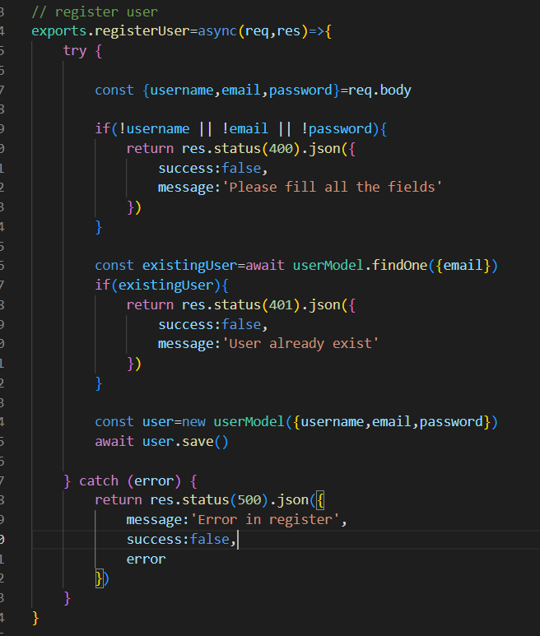
* You can send success res and status code 201
* Now you can check your api through postman weather user able to create account or not
* 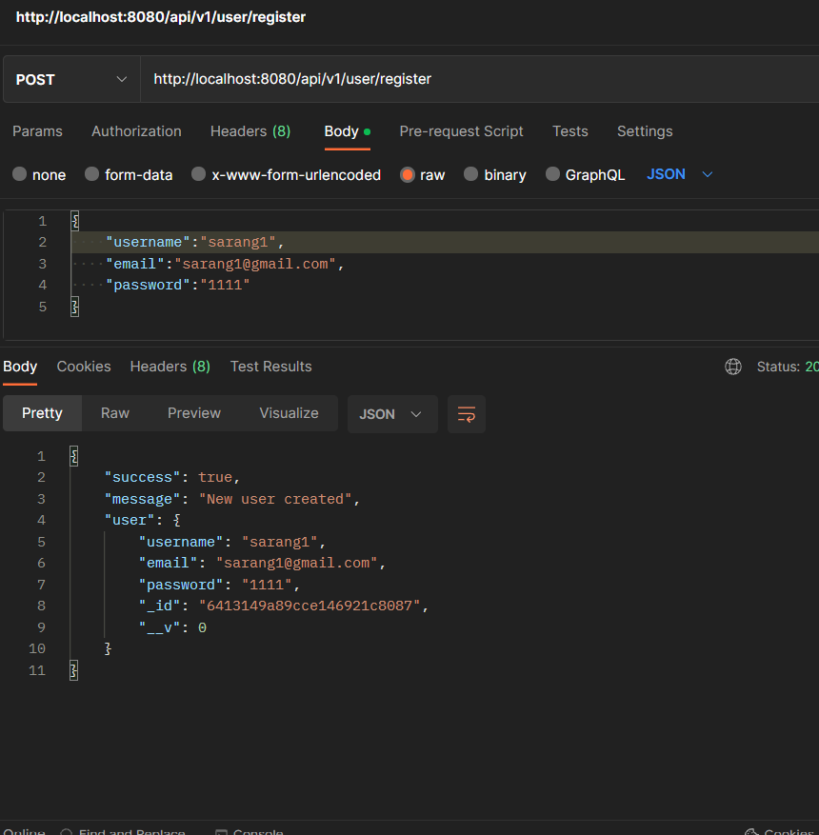

# Get all user callback apis

* Make callback func async/await and create try /catch block to handle error and send appropriate res from catch block
* userModel.find({}) method to get all the users store into variable and send res status and msg

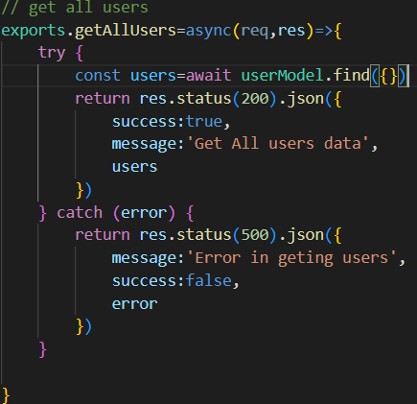

# Password hashing

* first install package bcrypt 
* before saving users details in db just bcrypt password by using bcrypt.hash() inside it pass your password and salt value 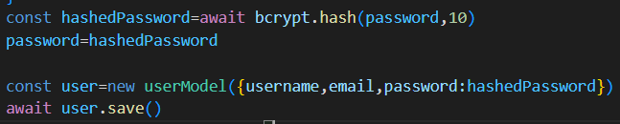

# User Login callback APIs

* First we make our callback fuction async and pass req,res to parameter
* We use try/catch block to handle errors
* In catch we send res status 500 and object which consist of error,message,and success status false.
* In try block first destructure email and password through req.body
* After that validate if email or password is there or not,if not send error
* Then validate if user is registerd or not if not registerd then send error
* Now compare password coming from body with user.password , if it is not match send error msg
* At the end send appropriate res of successfully login 