# A PROJECT REPORT

**ON**

**"Restaurant Billing System"**

# As A Minor Project For The Semester Five Of BACHELOR OF COMPUTER APPLICATION (B.C.A.)

**Submitted To**



# C.B. PATEL COMPUTER COLLEGE &

**J. N. M. PATEL SCIENCE COLLEGE, BHARTHANA, VESU, SURAT**

# Affiliated To

**VEER NARMAD SOUTH GUJARAT UNIVERSITY, SURAT ACADEMIC YEAR: 2023-24**

**GUIDED BY: SUBMITTED BY:**

### ASST. PROF Mohamedsohel Shaikh Sir Dev Tamakuwala (2125)

**INDEX**

|  |  |  |  |
| --- | --- | --- | --- |
| **Sr No.** | **Topic** | **Page No.** | **Sign** |
| 1 | Index | 2 |  |
| 2 | Introduction | 3 |  |
| 3 | Technology Used | 4 |  |
| 4 | Objective | 5 |  |
| 5 | Database(List of Tables) | 6 |  |
| 6 | Design (XML Code) | 8 |  |
| 7 | Source Code | 37 |  |
| 8 | Output | 57 |  |
| 9 | References | 63 |  |

**Introduction**

A **Brunch** is an application that is used by restaurants or cafes to take the orders from the customers. This application has two types of users 1) Admin & 2) Attenders.

1. Admin: - Admin can manage the menu items, menu category, attenders and orders.
2. Attenders(Staff): - Attenders(Staff) can order the items from the menu.

**Technology Used**

1. Hardware Requirements:
   * Laptop / Desktop
   * 8 GB ram
   * Android Phone
2. Software Requirement:
   * Android Studio
   * Windows 10 or Upper
3. Database Requirements:
   * SQLite
4. Language Used:
   * Android with Kotlin

**Objective**

* Using this app can:
* Manage the orders easily
* Admin can add, update and delete the Menu easily
* Easily keep the track record of the employees

**Database(List of Tables)**

tblUser

|  |  |  |
| --- | --- | --- |
| Sr no. | Field Name | Constructions |
| 1 | UserID | Primary Key |
| 2 | UNAME | Not Null |
| 3 | PASSWORD | Not Null |

tblAdmin

|  |  |  |
| --- | --- | --- |
| Sr no. | Field Name | Constructions |
| 1 | AdminID | Primary Key |
| 2 | UNAME | Not Null |
| 3 | PASSWORD | Not Null |

tblCategory

|  |  |  |
| --- | --- | --- |
| Sr no. | Field Name | Constructions |
| 1 | CategoryID | Primary Key |
| 2 | CATEGORY | Not Null |

tblProduct

|  |  |  |
| --- | --- | --- |
| Sr no. | Field Name | Constructions |
| 1 | ProductID | Primary Key |
| 2 | ProductName | Not Null |
| 3 | Price | Not Null |
| 4 | CategoryName | Not Null |
| 5 | DESCRIPTION | Not Null |
| 6 | Image | Not Null |

tblOrder

|  |  |  |
| --- | --- | --- |
| Sr no. | Field Name | Constructions |
| 1 | OrderID | Primary Key |
| 2 | ProductName | Not Null |
| 3 | QUANTITY | Not Null |
| 4 | TableNumber | Not Null |
| 5 | TotalPrice | Not Null |

**Design (XML Code)**

* MainActivity

<?xml version="1.0" encoding="utf-8"?>  
<LinearLayout xmlns:android="http://schemas.android.com/apk/res/android"  
 xmlns:app="http://schemas.android.com/apk/res-auto"  
 xmlns:tools="http://schemas.android.com/tools"  
 android:layout_width="match_parent"  
 android:layout_height="match_parent"  
 android:background="@color/white"  
 tools:context=".MainActivity"  
 android:gravity="center_vertical">  
  
 <ImageView  
 android:layout_width="match_parent"  
 android:layout_height="wrap_content"  
 android:layout_marginTop="20dp"  
 android:src="@drawable/logo"  
 android:importantForAccessibility="no" />  
  
</LinearLayout>

* Activity_Welcome

<?xml version="1.0" encoding="utf-8"?>  
<LinearLayout xmlns:android="http://schemas.android.com/apk/res/android"  
 xmlns:tools="http://schemas.android.com/tools"  
 android:layout_width="match_parent"  
 android:layout_height="match_parent"  
 android:background="@color/white"  
 android:gravity="center_horizontal"  
 android:orientation="vertical"  
 tools:context=".ActivityWelcome">  
  
 <ImageView  
 android:layout_width="match_parent"  
 android:layout_height="wrap_content"  
 android:layout_marginTop="20dp"  
 android:src="@drawable/logo"  
 android:importantForAccessibility="no" />  
  
 <TextView  
 android:layout_width="wrap_content"  
 android:layout_height="wrap_content"  
 android:layout_marginTop="30dp"  
 android:text="@string/welcome"  
 android:textColor="@color/black"  
 android:textSize="45sp"  
 android:textStyle="bold" />  
  
 <Button  
 android:id="@+id/btnAttender"  
 android:layout_width="350dp"  
 android:layout_height="50dp"  
 android:layout_marginTop="50dp"  
 android:background="@drawable/button"  
 android:backgroundTint="#6750A3"  
 android:text="@string/attender"  
 android:textColor="@color/white"  
 android:textSize="18sp"  
 android:textStyle="bold" />  
  
 <Button  
 android:id="@+id/btnAdmin"  
 android:layout_width="350dp"  
 android:layout_height="50dp"  
 android:layout_marginTop="20dp"  
 android:background="@drawable/button"  
 android:backgroundTint="#6750A3"  
 android:text="Admin"  
 android:textColor="@color/white"  
 android:textSize="18dp"  
 android:textStyle="bold" />  
  
</LinearLayout>

* attender_activity

<?xml version="1.0" encoding="utf-8"?>  
<LinearLayout xmlns:android="http://schemas.android.com/apk/res/android"  
 xmlns:tools="http://schemas.android.com/tools"  
 android:layout_width="match_parent"  
 android:layout_height="match_parent"  
 android:background="@color/white"  
 android:gravity="center_horizontal"  
 android:orientation="vertical"  
 tools:context=".ActivityAttender">  
  
 <ImageView  
 android:layout_width="match_parent"  
 android:layout_height="wrap_content"  
 android:importantForAccessibility="no"  
 android:src="@drawable/logo" />  
  
 <TextView  
 android:layout_width="wrap_content"  
 android:layout_height="wrap_content"  
 android:layout_marginTop="30dp"  
 android:text="@string/welcome"  
 android:textColor="@color/black"  
 android:textSize="45sp"  
 android:textStyle="bold" />  
  
 <EditText  
 android:id="@+id/edUsername"  
 android:layout_width="350dp"  
 android:layout_height="50dp"  
 android:layout_marginTop="30dp"  
 android:autofillHints=""  
 android:background="@drawable/forget"  
 android:hint="@string/enter_attender_id"  
 android:inputType="text"  
 android:textColor="#A1887F"  
 android:textColorHint="#A1887F"  
 android:textSize="18sp"  
 tools:ignore="VisualLintTextFieldSize" />  
  
 <EditText  
 android:id="@+id/edPassword"  
 android:layout_width="350dp"  
 android:layout_height="50dp"  
 android:layout_marginTop="20dp"  
 android:autofillHints=""  
 android:background="@drawable/forget"  
 android:hint="@string/enter_password"  
 android:inputType="textPassword"  
 android:textColor="#A1887F"  
 android:textColorHint="#A1887F"  
 android:textSize="18sp"  
 tools:ignore="VisualLintTextFieldSize" />  
  
 <Button  
 android:id="@+id/btnLogin"  
 android:layout_width="350dp"  
 android:layout_height="50dp"  
 android:layout_marginTop="30dp"  
 android:background="@drawable/button"  
 android:text="@string/login"  
 android:textSize="18sp"  
 tools:ignore="TextSizeCheck,VisualLintButtonSize" />  
  
</LinearLayout>

* Activity_attender_home

<?xml version="1.0" encoding="utf-8"?>  
<androidx.constraintlayout.widget.ConstraintLayout xmlns:android="http://schemas.android.com/apk/res/android"  
 xmlns:app="http://schemas.android.com/apk/res-auto"  
 xmlns:tools="http://schemas.android.com/tools"  
 android:layout_width="match_parent"  
 android:layout_height="match_parent"  
 android:background="@color/white"  
 tools:context=".ActivityAttenderHome">  
  
  
 <LinearLayout  
 android:id="@+id/ll"  
 android:layout_width="match_parent"  
 android:layout_height="match_parent"  
 android:orientation="vertical"  
 app:layout_constraintEnd_toEndOf="parent"  
 app:layout_constraintStart_toStartOf="parent"  
 app:layout_constraintTop_toTopOf="parent">  
  
 <TextView  
 android:id="@+id/tvHead"  
 android:layout_width="match_parent"  
 android:layout_height="wrap_content"  
 android:text="@string/menu"  
 android:textAlignment="center"  
 android:textColor="@color/black"  
 android:textSize="38sp"  
 android:textStyle="bold" />  
  
 <GridView  
 android:id="@+id/gridview"  
 android:layout_width="match_parent"  
 android:layout_height="match_parent"  
 android:layout_marginTop="55dp"  
 android:columnWidth="185dp"  
 android:gravity="center"  
 android:numColumns="2"  
 android:stretchMode="spacingWidthUniform"  
 android:verticalSpacing="18dp"  
 app:layout_constraintEnd_toEndOf="parent"  
 app:layout_constraintStart_toStartOf="parent"  
 app:layout_constraintTop_toBottomOf="@id/ll"  
 tools:ignore="NestedScrolling" />  
  
  
 </LinearLayout>  
  
  
 <com.google.android.material.floatingactionbutton.FloatingActionButton  
 android:id="@+id/btnLogout"  
 android:layout_width="wrap_content"  
 android:layout_height="wrap_content"  
 android:layout_margin="20dp"  
 android:background="@drawable/button"  
 android:importantForAccessibility="no"  
 android:src="@drawable/baseline_logout_24"  
 app:layout_constraintBottom_toBottomOf="parent"  
 app:layout_constraintEnd_toEndOf="parent" />  
  
</androidx.constraintlayout.widget.ConstraintLayout>

* Attender_menu_layout

<?xml version="1.0" encoding="utf-8"?>  
<com.google.android.material.card.MaterialCardView xmlns:android="http://schemas.android.com/apk/res/android"  
 xmlns:tools="http://schemas.android.com/tools"  
 android:layout_width="185dp"  
 android:layout_height="250dp"  
 xmlns:app="http://schemas.android.com/apk/res-auto"  
 android:background="@color/white"  
 android:orientation="vertical"  
 app:cardBackgroundColor="@color/white"  
 app:cardCornerRadius="25dp"  
 app:cardElevation="10dp"  
 tools:ignore="TextSizeCheck">  
  
 <LinearLayout  
 android:layout_width="wrap_content"  
 android:layout_height="wrap_content"  
 android:background="@color/white"  
 android:orientation="vertical"  
 tools:ignore="UseCompoundDrawables">  
  
 <TextView  
 android:id="@+id/tvID"  
 android:layout_width="wrap_content"  
 android:layout_height="wrap_content"  
 android:text=""  
 android:visibility="gone" />  
  
 <com.google.android.material.card.MaterialCardView  
 android:layout_width="wrap_content"  
 android:layout_height="wrap_content"  
 android:background="@color/white"  
 app:cardBackgroundColor="@color/white"  
 app:cardCornerRadius="20dp"  
 android:layout_margin="5sp"  
 app:cardElevation="10dp">  
  
 <ImageView  
 android:id="@+id/imgLogo"  
 android:layout_width="175sp"  
 android:layout_height="115dp"  
 android:importantForAccessibility="no"  
 android:src="@drawable/menu" />  
  
 </com.google.android.material.card.MaterialCardView>  
  
 <TextView  
 android:id="@+id/tvName"  
 android:layout_width="match_parent"  
 android:layout_height="wrap_content"  
 android:text="@string/menu"  
 android:textAlignment="center"  
 android:textColor="@color/black"  
 android:textSize="24sp"  
 android:textStyle="bold" />  
  
 <TextView  
 android:id="@+id/tvDesc"  
 android:layout_width="wrap_content"  
 android:layout_height="wrap_content"  
 android:visibility="gone" />  
  
 <TextView  
 android:id="@+id/tvPrice"  
 android:layout_width="match_parent"  
 android:layout_height="wrap_content"  
 android:textAlignment="center"  
 android:textColor="@color/black"  
 android:textSize="24sp"  
 android:textStyle="bold" />  
  
 <LinearLayout  
 android:layout_width="match_parent"  
 android:layout_height="wrap_content"  
 android:background="@color/white"  
 android:gravity="center">  
  
 <Button  
 android:id="@+id/btnBuyNow"  
 android:layout_width="wrap_content"  
 android:layout_height="wrap_content"  
 android:layout_marginEnd="2dp"  
 android:text="@string/buy_now"  
 android:textSize="18sp"  
 tools:ignore="ButtonStyle,TouchTargetSizeCheck" />  
 </LinearLayout>  
 </LinearLayout>  
  
</com.google.android.material.card.MaterialCardView>

* activity_order_now

<?xml version="1.0" encoding="utf-8"?>  
<androidx.constraintlayout.widget.ConstraintLayout xmlns:android="http://schemas.android.com/apk/res/android"  
 xmlns:app="http://schemas.android.com/apk/res-auto"  
 xmlns:tools="http://schemas.android.com/tools"  
 android:layout_width="match_parent"  
 android:layout_height="match_parent"  
 android:background="@color/white"  
 android:padding="10dp"  
 tools:context=".ActivityOrderNow">  
  
 <TextView  
 android:id="@+id/header"  
 android:layout_width="match_parent"  
 android:layout_height="wrap_content"  
 android:text="@string/order_here"  
 android:textAlignment="center"  
 android:textColor="@color/black"  
 android:textSize="24sp"  
 android:textStyle="bold"  
 app:layout_constraintEnd_toEndOf="parent"  
 app:layout_constraintStart_toStartOf="parent"  
 app:layout_constraintTop_toTopOf="parent" />  
  
 <com.google.android.material.card.MaterialCardView  
 android:id="@+id/cardViewOrders"  
 android:layout_width="wrap_content"  
 android:layout_height="wrap_content"  
 android:background="@color/white"  
 app:cardBackgroundColor="@color/white"  
 app:cardCornerRadius="20dp"  
 app:cardElevation="10dp"  
 app:layout_constraintBottom_toBottomOf="parent"  
 app:layout_constraintEnd_toEndOf="parent"  
 app:layout_constraintStart_toStartOf="parent"  
 app:layout_constraintTop_toBottomOf="@+id/header">  
  
 <LinearLayout  
 android:layout_width="wrap_content"  
 android:layout_height="wrap_content"  
 android:layout_gravity="center"  
 android:layout_marginStart="10sp"  
 android:layout_marginTop="0sp"  
 android:layout_marginEnd="10sp"  
 android:background="@color/white"  
 android:orientation="vertical"  
 tools:ignore="UseCompoundDrawables">  
  
 <com.google.android.material.card.MaterialCardView  
 android:layout_width="wrap_content"  
 android:layout_height="wrap_content"  
 android:layout_marginTop="10sp"  
 android:background="@color/white"  
 app:cardBackgroundColor="@color/white"  
 app:cardCornerRadius="20dp">  
  
 <ImageView  
 android:id="@+id/img"  
 android:layout_width="200sp"  
 android:layout_height="wrap_content"  
 tools:ignore="ContentDescription" />  
 </com.google.android.material.card.MaterialCardView>  
  
 <TextView  
 android:id="@+id/pname"  
 android:layout_width="match_parent"  
 android:layout_height="wrap_content"  
 android:layout_marginTop="10dp"  
 android:textAlignment="center"  
 android:textColor="@color/black"  
 android:textSize="22sp"  
 app:layout_constraintStart_toStartOf="parent"  
 app:layout_constraintTop_toBottomOf="@id/img" />  
  
 <TextView  
 android:id="@+id/price"  
 android:layout_width="match_parent"  
 android:layout_height="wrap_content"  
 android:layout_marginTop="10dp"  
 android:textAlignment="center"  
 android:textColor="@color/black"  
 android:textSize="22sp"  
 app:layout_constraintStart_toStartOf="parent"  
 app:layout_constraintTop_toBottomOf="@id/pname" />  
  
 <Spinner  
 android:id="@+id/qty"  
 style="@style/SpinnerTextColor"  
 android:layout_width="200sp"  
 android:layout_height="wrap_content"  
 android:layout_marginTop="10dp"  
 android:inputType="number"  
 android:minHeight="48dp"  
 android:textColorHint="#757575"  
 app:layout_constraintStart_toStartOf="parent"  
 app:layout_constraintTop_toBottomOf="@id/price" />  
  
 <Spinner  
 android:id="@+id/tblNo"  
 style="@style/SpinnerTextColor"  
 android:layout_width="200sp"  
 android:layout_height="wrap_content"  
 android:layout_marginTop="10dp"  
 android:inputType="number"  
 android:minHeight="48dp"  
 android:textColorHint="#757575"  
 app:layout_constraintStart_toStartOf="parent"  
 app:layout_constraintTop_toBottomOf="@id/qty" />  
  
 <LinearLayout  
 android:layout_width="match_parent"  
 android:layout_height="wrap_content"  
 android:gravity="center">  
  
 <Button  
 android:id="@+id/btnBuyNow"  
 android:layout_width="wrap_content"  
 android:layout_height="wrap_content"  
 android:layout_margin="5sp"  
 android:text="@string/order_now"  
 app:layout_constraintStart_toStartOf="parent"  
 app:layout_constraintTop_toBottomOf="@id/tblNo" />  
 </LinearLayout>  
 </LinearLayout>  
  
 </com.google.android.material.card.MaterialCardView>  
  
  
</androidx.constraintlayout.widget.ConstraintLayout>

* activity_admin_orders

<?xml version="1.0" encoding="utf-8"?>  
<androidx.constraintlayout.widget.ConstraintLayout xmlns:android="http://schemas.android.com/apk/res/android"  
 xmlns:tools="http://schemas.android.com/tools"  
 android:layout_width="match_parent"  
 android:layout_height="match_parent"  
 xmlns:app="http://schemas.android.com/apk/res-auto"  
 android:background="@color/white"  
 tools:context=".AdminOrdersActivity">  
  
 <TextView  
 android:id="@+id/tvHead"  
 android:layout_width="match_parent"  
 android:layout_height="wrap_content"  
 android:text="@string/order_list"  
 android:textAlignment="center"  
 android:textColor="@color/black"  
 android:textSize="25sp"  
 app:layout_constraintEnd_toEndOf="parent"  
 app:layout_constraintStart_toStartOf="parent"  
 app:layout_constraintTop_toTopOf="parent" />  
  
 <ListView  
 android:id="@+id/attenderList"  
 android:layout_width="match_parent"  
 android:layout_height="wrap_content"  
 android:layout_marginTop="20dp"  
 app:layout_constraintEnd_toEndOf="parent"  
 app:layout_constraintStart_toStartOf="parent"  
 app:layout_constraintTop_toBottomOf="@id/tvHead"  
 tools:ignore="VisualLintBounds" />  
  
</androidx.constraintlayout.widget.ConstraintLayout>

* activity_admin

<?xml version="1.0" encoding="utf-8"?>  
<LinearLayout xmlns:android="http://schemas.android.com/apk/res/android"  
 xmlns:tools="http://schemas.android.com/tools"  
 android:layout_width="match_parent"  
 android:layout_height="match_parent"  
 android:background="@color/white"  
 android:gravity="center_horizontal"  
 android:orientation="vertical"  
 tools:context=".ActivityAdmin">  
  
 <ImageView  
 android:layout_width="match_parent"  
 android:layout_height="wrap_content"  
 android:importantForAccessibility="no"  
 android:src="@drawable/logo" />  
  
 <TextView  
 android:layout_width="wrap_content"  
 android:layout_height="wrap_content"  
 android:layout_marginTop="30dp"  
 android:text="@string/welcome"  
 android:textColor="@color/black"  
 android:textSize="45sp"  
 android:textStyle="bold" />  
  
 <EditText  
 android:id="@+id/edUsername"  
 android:layout_width="350dp"  
 android:layout_height="50dp"  
 android:layout_marginTop="30dp"  
 android:autofillHints=""  
 android:background="@drawable/forget"  
 android:hint="@string/enter_admin_id"  
 android:inputType="text"  
 android:textColor="#A1887F"  
 android:textColorHint="#A1887F"  
 android:textSize="18sp"  
 tools:ignore="VisualLintTextFieldSize" />  
  
 <EditText  
 android:id="@+id/edPassword"  
 android:layout_width="350dp"  
 android:layout_height="50dp"  
 android:layout_marginTop="20dp"  
 android:autofillHints=""  
 android:background="@drawable/forget"  
 android:hint="@string/enter_password"  
 android:inputType="textPassword"  
 android:textColor="#A1887F"  
 android:textColorHint="#A1887F"  
 android:textSize="18sp"  
 tools:ignore="VisualLintTextFieldSize" />  
  
 <Button  
 android:id="@+id/btnLogin"  
 android:layout_width="350dp"  
 android:layout_height="50dp"  
 android:layout_marginTop="30dp"  
 android:background="@drawable/button"  
 android:text="@string/login"  
 android:textSize="18sp"  
 tools:ignore="TextSizeCheck,VisualLintButtonSize" />  
  
</LinearLayout>

* admin_option_activity

<?xml version="1.0" encoding="utf-8"?>  
<androidx.constraintlayout.widget.ConstraintLayout xmlns:android="http://schemas.android.com/apk/res/android"  
 xmlns:app="http://schemas.android.com/apk/res-auto"  
 xmlns:tools="http://schemas.android.com/tools"  
 android:layout_width="match_parent"  
 android:layout_height="match_parent"  
 android:background="@color/white"  
 tools:context=".AdminOptionActivity"  
 android:padding="10dp">  
  
 <com.google.android.material.card.MaterialCardView  
 android:id="@+id/cardViewMenu"  
 android:layout_width="200dp"  
 android:layout_height="200dp"  
 android:background="@color/white"  
 app:cardBackgroundColor="@color/white"  
 app:cardCornerRadius="20dp"  
 app:cardElevation="10dp"  
 app:layout_constraintEnd_toEndOf="parent"  
 app:layout_constraintBottom_toTopOf="@id/cardViewAttender"  
 app:layout_constraintHorizontal_bias="0.497"  
 app:layout_constraintStart_toStartOf="parent"  
 app:layout_constraintTop_toTopOf="parent">  
  
 <LinearLayout  
 android:layout_width="wrap_content"  
 android:layout_height="wrap_content"  
 android:background="@color/white"  
 android:orientation="vertical"  
 tools:ignore="UseCompoundDrawables">  
  
 <ImageView  
 android:layout_width="wrap_content"  
 android:layout_height="170dp"  
 android:importantForAccessibility="no"  
 android:src="@drawable/menu" />  
  
 <TextView  
 android:layout_width="match_parent"  
 android:layout_height="wrap_content"  
 android:text="@string/menu"  
 android:textAlignment="center"  
 android:textColor="@color/black"  
 android:textSize="20sp"  
 android:textStyle="bold" />  
 </LinearLayout>  
  
 </com.google.android.material.card.MaterialCardView>  
  
 <com.google.android.material.card.MaterialCardView  
 android:id="@+id/cardViewAttender"  
 android:layout_width="200dp"  
 android:layout_height="200dp"  
 android:background="@color/white"  
 app:cardBackgroundColor="@color/white"  
 app:cardCornerRadius="20dp"  
 app:cardElevation="10dp"  
 app:layout_constraintBottom_toTopOf="@id/cardViewOrders"  
 app:layout_constraintEnd_toEndOf="parent"  
 app:layout_constraintStart_toStartOf="parent"  
 app:layout_constraintTop_toBottomOf="@+id/cardViewMenu">  
  
 <LinearLayout  
 android:layout_width="wrap_content"  
 android:layout_height="wrap_content"  
 android:background="@color/white"  
 android:orientation="vertical"  
 tools:ignore="UseCompoundDrawables">  
  
 <ImageView  
 android:layout_width="wrap_content"  
 android:layout_height="170dp"  
 android:importantForAccessibility="no"  
 android:src="@drawable/attender" />  
  
 <TextView  
 android:layout_width="match_parent"  
 android:layout_height="wrap_content"  
 android:text="@string/attenders"  
 android:textAlignment="center"  
 android:textColor="@color/black"  
 android:textSize="20sp"  
 android:textStyle="bold" />  
 </LinearLayout>  
  
 </com.google.android.material.card.MaterialCardView>  
  
 <com.google.android.material.card.MaterialCardView  
 android:id="@+id/cardViewOrders"  
 android:layout_width="200dp"  
 android:layout_height="200dp"  
 android:background="@color/white"  
 app:cardBackgroundColor="@color/white"  
 app:cardCornerRadius="20dp"  
 app:cardElevation="10dp"  
 app:layout_constraintBottom_toBottomOf="parent"  
 app:layout_constraintEnd_toEndOf="parent"  
 app:layout_constraintStart_toStartOf="parent"  
 app:layout_constraintTop_toBottomOf="@+id/cardViewAttender">  
  
 <LinearLayout  
 android:layout_width="wrap_content"  
 android:layout_height="wrap_content"  
 android:background="@color/white"  
 android:orientation="vertical"  
 tools:ignore="UseCompoundDrawables">  
  
 <ImageView  
 android:layout_width="198sp"  
 android:layout_height="170dp"  
 android:importantForAccessibility="no"  
 android:src="@drawable/baseline_order_24" />  
  
 <TextView  
 android:layout_width="match_parent"  
 android:layout_height="wrap_content"  
 android:text="@string/orders"  
 android:textAlignment="center"  
 android:textColor="@color/black"  
 android:textSize="20sp"  
 android:textStyle="bold" />  
 </LinearLayout>  
  
 </com.google.android.material.card.MaterialCardView>  
  
 <com.google.android.material.floatingactionbutton.FloatingActionButton  
 android:id="@+id/btnLogout"  
 android:layout_width="wrap_content"  
 android:layout_height="wrap_content"  
 android:layout_margin="20dp"  
 android:background="@drawable/button"  
 android:src="@drawable/baseline_logout_24"  
 app:layout_constraintBottom_toBottomOf="parent"  
 app:layout_constraintEnd_toEndOf="parent"  
 android:importantForAccessibility="no" />  
  
  
</androidx.constraintlayout.widget.ConstraintLayout>

* activity_admin_menu

<?xml version="1.0" encoding="utf-8"?>  
<androidx.constraintlayout.widget.ConstraintLayout xmlns:android="http://schemas.android.com/apk/res/android"  
 xmlns:app="http://schemas.android.com/apk/res-auto"  
 xmlns:tools="http://schemas.android.com/tools"  
 android:layout_width="match_parent"  
 android:layout_height="match_parent"  
 android:background="@color/white"  
 android:orientation="vertical"  
 android:padding="5dp"  
 tools:context=".AdminMenuActivity">  
  
 <GridView  
 android:id="@+id/gridview"  
 android:layout_width="match_parent"  
 android:layout_height="match_parent"  
 android:layout_marginTop="55dp"  
 android:columnWidth="185dp"  
 android:gravity="center"  
 android:numColumns="2"  
 android:stretchMode="spacingWidthUniform"  
 android:verticalSpacing="18dp"  
 app:layout_constraintEnd_toEndOf="parent"  
 app:layout_constraintStart_toStartOf="parent"  
 app:layout_constraintTop_toBottomOf="@id/ll" />  
 <LinearLayout  
 android:id="@+id/ll"  
 android:layout_width="match_parent"  
 android:layout_height="wrap_content"  
 app:layout_constraintEnd_toEndOf="parent"  
 app:layout_constraintStart_toStartOf="parent"  
 app:layout_constraintTop_toTopOf="parent">  
  
 <TextView  
 android:id="@+id/tvHead"  
 android:layout_width="255dp"  
 android:layout_height="wrap_content"  
 android:text="@string/menu"  
 android:textAlignment="center"  
 android:textColor="@color/black"  
 android:textSize="38sp"  
 android:textStyle="bold" />  
  
 <Button  
 android:id="@+id/btnCategory"  
 android:layout_width="wrap_content"  
 android:layout_height="wrap_content"  
 android:layout_gravity="center"  
 android:text="@string/category"  
 android:textSize="18sp" />  
 </LinearLayout>  
  
 <com.google.android.material.floatingactionbutton.FloatingActionButton  
 android:id="@+id/btnAdd"  
 android:layout_width="wrap_content"  
 android:layout_height="wrap_content"  
 android:layout_margin="20dp"  
 android:background="@drawable/button"  
 android:importantForAccessibility="no"  
 android:src="@drawable/baseline_add_24"  
 app:layout_constraintBottom_toBottomOf="parent"  
 app:layout_constraintEnd_toEndOf="parent"  
 tools:ignore="ImageContrastCheck" />  
</androidx.constraintlayout.widget.ConstraintLayout>

* Activity_admin_add_menu

<?xml version="1.0" encoding="utf-8"?>  
<androidx.constraintlayout.widget.ConstraintLayout xmlns:android="http://schemas.android.com/apk/res/android"  
 xmlns:app="http://schemas.android.com/apk/res-auto"  
 xmlns:tools="http://schemas.android.com/tools"  
 android:layout_width="match_parent"  
 android:layout_height="match_parent"  
 android:background="@color/white"  
 android:padding="10dp"  
 tools:context=".AdminAddMenu">  
  
 <TextView  
 android:id="@+id/tvHead"  
 android:layout_width="match_parent"  
 android:layout_height="wrap_content"  
 android:text="@string/add_items"  
 android:textAlignment="center"  
 android:textColor="@color/black"  
 android:textSize="25sp"  
 android:textStyle="bold"  
 app:layout_constraintEnd_toEndOf="parent"  
 app:layout_constraintStart_toStartOf="parent"  
 app:layout_constraintTop_toTopOf="parent" />  
  
 <EditText  
 android:id="@+id/edProductName"  
 android:layout_width="350dp"  
 android:layout_height="50dp"  
 android:layout_marginTop="30dp"  
 android:autofillHints=""  
 android:background="@drawable/forget"  
 android:hint="@string/enter_product_name"  
 android:inputType="text"  
 android:textColor="#A1887F"  
 android:textColorHint="#A1887F"  
 android:textSize="18sp"  
 app:layout_constraintEnd_toEndOf="parent"  
 app:layout_constraintStart_toStartOf="parent"  
 app:layout_constraintTop_toBottomOf="@id/tvHead"  
 tools:ignore="VisualLintTextFieldSize" />  
  
 <EditText  
 android:id="@+id/edPrice"  
 android:layout_width="350dp"  
 android:layout_height="50dp"  
 android:layout_marginTop="20dp"  
 android:autofillHints=""  
 android:background="@drawable/forget"  
 android:hint="@string/enter_price"  
 android:inputType="numberDecimal"  
 android:textColor="#A1887F"  
 android:textColorHint="#A1887F"  
 android:textSize="18sp"  
 app:layout_constraintEnd_toEndOf="parent"  
 app:layout_constraintStart_toStartOf="parent"  
 app:layout_constraintTop_toBottomOf="@id/edProductName"  
 tools:ignore="VisualLintTextFieldSize" />  
  
 <EditText  
 android:id="@+id/edDesc"  
 android:layout_width="350dp"  
 android:layout_height="50dp"  
 android:layout_marginTop="20dp"  
 android:autofillHints=""  
 android:background="@drawable/forget"  
 android:hint="@string/add_description"  
 android:inputType="text"  
 android:textColor="#A1887F"  
 android:textColorHint="#A1887F"  
 android:textSize="18sp"  
 app:layout_constraintEnd_toEndOf="parent"  
 app:layout_constraintStart_toStartOf="parent"  
 app:layout_constraintTop_toBottomOf="@id/edPrice"  
 tools:ignore="VisualLintTextFieldSize" />  
  
 <TextView  
 android:id="@+id/tvPath"  
 android:layout_width="wrap_content"  
 android:layout_height="wrap_content"  
 android:textSize="28sp"  
 app:layout_constraintEnd_toEndOf="parent"  
 app:layout_constraintStart_toStartOf="parent"  
 app:layout_constraintTop_toBottomOf="@id/edDesc" />  
  
 <Spinner  
 android:id="@+id/spCat"  
 android:layout_width="wrap_content"  
 android:layout_height="wrap_content"  
 android:layout_marginTop="20dp"  
 android:minHeight="48dp"  
 app:layout_constraintEnd_toEndOf="parent"  
 app:layout_constraintStart_toStartOf="parent"  
 app:layout_constraintTop_toBottomOf="@id/tvPath" />  
  
 <LinearLayout  
 android:id="@+id/ll"  
 android:layout_width="match_parent"  
 android:layout_height="wrap_content"  
 app:layout_constraintEnd_toEndOf="parent"  
 app:layout_constraintStart_toStartOf="parent"  
 app:layout_constraintTop_toBottomOf="@id/spCat">  
  
 <Button  
 android:id="@+id/btnAddPhoto"  
 android:layout_width="wrap_content"  
 android:layout_height="wrap_content"  
 android:layout_gravity="center"  
 android:layout_marginStart="40dp"  
 android:text="@string/add_photo" />  
  
 <ImageView  
 android:id="@+id/img"  
 android:layout_width="150dp"  
 android:layout_height="150dp"  
 android:layout_marginStart="20dp"  
 android:contentDescription="@string/image" />  
  
 </LinearLayout>  
  
 <ImageView  
 android:id="@+id/img1"  
 android:layout_width="124dp"  
 android:layout_height="121dp"  
 android:contentDescription="@string/image"  
 app:layout_constraintBottom_toBottomOf="parent"  
 app:layout_constraintEnd_toEndOf="parent"  
 app:layout_constraintStart_toStartOf="parent" />  
  
 <Button  
 android:id="@+id/btnAdItem"  
 android:layout_width="350dp"  
 android:layout_height="50dp"  
 android:background="@drawable/button"  
 android:text="@string/add_item"  
 android:textSize="18sp"  
 app:layout_constraintEnd_toEndOf="parent"  
 app:layout_constraintStart_toStartOf="parent"  
 app:layout_constraintTop_toBottomOf="@id/ll"  
 android:layout_marginTop="20dp"  
 tools:ignore="TextSizeCheck,VisualLintButtonSize" />  
  
</androidx.constraintlayout.widget.ConstraintLayout>

* Activity_admin_category

<?xml version="1.0" encoding="utf-8"?>  
<androidx.constraintlayout.widget.ConstraintLayout xmlns:android="http://schemas.android.com/apk/res/android"  
 xmlns:app="http://schemas.android.com/apk/res-auto"  
 xmlns:tools="http://schemas.android.com/tools"  
 android:layout_width="match_parent"  
 android:layout_height="match_parent"  
 android:background="@color/white"  
 tools:context=".AdminCategoryActivity">  
  
 <TextView  
 android:id="@+id/tvHead"  
 android:layout_width="match_parent"  
 android:layout_height="wrap_content"  
 android:text="@string/category"  
 android:textAlignment="center"  
 android:textColor="@color/black"  
 android:textSize="38sp"  
 android:textStyle="bold"  
 app:layout_constraintEnd_toEndOf="parent"  
 app:layout_constraintStart_toStartOf="parent"  
 app:layout_constraintTop_toTopOf="parent" />  
  
 <ListView  
 android:id="@+id/categoryList"  
 android:layout_width="match_parent"  
 android:layout_height="wrap_content"  
 android:layout_marginTop="20dp"  
 app:layout_constraintEnd_toEndOf="parent"  
 app:layout_constraintStart_toStartOf="parent"  
 app:layout_constraintTop_toBottomOf="@id/tvHead"  
 tools:ignore="VisualLintBounds" />  
  
 <com.google.android.material.floatingactionbutton.FloatingActionButton  
 android:id="@+id/btnAdd"  
 android:layout_width="wrap_content"  
 android:layout_height="wrap_content"  
 android:layout_margin="20dp"  
 android:background="@drawable/button"  
 android:importantForAccessibility="no"  
 android:src="@drawable/baseline_add_24"  
 app:layout_constraintBottom_toBottomOf="parent"  
 app:layout_constraintEnd_toEndOf="parent"  
 tools:ignore="ImageContrastCheck" />  
  
</androidx.constraintlayout.widget.ConstraintLayout>

* Activity_admin_add_category

<?xml version="1.0" encoding="utf-8"?>  
<androidx.constraintlayout.widget.ConstraintLayout xmlns:android="http://schemas.android.com/apk/res/android"  
 xmlns:app="http://schemas.android.com/apk/res-auto"  
 xmlns:tools="http://schemas.android.com/tools"  
 android:layout_width="match_parent"  
 android:layout_height="match_parent"  
 tools:context=".AdminAddCategory"  
 android:background="@color/white">  
 <TextView  
 android:id="@+id/tvHead"  
 android:layout_width="match_parent"  
 android:layout_height="wrap_content"  
 android:text="@string/add_category"  
 android:textAlignment="center"  
 android:textColor="@color/black"  
 android:textSize="25sp"  
 android:textStyle="bold"  
 app:layout_constraintEnd_toEndOf="parent"  
 app:layout_constraintStart_toStartOf="parent"  
 app:layout_constraintTop_toTopOf="parent" />  
 <EditText  
 android:id="@+id/edCategory"  
 android:layout_width="350dp"  
 android:layout_height="50dp"  
 android:layout_marginTop="30dp"  
 android:autofillHints=""  
 android:background="@drawable/forget"  
 android:hint="@string/add_category"  
 android:inputType="text"  
 android:textColor="#A1887F"  
 android:textColorHint="#A1887F"  
 android:textSize="18sp"  
 app:layout_constraintEnd_toEndOf="parent"  
 app:layout_constraintStart_toStartOf="parent"  
 app:layout_constraintTop_toBottomOf="@id/tvHead"  
 tools:ignore="VisualLintTextFieldSize,DuplicateSpeakableTextCheck" />  
  
 <Button  
 android:id="@+id/btnAdItem"  
 android:layout_width="350dp"  
 android:layout_height="50dp"  
 android:layout_marginTop="30dp"  
 android:background="@drawable/button"  
 android:text="@string/add_category"  
 android:textSize="18sp"  
 app:layout_constraintEnd_toEndOf="parent"  
 app:layout_constraintStart_toStartOf="parent"  
 app:layout_constraintTop_toBottomOf="@id/edCategory"  
 tools:ignore="TextSizeCheck,VisualLintButtonSize" />

</androidx.constraintlayout.widget.ConstraintLayout>

* Activity_attender_list

<?xml version="1.0" encoding="utf-8"?>  
<androidx.constraintlayout.widget.ConstraintLayout xmlns:android="http://schemas.android.com/apk/res/android"  
 xmlns:app="http://schemas.android.com/apk/res-auto"  
 xmlns:tools="http://schemas.android.com/tools"  
 android:layout_width="match_parent"  
 android:layout_height="match_parent"  
 android:background="@color/white"  
 android:padding="10dp"  
 tools:context=".ActivityAttenderList">  
  
 <TextView  
 android:id="@+id/tvHead"  
 android:layout_width="match_parent"  
 android:layout_height="wrap_content"  
 android:text="@string/attender_list"  
 android:textAlignment="center"  
 android:textColor="@color/black"  
 android:textSize="25sp"  
 app:layout_constraintEnd_toEndOf="parent"  
 app:layout_constraintStart_toStartOf="parent"  
 app:layout_constraintTop_toTopOf="parent" />  
  
 <ListView  
 android:id="@+id/attenderList"  
 android:layout_width="match_parent"  
 android:layout_height="wrap_content"  
 android:layout_marginTop="20dp"  
 app:layout_constraintEnd_toEndOf="parent"  
 app:layout_constraintStart_toStartOf="parent"  
 app:layout_constraintTop_toBottomOf="@id/tvHead"  
 tools:ignore="VisualLintBounds" />  
  
 <com.google.android.material.floatingactionbutton.FloatingActionButton  
 android:id="@+id/btnAdd"  
 android:layout_width="wrap_content"  
 android:layout_height="wrap_content"  
 android:layout_margin="20dp"  
 android:background="@drawable/button"  
 android:importantForAccessibility="no"  
 android:src="@drawable/baseline_add_24"  
 app:layout_constraintBottom_toBottomOf="parent"  
 app:layout_constraintEnd_toEndOf="parent"  
 tools:ignore="ImageContrastCheck" />  
  
  
</androidx.constraintlayout.widget.ConstraintLayout>

* Activity_add_attenders

<?xml version="1.0" encoding="utf-8"?>  
<LinearLayout xmlns:android="http://schemas.android.com/apk/res/android"  
 xmlns:tools="http://schemas.android.com/tools"  
 android:layout_width="match_parent"  
 android:layout_height="match_parent"  
 android:background="@color/white"  
 android:gravity="center_horizontal"  
 android:orientation="vertical"  
 tools:context=".ActivityAddAttender">  
  
 <ImageView  
 android:layout_width="match_parent"  
 android:layout_height="wrap_content"  
 android:importantForAccessibility="no"  
 android:src="@drawable/logo" />  
  
 <TextView  
 android:layout_width="wrap_content"  
 android:layout_height="wrap_content"  
 android:layout_marginTop="30dp"  
 android:text="@string/welcome"  
 android:textColor="@color/black"  
 android:textSize="45sp"  
 android:textStyle="bold" />  
  
 <EditText  
 android:id="@+id/edUsername"  
 android:layout_width="350dp"  
 android:layout_height="50dp"  
 android:layout_marginTop="30dp"  
 android:autofillHints=""  
 android:background="@drawable/forget"  
 android:hint="@string/enter_attender_id"  
 android:inputType="text"  
 android:textColor="#A1887F"  
 android:textColorHint="#A1887F"  
 android:textSize="18sp"  
 tools:ignore="VisualLintTextFieldSize" />  
  
 <EditText  
 android:id="@+id/edPassword"  
 android:layout_width="350dp"  
 android:layout_height="50dp"  
 android:layout_marginTop="20dp"  
 android:autofillHints=""  
 android:background="@drawable/forget"  
 android:hint="@string/enter_password"  
 android:inputType="textPassword"  
 android:textColor="#A1887F"  
 android:textColorHint="#A1887F"  
 android:textSize="18sp"  
 tools:ignore="VisualLintTextFieldSize" />  
  
 <Button  
 android:id="@+id/btnLogin"  
 android:layout_width="350dp"  
 android:layout_height="50dp"  
 android:layout_marginTop="30dp"  
 android:background="@drawable/button"  
 android:text="@string/add_attender"  
 android:textSize="18sp"  
 tools:ignore="TextSizeCheck,VisualLintButtonSize" />  
  
</LinearLayout>

* Activity_show_all_orders

<?xml version="1.0" encoding="utf-8"?>  
<androidx.constraintlayout.widget.ConstraintLayout xmlns:android="http://schemas.android.com/apk/res/android"  
 xmlns:app="http://schemas.android.com/apk/res-auto"  
 xmlns:tools="http://schemas.android.com/tools"  
 android:layout_width="match_parent"  
 android:layout_height="match_parent"  
 android:background="@color/white"  
 tools:context=".ShowAllOrdersActivity">  
  
 <TextView  
 android:id="@+id/tvHead"  
 android:layout_width="match_parent"  
 android:layout_height="wrap_content"  
 android:text="@string/order_list"  
 android:textAlignment="center"  
 android:textColor="@color/black"  
 android:textSize="25sp"  
 app:layout_constraintEnd_toEndOf="parent"  
 app:layout_constraintStart_toStartOf="parent"  
 app:layout_constraintTop_toTopOf="parent" />  
  
 <ListView  
 android:id="@+id/attenderList"  
 android:layout_width="match_parent"  
 android:layout_height="wrap_content"  
 android:layout_marginTop="20dp"  
 app:layout_constraintEnd_toEndOf="parent"  
 app:layout_constraintStart_toStartOf="parent"  
 app:layout_constraintTop_toBottomOf="@id/tvHead"  
 tools:ignore="VisualLintBounds" />  
  
</androidx.constraintlayout.widget.ConstraintLayout>

* Xml files
* attender_list and category_layout

<?xml version="1.0" encoding="utf-8"?>  
<RelativeLayout xmlns:android="http://schemas.android.com/apk/res/android"  
 xmlns:tools="http://schemas.android.com/tools"  
 android:layout_width="match_parent"  
 android:layout_height="match_parent"  
 android:background="@color/white">  
  
 <TextView  
 android:id="@+id/list_item_string_number"  
 android:layout_width="wrap_content"  
 android:layout_height="wrap_content"  
 android:paddingStart="5dp"  
 android:text="@string/demo"  
 android:visibility="gone"  
 android:layout_alignParentStart="true"  
 android:textColor="@color/black"  
 android:textSize="20sp"  
 android:textStyle="bold"  
 tools:ignore="RtlSymmetry" />  
  
 <TextView  
 android:id="@+id/list_item_string"  
 android:layout_width="wrap_content"  
 android:layout_height="wrap_content"  
 android:paddingStart="5dp"  
 android:text="@string/demo"  
 android:layout_alignParentStart="true"  
 android:textColor="@color/black"  
 android:textSize="20sp"  
 android:textStyle="bold"  
 tools:ignore="RtlSymmetry" />  
  
 <Button  
 android:id="@+id/delete_btn"  
 android:layout_width="wrap_content"  
 android:layout_height="wrap_content"  
 android:layout_marginEnd="5dp"  
 android:layout_alignParentEnd="true"  
 android:text="@string/delete" />  
  
</RelativeLayout>

* Menu_layout

<?xml version="1.0" encoding="utf-8"?>  
<com.google.android.material.card.MaterialCardView xmlns:android="http://schemas.android.com/apk/res/android"  
 xmlns:app="http://schemas.android.com/apk/res-auto"  
 xmlns:tools="http://schemas.android.com/tools"  
 android:id="@+id/cardViewMenu"  
 android:layout_width="185dp"  
 android:layout_height="250dp"  
 android:background="@color/white"  
 android:orientation="vertical"  
 app:cardBackgroundColor="@color/white"  
 app:cardCornerRadius="25dp"  
 app:cardElevation="10dp"  
 tools:ignore="TextSizeCheck">  
  
 <LinearLayout  
 android:layout_width="wrap_content"  
 android:layout_height="wrap_content"  
 android:background="@color/white"  
 android:orientation="vertical"  
 tools:ignore="UseCompoundDrawables">  
  
 <TextView  
 android:id="@+id/tvID"  
 android:layout_width="wrap_content"  
 android:layout_height="wrap_content"  
 android:text=""  
 android:visibility="gone" />  
  
 <com.google.android.material.card.MaterialCardView  
 android:layout_width="wrap_content"  
 android:layout_height="wrap_content"  
 android:background="@color/white"  
 app:cardBackgroundColor="@color/white"  
 app:cardCornerRadius="20dp"  
 android:layout_margin="5sp">  
  
 <ImageView  
 android:id="@+id/imgLogo"  
 android:layout_width="175sp"  
 android:layout_height="115dp"  
 android:importantForAccessibility="no"  
 android:src="@drawable/menu" />  
  
 </com.google.android.material.card.MaterialCardView>  
  
 <TextView  
 android:id="@+id/tvName"  
 android:layout_width="match_parent"  
 android:layout_height="wrap_content"  
 android:text="@string/menu"  
 android:textAlignment="center"  
 android:textColor="@color/black"  
 android:textSize="24sp"  
 android:textStyle="bold" />  
  
 <TextView  
 android:id="@+id/tvDesc"  
 android:layout_width="wrap_content"  
 android:layout_height="wrap_content"  
 android:visibility="gone" />  
  
 <TextView  
 android:id="@+id/tvPrice"  
 android:layout_width="match_parent"  
 android:layout_height="wrap_content"  
 android:textAlignment="center"  
 android:textColor="@color/black"  
 android:textSize="24sp"  
 android:textStyle="bold" />  
  
 <LinearLayout  
 android:layout_width="match_parent"  
 android:layout_height="wrap_content"  
 android:background="@color/white"  
 android:gravity="center">  
  
 <Button  
 android:id="@+id/upd_btn"  
 android:layout_width="wrap_content"  
 android:layout_height="wrap_content"  
 android:layout_marginEnd="2dp"  
 android:text="@string/update"  
 android:textSize="11sp"  
 tools:ignore="ButtonStyle,TouchTargetSizeCheck" />  
  
 <Button  
 android:id="@+id/delete_btn"  
 android:layout_width="wrap_content"  
 android:layout_height="wrap_content"  
 android:text="@string/delete"  
 android:textSize="11sp"  
 tools:ignore="ButtonStyle,TouchTargetSizeCheck" />  
 </LinearLayout>  
 </LinearLayout>  
</com.google.android.material.card.MaterialCardView>

* Order_layout

<?xml version="1.0" encoding="utf-8"?>  
<androidx.constraintlayout.widget.ConstraintLayout xmlns:android="http://schemas.android.com/apk/res/android"  
 xmlns:app="http://schemas.android.com/apk/res-auto"  
 xmlns:tools="http://schemas.android.com/tools"  
 android:layout_width="match_parent"  
 android:layout_height="match_parent"  
 android:background="@color/white">  
  
  
 <TableRow  
 android:layout_width="match_parent"  
 android:layout_height="wrap_content"  
 app:layout_constraintEnd_toEndOf="parent"  
 app:layout_constraintStart_toStartOf="parent"  
 app:layout_constraintTop_toTopOf="parent">  
  
 <androidx.constraintlayout.widget.ConstraintLayout  
 android:layout_width="match_parent"  
 android:layout_height="match_parent">  
  
 <TextView  
 android:id="@+id/list_item_string_number"  
 android:layout_width="wrap_content"  
 android:layout_height="wrap_content"  
 android:paddingStart="5dp"  
 android:text="@string/demo"  
 android:textColor="@color/black"  
 android:textSize="20sp"  
 android:textStyle="bold"  
 android:visibility="gone"  
 app:layout_constraintStart_toStartOf="parent"  
 app:layout_constraintTop_toTopOf="parent"  
 tools:ignore="RtlSymmetry" />  
  
 <TextView  
 android:id="@+id/list_item_string"  
 android:layout_width="wrap_content"  
 android:layout_height="wrap_content"  
 android:paddingStart="5dp"  
 android:text="@string/demo"  
 android:textColor="@color/black"  
 android:textSize="20sp"  
 android:textStyle="bold"  
 app:layout_constraintStart_toStartOf="parent"  
 app:layout_constraintTop_toTopOf="parent"  
 tools:ignore="RtlSymmetry" />  
  
 <TextView  
 android:id="@+id/list_item_string_tblNo"  
 android:layout_width="wrap_content"  
 android:layout_height="wrap_content"  
 android:paddingStart="5dp"  
 android:text="@string/demo"  
 android:textColor="@color/black"  
 android:textSize="20sp"  
 app:layout_constraintStart_toStartOf="parent"  
 app:layout_constraintTop_toBottomOf="@id/list_item_string"  
 tools:ignore="RtlSymmetry" />  
  
 <Button  
 android:id="@+id/delete_btn"  
 android:layout_width="wrap_content"  
 android:layout_height="wrap_content"  
 android:layout_marginEnd="5dp"  
 android:text="@string/delete"  
 app:layout_constraintEnd_toEndOf="parent"  
 app:layout_constraintTop_toTopOf="parent" />  
  
 </androidx.constraintlayout.widget.ConstraintLayout>  
 </TableRow>  
  
  
</androidx.constraintlayout.widget.ConstraintLayout>

* Order_layout2

<?xml version="1.0" encoding="utf-8"?>  
<androidx.constraintlayout.widget.ConstraintLayout xmlns:android="http://schemas.android.com/apk/res/android"  
 xmlns:app="http://schemas.android.com/apk/res-auto"  
 xmlns:tools="http://schemas.android.com/tools"  
 android:layout_width="match_parent"  
 android:layout_height="match_parent"  
 android:background="@color/white">  
  
  
 <TableRow  
 android:layout_width="match_parent"  
 android:layout_height="wrap_content"  
 app:layout_constraintEnd_toEndOf="parent"  
 app:layout_constraintStart_toStartOf="parent"  
 app:layout_constraintTop_toTopOf="parent">  
  
 <androidx.constraintlayout.widget.ConstraintLayout  
 android:layout_width="match_parent"  
 android:layout_height="match_parent">  
  
 <TextView  
 android:id="@+id/list_item_string_number"  
 android:layout_width="wrap_content"  
 android:layout_height="wrap_content"  
 android:paddingStart="5dp"  
 android:text="@string/demo"  
 android:textColor="@color/black"  
 android:textSize="20sp"  
 android:textStyle="bold"  
 android:visibility="gone"  
 app:layout_constraintStart_toStartOf="parent"  
 app:layout_constraintTop_toTopOf="parent"  
 tools:ignore="RtlSymmetry" />  
  
 <TextView  
 android:id="@+id/list_item_string"  
 android:layout_width="wrap_content"  
 android:layout_height="wrap_content"  
 android:paddingStart="5dp"  
 android:text="@string/demo"  
 android:textColor="@color/black"  
 android:textSize="20sp"  
 android:textStyle="bold"  
 app:layout_constraintStart_toStartOf="parent"  
 app:layout_constraintTop_toTopOf="parent"  
 tools:ignore="RtlSymmetry" />  
  
 <TextView  
 android:id="@+id/list_item_string_tblNo"  
 android:layout_width="wrap_content"  
 android:layout_height="wrap_content"  
 android:paddingStart="5dp"  
 android:text="@string/demo"  
 android:textColor="@color/black"  
 android:textSize="20sp"  
 app:layout_constraintStart_toStartOf="parent"  
 app:layout_constraintTop_toBottomOf="@id/list_item_string"  
 tools:ignore="RtlSymmetry" />  
  
 </androidx.constraintlayout.widget.ConstraintLayout>  
 </TableRow>  
  
  
</androidx.constraintlayout.widget.ConstraintLayout>

* Source code
* MainActivity

class ActivityWelcome : AppCompatActivity() {  
 override fun onCreate(savedInstanceState: Bundle?) {  
 super.onCreate(savedInstanceState)  
 setContentView(R.layout.activity_welcome)  
 val btnAttender = findViewById<Button>(R.id.btnAttender)  
 val btnAdmin = findViewById<Button>(R.id.btnAdmin)  
 btnAttender.setOnClickListener {  
 intent = Intent(this, ActivityAttender::class.java)  
 startActivity(intent)  
 }  
 btnAdmin.setOnClickListener {  
 intent = Intent(this, ActivityAdmin::class.java)  
 startActivity(intent)  
 }  
 }  
}

* attender_activity

class ActivityAttender : AppCompatActivity() {  
 override fun onCreate(savedInstanceState: Bundle?) {  
 super.onCreate(savedInstanceState)  
 setContentView(R.layout.activity_attender)  
  
 val dbHelper = DatabaseHelper(this)  
 val username = findViewById<EditText>(R.id.edUsername)  
 val password = findViewById<EditText>(R.id.edPassword)  
 val login = findViewById<Button>(R.id.btnLogin)  
  
 val sharedPreferences =  
 applicationContext.getSharedPreferences("my_pref", Context.MODE_PRIVATE)  
  
 var user = sharedPreferences.getString("uname", "")  
  
 val check = dbHelper.checkUser(user!!)  
 if (check != 1) {  
 val editor = sharedPreferences.edit()  
 editor.remove("uname")  
 editor.remove("pass")  
 editor.apply()  
 }  
  
 user = sharedPreferences.getString("uname", "")  
  
 if (user!!.length > 0) {  
 intent = Intent(this, ActivityAttenderHome::class.java)  
 startActivity(intent)  
 finish()  
 }  
  
 login.setOnClickListener {  
 val res: Int = dbHelper.login(username.text.toString(), password.text.toString())  
 if (res > 0) {  
 val editor = sharedPreferences.edit()  
 editor.putString("uname", username.text.toString())  
 editor.putString("pwd", password.text.toString())  
 editor.apply()  
 intent = Intent(this, ActivityAttenderHome::class.java)  
 startActivity(intent)  
 finish()  
 } else {  
 Toast.makeText(this, "Wrong username or password..!!", Toast.LENGTH_LONG).show()  
 }  
 }  
  
 }  
}

* Activity_attender_home

class ActivityAttenderHome : AppCompatActivity() {  
 override fun onCreate(savedInstanceState: Bundle?) {  
 super.onCreate(savedInstanceState)  
 setContentView(R.layout.activity_attender_home)  
 val sharedPreferences = applicationContext.getSharedPreferences("my_pref", Context.MODE_PRIVATE)  
 DatabaseHelper(this)  
 val dbHelper = DatabaseHelper(this)  
 val gridView = findViewById<GridView>(R.id.gridview)  
 val res = dbHelper.showMenu()  
 val menuadapter = attenderMenuAdapter(this, res)  
 gridView.adapter = menuadapter  
 val btnLogout = findViewById<com.google.android.material.floatingactionbutton.FloatingActionButton>(R.id.btnLogout)  
 btnLogout.setOnClickListener {  
 val editor = sharedPreferences.edit()  
 editor.remove("uname")  
 editor.remove("pass")  
 editor.apply()  
 intent = Intent(this,ActivityAttender::class.java)  
 startActivity(intent)  
 finish()  
 }  
 }  
}

* Attender_menu_adapter

class attenderMenuAdapter(  
 private val context: Context,  
 private val MenuModel: List<menuModel>  
) :  
 BaseAdapter() {  
 private var layoutInflater: LayoutInflater? = null  
 private lateinit var PName: TextView  
 private lateinit var PID: TextView  
 private lateinit var img1: ImageView  
 private lateinit var tvPrice: TextView  
 private lateinit var tvDesc: TextView  
 private lateinit var bitmap: Bitmap  
 val dbHelper = DatabaseHelper(context)  
 private lateinit var btnBuyNow : Button  
  
 override fun getCount(): Int {  
 return MenuModel.size  
 }  
  
 override fun getItem(position: Int): menuModel {  
 return MenuModel[position]  
 }  
  
 override fun getItemId(position: Int): Long {  
 return MenuModel[position].productId.toLong()  
 }  
  
 @SuppressLint("SetTextI18n")  
 override fun getView(position: Int, convertView: View?, parent: ViewGroup?): View {  
 var convertView = convertView  
 if (layoutInflater == null) {  
 layoutInflater =  
 context.getSystemService(Context.LAYOUT_INFLATER_SERVICE) as LayoutInflater  
 }  
 if (convertView == null) {  
 convertView = layoutInflater!!.inflate(R.layout.attender_menu_layout, null)  
 }  
 img1 = convertView!!.findViewById(R.id.imgLogo)  
 btnBuyNow = convertView.findViewById(R.id.btnBuyNow)  
 PID = convertView.findViewById(R.id.tvID)  
 PName = convertView.findViewById(R.id.tvName)  
 tvPrice = convertView.findViewById(R.id.tvPrice)  
 tvDesc = convertView.findViewById(R.id.tvDesc)  
  
 val listItem = getItem(position) as menuModel  
  
 val img = listItem.img  
  
 img1.setImageBitmap(BitmapFactory.decodeByteArray(img, 0, img.size))  
 PName.text = MenuModel[position].productName  
 tvPrice.text = MenuModel[position].price + " \u20B9"  
 tvDesc.text = MenuModel[position].desc  
 PID.text = MenuModel[position].productId.toString()  
  
 btnBuyNow.setOnClickListener {  
 val intent = Intent(context,ActivityOrderNow::class.java)  
 intent.putExtra("ID",MenuModel[position].productId.toString())  
 context.startActivity(intent)  
 }  
 return convertView  
  
 }  
}

* activity_order_now

class ActivityOrderNow : AppCompatActivity() {  
 override fun onCreate(savedInstanceState: Bundle?) {  
 super.onCreate(savedInstanceState)  
 setContentView(R.layout.activity_order_now)  
  
 val ID: String = intent.extras?.getString("ID").toString()  
 val QTY = arrayOf<Any?>("--Select quentity--","1", "2", "3", "4", "5", "6", "7", "8", "9", "10")  
 val tblNo = arrayOf("--Select Table Number--","1", "2", "3", "4", "5")  
 val Pname = findViewById<TextView>(R.id.pname)  
 val Price = findViewById<TextView>(R.id.price)  
 val img = findViewById<ImageView>(R.id.img)  
 val qty = findViewById<Spinner>(R.id.qty)  
 val tblno = findViewById<Spinner>(R.id.tblNo)  
 val btnBuyNow = findViewById<Button>(R.id.btnBuyNow)  
 val dbHelper = DatabaseHelper(this)  
  
 val res = dbHelper.buyNow(ID)  
  
 var name: String  
 var price: String  
 var Img: ByteArray  
  
 while (res!!.moveToNext()) {  
 name = res.getString(1)  
 price = res.getString(2)  
 Img = res.getBlob(5)  
  
 img.setImageBitmap(BitmapFactory.decodeByteArray(Img, 0, Img.size))  
 Pname.text = name  
 Price.text = price  
 }  
  
 val adapter = ArrayAdapter<Any?>(this, R.layout.spinner_list, QTY)  
 adapter.setDropDownViewResource(R.layout.spinner_list)  
 qty.adapter = adapter  
  
 val adapterTbl = ArrayAdapter<Any?>(this, R.layout.spinner_list, tblNo)  
 adapterTbl.setDropDownViewResource(R.layout.spinner_list)  
 tblno.adapter = adapterTbl  
  
 val p = Integer.parseInt(Price.text.toString())  
 var Qty : String = ""  
 var tbl : String = ""  
  
 val spinnerItemChangeListener = object : AdapterView.OnItemSelectedListener {  
 override fun onItemSelected(  
 parent: AdapterView<*>?,  
 view: View?,  
 position: Int,  
 id: Long  
 ) {  
 Qty = qty.selectedItem.toString()  
  
 }  
 override fun onNothingSelected(parent: AdapterView<*>?) {  
 // Your code here  
 }  
 }  
  
 val spinnerItemChangeListener2 = object : AdapterView.OnItemSelectedListener {  
 override fun onItemSelected(  
 parent: AdapterView<*>?,  
 view: View?,  
 position: Int,  
 id: Long  
 ) {  
 tbl = tblno.selectedItem.toString()  
 }  
 override fun onNothingSelected(parent: AdapterView<*>?) {  
 // Your code here  
 }  
 }  
  
 qty.onItemSelectedListener = spinnerItemChangeListener  
 tblno.onItemSelectedListener = spinnerItemChangeListener2  
  
 btnBuyNow.setOnClickListener {  
 if (Qty == "--Select quentity--" || tbl =="--Select Table Number--"){  
 Toast.makeText(this, "Select Quentity & table number", Toast.LENGTH_SHORT).show()  
 }else{  
 Price.text = (p * Integer.parseInt(qty.selectedItem.toString())).toString()  
 dbHelper.order(Pname.text.toString(),Qty,tbl,Price.text.toString())  
 intent = Intent(this,AdminOrdersActivity::class.java)  
 startActivity(intent)  
 }  
 }  
 }  
}

* activity_admin_orders

class AdminOrdersActivity : AppCompatActivity() {  
 override fun onCreate(savedInstanceState: Bundle?) {  
 super.onCreate(savedInstanceState)  
 setContentView(R.layout.activity_admin_orders)  
  
 val dbHelper = DatabaseHelper(this)  
  
 val res = dbHelper.seeOrder  
  
 //generate list  
 val list = arrayListOf<String>()  
 val list1 = arrayListOf<String>()  
 val list2 = arrayListOf<String>()  
 val list3 = arrayListOf<String>()  
 val list4 = arrayListOf<String>()  
 while (res.moveToNext()) {  
 val row1 = res.getString(0)  
 list1.add(row1)  
 val row = res.getString(1)  
 list.add(row)  
 val row2 = res.getString(2)  
 list2.add(row2)  
 val row3 = res.getString(3)  
 list3.add(row3)  
 val row4 = res.getString(4)  
 list4.add(row4)  
 }  
  
 //instantiate custom adapter  
 val adapter = orderAdapter2(list1, list,list2,list3,list4,this)  
  
 //handle listview and assign adapter  
 val lView = findViewById<View>(R.id.attenderList) as ListView  
 lView.adapter = adapter  
  
 }  
}

* activity_admin

class ActivityAdmin : AppCompatActivity() {  
 override fun onCreate(savedInstanceState: Bundle?) {  
 super.onCreate(savedInstanceState)  
 setContentView(R.layout.activity_admin)  
  
 val sharedPreferences = applicationContext.getSharedPreferences("my_pref", Context.MODE_PRIVATE)  
   
  
 val User = sharedPreferences.getString("aname","")  
 if (User!!.length>0){  
 intent = Intent(this,AdminOptionActivity::class.java)  
 startActivity(intent)  
 finish()  
 }  
  
 var dbHelper = DatabaseHelper(this)  
 var username = findViewById<EditText>(R.id.edUsername)  
 var password = findViewById<EditText>(R.id.edPassword)  
 var login = findViewById<Button>(R.id.btnLogin)  
  
 login.setOnClickListener {  
 var res: Int = dbHelper.admin(username.text.toString(), password.text.toString())  
  
 val editor = sharedPreferences.edit()  
 editor.putString("aname", username.text.toString())  
 editor.putString("pass", password.text.toString())  
 val success = editor.commit()  
  
 if (res > 0) {  
 intent = Intent(this, AdminOptionActivity::class.java)  
 startActivity(intent)  
 username.text.clear()  
 password.text.clear()  
 password.clearFocus()  
 username.clearFocus()  
 finish()  
 } else {  
 Toast.makeText(this, "Wrong username or password..!!", Toast.LENGTH_LONG).show()  
 }  
 }  
  
 }  
}

* admin_option_activity

class AdminOptionActivity : AppCompatActivity() {  
 override fun onCreate(savedInstanceState: Bundle?) {  
 super.onCreate(savedInstanceState)  
 setContentView(R.layout.admin_option_activity)  
  
 val cardViewMenu = findViewById<CardView>(R.id.cardViewMenu)  
 val cardViewAttender = findViewById<CardView>(R.id.cardViewAttender)  
 val cardViewOrders = findViewById<CardView>(R.id.cardViewOrders)  
 val btnLogout = findViewById<FloatingActionButton>(R.id.btnLogout)  
 val sharedPreferences =  
 applicationContext.getSharedPreferences("my_pref", Context.MODE_PRIVATE)  
 val dbHelper = DatabaseHelper(this)  
  
 cardViewMenu.setOnClickListener {  
 intent = Intent(this, AdminMenuActivity::class.java)  
 startActivity(intent)  
 }  
  
 cardViewAttender.setOnClickListener {  
 intent = Intent(this, ActivityAttenderList::class.java)  
 startActivity(intent)  
 }  
 cardViewOrders.setOnClickListener {  
 intent = Intent(this, ShowAllOrdersActivity::class.java)  
 startActivity(intent)  
 }  
  
  
 btnLogout.setOnClickListener {  
 val editor = sharedPreferences.edit()  
 editor.remove("aname")  
 editor.remove("pass")  
 editor.apply()  
 intent = Intent(this, ActivityAdmin::class.java)  
 startActivity(intent)  
 finish()  
 }  
  
 }  
}

* activity_admin_menu

class AdminMenuActivity : AppCompatActivity() {  
 private lateinit var bitmap: Bitmap  
  
 override fun onCreate(savedInstanceState: Bundle?) {  
 super.onCreate(savedInstanceState)  
 setContentView(R.layout.activity_admin_menu)  
  
 val btnAddMenu = findViewById<FloatingActionButton>(R.id.btnAdd)  
 val btnCategory = findViewById<Button>(R.id.btnCategory)  
 val dbHelper = DatabaseHelper(this)  
 val gridView = findViewById<GridView>(R.id.gridview)  
  
 val res = dbHelper.showMenu()  
 val menuadapter = menuAdaapter(this, res)  
 gridView.adapter = menuadapter  
  
  
 btnAddMenu.setOnClickListener {  
 intent = Intent(this, AdminAddMenu::class.java)  
 startActivity(intent)  
 finish()  
 }  
  
 btnCategory.setOnClickListener {  
 intent = Intent(this, AdminCategoryActivity::class.java)  
 startActivity(intent)  
 }  
 }  
}

* menuAdapter

class menuAdaapter(  
 private val context: Context,  
 private var MenuModel: List<menuModel>  
) :  
 BaseAdapter() {  
 private var layoutInflater: LayoutInflater? = null  
 private lateinit var PName: TextView  
 private lateinit var PID: TextView  
 private lateinit var tvPrice: TextView  
 private lateinit var tvDesc: TextView  
 private lateinit var img1: ImageView  
 val dbHelper = DatabaseHelper(context)  
  
 override fun getCount(): Int {  
 return MenuModel.size  
 }  
  
 override fun getItem(position: Int): menuModel {  
 return MenuModel[position]  
 }  
  
 override fun getItemId(position: Int): Long {  
 return MenuModel[position].productId.toLong()  
 }  
  
 @SuppressLint("SetTextI18n")  
 override fun getView(position: Int, convertView: View?, parent: ViewGroup?): View? {  
  
 var convertView = convertView  
 if (layoutInflater == null) {  
 layoutInflater =  
 context.getSystemService(Context.LAYOUT_INFLATER_SERVICE) as LayoutInflater  
 }  
 if (convertView == null) {  
 convertView = layoutInflater!!.inflate(R.layout.menu_layout, null)  
 }  
 img1 = convertView!!.findViewById(R.id.imgLogo)  
 val btnUpdate = convertView.findViewById<Button>(R.id.upd_btn)  
 val btnDelete = convertView.findViewById<Button>(R.id.delete_btn)  
 PID = convertView.findViewById(R.id.tvID)  
 PName = convertView.findViewById(R.id.tvName)  
 tvPrice = convertView.findViewById(R.id.tvPrice)  
 tvDesc = convertView.findViewById(R.id.tvDesc)  
  
 val listItem = getItem(position) as menuModel  
  
 val img = listItem.img  
  
 img1.setImageBitmap(BitmapFactory.decodeByteArray(img, 0, img.size))  
 PName.text = MenuModel[position].productName  
 tvPrice.text = MenuModel[position].price + " \u20B9"  
 tvDesc.text = MenuModel[position].desc  
 PID.text = MenuModel[position].productId.toString()  
  
 btnUpdate.setOnClickListener {  
 val intent = Intent(context, AdminUpdateActivity::class.java)  
 intent.putExtra("id", MenuModel[position].productId.toString())  
 intent.putExtra("name", MenuModel[position].productName)  
 intent.putExtra("desc", MenuModel[position].desc)  
 intent.putExtra("price", MenuModel[position].price)  
 convertView.context.startActivity(intent)  
 }  
  
 btnDelete.setOnClickListener {  
 dbHelper.deleteItem(MenuModel[position].productId.toString())  
 refreshData(dbHelper.showMenu())  
 }  
 return convertView  
 }  
  
 private fun refreshData(newmyData: List<menuModel>) {  
 MenuModel = newmyData  
 notifyDataSetChanged()  
 }  
}

* Activity_admin_add_menu

class AdminAddMenu : AppCompatActivity() {  
 internal var dbHelper = DatabaseHelper(this)  
 private val GALLERY_PERMISSION_CODE = 101  
 private val SELECT_IMAGE_REQUEST_CODE = 201  
 private lateinit var img: ImageView  
 private lateinit var spCat: Spinner  
 private var imagePath: ByteArray? =null  
  
  
 @SuppressLint("Range")  
 override fun onCreate(savedInstanceState: Bundle?) {  
 super.onCreate(savedInstanceState)  
 setContentView(R.layout.activity_admin_add_menu)  
  
 img = findViewById(R.id.img)  
 val btnAddPhoto = findViewById<Button>(R.id.btnAddPhoto)  
 val btnAddItem = findViewById<Button>(R.id.btnAdItem)  
 val edProductName = findViewById<EditText>(R.id.edProductName)  
 val edPrice = findViewById<EditText>(R.id.edPrice)  
 val edDesc = findViewById<EditText>(R.id.edDesc)  
  
 val dbHelper = DatabaseHelper(this)  
 spCat = findViewById(R.id.spCat)  
  
 btnAddItem.setOnClickListener {  
 val category :String = spCat.selectedItem.toString()  
 val res = dbHelper.addMenu(edProductName.text.toString(),Integer.parseInt(edPrice.text.toString()),category, edDesc.text.toString(), imagePath)  
 if (res > 0){  
 intent = Intent(this,AdminMenuActivity::class.java)  
 startActivity(intent)  
 finish()  
 }  
 }  
  
 btnAddPhoto.setOnClickListener {  
 checkGalleryPermission()  
 }  
  
 val res = dbHelper.showCategory()  
  
 if (res!!.count > 0){  
 val list1 = arrayListOf<String>()  
 while (res.moveToNext()) {  
 val row1 = res.getString(1)  
 list1.add(row1)  
 }  
 val arrayAdapter = ArrayAdapter(this, android.R.layout.simple_spinner_dropdown_item, list1)  
 spCat.adapter = arrayAdapter  
 }  
 else{  
 intent = Intent(this,AdminAddCategory::class.java)  
 startActivity(intent)  
 }  
  
 }  
  
 private fun checkGalleryPermission() {  
 if (ContextCompat.checkSelfPermission(this, Manifest.permission.READ_EXTERNAL_STORAGE)  
 != PackageManager.PERMISSION_GRANTED  
 ) {  
 openGallery()  
 } else {  
 ActivityCompat.requestPermissions(  
 this,  
 arrayOf(Manifest.permission.READ_EXTERNAL_STORAGE),  
 GALLERY_PERMISSION_CODE  
 )  
 }  
 }  
  
 private fun openGallery() {  
 val intent = Intent(Intent.ACTION_PICK, MediaStore.Images.Media.EXTERNAL_CONTENT_URI)  
 startActivityForResult(intent, SELECT_IMAGE_REQUEST_CODE)  
 }  
  
 override fun onRequestPermissionsResult(  
 requestCode: Int,  
 permissions: Array<out String>,  
 grantResults: IntArray  
 ) {  
 super.onRequestPermissionsResult(requestCode, permissions, grantResults)  
 if (requestCode == GALLERY_PERMISSION_CODE) {  
 if (grantResults.isNotEmpty() && grantResults[0] == PackageManager.PERMISSION_GRANTED) {  
 openGallery()  
 }  
 }  
 }  
  
 override fun onActivityResult(requestCode: Int, resultCode: Int, data: Intent?) {  
 super.onActivityResult(requestCode, resultCode, data)  
 if (resultCode == Activity.RESULT_OK) {  
 when (requestCode) {  
 SELECT_IMAGE_REQUEST_CODE -> {  
 val imageUri = data?.data  
 val imageStream = contentResolver.openInputStream(imageUri!!)  
 val imageBitmap = BitmapFactory.decodeStream(imageStream)  
 imagePath= bitmapToByteArray(imageBitmap)  
 img.setImageBitmap(imageBitmap)  
 saveImageToGallery(imageBitmap)  
 }  
 }  
 }  
 }  
  
 fun bitmapToByteArray(bitmap: Bitmap, format: Bitmap.CompressFormat = Bitmap.CompressFormat.PNG, quality: Int = 100): ByteArray {  
 val outputStream = ByteArrayOutputStream()  
 bitmap.compress(format, quality, outputStream)  
 return outputStream.toByteArray()  
 }  
 private fun saveImageToGallery(bitmap: Bitmap) {  
 val fileName = "image_${System.currentTimeMillis()}.jpg"  
 val outputStream: OutputStream  
 try {  
 val imageFile = File(getExternalFilesDir(null), fileName)  
 outputStream = FileOutputStream(imageFile)  
 bitmap.compress(Bitmap.CompressFormat.JPEG, 100, outputStream)  
 outputStream.flush()  
 outputStream.close()  
  
 // Add the image to the device's gallery  
 MediaStore.Images.Media.insertImage(  
 contentResolver,  
 imageFile.absolutePath,  
 fileName,  
 "Image saved from ImageApp"  
 )  
 } catch (e: Exception) {  
 e.printStackTrace()  
 }  
 }  
}

* Activity_admin_category

class AdminCategoryActivity : AppCompatActivity() {  
  
 private lateinit var coursesGV: ListView  
  
  
 override fun onCreate(savedInstanceState: Bundle?) {  
 super.onCreate(savedInstanceState)  
 setContentView(R.layout.activity_admin_category)  
  
 val btnAddMenu = findViewById<FloatingActionButton>(R.id.btnAdd)  
 val dbHelper = DatabaseHelper(this)  
  
 coursesGV = findViewById(R.id.categoryList)  
 val res = dbHelper.showCategory()  
  
 val list = arrayListOf<String>()  
 val list1 = arrayListOf<String>()  
 while (res!!.moveToNext()) {  
 val row1 = res.getString(0)  
 list1.add(row1)  
 val row = res.getString(1)  
 list.add(row)  
 }  
 val adapter = categoryAdapter(list1, list, this)  
 coursesGV.adapter = adapter  
  
 btnAddMenu.setOnClickListener {  
 intent = Intent(this, AdminAddCategory::class.java)  
 startActivity(intent)  
 finish()  
 }  
 }  
}

* categoryAdapter

public class categoryAdapter extends BaseAdapter implements ListAdapter {  
 private ArrayList<String> list = new ArrayList<String>();  
 private ArrayList<String> listNumber = new ArrayList<String>();  
 private final Context context;  
  
  
 public categoryAdapter(ArrayList<String> listNumber, ArrayList<String> list, Context context) {  
 this.list = list;  
 this.listNumber = listNumber;  
 this.context = context;  
 }  
  
  
 @Override  
 public int getCount() {  
 return listNumber.size();  
 }  
  
 @Override  
 public Object getItem(int pos) {  
 return listNumber.get(pos);  
 }  
  
 @Override  
 public long getItemId(int pos) {  
 return 0;  
 //just return 0 if your list items do not have an Id variable.  
 }  
  
 @SuppressLint("InflateParams")  
 @Override  
 public View getView(final int position, View convertView, ViewGroup parent) {  
 View view = convertView;  
 if (view == null) {  
 LayoutInflater inflater = (LayoutInflater) context.getSystemService(Context.LAYOUT_INFLATER_SERVICE);  
 view = inflater.inflate(R.layout.category_layout, null);  
 }  
  
 //Handle TextView and display string from your list  
 TextView listItemText = (TextView) view.findViewById(R.id.list_item_string);  
 TextView listItemTextNumber = (TextView) view.findViewById(R.id.list_item_string_number);  
 listItemText.setText(list.get(position).toString());  
 listItemTextNumber.setText(listNumber.get(position).toString());  
  
 //Handle buttons and add onClickListeners  
 Button deleteBtn = (Button) view.findViewById(R.id.delete_btn);  
  
 deleteBtn.setOnClickListener(new View.OnClickListener() {  
 @Override  
 public void onClick(View v) {  
 SharedPreferences sharedPreferences = context.getSharedPreferences("my_pref",Context.MODE_PRIVATE);  
 //do something  
 DatabaseHelper dbHelper = new DatabaseHelper(context);  
 dbHelper.deleteCat(String.valueOf(listNumber.get(position)));  
 listNumber.remove(listNumber.get(position)); //or some other task  
 notifyDataSetChanged();  
 }  
 });  
  
 return view;  
 }  
}

* Activity_admin_add_category

class AdminAddCategory : AppCompatActivity() {  
 override fun onCreate(savedInstanceState: Bundle?) {  
 super.onCreate(savedInstanceState)  
 setContentView(R.layout.activity_admin_add_category)  
  
 val edCategory = findViewById<EditText>(R.id.edCategory)  
 val btnAdItem = findViewById<Button>(R.id.btnAdItem)  
 val dbHelper = DatabaseHelper(this)  
 btnAdItem.setOnClickListener {  
 dbHelper.addCategory(edCategory.text.toString())  
 intent = Intent(this,AdminCategoryActivity::class.java)  
 startActivity(intent)  
 finish()  
 }  
  
 }  
}

* Activity_attender_list

class ActivityAttenderList : AppCompatActivity() {  
 override fun onCreate(savedInstanceState: Bundle?) {  
 super.onCreate(savedInstanceState)  
 setContentView(R.layout.activity_attender_list)  
  
 val dbHelper = DatabaseHelper(this)  
  
 val btnAddAttender = findViewById<FloatingActionButton>(R.id.btnAdd)  
 val res = dbHelper.allData  
  
 //generate list  
 val list = arrayListOf<String>()  
 val list1 = arrayListOf<String>()  
 while (res.moveToNext()) {  
 val row1 = res.getString(0)  
 list1.add(row1)  
 val row = res.getString(1)  
 list.add(row)  
 }  
  
 //instantiate custom adapter  
 val adapter = attenderAdapter(list1, list, this)  
  
 //handle listview and assign adapter  
 val lView = findViewById<View>(R.id.attenderList) as ListView  
 lView.adapter = adapter  
  
 btnAddAttender.setOnClickListener {  
 intent = Intent(this, ActivityAddAttender::class.java)  
 startActivity(intent)  
 finish()  
 }  
 }  
}

* Activity_add_attenders

class ActivityAddAttender : AppCompatActivity() {  
 override fun onCreate(savedInstanceState: Bundle?) {  
 super.onCreate(savedInstanceState)  
 setContentView(R.layout.activity_add_attender)  
  
 var dbHelper = DatabaseHelper(this)  
 var username = findViewById<EditText>(R.id.edUsername)  
 var password = findViewById<EditText>(R.id.edPassword)  
 var login = findViewById<Button>(R.id.btnLogin)  
  
 login.setOnClickListener {  
 val res : Long = dbHelper.addUser(username.text.toString(),password.text.toString())  
 if (res > 0){  
 Toast.makeText(this,"Attender add Successfully..!!",Toast.LENGTH_LONG).show()  
 intent = Intent(this,ActivityAttenderList::class.java)  
 startActivity(intent)  
 finish()  
 }else{  
 Toast.makeText(this,"Attender not added please try again..!!",Toast.LENGTH_LONG).show()  
 }  
 }  
  
 }  
}

* attenderAdapter

public class attenderAdapter extends BaseAdapter implements ListAdapter {  
 private ArrayList<String> list = new ArrayList<String>();  
 private ArrayList<String> listNumber = new ArrayList<String>();  
 private final Context context;  
  
  
 public attenderAdapter(ArrayList<String> listNumber, ArrayList<String> list, Context context) {  
 this.list = list;  
 this.listNumber = listNumber;  
 this.context = context;  
 }  
  
  
 @Override  
 public int getCount() {  
 return list.size();  
 }  
  
 @Override  
 public Object getItem(int pos) {  
 return list.get(pos);  
 }  
  
 @Override  
 public long getItemId(int pos) {  
 return 0;  
 //just return 0 if your list items do not have an Id variable.  
 }  
  
 @SuppressLint("InflateParams")  
 @Override  
 public View getView(final int position, View convertView, ViewGroup parent) {  
 View view = convertView;  
 if (view == null) {  
 LayoutInflater inflater = (LayoutInflater) context.getSystemService(Context.LAYOUT_INFLATER_SERVICE);  
 view = inflater.inflate(R.layout.attender_list, null);  
 }  
  
 //Handle TextView and display string from your list  
 TextView listItemText = (TextView) view.findViewById(R.id.list_item_string);  
 TextView listItemTextNumber = (TextView) view.findViewById(R.id.list_item_string_number);  
 listItemText.setText(list.get(position));  
 listItemTextNumber.setText(listNumber.get(position));  
  
 //Handle buttons and add onClickListeners  
 Button deleteBtn = (Button) view.findViewById(R.id.delete_btn);  
  
 deleteBtn.setOnClickListener(new View.OnClickListener() {  
 @Override  
 public void onClick(View v) {  
 SharedPreferences sharedPreferences = context.getSharedPreferences("my_pref",Context.MODE_PRIVATE);  
 //do something  
 DatabaseHelper dbHelper = new DatabaseHelper(context);  
 dbHelper.deleteData(listNumber.get(position));  
 list.remove(position); //or some other task  
 notifyDataSetChanged();  
 }  
 });  
  
 return view;  
 }  
}

* Activity_show_all_orders

class ShowAllOrdersActivity : AppCompatActivity() {  
 override fun onCreate(savedInstanceState: Bundle?) {  
 super.onCreate(savedInstanceState)  
 setContentView(R.layout.activity_show_all_orders)  
  
 val dbHelper = DatabaseHelper(this)  
  
 val res = dbHelper.seeOrder  
  
 //generate list  
 val list = arrayListOf<String>()  
 val list1 = arrayListOf<String>()  
 val list2 = arrayListOf<String>()  
 val list3 = arrayListOf<String>()  
 val list4 = arrayListOf<String>()  
 while (res.moveToNext()) {  
 val row1 = res.getString(0)  
 list1.add(row1)  
 val row = res.getString(1)  
 list.add(row)  
 val row2 = res.getString(2)  
 list2.add(row2)  
 val row3 = res.getString(3)  
 list3.add(row3)  
 val row4 = res.getString(4)  
 list4.add(row4)  
 }  
  
 //instantiate custom adapter  
 val adapter = orderAdapter(list1, list,list2,list3,list4,this)  
  
 //handle listview and assign adapter  
 val lView = findViewById<View>(R.id.attenderList) as ListView  
 lView.adapter = adapter  
  
 }  
}

* menuModel

package com.example.miniproject  
  
class menuModel(var productId: Int, var productName: String, var img: ByteArray, var price : String, var desc : String)

* Database Helper

package com.example.miniproject  
  
import android.content.ContentValues  
import android.content.Context  
import android.database.Cursor  
import android.database.sqlite.SQLiteDatabase  
import android.database.sqlite.SQLiteOpenHelper  
  
class DatabaseHelper(context: Context) : SQLiteOpenHelper(context, DATABASE_NAME, null, 1) {  
 companion object {  
 const val DATABASE_NAME = "RestaurantDB.db"  
 }  
  
 override fun onCreate(db: SQLiteDatabase?) {  
 db!!.execSQL("CREATE TABLE tblUser(UserID INTEGER PRIMARY KEY AUTOINCREMENT,UNAME TEXT, PASSWORD TEXT)")  
 with(db) {  
 execSQL("CREATE TABLE tblAdmin(AdminID INTEGER PRIMARY KEY AUTOINCREMENT,UNAME TEXT, PASSWORD TEXT)")  
 execSQL("CREATE TABLE tblCategory(CategoryID INTEGER PRIMARY KEY AUTOINCREMENT,CATEGORY TEXT)")  
 execSQL(  
 "CREATE TABLE tblProduct(ProductID INTEGER PRIMARY KEY AUTOINCREMENT,ProductName TEXT,PRICE INTEGER,CategoryName TEXT,DESCRIPTION TEXT,image BLOB," +  
 "FOREIGN KEY(CategoryName) REFERENCES tblCategory(CATEGORY))"  
 )  
 execSQL("CREATE TABLE tblOrder(OrderID INTEGER PRIMARY KEY AUTOINCREMENT,ProductName TEXT,QUANTITY INTEGER,TableNumber TEXT,TotalPrice TEXT)")  
 }  
  
 val contentValues = ContentValues()  
 contentValues.put("UNAME", "dev")  
 contentValues.put("PASSWORD", "dev123")  
 db.insert("tblUser", null, contentValues)  
  
 val contentValue = ContentValues()  
 contentValue.put("UNAME", "admin")  
 contentValue.put("PASSWORD", "admin123")  
 db.insert("tblAdmin", null, contentValue)  
 }  
  
 val seeOrder: Cursor  
 get() {  
 val db = this.writableDatabase  
 return db.rawQuery("SELECT * FROM tblOrder", null)  
 }  
  
 fun order(pname: String, qty: String, tblNo: String, totPrice: String) {  
 val db = this.writableDatabase  
 val contentValues = ContentValues()  
 contentValues.put("ProductName", pname)  
 contentValues.put("QUANTITY", qty)  
 contentValues.put("TableNumber", tblNo)  
 contentValues.put("TotalPrice", totPrice)  
 db.insert("tblOrder", null, contentValues)  
 }  
  
 fun updItem(name: String, id: String, price: String, desc: String) {  
 val db = this.writableDatabase  
 val contentValues = ContentValues()  
 contentValues.put("ProductName", name)  
 contentValues.put("PRICE", price)  
 contentValues.put("DESCRIPTION", desc)  
 db.update("tblProduct", contentValues, " ProductID = ?", arrayOf(id))  
 }  
  
 fun deleteItem(id: String) {  
 val db = this.writableDatabase  
 db.delete("tblProduct", "ProductID = ?", arrayOf(id))  
 }  
  
 fun showMenu(): List<menuModel> {  
 val db = this.readableDatabase  
 val placeList = mutableListOf<menuModel>()  
 val cursor = db.rawQuery("select * from tblProduct", null)  
 while (cursor.moveToNext()) {  
 val id = cursor.getInt(cursor.getColumnIndexOrThrow("ProductID"))  
 val photo = cursor.getBlob(cursor.getColumnIndexOrThrow("image"))  
 val pname = cursor.getString(cursor.getColumnIndexOrThrow("ProductName"))  
 val price = cursor.getString(cursor.getColumnIndexOrThrow("PRICE"))  
 val desc = cursor.getString(cursor.getColumnIndexOrThrow("DESCRIPTION"))  
 val data = menuModel(id, pname, photo, price, desc)  
 placeList.add(data)  
 }  
 return placeList  
 }  
  
 fun buyNow(id: String): Cursor? {  
 val db = this.readableDatabase  
 val cursor = db.rawQuery("select * from tblProduct where ProductId = $id", null)  
 return cursor  
 }  
  
 fun deleteOrder(id: String) {  
 val db = this.writableDatabase  
 db.delete("tblOrder", "OrderID = ?", arrayOf(id))  
 }  
  
 fun addMenu(pname: String, price: Int, cname: String, desc: String, image: ByteArray?): Long {  
 val db = this.writableDatabase  
 val contentValues = ContentValues()  
 contentValues.put("ProductName", pname)  
 contentValues.put("PRICE", price)  
 contentValues.put("CategoryName", cname)  
 contentValues.put("DESCRIPTION", desc)  
 contentValues.put("image", image)  
 val res = db.insert("tblProduct", null, contentValues)  
 return res  
 }  
  
 fun checkUser(user: String): Int {  
 val db = this.writableDatabase  
 val res = db.rawQuery("SELECT * FROM tblUser where UNAME='$user'", null)  
 return res.count  
 }  
  
 fun addUser(uname: String, password: String): Long {  
 val db = this.writableDatabase  
 val contentValues = ContentValues()  
 contentValues.put("UNAME", uname)  
 contentValues.put("PASSWORD", password)  
 return db.insert("tblUser", null, contentValues)  
 }  
  
 fun addCategory(cname: String): Long {  
 val db = this.writableDatabase  
 val contentValues = ContentValues()  
 contentValues.put("CATEGORY", cname)  
 return db.insert("tblCategory", null, contentValues)  
 }  
  
 fun deleteData(id: String) {  
 val db = this.writableDatabase  
 db.delete("tblUser", "UserID = ?", arrayOf(id))  
 }  
  
 fun deleteCat(id: String) {  
 val db = this.writableDatabase  
 db.delete("tblCategory", "CategoryID = ?", arrayOf(id))  
 }  
  
 fun login(uname: String, password: String): Int {  
 val db = this.readableDatabase  
 val res = db.rawQuery(  
 "SELECT * FROM tblUser WHERE UNAME='" + uname + "' and PASSWORD = '" + password + "'",  
 null  
 )  
 return res.count  
 }  
  
 fun admin(uname: String, password: String): Int {  
 val db = this.readableDatabase  
 val res = db.rawQuery(  
 "SELECT * FROM tblAdmin WHERE UNAME='" + uname + "' and PASSWORD = '" + password + "'",  
 null  
 )  
 return res.count  
 }  
  
 override fun onUpgrade(db: SQLiteDatabase?, oldVersion: Int, newVersion: Int) {  
 db!!.execSQL("DROP TABLE IF EXISTS tblUser")  
 onCreate(db)  
 }  
  
 val allData: Cursor  
 get() {  
 val db = this.writableDatabase  
 val res = db.rawQuery("SELECT * FROM tblUser", null)  
 return res  
 }  
  
 fun showCategory(): Cursor? {  
 val db = this.writableDatabase  
 return db.rawQuery("SELECT * FROM tblCategory", null)  
 }  
}

* Outputs

 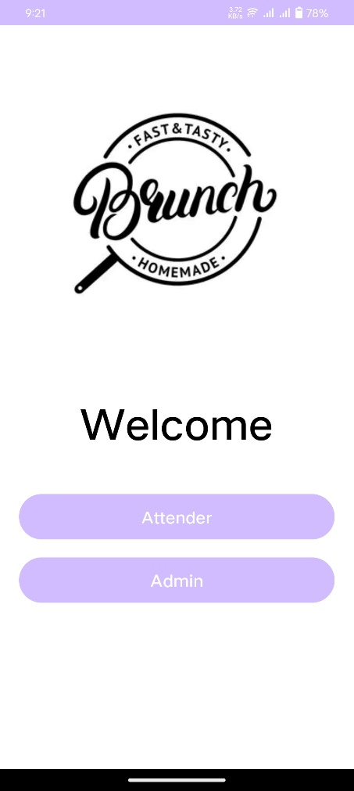

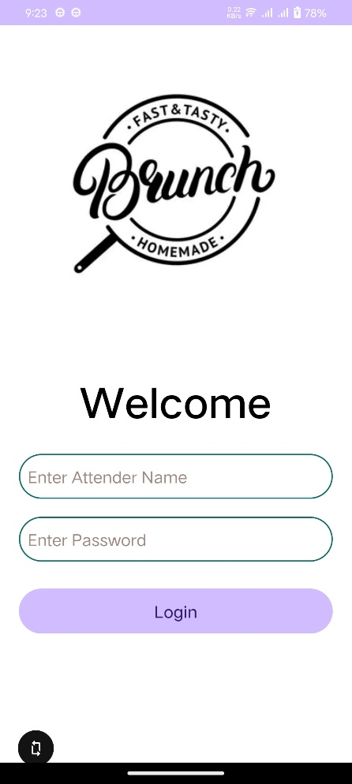 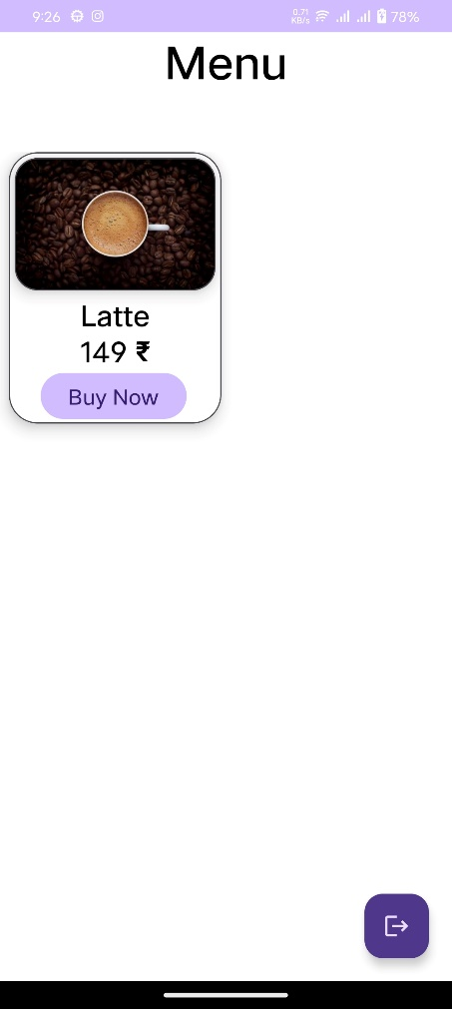

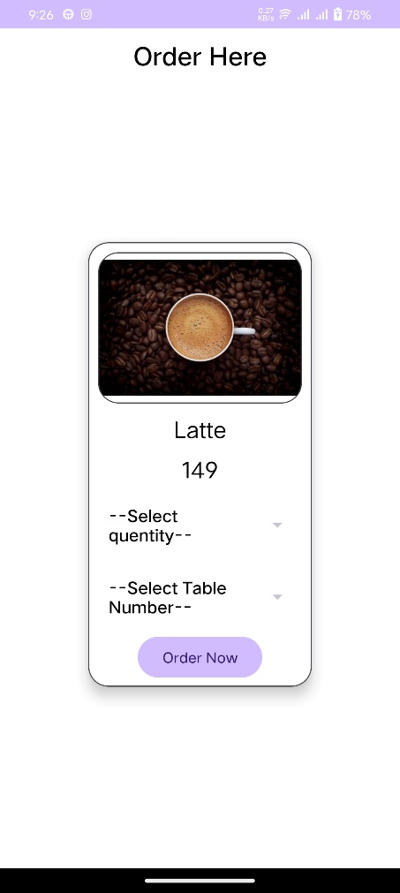 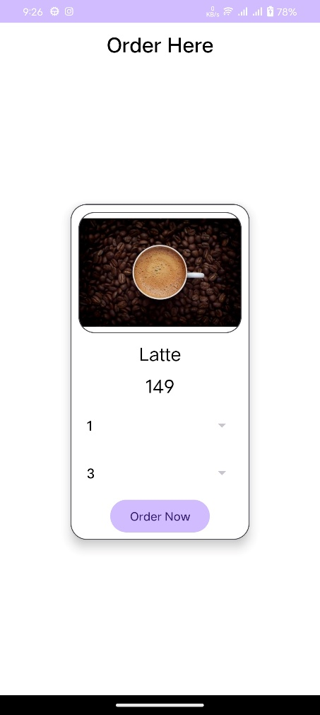

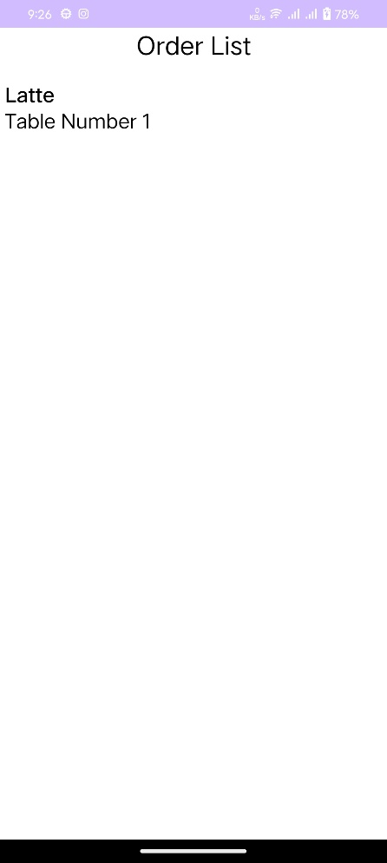 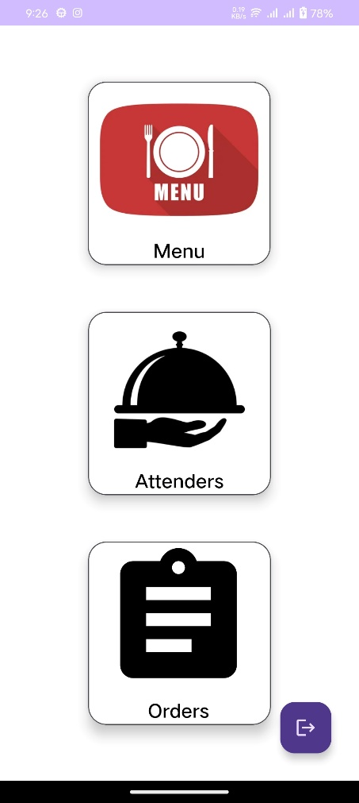

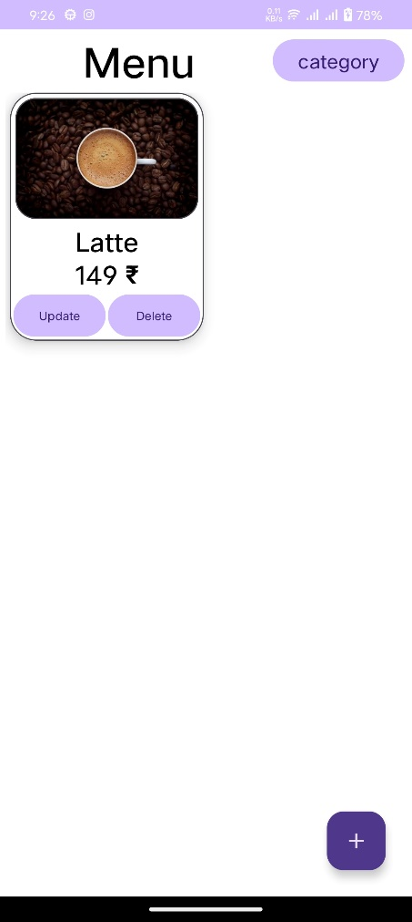 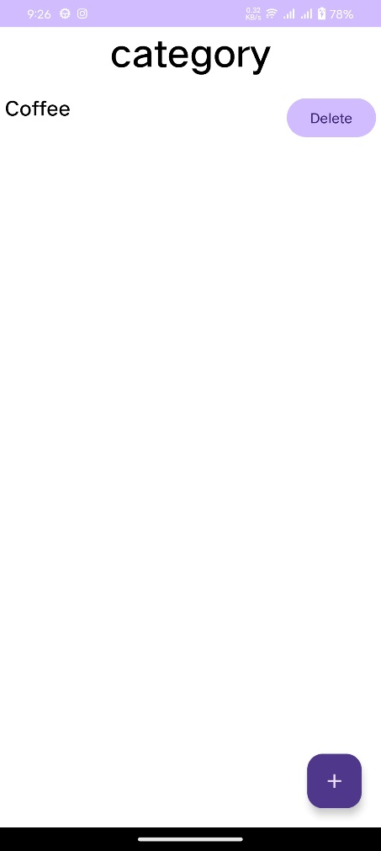

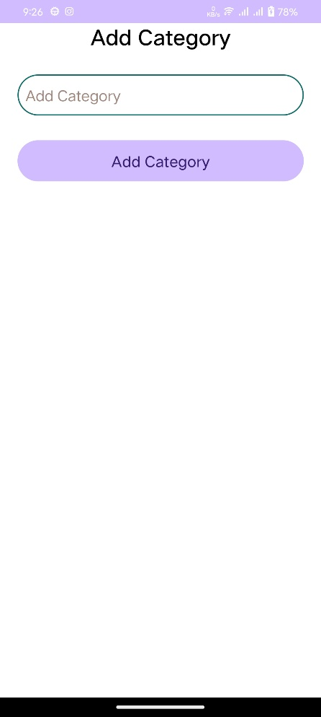 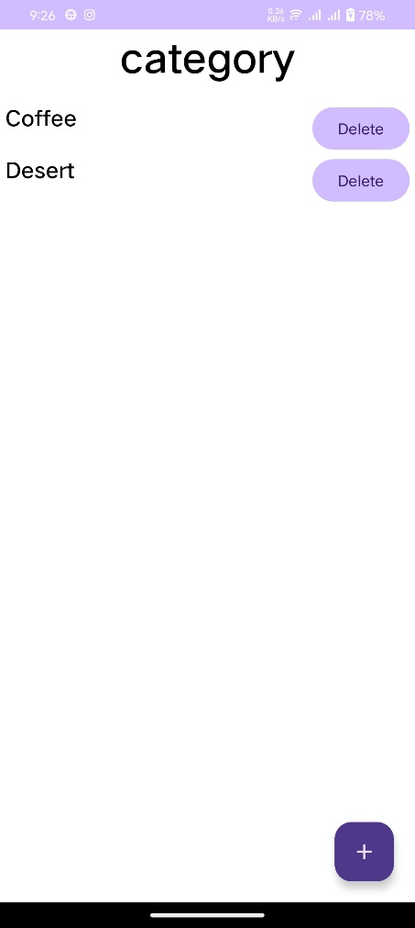

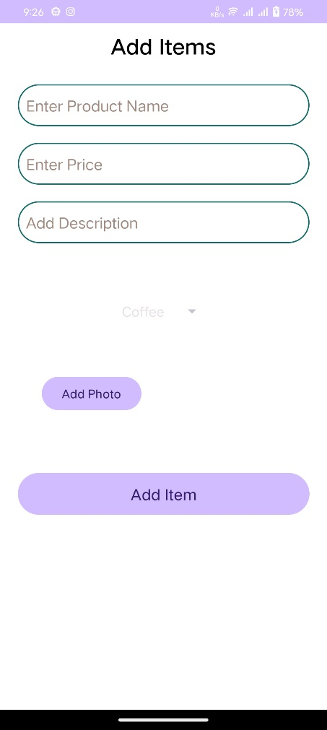 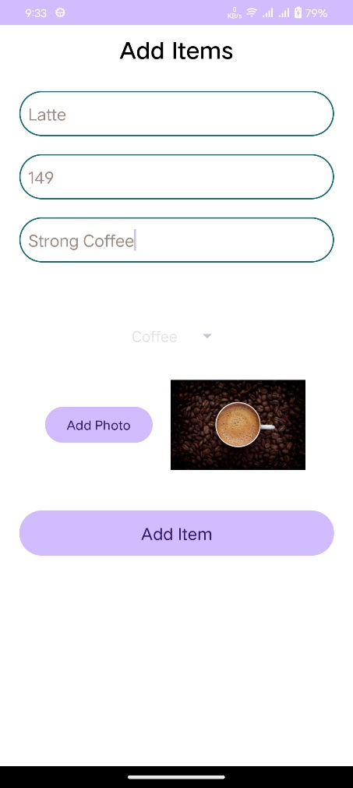

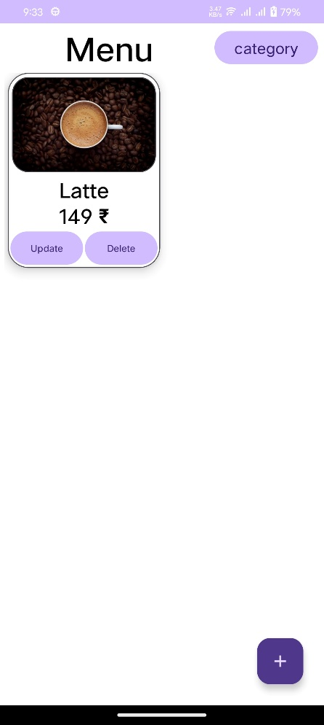 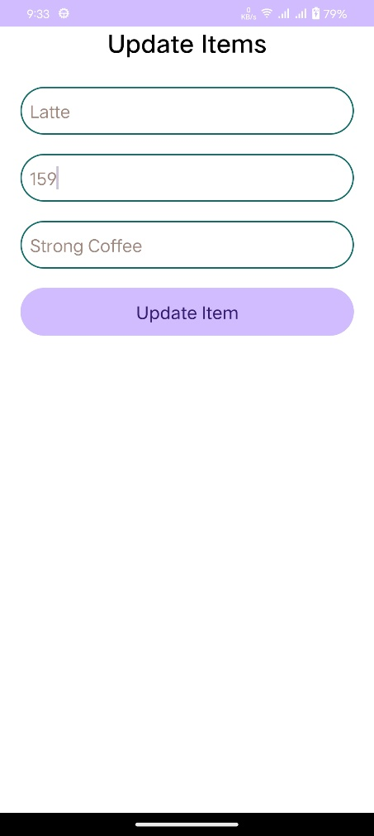

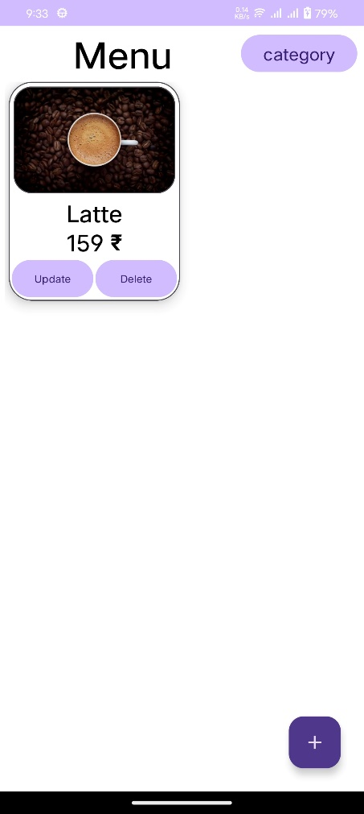 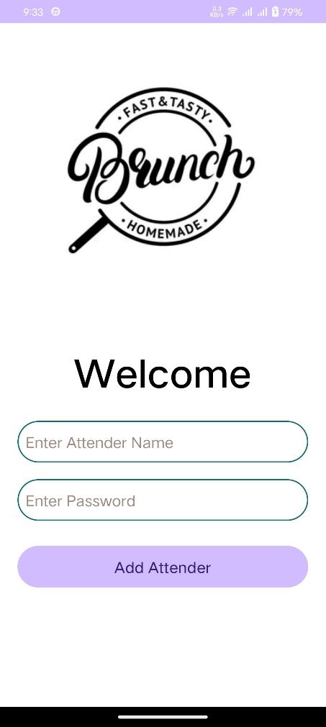

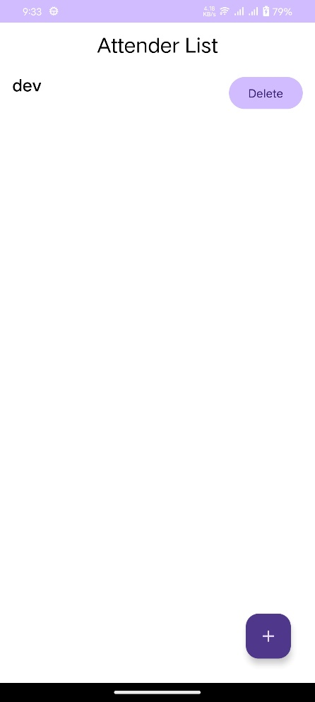 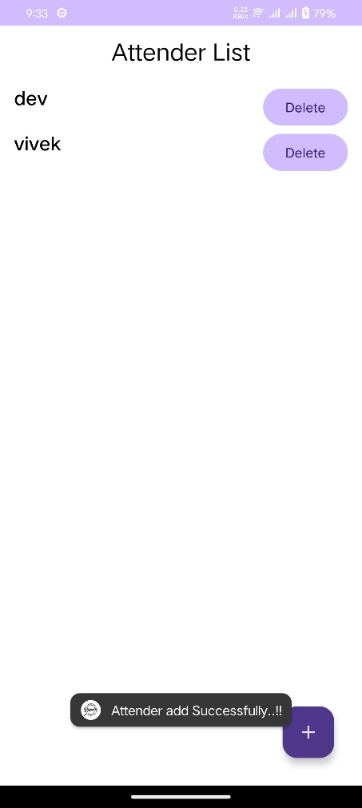

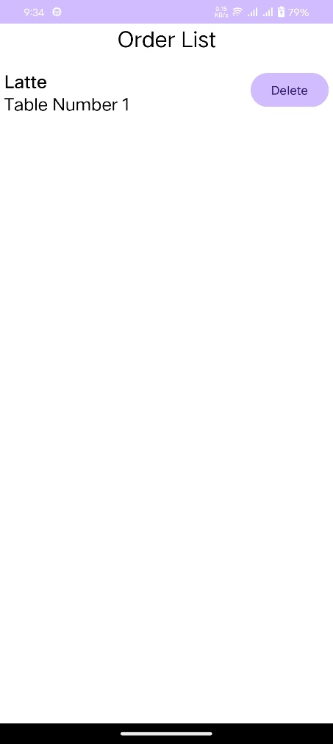

References

* <https://www.android.com/>
* <https://www.youtube.com/>
* <https://stackoverflow.com/>
* <https://www.geeksforgeeks.org/>