Manually Installing the War File
- Navigate to http://<hostname/ip>:9990/console/App.html
- In the “Authentication Required” box, enter the following information.
Username: (Default: admin)
Password: (Default: Admin#70365)
- Click the “Deployments” tab
- Click the “Add” button
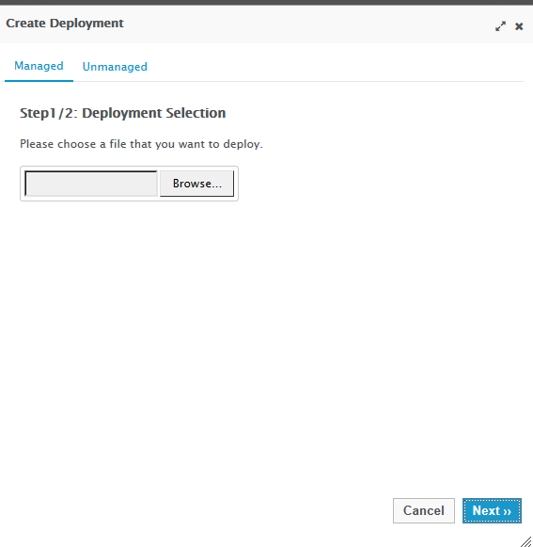
- Click “Browse...”
  - Locate the war on your local file system
  - Click “Open” button
- Click “Next”

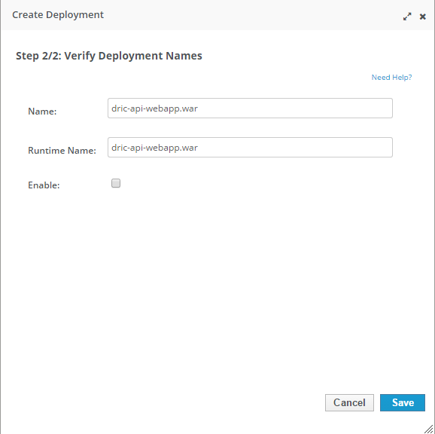
- Type in a name or accept the defaults
- Check “Enable”
- Click “Save”
- The .war file will be listed in the “Available Deployments” and should have a check mark next to it. If the check mark is missing complete the following:
  - Select the .war file
  - Click the “En/Disable” button
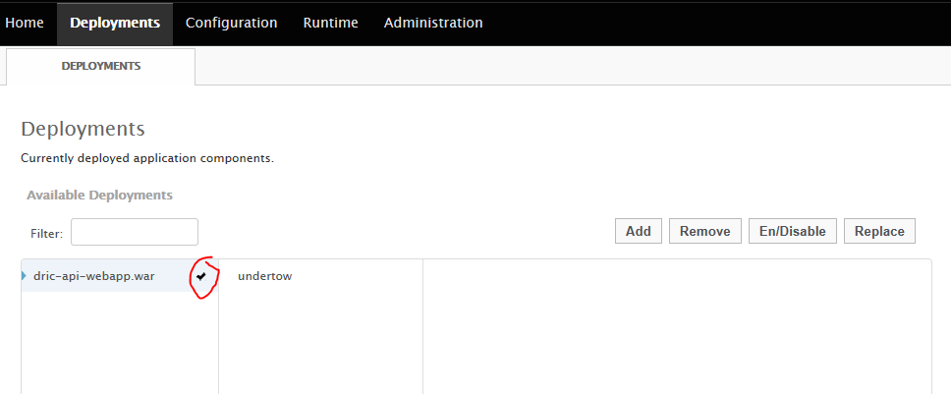
- Navigate to http://<your ip address>:8080/dric/
The Drug Recall Information center page will be displayed.

