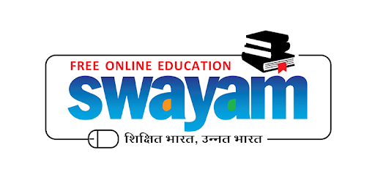

MASSIVE OPEN ONLINE COURSES (MOOCs)

Massive Open Online Courses (MOOCs) available for anyone to enrols. MOOCs provide an affordable and flexible way to learn new skills, advance your career and deliver quality educational experiences at scale. This programme is initiated by the Government of India and these courses can be accessed by anyone, anywhere and at any time. Shillong law college as a Host Institute will be offering online credit-based courses under MOOCs (Massive Open Online Courses) Programme.

MOOCs Co-ordinator: Dr. (Smti) Umeshwari Dkhar, Assistant Professor

Courses Offered :

Youtube Video will appear here with the link

Youtube Video will appear here with the link

Youtube Video will appear here with the link

|  |
| --- |
| FACULTY PARTICIPATION IN MOOCs : ( DYNAMIC LINK WITH SCROLLING ) |
| 1. View Course name & Certificate |
| 1. View Course name & Certificate |

Contact us : Dr. Umeshwari Dkhar (9089015276 )

Email: [slcmoocs@gmail.com](mailto:slcmoocs@gmail.com)