

**CV SHOWCASE WEB PAGE – SIX KEY DESIGN FEATURES AND THEIR IMPLEMENTATION**

**B00753973**

**TOBY KILLEN**

**SOFTWARE ENGINEERING - BENG (HONS)**

Table of Contents

Introduction 3

Feature 1 Navigation Bar 3

Feature 2 Social media 3

Feature 3 Request Form 4

Feature 5 Cookies of terms and conditions 4

Feature 6 Website analytics 4

# Introduction

This document includes all the features that are included on the webpage submitted for COM109. Below are six different features that I have highlighted and discussed, providing code samples along side images and screenshots which I have developed for my website.

## Feature 1 Navigation Bar

This is the code used for the navigation bar

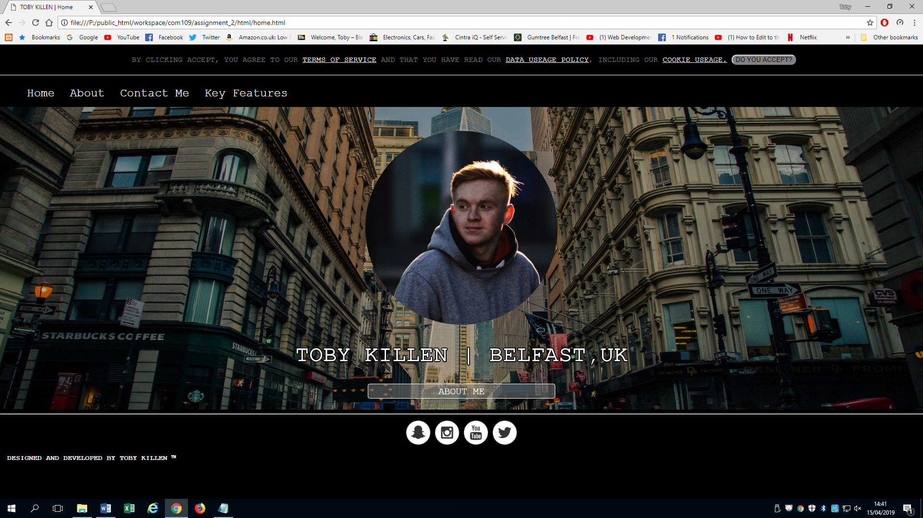

## Feature 2 Social media



## Feature 3 Request Form

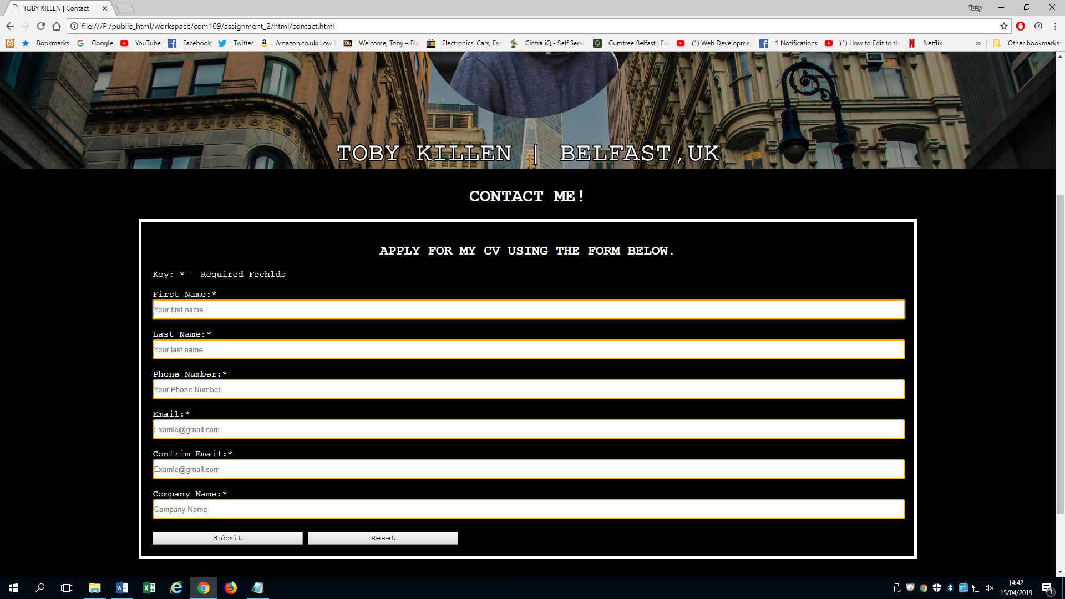

## Feature 4 Cookies of terms and conditions

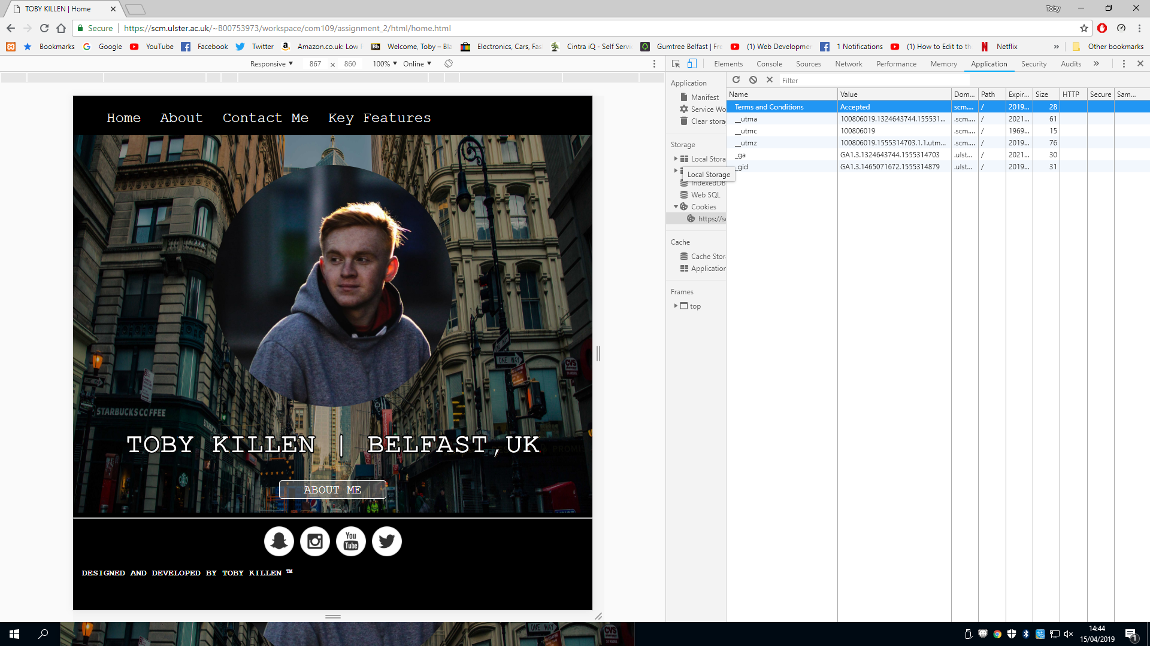

## Feature 5 Website analytics