SOFTWARE REQUIREMENTS SPECIFICATION
Task Manager Application
Practical Mini-Project Version — v1.0
Frontend | React.js
Backend | Node.js + Express.js
Authentication | JWT + bcrypt
Version Control | Git + GitHub

Team Details
Role | Name | Roll Number
Project Manager | Anirudh Dharane | PES1UG24CS555
Requirements/SRS Lead | Mohith N | PES1UG24CS580
QA/Test Lead | Chiranthan HG | PES1UG24CS564
Dev Lead | Akula Sai Nandan Royal | PES1UG24CS553

1. Introduction

1.1 Purpose
The Task Manager Application is a web-based tool that helps users organize and track their tasks in one place. A registered user can securely log in, create tasks, view and update them, change their status, and remove completed or unnecessary tasks. This document specifies the functional, non-functional, security, and interface requirements of the application. It is intended for the project team, including the development and QA/test leads.

1.2 Scope
The project focuses on a simple personal task-management workflow. The application will provide user authentication and the core Create, Read, Update, and Delete (CRUD) operations for tasks.
In scope:
- User registration and login.
- JWT-based authentication with bcrypt password hashing.
- Create, view, edit, and delete tasks.
- Task status: Pending, In Progress, or Completed.
- Task priority: Low, Medium, or High.
- Filtering by status and priority.
- A simple responsive dashboard for managing tasks.
Out of scope:
- Real-time collaboration, chat, calendar integration, notifications, and external productivity-service integrations.

1.3 Definitions, Acronyms, and Abbreviations
Term | Definition
JWT | JSON Web Token (used for session management)
CRUD | Create, Read, Update, Delete
UI | User Interface
API | Application Programming Interface
SRS | Software Requirements Specification
FR / NFR / SEC | Functional Requirement / Non-Functional Requirement / Security Requirement

1.4 References
- IEEE Std 830-1998, IEEE Recommended Practice for Software Requirements Specifications.

1.5 Overview
Section 2 describes the product, its functions, users, and constraints. Section 3 lists the functional requirements and data requirements. Section 4 defines the external interfaces. Section 5 lists the non-functional requirements, including the dedicated security requirements. Section 6 contains the UML use case diagram. Section 7 provides the QA traceability table and the review and approval record.

2. Overall Description

2.1 Product Perspective
The system follows a three-tier architecture comprising a React.js frontend, a Node.js/Express.js backend, and a database for persistent storage. It is a standalone application and does not depend on any external productivity service.

2.2 Product Functions
- Authentication — registration, login, logout, and protected access.
- Task Management — create, view, edit, and delete tasks.
- Task Status — move tasks between Pending, In Progress, and Completed.
- Priority — assign Low, Medium, or High priority.
- Task Organization — filter tasks by status or priority.
- Dashboard — display the user’s tasks in a clear list or column-based layout.
Basic user flow
New user: Register → Login → Dashboard → Create/View Tasks → Edit/Update/Delete → Logout
Returning user: Login → Dashboard → View/Filter Tasks → Manage Tasks → Logout

2.3 User Classes and Characteristics
User | Description | Access
Guest / New User | User who does not have an account. | Registration and login pages.
Registered User | Authenticated application user. | Dashboard and all personal task-management functions.

2.4 Operating Environment
- Frontend: Modern web browsers (Chrome, Firefox, Edge, Brave).
- Backend: Node.js runtime environment.
- Version control: Git and GitHub.

2.5 Assumptions and Constraints
- The application is intended primarily for individual task management.
- The team will use the agreed React.js and Node.js stack.
- A database will be available for persistent user and task storage.
- The exact database technology and deployment method will be finalized by the development team.
- Requirements should remain stable during the short project development period; major feature additions are restricted.

3. System Features (Functional Requirements)
Each requirement below has a unique ID and a measurable acceptance criterion. Requirement IDs are stable identifiers used for QA traceability and are not necessarily sequential within a section.

3.1 Authentication
ID | Feature | Requirement
FR-01 | User Registration | The system shall register a new user given a unique email address, a name, and a password, write the record to the database, and return a success response within 2 seconds.
FR-02 | User Login | The system shall authenticate valid credentials and issue a JWT to the client within 2 seconds of form submission.
FR-03 | Authentication | The system shall reject any protected API request lacking a valid JWT, returning HTTP status 401 Unauthorized within 500 milliseconds.
FR-13 | Logout | The system shall clear the client-side authentication state and redirect the user to the login screen within 1 second of the logout action being triggered.

3.2 Task Management
ID | Feature | Requirement
FR-04 | Create Task | The system shall allow an authenticated user to save a new task (title, optional description, priority, status, and optional due date) and display it on the dashboard within 1 second of submission.
FR-05 | View Tasks | The system shall retrieve and render up to 50 of the authenticated user’s tasks within 1.5 seconds of the dashboard loading.
FR-06 | Edit Task | The system shall update an existing task’s fields in the database and reflect the edits in the UI within 1 second of the user clicking “Save”.
FR-07 | Delete Task | The system shall permanently remove a selected task from the database and the active UI within 1 second of the user confirming a deletion prompt.

3.3 Task Organization
ID | Feature | Requirement
FR-08 | Update Status | The system shall allow users to change a task’s status between Pending, In Progress, and Completed, and reflect the change on the dashboard within 500 milliseconds.
FR-09 | Priority | The system shall allow users to assign Low, Medium, or High priority to a task and save the change within 500 milliseconds.
FR-10 | Filter Tasks | The system shall filter the displayed task list by status or priority in under 500 milliseconds without a full page reload.

3.4 System-wide Rules
ID | Feature | Requirement
FR-11 | User Data Isolation | The system shall return HTTP status 404 Not Found within 500 milliseconds if an authenticated user attempts to read, edit, or delete a task ID that belongs to a different user account.
FR-12 | Validation and Errors | The system shall display an inline UI error message (for example, “Email is required”) within 200 milliseconds if a user submits a form with missing required fields or invalid data formats.

3.5 Logical Database Requirements
The system shall persist the following data.
User
- User ID
- Name
- Email (unique)
- Password hash
Task
- Task ID
- User ID / Owner
- Title
- Description
- Status
- Priority
- Due date (optional)
- Created/updated timestamps

4. External Interface Requirements

4.1 User Interfaces
The user interface will be built using React.js and shall consist of the following:
- Registration page
- Login page
- Task dashboard
- Create/edit task form
- Task list or columns
- Status/priority controls
- Filter controls
- Logout option

4.2 Software Interfaces
The React.js frontend shall communicate with the Node.js/Express.js backend via HTTP/HTTPS RESTful API calls exchanging JSON payloads. The backend shall interface with the project database (for example, MongoDB or PostgreSQL) to store and retrieve users and tasks.

5. Non-Functional Requirements

5.1 Performance Requirements
ID | Requirement
NFR-01 | 95% of standard task CRUD API requests shall return a response to the client in under 1 second under normal load testing parameters.

5.2 Security Requirements
Security objectives
ID | Objective
OBJ-01 | Ensure the confidentiality of user credentials so that no plaintext password is stored, logged, or retrievable by administrators or attackers.
OBJ-02 | Ensure data isolation between users so that an authenticated session can access only its own user’s tasks.
Security requirements
ID | Requirement
SEC-01 | All user passwords shall be hashed using the bcrypt algorithm with a minimum work factor (salt rounds) of 10 before database insertion.
SEC-02 | All protected backend API routes shall validate a JWT signed with a 256-bit server-side secret. The JWT shall expire 24 hours after issuance.
SEC-01 supports OBJ-01. SEC-02, together with FR-03 and FR-11, supports OBJ-02.

5.3 Software Quality Attributes
ID | Attribute | Requirement
NFR-02 | Usability | A first-time user shall be able to register, log in, and create their first task in fewer than 5 cumulative UI clicks/taps.
NFR-03 | Reliability | Saved user profiles and tasks shall be recovered with 100% data integrity after any routine application or server restart.
NFR-04 | Compatibility | The web application shall render correctly and run with zero console errors on the latest stable versions of Google Chrome, Mozilla Firefox, and Microsoft Edge.
NFR-05 | Maintainability | Frontend components and backend routing logic shall be separated into distinct modules following MVC or standard API structural conventions.
NFR-06 | Testability | 100% of backend API endpoints shall be invocable and verifiable independently of the UI using an HTTP client, returning a documented status code and JSON body for both success and error cases.

6. System Models

6.1 UML Use Case Diagram
Figure 1 shows the interactions between the two user classes and the Task Manager Application. Edit Task and Delete Task include View Tasks, because the target task must be displayed before it can be modified or removed.
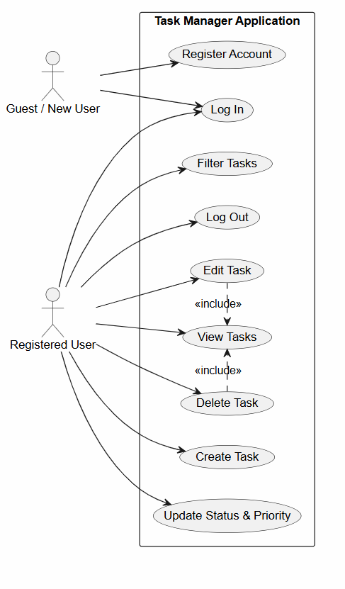
Figure 1: UML Use Case Diagram — Task Manager Application

7. Appendices

7.1 Requirement Traceability for QA
The requirement IDs above form the baseline for the QA/Test Lead. Test cases should reference these IDs so that every implemented feature can be traced to testing.
Requirement | Example Test Case Group | Levels
FR-01 Registration | TC-REG-* | Unit / Integration / System
FR-02 Login | TC-LOGIN-* | Unit / Integration / System
FR-03 Authentication | TC-AUTH-* | Unit / Integration / System
FR-04 Create Task | TC-CREATE-* | Unit / Integration / System
FR-05 View Tasks | TC-VIEW-* | Integration / System
FR-06/07 Edit & Delete | TC-MANAGE-* | Integration / System
FR-08/09 Status & Priority | TC-UPDATE-* | Unit / Integration / System
FR-10 Filter | TC-FILTER-* | Unit / System
FR-11 Data Isolation | TC-SECURITY-* | Integration / System
FR-12 Validation and Errors | TC-VALID-* | Unit / System
FR-13 Logout | TC-LOGOUT-* | Integration / System
SEC-01 Password Hashing | TC-SEC-PWD-* | Unit / Integration
SEC-02 JWT Validation and Expiry | TC-SEC-JWT-* | Unit / Integration / System
NFR-01 Performance | TC-PERF-* | System
NFR-02 Usability | TC-USAB-* | System
NFR-03 Reliability | TC-REL-* | System
NFR-04 Compatibility | TC-COMPAT-* | System
NFR-05 Maintainability | Code review / inspection | Inspection
NFR-06 Testability | TC-API-* | Integration

7.2 Review and Approval
This SRS should be reviewed by the project team before implementation. The Requirements/SRS Lead should update the document if the team changes an agreed requirement.
Role | Name | Signature / Date
Requirements/SRS Lead | Mohith N
Development Lead | Akula Sai Nandan Royal
QA/Test Lead | Chiranthan HG

