SOFTWARE REQUIREMENTS SPECIFICATION
Task Manager Application
Practical Mini-Project Version — v1.1
Frontend | React.js
Backend | Node.js + Express.js
Authentication | JWT + bcrypt
Version Control | Git + GitHub

1. Purpose
The Task Manager Application is a web-based application that helps users organize and track their tasks in one place. A registered user can securely log in, create tasks, view and update them, change their status, and remove completed or unnecessary tasks.

2. Scope
The project focuses on a simple personal task-management workflow. The application will provide user authentication and the core Create, Read, Update, and Delete (CRUD) operations for tasks.
The project will include:
- User registration and login.
- JWT-based authentication with bcrypt password hashing.
- Create, view, edit, and delete tasks.
- Update task status: Pending, In Progress, or Completed.
- Set task priority: Low, Medium, or High.
- Basic filtering by status and priority.
- A simple responsive dashboard for managing tasks.
The project will not include real-time collaboration, chat, calendar integration, notifications, or external productivity-service integrations.

3. Intended Audience
This document is intended for the following readers:
- Development Lead and development team — to implement the frontend, backend, and authentication features described in Sections 8 and 9.
- QA/Test Lead — to build the test plan using the functional requirement IDs (FR-01 to FR-13) and the traceability mapping in Section 17.
- Requirements/SRS Lead — to maintain and update this document if the team changes an agreed requirement.
- Course instructor / evaluator — to assess this document and the resulting implementation as a practical mini-project deliverable.

4. References
- Project SRS-Template.docx — the course-provided template used as the structural baseline for this document.
- IEEE Std 830-1998, IEEE Recommended Practice for Software Requirements Specifications.
- React.js official documentation — react.dev
- Node.js official documentation — nodejs.org
- Express.js official documentation — expressjs.com
- RFC 7519 — JSON Web Token (JWT) standard.
- bcrypt password-hashing library documentation (npm "bcrypt" package).

5. Product Perspective
The Task Manager Application is a new, standalone web application. It is not a modification of, or a component within, any existing larger system, and it does not integrate with external productivity or task-management platforms. It is a self-contained client-server system consisting of a React.js single-page frontend and a Node.js/Express.js backend API, built as a practical mini-project.

6. Operating Environment
- Client: any device running a modern web browser (Chrome, Firefox, Edge, or Brave) on Windows, macOS, or Linux.
- Frontend runtime: React.js single-page application, served to and executed in the browser.
- Backend runtime: Node.js (LTS version) running an Express.js server.
- Database: a persistent database reachable by the backend (technology finalized by the development team — see Section 10).
- Development/hosting: local development environment for the course project; no specific production hosting platform is mandated.
- Version control: Git, with the repository hosted on GitHub.

7. User Classes
User | Description | Access
Guest / New User | User who does not have an account. | Registration and login pages.
Registered User | Authenticated application user. | Dashboard and all task-management functions.

8. System Features
- Authentication — registration, login, logout, and protected access.
- Task Management — create, view, edit, and delete tasks.
- Task Status — move tasks between Pending, In Progress, and Completed.
- Priority — assign Low, Medium, or High priority.
- Task Organization — filter tasks by status or priority.
- Dashboard — display the user's tasks in a clear list or column-based layout.

9. Product Functions / Functional Requirements
ID | Feature | Requirement
FR-01 | User Registration | The system shall allow a new user to register using a name, email address, and password.
FR-02 | User Login | The system shall allow a registered user to log in using valid email and password credentials.
FR-03 | Authentication | The system shall use JWT-based authentication to protect authenticated user operations.
FR-04 | Create Task | An authenticated user shall be able to create a task with a title, description, priority, status, and optional due date.
FR-05 | View Tasks | An authenticated user shall be able to view the tasks associated with their account.
FR-06 | Edit Task | An authenticated user shall be able to edit the details of their own task.
FR-07 | Delete Task | An authenticated user shall be able to delete their own task.
FR-08 | Update Status | An authenticated user shall be able to change a task's status between Pending, In Progress, and Completed.
FR-09 | Priority | An authenticated user shall be able to assign Low, Medium, or High priority to a task.
FR-10 | Filter Tasks | An authenticated user shall be able to filter displayed tasks by supported criteria such as status or priority.
FR-11 | User Data Isolation | The system shall prevent one authenticated user from viewing, editing, or deleting another user's tasks.
FR-12 | Validation and Errors | The system shall validate required inputs and display an appropriate error when an operation cannot be completed.
FR-13 | Logout | The system shall provide a logout function that clears the user's authenticated application state.

10. Design and Implementation Constraints
- The frontend must be implemented in React.js and the backend in Node.js with Express.js, per the agreed project stack.
- Authentication must use JWT for token-based sessions and bcrypt for password hashing; no alternative authentication libraries are to be introduced.
- Version control must be maintained through Git, with the repository hosted on GitHub.
- The exact database technology and deployment method are left to the development team's discretion, provided persistence and the data model in Section 14 are supported.
- The project must be completed within the course/mini-project timeline, which bounds scope to the features defined in Section 2 (Scope).

11. Non-Functional Requirements
- Security: Passwords shall be stored using bcrypt hashing and protected operations shall require authentication.
- Usability: The interface should be simple enough for a first-time user to understand.
- Performance: Normal task operations should respond promptly in the project test environment.
- Reliability: Successfully saved users and tasks should remain available after normal application restarts.
- Compatibility: The application should work in modern browsers such as Chrome, Firefox, Edge, and Brave.
- Maintainability: Frontend and backend code should be separated into clear modules.
- Testability: Core APIs and important UI behavior should be testable independently.

12. Basic User Flow
New user: Register → Login → Dashboard → Create/View Tasks → Edit/Update/Delete → Logout
Returning user: Login → Dashboard → View/Filter Tasks → Manage Tasks → Logout

13. Analysis Models

13.1 Use Case Diagram
The Guest / New User can register or log in. Once authenticated, the Registered User can perform all task-management use cases shown below.
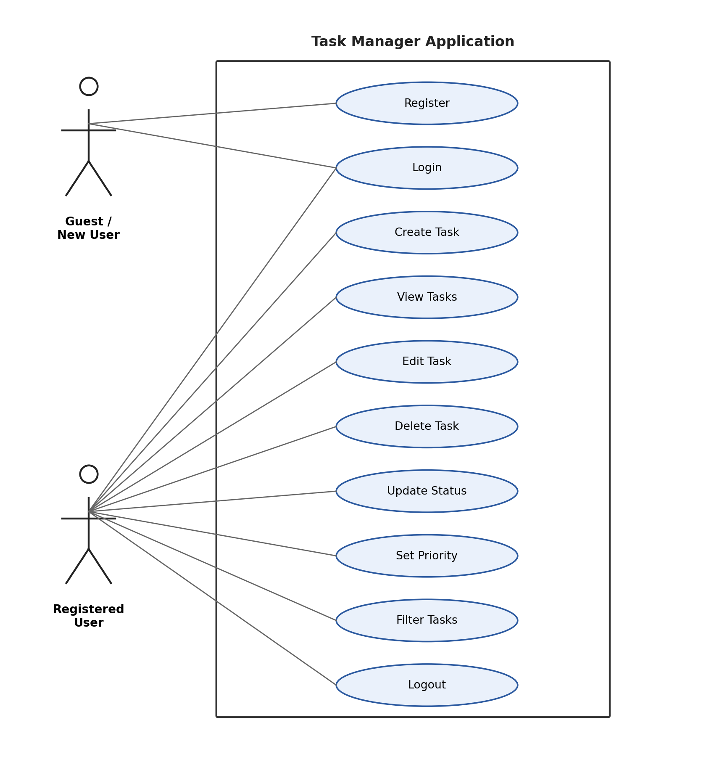
Figure 1: Use case diagram for the Task Manager Application.

13.2 Entity-Relationship Diagram
Each User owns zero or more Tasks. The relationship is one-to-many, enforced by the User ID foreign key on the Task entity (see FR-11, User Data Isolation).
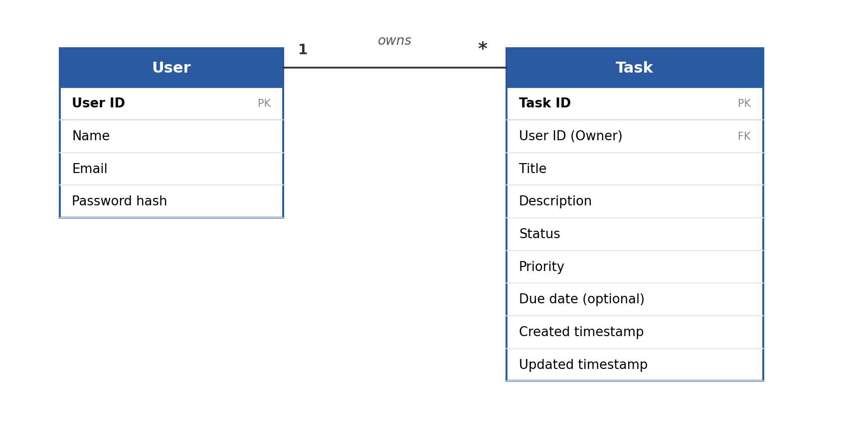
Figure 2: Entity-relationship diagram for User and Task.

14. Basic Data Requirements

14.1 User
- User ID
- Name
- Email
- Password hash

14.2 Task
- Task ID
- User ID / Owner
- Title
- Description
- Status
- Priority
- Due date (optional)
- Created/updated timestamps

15. External Interfaces

15.1 User Interface
- Registration page
- Login page
- Task dashboard
- Create/edit task form
- Task list or columns
- Status/priority controls
- Filter controls
- Logout option

15.2 Backend Interface
The React.js frontend shall communicate with the Node.js/Express.js backend using HTTP/HTTPS API requests. The backend shall communicate with the project database for storing and retrieving users and tasks.

16. Assumptions and Constraints

16.1 Assumptions
- The application is intended primarily for individual task management.
- A database will be available for persistent user and task storage.
- Requirements should remain stable during the short project development period; major feature additions should be avoided.

16.2 Constraints
- See Section 10 (Design and Implementation Constraints) for the mandated technology stack and process constraints.

17. Requirement Traceability for QA
The functional requirement IDs above form the baseline for the QA/Test Lead. Test cases should reference these IDs so that every implemented feature can be traced to testing.
Requirement | Example Test Case Group | Levels
FR-01 Registration | TC-REG-* | Unit / Integration / System
FR-02 Login | TC-LOGIN-* | Unit / Integration / System
FR-04 Create Task | TC-CREATE-* | Unit / Integration / System
FR-05 View Tasks | TC-VIEW-* | Integration / System
FR-06/07 Edit & Delete | TC-MANAGE-* | Integration / System
FR-08/09 Status & Priority | TC-UPDATE-* | Unit / Integration / System
FR-10 Filter | TC-FILTER-* | Unit / System
FR-11 Data Isolation | TC-SECURITY-* | Integration / System

18. Review and Approval
This SRS should be reviewed by the project team before implementation. The Requirements/SRS Lead should update the document if the team changes an agreed requirement.
Role | Name | Signature / Date
Requirements/SRS Lead | [Fill] | [Fill]
Development Lead | [Fill] | [Fill]
QA/Test Lead | [Fill] | [Fill]

Appendix A: Glossary
Term | Definition
CRUD | Create, Read, Update, Delete — the four basic persistent-storage operations.
JWT (JSON Web Token) | A compact, signed token format used to authenticate API requests after login.
bcrypt | A password-hashing function used to store passwords securely rather than in plain text.
API | Application Programming Interface; here, the HTTP endpoints exposed by the Express.js backend.
FR | Functional Requirement.
SRS | Software Requirements Specification.
Task | A user-created unit of work tracked by the application, with a title, status, and priority.
Priority | A classification (Low, Medium, High) indicating a task's relative importance.
Status | The lifecycle state of a task (Pending, In Progress, Completed).

Appendix B: Field Layouts

B.1 User
Field | Data Type | Required | Description
User ID | Identifier (e.g., ObjectId/UUID) | Yes (system-generated) | Unique identifier for the user.
Name | String | Yes | User's display name.
Email | String | Yes | Unique login identifier.
Password hash | String | Yes (system-generated) | bcrypt hash of the user's password; the plain password is never stored.

B.2 Task
Field | Data Type | Required | Description
Task ID | Identifier | Yes (system-generated) | Unique identifier for the task.
User ID (Owner) | Identifier (FK → User) | Yes | References the owning User; used to enforce FR-11 data isolation.
Title | String | Yes | Short task name.
Description | String | No | Additional detail about the task.
Status | Enum: Pending / In Progress / Completed | Yes | Current lifecycle state.
Priority | Enum: Low / Medium / High | Yes | Relative importance.
Due date | Date | No | Optional deadline.
Created timestamp | DateTime | Yes (system-generated) | Record creation time.
Updated timestamp | DateTime | Yes (system-generated) | Last modification time.

